**The Apostles Post**

26238 North Highway 59

Wauconda, Illinois

MAY 2016

2015



**FROM THE VICAR** *(M. C. Gillette)*

[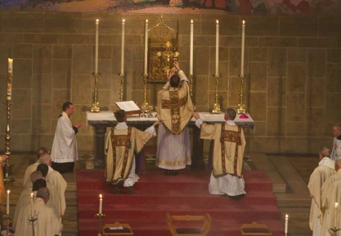](http://www.google.com/url?sa=i&rct=j&q=&esrc=s&source=images&cd=&cad=rja&uact=8&ved=0ahUKEwjFnPqrqarMAhVjl4MKHed9AAMQjRwIBw&url=http://www.livingchurch.org/two-anglo-catholic-moments&psig=AFQjCNGiGDrFDIM6QHjoOenL-Gj6R_LY5A&ust=1461692007976103)Two of our illustrious members, on a recent trip out-of-state, attended a local church. They were told by a member of that parish that theirs was an ‘Anglo-Catholic’ church. They were not sure what that meant. They are not alone. So, plagiarizing a piece by a prominent Anglo-Catholic church in the center of Oxford, England (their website is <http://www.stmarymagdalenoxford.org.uk/> and you can go there to learn more about them and their understanding of Anglo-Catholicism if you wish.

First, let’s set the scene. As I’m going to assume you know, England was predominantly Roman Catholic until King Henry VIII decided he could continue to worship in that tradition without acknowledging the primacy of the Pope. But this decision was made at a point in history when the Reformation was gaining strength, resulting in lots of people burning lots of other people at the stake as they tried to sort out whether God wanted folks to offer Communion wearing chasubles or not. (Obviously, infinitely more complex than this, but often just as painfully meaningless.) Ultimately the Church of England merged essential elements of the Roman Catholic and Protestant traditions, defining itself as a ‘via media,’ or ‘middle road’ between the two.

Our Episcopal Church was originally The Church of England in ‘The Colonies.’ Then there was this period of – um – social and political disagreement, resulting in a revolution, and the creation of a new country called The United States of America. Given that revolutions rarely leave participants on either side with warm, fuzzy feelings towards each other, those who had been members of the Church of England renamed it, revised the Book of Common Prayer (for example, taking out the prayers for the British Monarch and replacing them with prayers for the President), and started sorting out small details like how to ordain priests. Still, these good folks wanted to maintain their faith tradition and ties to what is known as the Anglican Communion. (The Anglican Communion consists of the branches of The Church of England that were created everywhere the Brits established colonies, which, dear reader, means that there are a lot of member churches in the Communion.)

Now on to our main topic. As the well-spoken author at St. Mary Magdalen’s writes, The Church of England and the wider Anglican Communion are confusing institutions. In the case of most Christian denominations, one can know simply by their name what one might expect to encounter in their worship or their preaching. But in the Church of England this is not the case. Here in Oxford, where St. Mary Magdalen's is situated, one can find churches which might be mistaken for conservative evangelical churches in the United States, and churches which might be thought to be traditionally Roman Catholic; with plenty of other churches falling somewhere in between these two. All of these churches, in fact, belong to the Church of England.

The term 'Anglo-Catholicism' describes a range of theological views and traditions within Anglicanism which emphasize the continuity of the Church of England - and those churches born out of it - with the teaching and practice of Christianity throughout the ages, rooted in scripture and the teachings of the early church. 'Anglo-Catholics' have always valued the sacramental life of the church, adhering strongly to doctrine such as the real presence of Christ in the Eucharist and the continuity of the apostolic orders of Bishop, Priest and Deacon. A significant stress on liturgy and worship - performed in order to maintain the beauty of holiness - makes worship in an Anglo-Catholic church an experience which is intended to appeal to one's whole person - to heart as well as head, to senses as well as to intellect.

In the 1830s, a group of academic churchmen sought (controversially) to denounce the increasing secularization of the Church of England, and to recall it to its heritage of apostolic order, and to the catholic doctrines of the early church fathers. Now conversations about ‘doctrine’ are generally contentious to some degree (which doesn’t mean people have to be slathered in tar and set alight) but the establishment of ‘doctrine’ is necessary because it defines what the church believes, what it believes to be its historical connections to the earliest church, what it teaches, what baptism means, what happens during eucharist, etc. Eventually, these ‘churchmen’ – called Tractarians after the little leaflets, or ‘tracts’ they published and passed around – generated a great revival of interest in liturgy, church architecture, individual and corporate holiness, and vocations to the religious life (i.e. nuns and monks).

It was probably inevitable that the attentions of those involved in this upheaval would turn to the social and evangelistic problems of the industrial working class. Young Oxford men found themselves called to work in new and demanding slum parishes. The ritual innovations they instituted in their parishes were often rooted in the desperate pastoral needs they encountered. For example, a group of Anglican nuns worked with the clergy of St. Peter's Plymouth in the cholera epidemics of the late 1840s, and petitioned the parish priest, Father George Rundle Prynne, for a celebration of the Eucharist each morning to strengthen them for their work. So began the first daily celebration of the Eucharist in the Church of England since the Reformation. Similarly the clergy of St Saviour's, Leeds (a parish Pusey had endowed), laid what medicines they had on the altar at each morning's communion, before carrying them out to the many dozens of their parishioners who would die of cholera that very day. One cannot underestimate the extraordinary transformation in Anglican practice which began with these early 'ritualists'. In the nineteenth century, vestments and candles were horrific to most, and yet in places such as the mission church of St George's in the East, thuribles (those wonderful containers of that wonderful incense we don’t use) were swung, genuflecting was encouraged, the sign of the cross was made frequently, and devotion to the blessed sacrament was taken for granted. Confessions were heard, holy anointing was practiced.

At the heart of such physical activity lay the Tractarian interpretation of the Christian doctrine of the incarnation. God, in Christ, lives among us as a physical reality. The poor must be brought the ministry of Christ in the celebration of the sacraments and the preaching of the gospel. Beauty and holiness were to go into the midst of squalor and depression, as a witness to the catholic faith in Jesus Christ, the incarnate God, present and active in his world. During such times of crisis as the East London cholera epidemic of 1866, the sick and dying were to receive this sacramental presence as far as was possible. Deathbed confessions, the oil of unction, and, even occasionally, communion from the reserved sacrament began to be administered. At the time such things were unknown in the Church of England. Now they are officially sanctioned and encouraged by its liturgical texts and regulations. The ritualists gave rise to a long and bitter battle, in which priests were imprisoned, many more dismissed, parish riots took place, rent-a-mob crowds were brought in, and bishops issued edicts from palaces to areas into which they would not dare set foot. Priests were prosecuted and, in five cases, imprisoned for practices which are now not just acceptable but actually the norm in the Church of England - having lighted altar candles, for example, or using wafer bread at the Eucharist.

The overwhelming success of the early Anglo-Catholics is seen not so much in those parishes which, like St Mary Magdalen's, rejoice in proclaiming their part in such a tradition. It is the rest of the church which has been the theater of transformation over the last five or six decades. The rediscovered emphases on apostolic succession and the catholicity of the church, on priesthood, on sacrament and sacrifice, on prayer, holiness and the beauty of worship, are the Tractarians' gifts to their successors. A glance round the contemporary Church of England, still vastly divergent but nevertheless teeming with colorful decorations, revised liturgies, ancient hymns, and thousands of processions, aumbries, (like that little box on our wall in which we keep the reserved sacrament), altars, and retreat houses, reminds us just how dramatically the life of the English Church was and is renewed by the movement which began in Oxford and spread, through the Anglican Communion, across the entire world. And there you go.

†††††††††††††††††††††††††††††††

**HERE AND THERE** (M. C. Gillette)

*In this on-going article, we pull things from our various Diocesan calendars and church websites so see what’s going on around us. For more information about what's happening at the Diocesan Headquarters and the Cathedral of Saint James, you can always visit their websites.*

**A Letter from Lusaka: Episcopal Church's ACC Members Write to the Church**

**The Anglican Consultative Council took place April 8-19**

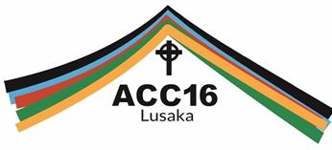

The Episcopal Church's three members on the Anglican Consultative Council have written a [**letter**](http://episcopaldigitalnetwork.com/ens/2016/04/19/a-letter-from-lusaka-episcopal-church-team-writes-to-the-church-at-conclusion-of-acc-meeting/) to the church at the conclusion ACC-16 in Lusaka, Zambia.

"Because this ACC meeting was held in the shadow of the January Primates Gathering and Meeting that sought to restrict our participation as members from The Episcopal Church, we want to assure you that we participated fully in this meeting and that we were warmly welcomed and included by other ACC members."

The Episcopal Church‘s three members on the Anglican Consultative Council have written the following letter to the church at the conclusion of ACC-16 in Lusaka, Zambia.

April 19, 2016

Dear Sisters and Brothers in Christ in The Episcopal Church:

The 16th meeting of the Anglican Consultative Council concluded today at the Cathedral of the Holy Cross in Lusaka, Zambia, and tonight and tomorrow, we are saying farewell to our fellow ACC members from across the Anglican Communion and making our way home.

ACC16 was filled with joy, grace and love as close to seventy Anglican sisters and brothers in Christ, laypeople, priests and bishops, came together in prayer, Bible study, and worship.  Our time together over the last thirteen days has visibly demonstrated, once again, our unity in diversity as the provinces of the Anglican Communion. Meeting fellow Anglicans from around the world in discussions, around the altar, in tea breaks, and at meals, we learned from each other what intentional discipleship across our differences means as the Body of Christ in the world today.  We are thankful to God and to The Episcopal Church for this privilege of representing our church on the Anglican Consultative Council.

Because this ACC meeting was held in the shadow of the January Primates Gathering and Meeting that sought to restrict our participation as members from The Episcopal Church, we want to assure you that we participated fully in this meeting and that we were warmly welcomed and included by other ACC members. Archbishop of Canterbury Justin Welby did report to the ACC on the Primates Gathering and Meeting on the first day of the meeting. Beyond that report, ACC members seemed to have little energy for answering the primates’ call for consequences, for discussing disagreements over human sexuality, or for taking up the call of Anglican Communion Secretary-General Josiah Idowu-Fearon to pursue the Anglican Covenant. Yesterday, in fact, a resolution that sought to pursue further consequences against The Episcopal Church was withdrawn just before it was scheduled for debate.

Instead our fellow ACC members and we were enlivened by our shared concerns about intentional discipleship, gender-based violence, climate change, religiously motivated violence, food security and other issues that affect all of us across the Anglican Communion. Morning prayer, bible study on the book of Ruth, and daily Eucharist shaped our days, and our opening Eucharist on April 10 with 5000 Anglicans from across the Province of Central Africa served as a joyful reminder that our identity as Anglicans is not primarily to be found in governing structures or documents but in our unity as the body of Christ gathered around one table. Our hosts in the Province of Central Africa had been planning for this meeting for two years and extended to us and to all of the ACC members and guests extraordinary hospitality, including organizing visits to local congregations on April 17 where we sang, danced and prayed for hours and were treated as honored guests.

On April 15, the three of us had the opportunity to meet informally with Archbishop Justin, Caroline his wife and members of his staff at Lambeth Palace. Our conversation was easy, open and honest, and we came away from the conversation with the conviction that while the Archbishop does not agree with the actions of our General Convention regarding marriage equality, he is firmly committed to our unity as the Anglican Communion and the autonomy of Anglican provinces. He expressed fervent hope that The Episcopal Church will continue to be committed to and involved in the life of the Anglican Communion. We are grateful to Archbishop Justin for taking the time to meet with us, for his candor, and for assuring us of his respect for us and for the Episcopal Church.

This was the first ACC meeting that both Archbishop Justin or Secretary General of the Anglican Communion Josiah Idowu-Fearon had attended—as both are relatively new in their posts. We found the process and program of the meeting, especially the opening days, to have been largely made up of reports by the staff of the Anglican Communion Office. We would have preferred more interactive time with our fellow ACC members as experienced at previous ACC meetings.

The work of the Anglican Consultative Council and the Anglican Communion Office is overseen by a Standing Committee, with a Chair and Vice-Chair, elected by the ACC members at each meeting.  ACC16 elected a strong slate of two lay people, a priest, and two bishops to the Standing Committee who are broadly inclusive of gender, age and geography. Canon Margaret Swinson, a laywoman from the Church of England, was elected our Vice-Chair and Archbishop Paul Kwong of Hong Kong Sheng Kung Hui, Chair. We do note that the election of an archbishop as Chair of the ACC means that all four Instruments of Communion are now headed by a primate, perhaps illustrating a drift towards increased primatial authority in the Anglican Communion. In addition, despite previous ACC resolutions endorsing gender parity on Anglican leadership bodies, this meeting included 50 men and only 20 women members. The ACC as a whole, however, remains committed to the full participation of all of God’s people, especially women, youth and lay people in the life and work of the Anglican Communion. We thus are heartened by the ACC’s overwhelming support for exploring the possibility of an Anglican Congress by 2025 (Resolution D9) and for expanding youth representation on the ACC (Resolution D4).

We leave Lusaka with enormous gratitude for the Anglican Consultative Council, for our fellow ACC members from around the world, and for the generosity of our hosts here in Zambia. In our time together as sister and brothers in Christ we have once again witnessed the breadth and diversity of our global family of churches known as the Anglican Communion. We thank God for the many and different ways that Anglicans around the world are participating in God’s mission of restoration and reconciliation and for our unity as disciples of Jesus. As members of ACC we are firmly committed to the Episcopal Church’s full participation in the Anglican Communion.

Thank you for your prayers and your support while we have represented The Episcopal Church at ACC16. Please join us in continuing to pray for all the members of ACC as they travel home to share our unity as Anglicans participating in the mission of God.

Faithfully

**Rosalie Simmonds Ballentine**

**Ian T. Douglas**

**Gay Clark Jennings**

***Episcopal Church embers of the 16th Anglican Consultative Council,***

***Lusaka, Zambia***

----------------------

**Lost Boys of Sudan Documentary Screening and Discussion**

**Hosted by All Saints Episcopal Church, Chicago**

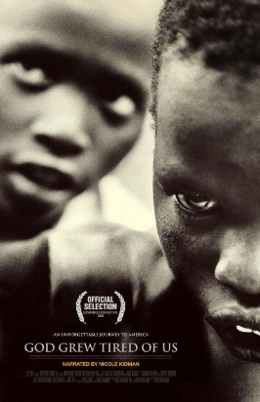All Saints Episcopal Church in Chicago invites us to a screening of the documentary film "[**God Grew Tired of Us**](https://en.wikipedia.org/wiki/God_Grew_Tired_of_Us)" on Thursday, May 12 at 7:30 pm. Lost Boy [**John Dau**](http://www.johndaufoundation.org/#!page3/cee5), one of the film's stars, will join the group for discussion following the film. We will also be joined by Sean Tenner from the [**Sudanese Community Association of Illinois**](http://sudaneseofillinois.org/).

(From Wikipedia) ***God Grew Tired of Us*** is a 2006 [documentary film](https://en.wikipedia.org/wiki/Documentary_film) about three of the "[Lost Boys of Sudan](https://en.wikipedia.org/wiki/Lost_Boys_of_Sudan)", a group of some 25,000 young men who have fled the wars in [Sudan](https://en.wikipedia.org/wiki/Sudan) since the 1980s, and their experiences as they move to the [United States](https://en.wikipedia.org/wiki/United_States). The film was written and directed by [Christopher Dillon Quinn](https://en.wikipedia.org/wiki/Christopher_Dillon_Quinn). *God Grew Tired Of Us* chronicles the arduous journey of three young Southern [Sudanese](https://en.wikipedia.org/wiki/Sudan) men, [John Bul Dau](https://en.wikipedia.org/wiki/John_Bul_Dau), Daniel Pach and [Panther Bior](https://en.wikipedia.org/wiki/Panther_Bior), to the [United States](https://en.wikipedia.org/wiki/United_States) where they strive for a brighter future. As young boys in the 1980s, they had walked a thousand miles to escape their war-ridden homeland, and then had to make another arduous journey to escape [Ethiopia](https://en.wikipedia.org/wiki/Ethiopia).

During the five years they walked in search of safety, thousands died from starvation, dehydration, bomb raids and genocidal murder. Finally, they found relative safety in [Kenya](https://en.wikipedia.org/wiki/Kenya)’s [Kakuma](https://en.wikipedia.org/wiki/Kakuma) refugee camp. In 2001, 3,600 lost boys, including John, Daniel and Panther, were invited by the United States to live in America. Assisted by [Catholic Charities](https://en.wikipedia.org/wiki/Catholic_Charities) International, the three boys uproot their lives and once again embark on a journey, leaving behind thousands of other refugees who, in the course of their traumatic odyssey, have become their adopted extended family. They must now learn to adapt to the [shock](https://en.wikipedia.org/wiki/Culture_shock) of being thrust into the economically intense culture of the United States, learning new customs, adapting to new and strange foods, coping with the ordeal of getting, and keeping a job, or multiple jobs, while never forgetting the loved ones they left behind in Africa. They dedicate themselves to doing whatever they can to help those they left behind in Kakuma, and to discovering the fate of their parents and family.

The title comes from a statement by John, in expressing that he thought the suffering and killings he saw during his country's civil war may have been the final judgment on the earth spoken of in the Bible, because "God was tired of us," "tired of the bad things the people were doing." *God Grew Tired Of Us* was produced, written and directed by [Christopher Dillon Quinn](https://en.wikipedia.org/wiki/Christopher_Dillon_Quinn) and narrated by [Nicole Kidman](https://en.wikipedia.org/wiki/Nicole_Kidman); the executive producer was [Brad Pitt](https://en.wikipedia.org/wiki/Brad_Pitt). The title of the documentary is a quote from [John Dau](https://en.wikipedia.org/wiki/John_Dau) discussing the despair he and other Sudanese felt during the civil war.

|  |  |  |  |  |
| --- | --- | --- | --- | --- |
| **UPCOMING SERVICES FOR CHURCH OF THE HOLY APOSTLES – MAY 2016** | | | | |
| Sunday 01 May  8:00 & 10:30 a.m. | Sunday 08 May  8:00 & 10:30 a.m.  Mother’s Day | Sunday 15 May  8:00 & 10:30 a.m.  **Day of Pentecost** | Sunday 22 May  8:00 & 10:30 a.m.  **Trinity Sunday** | Sunday 29 May  8:00 & 10:30 a.m. |
| Scheduled:  Presider: Gillette  Preacher:Gillette | Scheduled:  Presider: Gillette  Preacher: Gillette | Scheduled:  Presider: Gillette  Preacher: Gillette | Scheduled:  Presider: Gillette  Preacher: Gillette | Scheduled:  Presider: Gillette  Preacher: Gillette |
| 6th Sunday of Easter | 7th Sunday of Easter | Day of Pentecost  (Whitsunday) | 1st Sunday after Pentecost  (Trinity Sunday) | 2nd Sunday after Pentecost  Proper 4 (C) |
| FIRST LESSON  Acts 16:9-15  RESPONSE  Psalm 67  SECOND LESSON  Revelation  12:10, 22-22:5  GOSPEL  John5:1-9 | FIRST LESSON  Acts 16:16-34  RESPONSE  Psalm 97  SECOND LESSON  Rev. 22:12-14, 16-17, 20-21  GOSPEL  John 17:20-26 | FIRST LESSON  Genesis 11:1-9  RESPONSE  Psalm 104:25-25,37  SECOND LESSON  Romans 8:14-17  GOSPEL  John 14:8-17, 25-27 | FIRST LESSON  Proverbs 8:1-4, 22-31  RESPONSE  Psalm 8  SECOND LESSON  Romans5:1-5  GOSPEL  John 16:12-15 | FIRST LESSON  1 Kings 18:20-39  RESPONSE  Psalm 96  SECOND LESSON  Galatians 1:1-12  GOSPEL  Luke 7:1-10 |

**SOME CHURCHY STUFF** *(M. C. Gillette)In this monthly article, we look at terms and definitions of things you might see or hear around church. Nothing fancy here – these entries are out of the Armentrout/Slocum An Episcopal Dictionary of the Church, sometimes supplemented by me, and sometimes simply copied directly. If something in particular piques your interest, let me know, and we’ll deal with it in more depth.*

[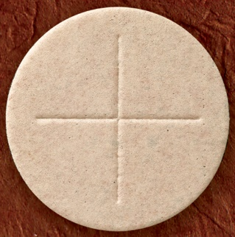](http://www.google.com/url?sa=i&rct=j&q=&esrc=s&source=images&cd=&cad=rja&uact=8&ved=0ahUKEwjN2JWFzarMAhXBwYMKHcoTB_8QjRwIBw&url=http://www.michiganchurchsupply.com/-c-29_169.html&psig=AFQjCNECci5QPHu0DJ10silEHNWGSf2D7g&ust=1461701626583099)[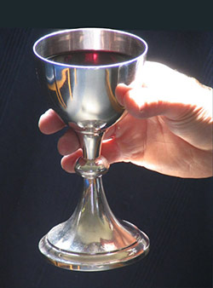](http://www.google.com/url?sa=i&rct=j&q=&esrc=s&source=images&cd=&cad=rja&uact=8&ved=0ahUKEwiYgJ7yzKrMAhXMlIMKHayXApEQjRwIBw&url=http://liturgy.co.nz/a-good-quality-wine&psig=AFQjCNGRs_qfeAGK4HIC_Ed2-5tCRnr8dQ&ust=1461701545574641)**COMMUNION IN BOTH KINDS**. Reception of BOTH the consecrated bread AND the wine in Holy Communion. It is the normal Episcopal (and, more broadly, Anglican) method of receiving communion, although communion in one kind is permitted. Each person receiving communion is given the opportunity to receive the consecrated bread and wine separately (i.e. eating the bread, then drinking from the chalice). However, as noted in the ‘additional directions’ for celebrating the Eucharist in the Book of Common Prayer, pages 406-409, the Sacrament may be received in both kinds simultaneously, in a manner approved by the bishop (i.e. holding the bread until it has been dipped the wine, then consuming it). The restoration of the chalice to the laity (letting folks – men until the 20th century – who weren’t ordained pass the wine around) was avidly sought by many in the Church of England from whence we come, and was accomplished in 1548.

[](http://www.google.com/url?sa=i&rct=j&q=&esrc=s&source=images&cd=&cad=rja&uact=8&ved=0ahUKEwiYgJ7yzKrMAhXMlIMKHayXApEQjRwIBw&url=http://liturgy.co.nz/a-good-quality-wine&psig=AFQjCNGRs_qfeAGK4HIC_Ed2-5tCRnr8dQ&ust=1461701545574641)[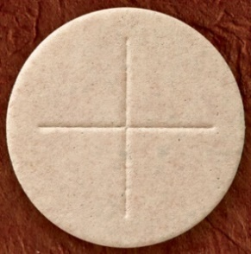](http://www.google.com/url?sa=i&rct=j&q=&esrc=s&source=images&cd=&cad=rja&uact=8&ved=0ahUKEwjN2JWFzarMAhXBwYMKHcoTB_8QjRwIBw&url=http://www.michiganchurchsupply.com/-c-29_169.html&psig=AFQjCNECci5QPHu0DJ10silEHNWGSf2D7g&ust=1461701626583099)**COMMUNION IN ONE KIND.** Reception of Holy Communion under the form of EITHER bread OR wine, but not both. It was the regular method by which lay people received communion in the western church (i.e. Latin/Roman, not Byzantine/Orthodox) from the 12th century to the Reformation (generally 16th century). There is evidence as early as the 3rd century that lay people took the consecrated bread home with them to receive during the week. The communion of the sick in one kind became common, apparently for practical reasons. Between the 7th and 11th centuries the practice of intinction (dipping the consecrated bread in the consecrated wine) became popular. By the 13th century, intinction had been replaced almost universally by communion in one kind. As noted above, the Reformers were strong advocates for the restoration of the chalice to the laity, and it was restored in the Church of England in 1548. In the Byzantine church, infants at their baptisms were usually communicated under the form of wine only, since they were unable to swallow bread. (Plus, this probably had the advantage of making for a calmer, quieter service….) This was also true of the Latin Church in the 1st millennium. The Book of Common Prayer (page 457) allows for administration of the Sacrament to the sick in one kind if the person is unable to receive either the consecrated bread or wine.

[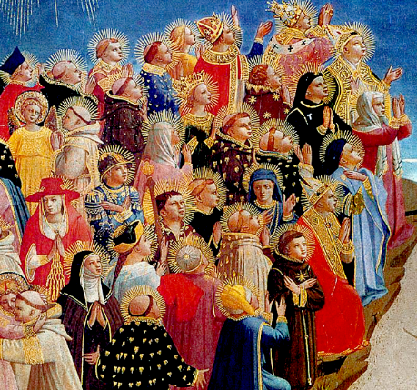](http://www.google.com/url?sa=i&rct=j&q=&esrc=s&source=images&cd=&cad=rja&uact=8&ved=0ahUKEwjmntasz6rMAhWKvYMKHdCQDAoQjRwIBw&url=http://cbts.edu/remembering-the-saints/&psig=AFQjCNErKWp0_61vvaTm2xQ2y8ceBGZj6A&ust=1461702230091667)

**(THE) COMMUNION OF THE SAINTS.** The union and shared life of all Christians in Christ, including those who now live in the world and those whose mortal lives have ended. The collect for All Saints’ Day states, ‘Almighty God, you have knit together your elect in one communion and fellowship in the mystical body of your Son Jesus Christ our Lord’ (Book of Common Prayer, page 245). The Apostles’ Creed affirms the communion of saints, and the Catechism explains that it is ‘the whole family of God, the living and the dead, those whom we love and those whom we hurt, bound together in Christ by sacrament, prayer, and praise (Book of Common Prayer, pages 99 and 862). A hymn text by Charles Wesley (number 526 in The Hymnal, 1982) prays ‘Let saints on earth in concert sing with those whose work is done; for all the servants of our King in heaven and earth are one.’

[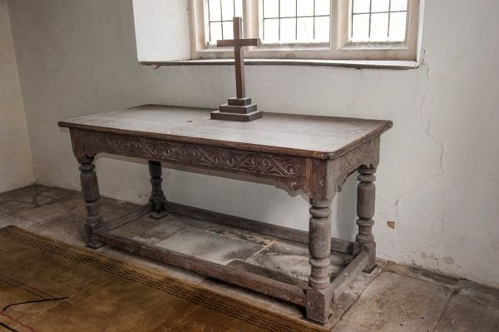](http://www.google.com/url?sa=i&rct=j&q=&esrc=s&source=images&cd=&cad=rja&uact=8&ved=0ahUKEwie64rUz6rMAhWploMKHX4DAKUQjRwIBw&url=http://www.britainexpress.com/attractions.htm?attraction%3D4001&psig=AFQjCNGRpSPyXWhq4RVb626vAxiFhmkRtw&ust=1461702316329379)

**COMMUNION TABLE (HOLY TABLE).** A name for the altar, the table on which the Eucharistic gifts of bread and wine are placed for the celebration of the Holy Eucharist. Also known as the Lord’s table. The name is intended to emphasize that the eucharist is a meal, while the term ‘altar’ suggests offering and sacrifice. The term was popular among 16th century Reformers who desired to do away with ‘papish’ ways and move away from the ‘travesties’ of Roman Catholicism; also, to distinguish a wooden table with legs from a solid stone altar. (Was this really difficult in the 16th century?)

**IN OUR** **PARISH LIFE**

**KENYA TRAVEL PRESENTATION:** On May 5, at 7:00 PM in the church, Gail Permenter will be sharing photos and observations from her recent visit to Kenya. All are welcome!

**SHAWL MINISTRY**: Thanks to our lovely ladies who diligently continue to knit, crochet, and tie blankets so that we have a selection to choose from for our gifting. We appreciate all of you who have given donations to the shawl ministry so that we can continue to purchase supplies as needed. The Shawl Ministry will meet on Monday, May 9 at 7:00pm, and Tuesday, May 24 at 1:00pm in Lincoln Hall. All are welcome to join us- no experience is required!

**WAUCONDA/ISLAND LAKE FOOD PANTRY:** The milk jug count for March was $120.10. In March the food pantry served 233 families which totaled 640 individuals.  Seven families were new to the pantry. Please keep them in your prayers. There is a sign-up sheet in Lincoln Hall if you are interested in volunteering on Saturdays between 10 AM and 12 noon.

**BOOK DISCUSSION GROUP:** The book discussion group generally meets on the fourth Tuesday of the month at 7:30pm (exceptions will be noted). New members or one-time visitors are always welcome!Please contact Lisa Earley for more information or questions. This month the Book Group will meet on May 24 to discuss *Preparation for the Next Life* by Atticus Lish, at the home of Lisa Earley.



|  |  |  |  |  |  |  |
| --- | --- | --- | --- | --- | --- | --- |
| **MAY 2016 (See PAGE 5 above for Service Schedule.)** | | | | | | |
| **SUN** | **MON** | **TUE** | **WED** | **THU** | **FRI** | **SAT** |
| 1  8:00 AM service  10:30 AM service | 2 | 3 | 4 | 5 | 6 | 7  Food Pantry  10am-noon |
| 8  8:00 AM service  10:30 AM service | 9  Shawl Ministry  7:00 PM | 10 | 11 | 12 | 13 | 14  Food Pantry  10am-noon |
| 15  8:00 AM service  10:30 AM service | 16 | 17  Bishop’s Comm.  Meeting  7:00 PM | 18 | 19 | 20 | 21  Food Pantry  10am-noon |
| 22  8:00 AM service 10:30 AM service  3:45 PM WCC | 23 | 24  Shawl Ministry  1:00 PM  Book Group  7:30 PM | 25 | 26 | 27 | 28  Food Pantry  10am-noon |
| 29  8:00 AM service 10:30 AM service | 30 | 31 |  |  |  |  |

**May Birthdays May Anniversaries**

May 03 Neil Rothenberg May 16 Carl and Lucy Reed

May 29 Don Hoebbel May 18 Graham Southall and Alicja Lukaszewicz-Southall

**FROM: Church of the Holy Apostles**

**26238 North Highway 59**

**Wauconda, Illinois 60084**