

**Fourteenth Sunday after Pentecost**

**Proper 17 (B)**

**Sunday 29 August 2021**

**Episcopal Church of the Holy Apostles**

26238 N HWY 59, Wauconda, IL 60084

*www.holyapostleswauconda.net*

***You are encouraged to look at pictures and videos if presented.***

***They tell the story in a different way than the words in front of you.***

***But the words are important too;***

***feel free to take your bulletins with you, or access them on our website.***

**OPENING VOLUNTARY**

**WORDS OF WELCOME**

**OPENING HYMN**

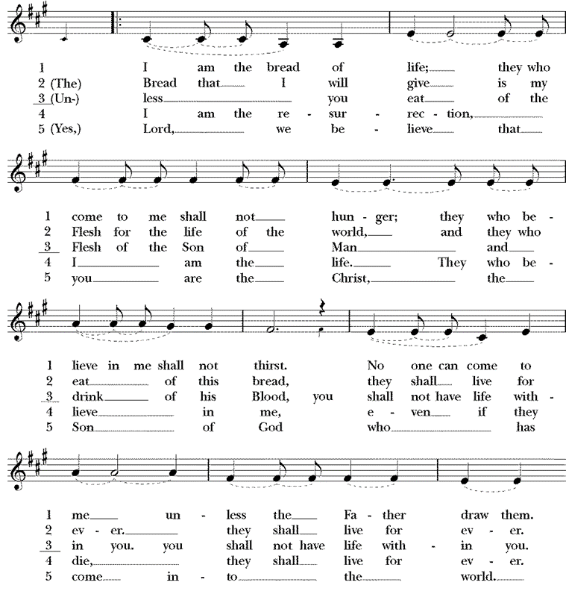



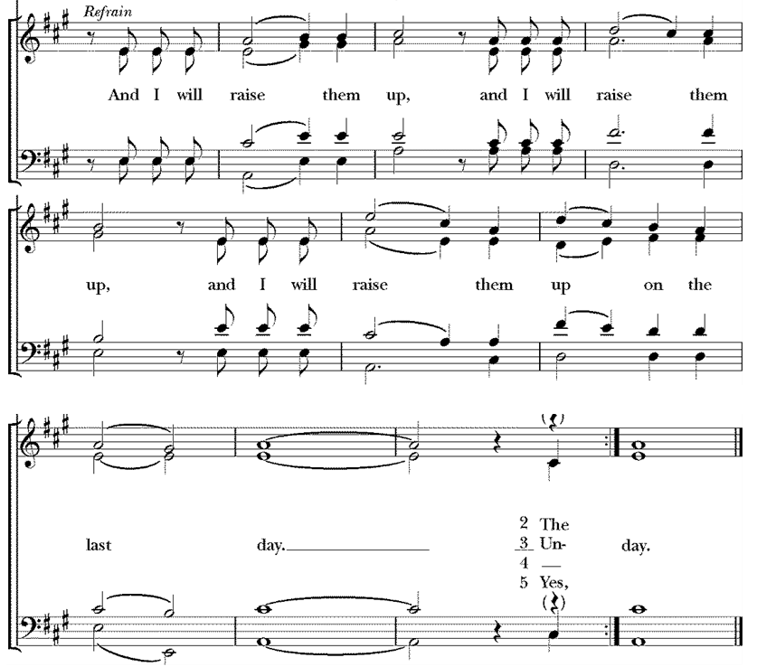

**OPENING SENTENCE**

**Presider:** Blessed be God: Holy Immortal One, Incarnate Word, and Breath of Life.

***People: And blessed be God’s kingdom, now and forever. Amen.***

**COLLECT FOR PURITY**

**Presider:** Almighty God, to you all hearts are open, all desires known, and from you no secrets are hid: Cleanse the thoughts of our hearts by the inspiration of your Holy Spirit, that we may perfectly love you, and worthily magnify your holy Name; through Christ our Lord.

***People: Amen.***

**HYMN OF PRAISE** *(Please say together in unison)* Canticle J, A Song of Judith

***I will sing a new song to my God, for your are great and glorious, wonderful in strength, invincible. Let the whole creation serve you, for you spoke and all things came into being. You sent your breath and it formed them, no one is able to resist your voice. Mountains and seas are stirred to their depths, rocks melt like wax at your presence. But to those who fear you, you continue to show mercy. No sacrifice, however fragrant, can please you, but whoever fears the Lord shall stand in your sight for ever.***

**COLLECT OF THE DAY**

**Presider:** The Lord be with you.

***People: And also with you.***

**Presider:** Let us pray. God of unclean hands, touching those rejected by the world, despised by the religious: guide us from false purity which hides misshapen hearts; lead us to the joyful feast in which all are renewed; through Jesus Christ, the beauty of God’s face.

***People: Amen.***

*(We read from the various translations authorized by our Church. This month, we read from the New Revised Standard Version, 1989)*

**FIRST LESSON** Song of Solomon 2:8-13

**Reader:** A reading from the Song of Solomon. The voice of my beloved! Look, he comes, leaping upon the mountains, bounding over the hills. 9My beloved is like a gazelle or a young stag. Look, there he stands behind our wall, gazing in at the windows, looking through the lattice. 10My beloved speaks and says to me: “Arise, my love, my fair one, and come away; 11for now the winter is past, the rain is over and gone. 12The flowers appear on the earth; the time of singing has come, and the voice of the turtledove is heard in our land. 13The fig tree puts forth its figs, and the vines are in blossom; they give forth fragrance. Arise, my love, my fair one, and come away. The Word of the Lord.

***People: Thanks be to God.***

**RESPONSE:** *(Please say together in unison)* Psalm 45:1-2, 7-10

***1My heart overflows with a goodly theme; I address my verses to the king; my tongue is like the pen of a ready scribe.***

***2You are the most handsome of men; grace is poured upon your lips; therefore God has blessed you forever. 7 you love righteousness and hate wickedness. Therefore God, your God, has anointed you with the oil of gladness beyond your companions;  
8your robes are all fragrant with myrrh and aloes and cassia. From ivory palaces stringed instruments make you glad;  
9daughters of kings are among your ladies of honor; at your right hand stands the queen in gold of Ophir.***

**SECOND LESSON** James 1:17-27

**Reader:** A reading from the letter of James. 17Every generous act of giving, with every perfect gift, is from above, coming down from the Father of lights, with whom there is no variation or shadow due to change. 18In fulfillment of his own purpose he gave us birth by the word of truth, so that we would become a kind of first fruits of his creatures. 19You must understand this, my beloved: let everyone be quick to listen, slow to speak, slow to anger; 20for your anger does not produce God’s righteousness. 21Therefore rid yourselves of all sordidness and rank growth of wickedness, and welcome with meekness the implanted word that has the power to save your souls. 22But be doers of the word, and not merely hearers who deceive themselves. 23For if any are hearers of the word and not doers, they are like those who look at themselves in a mirror; 24for they look at themselves and, on going away, immediately forget what they were like. 25But those who look into the perfect law, the law of liberty, and persevere, being not hearers who forget but doers who act—they will be blessed in their doing. 26If any think they are religious, and do not bridle their tongues but deceive their hearts, their religion is worthless. 27Religion that is pure and undefiled before God, the Father, is this: to care for orphans and widows in their distress, and to keep oneself unstained by the world. The Word of the Lord.

***People: Thanks be to God.***

**GOSPEL** Mark 7:1-8, 14-15, 21-23

**Presider:** The Holy Gospel of our Lord Jesus Christ according to Mark.

***People: Glory to you, Lord Christ.***

**Presider:** 7 Now when the Pharisees and some of the scribes who had come from Jerusalem gathered around him, 2they noticed that some of his disciples were eating with defiled hands, that is, without washing them. 3(For the Pharisees, and all the Jews, do not eat unless they thoroughly wash their hands, thus observing the tradition of the elders; 4and they do not eat anything from the market unless they wash it; and there are also many other traditions that they observe, the washing of cups, pots, and bronze kettles.) 5So the Pharisees and the scribes asked him, “Why do your disciples not live according to the tradition of the elders, but eat with defiled hands?” 6He said to them, “Isaiah prophesied rightly about you hypocrites, as it is written, ‘This people honors me with their lips, but their hearts are far from me; 7in vain do they worship me, teaching human precepts as doctrines.’ 8You abandon the commandment of God and hold to human tradition.” 14Then he called the crowd again and said to them, “Listen to me, all of you, and understand: 15there is nothing outside a person that by going in can defile, but the things that come out are what defile.” 21For it is from within, from the human heart, that evil intentions come: fornication, theft, murder, 22adultery, avarice, wickedness, deceit, licentiousness, envy, slander, pride, folly. 23All these evil things come from within, and they defile a person.” The Gospel of the Lord.

***People: Praise to you, Lord Christ.***

**THE SERMON**

*(A brief period of silence follows the sermon)*

**AFFIRMATION OF FAITH** *(Please say together in unison)*

*The Nicene Creed, the standard of the church, may be found on page 358-9 in the Prayer Book*

***We believe in God, the creator of all life and beauty, who blesses our journey. We believe in Jesus Christ, who lived as a friend and savior to all he met as he traveled, who ate and laughed, wept and celebrated with them in love. We believe in the Holy Spirit, who rides on the gentle breeze, who strengthens our bindings, and who offers hope eternal. We believe in the church, which stands open to all travelers, and bears witness to the everlasting love of God. Amen.***

**PRAYERS OF THE PEOPLE** Personalized Form V

**Leader:** In peace, let us pray to the Lord, saying, “Lord, have mercy.”

**Leader:**  For the holy Church of God, that it may be filled with truth and love, and be found without fault at the day of your coming, we pray to you, O Lord.

***People: Lord have mercy.***

**Leader:** For our Bishops, Priests, and Deacons, for those on our Anglican and Diocesan Cycles of Prayer, and for all the holy people of God, we pray to you, O Lord.

***People: Lord have mercy.***

**Leader:** For all who fear God and believe in you, Lord Christ, that our divisions may cease, and that all may be one as you and your Father are one, we pray to you, O Lord.

***People: Lord have mercy.***

**Leader:** For the mission of God, to which the church is called to be faithful, that in faithful witness it may preach the Gospel to the ends of the earth, we pray to you, O Lord.

***People: Lord have mercy.***

**Leader:** For the peace of the world, that a spirit of respect and forbearance may grow among nations and peoples, we pray to you, O Lord.

***People: Lord have mercy.***

**Leader:** For those in positions of public trust, that they may serve justice, and promote the dignity and freedom of every person, we pray to you, O Lord.

***People: Lord have mercy.***

**Leader:** For all who live and work in this community, we pray to you, O Lord.

***People: Lord have mercy.***

**Leader:** For the poor, the persecuted, the sick, and all who suffer, especially those on our parish prayer list, and those whose names we raise up now, either silently or aloud *(we will keep a 10-second silence)* _____; and for refugees, prisoners, and all who are in danger, that they may be relieved and protected, we pray to you, O Lord.

***People: Lord have mercy.***

**Leader:** For this congregation, that we may be delivered from hardness of heart, and show forth your glory in all that we do, we pray to you, O Lord.

***People: Lord have mercy.***

**Leader:** For all who have commended themselves to our prayers; for our families, friends, and neighbors; that being freed from anxiety, they may live in joy, peace, and health, we pray to you, O Lord.

***People: Lord have mercy.***

**Leader:** For all the blessings in our lives, for those celebrating birthdays and anniversaries this week, in particular those whose names we raise up now, either silently or aloud *(we will keep a 10-second silence)* _____; and for all those things for which we are thankful, we pray to you, O Lord.

***People:*** ***Lord have mercy.***

**Leader:** For those who have died in the course of service to others; for those departed whose faith is known to you alone; and for all who have died in the communion of your Church, in particular those whose names we raise up now, either silently or aloud *(we will keep a 10-second silence)* ____; we pray that, with all the saints, they may have rest in that place where there is no pain or grief, but life eternal, we pray to you, O Lord.

***People: Lord have mercy.***

**Leader:** Rejoicing in the fellowship of all the saints, let us commend ourselves, and one another, and all our life to Christ our God.

***People: To you, O Lord our God.***

*(Silence)*

*(The Presider will add this or another concluding Collect)* Creator God, you call us to love and serve you with body, mind, and spirit, through loving your creation and our sisters and brothers. Open our hearts in compassion and receive these petitions on behalf of the needs of the church and the world.

**CONFESSION AND ABSOLUTION** *(Please say together in unison)*

**Presider:** Let us confess our sins to God.

***God of love unbounded, you created us in love to live in love; but we confess that in our human weakness, our strength to love often fails. Christ of love unbounded, we confess that we do not always answer when you call us to bear your love-light into the world, afraid to love that which is not familiar. Spirit of love unbounded, your Holy Wind surrounds us with love; but we confess we often hold our breath for fear of inhaling too deeply and loving too much. Although we long for love, too often we fail to accept it or to offer it. Help us let go of our failings. Help us to believe that we are loved. Help us to believe that we can love others. Amen.***

**Presider:** God says to us, “I love you for your own sake.” **+**Know that you are loved and forgiven. Jesus invites you to pick up your lives anew and walk in love as he loves us.

***People: Amen.***

**THE PEACE** *(Please greet each other in the name of the Lord.)*

**Presider:** The Peace of the Lord be always with you.

***People: And also with you.***

**OFFERTORY SENTENCE**

*(The Presider gives this or another Offertory Sentence)* O Lord our God, you are worthy to receive glory and honor and power; because you have created all things, and by your will they were created and have their being.

*Please follow the Presider’s directions for Communion.*

**GREAT THANKSGIVING** EOW III

**Presider:** The Lord be with you.

***People: And also with you.***

**Presider:** Lift up your hearts.

***People: We lift them to the Lord.***

**Presider:** Let us give thanks to the Lord our God.

***People: It is right to give our thanks and praise.***

**Presider:**  All thanks and praise are yours at all times and in all places, our true and loving God; through Jesus Christ, your eternal Word, the Wisdom from on high by whom you created all things. You laid the foundations of the world and enclosed the sea when it burst out from the womb; You brought forth all creatures of the earth and gave breath to humankind.

Wondrous are you, Holy One of Blessing, all you create is a sign of hope for our journey; And so as the morning stars sing your praises we join the heavenly beings and all creation as we shout with joy:

**SANCTUS** *(Please say together in unison)*

***Holy, holy, holy Lord, God of power and might, heaven and earth are full of your glory. Hosanna in the highest. Blessed is the one who comes in the name of the Lord. Hosanna in the highest.***

**Presider:** Glory and honor are yours, Creator of all, your Word has never been silent; you called a people to yourself, as a light to the nations, you delivered them from bondage and led them to a land of promise. Of your grace, you gave Jesus to be human, to share our life, to proclaim the coming of your holy reign and give himself for us, a fragrant offering.

Through Jesus Christ our Redeemer, you have freed us from sin, brought us into your life, reconciled us to you, and restored us to the glory you intend for us.

**↑** We thank you that on the night before he died for us Jesus took bread, and when he had given thanks to you, he broke it, gave it to his friends and said: "Take, eat, this is my Body, broken for you. Do this for the remembrance of me."

**↑** After supper Jesus took the cup of wine, said the blessing, gave it to his friends and said: "Drink this, all of you: this is the new Covenant in my Blood, poured out for you and for all for the forgiveness of sin. Do this for the remembrance of me."

And so, remembering all that was done for us: the cross, the tomb, the resurrection and ascension, longing for Christ's coming in glory, and presenting to you these gifts your earth has formed and human hands have made, we acclaim you, O Christ:

***All: Dying, you destroyed our death. Rising, you restored our life. Christ Jesus, come in glory!***

**Presider:** **∞** Send your Holy Spirit upon us and upon these gifts of bread and wine that they may be to us the Body and Blood of your Christ. **+** Grant that we, burning with your Spirit's power, may be a people of hope, justice and love.

Giver of Life, draw us together in the Body of Christ, and in the fullness of time gather us with all your people into the joy of our true eternal home.

**↑** Through Christ and with Christ and in Christ, by the inspiration of your Holy Spirit, we worship you our God and Creator in voices of unending praise.

***All: Blessed are you now and for ever. AMEN.***

**LORD’S PRAYER** *(Please say together in unison)*

**Presider:** As our Savior Christ has taught us, we now pray,

***All: Our Father in heaven, hallowed be your Name, your kingdom come, your will be done, on earth as in heaven. Give us today our daily bread. Forgive us our sins as we forgive those who sin against us. Save us from the time of trial, and deliver us from evil. For the kingdom, the power, and the glory are yours, now and for ever. Amen.***

**FRACTION (THE BREAKING OF THE BREAD)**

*(The Presider breaks the consecrated bread. A brief period of silence is kept.)*

**Presider:** This is the true bread which comes down from heaven and gives life to the world.

***People: Whoever eats this bread will live for ever.***

**Presider:** **↑** The Gifts of God for the People of God. Take them in remembrance that Christ died for you, and feed on him in your hearts by faith, with thanksgiving.

**POST-COMMUNION PRAYER**

**Presider:** Let us pray.

***All: God of abundance, you have fed us with the bread of life and cup of salvation; you have united us with Christ and one another; and you have made us one with all your people in heaven and on earth. Now send us forth in the power of your Spirit, that we may proclaim your redeeming love to the world and continue for ever in the risen life of Christ our Savior. Amen.***

**PARISH ANNOUNCEMENTS**

**BLESSING**

**Presider**: Holy eternal Majesty, Holy incarnate Word, Holy abiding Spirit, Bless you for evermore.

***People: Amen.***

**CLOSING HYMN *(Instrumental)***

Lyrics:

When I am down, and oh, my soul’s so weary – when troubles come, and my heart burdened be – then I am still, and wait here in the silence, until you come and sit awhile with me.

You raise me so I can stand on mountains. You raise me up to walk on stormy seas. I am strong when I am on your shoulders. You raise me up to more than I can be.

**DISMISSAL**

*(The Presider gives this or another dismissal)*  Our worship is over, our service now begins. Let us go forth into the world, rejoicing in the power of the Holy Spirit.

***People: Thanks be to God.***

**CLOSING VOLUNTARY**

**Cover Image:** https://docplayer.ru/204791303-Serdce-cheloveka-rukovodstvo-izdateli-evangeliya-vseh-naciy.html

**Confession:** Saturday Morning Prayer from Daily Prayer For All Seasons: Church Publishing Company, New York

**Affirmation of Faith:** *From Shore to Shore*, p. 68

**Collect after the Prayers of the People:** Daily Prayer For All Seasons: Church Publishing Company, New York