Last Sunday After Pentecost – Proper 29 (A) – Christ the King
Sunday 22 November 2020

WORDS OF WELCOME

OPENING SENTENCE
Presider: + O God, light of the hearts that see you, life of the souls that love you, strength of the thoughts that seek you: to turn from you is to fall, to turn to you is to rise, to abide in you is to stand fast forever. Although we are unworthy to approach you, or to ask anything at all of you, grant us your grace and blessing for the sake of Christ our King.
People: Amen.

COLLECT FOR PURITY
Presider: Almighty God, to you all hearts are open, all desires known, and from you no secrets are hid: Cleanse the thoughts of our hearts by the inspiration of your Holy Spirit, that we may perfectly love you, and worthily magnify your holy Name; through Christ our Lord.
People: Amen

HYMN OF PRAISE
Presider: Thanks and praise to you, Jesus Christ, King and Lord of all, given the name above every other name;
People: Jesus, King and Lord of all, we worship and adore you.
Presider: King of righteousness, King of peace, enthroned at the right hand of Majesty on high;
People: Jesus, King and Lord of all, we worship and adore you.
Presider: Great high priest, living for ever to intercede for us;
People: Jesus, King and Lord of all, we worship and adore you.
Presider: Pioneer of our salvation, you bring us to glory through your death and resurrection;
People: Jesus, King and Lord of all, we worship and adore you.
Presider: Every knee bows to you; every tongue confesses, you are King of kings and Lord of Lords, to the glory of God the Father.

COLLECT OF THE DAY
Presider: The Lord be with you.
People: And also with you.
Presider: Let us pray. Destitute king, one with the hungry, the naked and the scorned; may our faith be proved not in dogma and piety but in serving you in the last and the least; through Jesus Christ, the stranger’s Lord.
People: Amen.

We read each month from the various biblical translations authorized by our Church. This month we read from the New International Version (1978)

FIRST LESSON Ezekiel 34:11-16, 20-24
Reader: A reading from Ezekiel. ¹¹ “‘For this is what the Sovereign Lord says: I myself will search for my sheep and look after them. ¹² As a shepherd looks after his scattered flock when he is with them, so will I look after my sheep. I will rescue them from all the places where they were scattered on a day of clouds and darkness. ¹³ I will bring them out from the nations and gather them from the countries, and I will bring them into their own land. I will pasture them on the mountains of Israel, in the ravines and in all the settlements in the land. ¹⁴ I will tend them in a good pasture, and the mountain heights of Israel will be their grazing land. There they will lie down in good grazing land, and there they will feed in a rich pasture on the mountains of Israel. ¹⁵ I myself will tend my sheep and have them lie down, declares the Sovereign Lord. ¹⁶ I will search for the lost and bring back the strays. I will bind up the injured and strengthen the weak, but the sleek and the strong I will destroy. I will shepherd the flock with justice. ²⁰ “‘Therefore this is what the Sovereign Lord says to them: See, I myself will judge between the fat sheep and the lean sheep. ²¹ Because you shove with flank and shoulder, butting all the weak sheep with your horns until you have driven them away, ²² I will save my flock, and they will no longer be plundered. I will judge between one sheep and another. ²³ I will place over them one shepherd, my servant David, and he will tend them; he will tend them and be their shepherd. ²⁴ I the Lord will be their God, and my servant David will be prince among them. I the Lord have spoken. This is your Word.
People: Thanks be to God.

RESPONSE (Please say together in unison) Psalm 100
¹ Shout for joy to the Lord, all the earth.
² Worship the Lord with gladness; come before him with joyful songs.
³ Know that the Lord is God. It is he who made us, and we are his; we are his people, the sheep of his pasture.
⁴ Enter his gates with thanksgiving and his courts with praise; give thanks to him and praise his name.
⁵ For the Lord is good and his love endures forever; his faithfulness continues through all generations.

SECOND READING Ephesians 1:15-23
Reader: A reading from the letter to the Ephesians. ¹⁵ For this reason, ever since I heard about your faith in the Lord Jesus and your love for all God’s people, ¹⁶ I have not stopped giving thanks for you, remembering you in my prayers. ¹⁷ I keep asking that the God of our Lord Jesus Christ, the glorious Father, may give you the Spirit of wisdom and revelation, so that you may know him better. ¹⁸ I pray that the eyes of your heart may be enlightened in order that you may know the hope to which he has called you, the riches of his glorious inheritance in his holy people, ¹⁹ and his incomparably great power for us who believe. That power is the same as the mighty strength ²⁰ he exerted when he raised Christ from the dead and seated him at his right hand in the heavenly realms, ²¹ far above all rule and authority, power and dominion, and every name that is invoked, not only in the present age but also in the one to come. ²² And God placed all things under his feet and appointed him to be head over everything for the church, ²³ which is his body, the fullness of him who fills everything in every way. This is your Word,
People: Thanks be to God.

PRAYER FOR ILLUMINATION
Presider: By your Word, O Light of this whole universe, we live, move and have our being. As you have illumined the hearts of people at many times in the past, we pray, eternal God, for your awakening within us.
Presider: From delusion to truth, and to your righteous way:
People: Lead us, source of all, our Father and our Mother.
Presider: From darkness to light and into your gracious will:
People: Lead us O Christ, our Friend and our Brother.
Presider: From death to eternal life and into your infinite joy:
People: Lead us Divine Spirit, enlivening Power within, for we seek your awakening touch.

GOSPEL Matthew 25:31-46
Presider: The Holy Gospel of our Lord Jesus Christ according to Matthew.
People: Glory be to you, O Lord Christ.
³¹ “When the Son of Man comes in his glory, and all the angels with him, he will sit on his glorious throne. ³² All the nations will be gathered before him, and he will separate the people one from another as a shepherd separates the sheep from the goats. ³³ He will put the sheep on his right and the goats on his left. ³⁴ “Then the King will say to those on his right, ‘Come, you who are blessed by my Father; take your inheritance, the kingdom prepared for you since the creation of the world. ³⁵ For I was hungry and you gave me something to eat, I was thirsty and you gave me something to drink, I was a stranger and you invited me in, ³⁶ I needed clothes and you clothed me, I was sick and you looked after me, I was in prison and you came to visit me.’ ³⁷ “Then the righteous will answer him, ‘Lord, when did we see you hungry and feed you, or thirsty and give you something to drink? ³⁸ When did we see you a stranger and invite you in, or needing clothes and clothe you? ³⁹ When did we see you sick or in prison and go to visit you?’ ⁴⁰ “The King will reply, ‘Truly I tell you, whatever you did for one of the least of these brothers and sisters of mine, you did for me.’ ⁴¹ “Then he will say to those on his left, ‘Depart from me, you who are cursed, into the eternal fire prepared for the devil and his angels. ⁴² For I was hungry and you gave me nothing to eat, I was thirsty and you gave me nothing to drink, ⁴³ I was a stranger and you did not invite me in, I needed clothes and you did not clothe me, I was sick and in prison and you did not look after me.’ ⁴⁴ “They also will answer, ‘Lord, when did we see you hungry or thirsty or a stranger or needing clothes or sick or in prison, and did not help you?’ ⁴⁵ “He will reply, ‘Truly I tell you, whatever you did not do for one of the least of these, you did not do for me.’ ⁴⁶ “Then they will go away to eternal punishment, but the righteous to eternal life.” Continue to speak to us, Lord.
People: Praise be to you, O Christ.

SERMON The Rev. M. C. Gillette
(A brief period of silence follows the sermon)

AFFIRMATION OF FAITH (Please say together in unison)

I believe in God, the God, the only God, who created everything and reigns as King over earth, sky, and water,
Sovereign and Holy, and yet revealing Himself in the intimacy of the name “Father”. He reigns over the nations; He is seated on his holy throne. ^{Psalm 47:8} I believe in Jesus Christ, the Son, the only-begotten Son, whose reign began in the weakness of a manger-bed, conceived by the Spirit and born of a virgin, who reigned
even while nailed to a cross of wood; who died and rose again, ascended and will come again. He will reign forever; and his kingdom will never end. ^{Luke 1:33} And I believe in the Spirit, the Holy Spirit, the Spirit of God
who as God Himself brings the presence of God and extends the reign of God in every believer and throughout the world, who ever directs hearts to our Lord and Savior, so that grace might reign … to bring eternal life through Jesus Christ our Lord. ^{Romans 5:21}

PRAYERS OF THE PEOPLE
Leader: In your comforting presence, we remember the poor and the homeless, the widows and the exploited women, the undernourished children and the victims of war, terrorism and unjust socio-economic systems. Where the mind is without fear, where the head is held high, into that haven of freedom O Lord, let our world awake.
People: Lord hear our prayer; let our cry come to you.
Leader: In your comforting presence, we remember those who cannot and may not read and write, those who are denied the power of knowledge and skill, those who are rendered voiceless through exploitation and oppression for being ignorant, those whose questioning faculty has been taken away, and the ones who are tormented and mentally ill. Where knowledge is free, where the clear stream of reason has not lost its way into the dreary desert sands of dead habit, into that haven of freedom, O Lord, let our world awake.
People: Lord hear our prayer; let our cry come to you.
Leader: In your comforting presence, we remember those who work without getting their due, the landless laborers, the child laborers, the bonded laborers, the dispossessed and those who are unjustly treated or falsely accused. Where tireless striving stretches its arms towards perfection, into that haven of freedom O Lord, let our world awake.
People: Lord hear our prayer; let our cry come to you.
Leader: In your comforting presence, we remember the victims of discrimination because of color, race, class, caste, nationality, religion, and traditions. Help our leaders and all those who serve in the Government. Grant them the will to do everything they can to build a society of equality and justice. Where the world has not been broken up into fragments by narrow domestic walls, into that haven of freedom, O Lord let our world awake.
People: Lord hear our prayer; let our cry come to you.
Leader: In your comforting presence, we remember those who suffer from any grief, pain, or trouble, especially those whose names we raise up now, either silently or aloud (we will keep a 10-second silence). We remember those who have died, especially our beloved departed, those who have lost their lives in service to others, and those whose names we raise up now, either silently or aloud (we will keep a 10-second silence). Where mourning has turned to dancing, O Lord, we remember those good gifts we have been given. We pray with glad hearts for those celebrating birthdays and anniversaries this week, especially those whose names we raise up now, either silently or aloud (we will keep a 10-second silence). We thank you for the joy and laughter in our lives.
People: Lord hear our prayer; let our cry come to you.
Leader: In your comforting presence, we remember those who labor in your church. Let the Church be a foretaste of the coming reign of God in the world, let her work in partnership with all humanity for reconciliation, justice and peace to make this world an oikumene - a happy home for all creation. Where words come out from the depths of truth, where the mind is led forward by you into ever-widening thought and action, into that haven of freedom, O Lord let my world awake.
People: Lord hear our prayer; let our cry come to you.

Presider: Eternal God, our Father and Mother, we commit our struggles and sufferings into your son's wounded hands, our hopes and aspirations into his praying hands, our poor, hungry and exploited people into his just and caring hands, our living and departed into his hands that hold the key to the future. Blessed be the Lord, forever. People: Amen.

CONFESSION AND ABSOLUTION
Presider: Brothers and sisters, we have come together to hear God's most holy Word, and to receive the Body and Blood of the Lord. Let us therefore kneel and examine ourselves in silence, seeking God's grace that we may draw near to him with repentance and faith.
(A brief period of silence is kept)
Presider: You who truly and earnestly repent of your sins, and are in love and peace with your neighbour, and intend to live a new life, following the commandments of God and walking from now on in his holy ways, make your humble confession to the compassionate God, that you may be reconciled anew to him through our Lord Jesus Christ.
All: Merciful God, we confess that we have sinned against you and our neighbour. We have walked in darkness rather than in light; we have named the name of Christ, but have not departed from iniquity. Have mercy upon us, we ask you; for the sake of Jesus Christ forgive us all our sins; cleanse us by your Holy Spirit; quicken our consciences; and enable us to forgive others; that we may hereafter serve you in newness of life, to the glory of your holy name. Amen.
Presider: Hear the gracious Word of God to all who truly turn to him through Jesus Christ: Come to me, all you that are weary and are carrying heavy burdens, and I will give you rest. ^{Matthew 11:28} For God so loved the world that he gave his only Son, so that everyone who believes in him may not perish but may have eternal life. ^{John 3:16}

Presider: + The Saviour of the world, the refuge of the repentant, forgives and strengthens all who truly seek his grace. He accepts you as his sons and daughters, and sets you free from the bondage of your past. For Christ died and rose to new life that we might all share his wholeness and abundant life. As God's own people, be merciful in action, kind in heart, humble in mind. Be always ready to forgive as freely as God has forgiven you. And, above everything else, be loving, and never forget to be thankful for what Christ has done for you.
People: Amen, thanks be to God.

THE PEACE ((Please stand as able and greet each other in the name of the Lord. It is appropriate to turn to the person next to you and, shaking hands, say ‘Peace be with you,’ ‘God’s peace,’ or something similar)
Presider: Having been forgiven and made whole through our Peacemaker, let us live together in Peace. God's Peace challenges us and guides us towards the acts of justice, peace and integration of the whole creation. Let us say `Shalom' to one another and give each other a sign of reconciliation and peace. The peace of the Lord be with you:
People: And also with you.

OFFERTORY SENTENCE
(The Presider gives this or another Offertory Sentence) O God, you have given us a new and living way to offer ourselves to you. Though unworthy we come to you, as we are, by that Way which is your Son Jesus of Nazareth; and in his name we ask you to accept and use us and our gifts however it best pleases you. All that is created is yours and everything that we can offer already belongs to you.
People: Amen.

OFFERTORY HYMN H1982, #293
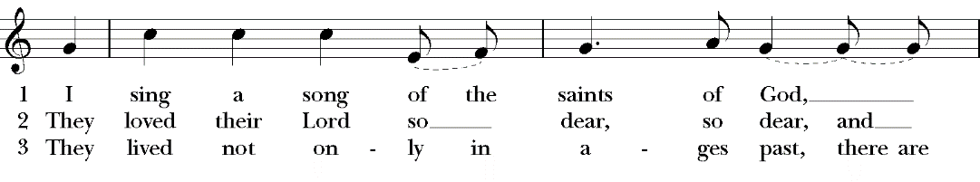
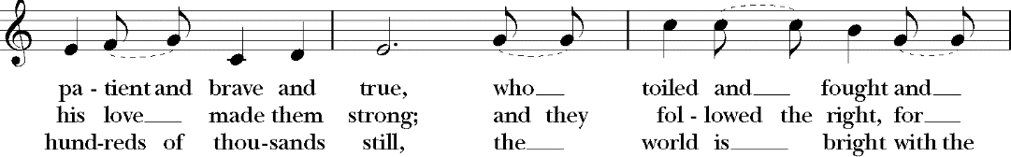
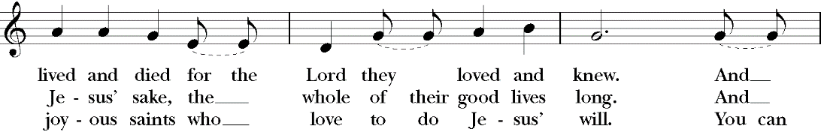
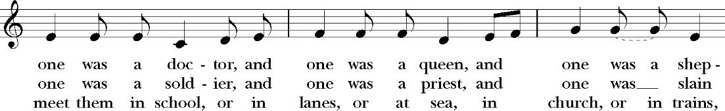
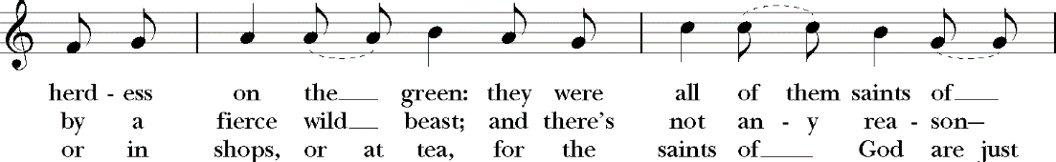
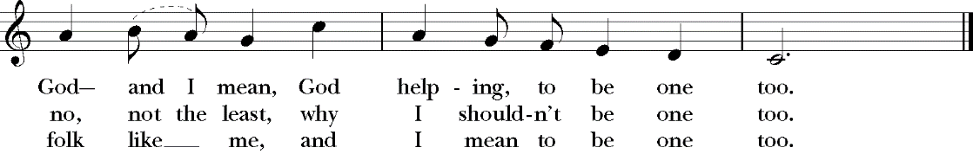

GREAT THANKSGIVING
Presider: Our Creator God is with us to bless us;
People: We surrender ourselves to the One who Creates.
Presider: The risen Lord is with us to bless us;
People: We surrender ourselves to the One who Redeems.
Presider: The transforming Spirit is with us to bless us;
People: We surrender ourselves to the One who Sustains.

Presider: We do not stand here alone as we proclaim and sing your glory, O God, but rather with angels and archangels and with all the company of heaven.
All: Holy, holy, holy Lord, God of power and might, heaven and earth are full of your glory, Hosanna in the highest. Blessed is he who comes in the name of the Lord. Hosanna in the highest.

Presider: ↑O God, Redeemer of fallen creation, at the last meal that your Son, Jesus Christ, shared with his disciples before his death, he took bread in his hands of compassion, gave you praise and thanks, and broke the bread. Then he said, Take, eat: this is my body, which is given for you. Do this in remembrance of me.
People: We celebrate through this bread, the self-offering of our Savior Christ.

Presider: ↑Then, after the meal, he took the cup of wine, offered praise and thanks to you, gave the cup to his disciples and said: Drink this, all of you: This is my blood of the new covenant, which is shed for you and for many for the forgiveness of sins. Do this, whenever you drink it, in remembrance of me.
People: We celebrate through this cup the new covenant of our Savior Christ.

Presider: As this bread is broken and this wine poured out, O Seeker and Savior of the lost, we remember again the poor and oppressed of the earth. We recall that your body was broken that the hungry might be nourished with the bread of new hope and new life.
All: Christ has died, Christ has risen, Christ will come in glory.

Presider: As this bread was once scattered seed, O Bread of life sown in the earth to die and rise to new life: so gather all peoples together in one humanity of your coming reign. Restore the broken life of your creation; heal the disfigured body of your world; draw all creatures unto yourself through the cross and in the power of your risen life. And grant to all the faithful departed a share in your bliss, that with them we too at the end may be welcomed into your eternal kingdom through your inexhaustible grace, and through the guidance of your indwelling Spirit.
All: +Sanctify us; ∞sanctify this bread; ∞sanctify this wine, so that together we may be the body of Christ. People: Amen.

LORD’S PRAYER
Presider: As our Savior has taught us, so we pray:
Our Father, who art in heaven, hallowed be your name, your kingdom come, your will be done, on earth as it is in heaven. Give us this day our daily bread. And forgive us our trespasses, as we forgive them that trespass against us. And lead us not into temptation, but deliver us from evil. For thine is the kingdom, the power and the glory, for ever and ever. Amen

FRACTION (THE BREAKING OF THE BREAD)
(The Presider breaks the consecrated bread. A brief period of silence is kept.)
Presider: (As the bread is raised and broken) When we break the bread, do we not share in the body of Christ?
People: We seek to share your life, gracious God.
Presider: (As the cup is lifted up) When we lift the cup, do we not share in the life-blood of Christ?
People: We seek to share your life, gracious God.
(The Communion is administered)

COMMUNION HYMN vv. 1, 3 MHSO, #118

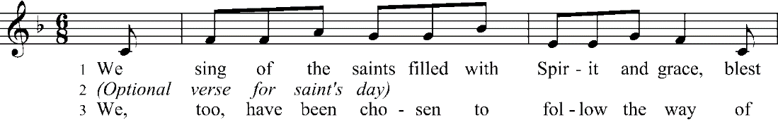
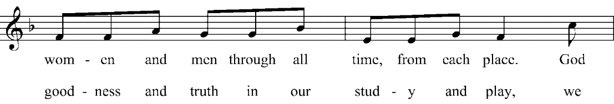
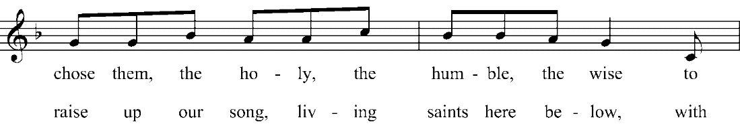
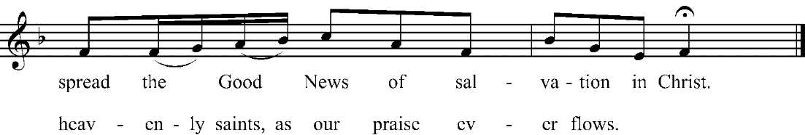

POST-COMMUNION PRAYER
Presider: Merciful God of all creation, holy Parent of all people through our Lord Jesus Christ who united all things in His fullness, we join your whole creation in exultant praise of your bountiful goodness. You have now touched us with new life and filled us with new hope that your reign will come, that the hungry will be fed, that the oppressed will be set free from evil, that your reconciling work will be done, that love and faithfulness will meet together, that justice and peace will kiss each other, and the whole creation will be filled with your glory. Amen.
People: Blessing, and glory, and wisdom, and thanksgiving, and honor, and power, and might, be unto our God, for ever and ever. AMEN

BLESSING
Presider: Go out into the world in peace; have courage; hold onto what is good; return no one evil for evil; strengthen the faint-hearted; support the weak, and help the suffering; honor all people; love and serve the Lord, rejoicing in the power of the Holy Spirit. And may the blessing of God almighty, the Father, the Son, and the Holy Spirit, be amongst you and remain with you always.
People: Amen.

DISMISSAL
(The Presider gives this or another dismissal) Our worship is over, our service now begins. Let us go forth, rejoicing in the power of the holy spirit.
People: Thanks be to God!

CLOSING VOLUNTARY

Hymn of Praise: Based on a prayer copyright © John Leach/administered by The Jubilate Group. Posted on The Jubilate Group website. http://www.jubilate.co.uk/liturgy/liturgy/kingship_call_to_worship
Collect of the Day: Prayers for an Inclusive Church, Stephen Shakespeare
Affirmation of Faith: Based on a prayer Copyright © 2009 Rick Lindholtz on his blog on the tracks. http://rlindholtz.blogspot.com/2009/09/creed-god-who-reigns.html
Confession: Based on a prayer by Bruce Prewer, and posted on Bruce Prewer’s Homepage. http://www.bruceprewer.com/DocA/61SAINTS.htm
Eucharistic Prayer and Other Service Elements: Adapted from Church of South India Order For The Lord’s Supper (2004)

