**The Apostles Post**

26238 North Highway 59

Wauconda, Illinois

MAY 2019

2015



**FROM THE VICAR’S DESK** *(M. C. Gillette)*

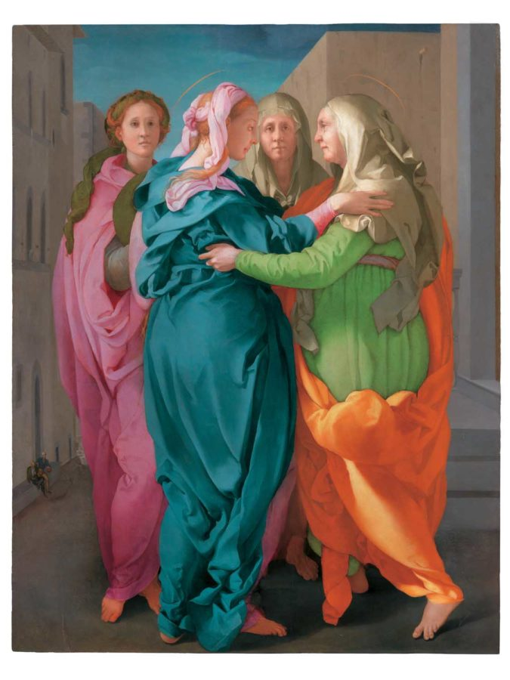 Issue IV of our “B-list” Holy Day series. I suppose I should note that we actually have an “A-list” Feast this month. (“A-listers” being those that push everything else aside, like Christmas and Easter. May brings us the Feast of the Ascension on 30 May – 40 days after Easter Day – on which we celebrate, reasonably enough, Jesus’ ascension into heaven “to sit at the right hand of his Father.”) Our “B-list” options for May include St. Philip and St. James, Apostles (they have to share for some reason), and the Visitation of the Blessed Virgin; and you just know I’m going to choose the Visitation. So, onward.

The readings appointed for the day are: 1 Samuel 2:1-10 / Psalm 113 / Romans 12:9-16 / Luke 1:39-57.

The first chapter of the Gospel according to Luke records that at the time of the Annunciation Mary learned (from the Angel Gabriel) her relative Elizabeth was miraculously pregnant. (“And, behold, thy cousin Elisabeth, she hath also conceived a son in her old age: and this is the sixth month with her, who was called barren. For with God nothing shall be impossible.” Luke 1:36-37) Mary, very quickly, scooted off to visit Elizabeth – we could speculate it was with the combined purpose of helping her older relative and processing her recent conversation with Gabriel. When they met, Mary of course greeted Elizabeth, and as she did so, Elizabeth’s child – who would be known as John the Baptizer – leaped in Elizabeth's womb. According to Roman Catholic teaching, John’s reaction was due to his having been cleansed from original sin in this moment, and filled with the grace of God. The teaching further holds that it was at this point that Mary “exercised for the first time the office which belonged to the Mother of God made man, that He might by her mediation sanctify and glorify us.” At the same time, Elizabeth “was filled with the Holy Ghost: And she spake out with a loud voice, and said, blessed art thou among women, and blessed is the fruit of thy womb. And whence is this to me, that the mother of my Lord should come to me?” Luke 1:41b-43 Elizabeth’s recognition of Mary as “the mother of my Lord” can be viewed as the earliest Church’s devotion to Mary. As with all authentic devotion to Mary, Elizabeth’s (the Church’s) words first praise God for what God has done to Mary. Only secondly does she praise Mary for trusting God’s words. Then comes the Magnificat Luke 1:46-55. Here, Mary herself—like the Church—traces all her greatness to God.”

Roman teaching continues to say that “The thrust of chapters one and two of Luke's Gospel is not simply a family event between Elizabeth and Mary. The Visitation is an event of salvation history. Elizabeth, a model of the Old Testament, meets the New Testament in Mary’s faith in the mystery of her own destiny. But what is most significant is the meeting of their unborn children. John, who leaps in his mother's womb, is already anticipating his role as precursor of the Messiah. In the Visitation narrative we look to Mary as model of the apostolate of the Church. She brings Jesus and a blessing to the house of Zechariah. The experience of the primitive Church was that the power of the Lord was the greatest gift it had to offer. To bring Jesus will always be the supreme norm of any genuine apostolate. The Church's mission is to show Jesus as wisdom and power in each situation of human need.”

A little artistic aside: The image is “Visitation” by the 16th century Italian Mannerist Jacopo da Pontormo. It is my favorite depiction of this scene. Not because the 5 poplar-wood planks on which it is painted are held together with cheese glue, although that is pretty awesome. Nor because of the slightly terrifying smiling donkey (which you probably can’t see at this resolution). Not even because it is “an enigmatic painting, complicated to interpret, whose significance scholars have yet to fathom in full.” Nope – I just like it. And I hope you do too.

**HERE AND THERE** *(M. C. Gillette at* [*hapostles@sbcglobal.net*](mailto:hapostles@sbcglobal.net)*)*

*In this on-going article, we pull things from our various Diocesan calendars and church websites to see what’s going on around us. For more information about what's happening at the Diocesan Headquarters and the Cathedral of Saint James, you can always visit their websites:* <https://www.episcopalchicago.org> or <https://www.saintjamescathedral.org/>

**God Is Waiting to Bring About New Life:** **An Easter message from Bishop Lee**

From Bellwether Farm in the Diocese of Ohio, Bishop Lee reflects on God's promise to bring new and abundant life.

"God is waiting to bring about new life in us, and at the end of our days, at the end of all things, to bring about new life in that mystery we call resurrection," he says.

To view the YouTube Video: ( <https://www.youtube.com/watch?v=oKD8fdJRDVo&feature=youtu.be> )

**Antiracism Training Opportunities** **April** **25-27, July 25-27 and October 17-19**

The [**Antiracism Commission**](http://r20.rs6.net/tn.jsp?f=001AJ8dF72P5xQdHqsnwCBbPTD4xrqjU7V6XGKfta0M75fqeuZdHR_j5Lzuj5fRb--BXRldB6J31HmHrXB_e__azzNNz9Ea4DQzvy6TH7PHYZUvrMbUqLkFpjvuKfcMmynQB_pi2FZ8uXtddJMbmKM-QVyDXcFkh9u0He-k3Up0yiv9RsXIpdy48vPkDEMaVYo0fRjDhfuj_8YuTvGn1ui7jlh-rjTWWVF3zlXl1NrDKrc=&c=YpePrO1pwB6uBVNDnApGYb50ZjcadSs_13Nw2Ey8-5-BBUzjAQmcnQ==&ch=AJVLQJxLRI6V0tRxDMWS2o4eRqaam44qBSR9IeWNzkeUYmoDSYjUPg==), in partnership with Chicago Regional Organizing for Antiracism (Chicago ROAR), offers subsidized training for members of the diocese. Upcoming two-and-a-half day sessions are scheduled for April 25-27, July 25-27 and October 17-19 in Chicago.

[**Visit the webpage for more information and online registration**](http://r20.rs6.net/tn.jsp?f=001AJ8dF72P5xQdHqsnwCBbPTD4xrqjU7V6XGKfta0M75fqeuZdHR_j5Lzuj5fRb--BXRldB6J31HmHrXB_e__azzNNz9Ea4DQzvy6TH7PHYZUvrMbUqLkFpjvuKfcMmynQB_pi2FZ8uXtddJMbmKM-QVyDXcFkh9u0He-k3Up0yiv9RsXIpdy48vPkDEMaVYo0fRjDhfuj_8YuTvGn1ui7jlh-rjTWWVF3zlXl1NrDKrc=&c=YpePrO1pwB6uBVNDnApGYb50ZjcadSs_13Nw2Ey8-5-BBUzjAQmcnQ==&ch=AJVLQJxLRI6V0tRxDMWS2o4eRqaam44qBSR9IeWNzkeUYmoDSYjUPg==).

(Website:<https://www.episcopalchicago.org/at-work-in-the-church/anti-racism> )

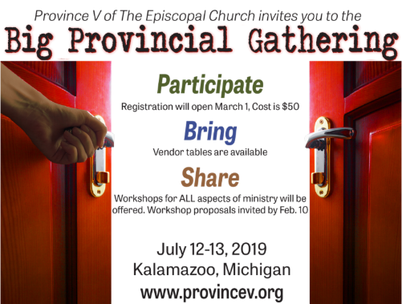

**Register for the Big Provincial Gathering**

**July 12-13 in Kalamazoo, Michigan**

[**Online registration**](http://r20.rs6.net/tn.jsp?f=001AJ8dF72P5xQdHqsnwCBbPTD4xrqjU7V6XGKfta0M75fqeuZdHR_j5AJRGZC2_pz0c4YXfV6oJg-Z1gT7ovjF-6ikffM0o539xrwxlNviNPASTnjZV8ILt_Z1b3YXCZOFN2wXXK08ZlhGthKjVcKwf2pfrDfvCiJcbZTL2NKoYGIjl0RXt6ZKAsrykJM50QGF&c=YpePrO1pwB6uBVNDnApGYb50ZjcadSs_13Nw2Ey8-5-BBUzjAQmcnQ==&ch=AJVLQJxLRI6V0tRxDMWS2o4eRqaam44qBSR9IeWNzkeUYmoDSYjUPg==) is open for the [**Big Provincial Gathering,**](http://r20.rs6.net/tn.jsp?f=001AJ8dF72P5xQdHqsnwCBbPTD4xrqjU7V6XGKfta0M75fqeuZdHR_j5KQVsLNejZgkJHk5uEqNPgyuxkZ8tx9Stq8wy478QLTkRP7kafpO44WKIs_EUV71vPXzP1OPHQAodLVgKk7noci9MY5HJb2OhSoXQDt47CEuP1m9Ge-wnwLimOhUjmG4KioKB-eZesQXvD4Crx5GKDTGJd_pH8EvpA==&c=YpePrO1pwB6uBVNDnApGYb50ZjcadSs_13Nw2Ey8-5-BBUzjAQmcnQ==&ch=AJVLQJxLRI6V0tRxDMWS2o4eRqaam44qBSR9IeWNzkeUYmoDSYjUPg==) July 12-13 in Kalamazoo, Michigan. The event is open to all Episcopalians, and activities will include worship, workshops, networking and vendor tables.  The $50 registration fee includes all programming, breakfasts and lunches. A range of housing is available, including low- or no-cost options. [**Learn more and register online**](http://r20.rs6.net/tn.jsp?f=001AJ8dF72P5xQdHqsnwCBbPTD4xrqjU7V6XGKfta0M75fqeuZdHR_j5KQVsLNejZgkJHk5uEqNPgyuxkZ8tx9Stq8wy478QLTkRP7kafpO44WKIs_EUV71vPXzP1OPHQAodLVgKk7noci9MY5HJb2OhSoXQDt47CEuP1m9Ge-wnwLimOhUjmG4KioKB-eZesQXvD4Crx5GKDTGJd_pH8EvpA==&c=YpePrO1pwB6uBVNDnApGYb50ZjcadSs_13Nw2Ey8-5-BBUzjAQmcnQ==&ch=AJVLQJxLRI6V0tRxDMWS2o4eRqaam44qBSR9IeWNzkeUYmoDSYjUPg==). A limited number of scholarships are available; please [**contact Courtney Reid**](mailto:creid@episcopalchicago.org) for details.

Workshops and pre-event learning opportunities have been added. Visit the [**website**](http://r20.rs6.net/tn.jsp?f=001AJ8dF72P5xQdHqsnwCBbPTD4xrqjU7V6XGKfta0M75fqeuZdHR_j5KQVsLNejZgkJHk5uEqNPgyuxkZ8tx9Stq8wy478QLTkRP7kafpO44WKIs_EUV71vPXzP1OPHQAodLVgKk7noci9MY5HJb2OhSoXQDt47CEuP1m9Ge-wnwLimOhUjmG4KioKB-eZesQXvD4Crx5GKDTGJd_pH8EvpA==&c=YpePrO1pwB6uBVNDnApGYb50ZjcadSs_13Nw2Ey8-5-BBUzjAQmcnQ==&ch=AJVLQJxLRI6V0tRxDMWS2o4eRqaam44qBSR9IeWNzkeUYmoDSYjUPg==) or the [**Big Provincial Gathering Facebook page**](http://r20.rs6.net/tn.jsp?f=001AJ8dF72P5xQdHqsnwCBbPTD4xrqjU7V6XGKfta0M75fqeuZdHR_j5KFLLl5R4QocoGZeQsHlvKCaqVFD95HiVvGzVVwXMemTTO6_2Q7d2rBd9af86j1kP0nHJ4GfL73-A_nUBp1f6Vdu8vPHeqgQB-V6bJ1Fdi6cQuDd5KcIELjx1qOlKLrV1tKtrhtjdv4ulIddjmb3_UGhOqvxWFml-ifRb2AqCE61p-1IKMl7Y1P_ZVzCfh6iqw==&c=YpePrO1pwB6uBVNDnApGYb50ZjcadSs_13Nw2Ey8-5-BBUzjAQmcnQ==&ch=AJVLQJxLRI6V0tRxDMWS2o4eRqaam44qBSR9IeWNzkeUYmoDSYjUPg==) for ongoing updates.  (<https://www.provincev.org/bigprovincialgathering.html> )

**Sacred Ground Web Dialogue Series Introductory webinar offered in April, May and June**

Anyone interested in learning more about [**Sacred Ground, the film-based dialogue series on race and faith**](http://r20.rs6.net/tn.jsp?f=001AJ8dF72P5xQdHqsnwCBbPTD4xrqjU7V6XGKfta0M75fqeuZdHR_j5MWuijljsdTXsPFy8a46_dIIO59ecq2lKArAZtCIaOJDd_talFnLkWFf-OQPy59B5aOp8klxY6SWYE7-54M-PNY7pPjQOg-FMnzPIyDSPsazihJeAFVOtgKjuL5N9EN_FChvcdMF2ZxRAVz0bxPCU68=&c=YpePrO1pwB6uBVNDnApGYb50ZjcadSs_13Nw2Ey8-5-BBUzjAQmcnQ==&ch=AJVLQJxLRI6V0tRxDMWS2o4eRqaam44qBSR9IeWNzkeUYmoDSYjUPg==), is 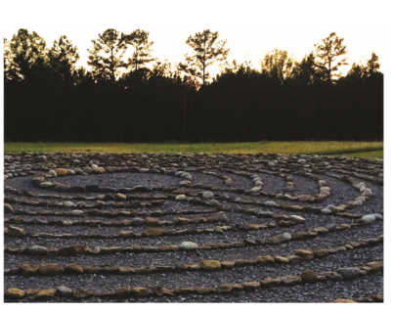invited to an introductory webinar hosted by Katrina Browne, Sacred Ground curriculum developer and producer/director of the acclaimed documentary

[**Traces of the Trade: A Story from the Deep North**](http://r20.rs6.net/tn.jsp?f=001AJ8dF72P5xQdHqsnwCBbPTD4xrqjU7V6XGKfta0M75fqeuZdHR_j5E9_tnSbUgYXB3YaGC6VS_tldQJaFKlyNRpv-Jo05KZ3B0P1Bu3rD_s-D8z-09xVhS5SIpcMOP8hzirRKKcys8EukA0IXzd_-KwqJ7uJtBt6UV6QwWhydgOJq0Q_-c22Qw==&c=YpePrO1pwB6uBVNDnApGYb50ZjcadSs_13Nw2Ey8-5-BBUzjAQmcnQ==&ch=AJVLQJxLRI6V0tRxDMWS2o4eRqaam44qBSR9IeWNzkeUYmoDSYjUPg==).

In the webinars, Browne will share background on the series and walk participants through the online Sacred Ground curriculum and resources, including the password-protected pages, to provide participants with an overview of all the elements of this resource. [**Learn more and register online**](http://r20.rs6.net/tn.jsp?f=001AJ8dF72P5xQdHqsnwCBbPTD4xrqjU7V6XGKfta0M75fqeuZdHR_j5MWuijljsdTXW4zXfhYX0k09DtXHHAli0iXEedQKPhZBr3rbu0FRPqxCzxf7wKErdSC-q7s5I4siU3bjHswFSBiQHkT9xROacIqXVIVGfiTFjRoNNfDgjjEeBsFB2JNibarUWyJzbCq46_3CaXM5zww_T0hsAKSvnA==&c=YpePrO1pwB6uBVNDnApGYb50ZjcadSs_13Nw2Ey8-5-BBUzjAQmcnQ==&ch=AJVLQJxLRI6V0tRxDMWS2o4eRqaam44qBSR9IeWNzkeUYmoDSYjUPg==).

( Website: <https://www.episcopalchurch.org/sacred-ground/webinars> )

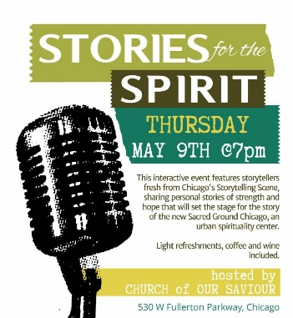

**Stories for the Spirit: A Benefit for the New Sacred Ground Chicago**

**May 9 at Church of Our Saviour, Chicago**

On May 9 at 7 pm, [**Sacred Ground Chicago**](http://r20.rs6.net/tn.jsp?f=001AJ8dF72P5xQdHqsnwCBbPTD4xrqjU7V6XGKfta0M75fqeuZdHR_j5GM89z0iXuzLClmMbBNBGsro2Z36D7egmzEdVNBwFcTWQRxyB3g9hHngnpeTBLGTjTQ_GNsYmnz-MZR5xRA7DbgoWbZYrLc37PQhN5OFBU8SYjgBwtQaXHib5lJCD-A9CbRlIAlDgc2M&c=YpePrO1pwB6uBVNDnApGYb50ZjcadSs_13Nw2Ey8-5-BBUzjAQmcnQ==&ch=AJVLQJxLRI6V0tRxDMWS2o4eRqaam44qBSR9IeWNzkeUYmoDSYjUPg==) will present "Stories for the Spirit," an interactive storytelling event at Church of Our Saviour in Chicago. [**Learn about the new organization**](http://r20.rs6.net/tn.jsp?f=001AJ8dF72P5xQdHqsnwCBbPTD4xrqjU7V6XGKfta0M75fqeuZdHR_j5GM89z0iXuzLClmMbBNBGsro2Z36D7egmzEdVNBwFcTWQRxyB3g9hHngnpeTBLGTjTQ_GNsYmnz-MZR5xRA7DbgoWbZYrLc37PQhN5OFBU8SYjgBwtQaXHib5lJCD-A9CbRlIAlDgc2M&c=YpePrO1pwB6uBVNDnApGYb50ZjcadSs_13Nw2Ey8-5-BBUzjAQmcnQ==&ch=AJVLQJxLRI6V0tRxDMWS2o4eRqaam44qBSR9IeWNzkeUYmoDSYjUPg==) and [**purchase tickets**](http://r20.rs6.net/tn.jsp?f=001AJ8dF72P5xQdHqsnwCBbPTD4xrqjU7V6XGKfta0M75fqeuZdHR_j5GM89z0iXuzLX0SoAAycU80WlJmbygQNuQ1RPL1PvEumcoxUFXAMjqCiU5gEQoWuKq5FFJx0pgwIl3yuJ0YJdqTHiD2JArtzG5XX5CduVuyycLLyf9HH6dHoEfNyWu-ZJ12H2XFF1GqCHkcwrOA93BQ=&c=YpePrO1pwB6uBVNDnApGYb50ZjcadSs_13Nw2Ey8-5-BBUzjAQmcnQ==&ch=AJVLQJxLRI6V0tRxDMWS2o4eRqaam44qBSR9IeWNzkeUYmoDSYjUPg==). (<https://www.sacredgroundchicago.org/> )

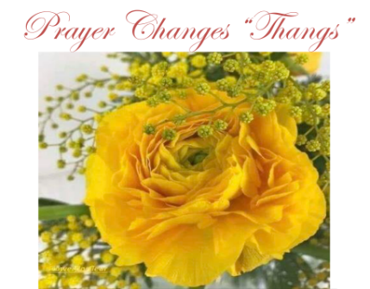

**Save the Date: Spring Jazz Prayer Breakfast**

**May 18 at the Hilton Oak Lawn**

Save the date for [**St. Thomas**](http://r20.rs6.net/tn.jsp?f=001AJ8dF72P5xQdHqsnwCBbPTD4xrqjU7V6XGKfta0M75fqeuZdHR_j5GUFDOBRr6POh1xsHoGpM4SoWC9f4chA5iHZF0XOWMTLrNFV_DSyyUFaaSvkokN61MRldmYBSQKZX9SBY_e5kehMlmzM04HJcwZ0KJcq0kjigPp0USJD9g3zJzDdo9Eudg==&c=YpePrO1pwB6uBVNDnApGYb50ZjcadSs_13Nw2Ey8-5-BBUzjAQmcnQ==&ch=AJVLQJxLRI6V0tRxDMWS2o4eRqaam44qBSR9IeWNzkeUYmoDSYjUPg==) Chicago's annual [**Spring Jazz Prayer Breakfast**](http://r20.rs6.net/tn.jsp?f=001AJ8dF72P5xQdHqsnwCBbPTD4xrqjU7V6XGKfta0M75fqeuZdHR_j5GM89z0iXuzLyL0n4HWn2Q7vDQ8Q5UeAK6bQnj-pKgF7hUC6MZHJBkr8jYhds1nSBvkt816Zpr59aO8G4xDl6berrURL9pCVSwSNLMVOA7kt0VqiF52cUEWZNd3Ybp0KK6rqAUyjfrsDt3FY1BJKI7_6vudMLtskZjuBs80ahdF0mv8EnXds_UfZuZHXYuNsIKMqI4haUnLD&c=YpePrO1pwB6uBVNDnApGYb50ZjcadSs_13Nw2Ey8-5-BBUzjAQmcnQ==&ch=AJVLQJxLRI6V0tRxDMWS2o4eRqaam44qBSR9IeWNzkeUYmoDSYjUPg==), on May 18 from 9:30 am to 12:30 pm at the [**Hilton Oak Lawn**](http://r20.rs6.net/tn.jsp?f=001AJ8dF72P5xQdHqsnwCBbPTD4xrqjU7V6XGKfta0M75fqeuZdHR_j5GM89z0iXuzLnr8ILyWnImfSxnRVnAyep0pRr39TkhUcSh01q3VMFnos8zSeL6qsn_QaVei2DXwcy3do_vi5zgzQp28lg_3fTSmsO6tTDlu9F1kRzxN9SsLSKEU5ByUVyuEN6Q-3e-SziEVDlNo3Fp52GOb8KVLmD1ewMMuv2rOVzYYyTj_CCHpC-n4sTV2ulUMrkZ5XBMdCEpIbwRln1FM=&c=YpePrO1pwB6uBVNDnApGYb50ZjcadSs_13Nw2Ey8-5-BBUzjAQmcnQ==&ch=AJVLQJxLRI6V0tRxDMWS2o4eRqaam44qBSR9IeWNzkeUYmoDSYjUPg==). The Rev. Christopher Griffin, vicar at St. Martin's Episcopal Church in Chicago, will be the guest speaker and gospel jazz saxophonist [**Lady Sax**](http://r20.rs6.net/tn.jsp?f=001AJ8dF72P5xQdHqsnwCBbPTD4xrqjU7V6XGKfta0M75fqeuZdHR_j5GM89z0iXuzLhUz2SVFNPJkIC809z3409wwlSzkJCFZ-IPpaI1Yd2mXL_ShEv4rcFGQTKr60zk2actWBOnA9AfBEEPasxAneQqCLGlMJhpg2Tv_lfseMgYE5fAx0wgpVAzV0q5jtbqTVuDcueQ3Gp9_cMBMmwWsfLWsGMcp-Xh0GYnHZ0A-zzOD57ZA-dafAYyzQGH3DNsbJb4p-kYGWDyVHrJtPHZ2QtYbf79nMsTQ9eBdkhraybgykAaDqh_2Row==&c=YpePrO1pwB6uBVNDnApGYb50ZjcadSs_13Nw2Ey8-5-BBUzjAQmcnQ==&ch=AJVLQJxLRI6V0tRxDMWS2o4eRqaam44qBSR9IeWNzkeUYmoDSYjUPg==) will perform. Watch for registration details to come.

**Healing One-Healing the World: Bishop Anderson Spring Benefit**

**May 19 at the Chicago Cultural Center Preston Bradley Hall**

On May 19 from 5 to 8 pm at the Chicago Cultural Center, Bishop Anderson House will hold its spring benefit, [**Healing One-Healing the World**](http://r20.rs6.net/tn.jsp?f=001AJ8dF72P5xQdHqsnwCBbPTD4xrqjU7V6XGKfta0M75fqeuZdHR_j5G7xsXdN30ZWjbQRWbsU4WNoHWW7GiMjP1hD0mqJsSfTbzfYWXBBjC2wLkCPxMIPb1aCKuRyWNDWJW0Q-So9Vm68FokHVZh1N9HMN0p4EILw4kbK9taCld2khtJ5tOWXOzk9d5HTUPa1CY8SoPrHlE8=&c=YpePrO1pwB6uBVNDnApGYb50ZjcadSs_13Nw2Ey8-5-BBUzjAQmcnQ==&ch=AJVLQJxLRI6V0tRxDMWS2o4eRqaam44qBSR9IeWNzkeUYmoDSYjUPg==). The event raises funds to support professional chaplaincy, Spiritual Care Visitor Training, and wellness for caregivers. [**Purchase tickets online**](http://r20.rs6.net/tn.jsp?f=001AJ8dF72P5xQdHqsnwCBbPTD4xrqjU7V6XGKfta0M75fqeuZdHR_j5G7xsXdN30ZWABjdxSA57wcf1Lk1RGZPnZFxZFMj89R9EgvYVdnkaC6aWvCqTDaBHlY6x7o6-GeaqgD3INcLq6-tu7v6MDuQ8uhEN_P07O3TcDctZ0PuonCx2tPeWk8vwf7ntBJyxgKqhrghfaHLrYG9ycWTkaR7lwEKxB4J-vI21tZDBifFfY--fRgZdKPccQ==&c=YpePrO1pwB6uBVNDnApGYb50ZjcadSs_13Nw2Ey8-5-BBUzjAQmcnQ==&ch=AJVLQJxLRI6V0tRxDMWS2o4eRqaam44qBSR9IeWNzkeUYmoDSYjUPg==). To Purchase Tickets:

<https://www.bishopandersonhouse.org/healing-one-healing-the-world-tickets/> )

|  |  |  |  |  |
| --- | --- | --- | --- | --- |
| **UPCOMING SERVICES FOR CHURCH OF THE HOLY APOSTLES – MAY 2019** | | | | |
| Sunday 05 May  8:00 am & 10:30 am | Sunday 12 May  8:00 am & 10:30 am | Sunday 19 May  8:00 am & 10:30 am | Sunday 26 May  8:00 am & 10:30 am | Friday 31 May  7:00 pm |
| Scheduled  Presider: Gillette  Preacher:Gillette | Scheduled  Presider: Gillette  Preacher: Gillette | Scheduled  Presider: Gillette  Preacher: Gillette | Scheduled  Presider: Gillette  Preacher: Gillette | Scheduled  Presider: Gillette |
| 3rd Sunday of  Easter (C) | 4th Sunday of  Easter (C) | 5th Sunday of  Easter (C) | 6th Sunday of  Easter (C) | Taize Service of Silence and Light |
| FIRST LESSON  Acts 9:1-20  RESPONSE Psalm 30  SECOND LESSON  Revelation 5:11-14  GOSPEL  John 21:1-19 | FIRST LESSON  Acts 9:36-43  RESPONSE Psalm 23  SECOND LESSON  Revelation 7:9-17  GOSPEL  John 10:22-30 | FIRST LESSON  Acts 11:1-18  RESPONSE Psalm 148  SECOND LESSON  Revelation 21:1-6  GOSPEL  John 13:31-35 | FIRST LESSON  Acts 16:9-15  RESPONSE Psalm 67  SECOND LESSON  Revelation  21:10, 22-22:5  GOSPEL  John 5:1-9 |  |

**SOME CHURCHY STUFF** *(M. C. Gillette at* [*hapostles@sbcglobal.net*](mailto:hapostles@sbcglobal.net)*) In this monthly article, we look at terms and definitions of things you might see or hear around church. Nothing fancy here – these entries are out of the Armentrout/Slocum An Episcopal Dictionary of the Church, sometimes supplemented by me, and sometimes simply copied directly. If something in particular piques your interest, let me know, and we’ll deal with it in more depth.*

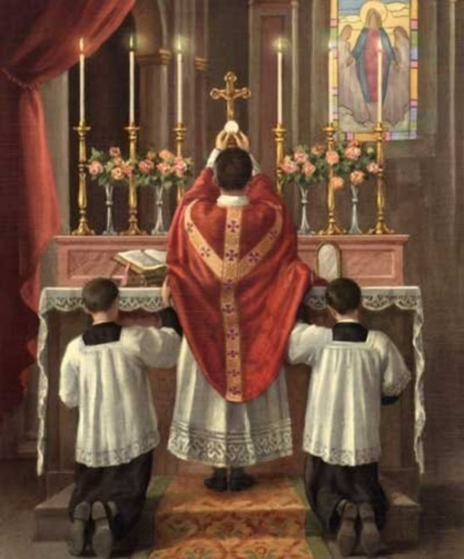

**EASTWARD POSITION.** The posture of the presider who stands at the altar with his or her back to the people. In churches oriented with the altar at the east end, as was once customary, the presider would thus be facing east. The practice originated in Rome in the eighth or ninth century. It replaced the ancient westward position, with the presider behind the altar and facing the people. In contemporary usage the westward position has been reintroduced and become common. I have no idea in what direction I’m standing on Sunday morning. All I know is that I’m either looking at you, or not at you, and that’s good enough for me.

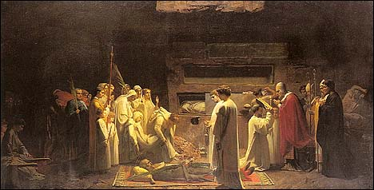**EBIONITES.** The term (Hebrew ebion, "poor") refers to a sect of Jewish Christians who upheld the Jewish law and rejected Paul's teaching and ministry to the uncircumcised. They lived an ascetic, communal life east of the Jordan in the early centuries of the Christian era. They regarded Jesus as the Messiah who would come to establish God's kingdom on earth. They rejected the virginal conception of Jesus, believing that he had a normal birth and was adopted as the divine Son at his baptism. They were thus the first adoptionists. (Adoptionists taught/teach that Jesus was born an "ordinary man" who lived an exemplary life pleasing to God and was consequently "adopted" by God as the divine Son. The moment of adoption was usually considered to be his baptism. Jesus' resurrection was also considered by some the moment of his adoption. Adoptionism relaxes the paradoxical divine-human relationship in Jesus in the interest of emphasizing his independent humanity. The church has regularly found this teaching one-sided and heretical in its failure to give full expression to Jesus' divine nature.)

**ECCLESIA.** The term is the Latin transliteration of the Greek ekklesia, which indicated a civic assembly. The

word was derived from the Greek for "call out" or "summon," so it was a "called assembly." In biblical usage it meant the assembly called by God, the church. Because of the Incarnation, in which the Word of God is united to humanity, the entire human family – past, present, future – is called into union with God in the Body of Christ. More specifically, the ecclesia is the body of those who are made members of His Body through baptism. They are sustained in that membership through participation in the eucharist. Samuel John Stone's hymn, "The Church's One Foundation" has been a favorite Anglican expression of the meaning of ecclesia. (So, ECCLESIASTICAL, “of or pertaining to the church.”)

**ECCLESIOLOGY.** From the Greek ekklesia, "church," and logia, "doctrine," the term refers to the doctrine of the church. The Greek word ekklesia (from ek, "out of," and kalein, "to call") describes the church as those "called out" by God from worldly existence to a new life in Christ. The account of the origin of the church on Pentecost (Acts 2) emphasizes the gift of the Holy Spirit to all the disciples. The church is described in Paul's Letter to the Ephesians as the body of Christ, with Christ as the head. The Johannine image of "vine and branches" (Jn 15:5) shows that life for the Christian is participation in the life of Christ. In the Treatise on the Laws of Ecclesiastical Polity, Book V, Richard Hooker emphasizes the importance of participation in the life of Christ through participation in the life of the church (especially the sacraments). The church is described in the creeds as one, holy, catholic, and apostolic. The mission of the church is to restore all people to unity with God and each other in Christ. The church carries out its mission through the ministry of all its members, including lay persons, bishops, priests, and deacons. A doctrine of ministry is usually included in ecclesiology. Recognition of the importance of the ministries of all baptized persons has led to a renewal of interest in ecclesiology.

|  |  |  |  |  |  |  |
| --- | --- | --- | --- | --- | --- | --- |
| **MAY 2019 (See PAGE 4 above for Service Schedule.)** | | | | | | |
|  | | | | | | |
| **SUN** | **MON** | **TUE** | **WED** | **THU** | **FRI** | **SAT** |
|  |  |  | 1 | 2 | 3 | 4  10 AM--noon  Food Pantry |
| 5  8:00 AM service  10:30 AM service | 6 | 7 | 8 | 9 | 10 | 11  10 AM--noon  Food Pantry |
| 12  8:00 AM service  10:30 AM service | 13  7:00 PM  Shawl Ministry | 14 | 15 | 16 | 17 | 18  10 AM--noon  Food Pantry |
| 19  8:00 AM service  10:30 AM service | 20 | 21  7:00 PM  Bishop’s Committee meeting | 22 | 23 | 24 | 25  10 AM--noon  Food Pantry |
| 26  8:00 AM service  10:30 AM service | 27 | 28  Book Group  7:30 PM | 29 | 30 | 31  Taize Service  7:00 PM |  |

**May Birthdays**

May 03 Neil Rothenberg May 20 Tim Zuellig May 06 Jackie Smith May 23 Marty Staton

May 10 Tim Hull

**May Anniversaries**

May 16 Carl and Lucy Reed

May 18 Graham Southall and Alicja Lukaszewicz-Southall





**IN OUR** **PARISH LIFE:**

**SHAWL MINISTRY:** The Shawl Ministry meets on **Monday 13 May at 7:00 PM** in Lincoln Hall. No experience is necessary! Please contact Marsha Taylor at [mktaylor730@hotmail.com](mailto:mktaylor730@hotmail.com) or 847-977-5399 with any questions.

**SUMMER LUNCH PROGRAM TRAINING:** Certified Food Handler course for Team Leaders for the summer lunch program will be **7-9 p.m. Monday 20 May at New Hope Church in Mundelein.** This is a special training arranged for us - normally it is 4-6 p.m. Food Handlers will learn about food preparation and food safety regulations as required by the state of Illinois. If you are interested in helping out with the Summer Lunch Program, please contact Mother Martha.

**BISHOP’S COMMITTEE MEETING:** Bishop’s Committee will meet on **Tuesday 21 May at 7:00 pm.**



**BOOK DISCUSSION GROUP:** This month the Book Group will meet **on May 28  at 7:30 PM** to discuss *The Guernsey Literary and Potato Peel Pie Society* by Annie Barrows and Mary Ann Shaffer, at the home of Mary Nickell.

 **RECYCLE YOUR SHOES!** We are continuing to collect shoes to be reused or recycled. Any and all shoes will be accepted-shoes in good condition will be given to others, and shoes that have seen better days will be ground up and reborn as playground material! You may deposit your old shoes in the collection box located in the Narthex near the Food Pantry milk jug. Please contact Marsha Fedor with any questions.



**THE LOBSTERS ARE BACK! THE LOBSTERS ARE BACK!** Our Lobster Sale willtake place from **11:00 AM to 2:00 PM on Saturday 15 June,** the day before Father’s Day**.** Live lobsters are $18, cooked lobsters are $20. Please encourage your friends, relatives and neighbors to participate in this delicious fundraiser!

**Orders may be placed on our website:** [**www.holyapostleswauconda.net**](http://www.holyapostleswauconda.net)

**DIAPER BANK COLLECTION:** In honor of Mother’s Day and Father’s Day,we will be collecting diapersfor our local Diaper Bank during the months of May and June. Diapers of all sizes are needed, especially those sized for adults. Please drop them off in Lincoln Hall.

**WAUCONDA FARMERS’ MARKET:**   This year we will have a weekly table set up at the Farmers Market, **11 July through 26 September, from 4:00 PM to 7:00 PM.** There is a sign-up sheet on the desk for those who would like to be a part of our 'ministry of presence' in the community. Help with setting up and taking down the tent is especially appreciated.

.  

**WAUCONDA/ISLAND LAKE FOOD PANTRY:** The milk jug count for May was $81.62. In May the food pantry served 209 families which totaled 560 individuals.  Six families were new to the pantry. Please keep them in your prayers. There is a sign-up sheet in Lincoln Hall if you are interested in volunteering on Saturdays between 10 AM and 12 noon.

Church of the Holy Apostles Covenant Statement:

*We are a welcoming, compassionate community seeking to grow in Christ,*

*and express God’s love for all, through worship, fellowship, service and prayer.*

**FROM: Church of the Holy Apostles**

**26238 North Highway 59**

**Wauconda, Illinois 60084**