**The Apostles Post**

26238 North Highway 59

Wauconda, Illinois

JANUARY 2016

2015



**FROM THE VICAR’S DESK** *(M. C. Gillette)*

**[](http://www.google.com/url?sa=i&rct=j&q=&esrc=s&source=images&cd=&cad=rja&uact=8&ved=0ahUKEwik-aHqndXJAhVDOCYKHeSdByAQjRwIBw&url=http://discovermagazine.com/2015/june/18-tomorrow-never-was&psig=AFQjCNEoyq8Ouaphby7n8RSPyp8SQM-rug&ust=1449972222609586)**Over the course of the next three months, I want to talk a little bit about three aspects of time that we encounter as we interact with scripture and church history (and therefore worship and our lives).

The first, that we’ll look at this month, is the difference between ‘Chronos’ – human time, secular time, the time of the kingdoms of the world – and ‘Kairos,’ God’s time, sacred time, the time of the kingdom of heaven. Both words come from the Greek. Basically, Chronos is the ‘minutes and seconds’ time that constantly challenges us with its relentless progression. (It’s also quite a captivating Myth, if you’re into the complexities of the ancient Greek pantheon.) It is the sequential, chronological time that patterns our weeks and years and ages – a measurable resource. Although Chronos time is one of God’s gifts to us, as affirmed in several scriptural passages (the first of which is Genesis 1:14-15), Chronos is also the stuff that kills you, especially if you allow it to become your master. In this case, it can take away everything you have and then mow you down too. If you think of ‘old Father Time’ – a weary, bent-backed old man with a long grey beard, carrying a scythe and an hourglass – you are thinking of Chronos. And the resemblance of this personification of linear time to the Grim Reaper is purposeful. Kairos, on the other hand, was represented by the Greeks as a young man, lithe and handsome. Kairos means the ‘right,’ or ‘opportune,’ or ‘appointed,’ or ‘supreme’ time. It is a way of perceiving time as a series of important or significant events. Whereas in Chronos, each moment is equally weighted (60 seconds in every minute, 60 minutes in every hour, 24 hours in every day…), in Kairos some times are longer, or shorter, or more or less important than others. There are windows of opportunity within Kairos that open and close, providing points of access to ‘something beyond.’ The ‘time’ during which these windows are open is measured in units of presence, experience, situation, and response, rather than in minutes. Our scripture, our history, our saints and mystics, even our own awareness, remind us that we need to be mindful of Kairos, even in the midst of a world regulated by Chronos. Such mindfulness is what keeps us aware of ‘opening windows’ and allows us to avoid missing out on something big God wants to do in our lives.

Chronos is quantitative. Kairos is qualitative. And as complicated or mysterious as this all might sound, you *have* experienced Kairos. Just think of when you were last so immersed in something that you ‘lost track of time,’ when you looked up from what you were doing, thinking ‘It must be about time for lunch,’ only to realize it is 4:00 in the afternoon and you need to get started on supper (or whatever you tend to do at 4:00 in the afternoon). Well, you have not ‘lost track of time’ – rather, you have experienced an incidence of Kairos time. As people called to be ‘in the world but not of it’ we have to make some concessions to Chronos; but we seek to rely more and more on Kairos in the living of our lives. We are asked to transcend our constant ‘doing,’ to overcome our subjugation to Chronos, so as to free ourselves to be able to ‘be’ more. It is wonderful when church operates on Kairos time, helping us transcend our preoccupation with our jam-packed day-planners by lifting us from the ‘time-bound’ busyness of our lives into the ‘timeless’ presence of God. (Perhaps you might have heard me muttering at some point – usually when someone has pointedly looked at their watch if the service starts a little late, or the sermon runs a little long, or there are too many announcements, or an extra liturgical element adds ten minutes onto the service – ‘We run on Kairos time here, not Chronos.) But Church is far from the only place we should be looking for Kairos. We can experience Kairos moments in the presence of our beloved, an absorbing book or craft project, a captivating play or concert, a blissful summer afternoon on the riverbank, or any of a million other places. We can’t control Kairos time any more than we can control Chronos time. But we can be ready for it. And whether it’s at the communion rail during a service that lasts 72 minutes instead of 60, or pausing to listen to a baby laugh as we’re racing to catch a plane, or forgetting to make an important phone call at the appointed hour because we’re sitting on the dock watching an amazing sunset, Kairos moments allow us to get a glimpse of the ‘other side.’ They can offer us a quick peak around the corner into eternity. We can actually get a glimpse of how God works. And ‘time’ might well stand still in the process.

**Christmas Message 2015**

Hello. Our original plan was for me to tape a Christmas message in front of the United Nations building in New York as a way of sending a message that this Jesus of Nazareth whom we follow came to show us the way to a different world, a world rounded in God’s peace and God’s justice, God’s love and God’s compassion.

I recently had surgery and so we had to change those plans and so I’m here in Raleigh on Capitol Square. Christ Church is here and we’re filming this message here just as a way of giving me a chance to say “Thank you” to all of you who sent cards and prayers in my recent surgery.  I’m doing well and I’m coming back to work.

But I did want to say something to you.  It occurs to me that this Jesus of Nazareth really does make a difference.  And God coming into the world in the person of Jesus matters profoundly for all of us regardless of our religious tradition.

In the park across from the United Nations, the Ralph Bunche Park, the words of the Prophet Isaiah are quoted,

*They will beat their swords into plowshares and their spears into pruning hooks  
Nation will not rise against nation  
Neither shall they learn war any more*

What’s not there is another part of that passage that’s in the second chapter of Isaiah, and it says,

*Come, let us go to the mountain of God,  
That he may show us His ways and teach us His paths*

We who follow Jesus believe that the mountain came to us when God came among us in the person of Jesus to show us the way to live, to show us the way to love, to show us the way to transform this world from the nightmare it often is into the dream that God intends for us all.

So, as the words were spoken on that night when Jesus was born, peace, good will to all people, God bless you, God keep you.  A blessed Advent, a Merry Christmas, and a Happy New Year to all.

**The Most Rev. Michael Curry  
Presiding Bishop and Primate  
The Episcopal Church**

🕊 🕊 🕊 🕊 🕊 🕊 🕊 🕊 🕊 🕊 🕊 🕊 🕊 🕊 🕊 🕊 🕊 🕊 🕊 🕊 🕊 🕊 🕊 🕊 🕊 🕊 🕊 🕊 🕊 🕊 🕊 🕊

**HERE AND THERE** (M. C. Gillette)

*In this on-going article, we pull things from our various Diocesan calendars and church websites to see what’s going on around us. For more information about what's happening at the Diocesan Headquarters and the Cathedral of Saint James, you can always visit their websites:* [http://www.episcopalchicago.org](http://www.episcopalchicago.org/) *or* [*http://www.saintjamescathedral.org/*](http://www.saintjamescathedral.org/)

*or for a direct link to Diocesan and Cathedral events calendars, go to:* <http://www.episcopalchicago.org/our-diocese/calendars/>

**Bishop Lee’s Christmas Message (remember, it’s Christmas until 06 January!)**

**But now, as at the ending,**

**The low is lifted high;**

**The stars shall bend their voices,**

**And every stone shall cry**

**In praises of the Child**

**By whose descent among us**

**The worlds are reconciled.**

***Hymn 104, The Hymnal,1982***

**Dear Friends,**

**I give thanks for all the ways each one of you leads the Church in praises of the Child. May the light of Christ surround you, those you love, and the People of God we serve together. Let us pray and work for the reconciliation God longs to give us.**

**Jeff**

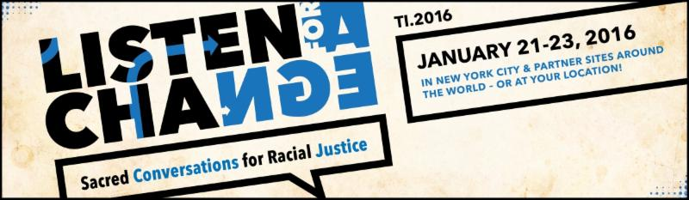**Trinity Institute 2016:  Listen for A Change Sacred Conversations for Racial Justice**

This year's Trinity Institute from [**Trinity Church Wall Street**](http://r20.rs6.net/tn.jsp?f=001TR3HmQYqxHYGsJKk4c_dUZvhOc0cRwoK6LjkvDdWUVmf0GYmYH-UUUenPYBxgS_BrMv172AMI247wSjsNPtT6beay6RWwccssk8g-1H4cSAirjZne89svoln47R_8w_yrNGik70MyuC2etJt1-Hrg49Q8GqUAHAMfByv8aZhKykWkj5n7UB1wo6kH36CaPNWT8zvUyu8XsXXhSxv34-2Vjuk6yzm2FF8&c=zaxjnh-52s40z4ZUKubOu10acGyfWQZXTOa_o3ntTkuwMP_MAvW3Pg==&ch=iQAqVhsBA_DY7ZSMLY0War6h6ikmb1yo2YVM__tJmDYIwFNZljd9KA==) in New York City will be broadcast in the Diocese of Chicago at partner sites [**St. Thomas Chicago**](http://r20.rs6.net/tn.jsp?f=001TR3HmQYqxHYGsJKk4c_dUZvhOc0cRwoK6LjkvDdWUVmf0GYmYH-UUasmMouEfSsHlUnaZpL8tqqOWU5UXNr7WYtFMIonyQGS8dUdv3VrYRYDb3Ha9Y0gpUsxYHGPOnnB9NOJdGeplhD6_qDo80-PhRrlZuMpChR4QjbKTtMzIoJg49ga-bC4_A==&c=zaxjnh-52s40z4ZUKubOu10acGyfWQZXTOa_o3ntTkuwMP_MAvW3Pg==&ch=iQAqVhsBA_DY7ZSMLY0War6h6ikmb1yo2YVM__tJmDYIwFNZljd9KA==), [**St. Luke's Evanston**](http://r20.rs6.net/tn.jsp?f=001TR3HmQYqxHYGsJKk4c_dUZvhOc0cRwoK6LjkvDdWUVmf0GYmYH-UUa3Y3fFpMgSyn0Yv8-BGUKkXXdWH5SBOeS7wdrJidTqJ3lWHxcJJJ7WvQdAbfd6W2dCG9pCQmFas0GKs2QjBUSvRlQUpL2fAgo7nKHxQzyYE3YkfMzkI8d0jY-Z0JUsdoGE2Z-D4QPOc&c=zaxjnh-52s40z4ZUKubOu10acGyfWQZXTOa_o3ntTkuwMP_MAvW3Pg==&ch=iQAqVhsBA_DY7ZSMLY0War6h6ikmb1yo2YVM__tJmDYIwFNZljd9KA==), and [**St. Mark's Glen Ellyn**](http://r20.rs6.net/tn.jsp?f=001TR3HmQYqxHYGsJKk4c_dUZvhOc0cRwoK6LjkvDdWUVmf0GYmYH-UUXMUmrMe4lqTcuFs-rdkbdi_GoXr9VevvXAczD1BRyl_PRGkZJ4ACpKBP91LxDggY9nJ16g9nZ3HsZTjV-eftSljHJK2TdGFGBDaWHswobrliff9FK34eee3kKa5XoSm5Q==&c=zaxjnh-52s40z4ZUKubOu10acGyfWQZXTOa_o3ntTkuwMP_MAvW3Pg==&ch=iQAqVhsBA_DY7ZSMLY0War6h6ikmb1yo2YVM__tJmDYIwFNZljd9KA==). The event, to be held from January 21-23, includes speakers Nicholas Kristof, Anna Deavere Smith, Michele Norris, an opening Eucharist with Presiding Bishop Michael Curry as preacher, and opportunities for theological reflection. For a preview, listen to Presiding Bishop Curry talk about the Black Lives Matter movement on the [**Trinity Wall Street Facebook page**](http://r20.rs6.net/tn.jsp?f=001TR3HmQYqxHYGsJKk4c_dUZvhOc0cRwoK6LjkvDdWUVmf0GYmYH-UUXnWElvJAhljWeSq87BBNUzRtRBW8fFeP4LX15WuKXAxs1ALGLFlnBXOYz5kkNgwTolJ-IVqEM_7cLXeCmWPGl-NOccXZsr5xT2LF25akvuXnlTPEFcbNM1PgJ9Qw6PZJrr8dHOkDPWyxBosMi9h2FLPDSDIII2fsh7vbkYm35kzIQH63L20rQZZ4_5LNRl63g==&c=zaxjnh-52s40z4ZUKubOu10acGyfWQZXTOa_o3ntTkuwMP_MAvW3Pg==&ch=iQAqVhsBA_DY7ZSMLY0War6h6ikmb1yo2YVM__tJmDYIwFNZljd9KA==).

**News from The Hunger Committee –New resource for individuals and churches**

The diocesan [Hunger Committee](http://www.episcopalchicago.org/at-work-in-the-world/hunger/) would like to share information about [Top Box Foods](http://www.topboxfoods.com/), a three-year old nonprofit that addresses the needs of people in the Chicago area who live in areas with poor access to healthy and aﬀordable foods.

Top Box Foods is a year-round resource for anyone who wants to bring fresh produce and frozen food home or who wants to help their neighbors do the same. Congregations can participate in one of four ways: being a delivery site in an underserved area that distributes food, being a partner site that orders food for people in the congregation or community from the delivery site, providing volunteers, or donating to support these efforts.

Currently, Top Box Foods primarily serves Chicago’s South and West Side neighborhoods and less affluent communities in Lake County. It caters to undeserved areas with limited nutritious options known as “food deserts.” It also caters to “food swamps,” communities that give rise to an abundance of junk food and fast-food joints through the lack of full-service grocery stores.

Top Box Foods sells food at wholesale prices once a month. Clients pre-order through a contact person at their church or community group. The food boxes are prepaid or can be paid for on delivery days through cash, credit, check or Link cards. Clients or a church volunteer goes to the delivery site to pick up the pre-ordered food.  Each partnership church receives 5 percent of all Top Box sales as an incentive or to cover its costs. Top Box staff are available to make presentations, display food boxes samples and explain the process at each church. Top Box Foods thanks churches for helping to make it an additional avenue for wholesome, wholesale food for God's people. For more information, please contact Jackie Combs Nelson, volunteer, at jackie@topboxfoods.com, or by telephone at (312) 527-7890 or (847) 276-0773.

----------

**Learning Opportunities**

|  |
| --- |
| **http://files.ctctcdn.com/dc5bcc8c101/b2ddce32-fe56-4eab-91f2-de92aa5c9572.pngIntroduction to Systemic Racism Workshop**  On January 16 from 9 am to 5 pm at Clarendon Hills Community Presbyterian Church, the Presbytery of Chicago will hold  [an introductory workshop on systemic racism](http://r20.rs6.net/tn.jsp?f=001TR3HmQYqxHYGsJKk4c_dUZvhOc0cRwoK6LjkvDdWUVmf0GYmYH-UUXnWElvJAhljoWImN3XMUrwZCEdC1hgKMrurnbb6mIjYKFszcqe2UnAd1Wmr57vtmbPhWeWiBKnYGn0M9WG0M-wlkUXSY56klQwLqWunz_sREVSVgsO_STnZ0fULHfPElZw6tlTMoANJp8Kwrah-aOssBeU4xYwFu6jd9bKsM8S7o3MlYGTY_MS_8028JifcXqmVnguq6_Ag&c=zaxjnh-52s40z4ZUKubOu10acGyfWQZXTOa_o3ntTkuwMP_MAvW3Pg==&ch=iQAqVhsBA_DY7ZSMLY0War6h6ikmb1yo2YVM__tJmDYIwFNZljd9KA==) conducted by  [Chicago Regional Organizing for Anti Racism](http://r20.rs6.net/tn.jsp?f=001TR3HmQYqxHYGsJKk4c_dUZvhOc0cRwoK6LjkvDdWUVmf0GYmYH-UUT4IFiTOb00kII42NtDZ3c3rSKajwe01WQvXsV7ewa5ligthxHuwOuj81Swab-Wk32FKDEULmmchLZZQxpHcU93fn4sNNtYzL1pl-yUIEG7If0gdvBBQwDzWh_uwDuA7cH1cxc-hx6Z3H9F76DyRwTkK1-1jh_I6fA==&c=zaxjnh-52s40z4ZUKubOu10acGyfWQZXTOa_o3ntTkuwMP_MAvW3Pg==&ch=iQAqVhsBA_DY7ZSMLY0War6h6ikmb1yo2YVM__tJmDYIwFNZljd9KA==). The cost is $25.    [Learn more and register online](http://r20.rs6.net/tn.jsp?f=001TR3HmQYqxHYGsJKk4c_dUZvhOc0cRwoK6LjkvDdWUVmf0GYmYH-UUXnWElvJAhljoWImN3XMUrwZCEdC1hgKMrurnbb6mIjYKFszcqe2UnAd1Wmr57vtmbPhWeWiBKnYGn0M9WG0M-wlkUXSY56klQwLqWunz_sREVSVgsO_STnZ0fULHfPElZw6tlTMoANJp8Kwrah-aOssBeU4xYwFu6jd9bKsM8S7o3MlYGTY_MS_8028JifcXqmVnguq6_Ag&c=zaxjnh-52s40z4ZUKubOu10acGyfWQZXTOa_o3ntTkuwMP_MAvW3Pg==&ch=iQAqVhsBA_DY7ZSMLY0War6h6ikmb1yo2YVM__tJmDYIwFNZljd9KA==). |

|  |
| --- |
| http://files.ctctcdn.com/dc5bcc8c101/bf92b074-aafd-4351-a223-2f8d97432e9e.jpg**Fierce Conversations Winter Workshop** January 27 - 28 at St. James Commons   A Fierce Conversations training will be held January 27 - 28 from 8:30-5 pm at  [Saint James Commons](http://r20.rs6.net/tn.jsp?f=001TR3HmQYqxHYGsJKk4c_dUZvhOc0cRwoK6LjkvDdWUVmf0GYmYH-UUQyYFcOHrDQI9vzbT9btciLDx53kY61iCFSEwv8AoVThF18Ah1MSItNDVqcsB6s6kjghA1aORQyl-puCUZRgOfAb1NrlT0mcG2tW0iTkPSSDBuBqPmLK0LZT5jLMdav1jA==&c=zaxjnh-52s40z4ZUKubOu10acGyfWQZXTOa_o3ntTkuwMP_MAvW3Pg==&ch=iQAqVhsBA_DY7ZSMLY0War6h6ikmb1yo2YVM__tJmDYIwFNZljd9KA==). Attendance is required both days. Continental breakfast and  lunch are provided. Fierce Conversations training teaches people how to have vital conversations that interrogate reality, provoke learning, resolve tough challenges and enrich relationships. While no single conversation is guaranteed to change the trajectory of a career, a congregation, a relationship, or a life ... any single conversation can. |
| http://files.ctctcdn.com/dc5bcc8c101/1a50aca3-1601-490e-9e6b-c303306a2efb.png**Spring 2016 Volunteer Chaplain Training** Beginning February 2016  [The Bishop Anderson House](http://r20.rs6.net/tn.jsp?f=001TR3HmQYqxHYGsJKk4c_dUZvhOc0cRwoK6LjkvDdWUVmf0GYmYH-UUT4IFiTOb00k300xAQ2IAso48ZlfUk0AzdCpDtuoFMyWTpHTJFZKDuRj-BmDyy2bkyCSmgSr6tJlaK9HayS6c0j6VBvXsdV58_oQIay7EJujwDWpCvbAE0fVraftiElnkw==&c=zaxjnh-52s40z4ZUKubOu10acGyfWQZXTOa_o3ntTkuwMP_MAvW3Pg==&ch=iQAqVhsBA_DY7ZSMLY0War6h6ikmb1yo2YVM__tJmDYIwFNZljd9KA==) 13-week course equips students with tools for serving as a volunteer visitor to the home-bound, hospital patients or folks in personal crisis. Students learn how to listen, what to say and what not to say, and how to recognize signs of addiction, cognitive distress or spiritual crisis. Spring 2016 Volunteer Chaplain Training takes place February 17 - May 11, on Wednesday evenings from 5:30 to 7:30 pm. Application period is open through January 30, 2016 and the class is is open to members of all faith traditions. [Learn more and apply here.](http://r20.rs6.net/tn.jsp?f=001TR3HmQYqxHYGsJKk4c_dUZvhOc0cRwoK6LjkvDdWUVmf0GYmYH-UUSdlFEccePk-BKH_w-yYKmmdnPy7qPgEyWnsgYu-0L0eVFUCBcn_V8HpLZDae65JFJSLuHoh6pOQR7M_WSvegOuEY-MXtpEZ42HzFYROazWtDykuNzuWGQW5xokpcHhFQMQ4q_IVlLjKbVByGFDhydRluEjt8z9J_1CzT9GoY-bdVB0p8iQDtxDp4LDii0J6Ag==&c=zaxjnh-52s40z4ZUKubOu10acGyfWQZXTOa_o3ntTkuwMP_MAvW3Pg==&ch=iQAqVhsBA_DY7ZSMLY0War6h6ikmb1yo2YVM__tJmDYIwFNZljd9KA==) |

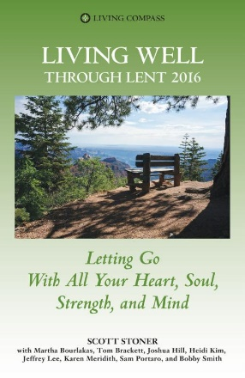

**Free Living Compass Lenten Booklets**

 Although we are still celebrating Christmas, Lent is only about six weeks away. This year, Living Compass is offering all congregations in the Diocese of Chicago free copies of its 2016 Lenten devotional booklets, "Living Well Through Lent 2016:  Letting Go With All Your Heart, Soul, Strength and Mind."

*(Note: We will be making a copy of this book available to all parishioners. A few additional copies will be available to give to people you think might wish to have one.)*

The booklet includes writing from Bishop Lee, Martha Johnson Bourlakas, the Rev. Tom Brackett, the Rev. Joshua Hill, Heidi J. Kim, Karen M. Meridith, the Rev. Dr. Sam A. Portaro, Jr., the Very Rev. Robert "Bobby" Nelson Smith, and the Rev. Dr. Scott Stoner.

🕊 🕊 🕊 🕊 🕊 🕊 🕊 🕊 🕊 🕊 🕊 🕊 🕊 🕊 🕊 🕊 🕊 🕊 🕊 🕊 🕊 🕊 🕊 🕊 🕊 🕊 🕊 🕊 🕊 🕊 🕊 🕊

|  |  |
| --- | --- |
|  |  |

|  |  |  |  |  |  |
| --- | --- | --- | --- | --- | --- |
| **UPCOMING SERVICES FOR CHURCH OF THE HOLY APOSTLES – JANUARY 2016** | | | | | |
| Sunday  03 January  8:00 &10:30 a.m. | Sunday  10 January  8:00 &10:30 a.m. | Sunday  17 January  8:00 &10:30 a.m. | Sunday  24 January  8:00 &10:30 a.m. | Friday  29 January  7:00 p.m.  **Taizé Prayer** | Sunday  31 January  8:00 &10:30 a.m. |
| Scheduled  Presider: Gillette  Preacher: Gillette | Scheduled  Presider: Gillette  Preacher: Gillette | Scheduled  Presider: Gillette  Preacher: Gillette | Scheduled  Presider: Moon  Preacher: Moon |  | Scheduled  Presider: Moon  Preacher: Moon |
| 2nd Sunday after  Christmas (C) | 1st Sunday after  the Epiphany (C)  **Celebration of the Epiphany and the Baptism of our Lord** | 2nd Sunday after  the Epiphany (C) | 3rd Sunday after  the Epiphany (C) | Taizé Prayer | 4th Sunday after  the Epiphany (C) |
| FIRST LESSON  Jeremiah  31:7-14  RESPONSE Psalm  84  SECOND  LESSON  Ephesians  1:3-6, 15-19a  GOSPEL  Luke 2:41-52 | FIRST LESSON  Isaiah  43:1-7  RESPONSE Litany for the Baptism of Jesus  SECOND  LESSON  Acts  8:14-17  GOSPEL  Luke 3:15-17, 21-22 | FIRST LESSON  Isaiah  62:1-5  RESPONSE Psalm  36:5-10  SECOND  LESSON  1 Corinthians  12:1-11  GOSPEL  John 2:1-11 | FIRST LESSON  Nehemiah  8:1-3, 5-6, 8-10  RESPONSE Psalm  19  SECOND  LESSON  1 Corinthians  12:12-31a  GOSPEL  Luke 4:14-21 |  | FIRST LESSON  Jeremiah  1:4-10  RESPONSE Psalm  71:1-6  SECOND  LESSON  1 Corinthians  13:1-13  GOSPEL  Luke4:21-30 |

**SOME CHURCHY STUFF** *(M. C. Gillette)*

*In this monthly article, we look at terms and definitions of things you might see or hear around church. Nothing fancy here – these entries are out of the Armentrout/Slocum An Episcopal Dictionary of the Church, sometimes supplemented by me, and sometimes simply copied directly.*

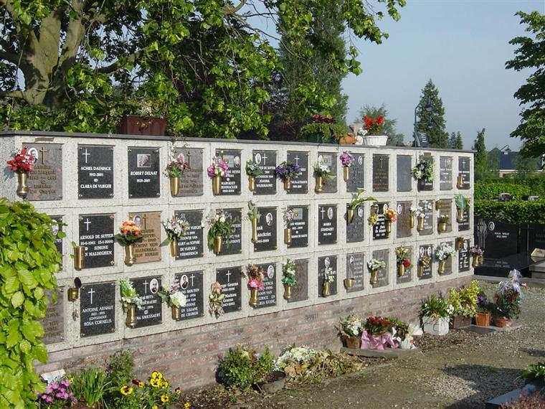

**COLUMBARIUM.** A vault or structure with niches (openings) for the burial or urns or other containers of ashes of the dead. Many parishes have a columbarium. It may be located in an undercroft or chapel or elsewhere on the church grounds. The Book of Common Prayer service of committal (page 501) allows the presider to state that the deceased person’s bodily ashes are committed to their ‘resting place’ rather than the traditional to the ‘earth’.

**Hear what comfortable words our Saviour Christ saith to all that truly turn to him.**  
COME unto me all that travail and be heavy leaden, and I shall refresh you. So God loved the world, that he gave his only-begotten Son, to the end that all that believe in him should not perish, but have life everlasting.  
    Hear also what S. Paul saith.  
    This is a true saying, and worthy of all men to be embraced and received, That Jesus Christ came into this world to save sinners.  
    Hear also what S. John saith.  
    If any man sin, we have an Advocate with the Father, Jesus Christ the righteous: he it is that obtained grace for our sins. (*1548 Prayer Book Version*)

**‘COMFORTABLE WORDS’.** A series of sentences from scripture that provide encouragement for penitent sinners. The term ‘comfortable’ originally meant ‘strengthening.’ The sentences appear after the confession and absolution in the Rite 1 Eucharist (Book of Common Prayer page 332), and in the Reconciliation of a Penitent (*aka ‘confession’*), Form 2, prior to the bidding to confession and the confession of sins by the penitent (Book of Common Prayer, pages 449-450). Use of the comfortable words is optional in both cases. All previous editions of the Prayer Book *required* that all 4 sentences be said at every eucharist. As of the current Prayer Book, one or more of the sentences *may* be said. The comfortable words date from the 1548 Order of the Communion. The Book of Common Prayer introduces the sentences with the statement, ‘Hear the Word of God to all who truly turn to him.’ The sentences are based on scripture – Matthew 11:28, John 3:16, Timothy 1:15, and 1 John 2:1-2

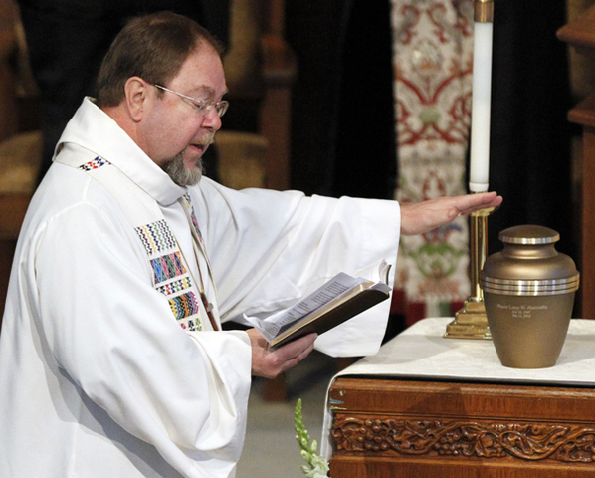**COMMENDATION, THE.** Concluding portion of the burial rite prior to the committal at the grave or other place of final repose. The commendation is typically said in the church building. After the post-communion prayer, or the prayers if there is no eucharist, the presider and other ministers take their places at the body. The anthem ‘Give rest, O Christ, to your servant(s) with your saints.’ based on the *Kontakion* (*a particular form of hymn performed in the Orthodox Church, in this case specific to the burial rite*) and *Ikos* (*a short musical/poetic composition which immediately follows the Kontakion*) of the Byzantine Rite, may be sung or said. Another suitable anthem or hymn may also be used at this time. After the anthem, the presider says the prayer of commendation, commending the deceased to our merciful Savior (Book of Common Prayer, page 499). A blessing and dismissal may follow the prayer of commendation. As the body is borne from the church, an appropriate hymn, anthem, or canticle may be sung or said. The commendation was added to the 1979 Prayer Book burial rite in response to the pastoral reality that many attending the burial service do not go to the grave for the committal of the body.

Images: Columbarium <http://urbastyle.com/en/node/754>

Comfortable Words <http://justus.anglican.org/resources/bcp/Communion_1548.htm>

Commendation <http://www.independentmail.com/news/abernathy-funeral>

**IN OUR** **PARISH LIFE**



**SHAWL MINISTRY :** TheShawl Ministry will meet on Monday, January 11 at 7:00pm, and

****Tuesday, January 26 at 1:00pm in Lincoln Hall. All are welcome to join us- no experience is required!

**BOOK DISCUSSION GROUP:** The book discussion group generally meets the fourth Tuesday of the month at 7:30pm (exceptions will be noted). New members or one-time visitors are always welcome!

**WARM BLANKETS NEEDED:** Deacon Laurie Michaels of St. Michael’s Episcopal Church, Barrington, continues to be involved on Monday nights with CUMALI-Homeless Chicago Urban Ministry and Life Intervention. Laurie is collecting warm blankets to take to homeless individuals living under Lower Wacker Drive in Chicago. Also needed are sleeping bags and any men's L, XL and XXL coats and sweatshirts, or L and XL women's coats, warm hats and gloves.  If you have something you can donate please email Laurie at [travelaurie@hotmail.com](mailto:travelaurie@hotmail.com)

**WAUCONDA/ISLAND LAKE FOOD PANTRY:** The milk jug count for November was $97.11. In November the food pantry served 239 families which totaled 679 individuals.  Thirteen families were new to the pantry. Please keep them in your prayers. There is a sign-up sheet in Lincoln Hall if you are interested in volunteering on Saturdays between 10 AM and 12 noon.

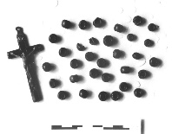

**Introduction to the Anglican rosary/Protestant prayer beads**

*A four-week Lenten study offered by the prayer bead ministry of the*

*Episcopal Church of the Holy Apostles in Wauconda*

Come learn about this traditional spiritual discipline and how it can deepen and enrich your prayer life!

When: 7 p.m. each Wednesday, February 24th - March 16th, 2016

Where: Episcopal Church of the Holy Apostles / 26238 N HWY 59, Wauconda, IL 60084

Cost: $20 per person (covers the entire 4-week series). Tuition includes one set of prayer beads**\*** and

a copy of Kristen E. Vincent's book ‘*A Bead and a Prayer: A Beginner's Guide to Protestant Prayer Beads*.’

Limited scholarship money is available for those who wish to attend but cannot afford it.

**This class is limited to 18 participants. Advance registration is required.**

|  |  |  |  |  |  |  |
| --- | --- | --- | --- | --- | --- | --- |
| **JANUARY 2016 (See PAGE 4 above for Service Schedule.)** | | | | | | |
| **SUN** | **MON** | **TUE** | **WED** | **THU** | **FRI** | **SAT** |
|  |  |  |  |  | 1 | 2  Food Pantry  10am-noon |
| 3  8:00 AM service  10:30 AM service  Un-greening | 4 | 5 | 6 | 7 | 8 | 9  Food Pantry  10am-noon |
| 10  8:00 AM service  10:30 AM service | 11  Shawl Ministry  7:00 PM | 12 | 13 | 14 | 15 | 16  Food Pantry  10am-noon |
| 17  8:00 AM service  10:30 AM service | 18 | 19  Bishop’s Committee 7 7:00 PM | 20 | 21 | 22 | 23  Food Pantry  10am-noon |
| 24  8:00 AM service  10:30 AM service  3:45 PM WCC | 25 | 26  Shawl Ministry  1:00 PM  Book Discussion  Group 7:30 PM | 27 | 28 | 29  Taize Service  Of Light  7:00 PM | 30 |
| 31  8:00 AM service  10:30 AM service |  |  |  |  |  |  |

**January Birthdays**

Jan 03 Michelle Permenter Jan 09 Rick Taylor

Jan 07 Lynn Chmiel Jan 10 Diane Cooper

Jan 08 Betty Jo Hoebbel Jan 25 Patti Glade

**January Anniversaries**

Jan 18 The Rev. Don and Jody Moon



**FROM: Church of the Holy Apostles**

**26238 North Highway 59**

**Wauconda, Illinois 60084**