**The Apostles Post**

26238 North Highway 59

Wauconda, Illinois

JULY 2022

2015



**FROM THE VICAR’S DESK** *(M. C. Gillette)* Angelology, Issue VII

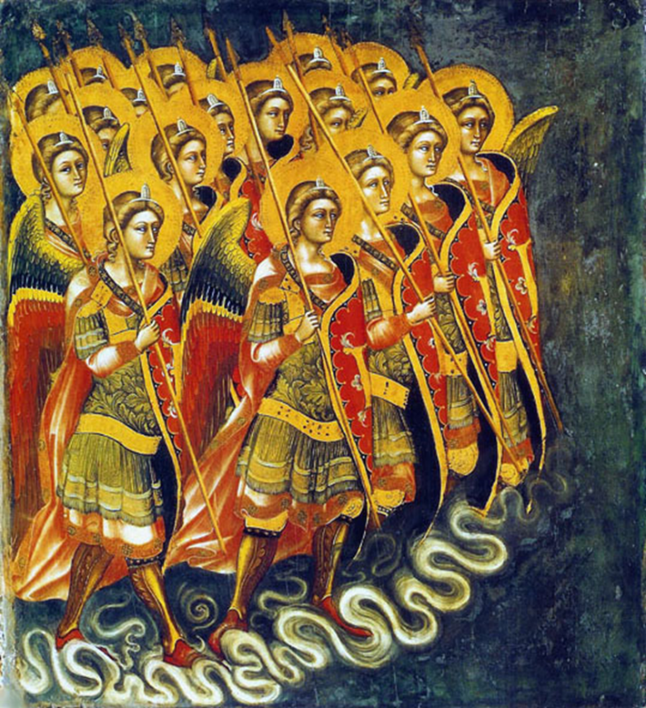 We have moved up the angelic hierarchy to the second, or middle, triad of orders (or choirs) of angels. Yay, us! This means, however, that we now find ourselves outside the realm of celestial beings who can effectively communicate with us; dealing with humans being a task relegated to those at the bottom of the angelic pecking order.

You will recall (surely) that Angels, Archangels, and Principalities are the three orders of the lowest angelic rank. This month we will contemplate what centuries of tradition have to tell us about the bottom level of the *next* group of three orders – Powers. (Virtues and Dominations/ Dominions will round out this trinity.) Whereas the fundamental duties of the lowest triad are to interact with humans as bearers of God’s messages when direct, theoretically comprehensible conversation is desired/ required, the basic tasks of the middle triad involve fulfilling God’s plan in the universe.

It is said that Powers are the order of angels created first by God. They are warrior angels tasked with fighting the war against the *demonic* choirs of angels. (I promised at the beginning of all this we wouldn’t try to delve into the realm of the “fallen” angels, and we won’t. But if we’re dealing with angelology at all, we should remember that the “good guys” have “bad guys” counterparts. Take a look at the three books of Enoch if you like, and/or some of the other “rejected” writings of Christian history. The “Encyclopedia of Lost and Rejected Scriptures” should help you out in this regard. I’m sure your friendly local library can lay hands on it for you or you can order/buy it from your local bookstore or from Indibound: <https://www.indiebound.org/>. And yeah, I’m sure you can find it on Amazon, and I can’t stop you, but I’d be sad; unless, I guess, you have a Kindle and they have it available for download.) Anyway, Powers are responsible for protecting the boundaries/ patrolling the borders between Heaven and Earth, which can’t be an easy job. They are sort of an elite guard, constantly watching out for demonic attack and engaging where and when necessary, protecting the world from infiltration by demons. (Looking around, I’m guessing they miss a few here and there, but I’m sure they do their best.) Powers are also responsible for protecting our souls from these evil beings. (I do regret to inform you that, perhaps because of their close proximity to the dark side, there are more Powers listed as Fallen Angels than from any other order.) And, because if you need something done you give it to the busy one, in addition to serving as the front line against the incursion of satanic forces, they are the angels of birth and death, guiding our soul’s transition between Heaven and Earth. They are the carriers of consciousness.

Powers’ purpose is to maintain/ restore order. Powers are called “Powers” because they have power over Satan’s forces; power to restrain demonic attack, repulse the temptations brought upon people by demons, and prevent the evil ones from harming anyone to the degree that they would wish. Powers are the angelic representatives of all lawful authority, ecclesiastical and civil. To that end, they observe how power is divided among humans. And while this is doubtless anthropomorphizing them overly much – although I’m not feeling particularly badly about that, given this entire topic is one big exercise in anthropomorphizing overly much – they are said to be academically guided and interested in ideology, philosophy, theology, religion, and the documents that belong to these studies. This would seem to make Powers the nerds of the angelic hierarchy – the policy wonks, the “subject matter experts,” the advisers. No wonder so many of them fall into the abyss.

--------------------------------------------------------------------------------------------------------------------------------------

|  |  |  |  |  |
| --- | --- | --- | --- | --- |
| **EPISCOPAL CHURCH OF THE HOLY APOSTLES UPCOMING SERVICES – JULY 2022** | | | | |
| Sunday  03 July  9:30 a.m. | Sunday  10 July  9:30 a.m. | Sunday  17 July  9:30 a.m. | Sunday  24 July  9:30 a.m. | Sunday  31 July  9:30 a.m. |
| Scheduled  Presider/ Preacher:  Jane Clark | Scheduled  Presider/ Preacher:  Gillette | Scheduled  Presider/ Preacher:  Gillette | Scheduled  Presider/ Preacher:  Judith Doran | Scheduled  Presider/ Preacher:  Gillette |
| 4th Sunday after  Pentecost  Proper 9 (C) | 5th Sunday after  Pentecost  Proper 10 (C) | 6th Sunday after Pentecost  Proper 11 (C) | 7th Sunday after Pentecost  Proper 12 (C) | 8th Sunday after Pentecost  Proper 13 (C) |
| FIRST LESSON  2 Kings 5:1-14  RESPONSE Psalm 30  SECOND  LESSON  Galatians  6:1-16  GOSPEL  Luke 10:1-11,16-20 | FIRST LESSON  Amos 7:7-17  RESPONSE Psalm 82  SECOND  LESSON  Colossians  1:1-14  GOSPEL  Luke  10:25-37 | FIRST LESSON  Amos 8:1-12  RESPONSE Psalm 52  SECOND  LESSON  Colossians  1:15-28  GOSPEL  Luke  10:38-42 | FIRST LESSON  Hosea 1:2-10  RESPONSE Psalm 85  SECOND  LESSON  Colossians  2:6-10  GOSPEL  Luke  11:1-13 | FIRST LESSON  Hosea 11:1-11  RESPONSE Psalm 107:1-9, 43  SECOND  LESSON  Colossians  3:1-11  GOSPEL  Luke  12:13-21 |

**HERE AND THERE** *(M. C. Gillette)*

*In this on-going article, we pull things from our various Diocesan calendars and church websites to see what’s going on around us. For more information about what's happening at the Diocesan Headquarters and the Cathedral of Saint James, you can always visit their websites:* <https://www.episcopalchicago.org>

or <https://www.saintjamescathedral.org/>

**Statement on Supreme Court Dobbs decision by Presiding Bishop Michael Curry**

June 24, 2022

Today the Supreme Court released its decision in the case of *Dobbs vs. Jackson Women’s Health Organization*. The court has overturned the constitutional right to abortion that was recognized in the seminal 1973 case *Roe v. Wade.*

While I, like many, anticipated this decision, I am deeply grieved by it. I have been ordained more than 40 years, and I have served as a pastor in poor communities; I have witnessed firsthand the negative impact this decision will have.

We as a church have tried carefully to be responsive both to the moral value of women having the right to determine their healthcare choices as well as the moral value of all life. Today’s decision institutionalizes inequality because women with access to resources will be able to exercise their moral judgment in ways that women without the same resources will not.

This is a pivotal day for our nation, and I acknowledge the pain, fear, and hurt that so many feel right now. As a church, we stand with those who will feel the effects of this decision—and in the weeks, months, and years to come.

The Episcopal Church maintains that access to equitable health care, including reproductive health care and reproductive procedures, is “an integral part of a woman’s struggle to assert her dignity and worth as a human being” (2018-D032). The church holds that “reproductive health procedures should be treated as all other medical procedures, and not singled out or omitted by or because of gender” (2018-D032). The Episcopal Church sustains its “unequivocal opposition to any legislation on the part of the national or state governments which would abridge or deny the right of individuals to reach informed decisions [about the termination of pregnancy] and to act upon them” (2018-D032). As stated in the 1994 Act of Convention, the church also opposes any “executive or judicial action to abridge the right of a woman to reach an informed decision…or that would limit the access of a woman to safe means of acting on her decision” (1994-A054).

The court’s decision eliminates federal protections for abortion and leaves the regulation of abortion to the states. The impact will be particularly acute for those who are impoverished or lack consistent access to health care services. As Episcopalians, we pray for those who may be harmed by this decision, especially for women and other people who need these reproductive services. We pray for the poor and vulnerable who may not have other options for access. We urge you to make your voice heard in the way you feel called but always to do so peacefully and with respect and love of neighbor.

 --------------------------------------------------------------------------------------------------------------------------------------

**Statement from Presiding Bishop Michael Curry and President of the House of Deputies Gay Clark Jennings on NYSRPA v. Bruen**

June 23, 2022

The Supreme Court’s decision today striking down New York’s regulation of the concealed carry of firearms—at a time when our nation is reeling from gun violence—raises grave concerns. We fear this decision will lead to more firearms on our streets and in our communities. When we signed onto [an amicus brief](https://www.episcopalchurch.org/wp-content/uploads/sites/2/2022/06/20210921185212421_41279-pdf-Jacquemot-br.pdf) in this case last year, we did so because we feared increased gun violence in churches and other houses of worship—a fear that was realized less than a week ago at Saint Stephen’s Episcopal Church in Vestavia Hills, Alabama.

As the conveners of the Bishops United Against Gun Violence network wrote [in a statement released today](https://bishopsagainstgunviolence.org/a-death-dealing-decision-new-york-state-rifle-pistol-association-v-bruen/), the ruling “puts people of faith at greater risk when we gather for prayer, worship, fellowship, and service.”

The Episcopal Church will continue its advocacy for commonsense gun violence prevention laws, and [we invite you to learn more](https://www.episcopalchurch.org/ogr/resources-to-respond-to-gun-violence/) about how you can become involved in these efforts.

Finally, we ask you to pray for all those who have lost a loved one to gun violence—or will lose one today or tomorrow.

--------------------------------------------------------------------------------------------------------------------------------------

|  |
| --- |
| **Online Diocesan Convention on November 19** |
| |  |  | | --- | --- | |  |  | |  |  |   The Standing Committee, in consultation with Bishop-elect Paula Clark, has determined that the 2022 Diocesan Convention will be held online on November 19.  “We are looking forward to a large, joyful consecration and gathering on September 17 to celebrate Bishop-elect Paula. With the amount of diocesan and staff resources necessary to host the consecration, we have decided that it is necessary to have Diocesan Convention virtually this year,” said Standing Committee President Anne Jolly. “While we always prefer to gather together in person, the joy of the consecration will carry us forward as we utilize the experiences of the past few years to have another effective online convention.” The diocese held successful online diocesan conventions on Zoom in 2020 and 2021. As diocesan bishop, Clark will chair the 2022 convention.  More information about the 185th Annual Convention, including calls for nominations, resolutions, registration and certification of delegates, will be published later this summer.  ------------------------------------------------------------------------------------------------------------------------------- |

**Mediation Skills Training** **- August 1-5 at St. Mark's, Glen Ellyn**

The Lombard Mennonite Peace Center will host a summer session of its Mediation Skills Training Institute (MSTI) for Church Leaders August 1-5 at St. Mark’s Episcopal Church in Glen Ellyn. MSTI training helps clergy and lay leaders deal more effectively with interpersonal, congregational, and other forms of group conflict. For more information contact the Lombard Mennonite Peace Center at 630-627-0507.

**SOME CHURCHY STUFF** *(M. C. Gillette)*

*In this monthly article, we look at terms and definitions of things you might see or hear around church. Nothing fancy here – these entries are out of the Armentrout/Slocum An Episcopal Dictionary of the Church, sometimes supplemented by me, and sometimes simply copied directly. If something in particular piques your interest, let me know, and we’ll deal with it in more depth.*

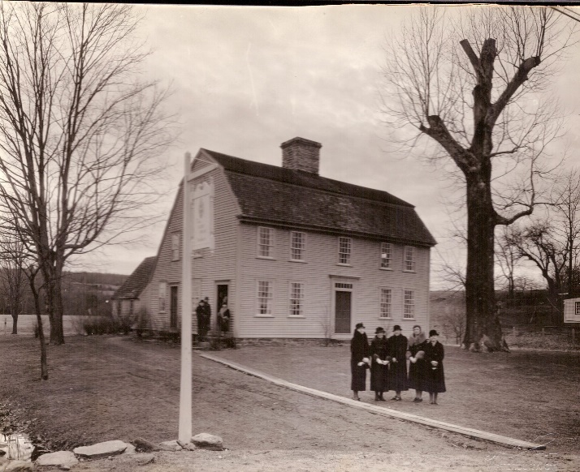**GLEBE.** The term is derived from a Latin word meaning “clod” or “soil.” Glebes were farm lands set aside for the support of the clergy in American colonies where the Church of England was established. These glebes sometimes included homes, barns, and slaves. Glebes were usually two hundred or more acres. It could be farmed to supplement the rector's salary, or it could be leased to others. After the American Revolution, most of the glebes were transferred to the newly organized Protestant Episcopal Church (that would be us). The Baptists led an effort in Virginia to seize the glebe lands. (Tsk, tsk!) In January 1802 the Virginia Assembly passed the Act Concerning the Glebe Lands and Churches within this Commonwealth. It provided that each county would have a group called the Overseers of the Poor, which would seize the glebes purchased prior to 1777 upon the death or resignation of the parish's present rector. This Act contributed to the decline of the Episcopal Church in Virginia after the Revolution. Alas.

**GLORIA IN EXCELSIS.**

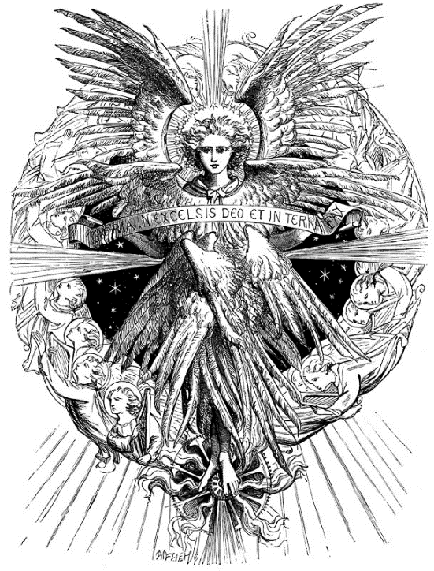 “Glory in the highest,” a short hymn of praise to the Trinity. Its opening verse is based on the song of the angels to the shepherds at the time of Jesus' birth, as reported in Luke 2:14. It is known as the “Angelic Hymn.” It is also known as the “Greater Doxology,” distinguishing it from the Gloria Patri, the “Lesser Doxology.” It dates from the fourth century. It continues to be used in the morning office by the eastern churches. The Gloria became a part of the entrance rite of the Roman Mass in the twelfth century and was dropped from the Daily Office in the west. The Gloria was also used in the eucharistic entrance rite of the 1549 Book of Common Prayer (BCP), but later editions used the Gloria as a postcommunion prayer. This reflected the penitential emphasis of those editions of the Prayer Book. The 1789 American Prayer Book allowed the use of the Gloria instead of the Gloria Patri as an option at the end of the psalmody in the Daily Office, but that option is no longer allowed. (No, I don’t know who decided to dis the angels.) The 1979 BCP restored the Gloria to its place in the eucharistic entrance rite (pages 324-325 for Rite I, 356 for Rite II). The Gloria may be used from Christmas Day through the Feast of the Epiphany, on Sundays in Easter season, on all the days of Easter Week, on Ascension Day, and at other times. The Gloria is not used at the eucharist on the Sundays or ordinary weekdays of Advent or Lent (as per the BCP, page 406). The 1979 BCP uses the Gloria as canticle 20, “Glory to God.” It is printed in the Rite II service for Morning Prayer, it may be used for Morning Prayer or Evening Prayer, and it is suggested for use at Morning Prayer on Thursday except in Advent and Lent. (Are you keeping all this straight? I’m not too sure what happens if you use it on a Monday in December, but I’m going to suggest you just don’t. Because.) The 1982 Hymnal provides various musical settings for the Gloria.

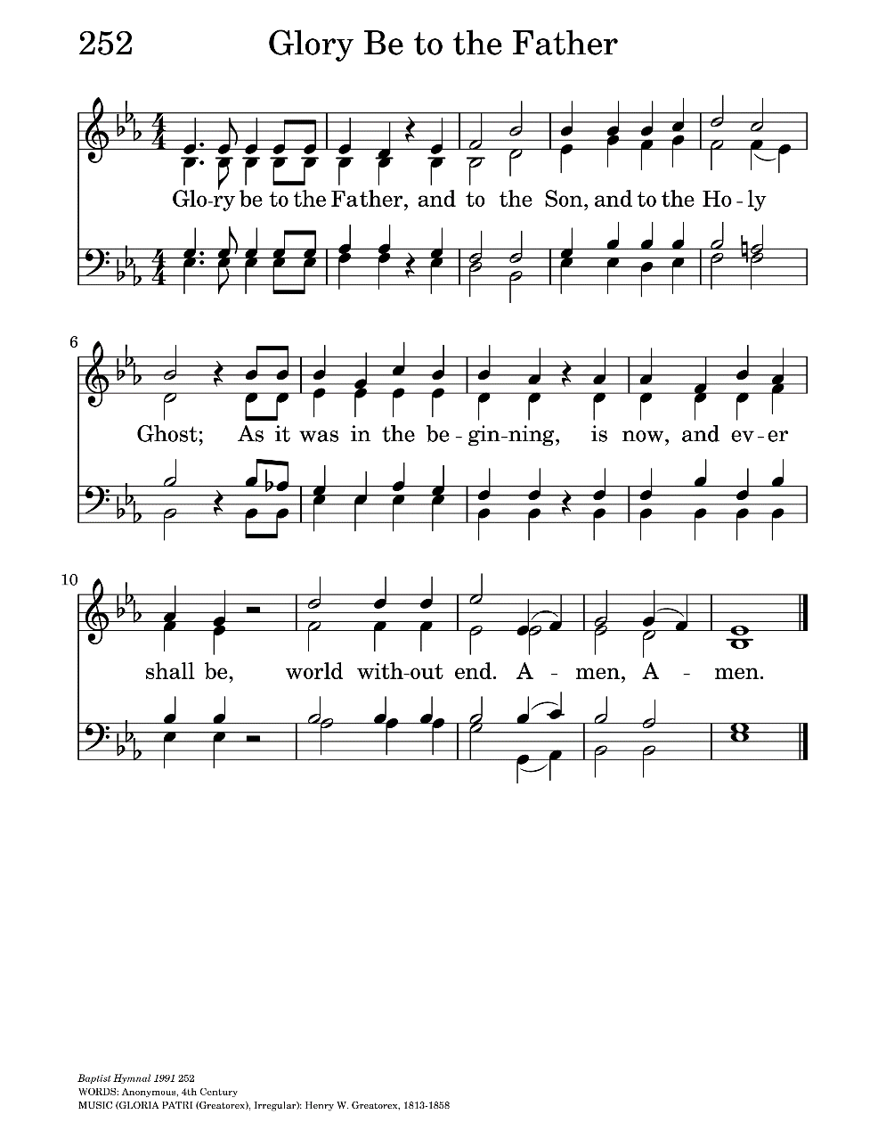**GLORIA PATRI**. The Gloria Patri, according to the New Creation Church of Hagerstown, “is a short, punchy acclamation that acts like training wheels for our lips and lives, teaching us to praise the good and holy Triune God.” The rest of us would probably simply refer to it as “a short acclamation of praise to the Trinity: Glory to the Father, and to the Son, and to the Holy Spirit: as it was in the beginning, is now, and will be for ever. Amen." The term Gloria Patri is from the opening words of the acclamation in Latin. Gloria Patri is also known as the "Lesser Doxology," distinguishing it from the Gloria in excelsis, the "Greater Doxology." It may have been influenced by the trinitarian baptismal formula of Matthew 28:19.

Gloria Patri is always sung or said at the conclusion of the entire portion of the Psalter at Morning Prayer, Noonday Prayer, Evening Prayer, and Compline. It may be used after the invitatory psalm or the canticle "Christ our Passover" at Morning Prayer; and after each psalm, and after each section of Psalm 119 at Morning and Evening Prayer. Gloria Patri is used in the Book of Common Prayer (BCP) to conclude Canticles 3, 4, 5, 8, 9, 10, 11, 15, 16, 17, and 19. It is also used to conclude the Magnificat and the Nunc dimittis in Evening Prayer, although Gloria Patri may be omitted after these canticles. It follows the opening versicle and response at Morning Prayer, Noonday Prayer, and Evening Prayer. (If you don’t know what all these funky little terms mean, feel free to grab a Prayer Book – you’ll figure it out.) It follows the confession of sin and a versicle and response from Psalm 70:1 at Compline. This pattern of versicle and response is based on the model for the beginning of the Daily Offices prescribed by St. Benedict of Nursia (c. 480-c. 550). Gloria Patri is also used with verses from Psalm 44 at the opening of the Supplication. An alternative pointing (directions for how these things should be said or sung) of the Gloria Patri is provided by the BCP (page 141). In Rite 1 services of Morning Prayer and Evening Prayer, it is permissible to use the form "Glory be to the Father, and to the Son, and to the Holy Ghost: As it was in the beginning, is now, and ever shall be, world without end. Amen."

Gloria Patri was traditionally used to provide a climax and cut-off for psalms that "covered" liturgical actions such as the procession at the entrance of the clergy, the presentation of the oblations, and the communion of the people. A signal would be given when the liturgical action was completed, and the psalm would then end with Gloria Patri. It was not used with gradual psalms or tracts, since these texts were understood to have their own integrity in the service. This tradition continues in modern practice. Gloria Patri is seldom used after the gradual psalm at the eucharist.

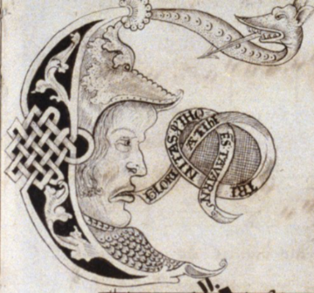

**GLORIA TIBI.** “Glory to you, Lord Christ.” The term is from the opening words of the statement in Latin; but *you* get to say in in English. It is the people's response to the announcement of the gospel at the eucharist (“The Holy Gospel of our Lord Jesus Christ according to . . . ) Because you mutter it every Sunday, you know it precedes the reading of the gospel. This response at the announcement of the gospel in the Roman rite was retained by the 1549 BCP. It is omitted before the Passion gospel on Palm Sunday (the Sunday of the Passion), and Good Friday.

|  |  |  |  |  |  |  |
| --- | --- | --- | --- | --- | --- | --- |
| **JULY 2022** | | | | | | |
| **SUN** | **MON** | **TUE** | **WED** | **THU** | **FRI** | **SAT** |
|  |  |  |  |  | 1 | 2  10 AM--noon  Food Pantry |
| 3  9:30 AM in church | 4 | 5 | 6 | 7  Farmers Market  4:00 – 7:00 PM | 8 | 9  10 AM--noon  Food Pantry |
| 10  9:30 AM in church | 11 | 12 | 13  Shawl Ministry  12:30 – 2:00 PM  Lincoln Hall | 14  Farmers Market  4:00 – 7:00 PM | 15 | 16  10 AM--noon  Food Pantry |
| 17  9:30 AM in church | 18 | 19  Bishop’s Committee  7:00 PM in  Lincoln Hall | 20 | 21  Farmers Market  4:00 – 7:00 PM | 22 | 23  10 AM--noon  Food Pantry |
| 24  9:30 AM in church  ----------------------  31  9:30 AM in church | 25 | 26  Book Group  7:30 PM | 27  Soup, Supper, Symposium at Federated Church  6:00 PM | 28  Farmers Market  4:00 – 7:00 PM | 29 | 30  10 AM--noon  Food Pantry |

**July Birthdays July Anniversaries**

July 01 Susan Allen July 05 Geoff and Diane Cooper

July 03 Michael Matson July 19 John and Grace Henecker

July 07 Daniel Caithmeier

July 11 Ron Bedal

July 12 Gail Permenter

July 30 Harry Krause, Marsha Taylor

**IN THE PARISH**

**SHAWL MINISTRY:** Our next in-person meeting will be **Wednesday 13 July from 12:30 - 2:00 PM** in Lincoln Hall. All are welcome- no experience necessary!

**BOOK GROUP**: The July selection for our book group is *Finding Freedom* by Erin French. We will meet at **7:30pm on 26 July.** Please contact Lisa Earley for more information at [lisa.earley@groble.me](mailto:lisa.earley@groble.me)

**COFFEE HOUR SIGN-UP:** Please sign up to host Coffee Hour after the service. A sign-up sheet is in Lincoln Hall.

**SOUP, SUPPER, SYMPOSIUM:  “BODY, MIND, and SPIRIT"**

**Sponsored by Holy Apostles and Federated Church of Wauconda**

​**What:**  Simple Supper, Interesting Information, and Collegial Conversation.

**Where:**  Federated Church, 200 Barrington Road, Wauconda 60084

**When:**  6:00 p.m. (Supper served; presentations start between 6:15 and 6:30 p.m.) to roughly 8:00 p.m.,

the 4th Wednesday of each month beginning in May and running through October.

**JULY 27**  Marilynn Kulieke PhD on “New Discoveries on Brain Functioning”

**Stacey Pyne’s Letter to the Congregation**

Greetings,

Mother Martha’s pending retirement in January 2023 requires our congregation to face the invigorating but challenging task of beginning the search for a new Priest. The Bishop’s Committee, as leadership, has met with Andrea Mysen, Director of Transition Ministry at the Episcopal Diocese, to understand the Episcopal process for finding a new priest. It was strongly recommended and decided that the entire congregation take the Congregation Assessment Tool (CAT) to be sure leadership really has a pulse on the needs, culture, energy, and worship/music needs of the whole. More information on this will be forthcoming.

The next big step is to form a Search Committee which may or may not include members of the Bishop’s Committee. As Bishop’s Warden I will be at the helm of this process but can only be as successful as those that assist. As a congregation we need to have conversations amongst ourselves about whom we would like to see on the search committee; talk to each other, get ideas about how each of us views the ministry of the church and where we see it going. Ultimately, the Bishops Committee selects the Search Committee but we need input, candidates, and prayerful consideration for people to step up and be a part of this process.

As I reviewed websites, processes, forms, costs, recommendations, time lines, and sampled CAT questions it dawned on me that as Bishop’s Warden I know of but do not know some of you. I am Stacey Pyne and have been an engaged, inactive, peripheral, and active member of Holy Apostles since I was a tyke. I remember meeting in the school gym with a few “Episcopalians” trying to cast a net of like-minded people. Then, as now we were small but mighty. Lincoln Hall was hauled in becoming the Church and Sunday school space. Families came and went but there was a core group that stuck together in faith; in their role to carry out the mission of Christ. There was no question the Pyne family would be at church on Sunday as well as at least one other day per week. Baptism’s, first communions, weddings, funerals; the rites of church passage were honored in our family and built the formative spiritual me.

There were not enough of us to run a confirmation class so five of us got up every Saturday morning, for what felt like forever, and joined the class at St. Michael’s in Barrington. *The Christian Way; Instructions and Devotions for Members of the Episcopal Church* given to me upon confirmation on April 27, 1969 at Holy Apostles still sits on my book shelf.

Before returning to Holy Apostles over thirty years ago I was active in the Church of Christ and Unitarian congregations. During a time of upheaval (yes we have had them) I attended Messiah Lutheran. At Holy Apostle I taught Sunday school (yep) sang in the choir (yep) and was on Altar Guild and Bishop’s Committee. This is my church home.

We are at a crossroads in determining the future of our church. We all know that churches are dying a slow death across the country and I do not want Holy Apostles to be part of that statistic. The financials are not promising but this is not new. I promised my dad, Jerry Pyne, that I would do what it took to see Holy Apostles into the future. This will require each of us to prayerfully discern what we have to give in energy and stewardship. Selecting the Search Committee (to be commissioned on July 17) and taking the CAT are the first steps in determining our future as a church family.

Please watch for emails, snail mail, bulletin handouts and newsletter updates about the search process. If interested in being on the Search committee please reach out to any of the Bishops Committee members. I can be contacted directly at 847-754-1435 to answer any questions.

In Faith,

Stacey Pyne

Church of the Holy Apostles

Warden, Bishop’s Committee

******************************************************************************************

*From the Treasurer:*

*If you have been to the church lately you will see that we have had the landscaping smartened up. Brushes have been cut back, the beds have been weeded and mulch has been spread to conserve moisture and reduce weed growth. Additionally on Sunday 10 June the church laptop hard drive passed away. So, we must purchase a new computer (it will have been purchased by the time you read this).*

*Why do I tell you this? Well, we don’t really have the money to fund this from our normal collections. So, if anyone has some cash tucked away under the mattress and feels like helping us out, an extra injection of money would be especially helpful, if you could see your way to giving us a little of it. We (well I essentially) would be so thankful. God Bless, Geoff Cooper*

**\*\*\*\*\*\*\*\*\*\*\*\*\*\*\*\*\*\*\*\*\*\*\*\*\*\*\*\*\*\*\*\*\*\*\*\*\*\*\*\*\*\*\*\*\*\*\*\*\*\*\*\*\*\*\*\*\*\*\*\*\*\*\*\*\*\*\*\*\*\*\*\*\*\*\*\*\*\*\*\*\*\*\*\*\*\*\*\*\*\*\***

**FROM: Church of the Holy Apostles**

**26238 North Highway 59**

**Wauconda, Illinois 60084**