**The Apostles Post**

26238 North Highway 59

Wauconda, Illinois

FEBRUARY 2021

2015



**FROM THE VICAR’S DESK** *(M. C. Gillette)*

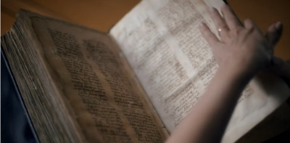 Gnostic Writings, Issue II. The Acts of Thomas, *aka* Judas Thomas, *aka* the twin brother of Jesus, who sells him into slavery – but whoa! I’m getting ahead of myself.

The illustration here is of Nicola Denzey Lewis in the British Library, examining a Syriac manuscript of the text copied in 936 CE. But the “Acts” are much older – probably the first half of the 3rd century. The “Acts” is the only one of the Gnostic writings preserved in its entirety (and with multiple copies) – and it is astonishingly long. One of the reasons it is so long is that there are pieces (for example the *Hymn of the Pearl*, a complete statement of a classic Gnostic myth describing the exile and redemption of the soul) which seem to have been independently composed then included in the “Acts” by a later redactor (and there appear to have been more than one “later redactors”). There is some debate as to whether it was originally composed in Syriac and translated to Greek, or Greek and translated to Syriac, but the predominance of opinion falls on the former.

The Acts of Thomas supposedly explains the ministry of the apostle (Judas) Thomas in India after Jesus’ ascension. Along with similar writings which focus on other disciples, it is heavily influenced by Gnosticism. One key element of Gnosticism is the rejection of all things material, especially the physical body; accordingly, (Judas) Thomas spends a lot of time convincing married couples to accept total celibacy. While there are some – mmm – unusual elements (poetic dragons and donkey exorcists come to mind), there are also some details found in the Acts of Thomas which are supported by other traditions or historical evidence, including relatively accurate cultural references and the reality that there was an early, relatively large influence of Christianity in the Indian subcontinent; a little more on that in a bit.

The story itself runs briefly as follows: After Christ’s ascension, the disciples divvied the world up (by lots) for proselytizing. India fell to (Judas) Thomas, who is described as Jesus’ twin brother. Thomas refused to accept the assignment, despite the assurances of his brother (and Lord). So, Jesus appeared in a supernatural way to Abban, the envoy of Gondophernes, an Indian king, who was searching for a carpenter (because apparently there were none in India? Well, whatever, it’s not my story.) Jesus sold Thomas to him to be his slave and serve him as a carpenter. Then Abban and Thomas sailed away until they came to Andrapolis, where they landed and attended the marriage feast of the ruler's daughter. Strange occurrences followed and Christ, under the appearance of Thomas exhorted the bride (and groom) to remain a virgins, because sex leads to kids, and kids – oh my God, you don’t want kids. The ruler was the first of many people who were unhappy with Thomas for converting people to total chastity. Finally arriving in India, Thomas was given the job of building a palace for Gondophernes, but he gave all the money he received to fund the project to the poor. Gondophernes was not pleased when he came to inspect the final product and found – no castle. He imprisoned him; but the Apostle escaped miraculously, and Gondophernes discovered Thomas had actually built him a palace in heaven (Gnosticism teaches that the physical and spiritual worlds are completely unrelated) and converted. Going about the country to preach, Thomas met with strange adventures from those dragons and wild asses. Eventually he came to the city of King Misdai (Syriac Mazdai), where he converted Tertia the wife of Misdai and Vazan his son (including that whole chastity thing). After this he was condemned to death, led out of city to a hill, and pierced through with spears by four soldiers. He was buried in the tomb of the ancient kings but his remains were afterwards removed to the West.

Now the side tidbit of all this is the reality of the Thomas (or Malabar) Christians, indigenous Indian Christian groups who have traditionally lived in Kerala, a state on the Malabar Coast of southwestern India. There are about 4 million of them; ecclesiastically, liturgically, and linguistically (their liturgical language is still Syriac) they represent one of the oldest Christian traditions in the world. They claim to have been evangelized by Thomas, and although there is no historical evidence of Thomas *actually* having been in India (“historical” by our standards), there are those little seeds which tend to grow into things like the “Acts” scattered about. There are, for example, inscriptions on stone crosses and on copper plates which prove that Christians have been on the Malabar Coast since the 2nd or 3rd century. There was also an Indo-Parthian king named Gondophernes who reigned from about 19-55 CE (although in Punjab, not the Malabar Coast). And there are also local oral traditions contained in such works as the *Thomma Parvam* (“Song of Thomas”) and such other songs as the “Margam Kali Pattu” and the “Rabban Pattu;” all composed in the native Malayalam language.

If you want to read the “Acts” itself – and why would you not want to hear more about donkeys that perform exorcisms and lavishly poetic dragons? – there are multiple sites with G. R. S. Mead’s translation available, including:

Hymn of the Pearl: <http://gnosis.org/library/hymnpearl.htm>

Hymn of the Pearl: <https://www.marquette.edu/maqom/The%20Hymn%20of%20the%20Pearl.pdf>

Acts of Thomas: <http://gnosis.org/library/actthom.htm>

Acts of Thomas: <https://www.newadvent.org/fathers/0823.htm>

Sources: NASSCAL, gnosis.org, Marquette University, Encyclopedia Britannica, Early Christian Writings, Biblewise, New Advent

**SOME CHURCHY STUFF** *(M. C. Gillette at* [*hapostles@sbcglobal.net*](mailto:hapostles@sbcglobal.net)*) In this monthly article, we look at terms and definitions of things you might see or hear around church. Nothing fancy here – these entries are out of the Armentrout/Slocum An Episcopal Dictionary of the Church, sometimes supplemented by me, and sometimes simply copied directly. If something in particular piques your interest, let me know, and we’ll deal with it in more depth.*

*.*

**DECALOGUE (aka the Ten Commandments)**. I like to think you know what the Decalogue is, even by that name, as it’s listed that way in the BCP and when we do our penitential services during Lent. But of course, one never knows. “Decalogue” means “Ten Words,” and in sermons and Ponder and Skyrockets we’ve discussed the fact that the Ten Commandments are, more properly, referred to as the Ten Words. They do not establish laws – the legal codes come later – they establish the Divine/Human relationship underpinning the Law. The Ten Words, were given by God at Sinai in connection with the making of the covenant (Exodus 20:1-17). Another slightly different version appears in the extended homily Moses delivers shortly before the entrance of the Hebrews into the Promised Land (Deuteronomy 5:6-21). The Ten Commandments form the fundamental relational requirements of God for Israel and concern the cult (no other gods, no images, no misuse of God's name, observance of the Sabbath) as well as social relations (honor of parents, no killing, no adultery, no false witness, no coveting). Unlike the case law of the Old Testament, where an offense is followed by its punishment, the Ten Commandments are categorical. Some religious communities differ from the numbering of the Ten Commandments in Anglican and reformed traditions, but agree in the content. In the New Testament, both Jesus (Mark 10:17-22 and parallel passages) and Paul (Romans 13:8-10) affirm their continuing validity.

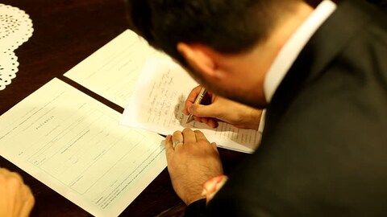**DECLARATION OF CONSENT**. A statement of belief in the scriptures and conformity to the doctrine, discipline, and worship of the Episcopal Church by an ordinand (someone about to be ordained) in the ordination service. The Declaration of Consent is stated by the ordinand and then a written version of the Declaration of Consent is signed by the ordinand in the sight of all present. Although the statement made by a bishop-elect is somewhat more elaborate than the statements made by those being ordained priest or deacon, all state "I solemnly declare that I do believe the Holy Scriptures of the Old and New Testaments to be the Word of God, and to contain all things necessary to salvation; and I do solemnly engage to conform to the doctrine, discipline, and worship of The Episcopal Church" (BCP, pp. 513, 526, 538).

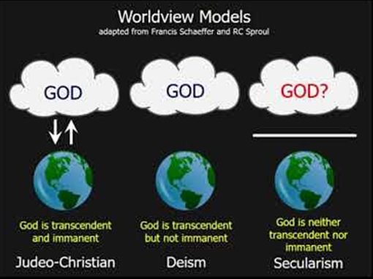**DEISM**. A teaching about God which appeared in both Christian and non-Christian forms during the seventeenth and eighteenth centuries in England and France, under the influence of rationalism and the rise of natural science. Lord Herbert of Cherbury (1580-1630) introduced deist thought to England. It was developed by Matthew Tindal (1653-1733) and John Toland (1670-1722), among others. The title of Toland's book, Christianity Not Mysterious, expresses the tone of this body of thought.

Deists used the cosmological argument to prove the existence of God, who created the universe and governed it through natural law. Natural laws were discoverable by reason, according to this "natural religion." Teachers, among whom Jesus was regarded as definitive, taught humans the divinely inspired moral law to keep their behavior in harmony with the divine plan. People were to be moved to obey the moral law by the expectation of future rewards and punishments. Some Deists viewed God as an original architect and initial mover of creation. Deism denied that God exercises providential care for humanity or the universe. It believed in a "divine clock-maker" who merely set the universe in motion. Deism also denied our need of special revelation, holding that human reason alone leads to the principles of natural reason and morality. Matthew Tindal, whose Christianity as Old as the Creation (1730) became known as the "Bible" of Deism, held that the gospel added nothing to the law of nature, that true religion was a "republication" of the law, and that God's design was to free humanity from superstition. A number of eighteenth-century Anglican theologians endeavored to show that Christianity did not contradict natural religion (Joseph Butler's Analogy of Religion), or that it could be understood in deistic terms (William Paley's Natural Religion). Deistic works were produced in America by Ethan Allen and Thomas Paine; Thomas Jefferson, who famously made his own Bible by cutting out all the miracles and “mysterious” bits, was another prominent deist.

|  |  |  |  |  |  |
| --- | --- | --- | --- | --- | --- |
| **EPISCOPAL CHURCH OF THE HOLY APOSTLES UPCOMING SERVICES FOR FEBRUARY 2021** | | | | | |
| ***This is subject to change week by week!***  ***Sunday 9:30 a.m. services may be in person or online, depending on Covid restrictions.***  ***Sunday 7:00 p.m. services will be online.***  ***The Annual Meeting will be online.***  ***Details for Ash Wednesday will be finalized closer to the date.***  ***To confirm any given service, feel free to text (Mother) Martha at 847.226.9043.*** | | | | | |
| Sunday  07 February  9:30 a.m.  7:00 p.m. | Sunday  14 February  9:30 a.m.  7:00 p.m. | Tuesday  16 February  **7:00 PM**  **WebEx** | Wednesday  17 February  Ashes Given throughout the day  Service at 7:00 p.m. | Sunday  21 February  9:30 a.m.  7:00 p.m. | Sunday  28 February  9:30 a.m.  7:00 p.m. |
| Scheduled  Presider:  Gillette  Preacher:  Gillette | Scheduled  Presider:  Gillette  Preacher:  Gillette |  | Scheduled  Presider:  Gillette  Preacher:  Gillette | Scheduled  Presider:  Gillette  Preacher:  Gillette | Scheduled  Presider:  Gillette  Preacher:  Gillette |
| Fifth Sunday after the Epiphany (B) | Last Sunday after the Epiphany (B): Transfiguration | **ANNUAL MEETING** | Ash Wednesday (B) | First Sunday  in Lent (B) | Second Sunday  in Lent (B) |
| FIRST  LESSON  Isaiah  40:21-31  RESPONSE Psalm  147:1-12, 21c  SECOND  LESSON  1 Corinthians  9:16-23  GOSPEL  Mark  1:29-39 | FIRST  LESSON  2 Kings  2:1-12  RESPONSE Psalm  50:1-6  SECOND  LESSON  2 Corinthians  4:3-6  GOSPEL  Mark  9:2-9 |  | FIRST  LESSON  Joel  2:1-2, 12-17  RESPONSE Psalm  103  SECOND  LESSON  2 Corinthians  5:20b-6:10  GOSPEL  Matthew  6:1-6, 16-21 | FIRST  LESSON  Genesis  9:8-17  RESPONSE Psalm  25:1-9  SECOND  LESSON  1 Peter  3:18-22  GOSPEL  Mark  1:9-15 | FIRST  LESSON  Genesis  17:1-7, 15-16  RESPONSE Psalm  22:22-30  SECOND  LESSON  Romans  4:13-25  GOSPEL  Mark  8:31-38 |

†

*Grant, O God, that your holy and life-giving Spirit may so move every human heart, and especially the hearts of the people of this land, that barriers which divide us may crumble, suspicions disappear, and hatreds cease; that our divisions being healed, we may live in justice and peace; through Jesus Christ our Lord. Amen.*

**IN OUR** **PARISH LIFE:**

**NEW BISHOP’S COMMITTEE MEMBERS NEEDED:** Three of our Bishop’s Committee members will be rolling off the committee in February. Therefore, three new members will need to be elected at the Annual Meeting in February. Please contact Mtr. Martha if you would like more information, or are willing to contribute to your church in a rewarding and meaningful way!

**ANNUAL MEETING:** Due to our inability to gather together in person this year, the Annual Meeting will be held on **Tuesday 16 FEBRUARY at 7:00 p.m. via WebEx.** Mother Martha will email an invitation to all parishioners.

**SHAWL MINISTRY:** Marcia Taylor writes, “Though Covid has kept us at home, our lovely ladies have continued to knit and crochet and keep us supplied in shawls to be gifted. We appreciate your devotion to this ministry.”

**BOOK DISCUSSION GROUP** (Lisa Earley at [lisa.earley@groble.me](mailto:lisa.earley@groble.me))

As it was for so many others, 2020 proved to be a challenging year for the CHA book group. We are proud to report we only missed one meeting and one title despite the tumultuous year, although we did a fair amount of scrambling and rescheduling. We have all learned how to use Zoom and have gotten comfortable with the technology. In fact, we have had members join from their cars, from out of state, and in inclement weather (when we may have canceled our meeting in the past under similar conditions). It’s not the same as meeting in person, but we enjoy our virtual socializing every month. For the foreseeable future, we will continue to meet virtually, although we fervently hope to be able to gather in person by summer. If you would like to join us for a meeting, please email Lisa at [lisa.earley@groble.me](mailto:lisa.earley@groble.me) so we can send you an invitation to the Zoom meeting. We can also add you to the regular email distribution list if you’d prefer to receive an invitation every month rather than just occasionally, and we can help you install and use Zoom if you’d like. Of course, it is now BYOB & snacks, although you won’t have to bring them very far! The Ela Area Public Library still provides our titles (at the drive-up window) with an extended lending period. You do not need to live in the EAPL district to participate in their book group lending program. This month we will meet at **7:30pm on February 23rd** to discuss *The Tears We Cannot Stop*by ME Dyson.

**COFFEE AND CONVERSATION: Are you missing the smiling faces of your fellow holy apostles?**

Join in on **Thursday mornings at 8:30 AM** for Virtual Coffee Hour - it’s easy, and you don’t even have to get out of your pajamas! Chat with your friends, it really helps with feeling connected. If you need an email invitation, please contact Mother Martha at 847-226-9043 or email her at [marthagillette@att.net](mailto:marthagillette@att.net).

**BIG TABLE:** Big Table is still providing food on **Tuesdays from 5:00 – 6:00 PM**. The current procedure involves driving your car up to the front door of Lincoln Hall, where a cheerful volunteer will bring a bag of groceries to your car to take home. You do not have to register ahead of time, just show up!

Thank You to the Holy Apostles Family:

As you may know my mother Doris passed away at the wonderful age of 98 on October 24th, 2020. I just want to thank you all for the cards and expressions of sympathy I have received. You all found the right words and thoughts to give me comfort and peace, and I am so grateful.

This has been a very difficult time and you have made it much easier for me.

I am truly blessed to be part of the Holy Apostles family.

Diane Cooper

|  |  |  |  |  |  |  |
| --- | --- | --- | --- | --- | --- | --- |
| **FEBRUARY 2021** | | | | | | |
| **SUN** | **MON** | **TUE** | **WED** | **THU** | **FRI** | **SAT** |
|  | 1 | 2 | 3 | 4  Coffee/Convo  8:30 am WebEx | 5 | 6  10 AM--noon  Food Pantry |
| 7  9:30 AM in church  7:00 PM Online | 8 | 9 | 10 | 11  Coffee/Convo  8:30 am WebEx | 12 | 13  10 AM--noon  Food Pantry |
| 14  9:30 AM in church  7:00 PM Online | 15 | 16  **ANNUAL MEETING**  **7:00 PM via WebEx** | 17 | 18  Coffee/Convo  8:30 am WebEx | 19 | 20  10 AM--noon  Food Pantry |
| 21  9:30 AM in church  7:00 PM Online | 22 | 23  Book Club 7:30 PM | 24 | 25  Coffee/Convo  8:30 am WebEx | 26 | 27  10 AM--noon  Food Pantry |
| 28  9:30 AM Online  7:00 PM Online |  |  |  |  |  |  |

**February Birthdays**

Feb 06 Lynn McAlister Feb 22 Alison Dura, Kendal Stephens

Feb 08 Fr. Don Moon Feb 13 Charlie Miller Feb 28 Beth McCarthy



From “Chicken Soup with Rice” by Maurice Sendak

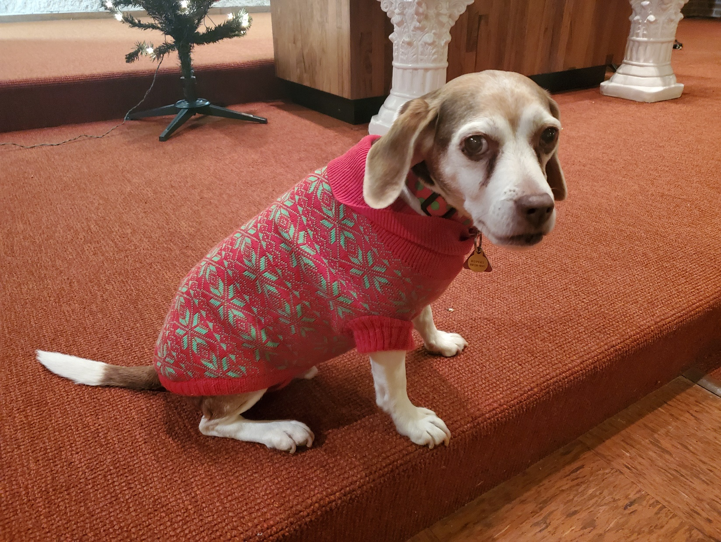

**Hi Everybody! I hope I will see you at the Annual Meeting on Tuesday 16 February.**

**Mommy will send an invitation to you at the beginning of February.**

**I miss you all so much!**

**With love, your Church Dog, Rupert**



**FROM: Church of the Holy Apostles**

**26238 North Highway 59**

**Wauconda, Illinois 60084**