**FIFTH SUNDAY AFTER THE EPIPHANY (B)**

*Episcopal Church of the Holy Apostles*

Sunday 07 February 2021

**OPENING VOLUNTARY**

*Near, My God, to Thee*

*It Is Well with My Soul (When Peace Like a River)*

**WORDS OF WELCOME**

**OPENING HYMN** H1982, #439

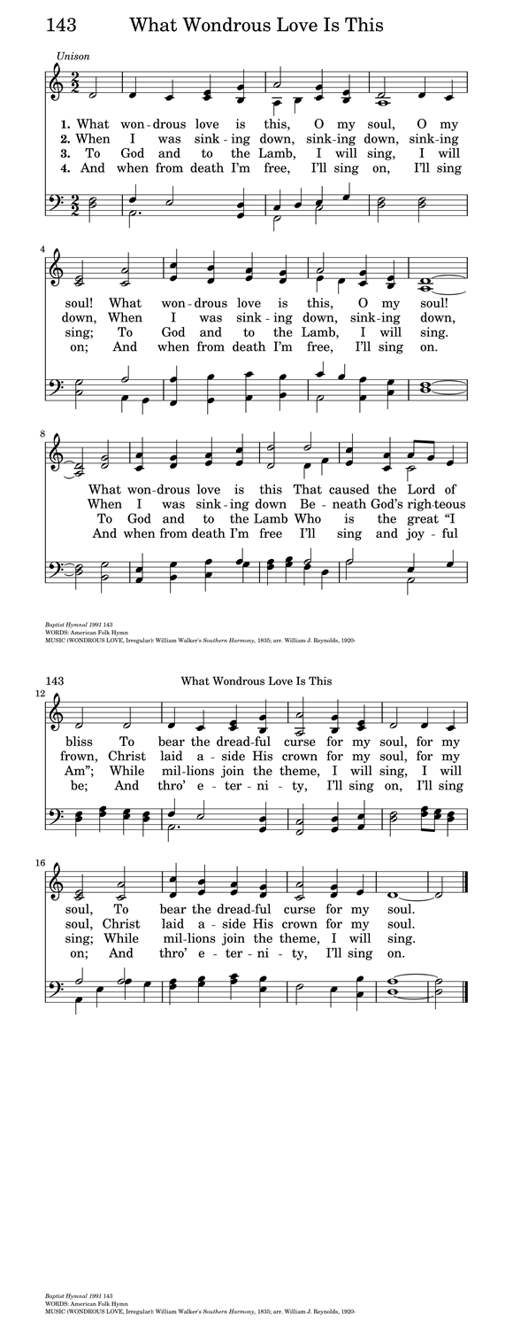

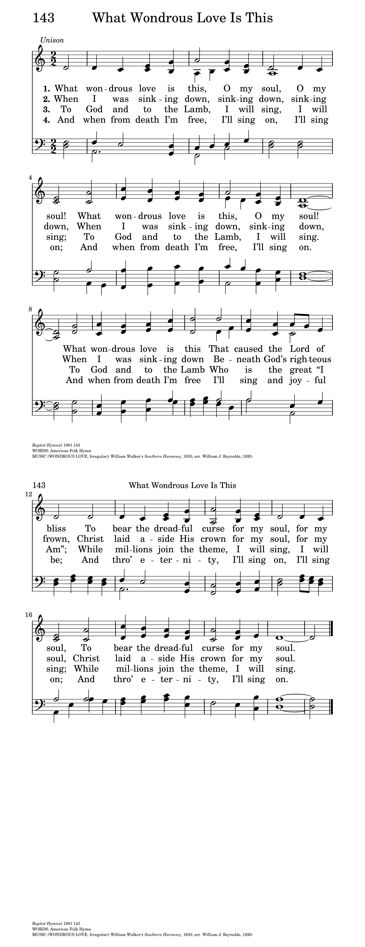

**OPENING SENTENCES**

**Presider:** Blessed be the one, holy, living, and Triune God.

***People: And blessed be God's kingdom, now and forever. Amen.***

**COLLECT FOR PURITY**

**Presider:** Almighty God, to you all hearts are open, all desires known, and from you no secrets are hid: Cleanse the thoughts of our hearts by the inspiration of your Holy Spirit, that we may perfectly love you, and worthily magnify your holy Name; through Christ our Lord. ***Amen.***

**HYMN OF PRAISE**



**COLLECT OF THE DAY**

**Presider:**  The Lord be with you.

***People: And also with you.***

**Presider:** Let us pray. God of fierce compassion, you name the forces of death in our hearts and institutions and even in the holy places: lift us from the canopy of fear that feeds on repression and pushes away what it cannot abide; go with us to dark and lonely places where we can learn again who we are called to be; through Jesus Christ, the healer of creation.

***People: Amen.***

*(We read from the various translations of the Bible authorized by our Church. During the season of Epiphany we read from the Good News Translation (Today’s English Version), 1976)*

**FIRST LESSON** Isaiah 40:21-31

**Reader:** A reading from Isaiah. Have you not known? Have you not heard? Has it not been told you from the beginning? Have you not understood from the foundations of the earth? It is he who sits above the circle of the earth, and its inhabitants are like grasshoppers; who stretches out the heavens like a curtain, and spreads them like a tent to live in; who brings princes to naught, and makes the rulers of the earth as nothing. Scarcely are they planted, scarcely sown, scarcely has their stem taken root in the earth, when he blows upon them, and they wither, and the tempest carries them off like stubble. To whom then will you compare me, or who is my equal? says the Holy One. Lift up your eyes on high and see: Who created these? He who brings out their host and numbers them, calling them all by name; because he is great in strength, mighty in power, not one is missing. Why do you say, O Jacob, and speak, O Israel, "My way is hidden from the LORD, and my right is disregarded by my God"? Have you not known? Have you not heard? The LORD is the everlasting God, the Creator of the ends of the earth. He does not faint or grow weary; his understanding is unsearchable. He gives power to the faint, and strengthens the powerless. Even youths will faint and be weary, and the young will fall exhausted; but those who wait for the LORD shall renew their strength, they shall mount up with wings like eagles, they shall run and not be weary, they shall walk and not faint. The word of the Lord.

***People: Thanks be to God.***

**RESPONSE** Psalm 147:1-12. 21c

***1 Alleluia! How good it is to sing praises to you, O God; how pleasant it is to honor you with praise!***

***2 For you rebuild Jerusalem and gather the exiles of Israel.***

***3 You heal the broken-hearted and bind up their wounds.***

***4 You count the number of the stars and call them all by their names.***

***5 Great are you and mighty in power; there is no limit to your wisdom.***

***6 You lift up the lowly, but cast the wicked to the ground.***

***7 We sing to you, Most High, with thanksgiving; we make music to you upon the harp,***

***8 For you cover the heavens with clouds and prepare rain for the earth;***

***9 You make grass to grow upon the mountains and green plants to serve humankind.***

***10 You provide food for flocks and herds and for the young ravens when they cry.***

***11 You are not impressed by the might of a horse; you have no pleasure in human strength;***

***12 But you have pleasure in those who fear you, in those who await your gracious favor.***

***21c Hallelujah!***

**SECOND LESSON** 1 Corinthians 9:16-23

**Reader:** A reading from the first letter to the Corinthians. If I proclaim the gospel, this gives me no ground for boasting, for an obligation is laid on me, and woe to me if I do not proclaim the gospel! For if I do this of my own will, I have a reward; but if not of my own will, I am entrusted with a commission. What then is my reward? Just this: that in my proclamation I may make the gospel free of charge, so as not to make full use of my rights in the gospel. For though I am free with respect to all, I have made myself a slave to all, so that I might win more of them. To the Jews I became as a Jew, in order to win Jews. To those under the law I became as one under the law (though I myself am not under the law) so that I might win those under the law. To those outside the law I became as one outside the law (though I am not free from God's law but am under Christ's law) so that I might win those outside the law. To the weak I became weak, so that I might win the weak. I have become all things to all people, that I might by all means save some. I do it all for the sake of the gospel, so that I may share in its blessings. The word of the Lord.

***People: Thanks be to God.***

**OFFERTORY HYMN** **(vv. 1, 2, 4)**

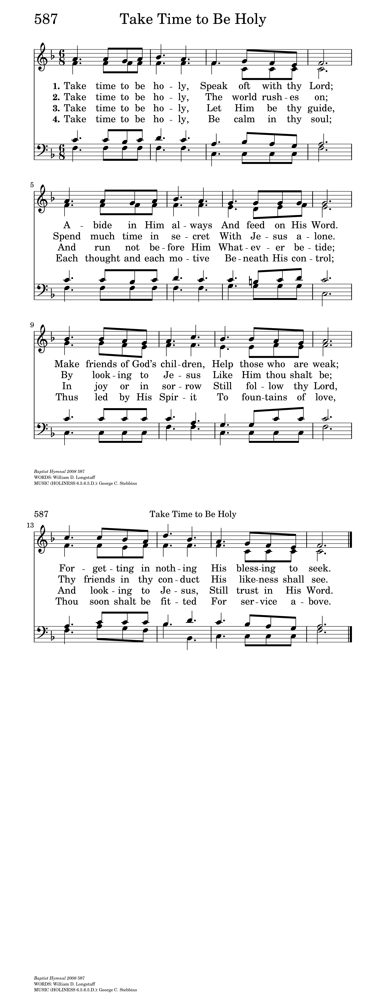



**GOSPEL** Mark 1:29-39

**Presider:** The Holy Gospel of our Lord Jesus Christ according to Mark.

***People: Glory to you, Lord Christ.***

**Presider:** Jesus left the synagogue at Capernaum, and entered the house of Simon and Andrew, with James and John. Now Simon's mother-in-law was in bed with a fever, and they told him about her at once. He came and took her by the hand and lifted her up. Then the fever left her, and she began to serve them. That evening, at sundown, they brought to him all who were sick or possessed with demons. And the whole city was gathered around the door. And he cured many who were sick with various diseases, and cast out many demons; and he would not permit the demons to speak, because they knew him. In the morning, while it was still very dark, he got up and went out to a deserted place, and there he prayed. And Simon and his companions hunted for him. When they found him, they said to him, "Everyone is searching for you." He answered, "Let us go on to the neighboring towns, so that I may proclaim the message there also; for that is what I came out to do." And he went throughout Galilee, proclaiming the message in their synagogues and casting out demons. The Gospel of the Lord.

***People: Praise to you, Lord Christ.***

**SERMON** The Rev. M. C. Gillette

*(A brief period of silence follows the sermon)*

**NICENE CREED**

***All: We believe in one God, the Father, the Almighty, maker of heaven and earth, of all that is, seen and unseen. We believe in one Lord, Jesus Christ, the only Son of God, eternally begotten of the Father, God from God, Light from Light, true God from true God, begotten, not made, of one Being with the Father. Through him all things were made. For us and for our salvation he came down from heaven: by the power of the Holy Spirit he became incarnate from the Virgin Mary, and was made man. For our sake he was crucified under Pontius Pilate; he suffered death and was buried. On the third day he rose again in accordance with the Scriptures; he ascended into heaven and is seated at the right hand of the Father. He will come again in glory to judge the living and the dead, and his kingdom will have no end. We believe in the Holy Spirit, the Lord, the giver of life, who proceeds from the Father and the Son. With the Father and the Son he is worshiped and glorified. He has spoken through the Prophets. We believe in one holy catholic and apostolic Church. We acknowledge one baptism for the forgiveness of sins. We look for the resurrection of the dead, and the life of the world to come. Amen***

**PRAYERS OF THE PEOPLE**

**Leader:** Lord, in this season of Epiphany, we remember the journey of the Magi who sought the Christ child, the light of the star which guided them, and their response to finding Jesus, the newborn king.

***People: Lord, let us seek you, follow your light, and worship you as they did long ago.***

**Leader:** We thank you for manifesting yourself to all people and for opening the doors of your church to both Jews and Gentiles.

***People: Reveal yourself, we pray, to all who long to find you, and grant them the joy of knowing you.***

**Leader:** We pray for your church around the world, that you might dwell among us, unite us, and transform us. We pray especially for those on our Episcopal and Diocesan cycles of prayer.

***People: Make your church a light to the nations, shining forth with mercy, power, and love.***

**Leader:** We pray for the leaders of our local, state, and national governments, and for all who hold power and authority in the world.

***People: Please guide their feet along the pathways of justice, compassion, reconciliation, and peace.***

**Leader:** We pray for all who suffer in body, mind, or spirit, and for those who are in any kind of trouble or sorrow, remembering especially those on our parish prayer list, and those whose names we raise up now, either silently or aloud: *(we will keep a 10-second silence)* _____

***People: Manifest yourself to them, merciful God. Grant them your gifts of healing, grace, wisdom, and comfort.***

**Leader:** We pray for those who have died. In particular, we pray for our beloved departed, and those whose names we raise up now, either silently or aloud: *(we will keep a 10-second silence)* _____ . We pray for those who have been killed in the course of service to others, giving thanks for their sacrifice.

***People: May they live eternally with you in Paradise.***

**Leader:** We thank you for the joy which fills our hearts, and for those celebrating birthdays and anniversaries this week, in particular those whose names we raise up now, either silently or aloud: (we will keep a 10-second silence: _____ . Keep us mindful of the good things in our lives.

***People: In your mercy, bless us, and make us a source of blessing to others as we share our joy with them.***

**Presider:** *(Says this or another Collect)* May your radiance shine upon us all as brightly today as the star shown upon those of another age so long ago: and grant us all a desire to seek and to serve; graciously accepting your gift of grace, and striving always to return through the love and kindness we show to our neighbors some small portion of that loving-kindness you have given us; through Jesus Christ our Lord.

***People: Amen***

**CONFESSION AND ABSOLUTION OF SIN**

**Presider:** Let us confess our sins against God and our neighbor.

*(A brief period of silence will be kept)*

***All: Most merciful God, we confess that we have sinned against you in thought, word, and deed, by what we have done, and by what we have left undone. We have not loved you with our whole heart; we have not loved our neighbors as ourselves. We are truly sorry and we humbly repent. For the sake of your Son Jesus Christ, have mercy on us and forgive us; that we may delight in your will, and walk in your ways, to the glory of your Name. Amen.***

**Presider:** Almighty God have mercy on you, forgive you all your sins through our Lord Jesus Christ, strengthen you in all goodness, and by the power of the Holy Spirit keep you in eternal life.  ***Amen.***

**THE PEACE** *(Please greet each other in the name of the Lord)*

**Presider:** The peace of the Lord be always with you.

***People: And also with you.***

*(The Presider gives an Offertory Sentence or says:)* Walk in love, as Christ loved us and gave himself for us, an offering and sacrifice to God.

**OFFERTORY HYMN (vv. 1, 2, 3)**



**THE GREAT THANKSGIVING (Rite II, Prayer B)**

**Presider:** The Lord be with you.

***People: And also with you.***

**Presider:** Lift up your hearts.

***People: We lift them to the Lord.***

**Presider:** Let us give thanks to the Lord our God.

***People: It is right to give God thanks and praise.***

**Presider:** It is indeed right and good to give you thanks and praise, almighty God and everlasting Father, through Jesus Christ your Son. Because in the mystery of the Word made flesh, you have caused a new light to shine in our hearts, to give the knowledge of your glory in the face of your Son Jesus Christ our Lord. And so we join our voices with angels and archangels and with all the company of heaven to proclaim your glory, forever praising you and saying:

**SANCTUS**

***All: Holy, holy, holy Lord, God of power and might, Heaven and earth are full of your glory. Hosanna in the highest. Blessed is the one who comes in the name of the Lord. Hosanna in the highest.***

**Presider:** We give thanks to you, O God, for the goodness and love which you have made known to us in creation; in the calling of Israel to be your people; in your Word spoken through the prophets; and above all in the Word made flesh, Jesus, your Son. For in these last days you sent him to be incarnate from the Virgin Mary, to be the Savior and Redeemer of the world. In him, you have delivered us from evil, and made us worthy to stand before you. In him, you have brought us out of error into truth, out of sin into righteousness, out of death into life.

**↑**On the night before he died for us, our Lord Jesus Christ took bread; and when he had given thanks to you, he broke it, and gave it to his disciples, and said, “Take, eat: This is my Body, which is given for you. Do this for the remembrance of me.”

**↑**After supper he took the cup of wine; and when he had given thanks, he gave it to them, and said, “Drink this, all of you: This is my Blood of the new Covenant, which is shed for you and for many for the forgiveness of sins. Whenever you drink it, do this for the remembrance of me.”

Therefore, according to his command, O Father,

***All: We remember his death, We proclaim his resurrection, We await his coming in glory;***

**Presider:** And we offer our sacrifice of praise and thanksgiving to you, O Lord of all; presenting to you, from your creation, this bread and this wine.

**∞**We pray you, gracious God, to send your Holy Spirit upon these gifts that they may be the sacrament of the Body of Christ and his Blood of the new Covenant. **+**Unite us to your Son in his sacrifice, that we may be acceptable through him, being sanctified by the Holy Spirit. In the fullness of time, put all things in subjection under your Christ, and bring us to that heavenly country where, with all your saints, we may enter the everlasting heritage of your sons and daughters; through Jesus Christ our Lord, the firstborn of all creation, the head of the Church, and the author of our salvation.

By him, and with him, and in him, in the unity of the Holy Spirit all honor and glory is yours, Almighty Father, now and for ever. ***AMEN.***

**LORD’S PRAYER:**

***All: Our Father in heaven, hallowed be your Name, your kingdom come, your will be done, on earth as in heaven. Give us today our daily bread. Forgive us our sins as we forgive those who sin against us. Save us from the time of trial and deliver us from evil. For the kingdom, the power, and the glory are yours, now and forever. Amen.***

**THE FRACTION (THE BREAKING OF THE BREAD)**

*(The Presider breaks the consecrated bread. A brief period of silence is kept.)*

**Presider:** We break this bread to share in the body of Christ.

***People: We who are many are one body, for we all share the one bread.***

**Presider:** The gifts of God for the People of God. Take them in remembrance that Christ died for you, and feed on him in your hearts by faith, with thanksgiving.

**COMMUNION HYMN** H1982, #328



**POST-COMMUNION PRAYER**

**Presider:** Let us pray.

***All: Eternal God, heavenly Father, you have graciously accepted us as living members of your Son our Savior Jesus Christ, and you have fed us with spiritual food in the Sacrament of his Body and Blood. Send us now into the world in peace, and grant us strength and courage to love and serve you with gladness and singleness of heart; through Christ our Lord. Amen.***

**BLESSING**

**Presider:** May Christ, the Son of God, be manifest in you, that your lives may be a light to the world; and the blessing of God Almighty, Father, Son, and Holy Spirit, be among you, and remain with you always. ***Amen.***

**CLOSING HYMN**

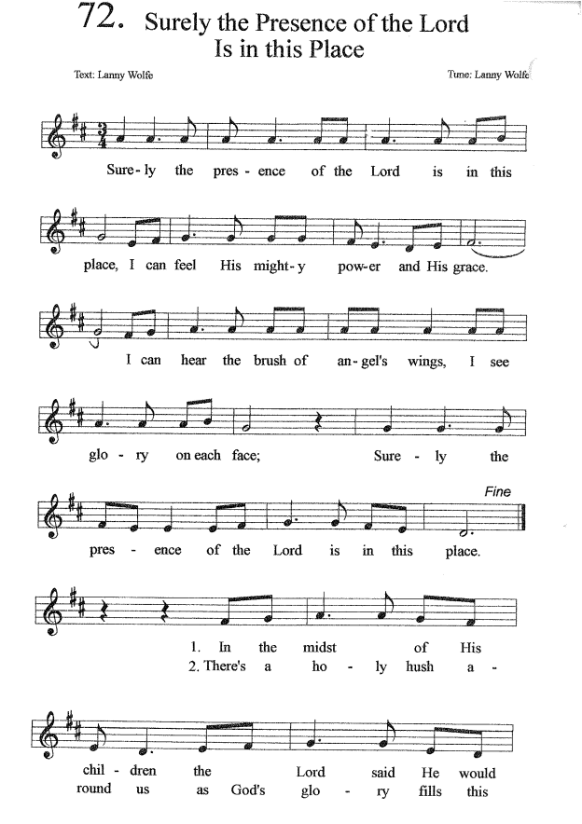

**DISMISSAL**

**Presider:** *(Says the following or another dismissal)* Our worship is over, our service now begins. Let us go forth into the world rejoicing in the power of the Holy Spirit.

***People: Thanks be to God!***

**Cover Image:** <https://vhoagland.wordpress.com/2015/02/07/he-takes-our-hand/peters-mother-in-law-2/>

**Collect of the Day:** “Prayers for an Inclusive Church,” Stephen Shakespeare