**The Apostles Post**

26238 North Highway 59

Wauconda, Illinois

JULY 2021

2015



**FROM THE VICAR’S DESK** *(M. C. Gillette)*

Gnostic Writings, Issue VII. The History of Joseph the Carpenter.

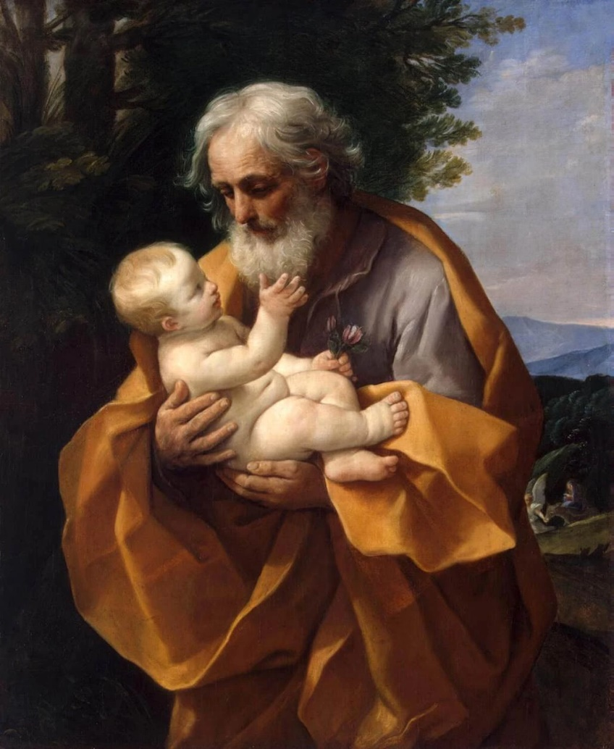 Well, we’re going to take a little break from scandalous texts about female super-disciples and feminine divine beings. (Actually, we’re going to be done with them, because the dismal reality is – there aren’t any more. Tragic, but true.) Instead, we’re going to talk about everybody’s favorite foster-father, Joseph the Carpenter.

*The History of Joseph the Carpenter*, like The Infancy Gospel of Thomas and The Infancy Gospel of James, is an example of a narrative legend created in order to answer questions about the life of Jesus. As we all know, the canonical gospels don’t tell us nearly as much about Jesus’ life before his public ministry began as we’d like. And the paucity of detail they provide didn’t satisfy our ancestors in the faith, either. They wanted those blanks filled in, dagnabbit, so, not at all intimidated by what we would call “historical accuracy,” they simply made stuff up. (We assume. But who knows. Someday we might be quite astonished to find out they were right and we were wrong. It happens.) Anyway, this text – probably composed in Byzantine Greek but surviving only in Coptic and Arabic versions – is written in the form of a dialogue between Jesus and his disciples on the Mount of Olives. The apostles ask Jesus about the death of his stepfather, Joseph, and the narrative records what he reveals to them. The book dates from the (pick one: 4th, 5th, 6th or 7th ) century. While *The History of Joseph* does focus on Joseph’s death, it also rather insistently asserts the doctrine of the perpetual virginity of Mary, relates some other traditions concerning the Holy Family, and references several canonical gospel texts.

The book describes Mary as a holy, perpetual virgin, set aside from birth and consecrated for her eventual purpose. In order to ensure she maintained her virginity (which was somehow considered unlikely in the Temple!?!), the text describes Joseph as chosen by lot to protect her. According to the story, he was a widower who, at the age of 90, lost his first wife (he’d married at 40 and had been married 49 years). He already had four sons and two daughters (Judas, Justus, James, Simon, Assia and Lydia) when Mary (12 at the time, 14 when she conceived Jesus) was entrusted to his care.

Time passes, as time does . . . and Joseph, 111 years old, lies on his deathbed. An angel had told him his death was imminent, and this apparently disturbed him (the death part, not the angel). He went to the temple to pray for a *peaceful* death. When he returned home, he was struck down with the same illness (whatever that might have been) that had killed his wife years before and died. Jesus fills the disciples in on all the details – lots of stuff about demons and angels and Death and tears and shrouds and decomposition and toting souls around. Well, the disciples seem quite impressed by all of this, but they are apparently having a bolder-than-usual day, and actually push back a little – “So, Jesus, if he was as great as you say, why couldn’t you have just had your *real* Father whisk him away like Enoch and Elias (Elijah), so he didn’t have to die at all?” Jesus, in typical Jesus fashion, doesn’t answer that question. He redirects it, saying that while Enoch and Elias might not be dead *yet*, at the end of time they (and Tabitha and someone named Schila, who may be Sibylla, which would be tidy because then there would be two men and two women) will have to come back to earth so the Antichrist can slay them and pour out their blood like water. Somehow that seems terribly unfair, but there you have it.

You can access a copy (written or read) here:

<https://archive.org/details/JosephTheCarpenter/page/n3/mode/2up>

<https://www.newadvent.org/fathers/0805.htm>

<https://www.youtube.com/watch?v=wjKMyzV9184>

**HERE AND THERE** *(M. C. Gillette)*

*In this on-going article, we pull things from our various Diocesan calendars and church websites to see what’s going on around us. For more information about what's happening at the Diocesan Headquarters and the Cathedral of Saint James, you can always visit their websites:* <https://www.episcopalchicago.org> or <https://www.saintjamescathedral.org/>

**Online Survey to Study the Impact of COVID-19 on the Episcopal Church**

TryTank Experimental Lab, a joint project of Virginia Theological Seminary in Alexandria, Virginia, and the General Theological Seminary in New York, in collaboration with York St. John University in York, England, have launched [**Episcopal Pulse**](https://r20.rs6.net/tn.jsp?f=001EpAUfIoreFZDNUtZytWgWkZpLErvlDhgrf37iZ--7ELjMs0qdkQsl3jUFolTUi3w-c3QyB35znopPWiEBzZfZbS9bgNTS8dHNqGxY-SN0te1WRmrqVYrkhtPYbIKeKQ3pi0tsqVITDI4ZXLFOqL1_ibXNsJtoSaCmAkvgxiN9YgYAIkn5RJ56ZcXm1XWLNkD2iwo5o-Jv7c=&c=-hJlR7vndjqY_IJhspeVsogvCMk-TsVsM7oXrb03JnX5Pt_L1FHZjQ==&ch=LWpgXfBsGG67IZMyHr2qjAYbc9UNG1PZEklZ9XKdV1ByeHzyCUBdIw==),

(<https://yorksj.eu.qualtrics.com/jfe/form/SV_5BbP3nFfW0pns7c>)

an online survey to study the impact of the COVID-19 pandemic on the Episcopal Church.

The survey seeks feedback on how Episcopalians have coped with the COVID-19 pandemic and how it might affect the church’s future. [**Learn more**](https://r20.rs6.net/tn.jsp?f=001EpAUfIoreFZDNUtZytWgWkZpLErvlDhgrf37iZ--7ELjMs0qdkQsl3jUFolTUi3wOoUmiCFoDRhajJHb0zgA-sPvUEMU3jwVp6kHqLd2K4QuJ5UkgTluaf-3y_IBQYv7f2q2CGZzVupGifd1U82ZRsXgCZyrIX1D&c=-hJlR7vndjqY_IJhspeVsogvCMk-TsVsM7oXrb03JnX5Pt_L1FHZjQ==&ch=LWpgXfBsGG67IZMyHr2qjAYbc9UNG1PZEklZ9XKdV1ByeHzyCUBdIw==). (<https://www.trytank.org/ep.html>)

|  |  |
| --- | --- |
| |  | | --- | | **Kellogg Faith Leader Summit July 15 - Free event online via Zoom**  On July 15 from 1 to 4 pm, the Center for Nonprofit Management at Northwestern University's Kellogg School of Management will hold “Re-Imagining Church,” a virtual, interactive half-day summit for faith leaders.  Confirmed speakers include Professors Nicholas Pearce and Brooke Vuckovic, Dr. Brianna Parker (founder & CEO of Black Millennial Cafe) and Jason Malave (Cardinal’s Liaison for Renew My Church, Chicago). [**Learn more and register online before July 14.**](https://r20.rs6.net/tn.jsp?f=001EpAUfIoreFZDNUtZytWgWkZpLErvlDhgrf37iZ--7ELjMs0qdkQsl3jUFolTUi3wKriy1RihA4iYcDitH6BqG9wQCVuTMVXbDCh59E00Owv0HY32h00GLu3nvEw-USpABwwG2lNzkv3BVrBZBm-x0NRc2X7_5Ci_DJTA_D9p9IV8NzS7h10xPKR4SkOC2JsKIR_mOiCc7WA8H1_WnyBM65HwlzucW2_I&c=-hJlR7vndjqY_IJhspeVsogvCMk-TsVsM7oXrb03JnX5Pt_L1FHZjQ==&ch=LWpgXfBsGG67IZMyHr2qjAYbc9UNG1PZEklZ9XKdV1ByeHzyCUBdIw==)  (<https://www.eventbrite.com/e/kellogg-faith-leader-summit-tickets-156908693125>) | |

|  |  |  |
| --- | --- | --- |
| |  |  | | --- | --- | | |  | | --- | |  | | |
| |  | | --- | | **Education for Ministry Program Openings** **for 2021-2022**  [**Education for Ministry**](https://r20.rs6.net/tn.jsp?f=001EpAUfIoreFZDNUtZytWgWkZpLErvlDhgrf37iZ--7ELjMs0qdkQslwH0mIQXmHiSe5zJHsVcsHbwY1BkGXl9UGI7l33jt0gBEqcRWPpssR3V5_MkmZFKHTCaiAB4nQldy8FXryh574dEdmIhtLYPtg==&c=-hJlR7vndjqY_IJhspeVsogvCMk-TsVsM7oXrb03JnX5Pt_L1FHZjQ==&ch=LWpgXfBsGG67IZMyHr2qjAYbc9UNG1PZEklZ9XKdV1ByeHzyCUBdIw==) (EfM), (<https://efm.sewanee.edu/>) a distance-learning formation program developed by the School of Theology at the University of the South, is recruiting participants for the 2021-2022 year. EfM is a four-year adult formation program, conducted in seminar groups of 6 to 12 people. Groups meet weekly for two to two-and-a-half hours to discuss texts and theological reflections. EfM groups in Chicago, Galena, Glen Ellyn, La Grange, Libertyville, Oak Park, St. Charles and Wilmette have openings for the 2021-2022 year. [**Learn more.**](https://r20.rs6.net/tn.jsp?f=001EpAUfIoreFZDNUtZytWgWkZpLErvlDhgrf37iZ--7ELjMs0qdkQslwH0mIQXmHiS5ey75pC3-uxkCmpIjRco0xep9181kOaWre7asK9ZaXRagVcwfIe2l9Kt91PeGM1FezPzFKLaRfoNl2RnbxLi1InAJNyjNHpoPOIiIn12N3lYk4-_ClUCGZJeFsFslH2xA718eVaNIXZDjMUkedycVqt-CfodRLtP&c=-hJlR7vndjqY_IJhspeVsogvCMk-TsVsM7oXrb03JnX5Pt_L1FHZjQ==&ch=LWpgXfBsGG67IZMyHr2qjAYbc9UNG1PZEklZ9XKdV1ByeHzyCUBdIw==)  (<https://episcopalchicago.org/education-for-ministry-efm-openings-for-2021-2022/>) | |

|  |  |
| --- | --- |
| |  | | --- | |  | |

**Diocesan COVID Restrictions Lifted**

As Illinois moves to Phase Five of the state reopening plan, Standing Committee President Anne Jolly and the Rev. Courtney Reid, the diocese's director of operations, have released diocesan congregations from COVID-19 restrictions.

"With the announcement by Governor Pritzker on June 11 that Illinois is now in Phase Five, we believe it is time to begin moving carefully into our new normal," [their letter reads](https://r20.rs6.net/tn.jsp?f=001EpAUfIoreFZDNUtZytWgWkZpLErvlDhgrf37iZ--7ELjMs0qdkQsl9_dg2p4J5EOMflI1DKHh9Jt3HOOJCIx6wKxdb-I9bQ2pbqDpaHsCVwd0HDxnYaTewOouw1WwIKo4EphOuhXVDvAW67jKGGKGtO3dJhew-ltIZh76me_K4o=&c=-hJlR7vndjqY_IJhspeVsogvCMk-TsVsM7oXrb03JnX5Pt_L1FHZjQ==&ch=LWpgXfBsGG67IZMyHr2qjAYbc9UNG1PZEklZ9XKdV1ByeHzyCUBdIw==). "Effective today, we release you from the expectation of restrictions imposed by diocesan guidelines, and instead ask that you and your leadership work together to discern prayerfully and thoughtfully the guidelines you will put in place for your own community."

The letter asks congregations to refrain from using the common cup and common loaf of bread for communion and recommends that they continue to require masks while singing.

[**Read the letter online in English and Spanish**](https://r20.rs6.net/tn.jsp?f=001EpAUfIoreFZDNUtZytWgWkZpLErvlDhgrf37iZ--7ELjMs0qdkQsl9_dg2p4J5EOMflI1DKHh9Jt3HOOJCIx6wKxdb-I9bQ2pbqDpaHsCVwd0HDxnYaTewOouw1WwIKo4EphOuhXVDvAW67jKGGKGtO3dJhew-ltIZh76me_K4o=&c=-hJlR7vndjqY_IJhspeVsogvCMk-TsVsM7oXrb03JnX5Pt_L1FHZjQ==&ch=LWpgXfBsGG67IZMyHr2qjAYbc9UNG1PZEklZ9XKdV1ByeHzyCUBdIw==). (<https://episcopalchicago.org/stage-5-guidance-orientacion-de-la-etapa-5/>)

Courtney Reid will continue to answer reopening questions and provide assistance each Wednesday from 12:30-1:00 pm through September 9, with the exception of July 28 and August 25. Join her on Zoom:

[**https://us02web.zoom.us/j/81768082004?pwd=Q1hHR2Y3NGNQRWtSWThJWjZPT0lhQT09**](https://r20.rs6.net/tn.jsp?f=001EpAUfIoreFZDNUtZytWgWkZpLErvlDhgrf37iZ--7ELjMs0qdkQsl0UoVN4Gqln-RRT-_NBuda3Sf2_kabv7X5EReeClmuljd2y4nEMjBFnp5CnianLjQsjC6YL3J30hAzEZRnMirD1a3Zw2pUoQHbysc6Dqu0UKh17r_s1gR0uGHCKW-ZPKv-1ZI6CPem8o6P6vPHW-5KkpGIOYSNoTTvqtFVPy9UAF&c=-hJlR7vndjqY_IJhspeVsogvCMk-TsVsM7oXrb03JnX5Pt_L1FHZjQ==&ch=LWpgXfBsGG67IZMyHr2qjAYbc9UNG1PZEklZ9XKdV1ByeHzyCUBdIw==)

Meeting ID: 817 6808 2004

Passcode: 74722

|  |  |  |  |
| --- | --- | --- | --- |
| **EPISCOPAL CHURCH OF THE HOLY APOSTLES UPCOMING SERVICES – JULY 2021** | | | |
| Sunday  04 July  **9:30 a.m.** In-church  **7:00 p.m.** Online | Sunday  11 July  **9:30 a.m.** In-church  **7:00 p.m.** Online | Sunday  18 July  **9:30 a.m.** In-church  **7:00 p.m.** Online | Sunday  25 July  **9:30 a.m.** In-church  **7:00 p.m.** Online |
| Scheduled  Presider: Gillette  Scheduled  Preacher: Gillette | Scheduled  Presider: Gillette  Scheduled  Preacher: Gillette | Scheduled  Presider: Gillette  Scheduled  Preacher: Gillette | Scheduled  Presider: Gillette  Scheduled  Preacher: Gillette |
| Sixth Sunday after Pentecost  Proper 9(B) | Seventh Sunday after Pentecost  Proper 10(B) | Eighth Sunday after Pentecost  Proper 11(B) | Ninth Sunday after Pentecost  Proper 12 (B) |
| FIRST LESSON  2 Samuel 5:1-5,  9-10  RESPONSE  Psalm 48  SECOND LESSON  2 Corinthians  12:2-10  GOSPEL  Mark 6:1-13 | FIRST LESSON  2 Samuel 6:1-5, 12b-19  RESPONSE  Psalm 24  SECOND LESSON  Ephesians 1:3-14  GOSPEL  Mark 6:14-29 | FIRST LESSON  2 Samuel 7:1-14a  RESPONSE  Psalm 89:20-37  SECOND LESSON  Ephesians 2:11-22  GOSPEL  Mark 6:30-34, 53-56 | FIRST LESSON  2 Samuel 11:1-5  RESPONSE  Psalm 14  SECOND LESSON  Ephesians 3:14-21  GOSPEL  John 6:1-21 |

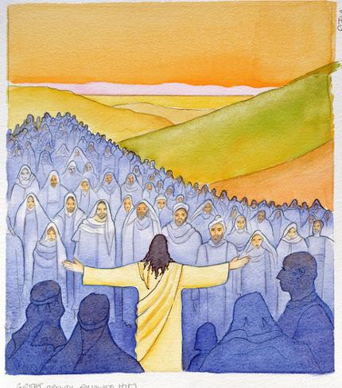

**SOME CHURCHY STUFF** *(M. C. Gillette at* [*hapostles@sbcglobal.net*](mailto:hapostles@sbcglobal.net)*) In this monthly article, we look at terms and definitions of things you might see or hear around church. Nothing fancy here – these entries are out of the Armentrout/Slocum An Episcopal Dictionary of the Church, sometimes supplemented by me, and sometimes simply copied directly. If something in particular piques your interest, let me know, and we’ll deal with it in more depth.*

**DIOCESE.** The territorial jurisdiction of a diocesan bishop. *(The Diocese of Chicago covers 22 counties located in the northern third of the state, from Lake Michigan to the Mississippi River, Wisconsin to Watseka, Illinois. Dioceses are varying sizes depending on population. Episcopal dioceses are organized into Provinces.)*  The term also refers to the congregations and church members of the diocese. Before the church adopted the word it had a long secular usage. It was originally used in the Roman Empire for an administrative subdivision. A diocese was a division of a prefecture of the Roman Empire. In the reorganization of Diocletian and Constantine, the Roman Empire was divided into twelve dioceses. As the church expanded out from the cities, it adopted the use of the word "diocese," and ecclesiastical dioceses tended to correspond to civil units. For example, at first the Diocese of Georgia corresponded with the State of Georgia.

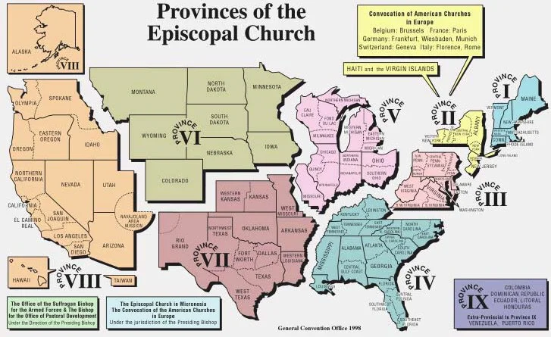Later, many statewide dioceses were divided into smaller dioceses for pastoral and practical reasons. For example, the State of New York includes six dioceses. In more recent years, some dioceses have been formed from portions of more than one state. The Diocese of the Rio Grande includes all of New Mexico and part of west Texas, and the Diocese of the Central Gulf Coast includes portions of southern Alabama and western Florida. In England, the diocese is the territory of the bishop and the parish is a subdivision of it. Every diocese in the Episcopal Church has a Standing Committee. When there is a bishop in charge of the diocese, the Standing Committee is the bishop's council of advice. When there is no bishop, bishop coadjutor or suffragan bishop, the Standing Committee is the ecclesiastical authority of the diocese. A diocese usually meets annually in a diocesan convention. Each diocese is entitled to representation in the House of Deputies by not more than four ordained persons, presbyters or deacons, canonically resident in the diocese, and not more than four lay persons, who are confirmed adult communicants of the Episcopal Church and in good standing in the diocese. Dioceses also elect clerical and lay deputies to the Provincial Synod. The Constitution and Canons of the Episcopal Church provide guidelines for the division of a diocese. Some persons insist that the diocese is the primary unit in the Episcopal Church.

**DIPTYCH.**

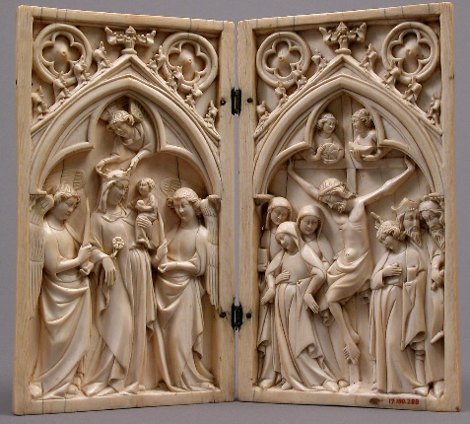A set of two tablets, made of wood or metal, and bound together by rings. The names of saints, bishops, rulers, and the faithful departed were inscribed on the inner surfaces. These names were read out by the deacon during the eucharistic liturgy. *(The word has the same basic meaning – mirrored panels, whether or not separated – in the secular world.)*

**DIRECT ORDINATION.** Sometimes called per saltum (by a leap), it is ordination directly to the order for which one is chosen *(as opposed to, for example, the standard process today whereby priests are ordained deacons first, then, after six months to a year, are ordained as priests)*. In the early church those elected presbyter (priest) or bishop were commonly ordained directly to that order. Although direct ordination continued in Rome and elsewhere until the eleventh century, notably in the elevation of archdeacons as popes, after the fourth century ordination gradually became sequential. One was expected to pass through a sequence of orders to get experience in leadership and ministry. By the late middle ages, orders *(groups of clergy, i.e. “deacons” or “bishops”)* were considered indelible and therefore cumulative. One was understood to remain in a "lower" order even after being ordained to a "higher" order. In the Episcopal Church in recent years there have been efforts to allow direct ordination. Although there is no historical or theological barrier, the restoration of direct ordination has been deferred for study and dialogue with Anglican and ecumenical partners.

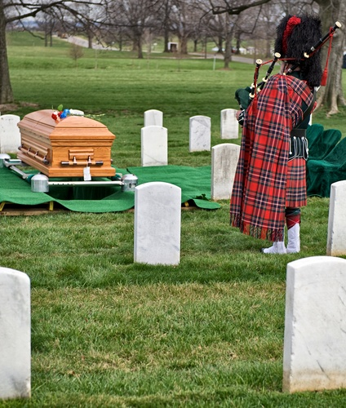**DIRGE.**  The name of some nightmarish creature or another in one of a number of video games. And/or, a mournful hymn. Because this is “Churchy Stuff” we are going to stick with the “hymn” definition. It can be a hymn (spoken, played – bagpipes are a perennial favorite – or sung) that expresses grief, and it may be a lament for the dead. The term comes from the Latin *Dirige*, the first word of the antiphon *(a short sentence sung or recited before or after a psalm)* *Dirige, Dominus Deus*, "Lead me, O Lord God" (Psalm 5:8). This antiphon preceded the first psalm in the Office of the Dead in medieval breviaries and in early English primers. A dirge came to mean a burial hymn.

**IN OUR** **PARISH LIFE:**

**BISHOP’S COMMITTEE MEETING** will be held on **Tuesday 20 July** at **7:00 PM** via WebEx.

**BOOK DISCUSSION GROUP** will meet on **Tuesday 27 July at 7:30 PM** at the home of Geoff and Diane Cooper to discuss *The Wildlands*by Abby Geni.

**BIG TABLE:** Big Table continues to provide food on **Tuesdays from 5:00 – 6:00 PM**. You do not have to register ahead of time, just show up!

**SHAWL MINISTRY UPDATE:** Please join our hearty group of yarn warriors! We knit, crochet and tie together prayer shawls and hats to be given away to people in need of comfort all over the world. Our next in-person meeting will be Wednesday July 7, 2021 at 1:00 pm in Lincoln Hall.

|  |  |  |  |  |  |  |
| --- | --- | --- | --- | --- | --- | --- |
| **JULY 2021** | | | | | | |
| **SUN** | **MON** | **TUE** | **WED** | **THU** | **FRI** | **SAT** |
|  |  |  |  | 1 | 2 | 3  10 AM--noon  Food Pantry |
| 4  9:30 AM in church  7:00 PM Online | 5 | 6 | 7  Shawl Ministry  1:00 PM  Lincoln Hall | 8 | 9 | 10  10 AM--noon  Food Pantry |
| 11  9:30 AM in church  7:00 PM Online | 12 | 13 | 14 | 15 | 16 | 17  10 AM--noon  Food Pantry |
| 18  9:30 AM in church  7:00 PM Online | 19 | 20  BC Meeting  7:00 PM  WebEx | 21 | 22 | 23 | 24  10 AM--noon  Food Pantry |
| 25  9:30 AM in church  7:00 PM Online | 26 | 27  Book Group  7:30 PM | 29 | 29 | 30 |  |

.

**July Birthdays July Anniversaries**

July 01 Susan Allen July 05 Geoff and Diane Cooper

July 03 Michael Matson July 19 John and Grace Henecker

July 07 Daniel Caithmeier

July 10 Eileen Kinney

July 11 Ron Bedal

July 12 Gail Permenter

July 30 Harry Krause, Marsha Taylor

**FROM: Church of the Holy Apostles**

**26238 North Highway 59**

**Wauconda, Illinois 60084**