**The Apostles Post**

26238 North Highway 59

Wauconda, Illinois

NOVEMBER 2022

2015



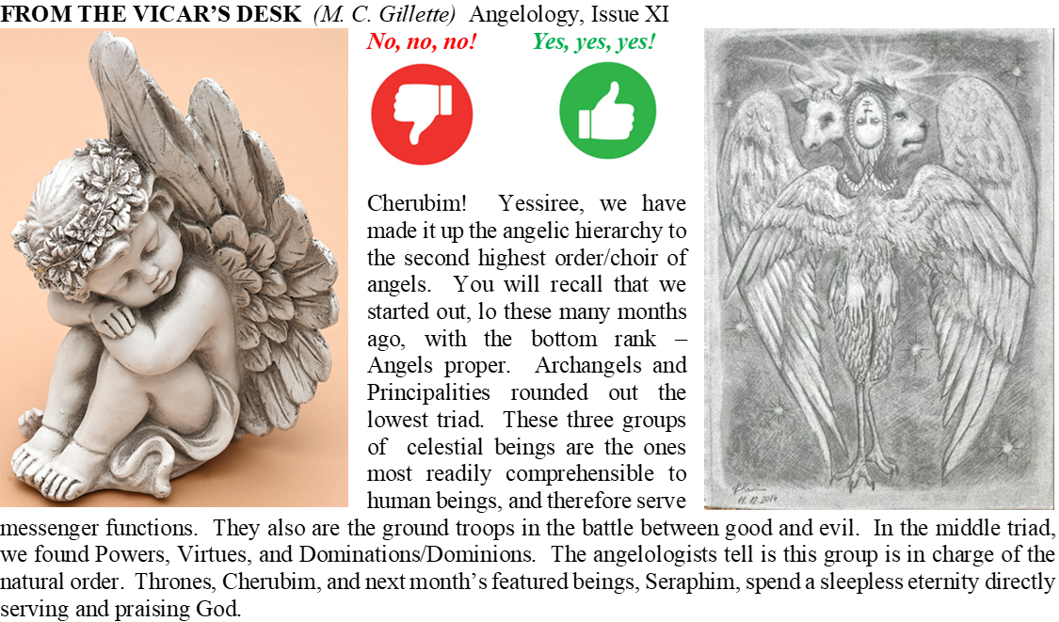

 In one way or another, Cherubim show up relatively often in scripture. The prophet Ezekiel mentions Cherubim in the 10th chapter of – Ezekiel. Seeing them while cowering on the floor of God’s throne room, he recognizes them as the “beings” he saw one day while in exile in Babylon, as he sat by the Kebar river. The day of his Babylonian vision, he says, “I noticed a windstorm coming from the north—an enormous cloud, with lightning flashing, such that bright light rimmed it and came from it like glowing amber from the middle of a fire. 5In the fire were what looked like four living beings. In their appearance they had human form, 6but each had four faces and four wings. 7Their legs were straight, but the soles of their feet were like calves’ feet. They gleamed like polished bronze. 8They had human hands under their wings on their four sides. As for the faces and wings of the four of them, 9their wings touched each other; they did not turn as they moved, but went straight ahead. 10Their faces had this appearance: Each of the four had the face of a man, with the face of a lion on the right, the face of an ox on the left, and also the face of an eagle. 11Their wings were spread out above them; each had two wings touching the wings of one of the other beings on either side and two wings covering their bodies.” If you recall last month’s contemplation of Thrones, you will remember that one of *their* functions seems to be serving as the “wheels” of God’s chariot. The Cherubim, in turn, are often considered to be the chariot itself, that/they which support and transport God. (Specifically, this thought comes from 2 Samuel 22:11: “And he rode upon a cherub, and did fly: and he was seen upon the wings of the wind.”)

The word *cherub* (*cherubim* is the Hebrew masculine plural, although we should note that as Ezekiel tries to describe them, he shifts back and forth between feminine and masculine) is a word perhaps borrowed from the Akkadian karabu, meaning “to bless”, or from the Assyrian *kirubu*, from *karâbu*, "to be near", hence it means near ones, familiars, personal servants, bodyguards, courtiers. According to the angelologists, through this nearness, they acquire particular, full knowledge and wisdom. They have the power to know and contemplate the Divinity, fill themselves with the gift of wisdom, and then communicate it “down the chain.” In addition to their function as God-bearers, they are also spoken of as guardians of holy places, obliged to let only those authorized enter. The understanding of the Cherubim serving as protectors of holy things and as God’s means of support is presumably why God dictated it be solid gold statues of Cherubim, facing each other, wings touching, 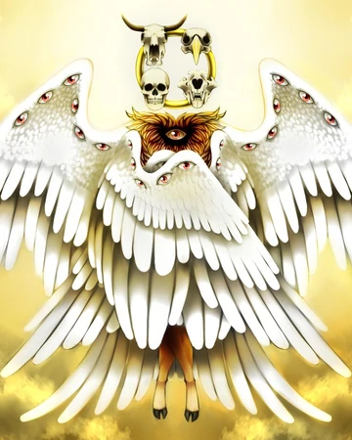that formed God’s resting place on top of the Mercy Seat (the lid of the Ark of the Covenant). (The Ark was ultimately kept in the Holy of Holies in the innermost sanctum of the First Temple. The last mention of its location is in 2 Chronicles, 40 years before Nebuchadnezzar raided it, 50 years before he burned it down. What happened to it is lost to history, although Revelation 11:19 mentions it as being in heaven. But I digress.)

Cherubim enter the biblical story early – it is Cherubim who were placed on the east side of the Garden of Eden with the flaming sword after God drove Adam and Eve out, to keep them out. And they exit late – they are mentioned in Revelation 4. In-between they appear in Exodus, Numbers, 1 Samuel, 2 Samuel, 1 Kings, 2 Kings, 1 Chronicles, Psalms, Isaiah, and, for good measure, Hebrews. Many of these appearances are in the context of God describing how the Tabernacle (the tent in which he rested as he traveled with the Israelites through the wilderness) should be constructed and what it should contain, and/or Solomon doing the same for the First Temple.

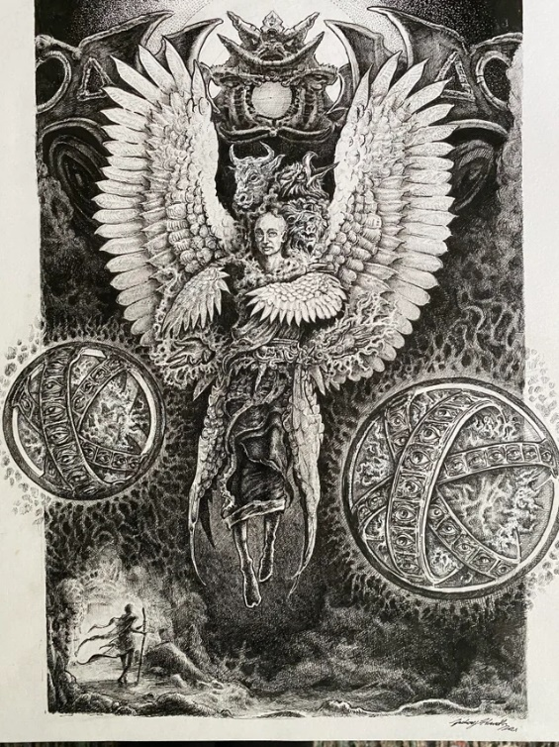 I think it is quite fair to ask (because I have asked) how in the world celestial beings Ezekiel described as dazzling, terrifying, full of wings and wheels, faces and eyes, roaring and spewing forth bolts of lightning, morphed into the chubby, naked, doe-eyed babies with wings and dreamy demeanors of Renaissance (and onward) art. Well, I suppose you’d have to ask Raphael or Philippe de Champaigne, or one of those guys. But according to the fine folks at My Jewish Learning, we might be able to lay a bit of blame on the rabbis and their midrash (scriptural commentary). While in Christian tradition, as we have seen, Cherubim are the second highest order of angels, in Judaic tradition they are often the second lowest, coming just above the *ishim*, the most human-like angels. And apparently there is a playful midrashic folk etymology — one that is certainly not correct in the historical sense — that connects the Hebrew word *keruv* (“cherub”) to the Aramaic expression *ke revaya* meaning “like a child” (according to a statement of Rabbi Abahu in Sukkah 5b). Rashi agrees that the cherubim have child-like faces. This tradition, therefore, might be the origin of the idea that cherubim look like winged babies. (But rabbinic literature is not single-mindedly committed to this image of the cherub as a child. In fact, in that same discussion on Sukkah 5b, Rabbi Abahu’s colleague, Abaye immediately challenges his suggestion.) I can’t imagine the Cherubim are particularly happy about the way in which they are most frequently depicted in contemporary culture; but I suppose, being holders of full knowledge and wisdom, they realize we tend to be silly, and just ignore us.

**HERE AND THERE** *(M. C. Gillette)*

*In this on-going article, we pull things from our various Diocesan calendars and church websites to see what’s going on around us. For more information about what's happening at the Diocesan Headquarters and the Cathedral of Saint James, you can always visit their websites:* <https://www.episcopalchicago.org> or <https://www.saintjamescathedral.org/>

**185th Annual Diocesan Convention**

**November 19**

The 185th Annual Convention of the Episcopal Diocese of Chicago will be held Saturday, November 19 as a virtual gathering on Zoom. Convention is the annual business meeting of the diocese, during which we elect leaders, consider resolutions and hear reports from across the diocese and the wider church. Voting participants at convention include the canonically resident clergy of the diocese and lay delegates elected from each congregation. All voting will be conducted electronically.

General attendees and visitors are invited to observe the proceedings online [**on YouTube**](https://r20.rs6.net/tn.jsp?f=001tdNOSGp4uk3bnTWTMVwm4tLGP4QVtiVn9ROLFywGXmHMScoobqbVuseehAnIyNjHoRkx_WVE1XGwkPAWfxu8LLLQwrNJkONXdil07WwDr4triRjpzhxgeUMPSuJqlMw6zJxkpVrAaFKXdHdzYeFH_fTrj2R76aQXy4x_6E68fydZL0oNjwWyYA==&c=_pzn2Y79WRKMrM4dGdCenKK69unehxrk_DpV5A__Au9c1yjrVtFHMA==&ch=BzmJiR1EyvNZXA2k8s3SCzb8CS5Ci5hZH97LuxxJNODkUlKLuXv7NQ==), (<https://www.youtube.com/c/EpiscopalDioceseofChicago>) and no registration is needed.

﻿Please watch for convention updates in upcoming newsletters and on the [**website**](https://r20.rs6.net/tn.jsp?f=001tdNOSGp4uk3bnTWTMVwm4tLGP4QVtiVn9ROLFywGXmHMScoobqbVuoG2dDXRRopRWgQA4N6oPu0Yfd2FatYGlgt4XdshjFNqeRNO_DlVuSA2TPzJCVbwLTudUhM9mqdJysvrQfQ1DddsmlYSaOivQmt3z8ma1WJ1es51PymFPTJ1B_ErpuMSr-iDeVShxK7C6SN4lL3tdsQ=&c=_pzn2Y79WRKMrM4dGdCenKK69unehxrk_DpV5A__Au9c1yjrVtFHMA==&ch=BzmJiR1EyvNZXA2k8s3SCzb8CS5Ci5hZH97LuxxJNODkUlKLuXv7NQ==). (<https://episcopalchicago.org/governance/2022-diocesan-convention/>)

**Pre-Lenten Men’s Retreat 2023**

**February 10-11**

**﻿** The 20th Annual Diocesan Pre-Lenten Men’s Retreat will be held at the [**DeKoven Retreat Center**](https://r20.rs6.net/tn.jsp?f=001tdNOSGp4uk3bnTWTMVwm4tLGP4QVtiVn9ROLFywGXmHMScoobqbVukGcHsxKeL1Z71dreZqxPho67RFxX1QmCKLCsm3SS4M7PB0OS6Zs6DYk2WY2XLNvZnwHOtZ3D8PbNBeXvc5s7KpjY1Bdrqtkgg==&c=_pzn2Y79WRKMrM4dGdCenKK69unehxrk_DpV5A__Au9c1yjrVtFHMA==&ch=BzmJiR1EyvNZXA2k8s3SCzb8CS5Ci5hZH97LuxxJNODkUlKLuXv7NQ==) (<https://www.dekovencenter.org/>) in Racine, Wisconsin from Friday, February 10 to Saturday February 11. This 24-hour event will be the first in-person Diocesan Men’s Retreat since February 2020, following a two-year break due to COVID.

The retreat will be led by the Rt. Rev. Whayne Hougland Jr., interim rector of St. Chrysostom’s. The theme of the retreat is “Renewal and New Beginnings.” [**Find more details and a registration form online**](https://r20.rs6.net/tn.jsp?f=001tdNOSGp4uk3bnTWTMVwm4tLGP4QVtiVn9ROLFywGXmHMScoobqbVukGcHsxKeL1Zd9Fhrm8HvYtnNHk6Z2I3La52CzhEejSzFzoHvWl6g7l6AbdF5Ptm3qU_eGjo8kykph0aSoTUHti-xsV2ilEUxkhBf_mE7hLpgrfZyCNMeRoS9mfOka5lCNQEeSLMpYMNxF0BWfpBu_s=&c=_pzn2Y79WRKMrM4dGdCenKK69unehxrk_DpV5A__Au9c1yjrVtFHMA==&ch=BzmJiR1EyvNZXA2k8s3SCzb8CS5Ci5hZH97LuxxJNODkUlKLuXv7NQ==). (<https://saintc.org/pre-lenten-mens-retreat-2023%EF%BF%BC/>)

|  |
| --- |
|  |

**SOME CHURCHY STUFF** *(M. C. Gillette)*

*In this monthly article, we look at terms and definitions of things you might see or hear around church. Nothing fancy here – these entries are out of the Armentrout/Slocum An Episcopal Dictionary of the Church, sometimes supplemented by me, and sometimes simply copied directly. If something in particular piques your interest, let me know, and we’ll deal with it in more depth.*

Oh, great.

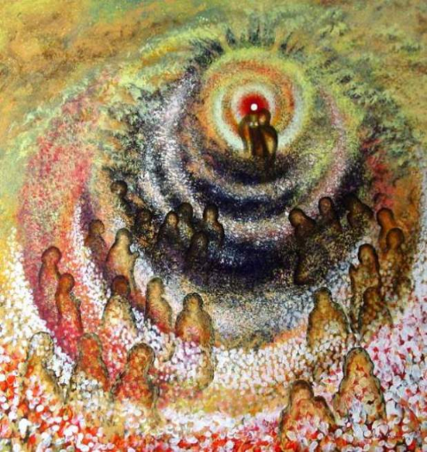**GREAT AMEN.** The response of assent by the congregation at the conclusion of the eucharistic prayer. (“Amen” comes from a post-classical Latin interjection meaning “truly,” or “so be it.”) As the eucharistic celebration is shared by the congregation and the presider, the Great Amen emphasizes the assent of the people to the words spoken on their behalf by the presider. The Great Amen is the “people's prayer” that concludes the eucharistic prayer. The Great Amen is printed in all capital letters in the Book of Common Prayer to emphasize the importance of this moment in the liturgy. Historically, the “moment of consecration” at the eucharist was considered to be the institution narrative in the western church. Some eastern churches understood the epiclesis (invocation of the Holy Spirit) to be the moment of consecration. However, the eucharistic prayer (including institution narrative and epiclesis) is now understood to be a single text, with the consecration completed as the eucharistic prayer concludes with the people's Great Amen.

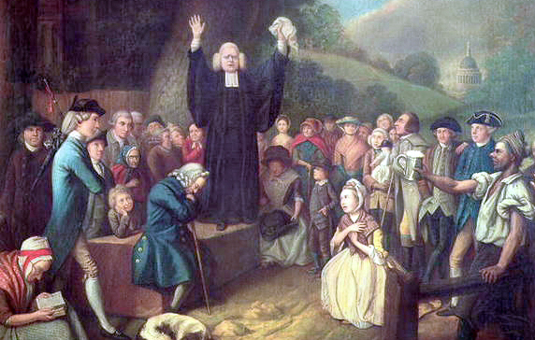**GREAT AWAKENING.** A religious revival in the American colonies in the eighteenth century. It occurred episodically from about 1720 until about 1770. (Church historians tend to talk about the 1st, 2nd, and 3rd “Awakenings” – some break things up a little differently and talk about a 4th.) The Great Awakening was part of the religious fervor which swept western Europe during the latter part of the seventeenth century and most of the eighteenth century. This movement was called pietism in Germany and evangelicalism in England. In the New World the Great Awakening was one of the first great movements to give the colonists a feeling of unity and sense of special purpose in God's providential plan. It was a reaction against arid rationalism in New England, formalism in liturgical practices among the Dutch Reformed in the Middle Colonies, and neglect of pastoral supervision in the South. Because the revival took place especially among the Dutch Reformed, the Congregationalists, the Presbyterians, the Baptists, and some Anglicans, it was largely a development toward evangelical Calvinism. Revival preachers tended to emphasize the “terrors of the law” to sinners, the unmerited grace of God, and a “new birth” in Jesus Christ. One of the movement's great figures was George Whitefield, an Anglican priest who was influenced first by John Wesley and then by Calvinists. (Useless factoid: He had measles as a child and was left cross-eyed and with a squint.) Jonathan Edwards (1703-1758), the great apologist of the movement, was a strong Calvinist and preached a doctrine of justification by faith. His chief opponent was Charles Chauncy (1704-1787), a Congregational minister of Boston. Chauncy preached against the revival, which he considered an outbreak of extravagant emotion. The Great Awakening was responsible for stemming the tide of Enlightenment rationalism in the colonies. It also led to divisions in some of the denominations between those who supported and those who rejected its tenets. It was responsible for stimulating missions to the Native Americans and the slaves (alas, not always with laudatory aim or outcome), and for the establishment and growth of several educational institutions, including Princeton, Dartmouth, and Brown. The itinerant preaching associated with the Great Awakening helped to break up the old parish system in which everyone in an area belonged to a single church. It also led to a broader religious toleration and the democratization of religious experience. It contributed to the fervor that resulted in the American Revolution. Although the Anglican Church in America was not strongly affected by the Great Awakening, there was significant participation in this revival by individual Anglican clergy and laity.

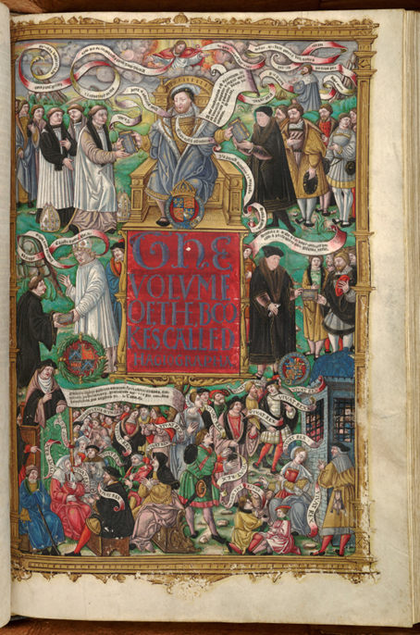

**GREAT BIBLE, The**

English Bible prepared by Miles Coverdale. The term is based on the size of the Bible. It was printed by Richard Grafton and Edward Whitchurch. It has been called “Whitchurch's Bible.” The printing was begun in Paris but later continued in London owing to the hostility of the Sorbonne. In Sept. 1538, Thomas Cromwell had ordered this Bible to be placed in every parish church. Two lavish, hand-illustrated copies were made – one for Henry and one for Cromwell. The Great Bible was finally issued in the early summer of 1539. It was based on Coverdale's Bible (1535), Matthew's Bible (1537), and the work of William Tyndale. The title page of the Great Bible depicts God blessing the King, who is handing out copies of the Bible to Thomas Cranmer and Thomas Cromwell. This artwork is generally attributed to Hans Holbein. (If you want to read a very short but interesting article about some shifty changes to the artwork, check out this link: <https://www.joh.cam.ac.uk/cromwells-final-portrait-discovered-henry-viii-bible-reveals-bid-influence-king>

Coverdale later revised the Great Bible, which was reissued with a preface by Thomas Cranmer in 1540. This version has been known as “Cranmer's Bible.” The Great Bible is also known as the “Treacle Bible,” due to Coverdale's distinctive rendering of Jeremiah 8:22, in which he mentions “treacle in Gilead” instead of “balm in Gilead.” The Great Bible influenced the Geneva Bible (1560) and the Bishops' Bible (1568). The Convocation of 1571 ordered the Bishops' Bible to be used in all the churches of England. The Psalter of the Great Bible became the Psalter of the 1549 Prayer Book. Coverdale's Psalter in the Great Bible has been carefully preserved in subsequent Prayer Book revisions, including the 1979 Book of Common Prayer, although some archaic words and inaccurate renderings have been changed.

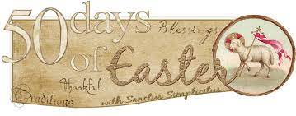**GREAT FIFTY DAYS.** The feast of Easter is a season of fifty days, from Easter Eve through the Day of Pentecost. From early times the Greek word *pentecost* (fiftieth day) was used also for the whole Paschal season. During this season there is no fasting. (Nooooo fasting.) The Council of Nicaea (325) directed that Christians are to pray standing. The word “alleluia” (praise the Lord) is said or sung repeatedly, which contrasts sharply with the season of Lent when the alleluia is omitted. The color of liturgical vestments and hangings is white or gold. The Book of Common Prayer notes that it is customary for the Paschal candle to burn at all services of the Easter season. The traditional Christian Easter greeting (derived from Luke 24:34, it’s the “Alleluia! Christ is risen! The Lord is risen indeed! Alleluia!” thing) serves as the opening acclamation at the eucharist during the Easter season. The “Alleluia, alleluia” may also be added to the dismissals and their responses during the Great Fifty Days. So basically, it’s a fancy name for Eastertide.

**GREAT LITANY, The**

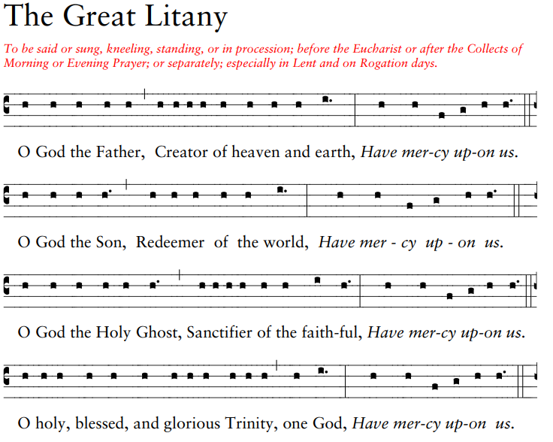As you will recall, this is the wearyingly long chant to which I subject you on the first Sunday in Lent. More formally, it is an intercessory prayer including various petitions that are said or sung by the leader, with fixed responses by the congregation. It was used as early as the fifth century in Rome. It was led by a deacon, with the collects led by a bishop or priest. The Litany was the first English language rite prepared by Archbishop Thomas Cranmer. It was first published in 1544. Cranmer modified an earlier litany form by consolidating certain groups of petitions into single prayers with response. The Litany’s use in church processions was ordered by Henry VIII when England was at war with Scotland and France. It was printed as an appendix to the eucharist in the 1549 Book of Common Prayer (BCP). The Litany was used in each of the three ordination rites of the 1550 ordinal (bishop, priest, deacon), with a special petition and concluding collect. The 1552 BCP called for use of the Litany after the fixed collects of Morning Prayer on Sundays, Wednesdays, and Fridays. The 1928 BCP allowed the Litany to be used after the fixed collects of Morning or Evening Prayer, or before the Eucharist, or separately. The 1928 BCP included a short Litany for Ordinations as an alternative to the Litany. The 1979 BCP titled the Litany “The Great Litany” to distinguishing it from other litanies in the Prayer Book.

The Great Litany may be said or sung. The officiant and people may kneel or stand, or it may be done in procession. The Great Litany may be done before the Eucharist, or after the collects of Morning or Evening Prayer, or separately. Because of its penitential tone, it is especially appropriate during Lent. The Great Litany includes an invocation of the Trinity; a series of deprecations which seek deliverance from evil, spiritual harm, and natural calamities; a series of obsecrations (obsecrations! now there’s a churchy word! It means “earnest entreaty, supplication”) which plead the power of Christ’s Incarnation, life, death, and resurrection for deliverance; prayers of general intercession; the Agnus Dei; the Kyrie; the Lord’s Prayer; a versicle and response based on Psalm 33:22; a concluding collect; and the grace (BCP, pages148-154). The Supplication (BCP, page 154) may be used at the conclusion of the Great Litany, taking the place of all that follows the Lord’s Prayer.

When the Great Litany precedes the eucharist, the Litany concludes with the Kyrie and the eucharist begins with the salutation and the collect of the day (BCP, page 153). The Great Litany should not be preceded by a hymn, psalm, or anthem when it is used as an entrance rite at the eucharist. The Great Litany takes the place of the prayers of the people at the eucharist. The confession may also be omitted.

The Great Litany is also especially appropriate on Rogation Days. The Book of Occasional Services (BOS) order for a Rogation Procession calls for the Great Litany to begin as the procession enters the church. It adds petitions for favorable weather, productive lands and waters, and God’s favor for all who care for the earth, the water, and the air. (“Rogation” days – “minor rogations” – are days devoted to special prayers for crops.) The Great Litany may also conclude the BOS Service for New Year’s Eve.

|  |  |  |  |  |
| --- | --- | --- | --- | --- |
| **EPISCOPAL CHURCH OF THE HOLY APOSTLES UPCOMING SERVICES – NOVEMBER 2022** | | | | |
| Sunday  06 November  9:30 a.m. | Sunday  13 November  9:30 a.m. | Sunday  20 November  9:30 a.m. | Wednesday  23 November  7:00 p.m. | Sunday  27 November  9:30 a.m. |
| Presider and Preacher:  Gillette | Presider and Preacher:  Gillette | Presider and Preacher:  Gillette | Presider and Preacher:  Gillette | Presider and Preacher:  Gillette |
| 22nd Sunday after Pentecost  Proper 27 (C)  *All Saints’ Day Observed* | 23rd Sunday after Pentecost  Proper 28 (C) | Last Sunday after Pentecost:  Christ the King  Proper 29 (C) | Thanksgiving Eve | 1st Sunday of Advent (A) |
| FIRST LESSON  Haggai 1:15b-2:9  RESPONSE Psalm 145:1-5, 18-22  SECOND LESSON  2 Thessalonians  2:1-5, 13-17  GOSPEL  Luke 20:27-38 | FIRST LESSON  Isaiah 65:17-25  RESPONSE Canticle 9  SECOND LESSON  2 Thessalonians  3:6-13  GOSPEL  Luke 21:5-19 | FIRST LESSON  Jeremiah 23:1-6  RESPONSE Canticle 16  SECOND LESSON  Colossians  1:11-20  GOSPEL  Luke 23:33-43 | FIRST LESSON  Deuteronomy 26:1-11  RESPONSE Psalm 100  SECOND LESSON  Philippians  4:4-9  GOSPEL  John 6:25-35 | FIRST LESSON  Isaiah 2:1-15  RESPONSE Psalm 122  SECOND LESSON  Romans  13:11-14  GOSPEL  Matthew 24:36-44 |

**IN THE PARISH**

**SHAWL MINISTRY:** Our next in-person meeting will be **Wednesday 09 November from 12:30 - 2:00 PM** in

Lincoln Hall. All are welcome- no experience necessary!

**BISHOP’S COMMITTEE MEETING:** Bishop’s Committee will meet on **Tuesday 15 November at 7:00 PM** in Lincoln Hall.

**BOOK GROUP**: The November selection for our book group is *American Wife* by Curtis Sittenfeld .We will meet at **7:30pm on Monday 21 November,** hosted by Julie Evans. Please contact Lisa Earley for more information at [lisa.earley@groble.me](mailto:lisa.earley@groble.me)

**THANKSGIVING EVE SERVICE AND PIE FELLOWSHIP:** There will be a Thanksgiving Eve service on **Wednesday 23 November beginning at 7:00 PM**. Following the service please join us for our traditional “Pie Fellowship” – bring a favorite Thanksgiving treat to share with others!

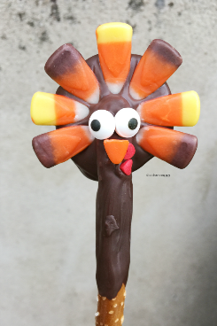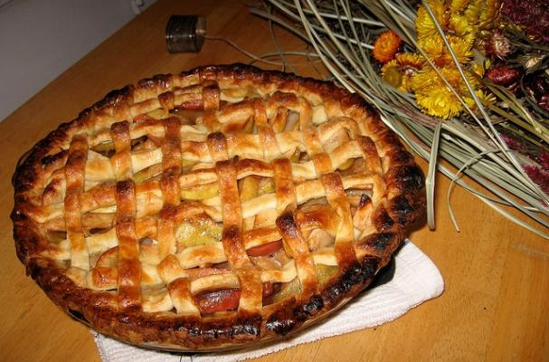

**November Birthdays**

Nov 02 Ed Dura

Nov 03 Kristi Connell

Nov 09 Virginia Balmes

Nov 13 Michele Seiler

Nov 15 Ken Balmes

Nov 20 Carl Reed

|  |  |  |  |  |  |  |
| --- | --- | --- | --- | --- | --- | --- |
| **NOVEMBER 2022** | | | | | | |
| **SUN** | **MON** | **TUE** | **WED** | **THU** | **FRI** | **SAT** |
|  |  | 1 | 2 | 3 | 4 | 5  10 AM--noon  Food Pantry |
| 6  9:30 AM in church | 7 | 8 | 9  Shawl Ministry  12:30 – 2:00 PM  Lincoln Hall | 10 | 11 | 12  10 AM--noon  Food Pantry |
| 13  9:30 AM in church | 14 | 15  Bishop’s Committee  7:00 PM in  Lincoln Hall | 16 | 17 | 18 | 19  10 AM--noon  Food Pantry |
| 20  9:30 AM in church | 21  Book Group  7:30 PM | 22 | 23  Thanksgiving Eve service 7:00 PM  Pie Fellowship to follow | 24 | 25 | 26  10 AM--noon  Food Pantry |
| 27  9:30 AM in church | 28 | 29 | 30 |  |  |  |

**FROM: Church of the Holy Apostles**

**26238 North Highway 59**

**Wauconda, Illinois 60084**