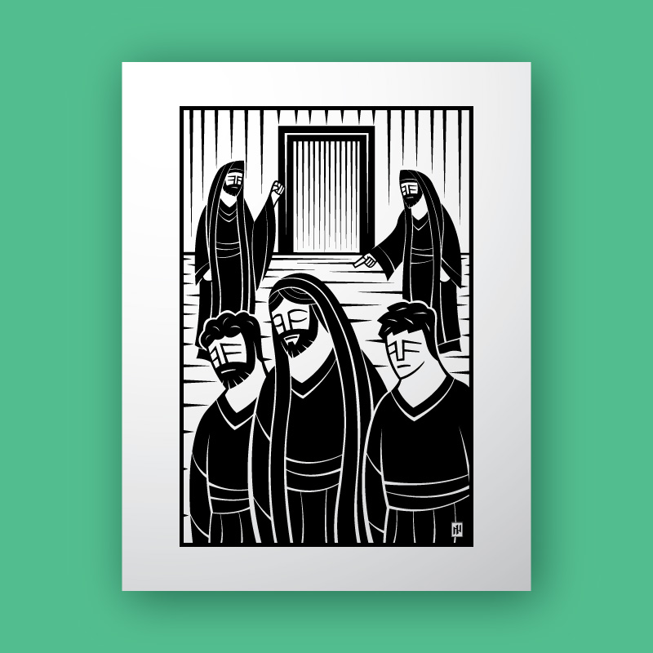

**Sixth Sunday after Pentecost**

**Proper 9 (B)**

**Sunday 04 July 2021**

**Episcopal Church of the Holy Apostles**

26238 N HWY 59, Wauconda, IL 60084

*www.holyapostleswauconda.net*

***You are encouraged to look at pictures and videos if presented.***

***They tell the story in a different way than the words in front of you.***

***But the words are important too;***

***feel free to take your bulletins with you, or access them on our website.***

**OPENING VOLUNTARY**

**WORDS OF WELCOME**

**OPENING HYMN** ***(Verses 1, 2, and 4)***

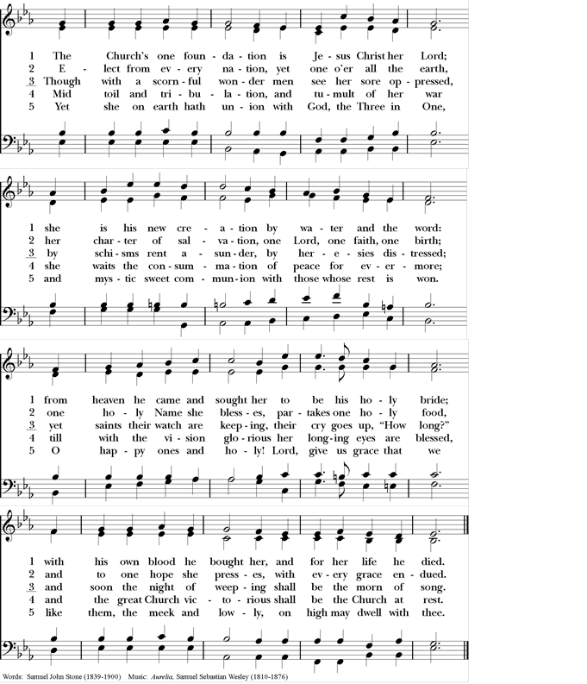

**OPENING SENTENCE**

**Presider:** Blessed be God: Holy Immortal One, Incarnate Word, and Breath of Life.

***People: And blessed be God’s kingdom, now and forever. Amen.***

**COLLECT FOR PURITY**

**Presider:** Almighty God, to you all hearts are open, all desires known, and from you no secrets are hid: Cleanse the thoughts of our hearts by the inspiration of your Holy Spirit, that we may perfectly love you, and worthily magnify your holy Name; through Christ our Lord.

***People: Amen.***

**HYMN OF PRAISE** *(Please say together in unison)*

***All: Gracious God, we bless you for our creation, preservation, and all the blessings of this life; but above all for your immeasurable love in the redemption of the world by our Lord Jesus Christ; for the means of grace, and for the hope of glory. And, we pray, give us such an awareness of your mercies, that with truly thankful hearts we may show forth your praise, not only with our lips, but in our lives, by giving up our selves to your service, and by walking before you in holiness and righteousness all our days; through Jesus Christ our Lord, to whom, with you and the Holy Spirit, be honor and glory throughout all ages.***

**COLLECT OF THE DAY**

**Presider:** The Lord be with you.

***People: And also with you.***

**Presider:** Let us pray. God of unearthly wisdom, we take offence at your humanity; we lose our faith that you can change us: come to us who are your own; convert our inward looking eyes and take us on the road where all is lost and all is gained, through Jesus Christ, the prophet.

***People: Amen.***

*(We read from the various translations authorized by our Church. This month, we read from the Common English Bible, 2012)*

**FIRST LESSON** 2 Samuel 5:1-5, 9-10

**Reader:** A reading from 2nd Samuel. 5 All the Israelite tribes came to David at Hebron and said, “Listen: We are your very own flesh and bone. 2In the past, when Saul ruled over us, you were the one who led Israel out to war and back. What’s more, the Lord told you, You will shepherd my people Israel, and you will be Israel’s leader. 3So all the Israelite elders came to the king at Hebron. King David made a covenant with them at Hebron before the Lord, and they anointed David king over Israel. 4David was 30 years old when he became king, and he ruled for forty years. 5He ruled over Judah for seven and a half years in Hebron. He ruled thirty-three years over all Israel and Judah in Jerusalem. 6The king and his troops marched on Jerusalem against the Jebusites, who inhabited the territory. The Jebusites said to David, “You’ll never get us in here! Even the blind and the lame will beat you back!” “David will never enter here,” they said to each other. 7But David did capture the fortress of Zion—which became David’s City. 8“On that day,” David said, “whoever attacks the Jebusites should strike the windpipe because David hates the lame and the blind.” That is why people say, “The blind and the lame will not enter the temple.” 9David occupied the fortress, so it was renamed David’s City. David built a city around it from the earthen terraces inward. 10David grew increasingly powerful, and the Lord of heavenly forces was with him. The Word of the Lord.

***People: Thanks be to God.***

**RESPONSE:** *(Please say together in unison)* Psalm 48

***1 In the city belonging to our God, the Lord is great and so worthy of praise!***

***2 His holy mountain 2is a beautiful summit, the joy of the whole world. Mount Zion, in the far north, is the city of the great king.***

***3God is in its fortifications, revealing himself as a place of safety.***

***4Look: the kings assembled themselves, advancing all together—when they saw it, they were stunned; they panicked and ran away frightened.***

***6Trembling took hold of them right there—like a woman giving birth,***

***7or like the east wind when it smashes the ships of Tarshish.***

***8Just like we had heard, now we’ve seen it for ourselves in the city of the Lord of heavenly forces, in the city of***

***our God. May God make it secure forever!***

***9We dwell on your faithful love, God, in your temple.***

***10Your praise, God, just like your reputation, extends to the far corners of the earth. Your strong hand is filled***

***with righteousness.***

***11Let Mount Zion be glad; let the towns of Judah rejoice because of your acts of justice!***

***12Walk around Zion; go all the way around it; count its towers.***

***13Examine its defenses closely; tour its fortifications so that you may tell future generations:***

***14“This is God, our God, forever and always! He is the one who will lead us even to the very end.”***

**SECOND LESSON** 2 Corinthians 12:2-10

**Reader:** A reading from the 2nd letter to the Corinthians. 2I know a man in Christ who was caught up into the third heaven fourteen years ago. I don’t know whether it was in the body or out of the body. God knows. 3-4I know that this man was caught up into paradise and that he heard unspeakable words that were things no one is allowed to repeat. I don’t know whether it was in the body or apart from the body. God knows. 5I’ll brag about this man, but I won’t brag about myself, except to brag about my weaknesses. 6If I did want to brag, I wouldn’t make a fool of myself because I’d tell the truth. I’m holding back from bragging so that no one will give me any more credit than what anyone sees or hears about me. 7I was given a thorn in my body because of the outstanding revelations I’ve received so that I wouldn’t be conceited. It’s a messenger from Satan sent to torment me so that I wouldn’t be conceited. 8I pleaded with the Lord three times for it to leave me alone. 9He said to me, “My grace is enough for you, because power is made perfect in weakness.” So I’ll gladly spend my time bragging about my weaknesses so that Christ’s power can rest on me. 10Therefore, I’m all right with weaknesses, insults, disasters, harassments, and stressful situations for the sake of Christ, because when I’m weak, then I’m strong. The Word of the Lord.

***People: Thanks be to God.***

**GOSPEL** Mark 6:1-13

**Presider:** The Holy Gospel of our Lord Jesus Christ according to Mark.

***People: Glory to you, Lord Christ.***

**Presider:** 6 Jesus came to his hometown. His disciples followed him. 2On the Sabbath, he began to teach in the synagogue. Many who heard him were surprised. “Where did this man get all this? What’s this wisdom he’s been given? What about the powerful acts accomplished through him? 3Isn’t this the carpenter? Isn’t he Mary’s son and the brother of James, Joses, Judas, and Simon? Aren’t his sisters here with us?” They were repulsed by him and fell into sin. 4Jesus said to them, “Prophets are honored everywhere except in their own hometowns, among their relatives, and in their own households.” 5He was unable to do any miracles there, except that he placed his hands on a few sick people and healed them. 6He was appalled by their disbelief. Then Jesus traveled through the surrounding villages teaching. 7He called for the Twelve and sent them out in pairs. He gave them authority over unclean spirits. 8He instructed them to take nothing for the journey except a walking stick—no bread, no bags, and no money in their belts. 9He told them to wear sandals but not to put on two shirts. 10He said, “Whatever house you enter, remain there until you leave that place. 11If a place doesn’t welcome you or listen to you, as you leave, shake the dust off your feet as a witness against them.” 12So they went out and proclaimed that people should change their hearts and lives. 13They cast out many demons, and they anointed many sick people with olive oil and healed them. The Gospel of the Lord.

***People: Praise to you, Lord Christ.***

**THE SERMON**

*(A brief period of silence follows the sermon)*

**NICENE CREED** *(Please say together in unison)*

***Note:*** *This is slightly different than the Nicene Creed found in the Book of Common Prayer, but is considered by the church to be more ancient.*

***All: We believe in one God, the Father, the Almighty, maker of heaven and earth, of all that is, seen and unseen. We believe in one Lord, Jesus Christ, the only Son of God, eternally begotten of the Father, God from God, Light from Light, true God from true God, begotten, not made, of one Being with the Father; through him all things were made. For us and for our salvation he came down from heaven, was incarnate of the Holy Spirit and the Virgin Mary and became truly human. For our sake he was crucified under Pontius Pilate; he suffered death and was buried. On the third day he rose again in accordance with the Scriptures; he ascended into heaven and is seated at the right hand of the Father. He will come again in glory to judge the living and the dead, and his kingdom will have no end. We believe in the Holy Spirit, the Lord, the giver of life, who proceeds FROM THE FATHER, WHO with the Father and the Son is worshiped and glorified., who has spoken through the Prophets. We believe in one holy catholic and apostolic Church. We acknowledge one baptism for the forgiveness of sins. We look for the resurrection of the dead, and the life of the world to come. Amen***

**PRAYERS OF THE PEOPLE** Personalized Form IV

**Leader:** Let us pray for the Church and for the world.

**Leader:** We pray this morning for those raised up in our Anglican and Diocesan Cycles of Prayer; and for all bishops, priests, and deacons. Guide them, guard them, and grant that they and all who confess your Name may be united in your truth, live together in your love, and reveal your glory in the world.

*(Silence)***Leader:**  Lord, in your mercy,

***People: Hear our prayer.***

**Leader:**  We pray for all who govern and hold authority in the nations of the world, particularly in those nations suffering the ravages of war or natural disaster. Guide the people of this land, and of all the earth, in the ways of justice and peace; that we may honor one another and serve the common good.

*(Silence)***Leader:**  Lord, in your mercy,

***People: Hear our prayer.***

**Leader:** As we commemorate the founding of our country, let us pray: Almighty God, who has given us this good land for our heritage: We humbly beseech you that we may always prove ourselves a people mindful of your presence and glad to obey your Son’s command to love without boundaries and serve the poor and hungry, sick and oppressed, wherever we may find them. Bless our land with honorable industry, sound learning, and pure manners. Save us from sowing the seeds of violence, discord, and confusion to further our own agendas; from pride and arrogance; and from every evil way. Strengthen us to work on behalf of liberty and justice for *all*; and to fashion into one united people the multitudes brought here out of many kindreds and tongues. Endue with the spirit of wisdom and compassion those who govern, so that there may peace and mutual respect at home, and that we may, through our obedience to you, may show forth your praise in all the earth. In the time of prosperity, fill our hearts with thankfulness, and in the day of trouble, suffer not our trust in you to fail; all of which we ask through Jesus Christ our Lord. Lord, in your mercy,

***People: Hear our prayer.***

**Leader:**  Give us all a reverence for the earth as your own creation, that we may use its resources rightly in the service of others and to your honor and glory.

*(Silence)***Leader:**  Lord, in your mercy,

***People: Hear our prayer.***

**Leader:** We give thanks for all the blessings in our lives. We give thanks for those celebrating birthdays and anniversaries this week, especially those whose names we raise up now, either silently or aloud (*we will keep a 10-second silence*): _____. Bless all whose lives are closely linked with ours, and grant that we may serve Christ in them, and love one another as he loves us.

*(Silence)***Leader:** Lord, in your mercy,

***People: Hear our prayer.***

**Leader:** Comfort and heal all those who suffer in body, mind or spirit, especially those on our parish prayer list and those whose names we raise up now, either silently or aloud (*we will keep a 10-second silence*): _____. Give them courage and hope in their troubles, and bring them the joy of your salvation.

*(Silence)***Leader:**  Lord, in your mercy,

***People: Hear our prayer.***

**Leader:** We commend to your mercy all who have died, especially those killed in the course of service to others or by violence or disaster, and those whose names we raise up now, either silently or aloud (*we will keep a 10-second silence*): _____. We pray that your will for them may be fulfilled, and we pray that we may share with all your saints in your eternal kingdom.

*(Silence)***Leader:** Lord, in your mercy,

***People: Hear our prayer.***

*(The Presider will add this or another concluding Collect)* Almighty God, to whom our needs are known before we ask: Help us to ask only what accords with your will; and those good things which we dare not, or in our blindness cannot ask, grant us for the sake of your Son Jesus Christ our Lord.

***People: Amen.***

**CONFESSION AND ABSOLUTION** (*Please say together in unison*)

***All: Holy God, you know how stubborn we can be. You call us to serve others, and we stay in the familiarity of our own homes. You would send us to where the hopeless live, but we are reluctant to leave the comfort of our complacency. You would feed us on the peace and joy of your word, but we pull our chairs up to the tables of those who serve false promises. Forgive us, Guiding God. Transform our defiance into discipleship, and our rejection of others into the resurrection of welcoming all people as sisters and brothers in Christ. Help us to love as faithfully as you have always loved us, and send us forth to take the good news of Jesus Christ to everyone we meet.***

**Presider:** We open our lips and confess our hearts. God hears our words and make us new, sending us our to bring hope and joy to all the world. + We are forgiven; and we Hearing the good news, believing the good news, we are forgiven; and sent to live out the good news. Thanks be to God.

***People: Amen.***

**THE PEACE** *(Please greet each other in the name of the Lord.)*

**Presider:** The Peace of the Lord be always with you.

***People: And also with you.***

**OFFERTORY SENTENCES**

**Presider:** We give in grateful thanksgiving for all that God has given us. In the upside down world of the gospel, we measure our wealth not by what we have, but what we can give away. Let us give away generously, of our time, our talent, our treasure, and ourselves, to bless your church, your people, your creation.

*Please follow the Presider’s directions for Communion.*

**GREAT THANKSGIVING** EOW-II

**Presider:** The Lord be with you.

***People: And also with you.***

**Presider:** Lift up your hearts.

***People: We lift them to the Lord.***

**Presider:** Let us give thanks to the Lord our God.

***People: It is right to give our thanks and praise.***

**Presider:** We praise you and we bless you, holy and gracious God, source of life abundant. From before time you made ready the creation. Your Spirit moved over the deep and brought all things into being: sun, moon, and stars; earth, winds, and waters; and every living thing. You made us in your image, and taught us to walk in your ways. But we rebelled against you, and wandered far away; and yet, as a mother cares for her children, you would not forget us. Time and again you called us to live in the fullness of your love.

And so this day we join with Saints and Angels in the chorus of praise that rings through eternity, lifting our voices to magnify you as we say/sing:

**SANCTUS** *(Please say together in unison)*

***All: Holy, holy, holy Lord, God of power and might, heaven and earth are full of your glory. Hosanna in the highest. Blessed is the one who comes in the name of the Lord. Hosanna in the highest.***

**Presider:** Glory and honor and praise to you, holy and living God. To deliver us from the power of sin and death and to reveal the riches of your grace, you looked with favor upon Mary, your willing servant, that she might conceive and bear a son, Jesus the holy child of God. Living among us, Jesus loved us. He broke bread with outcasts and sinners, healed the sick, and proclaimed good news to the poor. He yearned to draw all the world to himself yet we were heedless of his call to walk in love. Then, the time came for him to complete upon the cross the sacrifice of his life, and to be glorified by you.

**↑**On the night before he died for us, Jesus was at table with his friends. He took bread, gave thanks to you, broke it, and gave it to them, and said: "Take, eat; This is my Body, which is given for you. Do this for the remembrance of me."

**↑**As supper was ending, Jesus took the cup of wine. Again, he gave thanks to you, gave it to them, and said: "Drink this, all of you: This is my Blood of the new Covenant, which is poured out for you and for all for the forgiveness of sins. Whenever you drink it, do this for the remembrance of me."

Now gathered at your table, O God of all creation, and remembering Christ, crucified and risen, who was and is and is to come, we offer to you our gifts of bread and wine, and ourselves, a living sacrifice.

**∞** Pour out your Spirit upon these gifts that they may be the Body and Blood of Christ.

**+** Breathe your Spirit over the whole earth and make us your new creation, the Body of Christ given for the world you have made.

In the fullness of time bring us with all your saints, from every tribe and language and people and nation, to feast at the banquet prepared from the foundation of the world.

Through Christ and with Christ and in Christ, in the unity of the Holy Spirit, to you be honor, glory, and praise, for ever and ever. ***AMEN.***

**LORD’S PRAYER**

**People: Our Father who art in heaven**

**Presider:** How blissful it is to imagine heaven on earth. But lives are always endangered. Poverty consumes many, hunger and disease destroy many. The bodies of young people are for sale. Mothers and fathers are migrating to foreign lands seeking freedom and dignity and new opportunities. God, grant to us the experience of heaven on earth.

**People: Hallowed be your name**

**Presider:** Your name is holy, your people are holy. You created us in your image. But the dignity of the poor ones is crushed by those who whip the poor by laws and by rules. Your name was used by foreign powers. In your name colonizers invaded foreign lands. In your name they burned and smashed.

**People: Your kingdom come, your will be done, on earth as it is in heaven.**

**Presider:** We know that your kingdom is a kingdom of love, justice and of peace. A kingdom of righteousness and abundance for all. Do not allow us to be deceived by the standard of this world, where unjust wars rule and colonizers become rulers of the nations. Let your will be done soon, and vanish the pseudo-kingdom of empire power, until we can finally say, heaven is possible here on earth.

**People: Give us this day our daily bread.**

**Presider:** The bread that we eat today satisfies our hunger. But those who make the bread in many countries have empty stomachs. How can we be happy when our body is full while many are wanting? We have been told those who do not work should not eat. But how come those who work hard have too little to eat, while those who amass wealth by greed have plenty to throw away? May the daily bread we partake in be the communion of struggle and hope, and be the bread that is shared by all.

**People: Forgive us our debts, as we forgive debtors.**

**Presider:** We offer our self-criticisms. When we have failed to love You and our neighbor, renew us and enable us to make up whatever we have failed to do. Give us hearts that can share your grace by forgiving others. Let us be humble like a dove and make us wise as a serpent. May we be sustained in our courage, that we will not be manipulated by those who have wronged, exploited and oppressed your people. Forgiveness is for those who have admitted their accountability, for your grace is sufficient enough to correct our mistakes. But arrogance and conceit will lead us only to downfall.

**People: And lead us not into temptation, but deliver us from evil.**

**Presider:** Lead us not to resignation in our work for justice and peace. Let not cynicism rule us, but lead us to a deeper steadfastness to overcome evil in our midst.

**People: For thine is the kingdom, and the power, and the glory, forever and ever. Amen.**

**Presider:** This we believe. Let your power of love and the glory of justice and peace be with us all forever and ever. Amen.

**FRACTION (THE BREAKING OF THE BREAD)**

*(The Presider breaks the consecrated bread. A brief period of silence is kept.)*

**Presider:** We break this bread to share in the Body of Christ.

***People: We who are many are one body, for we all share in the one bread.***

**Presider:** **↑**The Gifts of God for the People of God. Take them in remembrance that Christ died for you, and feed on him in your hearts by faith, with thanksgiving.

**POST-COMMUNION PRAYER** *(Please say together in unison)*

**Presider:** Let us pray.

***All: Loving God, we give you thanks for restoring us in your image and nourishing us with spiritual food in the Sacrament of Christ’s Body and Blood. Now send us forth a people, forgiven, healed, renewed; that we may proclaim your love to the world and continue in the risen life of Christ our Savior. Amen.***

**PARISH ANNOUNCEMENTS**

**BLESSING**

**Presider**: May the blessing of the God of Abraham and Sarah, and of Jesus Christ born of our sister Mary, and of the Holy Spirit, who broods over the world as a mother over her children, be upon you and remain with you always.

***People: Amen.***

**CLOSING HYMN *(Verses 1, 2, and 3)***

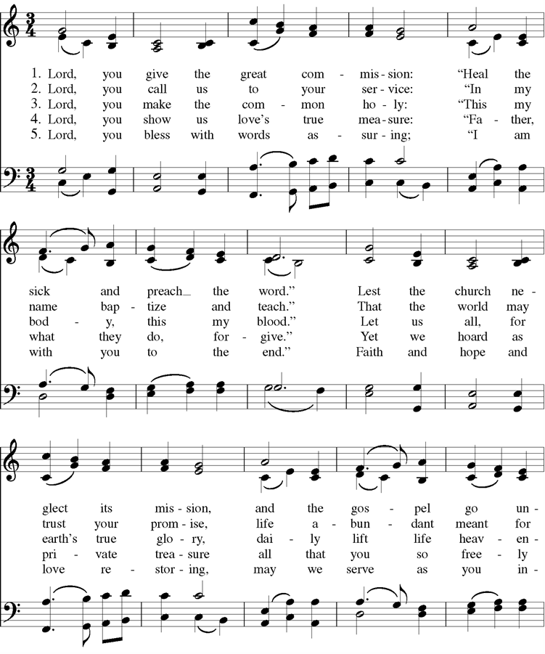

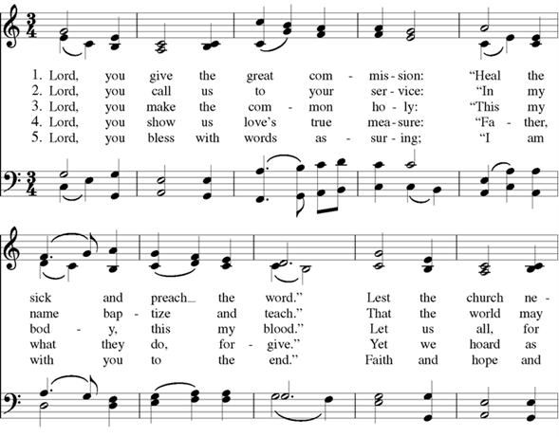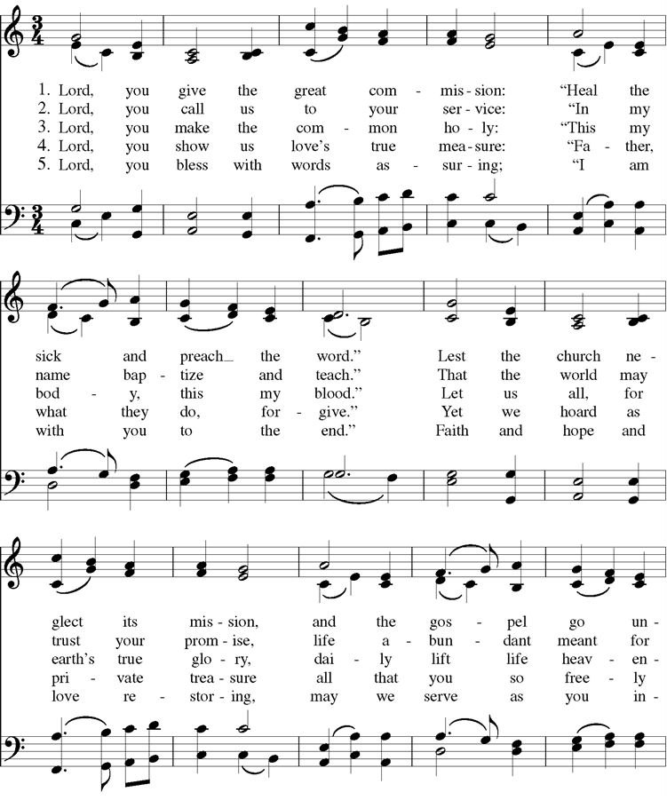



Cover Image: <https://paramentics.com/art/a-prophet-without-honor>

Confession: Adapted from Thom Shuman, accessed at <https://re-worship.blogspot.com/2012/06/confession-proper-9-b.html>

Offertory Sentences: Adapted from Quentin Chin, accessed at <https://re-worship.blogspot.com/2014/06/prayer-for-offering.html>

Lord’s Prayer: Adapted from a prayer by Norma P. Dollaga, accessed at <https://re-worship.blogspot.com/2013/07/prayer-for-others-based-on-lords-prayer.html>