We will:
Stay home if we feel ill

Remove all non-essential items from our worship spaces

Wear a mask at all times

Follow the seating plan
Physically distance – no hugs or handshakes

Enjoy instrumental music only

Properly dispose of all items used (bulletins, communion cups, etc.)

Use hand sanitizer as appropriate

Minimize bathroom use to the extent possible

Follow the modified communion procedure

Clean and disinfect after each service

Be patient, kind, tolerant and flexible

Second Sunday of Advent (B)
Sunday 06 December 2020

EPISCOPAL CHURCH OF THE HOLY APOSTLES
26238 N HWY 59, Wauconda, IL 60084
www.holyapostleswauconda.net

Under our modified communion procedure, the offering plate will not be passed.
If you have gifts to share, please place them in the plate at the entrance to the church.

OPENING VOLUNTARY

WORDS OF WELCOME

INTROIT
Presider: John went into all the region around the Jordan, proclaiming a baptism of repentance for the forgiveness of sins, as it is written in the book of the words of the prophet Isaiah, “The voice of one crying out in the wilderness: ‘Prepare the way of the Lord, make his paths straight.'”
Strange how one word / will so hollow you out. / But this word / has been in the wilderness / for months. / Years. / This word is what remained / after everything else / was worn away / by sand and stone. / It is what withstood / the glaring of sun by day, / the weeping loneliness of / the moon at night. / Now it comes to you / racing out of the wild / eyes blazing / and waving its arms, / its voice ragged with desert / but piercing and loud / as it speaks itself / again and again. / Prepare, prepare. / It may feel like / the word is leveling you / emptying you / as it asks you / to give up / what you have known. / It is impolite / and hardly tame / but when it falls / upon your lips / you will wonder / at the sweetness / like honey / that finds its way / into the hunger / you had not known / was there.

OPENING HYMN H1982, #65
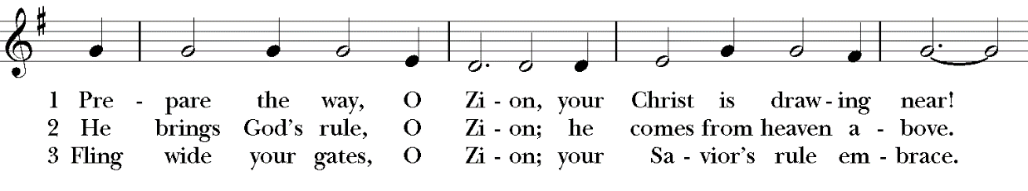
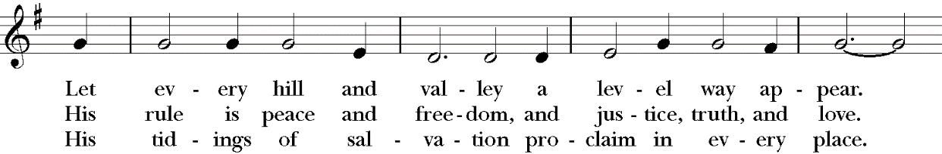
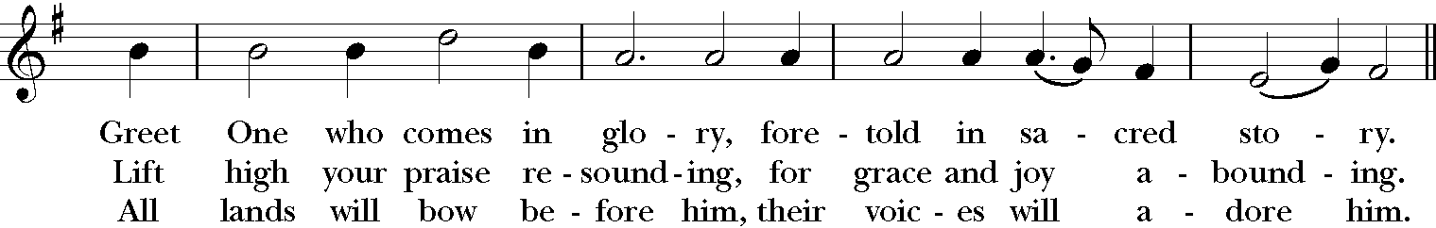
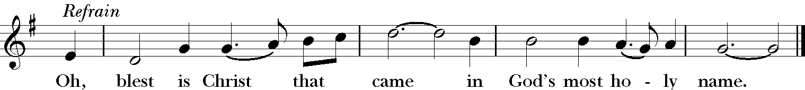

OPENING SENTENCES
Presider: The voice of one crying out in the wilderness: “Prepare the way of the Lord, make his paths straight.”
People: Walk gently in the way of peace.
Presider: “Every valley shall be filled, and every mountain and hill shall be made low.”
People: Walk gently in the way of peace.
Presider: “The crooked shall be made straight, and the rough ways made smooth.”
People: Walk gently in the way of peace.
Presider: “All flesh shall see the salvation of God.”
People: Walk gently in the way of peace.
Presider: Last week we lighted our first Advent candle to remind ourselves that hope is coming. This week we have lighted a second Advent candle, the candle of peace; as we remember that the Prince of Peace is coming, and we are called to join in the work of preparing the way. We walk gently in the way of peace. Amen. Based on Luke 3:1-6 and Isaiah 40:3-5
COLLECT FOR PURITY
Presider: Almighty God, to you all hearts are open, all desires known, and from you no secrets are hid: Cleanse the thoughts of our hearts by the inspiration of your Holy Spirit, that we may perfectly love you, and worthily magnify your holy Name; through Christ our Lord. Amen.

HYMN OF PRAISE (Please say together in unison) H1982, #74 (v. 1)
Blest be the King whose coming is in the name of God!
For him let doors be opened, no hearts against him barred!
Not robed in royal splendor, in power and pomp, comes he;
but clad as are the poorest, such is his humility!

COLLECT OF THE DAY (Please remain standing)
Presider: The Lord be with you.
People: And also with you.
Presider: Let us pray. Wild God of the wastes, whose gospel begins with a cry and a summons: take us to a pathless place where we can start again to taste creation’s gifts anew and await the Spirit’s touch; through Jesus Christ, the one who is to come.
People: Amen.

We read each month from the various biblical translations authorized by our Church. This month we read from the Authorized (King James) Bible (1611)

FIRST LESSON Isaiah 40:1-11
Reader: A reading from the book of the Prophet Isaiah. ¹ Comfort ye, comfort ye my people, saith your God. ² Speak ye comfortably to Jerusalem, and cry unto her, that her warfare is accomplished, that her iniquity is pardoned: for she hath received of the Lord's hand double for all her sins. ³ The voice of him that crieth in the wilderness, Prepare ye the way of the Lord, make straight in the desert a highway for our God. ⁴ Every valley shall be exalted, and every mountain and hill shall be made low: and the crooked shall be made straight, and the rough places plain: ⁵ And the glory of the Lord shall be revealed, and all flesh shall see it together: for the mouth of the Lord hath spoken it. ⁶ The voice said, Cry. And he said, What shall I cry? All flesh is grass, and all the goodliness thereof is as the flower of the field: ⁷ The grass withereth, the flower fadeth: because the spirit of the Lord bloweth upon it: surely the people is grass. ⁸ The grass withereth, the flower fadeth: but the word of our God shall stand for ever. ⁹ O Zion, that bringest good tidings, get thee up into the high mountain; O Jerusalem, that bringest good tidings, lift up thy voice with strength; lift it up, be not afraid; say unto the cities of Judah, Behold your God! ¹⁰ Behold, the Lord God will come with strong hand, and his arm shall rule for him: behold, his reward is with him, and his work before him. ¹¹ He shall feed his flock like a shepherd: he shall gather the lambs with his arm, and carry them in his bosom, and shall gently lead those that are with young. The word of the Lord.
People: Thanks be to God.

RESPONSE (Please say together in unison) Psalm 85:1-2, 8-13
¹ Lord, thou hast been favourable unto thy land: thou hast brought back the captivity of Jacob.
² Thou hast forgiven the iniquity of thy people, thou hast covered all their sin.
⁸ I will hear what God the Lord will speak: for he will speak peace unto his people, and to his saints: but let them not turn again to folly.
⁹ Surely his salvation is nigh them that fear him; that glory may dwell in our land.
¹⁰ Mercy and truth are met together; righteousness and peace have kissed each other.
¹¹ Truth shall spring out of the earth; and righteousness shall look down from heaven.
¹² Yea, the Lord shall give that which is good; and our land shall yield her increase.
¹³ Righteousness shall go before him; and shall set us in the way of his steps.

SECOND READING 2 Peter 3:8-15a
Reader: A reading from the second letter of Corinthians. ⁸ But, beloved, be not ignorant of this one thing, that one day is with the Lord as a thousand years, and a thousand years as one day. ⁹ The Lord is not slack concerning his promise, as some men count slackness; but is longsuffering to us-ward, not willing that any should perish, but that all should come to repentance. ¹⁰ But the day of the Lord will come as a thief in the night; in the which the heavens shall pass away with a great noise, and the elements shall melt with fervent heat, the earth also and the works that are therein shall be burned up. ¹¹ Seeing then that all these things shall be dissolved, what manner of persons ought ye to be in all holy conversation and godliness, ¹² Looking for and hasting unto the coming of the day of God, wherein the heavens being on fire shall be dissolved, and the elements shall melt with fervent heat? ¹³ Nevertheless we, according to his promise, look for new heavens and a new earth, wherein dwelleth righteousness. ¹⁴ Wherefore, beloved, seeing that ye look for such things, be diligent that ye may be found of him in peace, without spot, and blameless. ¹⁵ And account that the longsuffering of our Lord is salvation. The word of the Lord.
People: Thanks be to God.

GRADUAL HYMN (vv. 1, 2, 3) H1982 #60
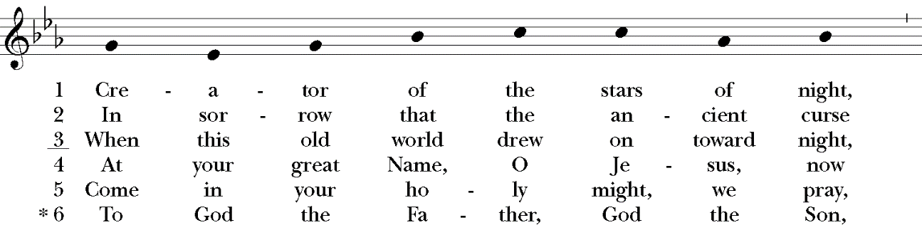
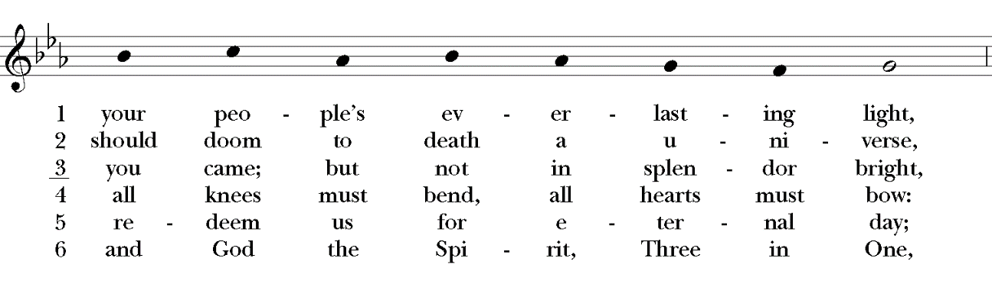
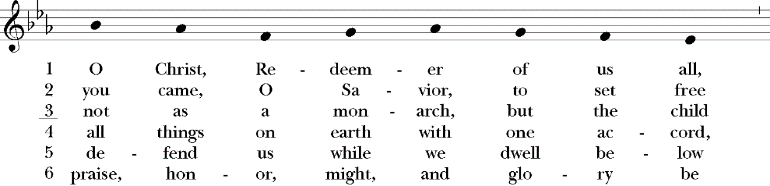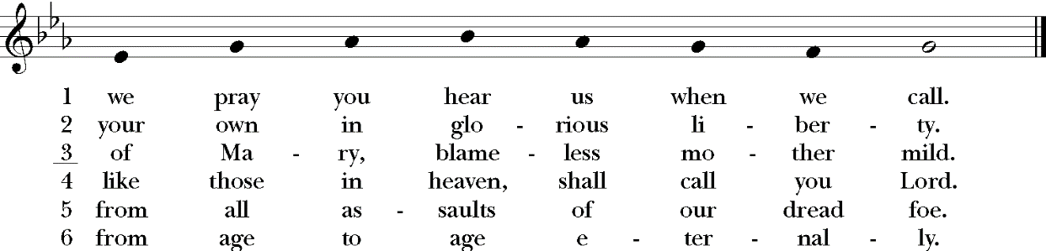

GOSPEL Mark 1:1-8
Presider: The Holy Gospel of our Lord Jesus Christ according to Mark.
People: Glory to you, Lord Christ.
Presider: ¹ The beginning of the gospel of Jesus Christ, the Son of God; ² As it is written in the prophets, Behold, I send my messenger before thy face, which shall prepare thy way before thee. ³ The voice of one crying in the wilderness, Prepare ye the way of the Lord, make his paths straight. ⁴ John did baptize in the wilderness, and preach the baptism of repentance for the remission of sins. ⁵ And there went out unto him all the land of Judaea, and they of Jerusalem, and were all baptized of him in the river of Jordan, confessing their sins. ⁶ And John was clothed with camel's hair, and with a girdle of a skin about his loins; and he did eat locusts and wild honey; ⁷ And preached, saying, There cometh one mightier than I after me, the latchet of whose shoes I am not worthy to stoop down and unloose. ⁸ I indeed have baptized you with water: but he shall baptize you with the Holy Ghost. The Gospel of the Lord.
People: Praise to you, Lord Christ.

SERMON The Rev. M. C. Gillette
(A brief period of silence follows the sermon)

AFFIRMATION OF FAITH FOR ADVENT (Please say together in unison)
We believe in God, creator and lover of the earth, origin and destiny of us all. We believe in Jesus the Christ—God coming to us in the fragile promise of a baby yet unborn—who emerges as the herald of hope, God's laughter in the face of despair. Plunged into death and hell, he liberated the captives, and is leading the way to the land of promise where justice and peace will flourish. We believe in the Holy Spirit, who implants the seed of truth, brings us to birth as the body of Christ, and empowers us to confront and transform all that is corrupt, degrading and deceitful. We believe in the coming reign of God. Announced by the Baptist, it has drawn near to us in Jesus, and will be consummated in the glorious marriage of earth and heaven, when all who have passed through the world's deep sorrow will be raised from the waters, robed in righteousness, and gathered into the joyous fulfilment of God's desire. For the coming of that day, on this day we work and pray: Come, Lord Jesus, Come!

PRAYERS OF THE PEOPLE
Leader: Let us pray to the Lord saying, ‘Lord Jesus, come in Glory.’
Leader: In this season of preparation, we pray for the whole church; for compassion, devotion, tolerance, and a commitment to unity and concord among her leaders and members. We pray for all bishops, priests, and deacons. We pray for those on our Anglican and Diocesan Cycles of prayer. We pray for all who minister, in any capacity.
People: Lord Jesus, come in Glory.
Leader: In this season of longing, we pray for our nation, and for all the nations of the world. We pray for all those who govern, and we ask you to grant them wisdom and vision. We pray for those who hold any sort of authority, that they be filled with kind and generous hearts, and a hunger for the common good.
People: Lord Jesus, come in Glory.
Leader: In this season of vigilance, we pray for the welfare of the world. We pray for strength and courage to live as you would have us live, gently, without greed, and with reverence for your good creation.
People: Lord Jesus, come in Glory.
Leader: In this season of expectation, we pray for the needs of our community; for healing and wholeness, relief and reconciliation. We pray especially for those whose names we raise up now, either silently or aloud (we will keep a 10-second silence). We pray for all who suffer from any want or worry.
People: Lord Jesus, come in Glory.
Leader: In this season of anticipation, we thank you for those celebrating birthdays and anniversaries this week, in particular those whose names we raise up now, either silently or aloud (we will keep a 10-second silence). We also offer prayers of thanksgiving for the blessings in our lives.
People: Lord Jesus, come in Glory.
Leader: In this season of hope, we pray for those who have died, especially those whose names we raise up now, either silently or aloud (we will keep a 10-second silence). We thank you that in your grace you have offered us a new, perfect, and eternal existence, in which we are united with all your people, in the joy of fully knowing and loving you and each other.
People: Lord Jesus, come in Glory.
(The Presider offers this or another concluding collect): Hasten, O Father, the coming of your kingdom; and grant that we your servants, who now live by faith, may with joy behold your Son at his coming in glorious majesty; even Jesus Christ, our only Mediator and Advocate.
People: Amen.
CONFESSION AND ABSOLUTION OF SIN (Please say together in unison)
Presider: Let us confess our sins to God.
Almighty God, you bring our fears and failings into the light of love; we prefer to hide in the shadows. Lord have mercy. Merciful God, you promise healing for the earth; we turn our backs on our common world and our brothers and sisters in Christ. Christ have mercy. Loving God, you come near in the vulnerable Word made flesh; we worship distant idols of celebrity and power. Lord have mercy.
Presider: God’s judgment is not vengeance, an eye for an eye; his peace is not false, a veil for injustice; he comes to break the spear, to silence the guns, and still our warring souls. God have mercy on you, pardon you, and set you free, strengthening you in all goodness and keeping you in life eternal.
People: Amen.

THE PEACE (Please greet each other in the name of the Lord.)
Presider: May the peace of Christ rule our world and heal our hearts.
People: Amen.

(The Presider gives an Offertory Sentence or says:) Ascribe to the Lord the honor due his Name; bring offerings and come into his courts.

OFFERTORY HYMN H1982, #69
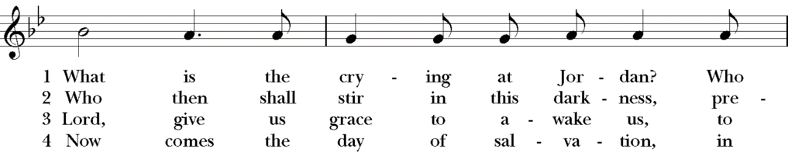
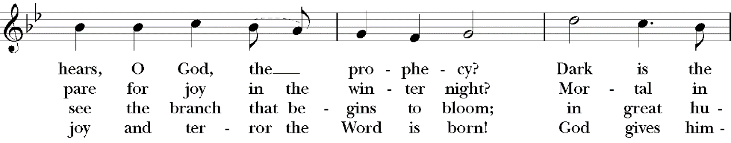
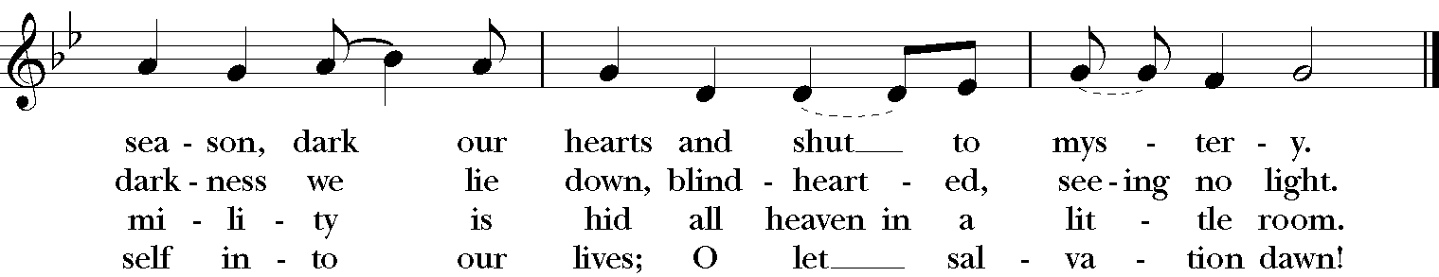

THE GREAT THANKSGIVING (Rite II, Prayer B)
Presider: The Lord be with you.
People: And also with you.
Presider: Lift up your hearts.
People: We lift them to the Lord.
Presider: Let us give thanks to the Lord our God.
People: It is right to give God thanks and praise.

Presider: Mystery of winter skies, we thank you in the darkening hour for opening our eyes to see your starlit beauty; for parting the wide heavens to send your gentle light; for offering your Word to take our mortal flesh. He was promised by those who shared your dream of peace; John the Baptist cleared his way with words of desert fire; Mary and Joseph accepted his coming with tenderness and faith; we know that he draws near again to show us who we really are with honesty and love. Now we take up the song of hope that we might awaken to his coming among us and the world might be touched by the footfall of his glory:
SANCTUS (Please say together in unison)
Holy, holy, holy Lord, God of power and might, heaven and earth are full of your glory. Hosanna in the highest. Blessed is he who comes in the name of the Lord. Hosanna in the highest.

Presider: We give thanks to you, O God, for the goodness and love which you have made known to us in creation; in the calling of Israel to be your people; in your Word spoken through the prophets; and above all in the Word made flesh, Jesus, your Son. For in these last days you sent him to be incarnate from the Virgin Mary, to be the Savior and Redeemer of the world. In him, you have delivered us from evil, and made us worthy to stand before you. In him, you have brought us out of error into truth, out of sin into righteousness, out of death into life.

↑On the night before he died for us, our Lord Jesus Christ took bread; and when he had given thanks to you, he broke it, and gave it to his disciples, and said, “Take, eat: This is my Body, which is given for you. Do this for the remembrance of me.”

↑After supper he took the cup of wine; and when he had given thanks, he gave it to them, and said, “Drink this, all of you: This is my Blood of the new Covenant, which is shed for you and for many for the forgiveness of sins. Whenever you drink it, do this for the remembrance of me.”

Therefore, according to his command, O Father,
We remember his death, We proclaim his resurrection, We await his coming in glory.

Presider: And we offer our sacrifice of praise and thanksgiving to you, O Lord of all; presenting to you, from your creation, this bread and this wine.

∞ We pray you, gracious God, to send your Holy Spirit upon these gifts that they may be the sacrament of the Body of Christ and his Blood of the new Covenant. + Unite us to your Son in his sacrifice, that we may be acceptable through him, being sanctified by the Holy Spirit. In the fullness of time, put all things in subjection under your Christ, and bring us to that heavenly country where, with all your saints, we may enter the everlasting heritage of your sons and daughters; through Jesus Christ our Lord, the firstborn of all creation, the head of the Church, and the author of our salvation.

↑By him, and with him, and in him, in the unity of the Holy Spirit all honor and glory is yours, Almighty Father, now and for ever. AMEN.

THE LORD’S PRAYER (Please say together in unison)
Presider: As our Savior Christ has taught us, we now pray,
Our Father in heaven, hallowed be your Name, your kingdom come, your will be done, on earth as in heaven. Give us today our daily bread. Forgive us our sins as we forgive those who sin against us. Save us from the time of trial, and deliver us from evil. For the kingdom, the power, and the glory are yours, now and for ever. Amen.

FRACTION (THE BREAKING OF THE BREAD)
(The Presider breaks the consecrated bread. A brief period of silence is kept.)

Presider: We break this bread to share in the body of Christ.
People: We who are many are one body, for we all share the one bread.

PRAYER OF HUMBLE ACCESS (Please say together in unison)
Most merciful Lord, your love compels us to come in. Our hands were unclean, our hearts were unprepared; we were not fit even to eat the crumbs from under your table. But you, Lord, are the God of our salvation, and share your bread with sinners. So cleanse and feed us with the precious body and blood of your Son, that he may live in us and we in him; and that we, with the whole company of Christ, may sit and eat in your kingdom. Amen.
Presider: The gifts of God for the People of God. Take them in remembrance that Christ died for you, and feed on him in your hearts by faith, with thanksgiving.

COMMUNION HYMN (vv, 1, 4, 5) H1982, #56
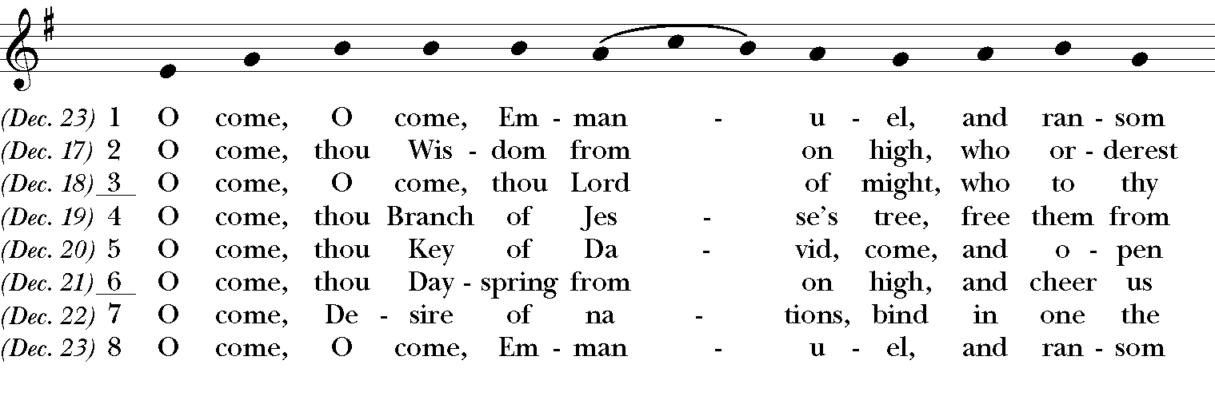
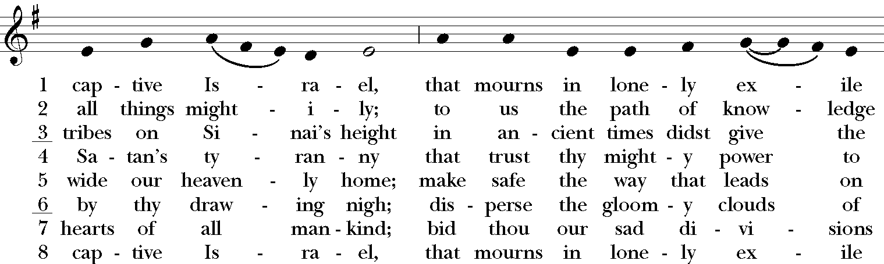
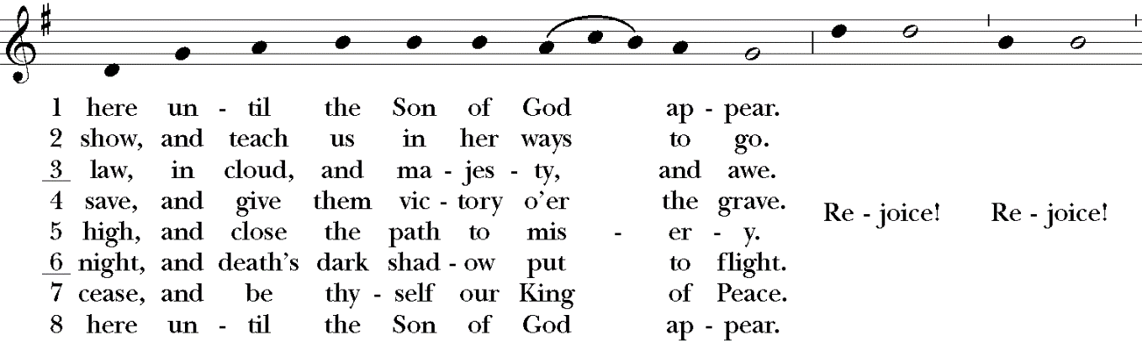

POST-COMMUNION PRAYER (Please say together in unison)
Presider: Let us pray.
Eternal God, we thank you that in Christ you give yourself into our hands: may we who have tasted life proclaim the coming feast when many will come from east and west, from north and south to greet the Lord of all; we ask this in his name. Amen.

BLESSING
Presider: May the God who brings heaven close to earth give truth to our judgment and flame to our longing that our hearts might be ready to be born again in love; and the blessing of God, the Holy Immortal One, the Incarnate Word, and the Breath of Life, be with you now and remain with you always. Amen.

CLOSING HYMN H1982, #76
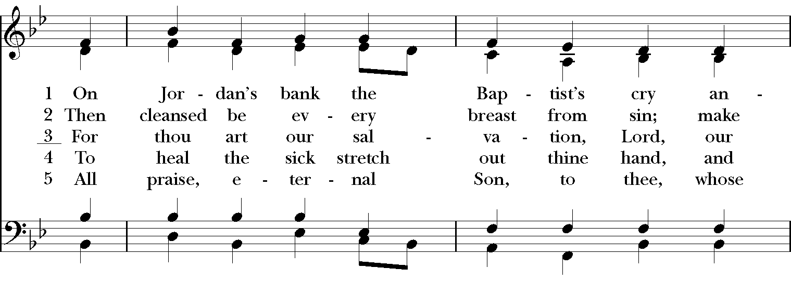
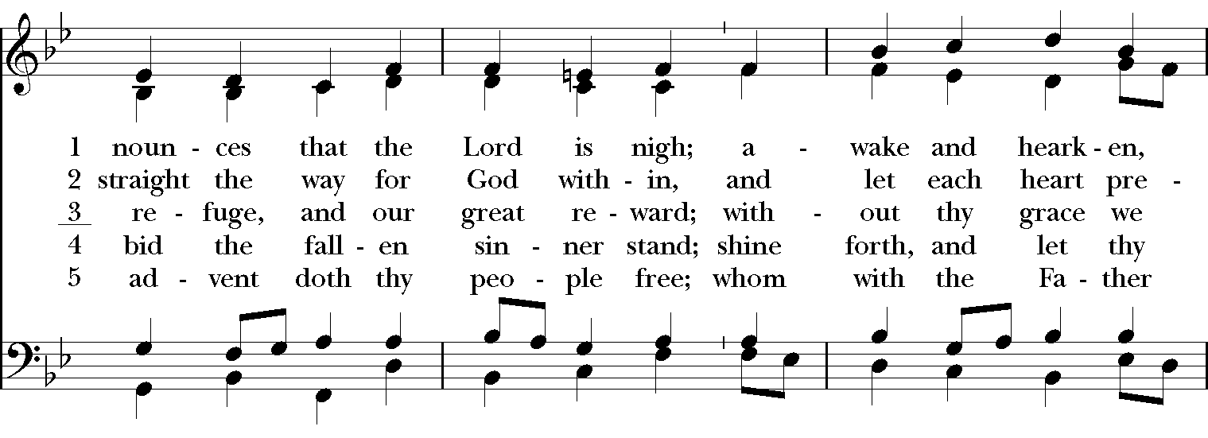
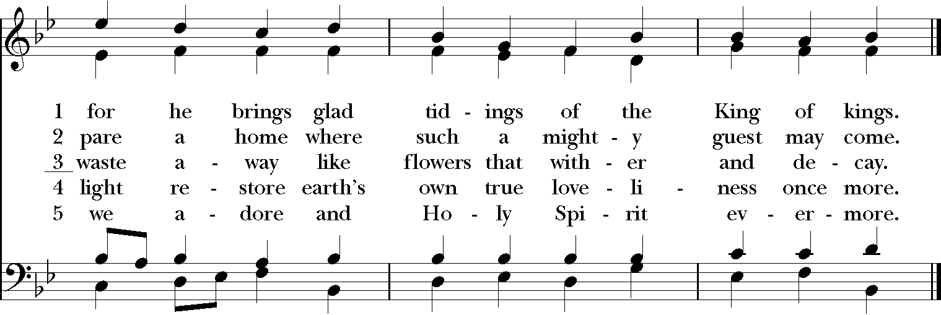

DISMISSAL
Presider: In this world: kingdom living.
People: In our mouths: kingdom praises.
Presider: In our hearts: kingdom goals.
People: In our hands: kingdom gifts.
Presider: Go forth to carry the Good News of God’s kingdom to a lost People in a world adrift, informed by the Word and inspired by the Spirit.
People: Amen. We will go!

CLOSING VOLUNTARY

Call to Worship: Leonard Sweet, posted on Preach the Story. https://preachthestory.com/
Opening Sentences: By Beth Richardson http://alivenow.upperroom.org/2010/11/08/advent-and-christmas-litanies/
Collect of the Day, Confession, Peace, Eucharistic Preface, Post-Communion Prayer, Blessing: Adapted from Prayers for an Inclusive Church, Steven Shakespeare
Affirmation of Faith: Written by Nathan Nettleton, and posted on his Laughingbird website.
Fraction Prayer of Access: A New Zealand Prayer Book
Dismissal: Carol Penner, and posted on Leading in Worship. http://carolpenner.typepad.com/

