**The Apostles Post**

26238 North Highway 59

Wauconda, Illinois

NOVEMBER 2019

2015



**FROM THE VICAR’S DESK** *(M. C. Gillette)*

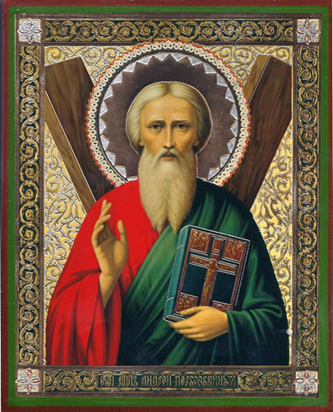 Issue X in our “B-list” Holy Days series. This month’s entry is Saint Andrew *aka* Andrew the Apostle. He just squeaks into November; his Feast Day is the 30th. The readings assigned for the day are: Deuteronomy 30:11-14 / Psalm 19 / Romans 10:8b-18 / Matthew 4:18-22. If you want to holiday in Scotland – and why wouldn’t you? Be aware that Andrew’s Feast Day is a public holiday there. He is, however, also the patron saint of the usual wide variety of places, people, and things, among them Greece, Russia, Ukraine, Georgia, and Barbados; fishermen and fishmongers, rope-makers and textile workers, singers, spinsters, miners, butchers, and farm workers; and protection against sore throats, convulsions, fever, and whooping cough. For your visual pleasure this month, you have (1) a tidy, respectable icon in which, icon style, he looks quite whole and healthy, (2) Caravaggio’s 1607 rendition of his crucifixion, in which he looks decidedly broken and unhealthy, because – Caravaggio – and (3) Juan Correa de Vivar’s rendition of his crucifixion (1540-1545) because it seems to fit somewhere in-between the other two, and who knew they had that kind of underwear in the 16th century?

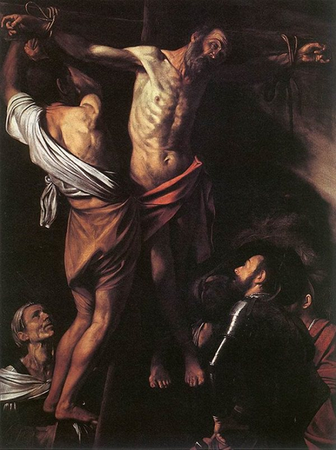 “Andrew” means manly, brave, valor. It is a Greek name, not Hebrew, suggesting that while he was Jewish, his family was probably Hellenized and had a certain cultural openness. As with most of our Saints and Apostles, we know little to nothing about him outside the biblical record which, typically, is sparse. We might assume he was born between AD 5 and AD 10 in Bethsaida, the principal fishing port of Palestine. His parents were Jona and Joanna; his brother was Simon Peter. Jona, along with his business-partner and friend Zebedee and his sons James and John, was a fisherman.

Your understanding of how Andrew became an Apostle depends on which gospel you prefer. In Matthew (4:18-22) and Mark (1:16-20), Jesus, as he was walking along the shore of the Sea of Galilee, observed Andrew and Peter fishing and called them to be “fishers of men” instead of fishers of – well, fish. Luke (5:1-11) tells the story of Jesus, after – appropriating – Peter’s boat for a bit of preaching, told him to lower his nets down for a catch. Although no fish at all had been caught in the previous night’s fishing, Peter did as he was told and hauled up a tremendous net-full of floppy-tailed goodness. While Andrew isn’t named specifically, it is clear Peter was not alone in the boat, and it is probably safe to assume his brother was there with him. John, being John, has a completely different version of Andrew’s calling. John says (John 1:35-42) that Andrew was a disciple of John the Baptist, whose testimony first led him, and another unnamed disciple of the Baptizer’s, to follow Jesus. According to John, it was Andrew who at once recognized Jesus as the Messiah, and hastened to introduce him to his brother. Several sources seem to favor John, but don’t let that sway you – be bold. Pick your own favorite. In any case, scripture attests to his close relationship with Jesus. For example, according to John’s gospel, 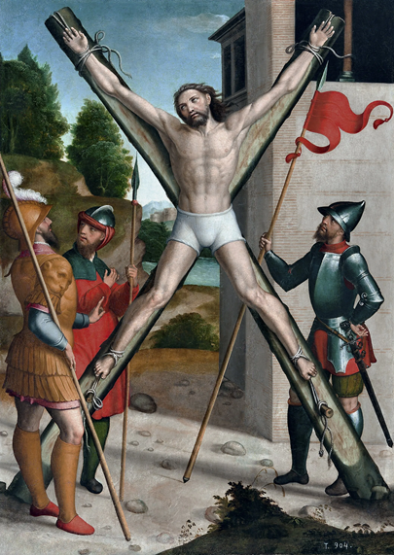it was Andrew who told Jesus about “the boy here with five barley loaves and two fishes” (John 6:8) – and Mark tells us (Mark 13:3-4) that it was Andrew, along with Peter, James, and John, who, while sitting with Jesus on the Mount of Olives, privately asked Jesus to tell him about the apocalyptic signs he had hinted at when he spoke of the destruction of the Temple. (Which prompted Jesus to launch into a long – especially for Mark – discourse on the end signs.)

According to the apocryphal 'Acts of Andrew,' he is said to have travelled to Asia Minor and the Black Sea. In the city of Synope he is believed to have suffered great hardships and the house he was in was nearly burnt down. He returned twice more to Asia Minor and Greece, even travelling as far as Hungary, Russia and to the banks of the Oder in Poland. In Greece, we read, Andrew forced his way through a forest inhabited by wolves, bears and tigers. Finally, in Patras, he was given the choice of being offered as a sacrifice to the gods or being scourged and crucified. He chose “crucified,” and by his own request the cross was diagonal, as he – like his brother Peter – felt himself unworthy to be crucified on the upright cross of Christ. Pious legend says that he hung for three days on his cross, fixed not by nails but by rope round his hands and feet. Even in his last agony, he continued to preach. Then he died, and bits and pieces of him were saved by – who knows who? – and eventually scattered (very intentionally, and with great political drama) across a great swath of Christendom. You can jump into that rabbit hole yourself if interested, after which you will probably find yourself wandering through an entire rabbit warren, so beware. If you would like to read the gnostic writings relating to Andrew, you can find the texts here:

The Acts of Andrew: <http://www.earlychristianwritings.com/text/actsandrew.html>

The Gospel of Saint Andrew: <http://gnosis.org/library/actandy.htm>

|  |  |  |  |  |  |
| --- | --- | --- | --- | --- | --- |
| **EPISCOPAL CHURCH OF THE HOLY APOSTLES UPCOMING SERVICES** | | | | | |
| Sunday  03 November  8:00/ 10:30 a.m. | Sunday  10 November  8:00/ 10:30 a.m. | Sunday  17 November  8:00/ 10:30 a.m. | Sunday  24 November  8:00/ 10:30 a.m. | Wednesday  27 November  7:00 p.m. | Friday  29 November  7:00 p.m. |
| Presider:  Gillette  Preacher:  Gillette | Presider:  Gillette  Preacher:  Gillette | Presider:  Gillette  Preacher:  Gillette | Presider:  Gillette  Preacher:  Gillette | Presider:  Gillette  Preacher:  Gillette | Presider:  Gillette |
| 21st Sunday after  Pentecost  Proper 26 (C) and All-Saints | 22nd Sunday after  Pentecost  Proper 27 (C) | 23rd Sunday after  Pentecost  Proper 28 (C) | Last Sunday after  Pentecost  Christ the King | Thanksgiving Eve | Taize Service of Silence and Light |
| 1st LESSON  Habakkuk  1:1-4; 2:1-4  RESPONSE Psalm  119:137-144  2nd LESSON  2 Thessalonians  1:1-4, 11-12  GOSPEL  Luke  19:1-1 | 1st LESSON  Haggai  1:15b-2:9  RESPONSE Psalm  145:1-5, 18-22  2nd LESSON  1 Thessalonians  2:1-5, 13-17  GOSPEL  Luke  20:27-38 | 1st LESSON  Isaiah  65:17-25  RESPONSE Canticle  9  2nd LESSON  2 Thessalonians  3:6-13  GOSPEL  Luke  21:5-10 | 1st LESSON  Jeremiah  23:1-6  RESPONSE Canticle  16  2nd LESSON  Colossians  1:11-20  GOSPEL  Luke  23:33-43 | 1st LESSON  Deuteronomy  26:1-11  RESPONSE Psalm  100  2nd LESSON  Philippians  4:4-9  GOSPEL  John  6:25-35 |  |

**SOME CHURCHY STUFF** *(M. C. Gillette at* [*hapostles@sbcglobal.net*](mailto:hapostles@sbcglobal.net)*) In this monthly article, we look at terms and definitions of things you might see or hear around church. Nothing fancy here – these entries are out of the Armentrout/Slocum An Episcopal Dictionary of the Church, sometimes supplemented by me, and sometimes simply copied directly. If something in particular piques your interest, let me know, and we’ll deal with it in more depth.*

**ELOHIM.** A Hebrew word sometimes used for pagan deities, such as the Moabite god Chemosh or the Sidonian goddess Astarte, and also for other majestic beings such as angels, kings, judges (the Old Testament shofeṭim), and the Messiah (as referred to in the Old Testament) but usually referring to Israel's one God, Yahweh. Although the word is plural (the singular form is Eloah), it typically appears with singular verbs when the term refers to God. The use of the plural form may be explained as a "plural of majesty" rather than an indication of polytheism. When referring to Yahweh, elohim very often is accompanied by the article ha-, to mean, in combination, “the God,” and sometimes with a further identification Elohim ḥayyim, meaning “the living God.” The Israelites probably borrowed the Canaanite plural noun Elohim and made it singular in meaning in their cultic practices and theological reflections. Jewish midrash on Exodus 3:6, in which God “introduces” Godself to Moses reads “The Holy One, Blessed be He, said to those, You want to know my name? I am called according to my actions. When I judge the creatures I am Elohim, and when I have mercy with my world, I am named YHVH.”

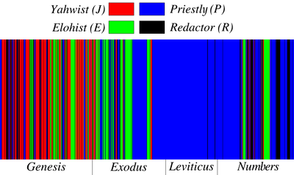**ELOHIST, THE.** One of four sources for the composition of the Pentateuch, according to a theory accepted by many biblical scholars (and based on several criteria). Known as the Documentary Theory, the hypothesis that the first five biblical books (traditionally said to be written by Moses) are the work of four separate authors/schools, was first put forth by German scholars led by Julius Wellhausen. The theory assigns the name Elohist to the source that consistently uses the Hebrew word Elohim for God until the call of Moses in Exodus 3, when the proper name Yahweh is first revealed. The four “authors” are referred to as the Yahwist, the Elohist, the Priestly writers, and the Deuteronomist (so called because he/they wrote the fifth book of the Pentateuch, Deuteronomy). The theory postulates that four ancient books, long lost, were at some point merged together by an editor dubbed the Redactor.



**LETTER.** Every postulant or candidate for holy orders in the Episcopal Church is required by canon to report to the bishop during the Ember Weeks. *(Ember Weeks are three days (because – does a week really need all seven days?) which occur four times a year: the Wednesday, Friday, and Saturday after St. Lucy's Day (? Saint Lucy? Who?), Ash Wednesday, the Day of Pentecost, and Holy Cross Day (Sept. 14)). The name comes from the Latin title Quattuor tempora, meaning "four times." In ancient Italy the times (of which there were originally only three) were associated with sowing, harvest, and vintage, for which one prayed, fasted, and gave alms. Later the four times (one for each season, I suppose) became occasions for ordination, for which the Christian community prayed and the candidates prepared themselves by prayer and retreat. (I still want to know who Saint Lucy is, and what she has to do with ordinations.) The Book of Common Prayer appoints proper collects and readings for this observance under the title "For the Ministry (Ember Days), including propers "For those to be ordained," "For the choice of fit persons for the ministry," and "For all Christians in their vocation.")* Anyway the report people slogging through the ordination process are required to give must be made in person or by letter, and must include reflection on the person's academic experience as well as personal and spiritual development.

**IN OUR** **PARISH LIFE:**

**SHAWL MINISTRY:** The Shawl Ministry meets on **Monday 11 November at 7:00 PM** in Lincoln Hall. No experience is necessary! Please contact Marsha Taylor at [mktaylor730@hotmail.com](mailto:mktaylor730@hotmail.com) or 847-977-5399 with any questions.

***A Message from Marsha:***

We have an amazing group of ladies who outdid themselves again this year with our knitted and crocheted shawls and oh-so-soft fleece blankets and knitted and fleece hats. Aline even recruited her daughter Megan and granddaughter Lila to assist in making the fleece blankets. A special thank you to them, and also Marsha Fedor, Eileen Kinney, Jane Allen, Peggy, Gail Permenter, Angie Pinder, Julie Zuidema, Penny Treptow, Jean Miller, Johnna Bradfield, Olga Kornienko, Lynn Chmiel, and Sharon Thompson.   The ladies at St. Michaels Episcopal

Church in Barrington also donated a few shawls to be added to the collection.

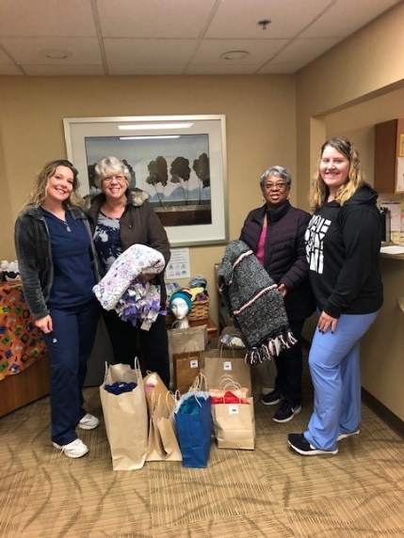 Our deliveries were warmly received with big smiles and grateful hearts.  We received a generous thank you of $50 cash donations from a few of the patients of the Medical Oncology Department at Advocate Good Shepherd.    These funds will go back into the ministry to purchase more medallions and supplies. We have an amazing group of dedicated women who no matter their busy circumstances have always come through and given of themselves.  I am so proud of you all.  Thank you for supporting our God blessed ministry.  We welcome new members at all times.  We even teach knitting and crocheting or tying blankets and making hats for those interested.

**Advocate Good Shepherd Hospital**

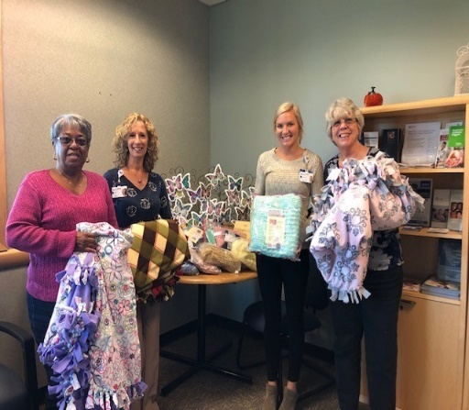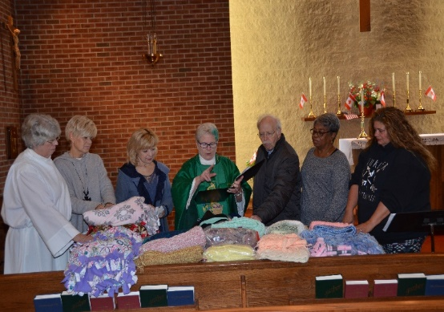

**Sage Cancer Center McHenry**

**Blessing of the Shawls**

**BISHOP’S COMMITTEE MEETING:** Bishop’s Committee will meet on **Tuesday 19 November at 7:00 p.m.** in Lincoln Hall.

**BOOK DISCUSSION GROUP:** This month the Book Group will meet **on 26 November at 7:30 PM** to discuss *Tribe: On Homecoming and Belonging* by Sebastian Junger, at the home of Mary Nickell.

**ADULT FORMATION:**  ***Making Sense of Scripture: Big Questions About the Book of Faith,*** by David J. Lose. The author invites us to engage in a conversation, one he imagines around his kitchen table. As he says, "Questions are, I think, the engine of all great conversations..." See dates and topics below:

**17 November** - How is the Bible the Word of God?

We will meet between services to engage in conversation surrounding the week's question. No sign-up is required, and no prior preparation is needed. Feel free to attend any one or all; each conversation stands on its own. (In the spring, we will converse around the remaining four questions of his work.)

Looking Ahead: On the **1st and 8th of December**, please join us between services as we look at some poetic reflections on the Revised Common Lectionary (RCL) for the seasons of Advent and Christmas. We will meet between services to look at the poems of Michael Coffey in his work ***Mystery Without Rhyme or Reason.***

**WAUCONDA/ISLAND LAKE FOOD PANTRY:** The milk jug count for September was $64.53. In September the food pantry served 165 families which totaled 424 individuals. Twelve families were new to the pantry.

**THANKSGIVING EVE SERVICE AND PIE FELLOWSHIP:** Please join us for the Thanksgiving Eve Service on Wednesday, November 25 at 7:00 pm. Please bring your favorite pie or autumn goodies to pass immediately following the service.

**TAIZE SERVICE of Silence and Light:** All are welcome to the next Taize Service on Friday, November 29, beginning at 7:00 pm. This service provides opportunities for silence, interspersed with chants and readings.

**RECYCLE YOUR SHOES!** Any and all shoes will be accepted-shoes in good condition will be given to others, and shoes that have seen better days will be ground up and reborn as playground material! You may deposit your old shoes in the collection box located in the Narthex. Please contact Marsha Fedor with any questions.

|  |  |  |  |  |  |  |
| --- | --- | --- | --- | --- | --- | --- |
| **NOVEMBER 2019 (See PAGE 3 above for Service Schedule.)** | | | | | | |
| **SUN** | **MON** | **TUE** | **WED** | **THU** | **FRI** | **SAT** |
|  |  |  |  |  | 1 | 2  10 AM—noon  Food Pantry |
| 3  8:00 AM service  10:30 AM service | 4 | 5 | 6 | 7 | 8 | 9  10 AM—noon  Food Pantry  PADS- 4:30PM |
| 10  8:00 AM service  10:30 AM service  P.A.D.S. ends at  8:00 AM | 11  7:00 PM  Shawl Ministry | 12 | 13 | 14 | 15 | 16  10 AM--noon  Food Pantry  **AUCTION DINNER**  6:00-11:00 PM |
| 17  8:00 AM service  Adult Formation  10:30 AM service | 18 | 19  Bishop’s Comm.  Mtg 7:00 PM | 20 | 21 | 22 | 23  10 AM--noon  Food Pantry |
| 24  8:00 AM service  10:30 AM service | 25 | 26  Book Group  7:30 PM | 27  7:00 PM  Thanksgiving Eve  Service and Fellowship | 28  THANKSGIVING DAY | 29  7:00 PM  Taize Service | 30  10 AM--noon  Food Pantry  10 AM--noon  Decorate the Church for Advent |

**November Birthdays**

Nov 02 Ed Dura Nov 17 Connie Brey

Nov 03 Kristi Connell Nov 20 Carl Reed

Nov 09 Virginia Balmes Nov 22 Aline Denges

Nov 15 Ken Balmes, Michele Seiler Nov 27 Colin McAlister

**IMPORTANT THINGS TO KNOW ABOUT**

***Holy Apostles 51ST Annual Dinner and Dance Fundraiser***

1. Saturday, November 16, 2019 at Mill Creek Banquets-333 Mill Street, Wauconda, beginning at 6:00 PM
2. Tickets are available between services most Sundays & on the website: www.holyapostleswauconda.net
3. $35/per person before Nov 3rd, $40/person after Nov 3rd
4. This year you can sign out tickets and sell them on your own.
5. All drink prices have been increased by a $1, and that $1 comes back to the church.
6. Turn in $75 of full face value Gift Cards (any denominations as long as they are full face value and total at least $75) and we will give you a $10 Big Raffle Ticket.
7. “The Big Raffle” tickets will be available, $10 per ticket.
8. Start thinking about building your Raffle Basket.
9. Start thinking about making items to donate.
10. We are selling ads for the Auction Booklet, forms are on Jackie’s desk.
11. "The last day dinner tickets will be sold is November 10th."

***Please remember that YOU ARE THE REASON the auction is a success!***

If you have any questions, please feel free to give me a call at 847-775-0770.

Todd Seiler, Auction Dinner Coordinator

**What is the PADS Shelter Program?**

PADS Emergency Overnight Shelter Program provides those experiencing homelessness with a safe, warm place to sleep every night from October through April. Each night there are at least two sites open to provide shelter. As many of you may know, Messiah Lutheran serves as one of those sites for Saturday night through Sunday morning. The guests are transported from the PADS Day Resource Center and arrive around 6:30 on Saturday evening. After a hot meal, they are free to watch a movie, play cards or board games, visit with the volunteers, or simply rest or sleep. In the morning, the guest receive a hot breakfast and a sack lunch. Holy Apostles has agreed to provide the staffing and the food for two weekends during the 2019-2020 PAD seasons. The first weekend is Saturday afternoon November 9 through Sunday morning November 10. The second is February 8-9, 2020, from Saturday afternoon until Sunday morning.

**Who Can Help?** In most cases, any adult or teenager can participate. For the overnight shifts, we require that the volunteers be adults and at least one of them must be a male. It doesn’t matter if you are a member of Holy Apostles, another church, or no church at all. That is not what is important. They only requirement is that you want to do something to fight homelessness and hunger in Lake County. So reach out to friends and family to invite them to join with you and help make a difference.

**How Can I Help?** There are many different ways to help, both **directly with the guests** and **indirectly behind the scenes.** Most opportunities require only a minimal time commitment. Any one is welcome to participate in as many different ways as he/she would like.

**DIRECTLY:** Volunteer to staff one (or more) of the shifts on Saturday or Sunday. If any of the direct contact positions appeal to you, sign up ONLINE using the Holy Apostles PAD page on Sign Up Genius: [www.SignUpGenius.com/go/10C0C4AAEAF22A7FD0-holy](http://www.signupgenius.com/go/10C0C4AAEAF22A7FD0-holy)

If you don’t wish to sign up online, or want more information, please contact us at [hapostles@sbcglobal.net](mailto:hapostles@sbcglobal.net) or via our Facebook page <https://www.facebook.com/WaucondaHolyApostles/>

**BEHIND THE SCENES:**

*FOOD*

* Donate items for the sack lunches that PADS provides when the guests leave on Sunday morning.
* Make desserts for dinner on Saturday
* Make / buy snacks for movie time on Saturday evening
* Make breakfast items for Sunday morning
* Donate money to defray the costs of providing Dinner, Breakfast & Sack Lunch (We are still working out costs, but it is likely to be between $10 - $20 per guest)

*SHELTER*

* Arrive in the afternoon on Saturday and set up the mattresses and bedding for the guests
* Arrive after guests depart (approx 6:30 am) to strip bedding & restack mattresses
* Do laundry to have bedding ready for following Saturday

If you are interested in helping “behind the scenes” (whether in lieu of, or in addition to volunteering for a shift, please contact us at [hapostles@sbcglobal.net](mailto:hapostles@sbcglobal.net) or via our Facebook page <https://www.facebook.com/WaucondaHolyApostles/>

|  |  |  |  |
| --- | --- | --- | --- |
| **Shift Name** | **Day and Time** | **Responsibilities** | **# of Volunteers Needed** |
| Set-up. Serve Dinner | Saturday Nov. 9  4:30PM – 7:00PM | Prepare beds and tables. Serve dinner. Start clean-up | **FILLED** |
| Guest Assist | Saturday Nov. 9  7:00PM – 10:00PM | Interact with guests. Watch a movie, play cards, pray, serve snacks | **1 person needed** |
| **Quiet Time** | **Saturday Nov. 9 – Sunday Nov. 10**  **10:00pm - 2:00am** | Assist while guest watch a movie or rest | **FILLED** |
| **Night Watch**  **Serve Breakfast** | **Sun. - 2:00am - 6:00am** | Watch over sleeping guest. Prep and serve breakfast | **1 MALE needed** |
| Clean-Up | 6:00am - 8:00a | Clean beds, bathrooms, kitchen and tables | **2 people needed** |

**A REMINDER:** Your Leadership Team (Bishop’s Committee, Treasurer, Parish Administrator, Priest-in-Charge, Warden) is always available to address any questions you might have.

**Bishop’s Committee:**

Ken Balmes / ksemlab@att.net

Lynn McAlister / rolymac@sbcglobal.net

Michele Seiler / utamce@comcast.net

Doug Connell / douglasconnell@yahoo.com

Marcie Suelzer / [suelzerm@hotmail.com](mailto:suelzerm@hotmail.com)

Kristi Connell / springerkristi@gmail.com

June Kramer / [juneakramer@gmail.com](mailto:juneakramer@gmail.com)

Sandy Stephens / sandybrown011@comcast.net

**Treasurer:** Geoff Cooper / 1950gmjc@gmail.com

**Parish Administrator:** Jackie Smith / holyapostlesoffice@gmail.com

**Priest-in-Charge:** The Rev. Martha Gillette / marthagillette@att.net

**Senior Warden:** Julie Zuidema / [smithz@aol.com](mailto:smithz@aol.com)

**Junior Warden:** Neil Rothenberg / neilroth03@yahoo.com

While only members are able to vote on business matters, Bishop’s Committee meetings are open to anyone who wishes to attend. Meetings are the 3rd Tuesday of each month, at 7:00 p.m., in Lincoln Hall.

Minutes of all meetings are available for you to review. They are in the black binder on the white unit next to the Parish Administrator’s desk. Please note that minutes cannot be posted until they have been approved by the Committee; therefore there is always at least one month’s delay before they are available.

**FROM: Church of the Holy Apostles**

**26238 North Highway 59**

**Wauconda, Illinois 60084**