**The Apostles Post**

26238 North Highway 59

Wauconda, Illinois

AUGUST 2021

2015



**FROM THE VICAR’S DESK** *(M. C. Gillette)*

Gnostic Writings, Issue VIII. Melchizedek.

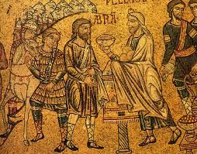For a guy who appears in exactly 13 verses of the Bible (Genesis 14:18-20; Psalm 110:4; Hebrews 5:6, 10, 20; Hebrews 7:1, 4, 6, 10-11, 15), Melchizedek plays an out-size role in scripture, theology, and liturgical practice. Although, as just noted, he doesn’t have a large footprint in canonical scripture, he is there; but also (and far more substantially) in the Gnostic scriptures, the Q’uran, Rabbinic literature, and various independent religious texts. Further, the Priesthood of Melchizedek influenced/ influences the Knights Templar, the Freemasons (and for those of you who are Masons, please forgive what might differ from your understanding/practice), the Church of the Latter Day Saints, and the Order of Melchizedek. (In case you were wondering, there *is* a Chicago Gnostic Academy, (<https://chicagognosis.org/index.html>), which, among other things, offers classes on Melchizedekian Spiritual Practices (<https://chicagognosis.org/articles/spiritual-practice-with-melchizedek)>). One could clearly devote an entire lifetime to Melchizedekian reading, study, and practice; but one could never reduce all that to fit into one small newsletter cover article. All you are going to get here, therefore, are bits and pieces pertaining to the treatise or tractate of *Melchizedek* (found in the Nag Hammadi library), although it is important to note that a separate work called *The Coming of Melchizedek* was found with the Dead Sea Scrolls. But after all, the focus of this “Gnostic Writings” series has been advertised all along to be only brief sketches to introduce you to the existence of these texts.

You can read academic translations of these eponymous writings online at the Gnostic Society Library; the tractate of *Melchizedek* here (<http://www.gnosis.org/naghamm/melchiz.html>) and *The Coming of Melchizedek* here (<http://www.gnosis.org/library/commelc.htm>.) Or, if you prefer mystical trance-induced translations, you can surf the web – there are several available. Both the Melchizedek texts are incomplete; the tractate particularly so. According to Giversen and Pearson (the translators) only 19 lines out of 745 have been fully preserved, and less than 50 percent of the text as a whole is recoverable. (“Recovery” generally means “reasonably interpolated.”) Academic speculation is that it was written in the third century, although arguments are made that the Order of Melchizedek not only shaped Christianity and Gnosticism 2,000+ years ago, but was present during the emergence of Judaism over 4,000 years ago, and that there are even older parallels with the ancient Egyptian God Toth and other deities who predate known written history.

“Melchizedek” can be transliterated from the Hebrew as Malki Tzedek, which in turn can be translated roughly as "Zedek (or Sedek) is my king" or "My king is righteous" or “King of Peace.” The former, which treats *Zedek* as a proper noun, refers to a Cannanite deity with that name. The term appears again in the Hebrew Bible in the name of the Jebusite king Adoni-zedek (Joshua 10:1) who led a coalition of five of the neighboring Amorite rulers to resist the invasion of Joshua, but was defeated at Gibeon. In Genesis 14, however, Melchizedek is also referred to as *King of Salem*, (“Salem” meaning “peace”), believed by many to be ancient Jerusalem, the fortress city of the Jebusites. The tractate itself presents him as a warrior angel, ranking above the Archangel Michael. Other theories about the identity of Melchizedek include:

1) The Spirit of Jesus, or the “Holy Spirit,” an eternal being who materializes in specific human form from time to time to lead humankind toward the light of God. (The tractate says “The lawyers will bury him quickly. They will call him 'impious man', 'lawless', 'impure'. And on the third day, he will rise from the dead.” And he is described in Hebrews 7:3 thusly: He is without father or mother or any family. He has no beginning or end of life, but he’s like God’s Son and remains a priest for all time). One way or the other, the tractate is notable for its anti-docetic emphasis on the real humanity of Jesus. (“They will say of him that he is unbegotten though he has been begotten, (that) he does not eat even though he eats, (that) he does not drink even though he drinks, (that) he is uncircumcised though he has been circumcised, (that) he is unfleshly though he has come in flesh, (that) he did not come to suffering, [though] he arose from [the] dead);

2) an idea – the union of priest and king into a single concept, representing a merging of consciousness between the duality of church and state;

3) an Ascended Master of Atlantis – a teacher in ancient mystery schools, who was later reincarnated as both Toth and Hermes.

4) a warrior angel (ranking above Michael – this is how the tractate itself presents him) and eschatological high priest.

Giversen and Pearson postulate the work originated with a sect of Melchizedekians; Koester argues that it shows a literary dependence on Hebrews; it has clear gnostic elements; Davila asserts it draws on varied Jewish traditions about Melchizedek that also gave rise to *The Coming Of Melchizedek* and other extra-canonical works such as 2 Enoch. In other words, it’s pretty much impossible to categorize the text’s religious perspective, unless, of course, you have a particular personal perspective in which you desire to categorize it.

|  |  |  |  |  |
| --- | --- | --- | --- | --- |
| **EPISCOPAL CHURCH OF THE HOLY APOSTLES UPCOMING SERVICES – AUGUST 2021** | | | | |
| Sunday  01 August  **9:30 a.m**.  In-church | Sunday  08 August  **9:30 a.m**.  In-church | Sunday  15 August  **9:30 a.m**.  In-church | Sunday  22 August  **9:30 a.m**.  In-church | Sunday  29 August  **9:30 a.m**.  In-church |
| Scheduled  Presider:  Gillette  Preacher:  Gillette | Scheduled  Presider:  Gillette  Preacher:  Gillette | Scheduled  Presider:  Idicula  Preacher:  Idicula | Scheduled  Presider:  Gillette  Preacher:  Gillette | Scheduled  Presider:  Gillette  Preacher:  Gillette |
| Tenth Sunday  after Pentecost  Proper 13(B) | Eleventh Sunday after Pentecost  Proper 14(B) | Twelfth Sunday after Pentecost  Proper 15(B) | Thirteenth Sunday  after Pentecost  Proper 16(B) | Fourteenth Sunday after Pentecost Proper 17(B) |
| 1st LESSON  2 Samuel  11:26-12:13a  RESPONSE Psalm 51:1-13  2nd LESSON  Ephesians  4:1-16  GOSPEL  John 6:24-35 | 1st LESSON  2 Samuel  18:5-9, 15, 31-33  RESPONSE Psalm 130  2nd LESSON  Ephesians  4:25-5:2  GOSPEL  John 6:35, 41-51 | 1st  LESSON  1 Kings  2::10-12, 3:3-14  RESPONSE Psalm 11  2nd LESSON  Ephesians  5:15-20  GOSPEL  John 6:51-18 | 1st LESSON  1 Kings  8:1, 6, 10-11, 22-30, 41-43  RESPONSE Psalm 84  2nd LESSON  Ephesians 6:10-20  GOSPEL  John  6:56-69 | 1st LESSON  Song of Solomon  2:8-13  RESPONSE Psalm 45:1-2, 7-10  2nd LESSON  James 1:17-27  GOSPEL  Mark  7:1-8, 14-15, 21-23 |

**HERE AND THERE** *(M. C. Gillette)*

*In this on-going article, we pull things from our various Diocesan calendars and church websites to see what’s going on around us. For more information about what's happening at the Diocesan Headquarters and the Cathedral of Saint James, you can always visit their websites:* <https://www.episcopalchicago.org> or <https://www.saintjamescathedral.org/>

**Consecration Postponed; Assisting Bishop To Be Appointed**

In a video recorded in Chicago on July 28, Presiding Bishop Michael Curry announced that the ordination and consecration of Bishop-elect Paula Clark has been postponed from August 28 to a date to be determined in consultation with the bishop-elect and her doctors.

“We continue to have every expectation that Bishop-elect Clark will make a recovery enabling her to serve as the bishop of Chicago,” he said. “But we are not there yet. Please hear me when I say, we are not there *yet*!”

Bishop-elect Clark, seated with the Presiding Bishop and Anne B. Jolly, president of the diocese’s Standing Committee, also greeted the people of the diocese. “Of course I am really sad I can’t be your bishop right now. It would be my preference to start as your bishop right this instant, but as you can hear from me right now, there is a little way that we have to go in order to be at full-time capacity,” she said, referring to her speech, which is still partially impaired in the wake of [a cerebral bleed she suffered in April](https://episcopalchicago.org/a-message-from-standing-committee-president-anne-jolly/). She is currently participating in a rigorous schedule of physical, occupational and speech therapy, Curry said, and her doctors report that her progress has been “remarkable.”

“While my medical team was confident I could have gone forward on August 28, the Presiding Bishop, Anne Jolly and I feel it is best if I can be healed more at the time of the consecration, and able to begin work with you together,” Clark said.

Curry plans to meet with the bishop-elect and her doctors in early October and, if necessary, every three months thereafter to assess her progress. “I have two criteria for discerning when we will be ready to proceed,” Curry said. “First, when our bishop-elect is able to take her place fully in the service of ordination and consecration both as bishop-elect, making her vows, leading us in the church’s profession of faith and receiving the laying on of hands, and then as the bishop, serving as the chief celebrant at the Holy Eucharist. Second, when she is also ready to assume the duties of bishop of the diocese, such as visitations with congregations, providing pastoral, programmatic and administrative oversight of ministry, certainly beginning at a reduced and planned level developed in consultation with the medical team.”

The Standing Committee remains the ecclesiastical authority of the diocese, Jolly said in the video. The group is in the final stages of securing an assisting bishop to serve the diocese beginning in the fall and expects to make an announcement in the coming weeks. “The Standing Committee, I will tell you, are your biggest cheerleaders,” Jolly told Clark. “We support you and pray for you and we have every expectation that you will make a full recovery and we look forward to the day that we can all serve together for this Diocese of Chicago we love so dearly.”

[Watch the video on YouTube](https://youtu.be/a7sljaigxsU).

|  |
| --- |
| **Tell Me the Truth About Racism: Diocese Awarded Becoming Beloved Community Grant Information Session for Christian educators on August 24** |
| |  |  | | --- | --- | |  | https://ci6.googleusercontent.com/proxy/hGrq11JG9KecB2nG0ztsJdIJsShd70PcMwlY7vDILI7Fc7SBVfbbc4wG_OUVaE6DKHnxEZLrHYsrLGiKl23tFIyxiTHqbeDSTQkpSvG9=s0-d-e1-ft#https://imgssl.constantcontact.com/letters/images/sys/S.gif | | https://ci6.googleusercontent.com/proxy/hGrq11JG9KecB2nG0ztsJdIJsShd70PcMwlY7vDILI7Fc7SBVfbbc4wG_OUVaE6DKHnxEZLrHYsrLGiKl23tFIyxiTHqbeDSTQkpSvG9=s0-d-e1-ft#https://imgssl.constantcontact.com/letters/images/sys/S.gif | https://ci6.googleusercontent.com/proxy/hGrq11JG9KecB2nG0ztsJdIJsShd70PcMwlY7vDILI7Fc7SBVfbbc4wG_OUVaE6DKHnxEZLrHYsrLGiKl23tFIyxiTHqbeDSTQkpSvG9=s0-d-e1-ft#https://imgssl.constantcontact.com/letters/images/sys/S.gif |   The Episcopal Diocese of Chicago has received a $15,000 Becoming Beloved Community grant from the Episcopal Church Executive Council to expand a pilot training program, "Tell Me the Truth About Racism: Training the Trainers," that prepares Christian educators to talk with children about the history of racism in the United States and the church's role in it.  Building on a Godly Play story called "The History of the Big Lie," the training program helps educators create a plan for how to share the story with children in their context and build relationships with parents and community leaders. [**Videos of an educator telling the story**](https://r20.rs6.net/tn.jsp?f=001NuusKQch8XjsbZVHJa3p0ScMbQou2h4TOp9VDndjLljT2Otd1borne-vON6AU3iu0PcJ0VdCuFkadXkp6l_ap39-xqa5uGu_OrPaiTZgsyUxG1njAAaHq2-_Q1Xi7EXJcynVFDUj5eOTo_JWlrUldYOOsyadqmanNelhzX3L66JjqRBftCUKbB0vbwvfJ2zy&c=Q8o-p3owB12LyUI__AgwuAzos27lt69xp0KpkUtGTNNA6v9br57uug==&ch=4gETJsr41arcpC2Lnl16AvR87K0SyZemR2PeO7qzSwQ7MZcZordM6g==) are available on YouTube.  "Theologically, this approach frames racism as systemic sin which distorts seeing/honoring the image of God in every person," the grant application reads. "To capture this in children's language we emphasize that racism tells us a 'lie' about who we really are. The curriculum counters this lie with the truth Christians know, that every person, in all their uniqueness, is equally loved and cherished by God."  "Tell Me the Truth About Racism" is now recruiting educators for its fall training cohort. To learn more, attend an information session on August 24 at 12:30 pm Central. RSVP through the [**Facebook event**](https://r20.rs6.net/tn.jsp?f=001NuusKQch8XjsbZVHJa3p0ScMbQou2h4TOp9VDndjLljT2Otd1borne-vON6AU3iuHJpXF9yI1F3pw527FmLw8T9ujHANn7vinILlM25mWaAg_m-GQB7InDQoMt5qfre2yD2k21_S0GdVlR5_naZszsabGvWMw6ufkHDwUp2KD8Xg4WugzHbXpjU3H4HvjF7XJOKDEn_fAnhW0zwpnsgzkB1r25zVj-HxizUvK3peA4WTt202Ics2v2YHTMmEkhLiOriMCWSjLG9N1HZK8t5KJJfthjdeJVg8L5SK4jcN7lw=&c=Q8o-p3owB12LyUI__AgwuAzos27lt69xp0KpkUtGTNNA6v9br57uug==&ch=4gETJsr41arcpC2Lnl16AvR87K0SyZemR2PeO7qzSwQ7MZcZordM6g==). |
| ------------------------------------------------------------------------------------------------------------------------------- |
| **Presiding Bishop Seeks Applicants for U.N. Climate Conference Delegation**  **Episcopalians invited to apply for virtual conference by August 20**  Presiding Bishop Michael Curry invites all Episcopalians over age 18 to consider applying to be a delegate to the 2021 United Nations climate change conference, known as the [**26th session of the Conference of the Parties**](https://r20.rs6.net/tn.jsp?f=001NuusKQch8XjsbZVHJa3p0ScMbQou2h4TOp9VDndjLljT2Otd1borne-vON6AU3iup1_TO5NJJW8ljbrVb1bUh7YdqNdK7S1RqNBUoxSkW_g6CRhCrxRL2ndUuqAOia7itehhqQh1SCxiGcPW5vUReu4bs2YTSTEFqKJGUkyyGtTuPXGQPuAQetru-cGxg-GQ0RWjx5ITkoXHsf1sjiHSjkT9gYRZ_fmQtPbCbAOdQz0YXQ--yUjCuQIyRzPkieBmpWUNZfSD1X7r07y1idR1wQ==&c=Q8o-p3owB12LyUI__AgwuAzos27lt69xp0KpkUtGTNNA6v9br57uug==&ch=4gETJsr41arcpC2Lnl16AvR87K0SyZemR2PeO7qzSwQ7MZcZordM6g==), or COP26.[**Applications**](https://r20.rs6.net/tn.jsp?f=001NuusKQch8XjsbZVHJa3p0ScMbQou2h4TOp9VDndjLljT2Otd1borne-vON6AU3iuXtJupZO4MbfFsYAcd6sGVxiH_SYbIhT2yOLJV98dmexjPm1w_K6jZExhwo1Qn6ys0TXqDm8oltLr5dtUknZ55GLLB0oP5OoT-zcaqZ4oR6DHeVIertZV-CGGw6Vszrf1nPTXPcNqLJZf6qCEEjyu7sqhbZDx3_dusn8sNQKtB7Zru0lSU95eVOeJOpq4JFvr_73eA8zDhRedp564K9JB7A==&c=Q8o-p3owB12LyUI__AgwuAzos27lt69xp0KpkUtGTNNA6v9br57uug==&ch=4gETJsr41arcpC2Lnl16AvR87K0SyZemR2PeO7qzSwQ7MZcZordM6g==) are due by August 20.  The presiding bishop’s delegation will attend daily virtual events during COP26, which takes place in Glasgow October 31 to November 12. Episcopalians who are young adults, people of color, Indigenous, LGBTQ identifying, and from communities affected by climate change and environmental injustice are especially encouraged to apply.  The presiding bishop will announce his nominations for the delegation by early September. Members will meet monthly ahead of COP26 via video conferencing as well as daily during the November event. [**Learn more and apply by August 20**](https://r20.rs6.net/tn.jsp?f=001NuusKQch8XjsbZVHJa3p0ScMbQou2h4TOp9VDndjLljT2Otd1borne-vON6AU3iunwuX7R-0_LYG8JPQGDwIQVqk-Y31AOYW4Yd-muF6ttOO-aoChGl-PxmSYwoj0-DwBt_9o-ZbVNVqiOFDMj9wrE7J11l46VasOYEygB1fWigzVmi85wwjrn7v5aM5gZjEJU9H1mWLYnVxdnhVlh9KdI2k_s_8R3m2au0Hl_8WqjajXgCSbUBDkMdIsTBWR50GEwmNmCalQJ0=&c=Q8o-p3owB12LyUI__AgwuAzos27lt69xp0KpkUtGTNNA6v9br57uug==&ch=4gETJsr41arcpC2Lnl16AvR87K0SyZemR2PeO7qzSwQ7MZcZordM6g==).  ------------------------------------------------------------------------------------------------------------------------------- |

**Diocesan Convention on November 20**

**184th Diocesan Convention to take place online**

The 184th Annual Convention of the Episcopal Diocese of Chicago will be held on Saturday, November 20 from 9 am to 3 pm on Zoom.

Convention is the annual business meeting of the diocese, during which we elect leaders, consider resolutions and hear reports from across the diocese and the wider church.

Voting participants at convention include the clergy of the diocese and lay delegates elected from each congregation. All voting will be conducted electronically. General attendees and visitors are invited to observe the proceedings online or to listen by phone.

Please watch for convention updates, including registration information and a preliminary schedule, in upcoming newsletters and on the [**diocesan website**](https://r20.rs6.net/tn.jsp?f=001NuusKQch8XjsbZVHJa3p0ScMbQou2h4TOp9VDndjLljT2Otd1bornaTQ-4iSrypIWzC4YZaebZYAxNAV5vvSD9gtVb2zfWYSTXf_IjyRJep5t91Y-GX1dnrFKTab50_emGdby4uE7c6YQuneRF5HOsflUqryMGj1wpKV6M83uk1BC32ZeaNJl_Z3ol3kFPViyKuNcr4N78Y=&c=Q8o-p3owB12LyUI__AgwuAzos27lt69xp0KpkUtGTNNA6v9br57uug==&ch=4gETJsr41arcpC2Lnl16AvR87K0SyZemR2PeO7qzSwQ7MZcZordM6g==).

**SOME CHURCHY STUFF** *(M. C. Gillette at* [*hapostles@sbcglobal.net*](mailto:hapostles@sbcglobal.net)*) In this monthly article, we look at terms and definitions of things you might see or hear around church. Nothing fancy here – these entries are out of the Armentrout/Slocum An Episcopal Dictionary of the Church, sometimes supplemented by me, and sometimes simply copied directly. If something in particular piques your interest, let me know, and we’ll deal with it in more depth.*

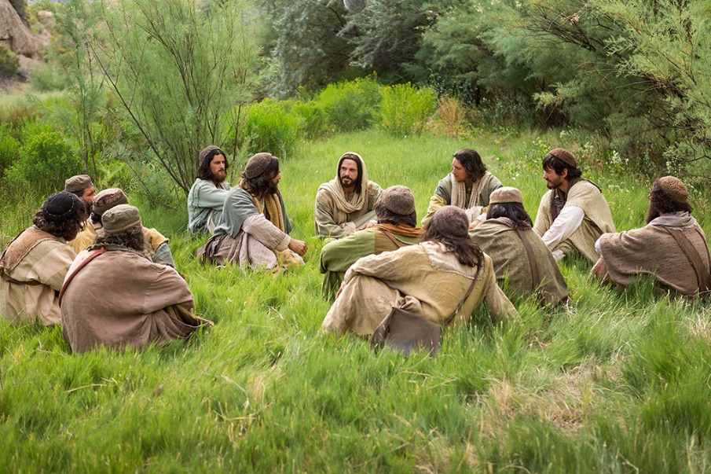**DISCIPLE, DISCIPLESHIP.**  A hard rock band, an indie film, and/or a follower or pupil of a great master. A disciple is a learner who follows a movement or teacher and helps to spread the master's teaching. The term is used in various senses and contexts in the New Testament to indicate the followers of Jesus. Although it is used at times relative to the Twelve, it is more frequently used as a general term for the first followers of Jesus. Luke 14:27 records Jesus' statement that "Whoever does not carry the cross and follow me cannot be my disciple." The term is also used in Acts to describe those who were Christian believers after Jesus' death and resurrection. At Antioch the disciples were first called Christians (Acts 11:26). The term "Christian" came to be the usual term for a Christian believer. The term "disciple" does not appear in the epistles *(the biblical letters)*. However, the concept of discipleship (being a Christian disciple) continues to be an important part of the Christian life. For example, Dietrich Bonhoeffer (1906-1945) considered discipleship in Die Nachfolge, or The Cost of Discipleship (1937). Bonhoeffer urged that grace without discipleship is "cheap grace," and that faith must be expressed in obedience.

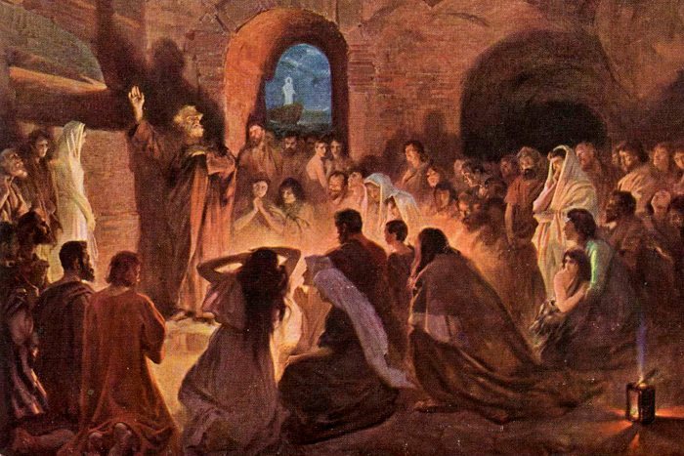**DISCIPLINA ARCANI**. The term is from Latin for the "discipline of secrecy." It concerns the secrecy practiced by the early church so that certain teachings and practices were not shared with converts until they were initiated and had begun full participation in the life of the Christian community. Catechumens in the early church were dismissed from the Sunday service before the prayers of the faithful, the peace, and eucharistic sharing. Some have noted parallels of the Disciplina Arcani to the secrecy of mystery religions. But the main reasons for the Disciplina Arcani were to protect the church during times of active persecution or marginal toleration, and a catechetical approach that emphasized experiencing the initiatory sacraments (including baptism, anointing, laying on of hands, and first communion) before learning about them. After the sixth century the need for secrecy had passed, but there was continuing catechetical emphasis on experience and participation. The Book of Occasional Services explains that "The catechetical methodology of the catechumenal and baptismal rites is: experience first, then reflect."

**DISCIPLINE.**

**1)** In a general sense, the right ordering of Christian life and community. The Constitution, Canons, Prayer Book rubrics, and rules of the church are meant to govern the proper conduct, responsibilities, services, and actions of church life. At the time of ordination, all persons being ordained bishop, priest, or deacon state that "I do solemnly engage to conform to the Doctrine, Discipline, and Worship of the Episcopal Church" (Art. VIII of the Constitution of the Episcopal Church).

**2)** In a specific sense, ecclesiastical discipline refers to the canonical provisions for presentment and trial of a member of the clergy. Grounds for presentment and trial of a member of the clergy include crime; immorality; holding and teaching any doctrine contrary to the doctrine of the Episcopal Church; violation of the rubrics of the Prayer Book; violation of the Constitution or Canons of the General Convention; violation of the Constitution or Canons of the diocese of canonical residence; violation of the Constitution or Canons of a diocese in which one was located temporarily; any act involving a violation of the ordination vows (including, under certain circumstances, disregard or disobedience of a Pastoral Direction); habitual neglect of the exercise of the ministerial office without cause, or habitual neglect of public worship and Holy Communion, according to the order and use of the Episcopal Church; or conduct unbecoming a member of the clergy. *(Merciful heavens, I can’t believe I’m still here.)*

The bishop may authorize a temporary inhibition of a priest or deacon who is charged with an offense or serious acts that would constitute grounds for a canonical Charge of an Offense. After allegations of the commission of an offense have been made to the ecclesiastical authority, or after Charges of an Offense have been filed, the accused member of the clergy may voluntarily submit to the discipline of the church prior to an ecclesiastical trial. The consent of the ecclesiastical authority is required. The canons also include provisions for renunciation of the ordained ministry by members of the clergy who may be charged with an offense. The canons make detailed provisions concerning ecclesiastical presentments, courts, trials, appeals, and remissions or modifications of judicial sentences. The three sentences that may be adjudged by an ecclesiastical trial court and imposed by the bishop are admonition, suspension, or deposition.

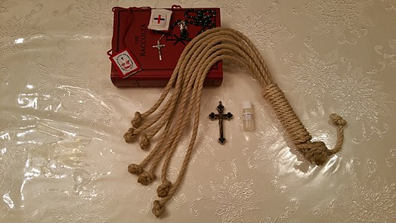 The Prayer Book rites for Holy Eucharist include Disciplinary Rubrics authorizing the priest to bar from communion those who are living a notoriously evil life, those who have done wrong to their neighbors and are a scandal to others of the congregation, and those who hate other members of the congregation and refuse to forgive them. A priest who bars a person from communion must notify the bishop within fourteen days and explain the reasons for refusing communion.

**3)** The term “discipline” also may indicate a whip or scourge of knotted cords that is used as an instrument of penance. And it’s the only definition you can really find an image of, so here you go.

**IN OUR** **PARISH LIFE:**

**BISHOP’S COMMITTEE MEETING** will be held on **Tuesday 17 August** at **7:00 PM** in person in Lincoln Hall.

**FARMERS MARKET:** The Farmers Market in Wauconda is held **every Thursday from 4:00 – 7:00PM.** Holy Apostles sells tickets for our Queen of Hearts raffle, and also collects donations for the Wauconda Food Pantry and Diaper Bank. We are in need of volunteers to help out on Thursdays with setting up the tent and having a presence in the community. To volunteer, please sign up on our church website www.holyapostleswauconda.net.

**BOOK DISCUSSION GROUP** will meet on **Tuesday 24 August at 7:30 PM** to discuss  *Being Mortal*  by Atul Gawande. Please contact Lisa Earley at [lisa.earley@groble.me](mailto:lisa.earley@groble.me) for more information.

**BIG TABLE:** Big Table continues to provide food on **Tuesdays from 5:00 – 6:00 PM**. You do not have to register ahead of time, just show up!

**SHAWL MINISTRY UPDATE:** Please join our hearty group of yarn warriors! We knit, crochet and tie together prayer shawls and hats to be given away to people in need of comfort all over the world. Our next in-person meeting will be **11 August at 1:00 PM** in Lincoln Hall.

|  |  |  |  |  |  |  |
| --- | --- | --- | --- | --- | --- | --- |
| **AUGUST 2021** | | | | | | |
| **SUN** | **MON** | **TUE** | **WED** | **THU** | **FRI** | **SAT** |
| 1  9:30 AM in church | 2 | 3 | 4 | 5  Farmers Mkt.  3:30-7:00 PM | 6 | 7  10 AM--noon  Food Pantry |
| 8  9:30 AM in church | 9 | 10 | 11  Shawl Ministry  1:00 PM  Lincoln Hall | 12  Farmers Mkt.  3:30-7:00 PM | 13 | 14  10 AM--noon  Food Pantry |
| 15  9:30 AM in church | 16 | 17  BC Meeting  7:00 PM  Lincoln Hall | 18 | 19  Farmers Mkt.  3:30-7:00 PM | 20 | 21  10 AM--noon  Food Pantry |
| 22  9:30 AM in church | 23 | 24  Book Group  7:30 PM | 25 | 26  Farmers Mkt.  3:30-7:00 PM | 27 | 28  10 AM--noon  Food Pantry |
| 29  9:30 AM in church | 30 | 31 |  |  |  |  |

**August Birthdays**

Aug 01 Lisa Earley Aug 14 Brennan Groble Aug 07 Tyler Sandberg Aug 15 Rachel Regan

Aug 09 Judi Dura Aug 18 Aggie Cebulka

Aug 11 Becky Deignan, Aug 26 Mimi Mantice

Aug 11 Todd Seiler

Aug 13 Bill Glade

**August Anniversaries**

Aug 06 Bill and Patti Glade

Aug 16 Chris and Becky Deignan

Aug 23 Marci and Ray Suelzer



**FROM: Church of the Holy Apostles**

**26238 North Highway 59**

**Wauconda, Illinois 60084**