**The Apostles Post**

26238 North Highway 59

Wauconda, Illinois

MARCH 2020

2015



**FROM THE VICAR’S DESK** *(M. C. Gillette)*

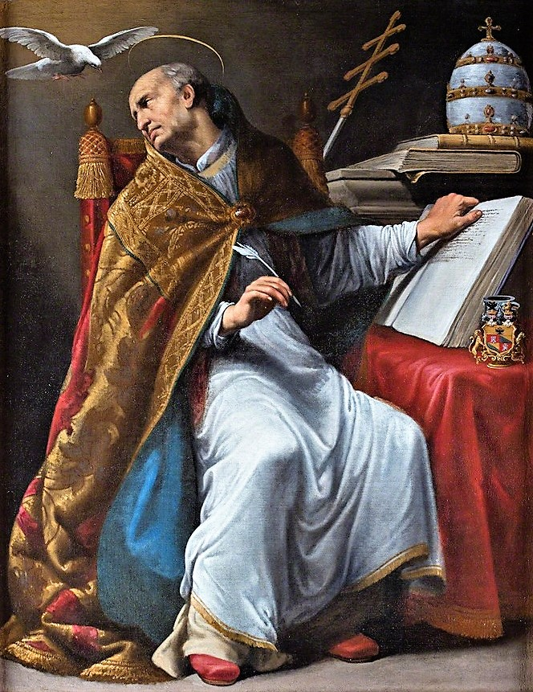Doctors of the Church issue III – Saint Gregory the Great (*aka* Pope Gregory I or simply Saint Gregory). Let me just say that a “great” amount of information about him is available online (and in about 5,000 books if you become obsessed). If you want to spend hours reading up on the details missing from this little piece, look him up on your favorite online data source and have at it.

Born (it is presumed, but not known with certainty) in 540, his feast day was historically the date of his death, 12 March (604), and that remains the date it is celebrated in the Episcopal church. (In the Roman Catholic tradition he is recognized on 03 September (the day he was elected Pope in 590), a revision directed by the Second Vatican Council in 1969.) The Episcopal readings assigned are 1 Chronicles 25:1a, 6-8; Psalm 57:6-11; Colossians 1:28-2:3; and Mark 10:42-45. He is the patron saint of musicians, students, teachers, and, according to the Franciscans, epilepsy.

Although the Western Roman Empire had collapsed long before his birth, many ancient Roman families still commanded great wealth and influence in the city. Gregory was born into one such family. His great-great-grandfather was Pope Felix III who reigned from 483 to 492. (Astute readers may find this rather scandalous, but that was before the clergy took vows of celibacy.)

His father, Gordianus, was a senator and a Prefect of Rome. (The exact responsibilities of Prefects varied, but in general they had civic responsibilities such as controlling prisons, overseeing police forces, and serving as administrators of geographic divisions, rather like governors.) Gordianus also held a position in the Church with the title of Regionarius (another type of administrator, responsible for a designated region of Rome and tasked with such duties as care of the poor and maintenance of the churches in that “neighborhood.”) Gregory’s mother, Silvia, was also from a noble family and, along with her sister Pateria were elevated as saints themselves. Gregory had a brother, but nothing more is known about him other than that he existed – not even his name.

Gregory received the best education available, and became Prefect of Rome himself. That lasted about 5 years, after which he renounced his official position, turned the family estate (his father having died) into a monastic enclave, and became a monk. (Next time you’re in Rome, you can go see the main monastery, known now as San Gregorio Magno al Celio.) Buuuuut, *that* didn’t last too long, because the Pope summoned him out of his monastery and sent him off to be papal representative in Constantinople. He wasn’t terribly successful (it probably didn’t help that he seems not to have acquired even the most rudimentary Greek during his time there), but it wasn’t all his fault. The difficult relations between the Eastern and Western churches were just one more piece of the perpetual strife of his time; another, more immediately significant, was the invasion of the Lombards (a Germanic people who ruled most of the Italian Peninsula from roughly 568 to 774). After six years in Constantinople, he returned and became the abbot of his monastery in Rome. Buuuuut, *that* didn’t last too long, because the Pope died, and the people of Rome demanded that Gregory be made Pontiff.

Gregory was as direct and firm as Pope as he had been as Abbott. He removed unworthy priests from office, forbade taking money for many services, emptied the papal treasury to ransom prisoners of the Lombards and to care for persecuted Jews and the victims of plague and famine. He was very concerned about the conversion of England, sending 40 monks from his own monastery (possibly because he was distressed at seeing pale-skinned British boys for sale in a slave-market, saying something to the effect of “they look like angels, and if they were Christian they might be.”) He is known for strengthening respect for doctrine. Rightly or wrongly (it’s disputed), he is said to be responsible for “Gregorian” chant, but what is certain is that his monastic background enabled him to improve the liturgy and church music. Many of the prayers recited in the (Roman) Eucharist are attributed to Pope Gregory; he is also credited with the placement of the “Our Father” in the Mass.

His book, *Pastoral Care*, addressing the duties and qualities of a bishop, was read for centuries after his death. All of his papal writings and teachings, based on a vision of pastoral care undertaken to meet the spiritual and physical needs of the people, were extremely influential. Gregory was not an original thinker as a theologian – his great gift was clarifying and systematizing the extant and emerging theology of the Church as a whole. As a preacher, he was down-to-earth, tempering his encouragement to spiritual discipline with day-to-day practicality. He himself lived as simply as a monk.

Gregory was a genuinely pastoral pope. His profound concern for the poor shaped the direction of ministry for centuries. No single person in the history of the church other than St. Benedict did more to reverse the Dark Age than Gregory the Great. One small example of Gregory’s pastoral concern was his introduction of illustrated Bibles in order to make the word of God accessible to the illiterate. An Anglican historian has written: “It is impossible to conceive what would have been the confusion, the lawlessness, the chaotic state of the Middle Ages without the medieval papacy; and of the medieval papacy, the real father is Gregory the Great.”

**HERE AND THERE** *(M. C. Gillette at* [*hapostles@sbcglobal.net*](mailto:hapostles@sbcglobal.net)*)*

*In this on-going article, we pull things from our various Diocesan calendars and church websites to see what’s going on around us. For more information about what's happening at the Diocesan Headquarters and the Cathedral of Saint James, you can always visit their websites:* <https://www.episcopalchicago.org> or <https://www.saintjamescathedral.org/>

|  |
| --- |
|  |
| **Resources for Keeping a Holy Lent**  The season of Lent--the 40 days between Ash Wednesday and Easter--begins on February 26.  The Episcopal Church, Episcopal Relief & Development, Living Compass, The Society for St. John the Evangelist and Lifelong Learning at Virginia Theological Seminary and United Thank Offering offer low- and no-cost Lenten devotions, reflections, calendars and curricula for individuals and congregations.  [**Life Transformed: The Way of Love in Lent and Easter**](http://r20.rs6.net/tn.jsp?f=001gIy1KWmPLcuGu38-M3Fvn3huEOnupQDnC6tpWg4auD8nKd7fzJimLmA1KLkd8y39_4pPsTibTVFohH_sdotQiCYSQWGn_tQpf61gEPCjr3SMBC9p7QuDMoweIsAVSm3pONPR_QeLXMJz24PGwb5EuuLVRrd9pvYGSSWNw8dhFW_xNSnQdZs5uc90i-vXZt7gXaiSvf5EacS5cjzZbq2cVdujRZv2x74-lIhMCl8lAZ3bNw9ucST8ftlYSOcrXUkT5B_LqeSeZqY=&c=ynVtttzdJkS0gDzUtWcJbIawhLlwe2tAsOrUOx3hY6INw9kcWFwTwQ==&ch=le81_eJhqyX0NpPrqjQtZNrUq55bli_67S2lFIoYfYv_1SWn7AUh9w==)  (https://episcopalchurch.org/posts/publicaffairs/life-transformed-way-love-lent-and-easter)  From the office of the Presiding Bishop, the updated and expanded [**Way of Love resources for Lent and Easter are available online**](http://r20.rs6.net/tn.jsp?f=001gIy1KWmPLcuGu38-M3Fvn3huEOnupQDnC6tpWg4auD8nKd7fzJimLmA1KLkd8y39vxg4xdoc7tEhyYn86e2KRa1p-fJjQSYJf3cU7f9dTQfMzK4mufjVvU6We0Aq12HqlCly1UZ0WJNLQArsZ33q9v7IC5SymZf4A8m71kGc3L8D8k_suBqIlhyCVggAXNQk4Sa6Oo2K4dI=&c=ynVtttzdJkS0gDzUtWcJbIawhLlwe2tAsOrUOx3hY6INw9kcWFwTwQ==&ch=le81_eJhqyX0NpPrqjQtZNrUq55bli_67S2lFIoYfYv_1SWn7AUh9w==) (https://episcopalchurch.org/life-transformed) and include a series of adult forums, a quiet day curriculum, a poster, and a daily calendar. Resources are available in English and Spanish.  [**Episcopal Relief & Development Lenten Meditations**](http://r20.rs6.net/tn.jsp?f=001gIy1KWmPLcuGu38-M3Fvn3huEOnupQDnC6tpWg4auD8nKd7fzJimLmA1KLkd8y39cfFbtPf35p6OdGOF8x4vEHbwY8C_veKKrLZPZndW6W-ow9xBcZPZXpqhHktndtQeocb-inXZN6dE2vBXmeKFnnlxmg4ZX9BoqUCUKz6-2UpNwArfJIkcvhKKYHtthF7wNOuwz2tYbNpZ_fLK0fvV5MYtn1Q1lAuvpsTxwI0l_4SkmfIpamC2YQ==&c=ynVtttzdJkS0gDzUtWcJbIawhLlwe2tAsOrUOx3hY6INw9kcWFwTwQ==&ch=le81_eJhqyX0NpPrqjQtZNrUq55bli_67S2lFIoYfYv_1SWn7AUh9w==)  (https://www.episcopalrelief.org/church-in-action/church-campaigns/lent/)  A 2020 book of Lenten meditations supports Episcopal Relief & Development's [**One Thousand Days of Love**](http://r20.rs6.net/tn.jsp?f=001gIy1KWmPLcuGu38-M3Fvn3huEOnupQDnC6tpWg4auD8nKd7fzJimLmA1KLkd8y39Zty1UdrNtbamjZ5uX9CIo6gMGKuDESOA6uPOSQhfO4bRms88Pwd7nW1p0A4A52ugffrv8a9zMHb4rTtzfMMY-ACpfkeJ1vhP-udtxQPw1cDYIJHTy_kGWDIh0wnITTqWOtYHSWYwlRo=&c=ynVtttzdJkS0gDzUtWcJbIawhLlwe2tAsOrUOx3hY6INw9kcWFwTwQ==&ch=le81_eJhqyX0NpPrqjQtZNrUq55bli_67S2lFIoYfYv_1SWn7AUh9w==) campaign (https://www.episcopalrelief.org/1000daysoflove/) and focuses on the spiritual lives of children.  [**Living Well Through Lent 2020**](http://r20.rs6.net/tn.jsp?f=001gIy1KWmPLcuGu38-M3Fvn3huEOnupQDnC6tpWg4auD8nKd7fzJimLp3eW16joo-QvrtMIUwPcyULR6AWBcGn31tThfQDJ7jWqxn7QxTU9HSLo4tEoVRz5j9BnQeb4o4mH7TW79EMc-iFH_smHROvamfez9HY4DrY7Q4Egc5w4UHapKJwq3jcvQ==&c=ynVtttzdJkS0gDzUtWcJbIawhLlwe2tAsOrUOx3hY6INw9kcWFwTwQ==&ch=le81_eJhqyX0NpPrqjQtZNrUq55bli_67S2lFIoYfYv_1SWn7AUh9w==)(https://shop.livingcompass.org/)  [**Living Compass' daily Lenten devotional**](http://r20.rs6.net/tn.jsp?f=001gIy1KWmPLcuGu38-M3Fvn3huEOnupQDnC6tpWg4auD8nKd7fzJimLp3eW16joo-QvrtMIUwPcyULR6AWBcGn31tThfQDJ7jWqxn7QxTU9HSLo4tEoVRz5j9BnQeb4o4mH7TW79EMc-iFH_smHROvamfez9HY4DrY7Q4Egc5w4UHapKJwq3jcvQ==&c=ynVtttzdJkS0gDzUtWcJbIawhLlwe2tAsOrUOx3hY6INw9kcWFwTwQ==&ch=le81_eJhqyX0NpPrqjQtZNrUq55bli_67S2lFIoYfYv_1SWn7AUh9w==) (https://shop.livingcompass.org/) is designed for individual reflection and group study. The booklet features reflections from the Very Rev. Dominic Barrington, the Rev. Heidi Haverkamp, and the Rev. Dr. Scott Stoner and is available in print and electronic editions with a downloadable facilitator guide and a closed Facebook discussion group. Members of the Episcopal Diocese of Chicago may [**order complimentary copies**](http://r20.rs6.net/tn.jsp?f=001gIy1KWmPLcuGu38-M3Fvn3huEOnupQDnC6tpWg4auD8nKd7fzJimLmA1KLkd8y390txKv2KuzMrQmpvisN1Qn0-SXfxz_8Z3MCWAVN1kdkauc3abSe3_c8nPh1-7Y68sbbNNUYsC6AT7koKgP2bM6UiJKBEDkMM-3NxCt30w8PzMe69j9T53hFjBc1_10gGUZqMommrSTA31w8jt9YkQKNCRlbM9u729yAXir0KgnAo=&c=ynVtttzdJkS0gDzUtWcJbIawhLlwe2tAsOrUOx3hY6INw9kcWFwTwQ==&ch=le81_eJhqyX0NpPrqjQtZNrUq55bli_67S2lFIoYfYv_1SWn7AUh9w==) using the code LENT2020.  [**Signs of Life: Why Church Matters**](http://r20.rs6.net/tn.jsp?f=001gIy1KWmPLcuGu38-M3Fvn3huEOnupQDnC6tpWg4auD8nKd7fzJimLmA1KLkd8y39yiufeIpUMJTdv9TL7GtnS3M1vQofQ_S6_KBRL2AstLOW6I-3DCEdkRzohWfyaJ5omulELdVWmM6d0TUZwkfs8rMN-HBsV3JaGVAPHlQ-0xP5zfwMJbFpyQ==&c=ynVtttzdJkS0gDzUtWcJbIawhLlwe2tAsOrUOx3hY6INw9kcWFwTwQ==&ch=le81_eJhqyX0NpPrqjQtZNrUq55bli_67S2lFIoYfYv_1SWn7AUh9w==)(https://www.signsoflife.org/)  [**The Society of St. John the Evangelist**](http://r20.rs6.net/tn.jsp?f=001gIy1KWmPLcuGu38-M3Fvn3huEOnupQDnC6tpWg4auD8nKd7fzJimLrsAAzGjwYMnr5A9rk0seSEg-rHwGd0UFVCvFHI9HxvePP0J2bAq9bLIfc3_tlCfJGrMb2rgUCcVdwN8b7Uf_9MjfMTbrVhw9EkxBGOA2haiZIaVU8z-kdc=&c=ynVtttzdJkS0gDzUtWcJbIawhLlwe2tAsOrUOx3hY6INw9kcWFwTwQ==&ch=le81_eJhqyX0NpPrqjQtZNrUq55bli_67S2lFIoYfYv_1SWn7AUh9w==) (https://www.ssje.org/) and [**Lifelong Learning at Virginia Theological Seminary**](http://r20.rs6.net/tn.jsp?f=001gIy1KWmPLcuGu38-M3Fvn3huEOnupQDnC6tpWg4auD8nKd7fzJimLmA1KLkd8y39dDdfdzmUduFRd0ELPzcjK-Pyel5_30jljZNHfDzr3I9V2fty2ZoulyT1OlQZvXPVIrjfGf5Sw6YiC5fF5keSiC9mHCe-VdEz2MaXsUxLBHw=&c=ynVtttzdJkS0gDzUtWcJbIawhLlwe2tAsOrUOx3hY6INw9kcWFwTwQ==&ch=le81_eJhqyX0NpPrqjQtZNrUq55bli_67S2lFIoYfYv_1SWn7AUh9w==) (https://vtslifelong.org/) have collaborated on a Lenten resource, [**Signs of Life: Why Church Matters**](http://r20.rs6.net/tn.jsp?f=001gIy1KWmPLcuGu38-M3Fvn3huEOnupQDnC6tpWg4auD8nKd7fzJimLmA1KLkd8y39yiufeIpUMJTdv9TL7GtnS3M1vQofQ_S6_KBRL2AstLOW6I-3DCEdkRzohWfyaJ5omulELdVWmM6d0TUZwkfs8rMN-HBsV3JaGVAPHlQ-0xP5zfwMJbFpyQ==&c=ynVtttzdJkS0gDzUtWcJbIawhLlwe2tAsOrUOx3hY6INw9kcWFwTwQ==&ch=le81_eJhqyX0NpPrqjQtZNrUq55bli_67S2lFIoYfYv_1SWn7AUh9w==). (https://www.signsoflife.org/) The free 5-week offering includes videos, facilitation guides and a calendar that encourages Episcopalians to explore our liturgy, sacraments, art and architecture.  [**United Thank Offering 2020 Devotional Calendar**](http://r20.rs6.net/tn.jsp?f=001gIy1KWmPLcuGu38-M3Fvn3huEOnupQDnC6tpWg4auD8nKd7fzJimLmA1KLkd8y397gklrv1yH5E0-g32f_oXia_bsxXj4pLK-mTbLaklHCs3FSr9lNGhSOoD46Xm8NKIvt-hTOqDISJMVTYsXAvG4jt0_lkG4IuqPfslGKZb99RxVvb15L91aJbX0aWM4r61i8pDpVmJLYw6yOAq7oeegSgZAmYObl-G&c=ynVtttzdJkS0gDzUtWcJbIawhLlwe2tAsOrUOx3hY6INw9kcWFwTwQ==&ch=le81_eJhqyX0NpPrqjQtZNrUq55bli_67S2lFIoYfYv_1SWn7AUh9w==)  (https://episcopalchurch.org/files/uto_lenten_calendar_2020.pdf)  In its third year, the [**United Thank Offering (UTO) Devotional Calendar**](http://r20.rs6.net/tn.jsp?f=001gIy1KWmPLcuGu38-M3Fvn3huEOnupQDnC6tpWg4auD8nKd7fzJimLmA1KLkd8y397gklrv1yH5E0-g32f_oXia_bsxXj4pLK-mTbLaklHCs3FSr9lNGhSOoD46Xm8NKIvt-hTOqDISJMVTYsXAvG4jt0_lkG4IuqPfslGKZb99RxVvb15L91aJbX0aWM4r61i8pDpVmJLYw6yOAq7oeegSgZAmYObl-G&c=ynVtttzdJkS0gDzUtWcJbIawhLlwe2tAsOrUOx3hY6INw9kcWFwTwQ==&ch=le81_eJhqyX0NpPrqjQtZNrUq55bli_67S2lFIoYfYv_1SWn7AUh9w==)  (https://episcopalchurch.org/files/uto_lenten_calendar_2020.pdf) offers an opportunity for daily reflection and encourages daily contributions using the [**UTO Blue Box**](http://r20.rs6.net/tn.jsp?f=001gIy1KWmPLcuGu38-M3Fvn3huEOnupQDnC6tpWg4auD8nKd7fzJimLmA1KLkd8y39W12GCeqh5BsjecacM-OlhGra9R06gbwbdGt3iuRJajA-a_5YaT4h6ciuIo-xZPaWau-69sp8bzg8RT5kKC0ej49YVSdFqC0BxJW2hv2NtHzSI1fQzEMqwh585CMl0faKhPQDTcatooTnlOyE4poaxgUojIQWeIzeQ3ri5epHZVlc2XjyiWB5nVIYg7QkRSqP65Ig7e2miSY=&c=ynVtttzdJkS0gDzUtWcJbIawhLlwe2tAsOrUOx3hY6INw9kcWFwTwQ==&ch=le81_eJhqyX0NpPrqjQtZNrUq55bli_67S2lFIoYfYv_1SWn7AUh9w==).  (https://shimaofnavajoland.com/collections/united-thank-offering/products/uto-125-blue-boxes)   |  | | --- | |  | |  |   **Freedom of Speech and the Right to Boycott: News from the Peace & Justice Committee**  In the coming weeks, members of the diocesan [**Peace & Justice Committee**](http://r20.rs6.net/tn.jsp?f=001gIy1KWmPLcuGu38-M3Fvn3huEOnupQDnC6tpWg4auD8nKd7fzJimLmA1KLkd8y39zWQ_qALCBWZDZqw80KGx-dgrvKDRyhwD6eamW6V_foBrhzJ8xtCgdozfLIBfR_5UrwtPCFXLPamNHLes9yRvCLxB0UtUpST7c7SqoCHisOgWbheBhjaSv-zcgm5c_cMgzf0euRvp5dsSSs3gB-3t0Z-VKF3kTU_s&c=ynVtttzdJkS0gDzUtWcJbIawhLlwe2tAsOrUOx3hY6INw9kcWFwTwQ==&ch=le81_eJhqyX0NpPrqjQtZNrUq55bli_67S2lFIoYfYv_1SWn7AUh9w==)  (https://episcopalchicago.org/peace-and-justice-committee/) will contact churches to ask for their help in hosting presentations about the implementation of [**Resolution G-182, "Freedom of Speech and the Right to Boycott"**](http://r20.rs6.net/tn.jsp?f=001gIy1KWmPLcuGu38-M3Fvn3huEOnupQDnC6tpWg4auD8nKd7fzJimLkOBfZO0UwsRWYGNfH0gizD35yCiy5InS6ksoP54IKl8ivullp0lrL2ZI-lCf4fqAR4flHCzgv8dYd-d6FurRvdlvDblJPgheqagOw6HaNAUZarLAk75FKM4A6zF3P667Qx1nDXwLjxJnhAQ819J4xZ9q4YDgZchL1WIkL3hDXaofpkVlDymAXgZalVBvof1741dfV90rY3UC2SjVBztNdo=&c=ynVtttzdJkS0gDzUtWcJbIawhLlwe2tAsOrUOx3hY6INw9kcWFwTwQ==&ch=le81_eJhqyX0NpPrqjQtZNrUq55bli_67S2lFIoYfYv_1SWn7AUh9w==) (https://episcopalchicago.org/wp-content/uploads/2019/12/Resolutions-for-2019-FINAL.pdf pages 14-16) The resolution, which was unanimously approved at diocesan convention in November, calls on state and federal elected representatives to oppose legislative efforts to penalize or criminalize support for nonviolent boycotts on behalf of Palestinian human rights. To learn more or get involved, [**email Priscilla Read**](mailto:read.priscilla@gmail.com) (read.priscilla@gmail.com) The Secretary of Convention will send a letter commending the resolution to elected and appointed officials representing districts in the Diocese of Chicago. |

|  |
| --- |
|  |

**SOME CHURCHY STUFF** *(M. C. Gillette at* [*hapostles@sbcglobal.net*](mailto:hapostles@sbcglobal.net)*) In this monthly article, we look at terms and definitions of things you might see or hear around church. Nothing fancy here – these entries are out of the Armentrout/Slocum An Episcopal Dictionary of the Church, sometimes supplemented by me, and sometimes simply copied directly. If something in particular piques your interest, let me know, and we’ll deal with it in more depth.*

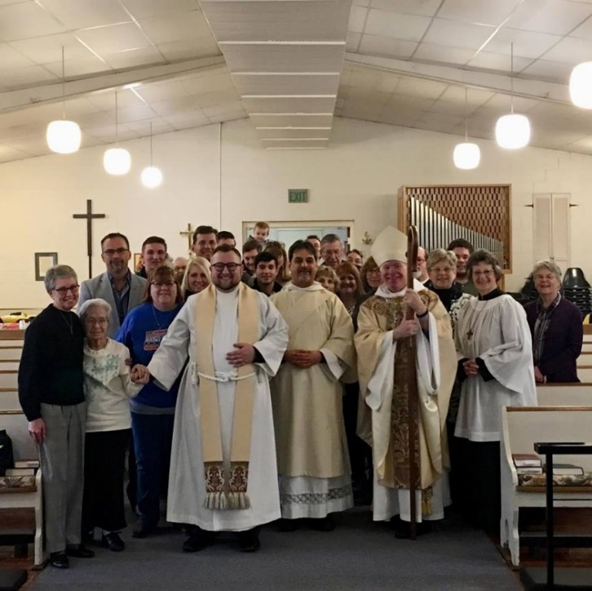**EPISCOPAL VISITATION.** And you thought all the “Episcopal” things were covered in last month’s newsletter. Well, I didn’t turn the page quickly enough. (Although please note that I spared you a great many “episcopal” things, such as “Episcopal Clerical Directory” and “Episcopal Evangelical Journal, The.”) Anyway, an Episcopal Visitation is a bishop's official pastoral visit to a congregation of the diocese. Of course, all the pictures I had from our last one are hiding in some roiling ball of pixels churning its way through deep space, so here is an image of someone else’s. Canon law requires every diocesan bishop to visit every congregation in his or her diocese at least once every three years. The canonical purposes of a visitation are for the bishop to examine the condition of the congregation, oversee the clergy, preach, confirm, preside at the eucharist, and examine parochial records. The Book of Common Prayer also assumes that the bishop's visitation will be an occasion for baptism, and that the bishop will preside. Bishop Lee was with us last year for a visit. With a new bishop being elected this June – and 125 congregations in the diocese – we’ll have to wait to see what sort of visitation schedule he/she will propose.

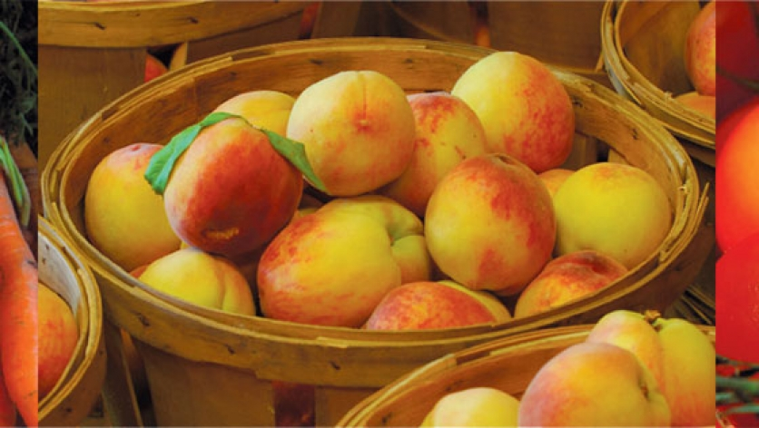**ESSE, BENE ESSE, PLENE ESSE.** The authors of our Dictionary assert “These terms have been frequently used with respect to the role of the historic episcopate in the life of the church.” Mmmmm. Well, perhaps I don’t spend enough time pondering the role of the historic episcopate in the life of the church, but I could not have told you what they meant or how they were used if my life depended on it, so “frequently” might be – relative. But now we will all know, and certainly our lives will be safer because of it.

These are terms for characterizing the significance of a doctrine or practice for the church. *Esse* indicates that which is of the essence of the very existence of the life of the church. *Bene esse* indicates that which is of benefit for the life of the church. *Plene esse* indicates that which is of the fullness of the Church's life. As noted above, they are “often” used with regard to the role bishops play in having a “legitimate” church. And this is actually not an abstract question as it plays out in the real world. This question has often been raised in the context of ecumenical discussions, especially with churches that do not have an episcopal ministry and do not require episcopal ordination of clergy. The statement "No bishop, no Church" would reflect the position that the historic episcopate is of the *esse* of the church. This view, strictly applied, serves to "unchurch" Protestant denominations that do not have the episcopate. It also serves to restrict severely the possibilities for Anglican ecumenical relations with these churches.

As you might imagine, there are no pictures to be found of “*Esse, Bene Esse, Plene Esse*,” so I have given you a picture of some lovely New Jersey peaches which, for whatever reason, appeared when I entered these words into my search engine.

The historic episcopate (as locally adapted) was identified by the Quadrilateral adopted by the (Episcopal Church) House of Bishops in 1886 as one of the four parts of the sacred deposit of the faith that are "essential to the restoration of unity among the divided branches of Christendom." (Well, duh, I suppose – what is the House of Bishops expected to say?) The historic episcopate was likewise identified by the Lambeth Conference of 1888 as one of the four bases for Home Reunion. (For spell-binding reading, see the Chicago-Lambeth Quadrilateral 1886, 1888 (BCP, pp. 876-878).) The other three "essential" parts identified by the House of Bishops in 1886 were the Holy Scriptures of the Old and New Testaments as the revealed Word of God; the Nicene Creed as the sufficient statement of Christian faith; and the two sacraments of Baptism and the Supper of the Lord, ministered with unfailing use of Christ's words of institution and of the elements ordained by Christ. The other three elements of the Lambeth Conference Resolution of 1888 are similar to the Chicago declaration, except that the Apostles' Creed as the Baptismal Symbol is mentioned along with the Nicene Creed as the sufficient statement of Christian faith.

The distinction of *esse* and *bene esse* with respect to the episcopate can be traced to the thought of Richard Hooker (c. 1554-1600). He believed that the apostles left bishops with authority above other pastors and that the church has power to determine its own positive law and governance. But Hooker also believed that episcopacy does not belong to "the essence of Christianity." On the other hand, nineteenth-century Tractarians took the position that Christ created the apostolic order. For example, in Tract 4, John Keble (1792-1866) doubted that there was assurance and safety for salvation except in the sacraments of the apostolic Church of England. Keble and other Tractarians believed that episcopacy was of the *esse* of the church.

The term *plene esse* was used in essays by H. W. Montefiore and Kenneth M. Carey in The Historic Episcopate (1954), edited by Carey. This collection of essays was published in response to the controversy concerning whether the Church of England should enter into full communion with the Church of South India. In the Church of South India, episcopal and non-episcopal churches came together on an episcopal basis. Clergy who had not been episcopally ordained were not reordained by bishops. But all future ordinands were to be episcopally ordained, so that the Church of South India would eventually be an episcopal church whose clergy were all episcopally ordained. Carey admits that the interim presence of nonepiscopally ordained clergy was an admitted "anomaly" for an episcopal church. Nevertheless, the essays by Montefiore and Carey support full communion with the Church of South India because the episcopate is of the *plene esse*, or fullness, of the church-not the essence. In 1955 the Convocations of Canterbury and York approved limited inter-communion between the Church of England and the Church of South India. A similar plan and understanding of episcopacy was the basis of the proposed Lutheran-Episcopal Concordat (1991). See Historic Episcopate; see Chicago-Lambeth Quadrilateral.

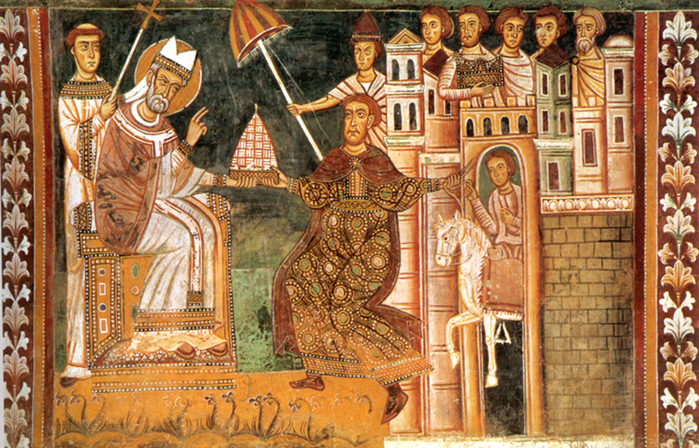**ESTABLISHMENT OF RELIGION.** So, um, this is what the First Amendment to the U.S. Constitution that really relates to. It does not mean you can’t talk about “state” stuff in church, or “church” stuff in the halls of government, although I do confess I sometimes wish that were what it meant. “Establishment of Religion” is an arrangement in which a religion or a particular religious institution enjoys official status and the state may enforce conformity. So if everyone in America *had* to be, say, Seventh-day Adventists, and Congress decided what “real” Seventh-day Adventists had to believe and do (or not do), well then, Seventh-day Adventist would be our “Established Religion,” and there would be no more Martini Ministry. Or bacon. Or Christmas. The framers of the Constitution, of course, put the Establishment of Religion amendment in there precisely because they didn’t think having a “Church of America” was any better than having a “Church of England,” and they didn’t think having a “Church of England” was such a good idea. The establishment of Christianity as an “official” state religion began with Constantine the Great (d. 337) who first tolerated Christianity instead of persecuting it, and then later actively sought to make it the official religion of the Roman Empire. Established Christianity was understood as ordering the ends of the state as well as providing for the salvation of individuals. It was expected to legitimate the authority and actions of the state. This was expressed in the duty of Christians to fight for the preservation and ends of the state and in the duty of the state to suppress and punish false religion and doctrine. In terms of faith, Christianity became less a matter of conscious decision and commitment and more a matter of birth and assimilation into the surrounding culture. No longer was there a process of initiation (the catechumenate) in preparation for adult baptism. Instead, all citizens were baptized at birth so that "Christian" became just another word for citizen. In this context, religious orders became "a higher way" which transcended the roles and relations of citizen to state and thereby at times challenged the authority of the state. With the Protestant Reformation and a renewed sense of the individual decision of faith, the increase of religious bodies, and the rise of the nation-state seeking to secure itself amidst competing religious bodies, establishment of religion gave way to religious freedom. This change ultimately led, in fact if not in principle, to the secular state. Anglicanism follows this development, moving from exclusive establishment at the time of the English Reformation, to increased religious toleration, to an established church in a secular state. Although the Church of England continues as an established church, the Anglican Communion worldwide is seen as a denomination whose churches are spread throughout the world by voluntary membership apart from the efforts of the state.

|  |  |  |  |  |  |  |  |  |
| --- | --- | --- | --- | --- | --- | --- | --- | --- |
| **EPISCOPAL CHURCH OF THE HOLY APOSTLES UPCOMING SERVICES – MARCH 2020** | | | | | | | | |
| Sunday  01 MAR  8:00 &  10:30 a.m. | Wednesday  04 MAR  7:00 p.m. | Sunday  08 MAR  8:00 &  10:30 a.m. | Wednesday  11 MAR  7:00 p.m. | Sunday  15 MAR  8:00 &  10:30 a.m. | Wednesday  18 MAR  7:00 p.m. | Sunday  22 MAR  8:00 &  10:30 a.m. | Wednesday  25 MAR  7:00 p.m. | Sunday  29 MAR  8:00 &  10:30 a.m. |
| Scheduled  Presider:  Gillette  Preacher:  Gillette | Scheduled  Presider:  Gillette  Preacher: | Scheduled  Presider:  Gillette  Preacher:  Gillette | Scheduled  Presider:  Gillette  Preacher: | Scheduled  Presider:  Gillette  Preacher:  Gillette | Scheduled  Presider:  Gillette  Preacher: | Scheduled  Presider:  Gillette  Preacher:  Gillette | Scheduled  Presider:  Gillette  Preacher: | Scheduled  Presider:  Gillette  Preacher:  Gillette |
| First  Sunday in Lent | Wednesday in the  First  Week of Lent | Second  Sunday in Lent | Wednesday in the Second  Week of Lent | Third  Sunday in Lent | Wednesday in the  Third  Week of Lent | Fourth Sunday in Lent | Wednesday in the  Fourth  Week of  Lent | Fifth Sunday in Lent |
| First Lesson  Genesis  2:15-17;  3:1-7  Response  Psalm  32  Second  Lesson  Romans  5:12-19  Gospel  Matthew  4:1-11 | Eucharist service using the Stations of the Cross as the Liturgy of the Word | First  Lesson  Genesis  12:1-4a  Response  Psalm  121  Second  Lesson  Romans  4:1-5,  13-17  Gospel  John  3:1-17l | Eucharist service using the Stations of the Cross as the Liturgy of the Word | First  Lesson  Exodus  17:1-7  Response  Psalm  95  Second  Lesson  Romans  5:1-11  Gospel  John  4:5-42 | Eucharist service using the Stations of the Cross as the Liturgy of the Word | First  Lesson  1 Samuel  16:1-13  Response  Psalm  23  Second  Lesson  Ephesians  5:8-14  Gospel  John  9:1-41 | Eucharist service using the Stations of the Cross  as the Liturgy of the Word | First  Lesson  Ezekiel  37:1-14  Response  Psalm  130  Second  Lesson  Romans  8:6-11  Gospel  John  11:;1-45 |

**IN OUR** **PARISH LIFE:**

**SHAWL MINISTRY:** The Shawl Ministry meets on **Monday 09 March at 7:00 PM** in Lincoln Hall. No experience is necessary! Please contact Marsha Taylor at [mktaylor730@hotmail.com](mailto:mktaylor730@hotmail.com) or 847-977-5399 with any questions.

**BISHOP’S COMMITTEE MEETING:** Bishop’s Committee will meet on **Tuesday 17 March at 7:00 p.m. in Lincoln Hall.**

**LENTEN STUDY:** On **Saturday, 28 March** we will take an afternoon to "walk" together with God. Based on the new Adam Hamilton book, *The Walk*, we will examine five essential practices of the Christian life. In particular, as the author posits, "I wondered if, in the seven last statements Jesus made, we might find evidence that Jesus himself pursued these spiritual practices." Please join us from **1:00 to 4:00 p.m**.

**BOOK DISCUSSION GROUP:** The Holy Apostles Book Club meets on the fourth Tuesday of the month (unless otherwise noted) at a different member’s home each month. Our titles are available at the Ela Public Library about a month before the discussion date and the due dates are extended to after the meeting. All are welcome to come to any meeting; there is no commitment for attendance or for hosting. If you see a title that catches or eye, or would just like to try something new, please feel free to join us! For more information, contact Lisa Earley at [lisa.earley@groble.me](mailto:lisa.earley@groble.me) . This month the Book Group will meet on **March 24 at 7:30 PM** to discuss *Born a Crime* by Trevor Noah, at the home of Barb Barrie.

**HOSTS NEEDED:** Please consider signing up to serve as Host for occasional Sunday services in 2020. Host duties are written up on a sheet and are easy to follow and carry out. You can sign up on the colorful board in Lincoln Hall.

**PLEASE REMEMBER** that we have an Alcoholics Anonymous meeting at Holy Apostles **EACH SATURDAY morning from 9 – 10 a.m.**  Please do not schedule any events prior to 10:30 a.m. Saturdays.  Should the AA meeting run a bit late and you a bit early, and you happen to encounter a participant, it is extremely important to honor the "anonymous" part of this recovery ministry.  As "un-Holy-Apostles-like" as it is, please refrain from greeting them, introducing yourself, etc.; please minimize your contact to the greatest extent possible.  If you have any questions, please see Mother Martha.

**LENTEN STUDY:** On **Saturday, 28 March** we will take an afternoon to "walk" together with God. Based on the new Adam Hamilton book, *The Walk*, we will examine five essential practices of the Christian life. In particular, as the author posits, "I wondered if, in the seven last statements Jesus made, we might find evidence that Jesus himself pursued these spiritual practices." Please join us from **1:00 to 4:00 p.m.**

|  |  |  |  |  |  |  |
| --- | --- | --- | --- | --- | --- | --- |
| **MARCH 2020 (See PAGE above for Service Schedule)** | | | | | | |
| **SUN** | **MON** | **TUE** | **WED** | **THU** | **FRI** | **SAT** |
| 1  8:00 AM service  10:30 AM service | 2 | 3 | 4  7:00 PM  Eucharist with  Stations | 5 | 6 | 7  10 AM—noon  Food Pantry |
| 8  8:00 AM service  10:30 AM service | 9  7:00 PM  Shawl Ministry | 10 | 11  7:00 PM  Eucharist with  Stations | 12 | 13 | 14  10 AM—noon  Food Pantry |
| 15  8:00 AM service  10:30 AM service | 16 | 17  7:00 PM  Bishop’s Comm.  Meeting | 18  7:00 PM  Eucharist with  Stations | 19 | 20 | 21  10 AM—noon  Food Pantry |
| 22  8:00 AM service  10:30 AM service | 23 | 24 | 25  7:00 PM  Eucharist with  Stations | 26 | 27 | 28  10 AM--noon  Food Pantry  1 – 4 PM Lenten  Mini-Retreat |
| 29  8:00 AM service  10:30 AM service | 30 | 31 |  |  |  |  |

**March Birthdays**

Mar 07 Sandy Stephens Mar 23 Chris Deignan

Mar 11 Judy Linarez Mar 28 Robert Cooper

Mar 18 Ashley Glade Mar 31 Rodney Petersen

Mar 18 Mariah Petersen

**March Anniversaries**

Mar 11 Todd and Michele Seiler

***DATES TO REMEMBER:***

*Wed 04 March Eucharist with Stations 7:00 PM*

*Wed 11 March Eucharist with Stations 7:00 PM*

*Wed 18 March Eucharist with Stations 7:00 PM*

*Wed 25 March Eucharist with Stations 7:00 PM*

*Sat 28 March Lenten “Mini-Retreat” 1:00 – 4:00 PM*

*Wed 01 April Eucharist with Stations 7:00 PM*

*Sun 05 April Palm Sunday Worship 8:00 AM, 10:30 AM*

*Wed 08 April Eucharist with Stations 7:00 PM*

*Thurs 09 April Maundy Thursday Meal 6:00 PM Soup Meal*

*Thurs 09 April Maundy Thursday Service 7:00 PM Service*

*Thurs 09 April Watch in the Garden of Repose 7:30 PM Thurs – 6:30 AM Fri*

*Fri 10 April Good Friday Worship 7:00 PM*

*Sun 12 April Easter- Single Service, Brunch 9:30 AM*

**FROM: Church of the Holy Apostles**

**26238 North Highway 59**

**Wauconda, Illinois 60084**