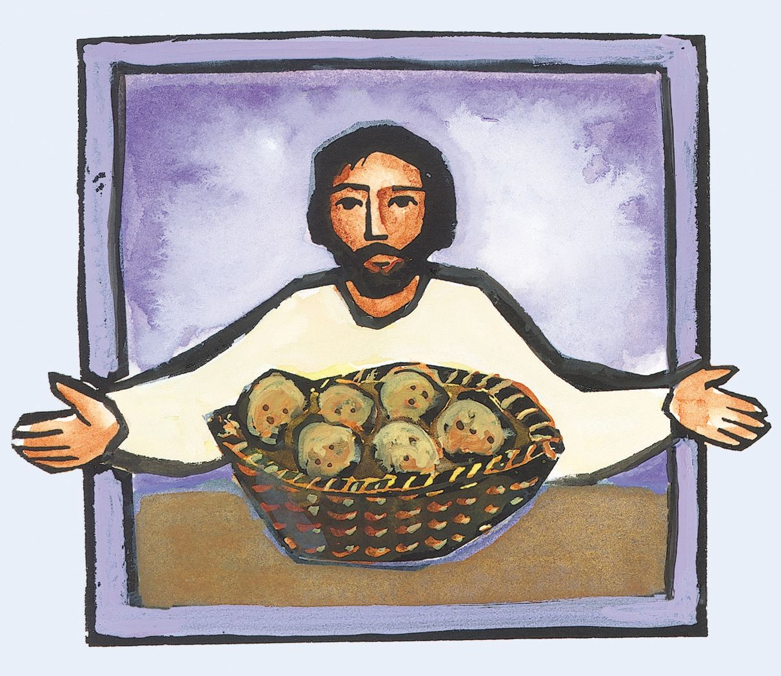

**Eleventh Sunday after Pentecost**

**Proper 14 (B)**

**Sunday 08 August 2021**

**Episcopal Church of the Holy Apostles**

26238 N HWY 59, Wauconda, IL 60084

*www.holyapostleswauconda.net*

***You are encouraged to look at pictures and videos if presented.***

***They tell the story in a different way than the words in front of you.***

***But the words are important too;***

***feel free to take your bulletins with you, or access them on our website.***

**OPENING VOLUNTARY**

**WORDS OF WELCOME**

**OPENING HYMN**

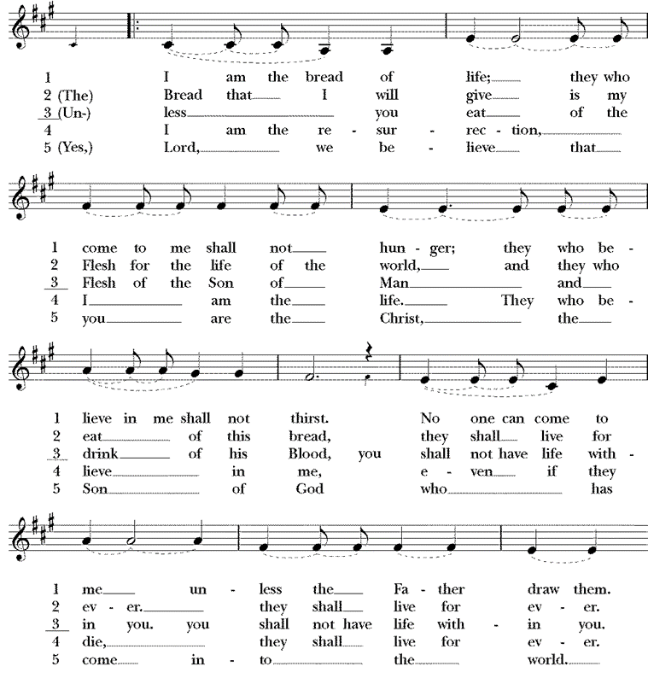



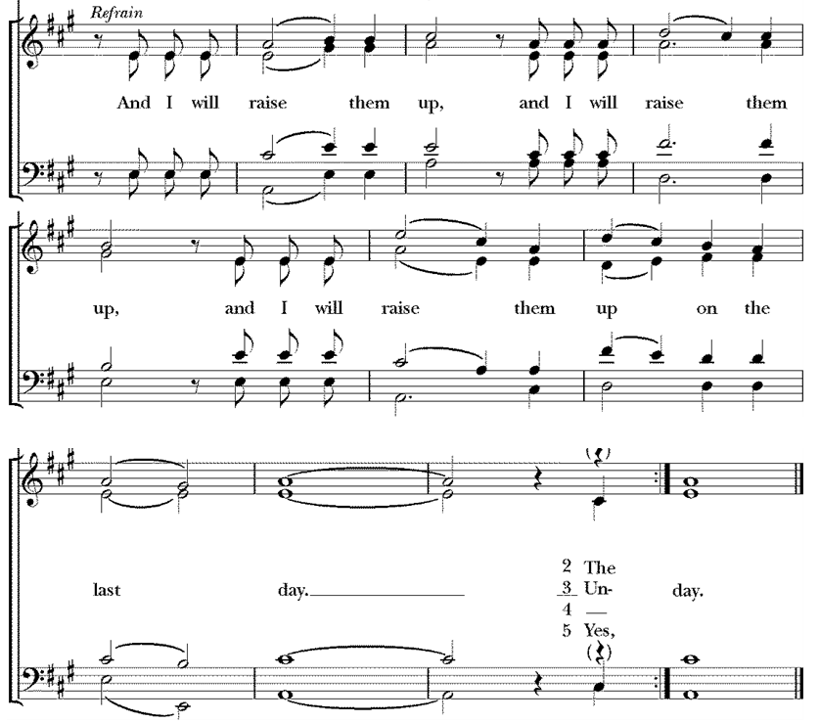

**OPENING SENTENCE**

**Presider:** Blessed be God: Holy Immortal One, Incarnate Word, and Breath of Life.

***People: And blessed be God’s kingdom, now and forever. Amen.***

**COLLECT FOR PURITY**

**Presider:** Almighty God, to you all hearts are open, all desires known, and from you no secrets are hid: Cleanse the thoughts of our hearts by the inspiration of your Holy Spirit, that we may perfectly love you, and worthily magnify your holy Name; through Christ our Lord.

***People: Amen.***

**HYMN OF PRAISE** *(Please say together in unison)* Canticle J, A Song of Judith

***I will sing a new song to my God, for your are great and glorious, wonderful in strength, invincible. Let the whole creation serve you, for you spoke and all things came into being. You sent your breath and it formed them, no one is able to resist your voice. Mountains and seas are stirred to their depths, rocks melt like wax at your presence. But to those who fear you, you continue to show mercy. No sacrifice, however fragrant, can please you, but whoever fears the Lord shall stand in your sight for ever.***

**COLLECT OF THE DAY**

**Presider:** The Lord be with you.

***People: And also with you.***

**Presider:** Let us pray. Unseen God, drawing all people to the end of our desires: teach us to know true bread from false and to feed on him who shares our flesh to share your love, Jesus Christ, our communion.

***People: Amen.***

*(We read from the various translations authorized by our Church. This month, we read from the New Revised Standard Version, 1989)*

**FIRST LESSON** 2 Samuel 18:5-9, 15, 31-33

**Reader:** A reading from 2nd Samuel. 5The king, David, ordered Joab and Abishai and Ittai, saying, “Deal gently for my sake with the young man Absalom.” And all the people heard when the king gave orders to all the commanders concerning Absalom. 6So the army went out into the field against Israel; and the battle was fought in the forest of Ephraim. 7The men of Israel were defeated there by the servants of David, and the slaughter there was great on that day, twenty thousand men. 8The battle spread over the face of all the country; and the forest claimed more victims that day than the sword. 9Absalom happened to meet the servants of David. Absalom was riding on his mule, and the mule went under the thick branches of a great oak. His head caught fast in the oak, and he was left hanging between heaven and earth, while the mule that was under him went on. 15And ten young men, Joab’s armor-bearers, surrounded Absalom and struck him, and killed him. 31Then the Cushite came; and the Cushite said, “Good tidings for my lord the king! For the Lord has vindicated you this day, delivering you from the power of all who rose up against you.” 32The king said to the Cushite, “Is it well with the young man Absalom?” The Cushite answered, “May the enemies of my lord the king, and all who rise up to do you harm, be like that young man.” 33The king was deeply moved, and went up to the chamber over the gate, and wept; and as he went, he said, “O my son Absalom, my son, my son Absalom! Would I had died instead of you, O Absalom, my son, my son!” The Word of the Lord.

***People: Thanks be to God.***

**RESPONSE:** *(Please say together in unison)* Psalm 130

***1Out of the depths I cry to you, O Lord.***

***2 Lord, hear my voice! Let your ears be attentive to the voice of my supplications!***

***3If you, O Lord, should mark iniquities, Lord, who could stand?  
4But there is forgiveness with you, so that you may be revered.***

***5I wait for the Lord, my soul waits, and in his word I hope;  
6my soul waits for the Lord more than those who watch for the morning, more than those who watch for the morning.***

***7O Israel, hope in the Lord! For with the Lord there is steadfast love, and with him is great power to redeem.  
8It is he who will redeem Israel from all its iniquities.***

**SECOND LESSON** Ephesians 4:25-5:2

**Reader:** A reading from the letter to the Ephesians. 25Putting away falsehood, let all of us speak the truth to our neighbors, for we are members of one another. 26Be angry but do not sin; do not let the sun go down on your anger, 27and do not make room for the devil. 28Thieves must give up stealing; rather let them labor and work honestly with their own hands, so as to have something to share with the needy. 29Let no evil talk come out of your mouths, but only what is useful for building up,[[b](https://www.biblegateway.com/passage/?search=ephesians+4&version=NRSV#fen-NRSV-29285b)] as there is need, so that your words may give grace to those who hear. 30And do not grieve the Holy Spirit of God, with which you were marked with a seal for the day of redemption. 31Put away from you all bitterness and wrath and anger and wrangling and slander, together with all malice, 32and be kind to one another, tenderhearted, forgiving one another, as God in Christ has forgiven you. 5 1Therefore be imitators of God, as beloved children, 2and live in love, as Christ loved us[[a](https://www.biblegateway.com/passage/?search=Ephesians%205&version=NRSV#fen-NRSV-29290a)] and gave himself up for us, a fragrant offering and sacrifice to God. The Word of the Lord.

***People: Thanks be to God.***

**GOSPEL** John 6:35, 41-51

**Presider:** The Holy Gospel of our Lord Jesus Christ according to John.

***People: Glory to you, Lord Christ.***

**Presider:** 235Jesus said to them, “I am the bread of life. Whoever comes to me will never be hungry, and whoever believes in me will never be thirsty. 41Then the Jews began to complain about him because he said, “I am the bread that came down from heaven.” 42They were saying, “Is not this Jesus, the son of Joseph, whose father and mother we know? How can he now say, ‘I have come down from heaven’?” 43Jesus answered them, “Do not complain among yourselves. 44No one can come to me unless drawn by the Father who sent me; and I will raise that person up on the last day. 45It is written in the prophets, ‘And they shall all be taught by God.’ Everyone who has heard and learned from the Father comes to me. 46Not that anyone has seen the Father except the one who is from God; he has seen the Father. 47Very truly, I tell you, whoever believes has eternal life. 48I am the bread of life. 49Your ancestors ate the manna in the wilderness, and they died. 50This is the bread that comes down from heaven, so that one may eat of it and not die. 51I am the living bread that came down from heaven. Whoever eats of this bread will live forever; and the bread that I will give for the life of the world is my flesh.” The Gospel of the Lord.

***People: Praise to you, Lord Christ.***

**THE SERMON**

*(A brief period of silence follows the sermon)*

**AFFIRMATION OF FAITH** *(Please say together in unison)*

*The Nicene Creed, the standard of the church, may be found on page 358-9 in the Prayer Book*

***We believe in God, the creator of all life and beauty, who blesses our journey. We believe in Jesus Christ, who lived as a friend and savior to all he met as he traveled, who ate and laughed, wept and celebrated with them in love. We believe in the Holy Spirit, who rides on the gentle breeze, who strengthens our bindings, and who offers hope eternal. We believe in the church, which stands open to all travelers, and bears witness to the everlasting love of God. Amen.***

**PRAYERS OF THE PEOPLE** Personalized Form V

**Leader:** In peace, let us pray to the Lord, saying, “Lord, have mercy.”

**Leader:**  For the holy Church of God, that it may be filled with truth and love, and be found without fault at the day of your coming, we pray to you, O Lord.

***People: Lord have mercy.***

**Leader:** For our Bishops, Priests, and Deacons, for those on our Anglican and Diocesan Cycles of Prayer, and for all the holy people of God, we pray to you, O Lord.

***People: Lord have mercy.***

**Leader:** For all who fear God and believe in you, Lord Christ, that our divisions may cease, and that all may be one as you and your Father are one, we pray to you, O Lord.

***People: Lord have mercy.***

**Leader:** For the mission of God, to which the church is called to be faithful, that in faithful witness it may preach the Gospel to the ends of the earth, we pray to you, O Lord.

***People: Lord have mercy.***

**Leader:** For the peace of the world, that a spirit of respect and forbearance may grow among nations and peoples, we pray to you, O Lord.

***People: Lord have mercy.***

**Leader:** For those in positions of public trust, that they may serve justice, and promote the dignity and freedom of every person, we pray to you, O Lord.

***People: Lord have mercy.***

**Leader:** For all who live and work in this community, we pray to you, O Lord.

***People: Lord have mercy.***

**Leader:** For the poor, the persecuted, the sick, and all who suffer, especially those on our parish prayer list, and those whose names we raise up now, either silently or aloud *(we will keep a 10-second silence)* _____; and for refugees, prisoners, and all who are in danger, that they may be relieved and protected, we pray to you, O Lord.

***People: Lord have mercy.***

**Leader:** For this congregation, that we may be delivered from hardness of heart, and show forth your glory in all that we do, we pray to you, O Lord.

***People: Lord have mercy.***

**Leader:** For all who have commended themselves to our prayers; for our families, friends, and neighbors; that being freed from anxiety, they may live in joy, peace, and health, we pray to you, O Lord.

***People: Lord have mercy.***

**Leader:** For all the blessings in our lives, for those celebrating birthdays and anniversaries this week, in particular those whose names we raise up now, either silently or aloud *(we will keep a 10-second silence)* _____; and for all those things for which we are thankful, we pray to you, O Lord.

***People:*** ***Lord have mercy.***

**Leader:** For those who have died in the course of service to others; for those departed whose faith is known to you alone; and for all who have died in the communion of your Church, in particular those whose names we raise up now, either silently or aloud *(we will keep a 10-second silence)* ____; we pray that, with all the saints, they may have rest in that place where there is no pain or grief, but life eternal, we pray to you, O Lord.

***People: Lord have mercy.***

**Leader:** Rejoicing in the fellowship of all the saints, let us commend ourselves, and one another, and all our life to Christ our God.

***People: To you, O Lord our God.***

*(Silence)*

*(The Presider will add this or another concluding Collect)* Creator God, you call us to love and serve you with body, mind, and spirit, through loving your creation and our sisters and brothers. Open our hearts in compassion and receive these petitions on behalf of the needs of the church and the world.

**CONFESSION AND ABSOLUTION** *(Please say together in unison)*

**Presider:** Let us confess our sins to God.

***God of love unbounded, you created us in love to live in love; but we confess that in our human weakness, our strength to love often fails. Christ of love unbounded, we confess that we do not always answer when you call us to bear your love-light into the world, afraid to love that which is not familiar. Spirit of love unbounded, your Holy Wind surrounds us with love; but we confess we often hold our breath for fear of inhaling too deeply and loving too much. Although we long for love, too often we fail to accept it or to offer it. Help us let go of our failings. Help us to believe that we are loved. Help us to believe that we can love others. Amen.***

**Presider:** God says to us, “I love you for your own sake.” **+**Know that you are loved and forgiven. Jesus invites you to pick up your lives anew and walk in love as he loves us.

***People: Amen.***

**THE PEACE** *(Please greet each other in the name of the Lord.)*

**Presider:** The Peace of the Lord be always with you.

***People: And also with you.***

**OFFERTORY SENTENCE**

*(The Presider gives this or another Offertory Sentence)* O Lord our God, you are worthy to receive glory and honor and power; because you have created all things, and by your will they were created and have their being.

*Please follow the Presider’s directions for Communion.*

**GREAT THANKSGIVING** EOW III

**Presider:** The Lord be with you.

***People: And also with you.***

**Presider:** Lift up your hearts.

***People: We lift them to the Lord.***

**Presider:** Let us give thanks to the Lord our God.

***People: It is right to give our thanks and praise.***

**Presider:**  All thanks and praise are yours at all times and in all places, our true and loving God; through Jesus Christ, your eternal Word, the Wisdom from on high by whom you created all things. You laid the foundations of the world and enclosed the sea when it burst out from the womb; You brought forth all creatures of the earth and gave breath to humankind.

Wondrous are you, Holy One of Blessing, all you create is a sign of hope for our journey; And so as the morning stars sing your praises we join the heavenly beings and all creation as we shout with joy:

**SANCTUS** *(Please say together in unison)*

***Holy, holy, holy Lord, God of power and might, heaven and earth are full of your glory. Hosanna in the highest. Blessed is the one who comes in the name of the Lord. Hosanna in the highest.***

**Presider:** Glory and honor are yours, Creator of all, your Word has never been silent; you called a people to yourself, as a light to the nations, you delivered them from bondage and led them to a land of promise. Of your grace, you gave Jesus to be human, to share our life, to proclaim the coming of your holy reign and give himself for us, a fragrant offering.

Through Jesus Christ our Redeemer, you have freed us from sin, brought us into your life, reconciled us to you, and restored us to the glory you intend for us.

**↑** We thank you that on the night before he died for us Jesus took bread, and when he had given thanks to you, he broke it, gave it to his friends and said: "Take, eat, this is my Body, broken for you. Do this for the remembrance of me."

**↑** After supper Jesus took the cup of wine, said the blessing, gave it to his friends and said: "Drink this, all of you: this is the new Covenant in my Blood, poured out for you and for all for the forgiveness of sin. Do this for the remembrance of me."

And so, remembering all that was done for us: the cross, the tomb, the resurrection and ascension, longing for Christ's coming in glory, and presenting to you these gifts your earth has formed and human hands have made, we acclaim you, O Christ:

***All: Dying, you destroyed our death. Rising, you restored our life. Christ Jesus, come in glory!***

**Presider:** **∞** Send your Holy Spirit upon us and upon these gifts of bread and wine that they may be to us the Body and Blood of your Christ. **+** Grant that we, burning with your Spirit's power, may be a people of hope, justice and love.

Giver of Life, draw us together in the Body of Christ, and in the fullness of time gather us with all your people into the joy of our true eternal home.

**↑** Through Christ and with Christ and in Christ, by the inspiration of your Holy Spirit, we worship you our God and Creator in voices of unending praise.

***All: Blessed are you now and for ever. AMEN.***

**LORD’S PRAYER** *(Please say together in unison)*

**Presider:** As our Savior Christ has taught us, we now pray,

***All: Our Father in heaven, hallowed be your Name, your kingdom come, your will be done, on earth as in heaven. Give us today our daily bread. Forgive us our sins as we forgive those who sin against us. Save us from the time of trial, and deliver us from evil. For the kingdom, the power, and the glory are yours, now and for ever. Amen.***

**FRACTION (THE BREAKING OF THE BREAD)**

*(The Presider breaks the consecrated bread. A brief period of silence is kept.)*

**Presider:** This is the true bread which comes down from heaven and gives life to the world.

***People: Whoever eats this bread will live for ever.***

**Presider:** **↑** The Gifts of God for the People of God. Take them in remembrance that Christ died for you, and feed on him in your hearts by faith, with thanksgiving.

**POST-COMMUNION PRAYER**

**Presider:** Let us pray.

***All: God of abundance, you have fed us with the bread of life and cup of salvation; you have united us with Christ and one another; and you have made us one with all your people in heaven and on earth. Now send us forth in the power of your Spirit, that we may proclaim your redeeming love to the world and continue for ever in the risen life of Christ our Savior. Amen.***

**PARISH ANNOUNCEMENTS**

**BLESSING**

**Presider**: Holy eternal Majesty, Holy incarnate Word, Holy abiding Spirit, Bless you for evermore.

***People: Amen.***

**CLOSING HYMN *(Instrumental)***

Lyrics:

When I am down, and oh, my soul’s so weary – when troubles come, and my heart burdened be – then I am still, and wait here in the silence, until you come and sit awhile with me.

You raise me so I can stand on mountains. You raise me up to walk on stormy seas. I am strong when I am on your shoulders. You raise me up to more than I can be.

**DISMISSAL**

*(The Presider gives this or another dismissal)*  Our worship is over, our service now begins. Let us go forth into the world, rejoicing in the power of the Holy Spirit.

***People: Thanks be to God.***

**CLOSING VOLUNTARY**

**Cover Image:** <https://www.pinterest.com/pin/329748003952368207/>

**Confession:** Saturday Morning Prayer from Daily Prayer For All Seasons: Church Publishing Company, New York

**Affirmation of Faith:** *From Shore to Shore*, p. 68

**Collect after the Prayers of the People:** Daily Prayer For All Seasons: Church Publishing Company, New York