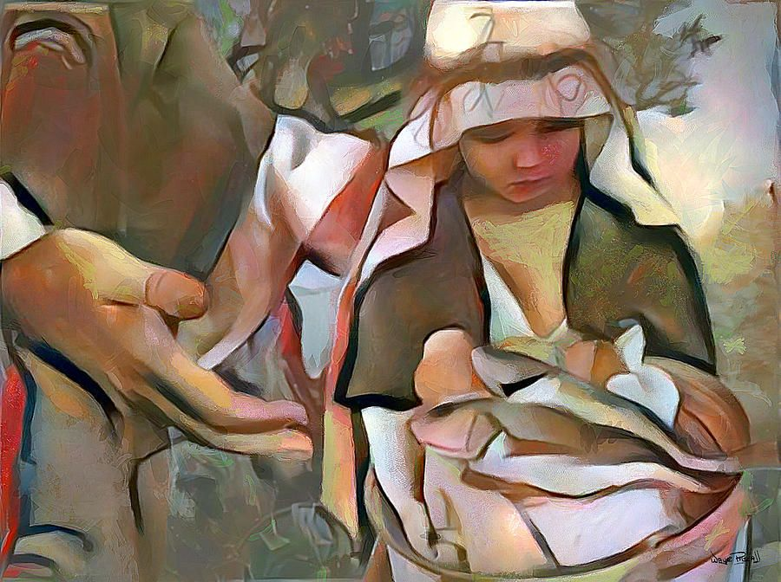

**Ninth Sunday after Pentecost**

**Proper 12 (B)**

**Sunday 25 July 2021**

**Episcopal Church of the Holy Apostles**

26238 N HWY 59, Wauconda, IL 60084

*www.holyapostleswauconda.net*

***You are encouraged to look at pictures and videos if presented.***

***They tell the story in a different way than the words in front of you.***

***But the words are important too;***

***feel free to take your bulletins with you, or access them on our website.***

**OPENING VOLUNTARY**

**WORDS OF WELCOME**

**OPENING HYMN** ***(Verses 1, 2, and 4)***

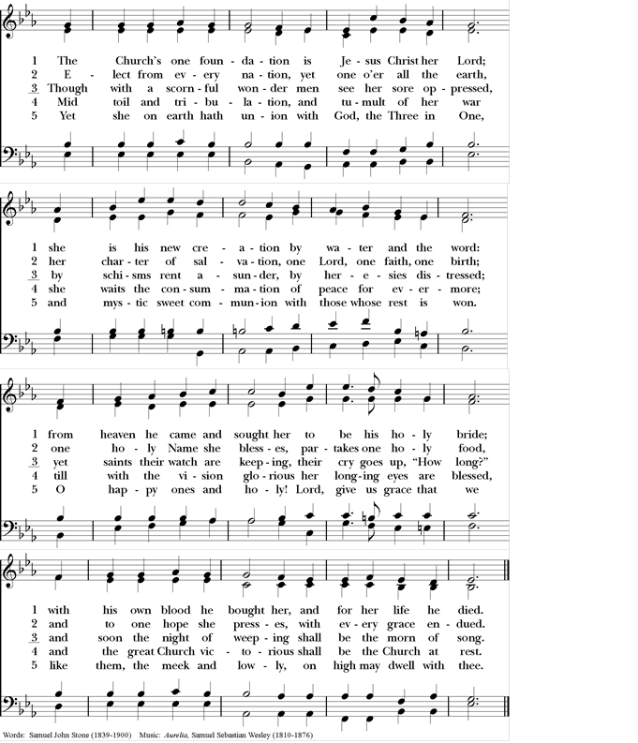

**OPENING SENTENCE**

**Presider:** Blessed be God: Holy Immortal One, Incarnate Word, and Breath of Life.

***People: And blessed be God’s kingdom, now and forever. Amen.***

**COLLECT FOR PURITY**

**Presider:** Almighty God, to you all hearts are open, all desires known, and from you no secrets are hid: Cleanse the thoughts of our hearts by the inspiration of your Holy Spirit, that we may perfectly love you, and worthily magnify your holy Name; through Christ our Lord.

***People: Amen.***

**HYMN OF PRAISE** *(Please say together in unison)*

***All: Gracious God, we bless you for our creation, preservation, and all the blessings of this life; but above all for your immeasurable love in the redemption of the world by our Lord Jesus Christ; for the means of grace, and for the hope of glory. And, we pray, give us such an awareness of your mercies, that with truly thankful hearts we may show forth your praise, not only with our lips, but in our lives, by giving up our selves to your service, and by walking before you in holiness and righteousness all our days; through Jesus Christ our Lord, to whom, with you and the Holy Spirit, be honor and glory throughout all ages.***

**COLLECT OF THE DAY**

**Presider:** The Lord be with you.

***People: And also with you.***

**Presider:** Let us pray. God of true abundance, in whom nothing is lost and all are fed: liberate us from meager rations of scarce and grudging love for which we must compete; show us another kingdom which stills our all-consuming fear and fills us with hew hope; through Jesus Christ, the peace of creation.

***People: Amen.***

*(We read from the various translations authorized by our Church. This month, we read from the Common English Bible, 2012)*

**FIRST LESSON** 2 Samuel 11:1-15

**Reader:** A reading from 2nd Samuel. 11 In the spring, when kings go off to war, David sent Joab, along with his servants and all the Israelites, and they destroyed the Ammonites, attacking the city of Rabbah. But David remained in Jerusalem. 2One evening, David got up from his couch and was pacing back and forth on the roof of the palace. From the roof he saw a woman bathing; the woman was very beautiful. 3David sent someone and inquired about the woman. The report came back: “Isn’t this Eliam’s daughter Bathsheba, the wife of Uriah the Hittite?” 4So David sent messengers to take her. When she came to him, he had sex with her. (Now she had been purifying herself after her monthly period.) Then she returned home. 5The woman conceived and sent word to David. “I’m pregnant,” she said. 6Then David sent a message to Joab: “Send me Uriah the Hittite.” So Joab sent Uriah to David. 7When Uriah came to him, David asked about the welfare of Joab and the army and how the battle was going. 8Then David told Uriah, “Go down to your house and wash your feet.” Uriah left the palace, and a gift from the king was sent after him. 9However, Uriah slept at the palace entrance with all his master’s servants. He didn’t go down to his own house. 10David was told, “Uriah didn’t go down to his own house,” so David asked Uriah, “Haven’t you just returned from a journey? Why didn’t you go home?” 11“The chest and Israel and Judah are all living in tents,” Uriah told David. “And my master Joab and my master’s troops are camping in the open field. How could I go home and eat, drink, and have sex with my wife? I swear on your very life, I will not do that!” 12Then David told Uriah, “Stay here one more day. Tomorrow I’ll send you back.” So Uriah stayed in Jerusalem that day. The next day 13David called for him, and he ate and drank, and David got him drunk. In the evening Uriah went out to sleep in the same place, alongside his master’s servants, but he did not go down to his own home. 14The next morning David wrote a letter to Joab and sent it with Uriah. 15He wrote in the letter, “Place Uriah at the front of the fiercest battle, and then pull back from him so that he will be struck down and die.” The Word of the Lord.

***People: Thanks be to God.***

**RESPONSE:** *(Please say together in unison)* Psalm 14

***14 Fools say in their hearts, There is no God. They are corrupt and do evil things; not one of them does anything good.***

***2The Lord looks down from heaven on humans to see if anyone is wise, to see if anyone seeks God,***

***3but all of them have turned bad. Everyone is corrupt. No one does good—not even one person!***

***4Are they dumb, all these evildoers, devouring my people like they are eating bread but never calling on the Lord?***

***5Count on it: they will be in utter panic because God is with the righteous generation.***

***6You evildoers may humiliate the plans of those who suffer, but the Lord is their refuge.***

***7Let Israel’s salvation come out of Zion! When the Lord changes his people’s circumstances for the better, Jacob will rejoice; Israel will celebrate!***

**SECOND LESSON** Ephesians 3:14-21

**Reader:** A reading from the letter to the Ephesians. 14This is why I kneel before the Father. 15Every ethnic group in heaven or on earth is recognized by him. 16I ask that he will strengthen you in your inner selves from the riches of his glory through the Spirit. 17I ask that Christ will live in your hearts through faith. As a result of having strong roots in love, 18I ask that you’ll have the power to grasp love’s width and length, height and depth, together with all believers. 19I ask that you’ll know the love of Christ that is beyond knowledge so that you will be filled entirely with the fullness of God. 20Glory to God, who is able to do far beyond all that we could ask or imagine by his power at work within us; 21glory to him in the church and in Christ Jesus for all generations, forever and always. Amen. The Word of the Lord.

***People: Thanks be to God.***

**GOSPEL** John 6:1-21

**Presider:** The Holy Gospel of our Lord Jesus Christ according to John.

***People: Glory to you, Lord Christ.***

**Presider:** 6 After this Jesus went across the Galilee Sea (that is, the Tiberias Sea). 2A large crowd followed him, because they had seen the miraculous signs he had done among the sick. 3Jesus went up a mountain and sat there with his disciples. 4It was nearly time for Passover, the Jewish festival. 5Jesus looked up and saw the large crowd coming toward him. He asked Philip, “Where will we buy food to feed these people?” 6Jesus said this to test him, for he already knew what he was going to do. 7Philip replied, “More than a half year’s salary worth of food wouldn’t be enough for each person to have even a little bit.” 8One of his disciples, Andrew, Simon Peter’s brother, said, 9“A youth here has five barley loaves and two fish. But what good is that for a crowd like this?” 10Jesus said, “Have the people sit down.” There was plenty of grass there. They sat down, about five thousand of them. 11Then Jesus took the bread. When he had given thanks, he distributed it to those who were sitting there. He did the same with the fish, each getting as much as they wanted. 12When they had plenty to eat, he said to his disciples, “Gather up the leftover pieces, so that nothing will be wasted.” 13So they gathered them and filled twelve baskets with the pieces of the five barley loaves that had been left over by those who had eaten. 14When the people saw that he had done a miraculous sign, they said, “This is truly the prophet who is coming into the world.” 15Jesus understood that they were about to come and force him to be their king, so he took refuge again, alone on a mountain. 16When evening came, Jesus’ disciples went down to the lake. 17They got into a boat and were crossing the lake to Capernaum. It was already getting dark and Jesus hadn’t come to them yet. 18The water was getting rough because a strong wind was blowing. 19When the wind had driven them out for about three or four miles, they saw Jesus walking on the water. He was approaching the boat and they were afraid. 20He said to them, “I Am. Don’t be afraid.” 21Then they wanted to take him into the boat, and just then the boat reached the land where they had been heading. The Gospel of the Lord.

***People: Praise to you, Lord Christ.***

**THE SERMON**

*(A brief period of silence follows the sermon)*

**NICENE CREED** *(Please say together in unison)*

***Note:*** *This is slightly different than the Nicene Creed found in the Book of Common Prayer, but is considered by the church to be more ancient.*

***All: We believe in one God, the Father, the Almighty, maker of heaven and earth, of all that is, seen and unseen. We believe in one Lord, Jesus Christ, the only Son of God, eternally begotten of the Father, God from God, Light from Light, true God from true God, begotten, not made, of one Being with the Father; through him all things were made. For us and for our salvation he came down from heaven, was incarnate of the Holy Spirit and the Virgin Mary and became truly human. For our sake he was crucified under Pontius Pilate; he suffered death and was buried. On the third day he rose again in accordance with the Scriptures; he ascended into heaven and is seated at the right hand of the Father. He will come again in glory to judge the living and the dead, and his kingdom will have no end. We believe in the Holy Spirit, the Lord, the giver of life, who proceeds FROM THE FATHER, WHO with the Father and the Son is worshiped and glorified., who has spoken through the Prophets. We believe in one holy catholic and apostolic Church. We acknowledge one baptism for the forgiveness of sins. We look for the resurrection of the dead, and the life of the world to come. Amen***

**PRAYERS OF THE PEOPLE** Personalized Form IV

**Leader:** Let us pray for the Church and for the world.

**Leader:** We pray this morning for those raised up in our Anglican and Diocesan Cycles of Prayer; and for all bishops, priests, and deacons. Guide them, guard them, and grant that they and all who confess your Name may be united in your truth, live together in your love, and reveal your glory in the world.

*(Silence)***Leader:**  Lord, in your mercy,

***People: Hear our prayer.***

**Leader:**  We pray for all who govern and hold authority in the nations of the world, particularly in those nations suffering the ravages of war or natural disaster. Guide the people of this land, and of all the earth, in the ways of justice and peace; that we may honor one another and serve the common good.

*(Silence)***Leader:**  Lord, in your mercy,

***People: Hear our prayer.***

**Leader:**  Give us all a reverence for the earth as your own creation, that we may use its resources rightly in the service of others and to your honor and glory.

*(Silence)***Leader:**  Lord, in your mercy,

***People: Hear our prayer.***

**Leader:** We give thanks for all the blessings in our lives. We give thanks for those celebrating birthdays and anniversaries this week, especially those whose names we raise up now, either silently or aloud (*we will keep a 10-second silence*): ___. Bless all whose lives are closely linked with ours, and grant that we may serve Christ in them, and love one another as he loves us.

*(Silence)***Leader:** Lord, in your mercy,

***People: Hear our prayer.***

**Leader:** Comfort and heal all those who suffer in body, mind or spirit, especially those on our parish prayer list and those whose names we raise up now, either silently or aloud (*we will keep a 10-second silence*): ___. Give them courage and hope in their troubles, and bring them the joy of your salvation.

*(Silence)***Leader:**  Lord, in your mercy,

***People: Hear our prayer.***

**Leader:** We commend to your mercy all who have died, especially those killed in the course of service to others or by violence or disaster, and those whose names we raise up now, either silently or aloud (*we will keep a 10-second silence*): ___. We pray that your will for them may be fulfilled, and we pray that we may share with all your saints in your eternal kingdom.

*(Silence)***Leader:** Lord, in your mercy,

***People: Hear our prayer.***

*(The Presider will add this or another concluding Collect)* Almighty God, to whom our needs are known before we ask: Help us to ask only what accords with your will; and those good things which we dare not, or in our blindness cannot ask, grant us for the sake of your Son Jesus Christ our Lord.

***People: Amen.***

**CONFESSION AND ABSOLUTION** (*Please say together in unison*)

***All: Holy God, you know how stubborn we can be. You call us to serve others, and we stay in the familiarity of our own homes. You would send us to where the hopeless live, but we are reluctant to leave the comfort of our complacency. You would feed us on the peace and joy of your word, but we pull our chairs up to the tables of those who serve false promises. Forgive us, Guiding God. Transform our defiance into discipleship, and our rejection of others into the resurrection of welcoming all people as sisters and brothers in Christ. Help us to love as faithfully as you have always loved us, and send us forth to take the good news of Jesus Christ to everyone we meet.***

**Presider:** We open our lips and confess our hearts. God hears our words and make us new, sending us our to bring hope and joy to all the world. + We are forgiven; and we Hearing the good news, believing the good news, we are forgiven; and sent to live out the good news. Thanks be to God.

***People: Amen.***

**THE PEACE** *(Please greet each other in the name of the Lord.)*

**Presider:** The Peace of the Lord be always with you.

***People: And also with you.***

**OFFERTORY SENTENCES**

**Presider:** We give in grateful thanksgiving for all that God has given us. In the upside down world of the gospel, we measure our wealth not by what we have, but what we can give away. Let us give away generously, of our time, our talent, our treasure, and ourselves, to bless your church, your people, your creation.

*Please follow the Presider’s directions for Communion.*

**GREAT THANKSGIVING** EOW-II

**Presider:** The Lord be with you.

***People: And also with you.***

**Presider:** Lift up your hearts.

***People: We lift them to the Lord.***

**Presider:** Let us give thanks to the Lord our God.

***People: It is right to give our thanks and praise.***

**Presider:** We praise you and we bless you, holy and gracious God, source of life abundant. From before time you made ready the creation. Your Spirit moved over the deep and brought all things into being: sun, moon, and stars; earth, winds, and waters; and every living thing. You made us in your image, and taught us to walk in your ways. But we rebelled against you, and wandered far away; and yet, as a mother cares for her children, you would not forget us. Time and again you called us to live in the fullness of your love.

And so this day we join with Saints and Angels in the chorus of praise that rings through eternity, lifting our voices to magnify you as we say/sing:

**SANCTUS** *(Please say together in unison)*

***All: Holy, holy, holy Lord, God of power and might, heaven and earth are full of your glory. Hosanna in the highest. Blessed is the one who comes in the name of the Lord. Hosanna in the highest.***

**Presider:** Glory and honor and praise to you, holy and living God. To deliver us from the power of sin and death and to reveal the riches of your grace, you looked with favor upon Mary, your willing servant, that she might conceive and bear a son, Jesus the holy child of God. Living among us, Jesus loved us. He broke bread with outcasts and sinners, healed the sick, and proclaimed good news to the poor. He yearned to draw all the world to himself yet we were heedless of his call to walk in love. Then, the time came for him to complete upon the cross the sacrifice of his life, and to be glorified by you.

**↑**On the night before he died for us, Jesus was at table with his friends. He took bread, gave thanks to you, broke it, and gave it to them, and said: "Take, eat; This is my Body, which is given for you. Do this for the remembrance of me."

**↑**As supper was ending, Jesus took the cup of wine. Again, he gave thanks to you, gave it to them, and said: "Drink this, all of you: This is my Blood of the new Covenant, which is poured out for you and for all for the forgiveness of sins. Whenever you drink it, do this for the remembrance of me."

Now gathered at your table, O God of all creation, and remembering Christ, crucified and risen, who was and is and is to come, we offer to you our gifts of bread and wine, and ourselves, a living sacrifice.

**∞** Pour out your Spirit upon these gifts that they may be the Body and Blood of Christ.

**+** Breathe your Spirit over the whole earth and make us your new creation, the Body of Christ given for the world you have made.

In the fullness of time bring us with all your saints, from every tribe and language and people and nation, to feast at the banquet prepared from the foundation of the world.

Through Christ and with Christ and in Christ, in the unity of the Holy Spirit, to you be honor, glory, and praise, for ever and ever. ***AMEN.***

**LORD’S PRAYER**

**People: Our Father who art in heaven**

**Presider:** How blissful it is to imagine heaven on earth. But lives are always endangered. Poverty consumes many, hunger and disease destroy many. The bodies of young people are for sale. Mothers and fathers are migrating to foreign lands seeking freedom and dignity and new opportunities. God, grant to us the experience of heaven on earth.

**People: Hallowed be your name**

**Presider:** Your name is holy, your people are holy. You created us in your image. But the dignity of the poor ones is crushed by those who whip the poor by laws and by rules. Your name was used by foreign powers. In your name colonizers invaded foreign lands. In your name they burned and smashed.

**People: Your kingdom come, your will be done, on earth as it is in heaven.**

**Presider:** We know that your kingdom is a kingdom of love, justice and of peace. A kingdom of righteousness and abundance for all. Do not allow us to be deceived by the standard of this world, where unjust wars rule and colonizers become rulers of the nations. Let your will be done soon, and vanish the pseudo-kingdom of empire power, until we can finally say, heaven is possible here on earth.

**People: Give us this day our daily bread.**

**Presider:** The bread that we eat today satisfies our hunger. But those who make the bread in many countries have empty stomachs. How can we be happy when our body is full while many are wanting? We have been told those who do not work should not eat. But how come those who work hard have too little to eat, while those who amass wealth by greed have plenty to throw away? May the daily bread we partake in be the communion of struggle and hope, and be the bread that is shared by all.

**People: Forgive us our debts, as we forgive debtors.**

**Presider:** We offer our self-criticisms. When we have failed to love You and our neighbor, renew us and enable us to make up whatever we have failed to do. Give us hearts that can share your grace by forgiving others. Let us be humble like a dove and make us wise as a serpent. May we be sustained in our courage, that we will not be manipulated by those who have wronged, exploited and oppressed your people. Forgiveness is for those who have admitted their accountability, for your grace is sufficient enough to correct our mistakes. But arrogance and conceit will lead us only to downfall.

**People: And lead us not into temptation, but deliver us from evil.**

**Presider:** Lead us not to resignation in our work for justice and peace. Let not cynicism rule us, but lead us to a deeper steadfastness to overcome evil in our midst.

**People: For thine is the kingdom, and the power, and the glory, forever and ever. Amen.**

**Presider:** This we believe. Let your power of love and the glory of justice and peace be with us all forever and ever. Amen.

**FRACTION (THE BREAKING OF THE BREAD)**

*(The Presider breaks the consecrated bread. A brief period of silence is kept.)*

**Presider:** We break this bread to share in the Body of Christ.

***People: We who are many are one body, for we all share in the one bread.***

**Presider:** **↑**The Gifts of God for the People of God. Take them in remembrance that Christ died for you, and feed on him in your hearts by faith, with thanksgiving.

**POST-COMMUNION PRAYER** *(Please say together in unison)*

**Presider:** Let us pray.

***All: Loving God, we give you thanks for restoring us in your image and nourishing us with spiritual food in the Sacrament of Christ’s Body and Blood. Now send us forth a people, forgiven, healed, renewed; that we may proclaim your love to the world and continue in the risen life of Christ our Savior. Amen.***

**PARISH ANNOUNCEMENTS**

**BLESSING**

**Presider**: May the blessing of the God of Abraham and Sarah, and of Jesus Christ born of our sister Mary, and of the Holy Spirit, who broods over the world as a mother over her children, be upon you and remain with you always.

***People: Amen.***

**CLOSING HYMN *(Verses 1, 2, and 3)***

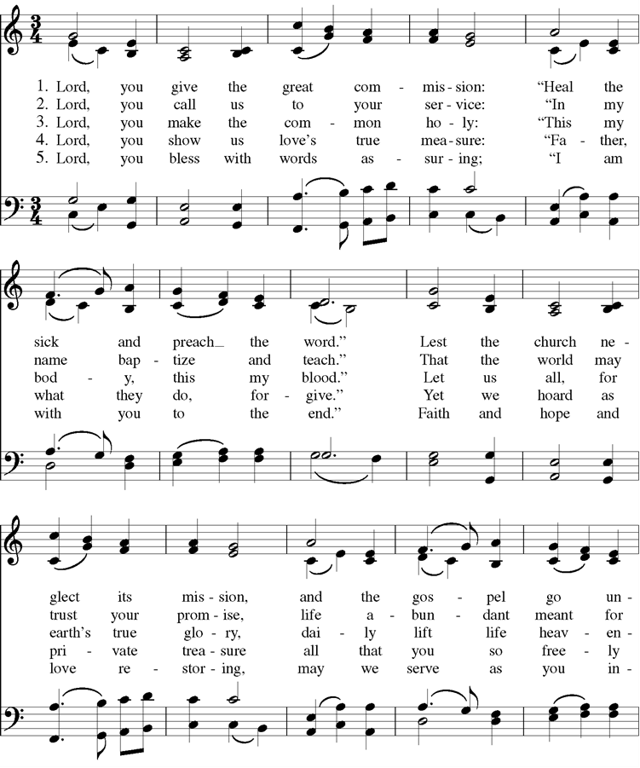

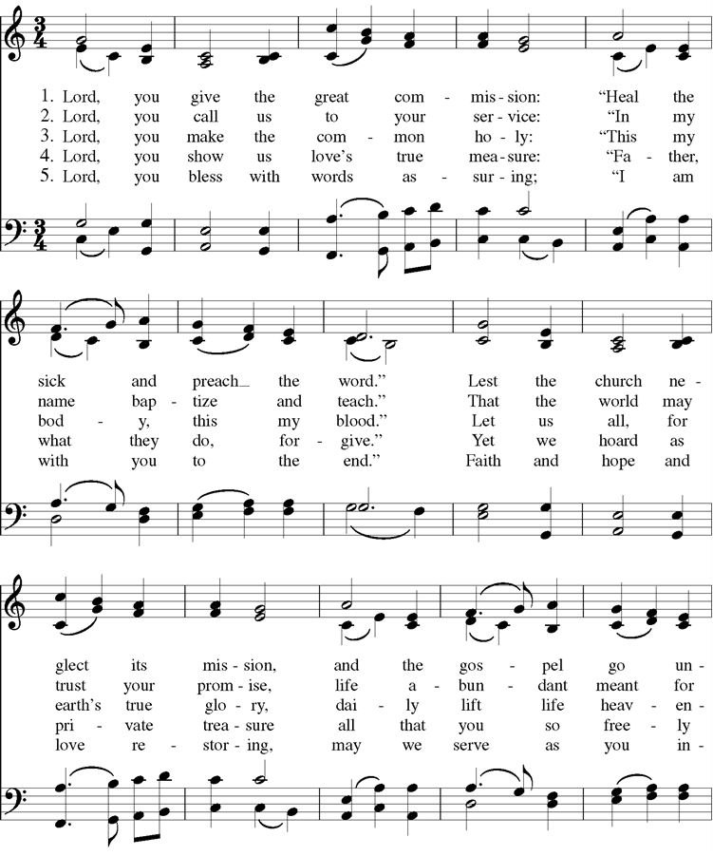



Cover Image: https://www.allposters.com/-sp/Great-Crowds-Followed-Jesus-as-He-Preached-the-Good-News-2004-Posters_i9823150_.htm

Confession: Adapted from Thom Shuman, accessed at <https://re-worship.blogspot.com/2012/06/confession-proper-9-b.html>

Offertory Sentences: Adapted from Quentin Chin, accessed at <https://re-worship.blogspot.com/2014/06/prayer-for-offering.html>

Lord’s Prayer: Adapted from a prayer by Norma P. Dollaga, accessed at <https://re-worship.blogspot.com/2013/07/prayer-for-others-based-on-lords-prayer.html>