**FIRST SUNDAY AFTER THE EPIPHANY (B)**

*Episcopal Church of the Holy Apostles*

Sunday 10 January 2021

**OPENING VOLUNTARY**

*As with Gladness Men of Old*

*Come, Thou Fount of Every Blessing*

*Come Down, O Love Divine*

**WORDS OF WELCOME**

**LITANY FOR THE BAPTISM OF JESUS**

**Presider:** The Father's voice bears witness to the Son.

***People: God has shown himself to us.***

**Presider:** The Son bows his head beneath the waters of the Jordan.

***People: God has shown himself to us.***

**Presider:** Christ submits to John's baptism and frees us from slavery.

***People: God has shown himself to us.***

**Presider:** God's love is seen to the end of the world.

***People: God has shown himself to us.***

**OPENING HYMN** LEVAS, #141

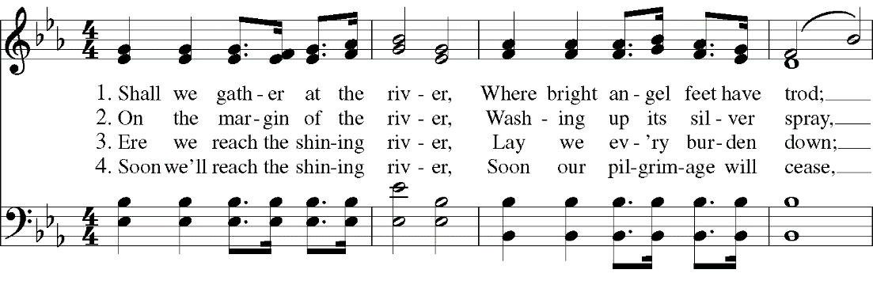

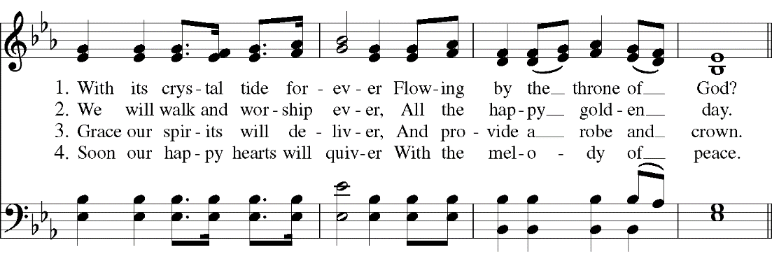

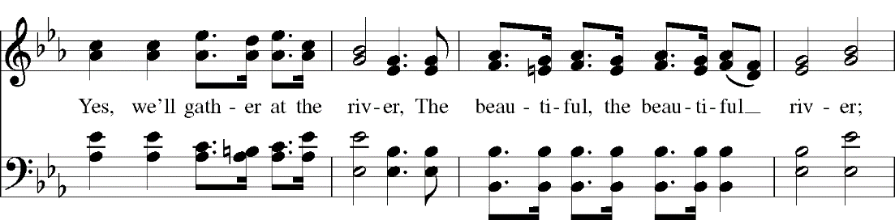

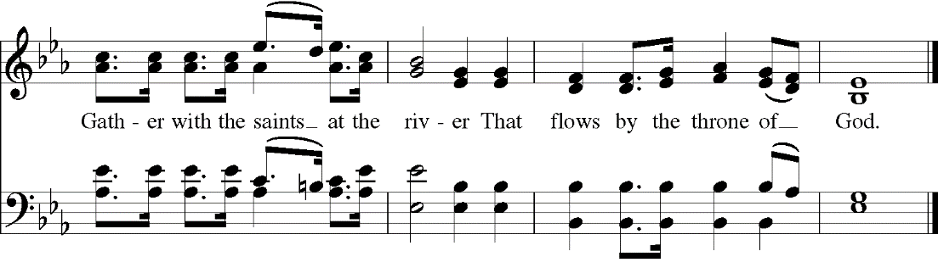

**OPENING SENTENCES**

**Presider:** Blessed be God: Holy Immortal One, Incarnate Word, and Breath of Life.

***People: And blessed be God's kingdom, now and forever. Amen.***

**COLLECT FOR PURITY**

**Presider:** Almighty God, to you all hearts are open, all desires known, and from you no secrets are hid: Cleanse the thoughts of our hearts by the inspiration of your Holy Spirit, that we may perfectly love you, and worthily magnify your holy Name; through Christ our Lord.

***People: Amen.***

**HYMN OF PRAISE**

**Presider:** God whose love reaches to the highest heavens,

***People: how can we keep silent?***

**Presider:** God whose righteousness stands like the tallest mountain

***People: how can we keep silent?***

**Presider:** God whose justice is deeper than any ocean

***People: how can we keep silent?***

**Presider:** God whose grace flows like a never-ending river

***People: how can we keep silent?***

**Presider:** How can we not proclaim your majesty from generation to generation?

***People: How can we not raise the lamp of your Salvation for all the world to see?***

***All: God whose love reaches to the highest heavens we praise your mighty name!***

**COLLECT OF THE DAY**

**Presider:**  The Lord be with you.

***People: And also with you.***

**Presider:** Let us pray. God of the tearing heaven, whose holiness is unveiled by one who is submerged in all the pain and sin of earth: give us faith to follow him who goes to the heart of darkness bearing only the Spirit of gentle, insistent peace; through Jesus Christ, the promise one.

***People: Amen.***

*(We read from the various translations of the Bible authorized by our Church. This month we read from the Good News Translation (Today’s English Version), 1976)*

**FIRST LESSON** Genesis 1:1-5

**Reader:** A reading from Genesis. 1 In the beginning, when God created the universe,  2the earth was formless and desolate. The raging ocean that covered everything was engulfed in total darkness, and the Spirit of God was moving over the water. 3Then God commanded, “Let there be light”—and light appeared. 4God was pleased with what he saw. Then he separated the light from the darkness, 5and he named the light “Day” and the darkness “Night.” Evening passed and morning came—that was the first day. The word of the Lord.

***People: Thanks be to God.***

**RESPONSE** *(Please say together)* Psalm 29

***29 Praise the Lord, you heavenly beings; praise his glory and power.  
2Praise the Lord's glorious name; bow down before the Holy One when he appears.***

***3The voice of the Lord is heard on the seas; the glorious God thunders,  and his voice echoes over the ocean.  
4The voice of the Lord is heard in all its might and majesty.***

***5The voice of the Lord breaks the cedars, even the cedars of Lebanon.  
6He makes the mountains of Lebanon jump like calves  and makes Mount Hermon leap like a young bull.***

***7The voice of the Lord makes the lightning flash.  
8His voice makes the desert shake; he shakes the desert of Kadesh.  
9The Lord's voice shakes the oaks and strips the leaves from the trees while everyone in his Temple shouts, “Glory to God!”***

***10The Lord rules over the deep waters; he rules as king forever.  
11The Lord gives strength to his people and blesses them with peace.***

**SECOND LESSON** Acts 19:1-7

**Reader:** A reading from the Acts of the Apostles. 19 While Apollos was in Corinth, Paul traveled through the interior of the province and arrived in Ephesus. There he found some disciples 2and asked them, “Did you receive the Holy Spirit when you became believers?” “We have not even heard that there is a Holy Spirit,” they answered. 3“Well, then, what kind of baptism did you receive?” Paul asked. “The baptism of John,” they answered. 4Paul said, “The baptism of John was for those who turned from their sins; and he told the people of Israel to believe in the one who was coming after him—that is, in Jesus.” 5When they heard this, they were baptized in the name of the Lord Jesus. 6Paul placed his hands on them, and the Holy Spirit came upon them; they spoke in strange tongues and also proclaimed God's message. 7They were about twelve men in all. The word of the Lord.

***People: Thanks be to God.***

**GOSPEL HYMN** H1982, #139



**GOSPEL** Mark 1:4-11

**Presider:** The Holy Gospel of our Lord Jesus Christ according to Mark.

***People: Glory to you, Lord Christ.***

**Presider:** 4John appeared in the desert, baptizing and preaching. “Turn away from your sins and be baptized,” he told the people, “and God will forgive your sins.” 5Many people from the province of Judea and the city of Jerusalem went out to hear John. They confessed their sins, and he baptized them in the Jordan River. 6John wore clothes made of camel's hair, with a leather belt around his waist, and his food was locusts and wild honey. 7He announced to the people, “The man who will come after me is much greater than I am. I am not good enough even to bend down and untie his sandals. 8I baptize you with water, but he will baptize you with the Holy Spirit.” 9Not long afterward Jesus came from Nazareth in the province of Galilee, and was baptized by John in the Jordan. 10As soon as Jesus came up out of the water, he saw heaven opening and the Spirit coming down on him like a dove. 11And a voice came from heaven, “You are my own dear Son. I am pleased with you.” The Gospel of the Lord.

***People: Praise to you, Lord Christ.***

**SERMON** The Rev. M. C. Gillette

*(A brief period of silence follows the sermon)*

**RENEWAL OF BAPTISMAL VOWS**

**Presider:** Do you reaffirm your renunciation of evil and renew your commitment to Jesus Christ?

***People: I do.***

**Presider:** Do you believe in God the Father?

***People: I believe in God, the Father almighty, creator of heaven and earth.***

**Presider:** Do you believe in Jesus Christ, the Son of God?

***People: I believe in Jesus Christ, his only Son, our Lord. He was conceived by the power of the Holy Spirit and born of the Virgin Mary. He suffered under Pontius Pilate, was crucified, died, and was buried. He descended to the dead. On the third day he rose again. He ascended into heaven, and is seated at the right hand of the Father. He will come again to judge the living and the dead.***

**Presider:** Do you believe in God the Holy Spirit?

***People: I believe in the Holy Spirit, the holy catholic Church, the communion of saints, the forgiveness of sins, the resurrection of the body, and the life everlasting.***

**Presider:** Will you continue in the apostles' teaching and fellowship, in the breaking of bread, and in the prayers?

***People: I will, with God's help.***

**Presider:** Will you persevere in resisting evil, and, whenever you fall into sin, repent and return to the Lord?

***People: I will, with God's help.***

**Presider:** Will you proclaim by word and example the Good News of God in Christ?

***People: I will, with God’s help.***

**Presider:** Will you seek and serve Christ in all persons, loving your neighbor as yourself?

***People: I will, with God’s help.***

**Presider:** Will you strive for justice and peace among all people, and respect the dignity of every human being?

***People: I will, with God's help.***

**Presider:** May Almighty God, the Father of our Lord Jesus Christ, who has given us a new birth by water and the Holy Spirit, and bestowed upon us the forgiveness of sins, keep us in eternal life by his grace, in Christ Jesus our Lord.

***People: Amen.***

**PRAYERS OF THE PEOPLE**

**Leader:** Lord, in this season of Epiphany, we remember the journey of the Magi who sought the Christ child, the light of the star which guided them, and their response to finding Jesus, the newborn king.

***People: Lord, let us seek you, follow your light, and worship you as they did long ago.***

**Leader:** We thank you for manifesting yourself to all people and for opening the doors of your church to both Jews and Gentiles.

***People: Reveal yourself, we pray, to all who long to find you, and grant them the joy of knowing you.***

**Leader:** We pray for your church around the world, that you might dwell among us, unite us, and transform us. We pray especially for those on our Episcopal and Diocesan cycles of prayer.

***People: Make your church a light to the nations, shining forth with mercy, power, and love.***

**Leader:** We pray for the leaders of our local, state, and national governments, and for all who hold power and authority in the world.

***People: Please guide their feet along the pathways of justice, compassion, reconciliation, and peace.***

**Leader:** We pray for all who suffer in body, mind, or spirit, and for those who are in any kind of trouble or sorrow, remembering especially those on our parish prayer list, and those whose names we raise up now, either silently or aloud: *(we will keep a 10-second silence)* _____

***People: Manifest yourself to them, merciful God. Grant them your gifts of healing, grace, wisdom, and comfort.***

**Leader:** We pray for those who have died. In particular, we pray for our beloved departed, and those whose names we raise up now, either silently or aloud: *(we will keep a 10-second silence)* _____ . We pray for those who have been killed in the course of service to others, giving thanks for their sacrifice.

***People: May they live eternally with you in Paradise.***

**Leader:** We thank you for the joy which fills our hearts, and for those celebrating birthdays and anniversaries this week, in particular those whose names we raise up now, either silently or aloud: (we will keep a 10-second silence: _____ . Keep us mindful of the good things in our lives.

***People: In your mercy, bless us, and make us a source of blessing to others as we share our joy with them.***

**Presider:** *(Says this or another Collect)* May your radiance shine upon us all as brightly today as the star shown upon those of another age so long ago: and grant us all a desire to seek and to serve; graciously accepting your gift of grace, and striving always to return through the love and kindness we show to our neighbors some small portion of that loving-kindness you have given us; through Jesus Christ our Lord.

***People: Amen***

**CONFESSION OF SIN**

**Presider:** Let us confess our sins before God and our neighbor. When we have failed to recognize your love in the actions of friend or stranger,

***People: Merciful Lord, forgive us.***

**Presider:** When we have failed to recognize your presence in the world in which we live,

***People: Merciful Lord, forgive us.***

**Presider:** When we have failed to remember your gospel in our actions, thoughts, and words,

***People: Merciful Lord, forgive us.***

**Presider:** When we are struggling with life, searching for answers in vain, relying on our own strength and failing again, and again,

***People: Merciful Lord, forgive us.***

**Presider:** When we forget that you are the strength upon whom we can call, the power to endure, the answer that we seek, the one in whose arms we can safely fall,

***People: Merciful Lord, forgive us.***

*(Silence)****All: Merciful Lord, renew our hearts in worship, our minds in wisdom , and our hands in service. Take our lives and use them, as a sacrifice of love.***

**Presider:** God has opened our ears and our hearts to know God’s love and forgiveness. There is nothing we need to do other than love one another and love God, for all things come from God’s love. You have been forgiven; you have been reconciled to God. Live in the way of Christ.

***People: Amen.***

**THE PEACE** *(Please greet each other in the name of the Lord – from a safe distance!)*

**Presider:** We are the body of Christ. In the one Spirit we were all baptized into one body.

***People: Let us then pursue all that makes for peace and builds up our common life.***

*(The Presider gives an Offertory Sentence or says:)* Open the heavens, Holy Spirit, for us to see Jesus interceding for us; may we be willing to share his baptism, ready to share his cup, and strengthened to serve him forever.

***People: Amen.***

**OFFERTORY HYMN** H1982, #126

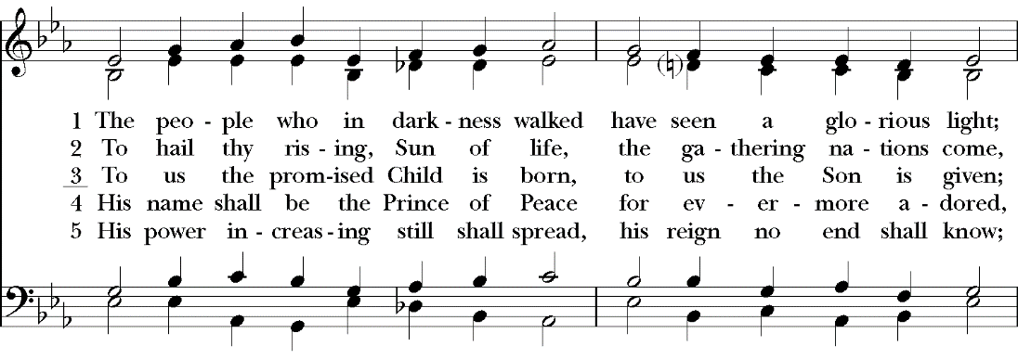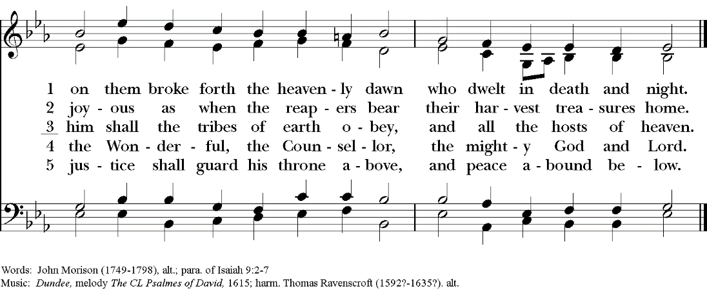

**THE GREAT THANKSGIVING**  Rite II, Prayer B

**Presider:** The Lord be with you.

***People: And also with you.***

**Presider:** Lift up your hearts.

***People: We lift them to the Lord.***

**Presider:** Let us give thanks to the Lord our God.

***People: It is right to give God thanks and praise.***

**Presider:** We praise you, God of many names, whose Spirit runs free through all the earth, whose image lies deep in every mortal soul. In your grace your Word is made known to every people, calling forth the best they have to offer; your Beloved is immersed in the waters of creation, healing the chaos that floods our world; your Son is the guest who offers new wine, changing hearts grown withered and cold. Therefore we celebrate the rays of morning light that bathe the world in glory and kindle a new song:

**SANCTUS**

***All: Holy, holy, holy Lord, God of power and might, heaven and earth are full of your glory. Hosanna in the highest. Blessed is he who comes in the name of the Lord. Hosanna in the highest.***

**Presider:** We give thanks to you, O God, for the goodness and love which you have made known to us in creation; in the calling of Israel to be your people; in your Word spoken through the prophets; and above all in the Word made flesh, Jesus, your Son. For in these last days you sent him to be incarnate from the Virgin Mary, to be the Savior and Redeemer of the world. In him, you have delivered us from evil, and made us worthy to stand before you. In him, you have brought us out of error into truth, out of sin into righteousness, out of death into life.

**↑**On the night before he died for us, our Lord Jesus Christ took bread; and when he had given thanks to you, he broke it, and gave it to his disciples, and said, “Take, eat: This is my Body, which is given for you. Do this for the remembrance of me.”

**↑**After supper he took the cup of wine; and when he had given thanks, he gave it to them, and said, “Drink this, all of you: This is my Blood of the new Covenant, which is shed for you and for many for the forgiveness of sins. Whenever you drink it, do this for the remembrance of me.”

Therefore, according to his command, O Father,

***All: We remember his death, We proclaim his resurrection, We await his coming in glory;***

**Presider:** And we offer our sacrifice of praise and thanksgiving to you, O Lord of all; presenting to you, from your creation, this bread and this wine.

**∞** We pray you, gracious God, to send your Holy Spirit upon these gifts that they may be the sacrament of the Body of Christ and his Blood of the new Covenant. **+** Unite us to your Son in his sacrifice, that we may be acceptable through him, being sanctified by the Holy Spirit. In the fullness of time, put all things in subjection under your Christ, and bring us to that heavenly country where, with all your saints, we may enter the everlasting heritage of your sons and daughters; through Jesus Christ our Lord, the firstborn of all creation, the head of the Church, and the author of our salvation.

By him, and with him, and in him, in the unity of the Holy Spirit all honor and glory is yours, Almighty Father, now and forever. ***AMEN.***

**THE LORD’S PRAYER:**

**Presider:** As our Savior Christ has taught us, we now pray,

***All: Our Father in heaven, hallowed be your Name, your kingdom come, your will be done, on earth as in heaven. Give us today our daily bread. Forgive us our sins as we forgive those who sin against us. Save us from the time of trial, and deliver us from evil. For the kingdom, the power, and the glory are yours, now and forever. Amen.***

**THE FRACTION (THE BREAKING OF THE BREAD)**

*(The Presider breaks the consecrated bread. A brief period of silence is kept.)*

**Presider:** Alleluia. Christ our Passover is sacrificed for us;

***People: Therefore let us keep the feast. Alleluia.***

**Presider:** The gifts of God for the People of God. Take them in remembrance that Christ died for you, and feed on him in your hearts by faith, with thanksgiving.

**COMMUNION HYMN**  H1982, #362

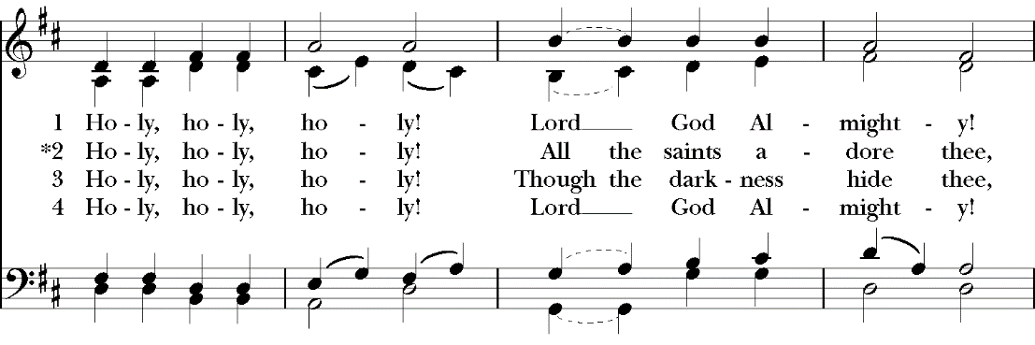

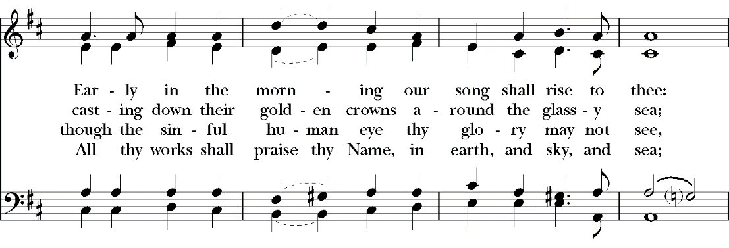

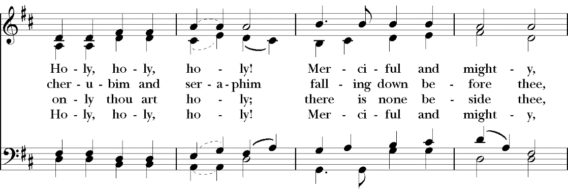

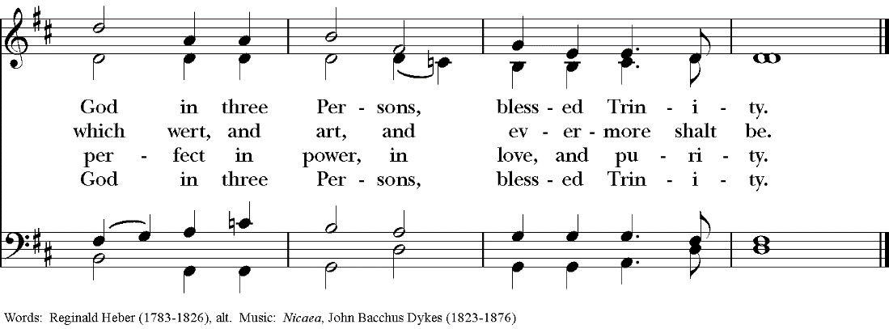

**POST COMMUNION PRAYER**

**Presider:** Lord of the wedding feast, we thank you for sharing with us the abundance of your life: in the beauty of humility may we receive with joy the stranger’s gift, the water’s grace, the living wine of love’s desire.

***People: Amen.***

**BLESSING**

**Presider:** *(Gives this or another blessing)* May God, who in Christ gives us a spring of water welling up to eternal life, perfect in you the image of his glory; and the blessing of God Almighty, the Holy Immortal One, the Incarnate Word, and the Breath of Life, be among you, and remain with you always. ***People: Amen.***

**CLOSING HYMN**  H1982, #135

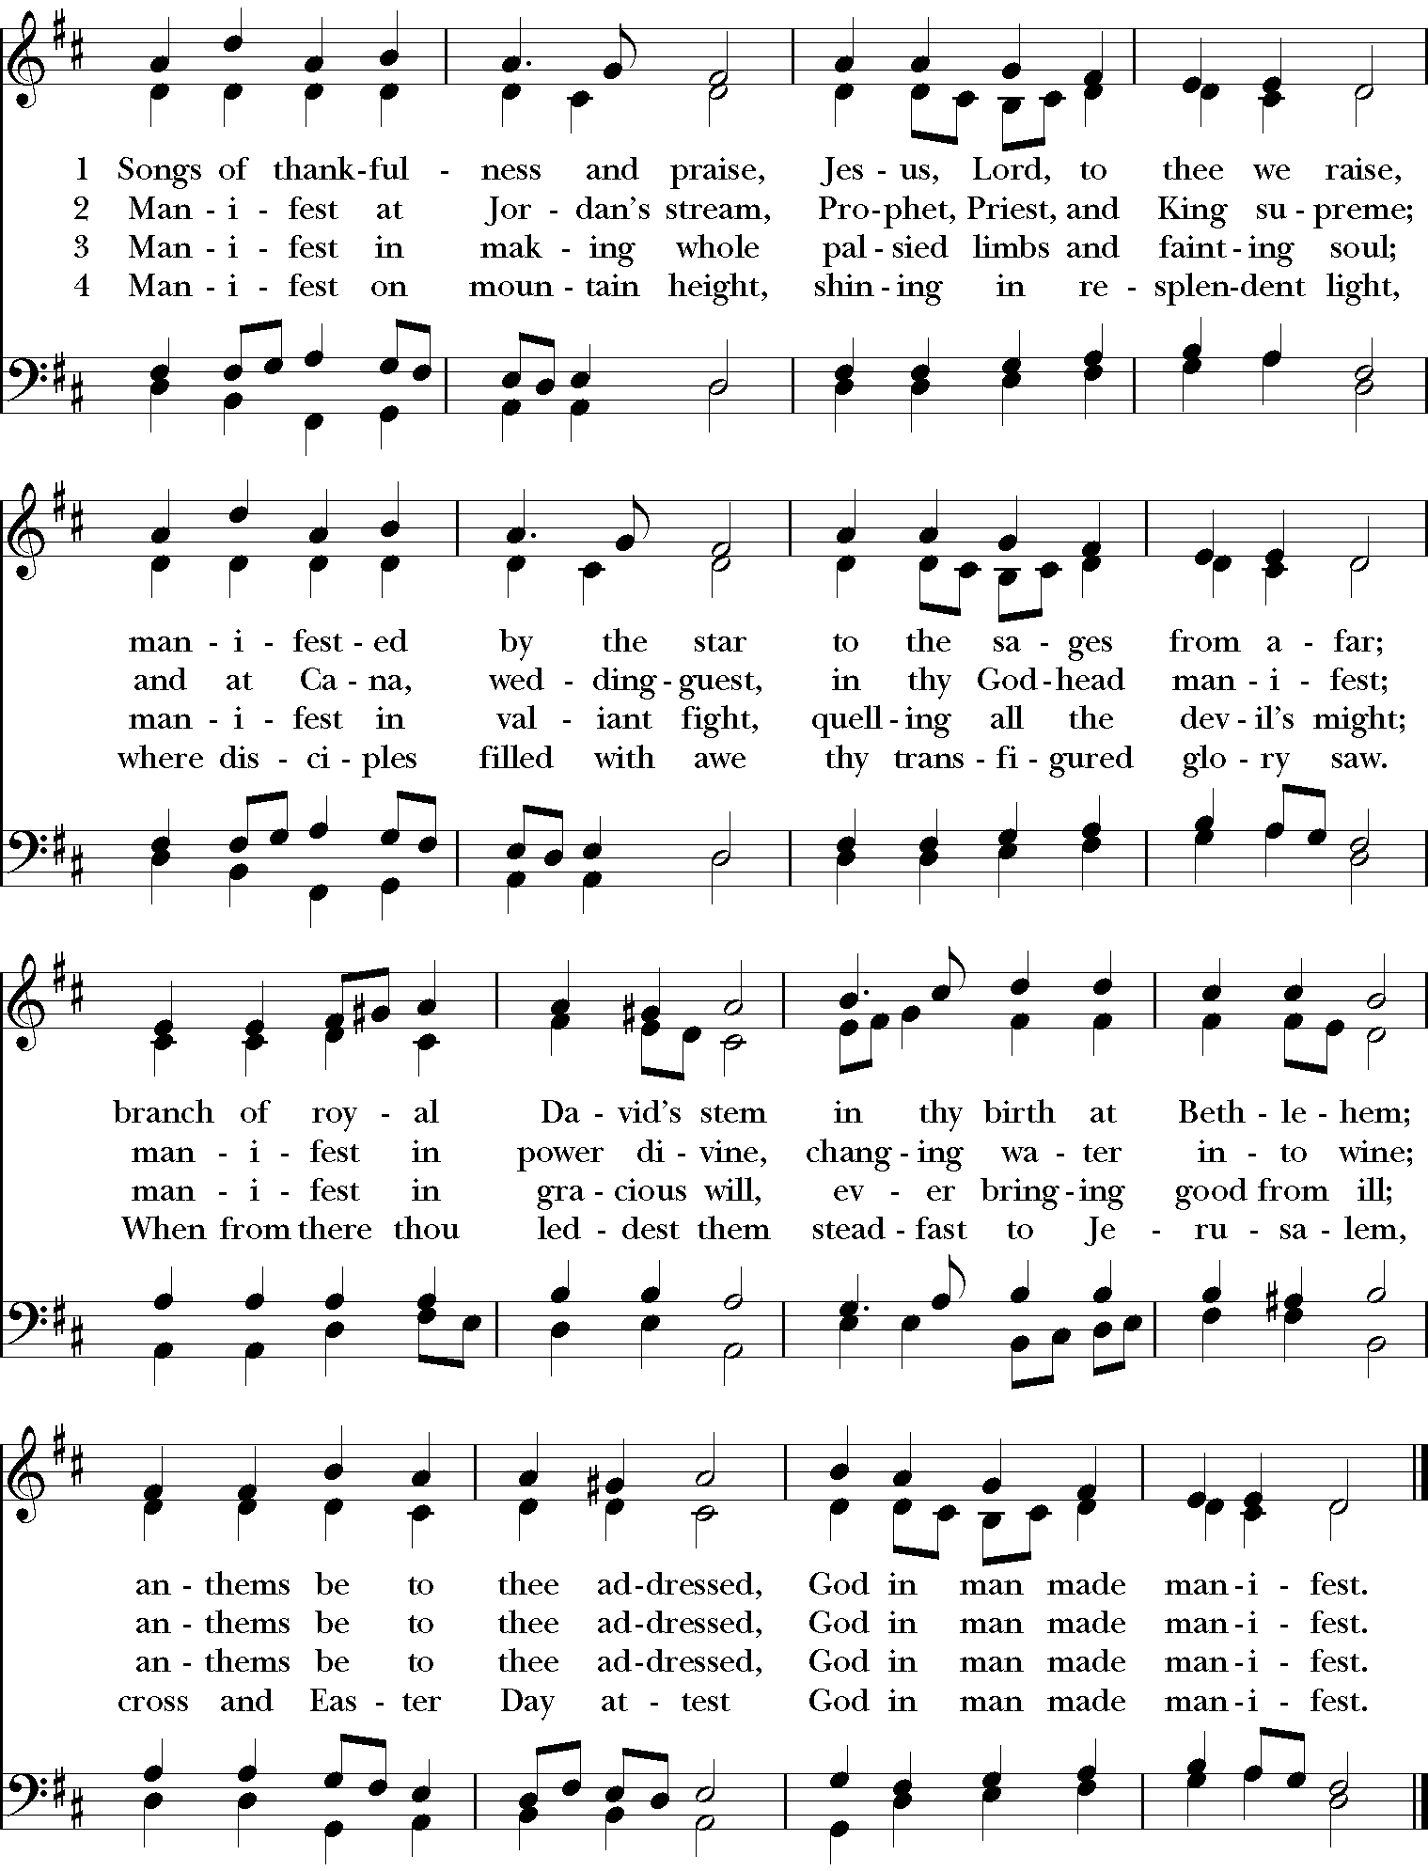



**DISMISSAL**

**Presider:** *(The Presider gives this or another dismissal)* The curtain of heaven has parted; Jesus our savior reveals the kingdom of heaven around us. Opportunities abound to be subversive doing God's work. Go forth, knowing Christ is with you.

***People: Amen! We will go!***

**CLOSING VOLUNTARY**

**Litany for the Baptism of Jesus:** Based on Mark 1:9-11, Luke 3:21-23; Lutheran Church of Australia. Accessed at

<http://re-worship.blogspot.com/2011/12/responsive-litany-baptism-of-jesus.html>

**Hymn of Praise:** John Birch, accessed at <https://theworshipcloud.com/view/written/prayer-god-whose-love-reaches-the-highest-heavens>

**Confession:** John Birch, accessed at <http://www.faithandworship.com/prayers_Repentance.htm>

**Absolution:** The Rev. Mindi Welton-Mitchell, accessed at http://rev-o-lution.org.

**Various elements adapted from** <http://www.churchofengland.org/media/41154/tandsepiphany.pdf>