**The Apostles Post**

26238 North Highway 59

Wauconda, Illinois

JUNE 2022

2015



**FROM THE VICAR’S DESK** *(M. C. Gillette)*Angelology, Issue VI

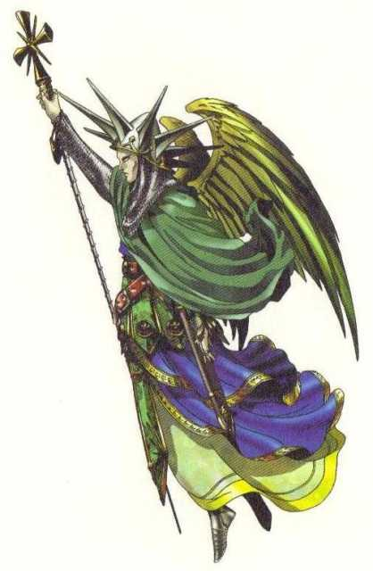

OK. So, we’ve waded through Angelology in general; have talked about Saint Gregory the Great’s assessment that “the authority of Scripture” informs us that “there are nine orders [*also known as “choirs”*] of angels, viz., Angels, Archangels, Virtues, Powers, Principalities, Dominations [*aka Dominions*], Thrones, Cherubim and Seraphim;” lamented the fact that although we lump all these heavenly beings into the category of “angels,” those inhabiting the lowest rank are the only ones who are actually “Angels;” and struggled through two issues worth of thought on what is arguably the most well-known order/choir – Archangels.

Cherubim and Seraphim are also probably familiar orders, at least in terms of our having heard their names and seen their images in music and art. (But, spoiler alert – “Cherubs” are not – mmm – cherubic. Stay tuned.) This leaves us with the five orders of outliers. And with all due respect to the venerable Gregory, the historical consensus (in the Christian tradition) about the ordering of the ranks is: Lowest orders: Angels, Archangels, Principalities. Middle orders: Powers, Virtues, Dominions. Highest orders: Thrones, Cherubim, Seraphim. After all, if Beatrice lists them his way for Dante as the two of them wander through the Divine Comedy toward Paradiso, I most certainly am not going to argue. (Explaining the angelic hierarchy, Beatrice notes that Dionysius (the Areopagite, Paul’s disciple) got things right, while “Gregory, later, differed with his conclusions. But hardly had he wakened in this heaven than he was moved to laugh at his own delusions.”) On, then, to Principalities.

The Principalities, being the highest rank of the lowest order of angels, constitute the bridge between material manifestation and spiritual essence. They are the “senior” angels in the “messenger” group, the orders who, being the furthest from the throne of God, have the greatest ability to communicate with humans in ways we can understand. Principalities are said to have command over Archangels and Angels. They direct the Archangels and Angels in the fulfillment of divine orders given to them, in turn, by the Dominations. Principalities are also known as “Princedoms” or “Rules,” as they directly watch over and guide large groups and institutions, including nations and the Church. They choose individuals suitable for governing, administering, inventing, and fostering trade and military affairs. Principalities are the guardian angels of time and historical eras, which is actually the duty from which the “guiding” and “choosing” arise, as they decide who should take the lead in a certain period or inspire the birth of new ideas or inventions capable of marking a certain epoch. I don’t know quite what to say about this; far be it from me to question celestial beings of any rank, but it seems as if one might wish the Principalities were a bit more – successful – in their choosing and guiding missions right about now. (I am assuming, quite confidently, that the Divine isn’t very pleased with various institutions, some nations, a chunk of the Church, and more than a handful of world leaders at the moment.) Anyway, Principalities are often depicted wearing crowns and holding scepters. Principalities are the order that helped David slay Goliath. I, for one, didn’t realize he’d had help. Somehow that doesn’t seem quite fair.

**HERE AND THERE** *(M. C. Gillette)*

*In this on-going article, we pull things from our various Diocesan calendars and church websites to see what’s going on around us. For more information about what's happening at the Diocesan Headquarters and the Cathedral of Saint James, you can always visit their websites:* <https://www.episcopalchicago.org>

or <https://www.saintjamescathedral.org/>

[**May Our Anguish Move Us to Action:**](https://r20.rs6.net/tn.jsp?f=001SegzIn9XsAFEBuGt4GuXwC_NbFmT9E6_AzmhwcuKmlL3SMvXY6xMbFg2fYKnC3Nn-4Q5kJ3Bj8yDcCappujZPKIAfYMcwI-GqnpYdkrxlk7wOB35ZQCEAdzYf3_wBIL3opGMH4leuWElOwtDRN59MMTtwCi1RoIqHnw02Mq-BBTlXsSoCmSsUGPWn4axFS7iLyMLuH13ahgXqCVJ9liDmU8lHK6-e71TvPvKDSYNFyh9f2uvAk8Grfz2JkxadhdF&c=2wkBLEqUvpp5AOcLG-0cD_IwhtEMaP1RXBPs7h6wCcvC1MfV6wyH4g==&ch=3cOLkSAqFNbBV4QpVkCaKrYtrVC0Sr6UrLGHaJbBjPh_wsOJnqDJhg==) **A Message from Bishop-elect Paula Clark**

Dear People of God in the Diocese of Chicago:

The words of the prophet Jeremiah come to mind so often these days:

Thus says the Lord:

A voice is heard in Ramah,

    lamentation and bitter weeping.

Rachel is weeping for her children;

    she refuses to be comforted for her children,

    because they are no more.    (Jeremiah 31:15)

On days such as this one, we are all Rachel, all weeping, all beyond comfort. Please pray today for the dead in Uvalde, Texas, and in Buffalo, New York. Pray too for those who die daily on the streets of Chicago and other cities, for victims of domestic violence, and for those who die alone and in despair.

We are heartbroken, and I pray that our anguish moves us to action. The Episcopal Church’s Office of Government Relations has provided [**resources for taking advocacy action and contacting your members of Congress**](https://r20.rs6.net/tn.jsp?f=001SegzIn9XsAFEBuGt4GuXwC_NbFmT9E6_AzmhwcuKmlL3SMvXY6xMbFg2fYKnC3NnkV8NhfPmIqqf7Pvwv-dQbYwhrdQEo2koC0d68vSa4hSbii57EXfhc3WjSkDRrjyjo4DXVXBIHJnmCDLe6oPhiZBMjkEKWMytZjx5x7PQ3lttjXHk6zga2Lwk8zFurAr_2oYWdtrLyuaVnsgP8RZSGA==&c=2wkBLEqUvpp5AOcLG-0cD_IwhtEMaP1RXBPs7h6wCcvC1MfV6wyH4g==&ch=3cOLkSAqFNbBV4QpVkCaKrYtrVC0Sr6UrLGHaJbBjPh_wsOJnqDJhg==). You can also participate in [**Wear Orange Weekend**](https://r20.rs6.net/tn.jsp?f=001SegzIn9XsAFEBuGt4GuXwC_NbFmT9E6_AzmhwcuKmlL3SMvXY6xMbFg2fYKnC3Nn1IfaiRnmSWD4gQUCRoy_O7ftk67oBsKucBz5NZj51DkInwbUtcg0i6_kXQh7pD5laI-cQisuEq1BlWCDN3QEQuyDqwjC4Qo8YNt_iZtvs9xbHvkBjzFv2kGeLZ9-fBq8Wb4Sot0N38g=&c=2wkBLEqUvpp5AOcLG-0cD_IwhtEMaP1RXBPs7h6wCcvC1MfV6wyH4g==&ch=3cOLkSAqFNbBV4QpVkCaKrYtrVC0Sr6UrLGHaJbBjPh_wsOJnqDJhg==)on June 4 and 5, and you can donate to support the [**people of the East Side of Buffalo**](https://r20.rs6.net/tn.jsp?f=001SegzIn9XsAFEBuGt4GuXwC_NbFmT9E6_AzmhwcuKmlL3SMvXY6xMbFg2fYKnC3NnuwEXrXezd9Z6mSZaH2AymD2iM2PJs2UYg0j5ZRTFathcahQfYsIB6FH7PL_3cYGF-wzlV5tkNCxgmRIcMQN2jJP_axAlqkfNT_tIDRZOz3ufEWxabiEq7w==&c=2wkBLEqUvpp5AOcLG-0cD_IwhtEMaP1RXBPs7h6wCcvC1MfV6wyH4g==&ch=3cOLkSAqFNbBV4QpVkCaKrYtrVC0Sr6UrLGHaJbBjPh_wsOJnqDJhg==) and the [**people of Uvalde**](https://r20.rs6.net/tn.jsp?f=001SegzIn9XsAFEBuGt4GuXwC_NbFmT9E6_AzmhwcuKmlL3SMvXY6xMbFg2fYKnC3NnkWSIOlPDvLViLx0hJhr-9_LQcCAcVf3bnlNIGMunI7GEYAgSu2RAsjvjDWDp32NXpk_vw2GTI9TDkh3J94Qec0cbgO5qb7clNqOgr-hJalEC233KBws05sRG6V2VBN1XfqigArZlkabiZq_LOw1dfz3hqC2dBHAe&c=2wkBLEqUvpp5AOcLG-0cD_IwhtEMaP1RXBPs7h6wCcvC1MfV6wyH4g==&ch=3cOLkSAqFNbBV4QpVkCaKrYtrVC0Sr6UrLGHaJbBjPh_wsOJnqDJhg==).

Especially now, as we struggle to understand this unfathomable violence, may God grant us the peace that passes understanding.

Faithfully,

Bishop-elect Paula Clark

**Ordination and Consecration of Bishop-elect Paula Clark set for September 17**

Presiding Bishop Michael Curry has set September 17 as the day he will ordain and consecrate the Rev. Paula E. Clark as the Thirteenth Bishop of Chicago. The service will take place at the Westin Chicago Lombard in Lombard, Illinois.

“Bishop-elect Paula E. Clark of the Episcopal Diocese of Chicago, in collaboration with diocesan leadership, has worked through tremendous challenges over the past year, and I am pleased to announce that I will serve as her chief consecrator in a liturgy now scheduled for September 17, 2022,” Curry wrote in a statement issued earlier today.

“I am overjoyed that God has brought us to this day!” Bishop-elect Clark said. “On September 17, we will make a new beginning together, and I could not be more excited to discover where the Holy Spirit will lead us in our ministry.”

The hotel, where the diocese held its annual diocesan conventions for more than a decade before the pandemic forced them online, is familiar to many people in the diocese. Holding the service there will allow more people to attend than a service held in any of the diocese’s church buildings, said the Rev. Courtney Reid, director of operations on the bishop’s staff.

The Presiding Bishop told the Standing Committee last week that he had set a date for the service, and Bishop-elect Clark and the Standing Committee met together on Friday to prepare for the announcement. Watch upcoming issues of the diocesan newsletter for more information about plans for the ordination and consecration.

**Mediation Skills Training: August 1-5 at St. Mark's, Glen Ellyn**

The Lombard Mennonite Peace Center will host a summer session of its Mediation Skills Training Institute (MSTI) for Church Leaders August 1-5 at St. Mark’s Episcopal Church in Glen Ellyn. MSTI training helps clergy and lay leaders deal more effectively with interpersonal, congregational, and other forms of group conflict. For more information contact the Lombard Mennonite Peace Center at 630-627-0507.

**Archbishop of Canterbury issues call to prayer for the 15th Lambeth Conference**

Archbishop of Canterbury Justin Welby has issued a call for people to pray for the Lambeth Conference of Anglican bishops, and to set aside Trinity Sunday – June 12 – as a dedicated day of prayer. Bishops from dioceses in more than 165 countries have been invited to Canterbury, England, for the once-a-decade gathering, which will take place from July 26 to Aug. 8 at the University of Kent in Canterbury, Canterbury Cathedral, and Lambeth Palace.

“The Lambeth Conference theme of ‘God’s Church for God’s World’ reminds us that we are called upon as Christians to pray for the needs of the world,” Welby said in a message posted on the official Lambeth Conference website. “There are many calls upon our prayers at this time: world peace, the global climate crisis, the effects of the pandemic – to name but a few.

“I invite you to call all those in your care to pray for the Lambeth Conference,” he said. “Please pray that as we meet and consider our shared mission and ministry, that we may hear the call from God. In turn, that we might add our voices to call others to make a difference for Christ in the world.”

Brother Christopher John, part of the chaplaincy team at the event, has prepared a prayer guide which is available at: <https://www.lambethconference.org/wp-content/uploads/2022/05/Lambeth-Conference-Prayer-Guide-2022-ENG.pdf>

|  |  |
| --- | --- |
| **‘Grace & Gardens’ in England’s ‘green and pleasant land’**  Hosted by Virginia Theological Seminary Sept. 8-20 |  |

|  |  |
| --- | --- |
|  |  |
| **Event Title** “Grace & Gardens” in England’s ‘green and pleasant land’ | |
|  |  |
| **When does it start?** 09/08/2022 **When does it end?** 09/20/2022 | |
|  |  |
|  |  |
| **Event Host and/or Location** Virginia Theological Seminary | |
|  |  |
| **What kind of event is it?** Tour | |
|  |  |
| **Event Details** | |
|  | Plan your 2022 adventures with Virginia Theological Seminary. We offer a diverse portfolio of travel opportunities, including exciting pilgrimages to the Holy Land, as well as carefully designed new itineraries. Limited spaces are available for these pilgrimages, which are part of Virginia Theological Seminary’s historic Bicentenary during 2022-2023.   * Gothic France – May 13–23, 2022 * Pilgrimage to the Holy Land – August 11–22, 2022 * Pilgrimages to the Holy Land – October 15–26, 2022 and  October 27–November 7, 2022 * Advent in Salzburg – November 27–December 2, 2022 * Epiphany Pilgrimages to the Holy Land – January 7–18, 2023 and  January 19–30, 2023 |
| **Website** [www.vts.edu](http://www.vts.edu) **Contact name** Victoria Elie **Email** [velie@vts.edu](mailto:velie@vts.edu)   |  |  | | --- | --- | |  |  | | |
|  |  |



**SOME CHURCHY STUFF** *(M. C. Gillette)*

*In this monthly article, we look at terms and definitions of things you might see or hear around church. Nothing fancy here – these entries are out of the Armentrout/Slocum An Episcopal Dictionary of the Church, sometimes supplemented by me, and sometimes simply copied directly. If something in particular piques your interest, let me know, and we’ll deal with it in more depth.*

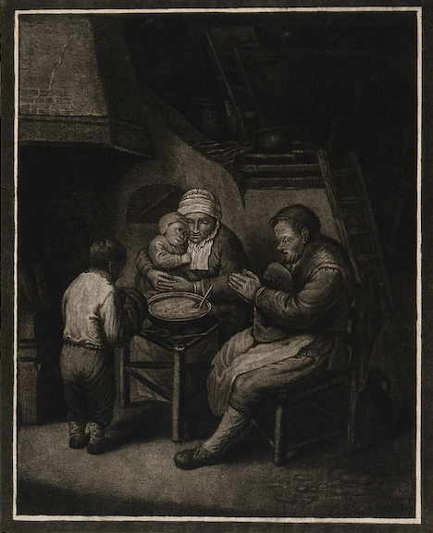**GENERAL THANKSGIVING.**  The Book of Common Prayer (BCP) includes two prayers of General Thanksgiving *[conveniently copied for you below*]. The traditional prayer of General Thanksgiving was composed by Edward Reynolds (1599-1676), Bishop of Norwich. It was possibly inspired by a private prayer of Queen Elizabeth that was issued in 1596. Prior to the 1604 revision of the Prayer Book, Puritans complained that there were not enough prayers of thanksgiving in the Prayer Book. This prayer was added to the Prayer Book in 1662 under the heading, "A General Thanksgiving." It preceded other prayers of thanksgiving for particular benefits. This prayer asks God to "give us such an awareness of your mercies, that with truly thankful hearts we may show forth your praise, not only with our lips, but in our lives, by giving up our selves to your service, and by walking before you in holiness and righteousness all our days." The first American Prayer Book (1789) required use of this prayer at every Daily Office [*Morning Prayer, Evening Prayer, etc.*]. In 1892 its use became optional, except on Sundays when the litany [*the Great Litany, that really long sung thing to which I only subject you on the first Sunday in Lent*] or eucharist did not follow immediately. The prayer appears as "The General Thanksgiving" in the 1979 BCP. It precedes "A Prayer of St. Chrysostom" and the dismissal at the close of Morning Prayer and Evening Prayer (BCP pages 58-59 (Rite I Morning Prayer), 71-72 (Rite I Evening Prayer), 101 (Rite II Morning Prayer), 125 (Rite II Evening Prayer). Its use is optional. The General Thanksgiving is said by the officiant and the people.

The 1979 BCP also includes "A General Thanksgiving" among the Prayers and Thanksgivings found near the end of the BCP (page 836). This new occasional prayer of thanksgiving was composed by the Reverend Charles P. Price. It thanks God for the splendor of creation, for the blessing of family and friends, for tasks which demand our best efforts, for disappointments that lead us to acknowledge our dependence on God, for Jesus, and for his resurrection that raises us to the life of God's kingdom, and for the gift of the Spirit through whom we give thanks to God in all things.

**The General Thanksgiving (Rite I Morning and Evening Prayer)**

Almighty God, Father of all mercies, we thine unworthy servants do give thee most humble and hearty thanks  
for all thy goodness and loving-kindness to us and to all men. We bless thee for our creation, preservation, and all the blessings of this life; but above all for thine inestimable love in the redemption of the world by our Lord Jesus Christ; for the means of grace, and for the hope of glory. And, we beseech thee, give us that due sense of all thy mercies, that our hearts may be unfeignedly thankful; and that we show forth thy praise, not only with our lips, but in our lives, by giving up our selves to thy service, and by walking before thee in holiness and righteousness all our days; through Jesus Christ our Lord, to whom, with thee and the Holy Ghost, be all honor and glory, world without end. Amen.

**The General Thanksgiving (Rite II Morning and Evening Prayer)**

Almighty God, Father of all mercies, we your unworthy servants give you humble thanks for all your goodness and loving-kindness to us and to all whom you have made. We bless you for our creation, preservation, and all the blessings of this life; but above all for your immeasurable love in the redemption of the world by our Lord Jesus Christ; for the means of grace, and for the hope of glory. And, we pray, give us such an awareness of your mercies, that with truly thankful hearts we may show forth your praise, not only with our lips, but in our lives, by giving up our selves to your service, and by walking before you in holiness and righteousness all our days; through Jesus Christ our Lord, to whom, with you and the Holy Spirit, be honor and glory throughout all ages. Amen.

**General Thanksgiving 1979 Version (Prayers and Thanksgivings)**

Accept, O Lord, our thanks and praise for all that you have done for us. We thank you for the splendor of the whole creation, for the beauty of this world, for the wonder of life, and for the mystery of love. We thank you for the blessing of family and friends, and for the loving care which surrounds us on every side. We thank you for setting us at tasks which demand our best efforts, and for leading us to accomplishments which satisfy and delight us. We thank you also for those disappointments and failures that lead us to acknowledge our dependence on you alone. Above all, we thank you for your Son Jesus Christ; for the truth of his Word and the example of his life; for his steadfast obedience, by which he overcame temptation; for his dying, through which he overcame death; and for his rising to life again, in which we are raised to the life of your kingdom. Grant us the gift of your Spirit, that we may know ***him*** and make him known; and through him, at all times and in all places, may give thanks to you in all things. Amen. [In 2007 the highlighted text was changed from “him” to “Christ.” *Do not bother to ask me how a 2007 thing can be “included” in the 1979 BCP. I have no idea, but far be it from me to argue with the leadership of the Episcopal Church. I’m not making the news, I’m just reporting it.*

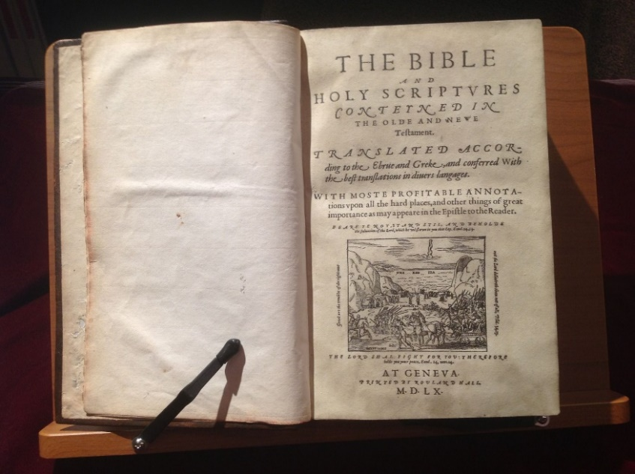

**GENEVA BIBLE.**

An English translation of the Bible published at Geneva, Switzerland, in 1560. Based on translations by William Tyndale (who, mind you, was strangled and then burned at the stake for his efforts) and Miles Coverdale, it was the work of Protestant exiles in Geneva. Its notes reflect Calvinist influence. The Geneva Bible was the first English edition with verse numeration. It is known as the “Breeches Bible” because its translation of Genesis 3:7 states that Adam and Eve made fig leaf “breeches” for themselves, instead of “garments.” It was the most widely read English version of the Bible until publication of the Authorized Version (*aka* King James Version, 1611).

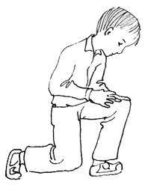**GENUFLECTION (or GENUFLEXION).** A gesture of reverence in worship. It involves touching a knee briefly to the floor while holding the upper body upright, and then returning to a standing position. It is not required by the Prayer Book at any time. In some parishes it is a customary gesture of reverence for Christ's real presence in the consecrated eucharistic elements of bread and wine. Genuflections are often customary in parishes with an Anglo-catholic piety. Genuflections may be seen as people enter or leave a church, or the seating area of a church, or the vicinity of a tabernacle where the Blessed Sacrament is reserved. The celebrant and assisting ministers may genuflect at the end of the eucharistic prayer or after the words of institution concerning each element in the eucharistic prayer. Genuflection has also been associated with veneration of the cross at the Good Friday liturgy and with the affirming of the Incarnation in the Nicene Creed. The genuflection is from imperial and feudal ceremonial. The custom of genuflecting to the Blessed Sacrament dates from the eleventh century, and it was introduced into the Mass in the fourteenth century. Some prefer the profound bow as a more ancient gesture of reverence in worship.

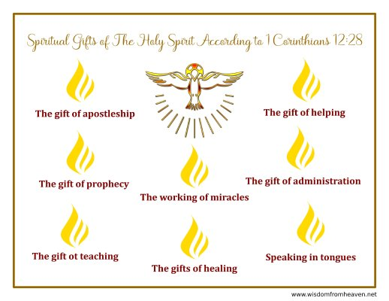**GIFTS OF THE SPIRIT.** Five New Testament texts form the basis for understanding the gifts of the Spirit, known as the charismata in Greek. These texts include 1 Corinthians 12:1-14:40, Romans 12:8, Ephesians 4:11-12, Romans 1:11, and 1 Corinthians 2:14. The lists of gifts in the New Testament passages are neither exhaustive nor entirely consistent. Apostles, prophets, and teachers are mentioned in 1 Corinthians 12:28-30. Those who exhort, give, preside, and show mercy are mentioned in Romans 12:6-8. Evangelists and pastors are mentioned in Ephesians 4:11. These gifts may be understood as charismatic ministries rather than offices. Some gifts, on the other hand, refer to functions or activities. Knowledge, healing, working of miracles, prophecy, tongues, and interpretation of tongues are mentioned in 1 Corinthians 12:7-10. Some contemporary charismatics consider tongues to be the essential gift of the Spirit, despite Paul's statement in 1 Corinthians 14:18-19 that he would rather speak five words with his mind in church to instruct others than ten thousand words in a tongue. Paul declares that he intends to share his gifts with the Christian church in Rome (Romans 1:11), indicating that gifts can be shared with others. In 1 Corinthians 12:7, each believer is said to have a gift, which suggests that there are many gifts. These points are prominent in contemporary discussion of the gifts of the Spirit.

At baptism, at the sanctifying of the water, the celebrant prays that by the power of the Holy Spirit "those who here are cleansed from sin and born again may continue for ever in the risen life of Jesus Christ our Savior" (Book of Common Prayer (BCP) page 307). In a general sense, the life of faith-including forgiveness and renewal-can be understood as a gift of the Spirit. After the action of baptizing with water, the celebrant prays for specific gifts for the newly baptized from the Lord in the Spirit, including an inquiring and discerning heart, the courage to will and to persevere, a spirit to know and love God, and the gift of joy and wonder in all God's works (BCP, page 308). The "sevenfold gifts" imparted to all by the Holy Spirit are mentioned by the hymns *Veni Creator Spiritus* and *Veni Sancte Spiritus*, one of which is sung prior to the prayer of consecration at ordinations of bishops, priests, and deacons.

|  |  |  |  |  |  |  |
| --- | --- | --- | --- | --- | --- | --- |
| **JUNE 2022** | | | | | | |
| **SUN** | **MON** | **TUE** | **WED** | **THU** | **FRI** | **SAT** |
|  |  |  | 1 | 2 | 3 | 4  10 AM--noon  Food Pantry |
| 5  9:30 AM in church | 6 | 7 | 8  Shawl Ministry  12:30 – 2:00 PM  Lincoln Hall | 9 | 10 | 11  10 AM--noon  Food Pantry |
| 12  9:30 AM in church | 13 | 14 | 15 | 16 | 17 | 18  10 AM--noon  Food Pantry |
| 19  9:30 AM in church | 20 | 21  Bishop’s Committee  7:00 PM in  Lincoln Hall | 22 | 23 | 24 | 25  10 AM--noon  Food Pantry |
| 26  9:30 AM in church  Baking Competition  After the service | 27 | 28  Book Group  7:30 PM | 29 | 30 |  |  |

. **June Birthdays June Anniversaries**

June 05 Jeremy Harvey June 03 Jim and Angie Pinder

June 12 Johnna Bradfield, Keiran Groble June 12 Ed and Judi Dura

June 17 Angie Pinder June 26 Michael Groble and Lisa Earley

June 28 Grace Henecker

June 30 Lucy Reed

**IN THE PARISH**

**SHAWL MINISTRY:** Our next in-person meeting will be **Wednesday May 11 from 12:30 - 2:00 PM** in Lincoln Hall. All are welcome- no experience necessary!

**BAKE COMPETITION AND SALE:** Dust off your cake pans, pie tins, and cookie sheets, and join in the friendly baking competition on Sunday 26 June immediately following the service. Prizes, and the admiration of your peers, will be awarded! For more information, contact Gail Permenter at [gperment@aol.com](mailto:gperment@aol.com)

**BOOK GROUP**: The June selection for our book group is *The Girl Who Was Taken* by Charles Donlea, which is available through the Ela Area Public Library. We will meet at **7:30pm on 28 June.** Please contact Lisa Earley for more information at [lisa.earley@groble.me](mailto:lisa.earley@groble.me)

**COFFEE HOUR SIGN-UP:** Please sign up to host Coffee Hour after the service. A sign-up sheet is in Lincoln Hall.

**SOUP, SUPPER, SYMPOSIUM:  “BODY, MIND, and SPIRIT"**

**Sponsored by Holy Apostles and Federated Church of Wauconda**

​**What:**  Simple Supper, Interesting Information, and Collegial Conversation.

**Where:**  Federated Church, 200 Barrington Road, Wauconda 60084

**When:**  6:00 p.m. (Supper served; presentations start between 6:15 and 6:30 p.m.) to roughly 8:00 p.m.,

the 4th Wednesday of each month beginning in May and running through October.

**MAY 25**  Karen Homes on “Soulful Gardening”

**JUNE 22**  Louie Sharp on “Fun and Goals”

**JULY 27**  Marilynn Kulieke PhD on “New Discoveries on Brain Functioning”

**AUG 24**  Allison Deputy on “Healing Movement for Every Body” (Tai Chi)

**SEP 28**  John Kennedy on “Training Your Brain”

**OCT 26**  Rev. Dr. Regina Davis Bridges on “Spirituality and Personality Types”

|  |  |  |  |
| --- | --- | --- | --- |
| **EPISCOPAL CHURCH OF THE HOLY APOSTLES UPCOMING SERVICES – JUNE 2022** | | | |
| Sunday 05 June  9:30 a.m. | Sunday 12 June  9:30 a.m. | Sunday 19 June  9:30 a.m. | Sunday 26 June  9:30 a.m. |
| Scheduled  Presider/ Preacher:  Gillette | Scheduled  Presider/ Preacher:  Gillette | Scheduled  Presider/ Preacher:  Gillette | Scheduled  Presider/ Preacher:  Gillette |
| Day of Pentecost  Whitsunday (C) | 1st Sunday after  Pentecost  Trinity Sunday (C) | 2nd Sunday after Pentecost  Proper 7 (C) | 3rd Sunday after  Pentecost  Proper 8 (C) |
| FIRST LESSON  Genesis 11:1-9  RESPONSE  Psalm 104:24-34, 35b  SECOND LESSON  Acts 2:1-21  GOSPEL  John 14:8-27 | FIRST LESSON  Proverbs 8:1-4, 22-31  RESPONSE  Canticle 13  SECOND LESSON  Romans 5:1-5  GOSPEL  John 16:12-15 | FIRST LESSON  1 Kings 19:1-15a  RESPONSE  Psalm 42 & 43  SECOND LESSON  Galatians 3:23-29  GOSPEL  Luke 8:26-39 | FIRST LESSON  2 Kings 2:1-2, -14  RESPONSE  Psalm 77:1-2, 11-20  SECOND LESSON  Galatians 5:1, 13-25  GOSPEL  Luke 9:51-62 |

. **June Birthdays June Anniversaries**

June 05 Jeremy Harvey June 03 Jim and Angie Pinder

June 12 Keiran Groble June 12 Ed and Judi Dura

June 17 Angie Pinder June 26 Michael Groble and Lisa Earley

June 28 Grace Henecker

June 30 Lucy Reed

**FROM: Church of the Holy Apostles**

**26238 North Highway 59**

**Wauconda, Illinois 60084**