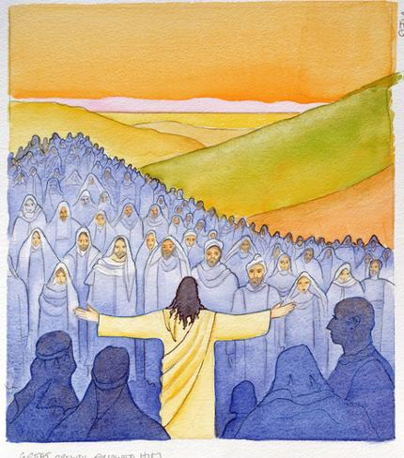

**Eighth Sunday after Pentecost**

**Proper 11 (B)**

**Sunday 18 July 2021**

**Episcopal Church of the Holy Apostles**

26238 N HWY 59, Wauconda, IL 60084

*www.holyapostleswauconda.net*

***You are encouraged to look at pictures and videos if presented.***

***They tell the story in a different way than the words in front of you.***

***But the words are important too;***

***feel free to take your bulletins with you, or access them on our website.***

**OPENING VOLUNTARY**

**WORDS OF WELCOME**

**OPENING HYMN** ***(Verses 1, 2, and 4)***

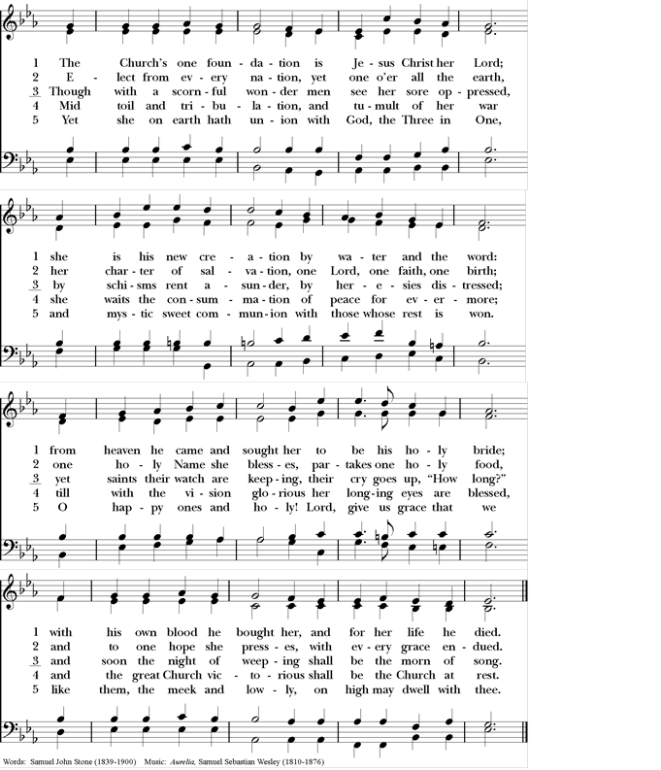

**OPENING SENTENCE**

**Presider:** Blessed be God: Holy Immortal One, Incarnate Word, and Breath of Life.

***People: And blessed be God’s kingdom, now and forever. Amen.***

**COLLECT FOR PURITY**

**Presider:** Almighty God, to you all hearts are open, all desires known, and from you no secrets are hid: Cleanse the thoughts of our hearts by the inspiration of your Holy Spirit, that we may perfectly love you, and worthily magnify your holy Name; through Christ our Lord.

***People: Amen.***

**HYMN OF PRAISE** *(Please say together in unison)*

***All: Gracious God, we bless you for our creation, preservation, and all the blessings of this life; but above all for your immeasurable love in the redemption of the world by our Lord Jesus Christ; for the means of grace, and for the hope of glory. And, we pray, give us such an awareness of your mercies, that with truly thankful hearts we may show forth your praise, not only with our lips, but in our lives, by giving up our selves to your service, and by walking before you in holiness and righteousness all our days; through Jesus Christ our Lord, to whom, with you and the Holy Spirit, be honor and glory throughout all ages.***

**COLLECT OF THE DAY**

**Presider:** The Lord be with you.

***People: And also with you.***

**Presider:** Let us pray. God of the storm’s still eye: when we are overwhelmed by pressures and demands which cut us off from life, take us to a place apart where we might find again our true heart’s center, our far horizon, the silence that awaits a world where we can breathe; through Jesus Christ, who brings us near to you.

***People: Amen.***

*(We read from the various translations authorized by our Church. This month, we read from the Common English Bible, 2012)*

**FIRST LESSON** 2 Samuel 7:1-14a

**Reader:** A reading from 2nd Samuel. 7 When David was settled in his palace, and the Lord had given him rest from all his surrounding enemies, 2the king said to the prophet Nathan, “Look! I’m living in a cedar palace, but God’s chest is housed in a tent!” 3Nathan said to the king, “Go ahead and do whatever you are thinking, because the Lord is with you.” 4But that very night the Lord’s word came to Nathan: 5Go to my servant David and tell him: This is what the Lord says: You are not the one to build the temple for me to live in. 6In fact, I haven’t lived in a temple from the day I brought Israel out of Egypt until now. Instead, I have been traveling around in a tent and in a dwelling. 7Throughout my traveling around with the Israelites, did I ever ask any of Israel’s tribal leaders I appointed to shepherd my people: Why haven’t you built me a cedar temple? 8So then, say this to my servant David: This is what the Lord of heavenly forces says: I took you from the pasture, from following the flock, to be leader over my people Israel. 9I’ve been with you wherever you’ve gone, and I’ve eliminated all your enemies before you. Now I will make your name great—like the name of the greatest people on earth. 10I’m going to provide a place for my people Israel, and plant them so that they may live there and no longer be disturbed. Cruel people will no longer trouble them, as they had been earlier, 11when I appointed leaders over my people Israel. And I will give you rest from all your enemies. And the Lord declares to you that the Lord will make a dynasty for you. 12When the time comes for you to die and you lie down with your ancestors, I will raise up your descendant—one of your very own children—to succeed you, and I will establish his kingdom. 13He will build a temple for my name, and I will establish his royal throne forever. 14I will be a father to him, and he will be a son to me. The Word of the Lord.

***People: Thanks be to God.***

**RESPONSE:** *(Please say together in unison)* Psalm 89:20-37

***20I discovered my servant David.  I anointed him with my holy oil.***

***21My hand will sustain him—yes, my arm will strengthen him!***

***22No enemy will oppress him; no wicked person will make him suffer.***

***23I will crush all his foes in front of him. I will strike down all those who hate him.***

***24My faithfulness and my loyal love will be with him. He will be strengthened by my name.***

***25I will set his hand on the sea. I will set his strong hand on the rivers.***

***26He will cry out to me: “You are my father, my God, the rock of my salvation.”***

***27Yes, I’ll make him the one born first—I’ll make him the high king of all earth’s kings.***

***28I will always guard my loyal love toward him. My covenant with him will last forever.***

***29I will establish his dynasty for all time. His throne will last as long as heaven does.***

***30But if his children ever abandon my Instruction, stop following my rules—***

***31if they treat my statutes like dirt, stop keeping my commandments—***

***32then I will punish their sin with a stick, and I will punish their wrongdoing with a severe beating.***

***33But even then I won’t withdraw my loyal love from him. I won’t betray my faithfulness.***

***34 I won’t break my covenant. I won’t renege on what crossed my lips.***

***35By my own holiness I’ve sworn one thing: I will not lie to David.***

***36His dynasty will last forever. His throne will be like the sun, always before me.***

***37It will be securely established forever; like the moon, a faithful witness in the sky.***

**SECOND LESSON** Ephesians 2:11-22

**Reader:** A reading from the letter to the Ephesians. 11So remember that once you were Gentiles by physical descent, who were called “uncircumcised” by Jews who are physically circumcised. 12At that time you were without Christ. You were aliens rather than citizens of Israel, and strangers to the covenants of God’s promise. In this world you had no hope and no God. 13But now, thanks to Christ Jesus, you who once were so far away have been brought near by the blood of Christ. 14Christ is our peace. He made both Jews and Gentiles into one group. With his body, he broke down the barrier of hatred that divided us. 15He canceled the detailed rules of the Law so that he could create one new person out of the two groups, making peace. 16He reconciled them both as one body to God by the cross, which ended the hostility to God. 17When he came, he announced the good news of peace to you who were far away from God and to those who were near. 18We both have access to the Father through Christ by the one Spirit. 19So now you are no longer strangers and aliens. Rather, you are fellow citizens with God’s people, and you belong to God’s household. 20As God’s household, you are built on the foundation of the apostles and prophets with Christ Jesus himself as the cornerstone. 21The whole building is joined together in

him, and it grows up into a temple that is dedicated to the Lord. 22Christ is building you into a place where God lives through the Spirit. The Word of the Lord.

***People: Thanks be to God.***

**GOSPEL** Mark 6:30-34, 53-56

**Presider:** The Holy Gospel of our Lord Jesus Christ according to Mark.

***People: Glory to you, Lord Christ.***

**Presider:** 130The apostles returned to Jesus and told him everything they had done and taught. 31Many people were coming and going, so there was no time to eat. He said to the apostles, “Come by yourselves to a secluded place and rest for a while.” 32They departed in a boat by themselves for a deserted place. 33Many people saw them leaving and recognized them, so they ran ahead from all the cities and arrived before them. 34When Jesus arrived and saw a large crowd, he had compassion on them because they were like sheep without a shepherd. Then he began to teach them many things. 53When Jesus and his disciples had crossed the lake, they landed at Gennesaret, anchored the boat, 54and came ashore. People immediately recognized Jesus 55and ran around that whole region bringing sick people on their mats to wherever they heard he was. 56Wherever he went—villages, cities, or farming communities—they would place the sick in the marketplaces and beg him to allow them to touch even the hem of his clothing. Everyone who touched him was healed. The Gospel of the Lord.

***People: Praise to you, Lord Christ.***

**THE SERMON**

*(A brief period of silence follows the sermon)*

**NICENE CREED** *(Please say together in unison)*

***Note:*** *This is slightly different than the Nicene Creed found in the Book of Common Prayer, but is considered by the church to be more ancient.*

***All: We believe in one God, the Father, the Almighty, maker of heaven and earth, of all that is, seen and unseen. We believe in one Lord, Jesus Christ, the only Son of God, eternally begotten of the Father, God from God, Light from Light, true God from true God, begotten, not made, of one Being with the Father; through him all things were made. For us and for our salvation he came down from heaven, was incarnate of the Holy Spirit and the Virgin Mary and became truly human. For our sake he was crucified under Pontius Pilate; he suffered death and was buried. On the third day he rose again in accordance with the Scriptures; he ascended into heaven and is seated at the right hand of the Father. He will come again in glory to judge the living and the dead, and his kingdom will have no end. We believe in the Holy Spirit, the Lord, the giver of life, who proceeds FROM THE FATHER, WHO with the Father and the Son is worshiped and glorified., who has spoken through the Prophets. We believe in one holy catholic and apostolic Church. We acknowledge one baptism for the forgiveness of sins. We look for the resurrection of the dead, and the life of the world to come. Amen***

**PRAYERS OF THE PEOPLE** Personalized Form IV

**Leader:** Let us pray for the Church and for the world.

**Leader:** We pray this morning for those raised up in our Anglican and Diocesan Cycles of Prayer; and for all bishops, priests, and deacons. Guide them, guard them, and grant that they and all who confess your Name may be united in your truth, live together in your love, and reveal your glory in the world.

*(Silence)***Leader:**  Lord, in your mercy,

***People: Hear our prayer.***

**Leader:**  We pray for all who govern and hold authority in the nations of the world, particularly in those nations suffering the ravages of war or natural disaster. Guide the people of this land, and of all the earth, in the ways of justice and peace; that we may honor one another and serve the common good.

*(Silence)***Leader:**  Lord, in your mercy,

***People: Hear our prayer.***

**Leader:**  Give us all a reverence for the earth as your own creation, that we may use its resources rightly in the service of others and to your honor and glory.

*(Silence)***Leader:**  Lord, in your mercy,

***People: Hear our prayer.***

**Leader:** We give thanks for all the blessings in our lives. We give thanks for those celebrating birthdays and anniversaries this week, especially those whose names we raise up now, either silently or aloud (*we will keep a 10-second silence*): ___. Bless all whose lives are closely linked with ours, and grant that we may serve Christ in them, and love one another as he loves us.

*(Silence)***Leader:** Lord, in your mercy,

***People: Hear our prayer.***

**Leader:** Comfort and heal all those who suffer in body, mind or spirit, especially those on our parish prayer list and those whose names we raise up now, either silently or aloud (*we will keep a 10-second silence*): ___. Give them courage and hope in their troubles, and bring them the joy of your salvation.

*(Silence)***Leader:**  Lord, in your mercy,

***People: Hear our prayer.***

**Leader:** We commend to your mercy all who have died, especially those killed in the course of service to others or by violence or disaster, and those whose names we raise up now, either silently or aloud (*we will keep a 10-second silence*): ___. We pray that your will for them may be fulfilled, and we pray that we may share with all your saints in your eternal kingdom.

*(Silence)***Leader:** Lord, in your mercy,

***People: Hear our prayer.***

*(The Presider will add this or another concluding Collect)* Almighty God, to whom our needs are known before we ask: Help us to ask only what accords with your will; and those good things which we dare not, or in our blindness cannot ask, grant us for the sake of your Son Jesus Christ our Lord.

***People: Amen.***

**CONFESSION AND ABSOLUTION** (*Please say together in unison*)

***All: Holy God, you know how stubborn we can be. You call us to serve others, and we stay in the familiarity of our own homes. You would send us to where the hopeless live, but we are reluctant to leave the comfort of our complacency. You would feed us on the peace and joy of your word, but we pull our chairs up to the tables of those who serve false promises. Forgive us, Guiding God. Transform our defiance into discipleship, and our rejection of others into the resurrection of welcoming all people as sisters and brothers in Christ. Help us to love as faithfully as you have always loved us, and send us forth to take the good news of Jesus Christ to everyone we meet.***

**Presider:** We open our lips and confess our hearts. God hears our words and make us new, sending us our to bring hope and joy to all the world. + We are forgiven; and we Hearing the good news, believing the good news, we are forgiven; and sent to live out the good news. Thanks be to God.

***People: Amen.***

**THE PEACE** *(Please greet each other in the name of the Lord.)*

**Presider:** The Peace of the Lord be always with you.

***People: And also with you.***

**OFFERTORY SENTENCES**

**Presider:** We give in grateful thanksgiving for all that God has given us. In the upside down world of the gospel, we measure our wealth not by what we have, but what we can give away. Let us give away generously, of our time, our talent, our treasure, and ourselves, to bless your church, your people, your creation.

*Please follow the Presider’s directions for Communion.*

**GREAT THANKSGIVING** EOW-II

**Presider:** The Lord be with you.

***People: And also with you.***

**Presider:** Lift up your hearts.

***People: We lift them to the Lord.***

**Presider:** Let us give thanks to the Lord our God.

***People: It is right to give our thanks and praise.***

**Presider:** We praise you and we bless you, holy and gracious God, source of life abundant. From before time you made ready the creation. Your Spirit moved over the deep and brought all things into being: sun, moon, and stars; earth, winds, and waters; and every living thing. You made us in your image, and taught us to walk in your ways. But we rebelled against you, and wandered far away; and yet, as a mother cares for her children, you would not forget us. Time and again you called us to live in the fullness of your love.

And so this day we join with Saints and Angels in the chorus of praise that rings through eternity, lifting our voices to magnify you as we say/sing:

**SANCTUS** *(Please say together in unison)*

***All: Holy, holy, holy Lord, God of power and might, heaven and earth are full of your glory. Hosanna in the highest. Blessed is the one who comes in the name of the Lord. Hosanna in the highest.***

**Presider:** Glory and honor and praise to you, holy and living God. To deliver us from the power of sin and death and to reveal the riches of your grace, you looked with favor upon Mary, your willing servant, that she might conceive and bear a son, Jesus the holy child of God. Living among us, Jesus loved us. He broke bread with outcasts and sinners, healed the sick, and proclaimed good news to the poor. He yearned to draw all the world to himself yet we were heedless of his call to walk in love. Then, the time came for him to complete upon the cross the sacrifice of his life, and to be glorified by you.

**↑**On the night before he died for us, Jesus was at table with his friends. He took bread, gave thanks to you, broke it, and gave it to them, and said: "Take, eat; This is my Body, which is given for you. Do this for the remembrance of me."

**↑**As supper was ending, Jesus took the cup of wine. Again, he gave thanks to you, gave it to them, and said: "Drink this, all of you: This is my Blood of the new Covenant, which is poured out for you and for all for the forgiveness of sins. Whenever you drink it, do this for the remembrance of me."

Now gathered at your table, O God of all creation, and remembering Christ, crucified and risen, who was and is and is to come, we offer to you our gifts of bread and wine, and ourselves, a living sacrifice.

**∞** Pour out your Spirit upon these gifts that they may be the Body and Blood of Christ.

**+** Breathe your Spirit over the whole earth and make us your new creation, the Body of Christ given for the world you have made.

In the fullness of time bring us with all your saints, from every tribe and language and people and nation, to feast at the banquet prepared from the foundation of the world.

Through Christ and with Christ and in Christ, in the unity of the Holy Spirit, to you be honor, glory, and praise, for ever and ever. ***AMEN.***

**LORD’S PRAYER**

**People: Our Father who art in heaven**

**Presider:** How blissful it is to imagine heaven on earth. But lives are always endangered. Poverty consumes many, hunger and disease destroy many. The bodies of young people are for sale. Mothers and fathers are migrating to foreign lands seeking freedom and dignity and new opportunities. God, grant to us the experience of heaven on earth.

**People: Hallowed be your name**

**Presider:** Your name is holy, your people are holy. You created us in your image. But the dignity of the poor ones is crushed by those who whip the poor by laws and by rules. Your name was used by foreign powers. In your name colonizers invaded foreign lands. In your name they burned and smashed.

**People: Your kingdom come, your will be done, on earth as it is in heaven.**

**Presider:** We know that your kingdom is a kingdom of love, justice and of peace. A kingdom of righteousness and abundance for all. Do not allow us to be deceived by the standard of this world, where unjust wars rule and colonizers become rulers of the nations. Let your will be done soon, and vanish the pseudo-kingdom of empire power, until we can finally say, heaven is possible here on earth.

**People: Give us this day our daily bread.**

**Presider:** The bread that we eat today satisfies our hunger. But those who make the bread in many countries have empty stomachs. How can we be happy when our body is full while many are wanting? We have been told those who do not work should not eat. But how come those who work hard have too little to eat, while those who amass wealth by greed have plenty to throw away? May the daily bread we partake in be the communion of struggle and hope, and be the bread that is shared by all.

**People: Forgive us our debts, as we forgive debtors.**

**Presider:** We offer our self-criticisms. When we have failed to love You and our neighbor, renew us and enable us to make up whatever we have failed to do. Give us hearts that can share your grace by forgiving others. Let us be humble like a dove and make us wise as a serpent. May we be sustained in our courage, that we will not be manipulated by those who have wronged, exploited and oppressed your people. Forgiveness is for those who have admitted their accountability, for your grace is sufficient enough to correct our mistakes. But arrogance and conceit will lead us only to downfall.

**People: And lead us not into temptation, but deliver us from evil.**

**Presider:** Lead us not to resignation in our work for justice and peace. Let not cynicism rule us, but lead us to a deeper steadfastness to overcome evil in our midst.

**People: For thine is the kingdom, and the power, and the glory, forever and ever. Amen.**

**Presider:** This we believe. Let your power of love and the glory of justice and peace be with us all forever and ever. Amen.

**FRACTION (THE BREAKING OF THE BREAD)**

*(The Presider breaks the consecrated bread. A brief period of silence is kept.)*

**Presider:** We break this bread to share in the Body of Christ.

***People: We who are many are one body, for we all share in the one bread.***

**Presider:** **↑**The Gifts of God for the People of God. Take them in remembrance that Christ died for you, and feed on him in your hearts by faith, with thanksgiving.

**POST-COMMUNION PRAYER** *(Please say together in unison)*

**Presider:** Let us pray.

***All: Loving God, we give you thanks for restoring us in your image and nourishing us with spiritual food in the Sacrament of Christ’s Body and Blood. Now send us forth a people, forgiven, healed, renewed; that we may proclaim your love to the world and continue in the risen life of Christ our Savior. Amen.***

**PARISH ANNOUNCEMENTS**

**BLESSING**

**Presider**: May the blessing of the God of Abraham and Sarah, and of Jesus Christ born of our sister Mary, and of the Holy Spirit, who broods over the world as a mother over her children, be upon you and remain with you always.

***People: Amen.***

**CLOSING HYMN *(Verses 1, 2, and 3)***

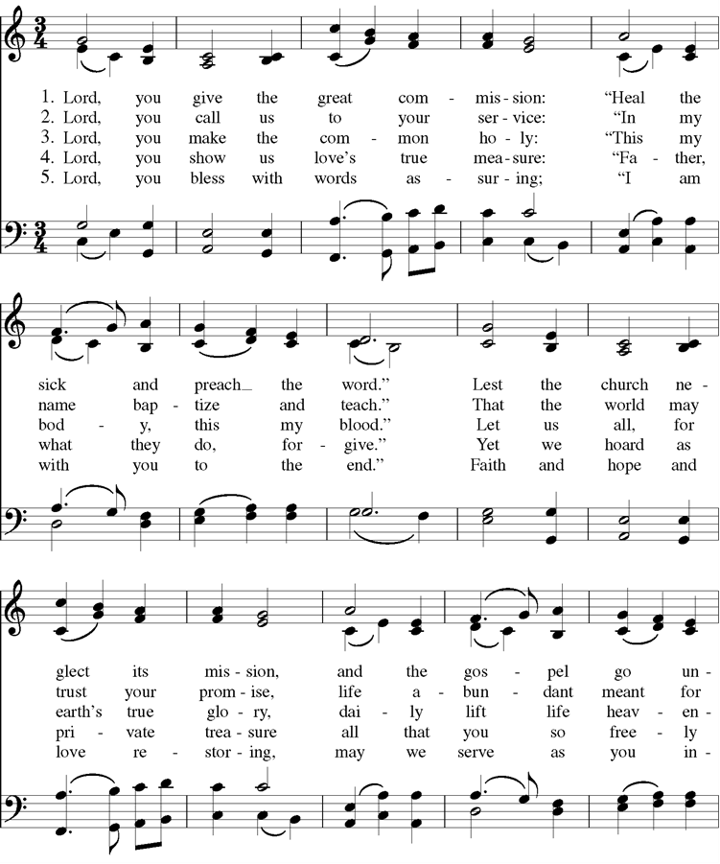

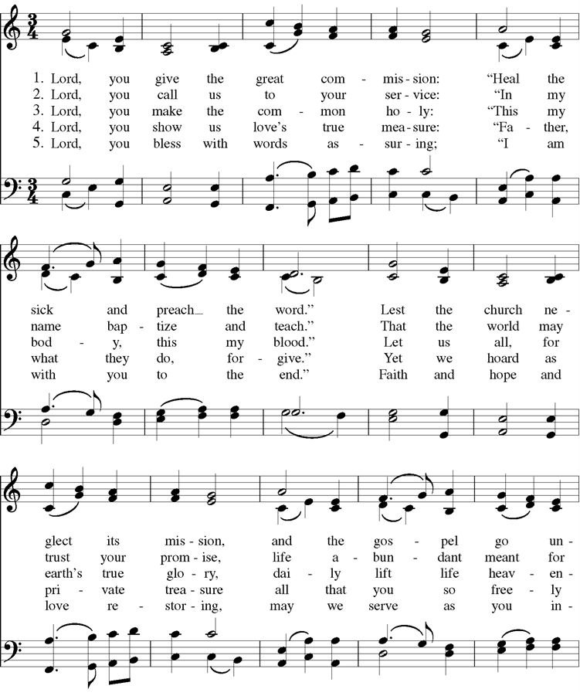



Cover Image: https://www.allposters.com/-sp/Great-Crowds-Followed-Jesus-as-He-Preached-the-Good-News-2004-Posters_i9823150_.htm

Confession: Adapted from Thom Shuman, accessed at <https://re-worship.blogspot.com/2012/06/confession-proper-9-b.html>

Offertory Sentences: Adapted from Quentin Chin, accessed at <https://re-worship.blogspot.com/2014/06/prayer-for-offering.html>

Lord’s Prayer: Adapted from a prayer by Norma P. Dollaga, accessed at <https://re-worship.blogspot.com/2013/07/prayer-for-others-based-on-lords-prayer.html>