**The Apostles Post**

26238 North Highway 59

Wauconda, Illinois

JULY 2020

2015



**FROM THE VICAR’S DESK** *(M. C. Gillette)*

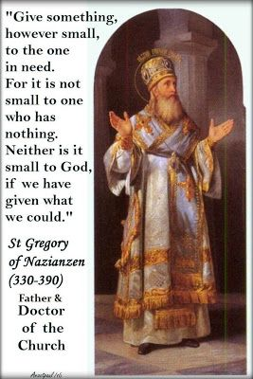**-**

Doctors of the Church issue VII – Saint Gregory of Nazianzen (or Nazianzus) *aka* Saint Gregory the Theologian. (Actually, Saint Gregory of Nazianzen/us is properly his father’s title, so we should act informed and stick with “the Theologian.”) Born *circa* 325-330 at his father’s estate in Arianzus, near Nazianzus (exact location lost to time), Cappadocia in Asia Minor, to Saint Gregory of Nazianzen the Elder and Saint Nonna. Brother of Saint Caesar Nazianzen, and Saint Gorgonius. Dearest friend (until he wasn’t – more on that later) of last month’s Doctor, Saint Basil the Great. He and Basil were (brilliant) students together in Athens, then spent 5 or so delightful years (saying of themselves they were one soul in two bodies) as monks at Basil’s monastery. Then things went wonky, but although things were never completely resolved, they were more or less reconciled in the end, and his panegyric for Basil (probably given on the anniversary of Basil’s death, as Gregory was unable to make it to the funeral) is powerful and beautiful (and 62 pages folio in its present form, which suggests that it was amplified fairly substantially after delivery). He died on either on 25 January 390 or *circa* 389 – you might think there would be either specificity or generality on this point, but obviously you would be wrong. God loves you anyway. His feast day is – hmmm. Pick a day in January, you have options; or stick with the Episcopal Church, which happens to celebrate it on 09 May. The readings appointed are Wisdom 7:7-14 / Psalm 37:3-6, 32-33 / Ephesians 3:14-21 / John 8:25-32.

Look! You can buy a peg doll of him. Why anyone would want such a thing is beyond me, but see, I am not making this up.

 I kinda’ like this particular Saint Gregory (you know there are several – we’ve already seen one in this series of articles, March’s Saint Gregory the Great) because he was a very reluctant priest (and a positively miserable bishop) who hated controversy and political intrigue, and mostly just wanted to be a hermit and write poetry. He always seemed to end up – over his own protests – in places and jobs clearly unsuited to his disposition and temperament. Affectionate and tender by nature, of highly sensitive temperament, simple and humble, lively and cheerful by disposition, yet liable to despondency and irritability, of frail health, and neither particularly decisive nor self-controlled, he was very human, very lovable, very gifted – and pretty much always stuck doing something he didn’t want to do, because – well, see above, mostly what he wanted to do was be a hermit and write poetry.

Gregory’s father was a Hypsistarian, and if you tell me you knew there was such a thing prior to right this very minute, I would raise one eyebrow skeptically. Hypsistarians were members of a monotheistic Jewish-pagan sect which was mostly confined to Asia Minor, and mostly active from 200 B.C. to 400 A.D. Gregory’s mother, however, came from a Christian family, and the elder Gregory converted, then found himself ordained and consecrated bishop post haste. As nifty as all this is, it is really only important because in 362 Gregory grudgingly accepted ordination to the priesthood to assist his father in Naziazus; during which time he also assisted Basil in his struggle with the Arians and their supportive Emperor, Valens. When Valens chopped Cappadocia up into provinces in an attempt to thwart Basil’s efforts to stamp out Arianism and regain the church for Orthodoxy, Basil begged – pressured – Gregory to become a bishop and accept the episcopate of Sasima. This is the point at which the best-friends were no longer best friends. Gregory took umbrage at what he felt was Basil’s presumption on their friendship, never actually took possession of his see (bishop-place), and went back home bearing a heavy (probably righteous) grudge. When Basil died, however, Gregory sent letters of condolence and twelve memorial poems to Basil’s brother, Saint Gregory of Nyssa (I told you there were a lot of Saints Gregory).

Shortly after Basil’s death, circumstances conspired to lure (this) Gregory to Constantinople. For 30 or so years it had been more or less given over to Arianism. The small band of Orthodox Christians had neither church nor pastor at that point; when Gregory arrived he held his services in a private house which he described as “an Anastasia, the scene of the resurrection of the faith”, and from where he preached his famous five sermons on the Trinity, called the Triadica. Retiring and sensitive, he hated Constantinople and dreaded being drawn into the whirlpool of corruption and violence that defined the Arian/Orthodox disputes. He was slandered, insulted, beaten up, and a rival “bishop” tried to take over his diocese. However, he had the last laugh. When he left Constantinople two years later, the Arians did not have one church left to them in the city.

That he was in Constantinople such a short time is due to a variety of factors, including his poor health, but the precipitating one is probably the disappointment and opposition he experienced in the proceedings of the First Council of Constantinople, to which 150 bishops were summoned in May of 381 by Emperor Theodosius. The stated purpose of the Council was to confirm the (Trinitarian) faith of Nicaea. But politics are ever politics, and as president of the Council, Gregory experienced such challenge and antipathy that he concluded the only thing he could do was resign and withdraw, which he received permission from the Emperor to do. After delivering a wonderful farewell sermon – the Syntacterion – in which, not surprisingly, he held up the Divinity of the Son, he retired to the place where he was born, and spent his final days – finally – being a hermit and writing poetry.

**HERE AND THERE** *(M. C. Gillette at* [*hapostles@sbcglobal.net*](mailto:hapostles@sbcglobal.net)*)*

*In this on-going article, we pull things from our various Diocesan calendars and church websites to see what’s going on around us. For more information about what's happening at the Diocesan Headquarters and the Cathedral of Saint James, you can always visit their websites:* <https://www.episcopalchicago.org> or <https://www.saintjamescathedral.org/>

Our Diocese recommends the following resources for talking about Racism and how our faith calls us to lead in this pivotal moment:

[**Racial Justice from the Equal Justice Initiative**](http://r20.rs6.net/tn.jsp?f=001WxwbsXrUkCUojuZzGRk412OhDeiKTn9qJvVYz3k8kTZAsJyTRNTmS6Or5KPBOuOrelcRTtpEnyv3N6RVhTQk2gIvUcqLD335h_d2U-wO5exqg-Pz2z5LHW1v9_W0Ca31fqwbA7ZbW1qGxdVYG7eX82rR0HAyyeK35-yJATULLrGRqxW0jlNItslN82zCt7CaW6-q8jZP-gMD9T7teTqPlQ6D8xZyHMnh11JJ6ieg7OMB--3877uMkQ==&c=4dqzoCFgmEsy_W5y3b3RrXRZplfU9O0adbNCsGZBHUhx84ht2-M-Gw==&ch=aBjEFcGsCt8SkT5ExcP5N2STqcL-JSetbJzUxr0eXedEQNtDO2-_iA==)

<https://eji.org/racial-justice/?mc_cid=978bdea35f&mc_eid=b7f67732eb>

[**Talking about Race from the National Museum of African American History & Culture**](http://r20.rs6.net/tn.jsp?f=001WxwbsXrUkCUojuZzGRk412OhDeiKTn9qJvVYz3k8kTZAsJyTRNTmS6Or5KPBOuOr0Zi1IDmhcsfyeWnIg2D0KKy4XPz9s8AYdrP0HqOz8iQbrBqz2k13BXyONDWGqyjovMYv-IOdBb6jo7CWHqda5H-MBfz7tnf5Lj9umylYmwuIbPOLoj6mtOK4Zpi6mG2-z2YyGRZuu3Eez-EjHv8DCvvyl6xJmUJDHQoSxUY6pzEVqyu5Vo1RwtsGEB0tzz3ft5k-HJvaeL0=&c=4dqzoCFgmEsy_W5y3b3RrXRZplfU9O0adbNCsGZBHUhx84ht2-M-Gw==&ch=aBjEFcGsCt8SkT5ExcP5N2STqcL-JSetbJzUxr0eXedEQNtDO2-_iA==)  
<https://nmaahc.si.edu/learn/talking-about-race?mc_cid=978bdea35f&mc_eid=b7f67732eb>

[**When the Cameras are Gone, We'll Still Be Here: A Word to the Church from Presiding Bishop Michael Curry**](http://r20.rs6.net/tn.jsp?f=001WxwbsXrUkCUojuZzGRk412OhDeiKTn9qJvVYz3k8kTZAsJyTRNTmS8HItlT-ksUMjwoLA2oN0J162SP9vt8rrCWfz7B_Ng6cB1OsF9sD1AaH8Xcr9BoTjoTZ2c7HdF6854SNHfT6tOVBJupOUp8WOlSCVXats5fwPSMot1hIf-KbV8hNDal82dy-cWJE4D11mPe7yXJR-8wEWgGJSnWivtvL-H0pq3mAfF4s1Zy9zxgT5-F2worEvp8Jqx6XnPCeJOlBqC_HsyoRspim_cJ5WtlMXFuBxnzlfbYqTDiRuYLl35Hts5nWt2xh1pe7WPbSnLtdGPdNDpQ=&c=4dqzoCFgmEsy_W5y3b3RrXRZplfU9O0adbNCsGZBHUhx84ht2-M-Gw==&ch=aBjEFcGsCt8SkT5ExcP5N2STqcL-JSetbJzUxr0eXedEQNtDO2-_iA==),   
<https://www.episcopalnewsservice.org/pressreleases/presiding-bishops-word-to-the-church-when-the-cameras-are-gone-we-will-still-be-here/>

[**Responding to Racist Violence**](http://r20.rs6.net/tn.jsp?f=001WxwbsXrUkCUojuZzGRk412OhDeiKTn9qJvVYz3k8kTZAsJyTRNTmS8HItlT-ksUMhgrA2sIQ_bLpGPMtR1zqzSlQ6LZ2j2VnAHMA5y9uhMEiqbfm5M1mVxtQF-ut7DtyVln2cz1Webt9qSQOzkYvSWo5BcIknKESQdcI4EhQUwXv25sqy62xS7N6grayVW-eDuncf6YXA6hhAMYwvM4uHA==&c=4dqzoCFgmEsy_W5y3b3RrXRZplfU9O0adbNCsGZBHUhx84ht2-M-Gw==&ch=aBjEFcGsCt8SkT5ExcP5N2STqcL-JSetbJzUxr0eXedEQNtDO2-_iA==) <https://episcopalchurch.org/responding-to-racist-violence>

[**Reading and Resources**](http://r20.rs6.net/tn.jsp?f=001WxwbsXrUkCUojuZzGRk412OhDeiKTn9qJvVYz3k8kTZAsJyTRNTmS0QC3wRKgCK5x2orsZnYBu93RhfDOLNgDsBEZy2W6icxskM2K86i0WpEMVdA4x-kCNycrZZ3yWKNZ_GaGyzLCUDa0QVx2JsWR4G_ybyMYjlZvnEA8Ilvn8BksWkcobLTz-X3YNBGMhTEJ_6uC95I1TuOHsoBnNYZOVEcS7PiV-ak_B_EamsGw2E=&c=4dqzoCFgmEsy_W5y3b3RrXRZplfU9O0adbNCsGZBHUhx84ht2-M-Gw==&ch=aBjEFcGsCt8SkT5ExcP5N2STqcL-JSetbJzUxr0eXedEQNtDO2-_iA==)  [https://episcopalchicago.org/antiracism/reading-and-resources/](%20%20https://episcopalchicago.org/antiracism/reading-and-resources/)

[**Antiracism Commission Reading and Resources**](http://r20.rs6.net/tn.jsp?f=001FWe5Fd1tC6PkT7Pfdy5i9osxd9hC60Df-ivBKDcQIlWUwdLgnxuqf5Pyd1XaDZd1YUWj7g5pga_88Di_49_jOhihodrKSbmoVerwgWbjgfIlMMelLYmaq-Aq29KhpSNHVsvKhh7BTLw2s_SdffzbvaPTB_ewfG5AzLSpetACt7P8xyACvW9Wjnrne8EdRjCvoGo5e3gGv_QFMMUbtQahGnvXrP0k3gL4j_LDHrLhQGk=&c=ys36-XAoJBAzFsjoY4L7IdFV2DnQZ5mCOQ0x-bziyagh8VL4tbgB6Q==&ch=Q8aXfayKIUY0QaauMOVR9fRNr3SLBA89Q0fQjg9xnnf_ZPqIKl2rLg==) page (updates ongoing)

<https://episcopalchicago.org/antiracism/reading-and-resources/>

[**A Father's Day Sermon by the Rt. Rev. Dr. Nathan D. Baxter**](http://r20.rs6.net/tn.jsp?f=001FWe5Fd1tC6PkT7Pfdy5i9osxd9hC60Df-ivBKDcQIlWUwdLgnxuqf6DhRDUMYmoFnpOfc6XUQrlv5_tGr32ch3TiCnPSs0TLiXvmOTprEuLkeip_NxUlLJcvQc77EmqzMiF54bpAkzLGzDP1_FW112YGWUqPWvbA_WrmRKdrp8OsxkkwxxH8GZXPOuKOXS27_1d4_o4Arr8=&c=ys36-XAoJBAzFsjoY4L7IdFV2DnQZ5mCOQ0x-bziyagh8VL4tbgB6Q==&ch=Q8aXfayKIUY0QaauMOVR9fRNr3SLBA89Q0fQjg9xnnf_ZPqIKl2rLg==)

<https://www.ube.org/dfc/newsdetail_2/3203778>

[**Celebrating Juneteenth: A Journey to Justice**](http://r20.rs6.net/tn.jsp?f=001FWe5Fd1tC6PkT7Pfdy5i9osxd9hC60Df-ivBKDcQIlWUwdLgnxuqf6DhRDUMYmoFGXJ1rbTDsAVYVjh7MJdz7WXHCGjlVommR5rl8L2fjQKJL-yrI1iJctnbq8s8k2UqZUAP1gGTqaznPZc8bIoa7vpTlOEi4rYqC0XCbXzPtUfwVz3hc8ckmQxBPe9y3OcB0YTCKxMvERo=&c=ys36-XAoJBAzFsjoY4L7IdFV2DnQZ5mCOQ0x-bziyagh8VL4tbgB6Q==&ch=Q8aXfayKIUY0QaauMOVR9fRNr3SLBA89Q0fQjg9xnnf_ZPqIKl2rLg==),

<https://www.ube.org/dfc/newsdetail_2/3203740>

[**Union of Black Episcopalians Prayer Vigil for Racial Justice and Healing of Our Nation**](http://r20.rs6.net/tn.jsp?f=001FWe5Fd1tC6PkT7Pfdy5i9osxd9hC60Df-ivBKDcQIlWUwdLgnxuqf6DhRDUMYmoFGzg0HykHTQlTEWtQThTqBiMfV8OaQfI8jku6ZBW3dMmNR45HJY1sHLv-hwTW-Bf_9igF4WZCZZ9QqXbrZSUVSWV_7J-E61-bsfLryCLSvMdGzTsk8bVMCt7JQqmNnDRthgdKMNvvqWGb98AbaQ2Nh1GgtxmafdmgS26KQHPbE1KL4-svdpFGlrbRmQspJrl6&c=ys36-XAoJBAzFsjoY4L7IdFV2DnQZ5mCOQ0x-bziyagh8VL4tbgB6Q==&ch=Q8aXfayKIUY0QaauMOVR9fRNr3SLBA89Q0fQjg9xnnf_ZPqIKl2rLg==),

<https://www.youtube.com/watch?time_continue=13&v=MUKPyj-Vf7Q&feature=emb_logo>

[**Virtual Pilgrimage for Racial Justice**](http://r20.rs6.net/tn.jsp?f=001FWe5Fd1tC6PkT7Pfdy5i9osxd9hC60Df-ivBKDcQIlWUwdLgnxuqf6DhRDUMYmoFHJPwUBJ8oPB0L8BLTsKkTAv1_44bDqyZFl1tJ06m0jwxJHXVuyztXIW0iKFyDcV0uMibsDgnq2x49i0jGVHH8vPa5b-umsq5hHHKqdRa0z30SLYnrO-T-CZidII-gocylT01AEQb6Q0TRn94RohXUg==&c=ys36-XAoJBAzFsjoY4L7IdFV2DnQZ5mCOQ0x-bziyagh8VL4tbgB6Q==&ch=Q8aXfayKIUY0QaauMOVR9fRNr3SLBA89Q0fQjg9xnnf_ZPqIKl2rLg==),

<https://www.facebook.com/groups/733003914102386/#_=_>

[**Just Mercy**](http://r20.rs6.net/tn.jsp?f=001FWe5Fd1tC6PkT7Pfdy5i9osxd9hC60Df-ivBKDcQIlWUwdLgnxuqf8uZDjg1QrGylgRsysPGExNQs9ja0ou5szCjtZFPlRDDxMfsS_S1MSYXchv1BkoGLiv8FcJglaP390ASRLzl15PHl5THNWqZgI58eWuo2t1GuywjJYJ4vNRYbfXJVrxLyA==&c=ys36-XAoJBAzFsjoY4L7IdFV2DnQZ5mCOQ0x-bziyagh8VL4tbgB6Q==&ch=Q8aXfayKIUY0QaauMOVR9fRNr3SLBA89Q0fQjg9xnnf_ZPqIKl2rLg==), the movie based on the true story of civil-rights attorney [**Bryan Stevenson**](http://r20.rs6.net/tn.jsp?f=001FWe5Fd1tC6PkT7Pfdy5i9osxd9hC60Df-ivBKDcQIlWUwdLgnxuqf8uZDjg1QrGym5fzHpXfHcn7gkxszBJ3ctgT81H0-RqnhH_1hbNSUKtsPQJLu2imRg4HBpDue0BAU1npe8johUYv7-Tf_wfwEHrAjDdNm8atddUzwf8r2jlzNrQ8az53zg==&c=ys36-XAoJBAzFsjoY4L7IdFV2DnQZ5mCOQ0x-bziyagh8VL4tbgB6Q==&ch=Q8aXfayKIUY0QaauMOVR9fRNr3SLBA89Q0fQjg9xnnf_ZPqIKl2rLg==)

<https://www.justmercyfilm.com/>

"[**As a black man I understand the anger in our streets. But we must still chose love"**](http://r20.rs6.net/tn.jsp?f=001FWe5Fd1tC6PkT7Pfdy5i9osxd9hC60Df-ivBKDcQIlWUwdLgnxuqf8uZDjg1QrGycpEBeCuHQXKNchiMMtlnjJk5gXahhURxFPj0w35-HFwpFQtWUf5NOcyYSLr_vipRGke8IpS17fbWv-T9bd0z4m9zrlqxaoHOI7zX9RXpTB4QjjbTUhAJi1txKxnrsZ4LUVgXjZb6fEHwLA5dJF7MnWJS-5P6jJmjJC5jvARZSJ4ExymjPcg0nxIw4F3pSl7Jy-FKYmkx7QPDW-8sCNALCX_knz_Iei4LPAUf7PMX2c3m9Zwfghh9rQ==&c=ys36-XAoJBAzFsjoY4L7IdFV2DnQZ5mCOQ0x-bziyagh8VL4tbgB6Q==&ch=Q8aXfayKIUY0QaauMOVR9fRNr3SLBA89Q0fQjg9xnnf_ZPqIKl2rLg==)

<https://www.washingtonpost.com/opinions/2020/05/31/black-man-i-understand-anger-our-streets-we-must-still-choose-love/>

"**America's Lost Soul,"**<https://utsnyc.edu/americas-lost-soul/>

[**My God, Why Have You Forsaken Me? A Time of Lament.**](http://r20.rs6.net/tn.jsp?f=001FWe5Fd1tC6PkT7Pfdy5i9osxd9hC60Df-ivBKDcQIlWUwdLgnxuqf8uZDjg1QrGy2C7UL4WVh7qKvoDk1vNtp37jn1t0QE6R7Mi6u2YnuonVSQJWYgS5qkaFl2zhi_FbdhIR7MShoCOQhYlSRfFAJmfWZ5ik4FE38GZTU8Zl0iCr6iASQLaVTUHYG8CVmJu5yC9J1FiUtldZT8-vv7mQ1w==&c=ys36-XAoJBAzFsjoY4L7IdFV2DnQZ5mCOQ0x-bziyagh8VL4tbgB6Q==&ch=Q8aXfayKIUY0QaauMOVR9fRNr3SLBA89Q0fQjg9xnnf_ZPqIKl2rLg==)

<https://www.stlukesatlanta.org/time-of-lament.html>

[**Statement on the Murder of George Floyd and The Resulting Demonstrations in Atlanta and Elsewhere**](http://r20.rs6.net/tn.jsp?f=001FWe5Fd1tC6PkT7Pfdy5i9osxd9hC60Df-ivBKDcQIlWUwdLgnxuqf8uZDjg1QrGyA88ZMJV5Kz3uR7IokDyqmRUJNCmfpSMaA3YTqPCHy10qZcEVoxphy50z_vkXtlmuvpfwZcs9m-mmmh8n5BfhGAGNsy8fGZomCL5-vBikkDgQUKKPWFEyarTON1KjH5KW-UH0Q6Jn-TMhSP7nNxc674ggYI-gb3qDU6SoHVrxuyfS9NnDigDHY8CnPPWHXfpFx4VDbFhBzolI3ZPbEUUrn7GC75gDv-Uq_w7GlRM71yEArDKey_XxIzUEB4fpVx2ver4P7AjZeIo=&c=ys36-XAoJBAzFsjoY4L7IdFV2DnQZ5mCOQ0x-bziyagh8VL4tbgB6Q==&ch=Q8aXfayKIUY0QaauMOVR9fRNr3SLBA89Q0fQjg9xnnf_ZPqIKl2rLg==)

<https://www.episcopalatlanta.org/news/statement-on-the-murder-of-george-floyd-and-the-resulting-demonstrations-in-atlanta-and-elsewhere/>

[**A Reflection of Personal Experience, Hope and Challenge for the Church on Dismantling White Supremacy and Racism**](http://r20.rs6.net/tn.jsp?f=001FWe5Fd1tC6PkT7Pfdy5i9osxd9hC60Df-ivBKDcQIlWUwdLgnxuqf2E0RbVvhoNpqHl1DJpHivR6YazTn3xXP5FmEiAQmPI1wAfGDnDJXV44Qpr4HCrE-SbQLenduawdoPJBTFxqEa48Z3sA5FpNb0LxUIWN8PzjIACsHjK6kUB2NkIcycnOrwKM-s-sBLHVH1K-bkFfvfEwY0aUPYiDczlVHGiuWBZpXOctfaSuEt_55NZ1MUGEHBnSPOtfTzyNayeLSw2Y35Me5hlyDGAGFkJGmEuARexlBWvbC8xStFvhx-22wj0KV0CCS3_ETB9oY1avmp0aVNUR8IMPjRw5MQA9RlEWgjatDyzsHeRQmZdGtM1N57X-cTsTW7QhO00qhJ0AkODbzaX6LdfUBvOZMl4-wGoq5-R09bj54uc2SAA4r4PCY5Ea-eeIUZBjIoTc&c=ys36-XAoJBAzFsjoY4L7IdFV2DnQZ5mCOQ0x-bziyagh8VL4tbgB6Q==&ch=Q8aXfayKIUY0QaauMOVR9fRNr3SLBA89Q0fQjg9xnnf_ZPqIKl2rLg==)

[https://indydio.org/from-bishop-jennifer-a-reflection-of-personal-experience-hope-and-challenge-for-the-church-on-dismantling-white-supremacy-and-racism/?fbclid=IwAR3mAPD0kvmeJ0LwvufKbFvZsZGMKGzwHWHt37qy3WXE0HCEnaCn6Sf9wPs#](https://indydio.org/from-bishop-jennifer-a-reflection-of-personal-experience-hope-and-challenge-for-the-church-on-dismantling-white-supremacy-and-racism/?fbclid=IwAR3mAPD0kvmeJ0LwvufKbFvZsZGMKGzwHWHt37qy3WXE0HCEnaCn6Sf9wPs)

[**Responding to Racist Violence**](http://r20.rs6.net/tn.jsp?f=001FWe5Fd1tC6PkT7Pfdy5i9osxd9hC60Df-ivBKDcQIlWUwdLgnxuqf8uZDjg1QrGy_mn7cbtlPZ22FhcQIx3kOeZXT8y5rFaU2blSheBA9HpDL2DjUfwxVVPQntBd9vtIC-kYEU8d64kRHz_w7gKQRBppK3WSkPDDZf18CNraGC7byuJZRmLoBHZ8wKGjrmH2fOKfA7iWjIvUjmGRRsW9Pw==&c=ys36-XAoJBAzFsjoY4L7IdFV2DnQZ5mCOQ0x-bziyagh8VL4tbgB6Q==&ch=Q8aXfayKIUY0QaauMOVR9fRNr3SLBA89Q0fQjg9xnnf_ZPqIKl2rLg==)<https://episcopalchurch.org/responding-to-racist-violence>

__________________________________________________________________________________________

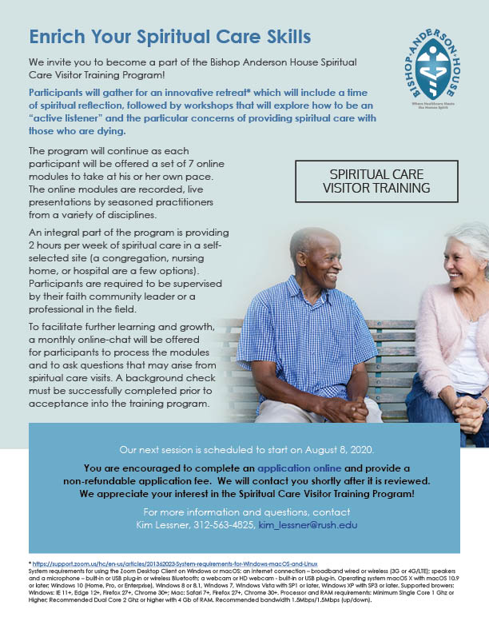**Bishop Anderson House Spiritual Care Visitor Training**

**Virtual training begins August 8, applications due July 27**

Bishop Anderson House will offer its [**Spiritual Care Visitor Training Program**](http://r20.rs6.net/tn.jsp?f=001FWe5Fd1tC6PkT7Pfdy5i9osxd9hC60Df-ivBKDcQIlWUwdLgnxuqf6DhRDUMYmoFQEssD2dud4zLfSLW7OKaFl1Rc5a_dqZJcVxVK64WzleSDdZYFTqmcyiD5d0syfXAN6ovCHDOdyoSdlmk4iSI4MSUN7m820roakUFa-yGQUEWi8vuPAGfmw5HBCcxQJ0FNC2CdWV-7QLgtynbRGD-8DHa1T86NQobuFVyB4nEH6M=&c=ys36-XAoJBAzFsjoY4L7IdFV2DnQZ5mCOQ0x-bziyagh8VL4tbgB6Q==&ch=Q8aXfayKIUY0QaauMOVR9fRNr3SLBA89Q0fQjg9xnnf_ZPqIKl2rLg==)

<https://www.bishopandersonhouse.org/spiritual-care-visitor-training-2/>

beginning on August 8. The training will start with a virtual retreat held over Zoom in three mandatory sessions over two days:

* August 8 from 10 am-12 pm and 1:30-3 pm
* August 15 from 10 am-12 pm (all CDT)

The program continues with seven online modules covering a variety of topics, plus additional coursework. A $50 application fee is required to cover the costs of a background check, which must successfully be completed prior to the start of the retreat. The course fee is $325, with discounts offered for groups of five or more from the same organization. Limited scholarship funds available are available. [**Download the program brochure.**](http://r20.rs6.net/tn.jsp?f=001FWe5Fd1tC6PkT7Pfdy5i9osxd9hC60Df-ivBKDcQIlWUwdLgnxuqf6DhRDUMYmoFCJFRDzYVLkd7gAKyZn67VCcsZqu8X6n83rvHK_wawVVcnunpH2eLoWlG4go1UUiEREKn8Q-4LEjUzNALdMyFgC01Ua9Sk6OWeLqoOODd9YtMdZGT8TWUlnAXzd_b33cRB2HNfb39HOBMejzxQAP3JxPZ5elkIVl4vbZSjhOcVJV2Z5PxBy5l2Ejwq2sLscU5kpXLr6F-lDY=&c=ys36-XAoJBAzFsjoY4L7IdFV2DnQZ5mCOQ0x-bziyagh8VL4tbgB6Q==&ch=Q8aXfayKIUY0QaauMOVR9fRNr3SLBA89Q0fQjg9xnnf_ZPqIKl2rLg==)

<https://www.bishopandersonhouse.org/wp-content/uploads/2020/06/SCVTPFlyer0720-1.pdf>

Applications are due no later than July 27. Please contact Kim Lessner, Registrar, at 312-563-4825.

__________________________________________________________________________________________

**Save the Dates: Upcoming Diocesan Events**

November 21: Annual Diocesan Convention (online)

December 12: Convention to elect the 13th Bishop of Chicago (online)

__________________________________________________________________________________________

**Bishop Lee to Retire at Year-end; Election planned for December 12**

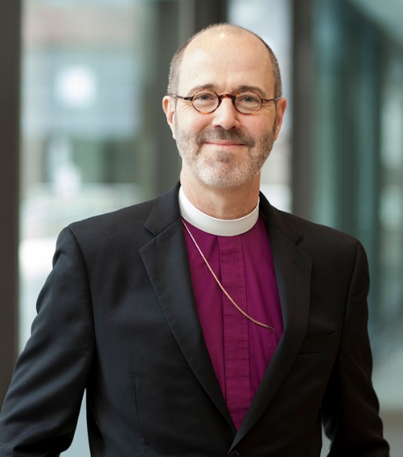June 17, 2020

Dear friends,

You may remember that, in March, as we began to understand the ways in which the COVID-19 pandemic would disrupt our plans and priorities, I postponed both my retirement originally scheduled for August and the bishop election that we had originally planned to hold this Saturday.

Although the pandemic will not come to an end for some time, your creative and resourceful responses to the challenge of worshipping and gathering online have made it clear that the future of our diocese is in excellent hands. With gratitude for your spirit and faithfulness, I will now plan to retire at the end of 2020.

Thanks to our new ability to gather in ways we previously would not have imagined, and after consultation with the Standing Committee, we now plan to elect the next bishop of Chicago at a virtual electing convention on December 12. The details of this event and the opportunities to meet the nominees that will precede it are still being developed. Please look for more news coming soon from the Standing Committee and on the [**bishop search and transition website**](http://r20.rs6.net/tn.jsp?f=001lPBCdeLHoR1zpEqrq-L8eaVI5BZExhTM5UfCMTEqGJRRYoElcpVCdbLdeh-ZynHHpkbr7JmqmzpeVHC4cwZ4keQzrdvdLp1vTJML05ERZzEOFUxKA0Buh7veS5eSDY7QHuRBwXX0pIRvnY8q3oqjIiR8sJggjx8AYPq0PivKR3M0EscQGAu3lA==&c=Z_wGjxgfqDMEubwjjAH_9e_fkN8PJGsewSCGqrUS6XWxBoKSnqgN0g==&ch=6Wlg4BHUhrUOX8BiSdYOpzeJqDBiTVCxKzXFQOpgTGPRQDhlG_4IZw==). [**https://chicagobishopsearch.org/**](https://chicagobishopsearch.org/)

Faithfully,

Bishop Jeffrey Lee

**SOME CHURCHY STUFF** *(M. C. Gillette at* [*hapostles@sbcglobal.net*](mailto:hapostles@sbcglobal.net)*) In this monthly article, we look at terms and definitions of things you might see or hear around church. Nothing fancy here – these entries are out of the Armentrout/Slocum An Episcopal Dictionary of the Church, sometimes supplemented by me, and sometimes simply copied directly. If something in particular piques your interest, let me know, and we’ll deal with it in more depth.*

**ECUMENICAL MOVEMENT.** Inspired in part by the Chicago-Lambeth Quadrilateral (1880), the ecumenical movement was born at the International Missionary Conference of Edinburgh (1910) as a search for the reunion of Christians. (A primary source for the Quadrilateral was The Church-Idea, An Essay Towards Unity (1870) by William Reed Huntington (1838-1909), an Episcopal priest. He indicated the Anglican basis for an ecumenical "Church of the Reconciliation" in America should be acceptance of l) the Holy Scriptures as the Word of God; 2) the Nicene Creed as the rule of faith; 3) the two sacraments ordained by Christ himself (baptism and the eucharist); and 4) the episcopate as the keystone of governmental unity in the church. This "foursquare" approach became known as the "Quadrilateral." The U. S. version was approved by the House of Bishops in 1886; bishops of the Anglican Communion at the Lambeth Conference of 1888.)

After the Quadrilateral, two organizations were formed: Life and Work, and Faith and Order, which joined together in 1948 as the World Council of Churches (WCC). (Picture one from 1948; picture two from 2014The Anglican Communion is part of the WCC along with most Protestant and some Orthodox churches. Through plenary meetings in Amsterdam (1948), Evanston (1954), New Delhi (1961), Uppsala (1968), Nairobi (1975), Vancouver (1983), and Canberra (1994), along with meetings of its Faith and Order Commission in Lund (1950), Montreal (1963), and Compostella (1993), the WCC has assisted the churches in working together toward the reunion of Christians and better stewardship of creation. Vatican Council II (1962-1965) gave further impetus to the movement by involving the Roman Catholic Church through its Pontifical Council for the Unity of Christians.

If you’re interested in learning more about the WCC today, this is their News Feed:

<https://www.oikoumene.org/en/press-centre/news>

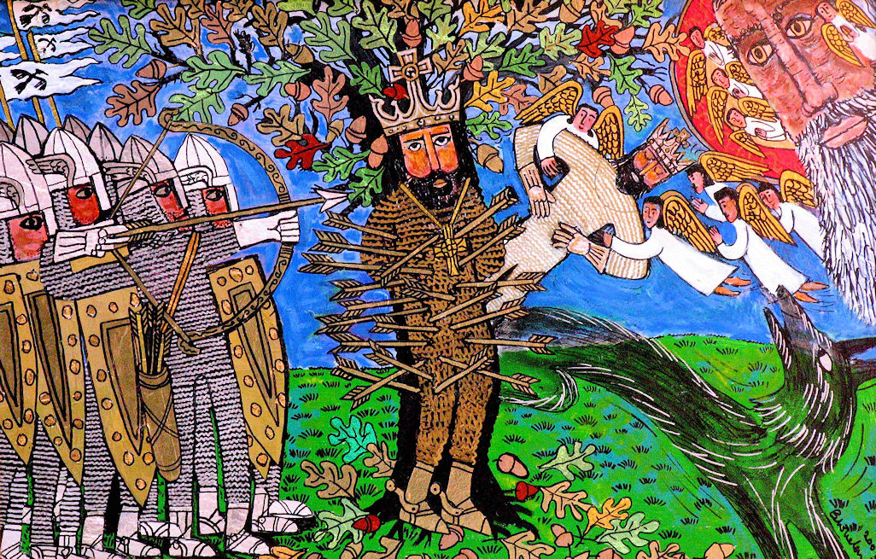**EDMUND OF EAST ANGLIA**. (c. 840 – 20 November 20, 870). Christian martyr and King of East Anglia. (*Brief excursus. The “Angles” were one of the main Germanic peoples that settled in Great Britain in the post-Roman period. ("Land of Ængle" gave us England.*) *The kingdom was roughly comprised what is now the English counties of Norfolk and Suffolk.*) And may I just say how much I love this painting (acrylic on board, Brian Whelan, 2003)?

Edmund became king at the age of fifteen. He was subsequently defeated and captured by an army of invading Danes. The invaders offered to spare his life if he would share his kingdom with a Danish leader. As a Christian, Edmund refused to collaborate in this way with a pagan or compromise the faith. He was tortured, used as a target for the Danes' archery practice, and finally beheaded. A cult of the martyr developed immediately, and Edmund was declared a saint. He is commemorated in the Episcopal calendar of the church year on 20 November.

**EFFICACIOUS GRACE**. This is “effective” grace that accomplishes its intended result in the human soul, especially in terms of a saving work or salvation. I feel rather badly about all the “better luck next time” grace, but I’m afraid I’m not in a position to help. The English reformers affirmed the efficacious nature of the sacraments, urging that they are not mere "badges or tokens of Christian men's profession," but "they be certain sure witnesses, and effectual signs of grace" (Art. XXV, Articles of Religion, Book of Common Prayer, page 872). The grace conveyed by the sacraments (Baptism, Confirmation, Eucharist, Reconciliation, Anointing of the Sick, Marriage, and Holy Orders) invariably affects the human soul, working to the soul's good. Richard Hooker stated in his “Of the Laws of Ecclesiastical Polity” that the sacraments convey the "grace which worketh salvation," which he called a "saving efficacy." (*Want to know more than you want to know about grace? Start with the essay on general grace in “Pierre Nicole, Jansenist and Humanist: A Study of his Thought.” Jansenism emphasized original sin, human depravity, the necessity of divine grace, and predestination. Humanism stresses the potential value and goodness of human beings, and attach prime importance to human rather than divine or supernatural matters. You put all this together and let me know what you think.* )

|  |  |  |  |  |  |  |  |  |
| --- | --- | --- | --- | --- | --- | --- | --- | --- |
| **EPISCOPAL CHURCH OF THE HOLY APOSTLES UPCOMING SERVICES FOR JULY 2020** | | | | | | | | |
| **Sunday**  **July**  **05th**    **7:00 PM**  Evening  Worship | **Mondays**  July 06th  July 13th  July 20th  July 27th  **8:30 a.m**.  Morning  Prayer | **Tuesdays**  July 07th  July 14th  July 21st  July 28th  **8:30 a.m.**  Virtual  Coffee  Hour | **Wednesdays**  July 1st  July 08th  July 15th  July 22nd  July 29th  **8:30 a.m.**  Morning  Prayer | **Thursdays**  July2nd  July09th  July 16th  July 23rd  July 30th  **8:30 a.m.**  Virtual  Coffee  Hour | **Fridays**  Jul 3rd  July 10th  July 17th  July 24th  July 31st  **8:30 a.m.**  Morning  Prayer | **Sunday**  **July 12th**  **7:00 PM**  Evening  Worship | **Sunday**  **July 19th**  **7:00 PM**  Evening  Worship | **Sunday**  **July 26th**  **7:00 PM**  Evening  Worship |
| Services Conducted online via WebEx  If you would like to participate but need an invitation/another invitation, please contact  (Mother) Martha at [marthagillette@att.net](mailto:marthagillette@att.net) or by text at 847.226.9043 | | | | | | | | |

**IN OUR** **PARISH LIFE:**

**COFFEE AND CONVERSATION: Are you missing the smiling faces of your fellow holy apostles??**Join in on Tuesday and Thursday mornings at 8:30 AM for Virtual Coffee Hour! It’s easy, and you don’t even have to get out of your pajamas! Chat with your friends, it really helps with feeling connected. If you need an email invitation because you can’t find the original email that Mother Martha sent on March 31, she can send another invitation to your email address – contact her at 847-226-9043 or email at [marthagillette@att.net](mailto:marthagillette@att.net). Then be sure to click on JOIN MEETING to accept the invitation right away, otherwise it will expire in 2 days. Accepting the invitation does not commit you to attend any, some, or all of the sessions, but it is necessary if you wish to do so. Then be sure to SAVE that email- DO NOT DELETE it! You can reuse it to join all subsequent Coffee Hours.

**MORNING PRAYER:** Please join Mother Martha and other apostles on Monday, Wednesday, and Friday mornings beginning at 8:30 AM for Virtual Morning Prayer. It’s the same drill as above, receive an email invitation, and click on JOIN MEETING.

**BISHOP’S COMMITTEE MEETING:** Bishop’s Committee will meet on **Tuesday 21 July at 7:00 p.m. via WebEx.** Mother Martha will email an invitation to all committee members.

**BOOK DISCUSSION GROUP:** The Holy Apostles Book Club meets on the fourth Tuesday of the month (unless otherwise noted) at a different member’s home each month. Our titles are available at the Ela Public Library about a month before the discussion date and the due dates are extended to after the meeting. All are welcome to come to any meeting; there is no commitment for attendance or for hosting. If you see a title that catches your eye, or would just like to try something new, please feel free to join us! For more information, contact Lisa Earley at [lisa.earley@groble.me](mailto:lisa.earley@groble.me) . This month the Book Group will meet on **July 28th at 7:30 PM** to discuss *The Dutch House* by Ann Patchett. Please contact Lisa for more information on location, virtual or otherwise.

**BIG TABLE:** Big Table is still providing food on Tuesdays from 5:00 – 6:00 PM. The current procedure involves driving your car up to the front door of Lincoln Hall, where a cheerful volunteer will bring a bag of groceries to your car to take home. You do not have to register ahead of time, just show up!

|  |  |  |  |  |  |  |
| --- | --- | --- | --- | --- | --- | --- |
| **JULY 2020** | | | | | | |
| **SUN** | **MON** | **TUE** | **WED** | **THU** | **FRI** | **SAT** |
|  |  |  | 1  8:30 AM  Virtual M.P. | 2  8:30 AM  Virtual Coffee | 3  8:30 AM  Virtual M.P. | 4  10 AM—noon  Food Pantry |
| 5  7:00 PM  WebEx service | 6  8:30 AM  Virtual M.P. | 7  8:30 AM  Virtual Coffee | 8  8:30 AM  Virtual M.P. | 9  8:30 AM  Virtual Coffee | 10  8:30 AM  Virtual M.P. | 11  10 AM—noon  Food Pantry |
| 12  7:00 PM  WebEx service | 13  8:30 AM  Virtual M.P. | 14  8:30 AM  Virtual Coffee | 15  8:30 AM  Virtual M.P. | 16  8:30 AM  Virtual Coffee | 17  8:30 AM  Virtual M.P. | 18  10 AM—noon  Food Pantry |
| 19  7:00 PM  WebEx service | 20  8:30 AM  Virtual M.P. | 21  8:30 AM  Virtual Coffee  7:00 PM  Bishop’s Committee | 22  8:30 AM  Virtual M.P. | 23  8:30 AM  Virtual Coffee | 24  8:30 AM  Virtual M.P. | 25  10 AM--noon  Food Pantry |
| 26  7:00 PM  WebEx service | 27  8:30 AM  Virtual M.P. | 28  8:30 AM  Virtual Coffee  7:30 PM  Book Group | 29  8:30 AM  Virtual M.P. | 30  8:30 AM  Virtual Coffee | 31  8:30 AM  Virtual M.P. |  |

**July Birthdays July Anniversaries**

July 01 Susan Allen July 05 Geoff and Diane Cooper

July 03 Michael Matson July 11 Rick and Marsha Fedor

July 07 Daniel Caithmeier July 19 John and Grace Henecker

July 10 Eileen Kinney

July 11 Ron Bedal

July 12 Gail Permenter

July 20 Marsha Fedor

July 30 Harry Krause, Marsha Taylor



**FROM: Church of the Holy Apostles**

**26238 North Highway 59**

**Wauconda, Illinois 60084**