**The Apostles Post**

26238 North Highway 59

Wauconda, Illinois

APRIL 2019

2015



**FROM THE VICAR’S DESK** *(M. C. Gillette)*

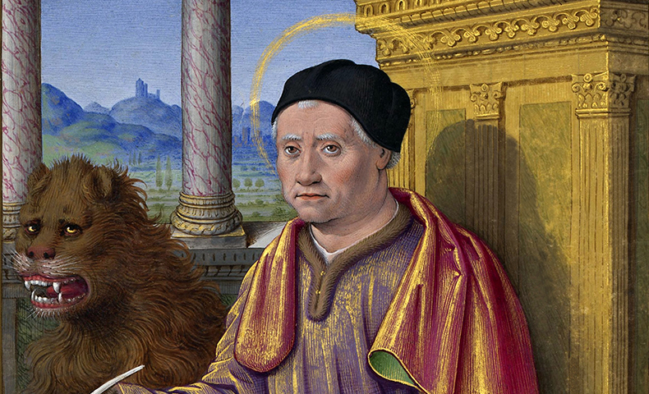 Issue III of our “B-list” Holy Days series.  And thank goodness for St. Mark, or else my beautiful plan to feature one of these special days each month would be ended before it had hardly begun.  April, apparently, has  been an “off season” for saints, martyrs, and peculiar events of the church, because St. Mark is the only “B-list” entry on the month’s liturgical calendar.  And even he, poor thing, has had his Feast “transferred” this year, from it’s “actual” date of 25 April to 29 April.  (“Transferring” holy days is something that happens when less important ones have the misfortune of occurring on a day a more important one up and demands to temporarily take over, and no, I am not sure who rank-ordered these things to begin with, nor their prioritization scheme.  I’m sure the information is out there somewhere – in the Vatican Archives’ secret vault, perhaps, along with the silver hammer they use to whack the pope on the head (3 times) to make sure he’s really dead (I’m not making this up) – but honestly, these answers are just not that important to me.  The bottom line is that St. Mark got shuffled from 25 to 29 April this year because any sort of Holy Day that falls during Easter Week gets punted to the week after 2nd Easter.  Why “Thursday in Easter Week” should take precedence over “St. Mark” is another enigma I’m not sufficiently fired up about to investigate more thoroughly.)

So – on to St. Mark.  The readings appointed for his Feast Day are Isaiah 52:7-10 / Psalm 2 / Ephesians 4:7-8, 11-16 / Mark 1:1-15 *or* Mark 16:15-20.  Mark, as presumably you know, is the presumptive author of the second gospel (which was actually the first gospel written, but whatever). He was also known as John Mark. He was the son of Mary of Jerusalem who, although she was a widow, was a woman of means – she owned a house big enough to hold a large Christian gathering, and she had at least one maid. The Last Supper of Jesus and his disciples may have been in her house; and when St. Peter escaped from prison, that’s where he went. It is also believed that Mark was Peter’s secretary and wrote down many of the things Peter remembered about Jesus; so Mark’s gospel may be based on Peter’s eyewitness reports. It emphasizes Jesus’s rejection by humanity while being God’s triumphant envoy. Probably written for gentile converts in Rome – after the death of Peter and Paul sometime between A.D. 60 and 70 – Mark’s Gospel is the gradual manifestation of a “scandal”: a crucified Messiah.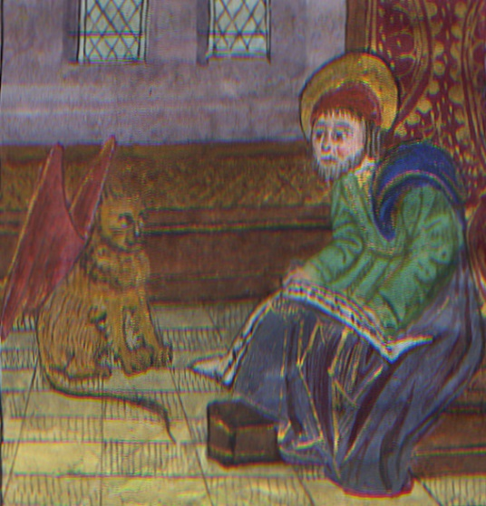Like Luke, Mark was not one of the 12 apostles. We cannot be certain whether he knew Jesus personally, although some scholars feel that the evangelist is speaking of himself when describing the arrest of Jesus in Gethsemane: “Now a young man followed him wearing nothing but a linen cloth about his body. They seized him, but he left the cloth behind and ran off naked” (Mark 14:51-52). Later on, Mark went to Antioch with his cousin Barnabas. He accompanied Paul and Barnabas on part of their first missionary journey, but "ran away" again for some unknown reason. His action angered Paul. When Mark asked to go along on the second journey, Paul flatly refused. (But later Paul asked Mark to visit him in prison, so apparently things were smoothed over.)

Mark is supposed to have taken Christianity to Alexandria. The church in Alexandria claims Mark as its first bishop. One ancient account states that he suffered a martyr's death there. Mark's life is commemorated in the Episcopal calendar of the church year on 25 April (most years). His symbol is a winged lion. The lion derives from Mark’s description of John the Baptist as a “voice of one crying out in the desert” (Mark 1:3), which artists compared to a roaring lion. The wings come from the application of Ezekiel’s vision of four winged creatures to the evangelists. There are, of course, fierce interpretations of this creature, but I’m quite charmed by this sweet little red-winged house-lion, and feel rather sorry for the bored-out-of-his-wits eye-rolling lion above.

Mark is the patron saint of – well, lions. Also Notaries, lawyers, pharmacists, painters, and secretaries. And Venice. And, apparently, people dealing with insect bites. Who decides these things?

**HERE AND THERE** *(M. C. Gillette at* [*hapostles@sbcglobal.net*](mailto:hapostles@sbcglobal.net)*)*

*In this on-going article, we pull things from our various Diocesan calendars and church websites to see what’s going on around us. For more information about what's happening at the Diocesan Headquarters and the Cathedral of Saint James, you can always visit their websites:* <https://www.episcopalchicago.org> or <https://www.saintjamescathedral.org/>

**Registration Open: Preparing for the Paschal Feast Tuesday, April 16 at St. James Cathedral**

On Tuesday in Holy Week, April 16, all members of the diocese are invited to gather at St. James Commons and St. James Cathedral to prepare for the celebrations of Maundy Thursday, Good Friday, and the Great Vigil of Easter.

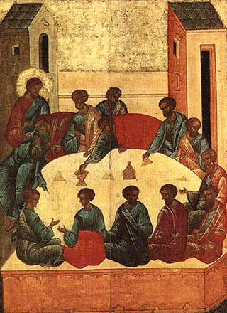The half-day retreat is offered as a time of refreshment and reflection and will include a celebration of the Eucharist with the blessing of chrism and conclude with an informal lunch for those who can attend. Bishop Lee will preach and lead the morning program. Clergy are invited to vest and process (alb and red stole). Bottles for chrism will be provided.

* 10 am check in and coffee
* 10:30 am program, led by Bishop Lee
* 12:10 Eucharist with the blessing of chrism
* 1 pm lunch (optional)

[**Please register online to attend**](http://r20.rs6.net/tn.jsp?f=001t_pCZvyCJBd8cxXfvyHX3kGrueQBI98SbDgwNgG71SN3Q4FTIbA4CTo8VWWYl_TQ66b5blZaTQURNU4VAV8HXue-4j2q59TLPsy9b-AHO8mA9ATDIexVDYQOQvcYRVD1y7mBKinDX-40nfLgX_SoGhnUr7DV-yfHntzVPLZJNHNOJi8zafOXPZxOIAfrGLPSL6tRHD960c90q9QS3swrrKU1zL4bC-pz&c=hZcXT55k7YUOsJzMtLVZ1TgADjUcnvEQI8s5ZqwFQN93DCM8xP-XYA==&ch=YFfiOrczntoWdMqv1UmEbg34EvIrkyEltVETYACmisC2pSEqecviLg==). (<https://episcopalchicago.wufoo.com/forms/q3893rz0ij5omy/>) For more information [**contact Karin Gutierrez**](mailto:kgutierrez@episcopalchicago.org).  (<https://episcopalchicago.wufoo.com/forms/q3893rz0ij5omy/>)

**A Reception to Celebrate the Episcopal Diocese of Jerusalem**

**Thursday, April 11 from 6-8 pm at St. James Commons**

Bishop Jeff Lee, Dean Dominic Barrington, and the Board of Trustees of the [**American Friends of the Episcopal Diocese of Jerusalem**](http://r20.rs6.net/tn.jsp?f=001t_pCZvyCJBd8cxXfvyHX3kGrueQBI98SbDgwNgG71SN3Q4FTIbA4CTo8VWWYl_TQJHT2QUcsIeOyPLIqpXRP9UWXm6x7HRKcbDivZrsE6fsNrSZ5NQuikQK-xDACL2twVN6JEzoXURIjKZaIgUe_mYTu1OUPvQ7wUqAjcHEEMKk=&c=hZcXT55k7YUOsJzMtLVZ1TgADjUcnvEQI8s5ZqwFQN93DCM8xP-XYA==&ch=YFfiOrczntoWdMqv1UmEbg34EvIrkyEltVETYACmisC2pSEqecviLg==) https://www.afedj.org/ invite the diocese to a reception on April 11 from 6-8 pm at St. James Commons, to celebrate the Episcopal Diocese of Jerusalem and its Christian witness in the Holy Land.

 Guests will learn about pilgrimages to the Holy Land, hear reports on how U.S. donations are transforming lives in the Middle East, and enjoy Middle Eastern food. To attend please rsvp [**by email**](mailto:bwilson@afedj.org) (https://www.afedj.org/) or phone (203.655.3575) by April 5.

**Province V ECW Annual Conference and Meeting**

**Growing in Grace and Gratitude: April 26-28 in Springfield, IL**

All women of the diocese are invited to gather in Springfield, Illinois, April 26-28, for *Growing in Grace and Gratitude*, the Province V ECW Annual Conference and Meeting. The two-day program includes worship, networking opportunities, workshops and opportunities to explore local history. The conference takes place at the President Abraham Lincoln Hotel. [**Learn more and register**](http://r20.rs6.net/tn.jsp?f=001t_pCZvyCJBd8cxXfvyHX3kGrueQBI98SbDgwNgG71SN3Q4FTIbA4CTo8VWWYl_TQK9AzBiMzpr0LGiAy1Vfw9yg-NHs40Tk0EEMDaviStFWZ-SW1AUTwkgIYfq3fy_2zERtG53GzU2wOvenFLX9g1LH8aVw3-iwp2DBphYXpG3yo0E6SvMF3gwFaJzVf6iNw&c=hZcXT55k7YUOsJzMtLVZ1TgADjUcnvEQI8s5ZqwFQN93DCM8xP-XYA==&ch=YFfiOrczntoWdMqv1UmEbg34EvIrkyEltVETYACmisC2pSEqecviLg==). (https://www.ecwchicago.org/education/)

**Diocese of Chicago ECW Annual Meeting**

**Saturday, May 11 at St. Andrew's, Downers Grove**

The 2019 ECW Annual Meeting will be held Saturday, May 11 at [**St. Andrew's**](http://r20.rs6.net/tn.jsp?f=001t_pCZvyCJBd8cxXfvyHX3kGrueQBI98SbDgwNgG71SN3Q4FTIbA4CciE7_xx2NhWVweZ9Dfpnj6Kcuh9bqX5dAJLjqO24Lp4gYbNwlcKsZKM9n8H2KLmlpaHpXpaJJFTNBYmAh2Oj8j85jwSeMFvjmhYiJbZLglpXnGP-W1xZMbd9hXwO84gfbwkbhgPpWiH&c=hZcXT55k7YUOsJzMtLVZ1TgADjUcnvEQI8s5ZqwFQN93DCM8xP-XYA==&ch=YFfiOrczntoWdMqv1UmEbg34EvIrkyEltVETYACmisC2pSEqecviLg==), (http://www.saintandrewschurch.net/ ) Downers Grove. The theme is "Reaching the World with God's Love" and will include officer elections, workshops and worship led by Bishop Lee. Visit the [**ECW website**](http://r20.rs6.net/tn.jsp?f=001t_pCZvyCJBd8cxXfvyHX3kGrueQBI98SbDgwNgG71SN3Q4FTIbA4CTo8VWWYl_TQXDllJAieSgXzM2ZaO-tGRrZhCgx578naeNo68zCs1bnfb-K1y6R8J5CgirCNUvcHi2bweREHDq2HZIfk6RhExqgFnMsa0nvVKwtM3W6eZJ8mPidOzJ0SVQ==&c=hZcXT55k7YUOsJzMtLVZ1TgADjUcnvEQI8s5ZqwFQN93DCM8xP-XYA==&ch=YFfiOrczntoWdMqv1UmEbg34EvIrkyEltVETYACmisC2pSEqecviLg==) (https://www.ecwchicago.org/) for details.

**Registration is Open for the Big Provincial Gathering July 12-13 in Kalamazoo, Michigan**

[**Online registration**](http://r20.rs6.net/tn.jsp?f=001t_pCZvyCJBd8cxXfvyHX3kGrueQBI98SbDgwNgG71SN3Q4FTIbA4CTo8VWWYl_TQSHLHkDcAeuYx7j7yQn9UQZW-W3ouKDWdKFwUyuj1QXg60FaDFsjdNviTXqNntM5jypu22JXgLxiFaWLF_5UYp-waDi8qMFOm75XyNNTWvLMIUoJjuufuJKsy1FfUR5FN&c=hZcXT55k7YUOsJzMtLVZ1TgADjUcnvEQI8s5ZqwFQN93DCM8xP-XYA==&ch=YFfiOrczntoWdMqv1UmEbg34EvIrkyEltVETYACmisC2pSEqecviLg==) (https://www.provincev.org/bpgreg.html) is open for the Big Provincial Gathering, Friday, July 12-Saturday, July 13 in Kalamazoo, Michigan. The event is open to all Episcopalians and activities will include worship, workshops, networking and vendor tables.

The theme of the event is "Behold! I have set before you an open door." The keynote speaker is the Rev. Michael Michie, the Episcopal Church staff officer for church planting infrastructure.

 The $50 registration fee includes all programming, breakfasts and lunches. A range of housing is available, including low- or no-cost options. [**Learn more and register online**](http://r20.rs6.net/tn.jsp?f=001t_pCZvyCJBd8cxXfvyHX3kGrueQBI98SbDgwNgG71SN3Q4FTIbA4CapNhlzv6hhs_Mv_T7yWiVE5gEjYY0bFFb0XblHS8pllaJ8ahvmLxj33TJ-wXhOHwQ43daO_gHPICAbVkfxbNJ6zrQ5PP8Jh0phTeeDXT9QEstR8TW5PukuBcufCNCt7HS8pb4UUMrFOgETUuu5mLjX6K4nGwzP-Gw==&c=hZcXT55k7YUOsJzMtLVZ1TgADjUcnvEQI8s5ZqwFQN93DCM8xP-XYA==&ch=YFfiOrczntoWdMqv1UmEbg34EvIrkyEltVETYACmisC2pSEqecviLg==). A limited number of scholarships are available, please [**contact Courtney Reid**](mailto:creid@episcopalchicago.org) for details.

**2019 HOLY APOSTLES LENTEN SERVICE SCHEDULE**

|  |  |  |
| --- | --- | --- |
| Tuesday 05 March | 5:00 - 7:00 PM | Shrove Tuesday Pancake Supper |
| Wednesday 06 March | 7:00 p.m. | Ash Wednesday Service |
| Sunday 10 March | Before bed Saturday! | Daylight Savings Time Begins – *don’t be late!* |
| Sunday 14 April  *Palm/Passion Sunday* | 8:00 & 10:30 a.m. | Palm/Passion Sunday Worship |
| Monday 15 April | 7:00 p.m. | Stations of the Cross |
| Tuesday 16 April | 7:00 p.m. | Stations of the Cross |
| Wednesday 17 April | 7:00 p.m. | Stations of the Cross |
| Thursday 18 April  *Maundy Thursday* | 6:00 p.m.  7:00 p.m. | Soup Supper *(Soup provided, donations accepted)*  Maundy Thursday Service |
| Thursday 18 April through Friday 19 April | 7:30 p.m. through  6:30 a.m. | Watch in the Garden of Repose |
| Friday 19 April  *Good Friday* | 7:00 p.m. | Good Friday Service |
| Saturday 20 April  *Great Vigil of Easter* | 7:30 p.m. | Easter Vigil at Holy Apostles |
| Sunday 21 April  *Easter Sunday* | 9:30 a.m. | Single Service and Pot-luck Brunch |

|  |  |  |  |  |  |  |  |  |  |  |
| --- | --- | --- | --- | --- | --- | --- | --- | --- | --- | --- |
| **UPCOMING SERVICES FOR CHURCH OF THE HOLY APOSTLES – APRIL 2019** | | | | | | | | | | |
| **SUN**  **07 April**  8:00 & 10:30 a.m. | **SUN**  **14 April**  8:00 & 10:30 a.m. | **MON**  **15 April**  *Stations*  at 7:00 p.m.  *Soup*  at 6:30 | **TUE**  **16 April**  *Stations*  at 7:00 p.m.  *Soup*  at 6:30 | **WED**  **17 April**  *Stations*  at 7:00  p.m.  *Soup*  at 6:30 | **THU**  **18 April**  7:00  p.m. | W  A T  C  H  in  T  H  E  G  A  R  D  E N  of  R  E  P  O  S  E | **FRI**  **21 April**  7:00 p.m. | **SAT**  **20 April**  7:00 p.m. | **SUN**  **21 April** *Single Service 9:30 a.m. --*  *Festive Brunch*  *Follows* | **SUN**  **28 April**  8:00 & 10:30 a.m. |
| Presider:  Dueholm  Preacher:  Dueholm | Presider:  Gillette  Preacher:  Gillette | Presider:  Gillette | Presider:  Gillette | Presider:  Gillette | Presider:  Gillette | Presider:  Gillette | Presider:  Gillette  Preacher:  Dueholm | Presider:  Gillette  Preacher:  Gillette | Presider:  Gillette  Preacher:  Gillette |
| 5th Sunday  in Lent (C) | Sunday of the Passion: Palm Sunday (C) | Monday in Holy Week (C) | Tuesday in Holy Week (C) | Wednesday  In Holy Week (C) | Maundy  Thursday (C) | Good Friday (C) | Great  Vigil of Easter (C) | EASTER  Sunday (C) | 2nd Sunday of Easter (C) |
| 1st Lesson  Isaiah  43:16-21  Response  Psalm  126  2nd Lesson  Philip-  pians 3:4b-14  Gospel  John  12:1-8 | *Litany*  *of the*  *Palms*  John  12:12-19  *Eucharist*  1st Lesson  Isaiah  50:4-9a  Response  Psalm  31:9-16  2nd Lesson  Philip-  pians  2:5-11  Gospel  Mark  14:1-15:47 | *Stations*  *of the*  *Cross* | *Stations*  *of the*  *Cross* | *Stations*  *of the Cross* | *Maundy Thursday*  *Liturgy* | 1st  Lesson  Isaiah  52:13-  53:12  Response  Psalm  22  Gospel  John  18:1-  19:37 | *Service of*  *Lessons*  Genesis  1:1-2:4  Genesis  7:1-5,  11-18;  8:6-18;  9:8-13  Exodus  14:10-31;  15:20-21  Proverbs  8:1-8,9-21  9:4-6  Ezekiel  37:1-14  Zephaniah  3:14-20  *Eucharist*  Romans  6:3-11  Luke  24:1-12 | 1st Lesson  Isaiah  65:17-25  Response  Psalm  118: 1-2, 14-24  2nd Lesson  Acts  10:34-43  Gospel  John  20:1-18 | 1st Lesson  Acts  5:27-32  Response  Psalm  150  2nd Lesson  Revela-tion  1:4-8  Gospel  John  20:19-31 |

**SOME CHURCHY STUFF** *(M. C. Gillette at* [*hapostles@sbcglobal.net*](mailto:hapostles@sbcglobal.net)*) In this monthly article, we look at terms and definitions of things you might see or hear around church. Nothing fancy here – these entries are out of the Armentrout/Slocum An Episcopal Dictionary of the Church, sometimes supplemented by me, and sometimes simply copied directly. If something in particular piques your interest, let me know, and we’ll deal with it in more depth.*

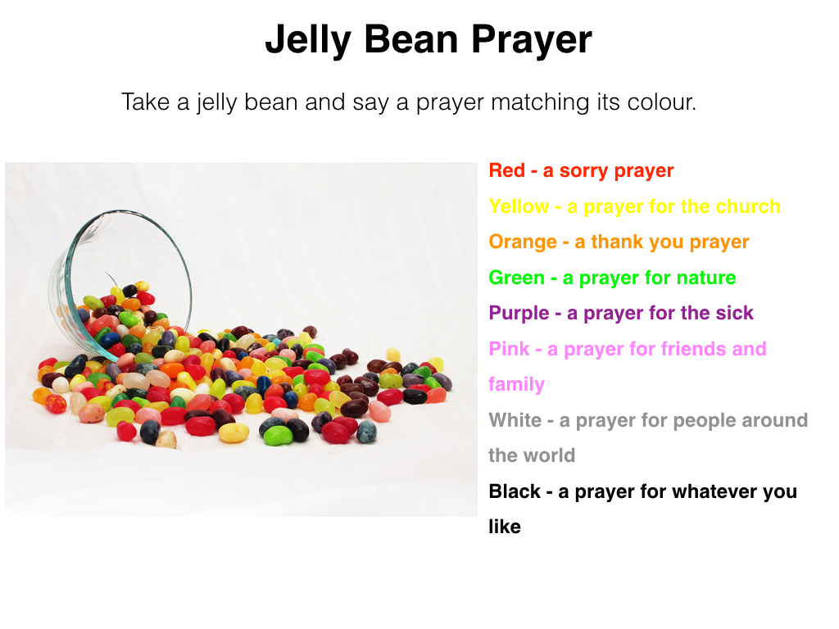**EASTER.** Presumably, you know perfectly well what “Easter” is, but the world is a strange place full of the unexpected, so let’s accept this entry. But first, let me say that exemplary of the sorts of unexpected things that make the world a strange place is this “Jelly Bean Prayer” sheet. I – wow. I simply couldn’t help myself, I had to share this wondrous find with you. (But maybe you pray your way through your jelly beans every year? I don’t particularly like them, so they don’t show up in my basket and I could be the lone hold-out here. Oh, and the yellow is “a prayer for the church” in case you can’t read it.) Anyway. Easter = The Feast of Christ's Resurrection. According to Bede (you remember Bede the Venerable, of course, the late 7th – early 8th century monk, priest, theologian, chronologist, and historian whose *Ecclesiastical History of the English People* is the primary source for the period 597 – 731 in English history) – according to Bede, the word derives from the Anglo-Saxon spring goddess Eostre. Christians in England applied the word to the principal festival of the church year, both day and season. (Making English quite off-center in this regard, as much of the rest of the world uses some form of “Pascha” or “Pesach” to identify this time – think our “Paschal Candle,” that really big candle we light during Eastertide and at baptisms and funerals.)

Easter *Day* is the annual feast of the resurrection, the pascha or Christian Passover, and the eighth day of cosmic creation. (If you want to wander down an interesting path, put “cosmic creation” into your search engine. In this context, it simply refers to the “new creation” – perfected in Christ – which supplants the old “seven-day” creation.) Faith in Jesus' resurrection on the Sunday or third day following his crucifixion is at the heart of Christian belief. Easter sets the experience of springtime next to the ancient stories of deliverance and the proclamation of the risen Christ. In the west, Easter occurs on the first Sunday after the full moon on or after the vernal equinox; always between 22 March and 25 April. Following Jewish custom, in the Western (Roman) Church, the feast begins at sunset on Easter Eve with the Great Vigil of Easter. The Eastern Orthodox Church, on the other hand, celebrates Easter on the first Sunday after the Jewish pesach or Passover (which follows the spring full moon). Although the two dates sometimes coincide (they do this year! Yay!), the eastern date is often one or more weeks later.

Easter *Season*. This is also known as the Great Fifty Days or Eastertide. The Feast of Easter is a season of fifty days, from Easter Eve through the Day of Pentecost. From early times the Greek word pentecost (“fiftieth day”) was used also for the whole Paschal season. During this season there is no fasting. (Fifty days of chocolate, people!) The Council of Nicaea (325) directed that Christians are to pray standing. The word "alleluia" (praise the Lord) is said or sung repeatedly, which contrasts sharply with the season of Lent when the alleluia is omitted. The color of liturgical vestments and hangings is white or gold. The Book of Common Prayer notes that it is customary for the Paschal candle to burn at all services of the Easter season. The "Alleluia, alleluia" may be added to the dismissals and their responses during the Great Fifty Days.

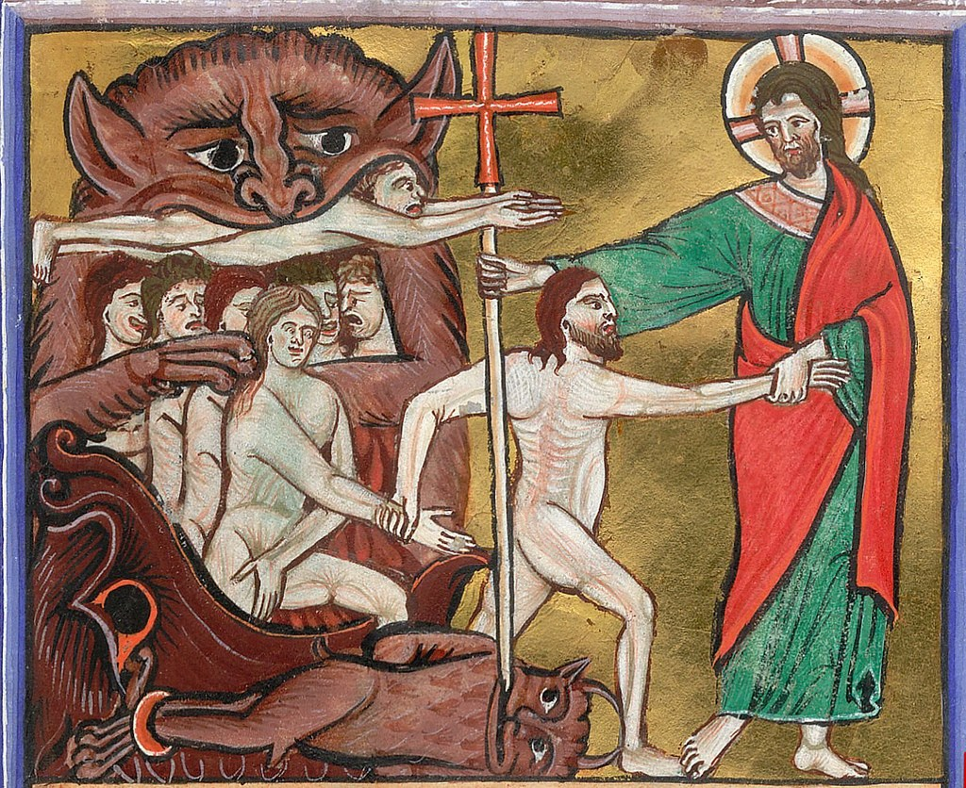**EASTER EVE, EASTER EVEN.** This sounds like some sort of children’s rhyme, but it is really two names for the Saturday before Easter. (Because in the Episcopal Church we do like our trinities, we call it by a third name, “Holy Saturday.”) It is, of course, the Saturday after Good Friday (when we commemorate the death of God-in-Christ), and on this Saturday we acknowledge our creedal confession that as his body lay in the tomb of Joseph of Arimathea, Christ offered liberation to the dead (“He descended into Hell” is how the Apostles’ Creed puts it). In the early church it was a day of fasting and preparation for the Easter Vigil. There is no celebration of the eucharist on this day, in accordance with church tradition. The term "Easter Even" was used by the 1549 Prayer Book (as you may recall?). The 1979 Book of Common Prayer uses the title "Holy Saturday" for the Saturday before Easter. The title distinguishes this day and its proper liturgy from the Easter Vigil. The Book of Common Prayer provides a simple liturgy for Holy Saturday, with brief prayers and readings. In the ancient church, those preparing for baptism and perhaps others continued the fast they began on Good Friday. Holy Saturday ends at sunset. Fasting and other preparations end at sunset or with the Easter Vigil, which begins the celebration of Easter.

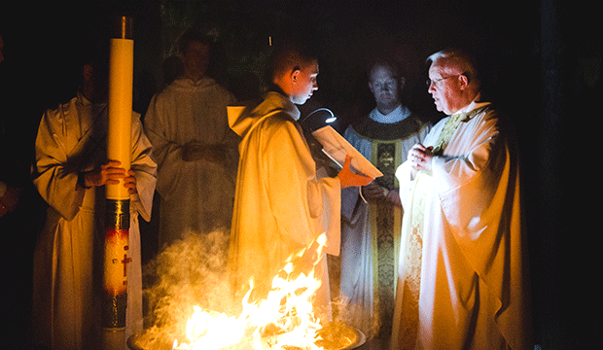**EASTER VIGIL.** The liturgy intended as the first (and arguably, the primary) celebration of Easter. It is also known as the Great Vigil. The service (ideally) begins in darkness, sometime between sunset on Holy Saturday and sunrise on Easter (unless Easter is “late” and you live in the Midwest and your priest doesn’t think you’ll come out at 10 p.m., stay until midnight, then return at 9:30 Easter morning, in which case it starts in the gloaming of 7:00 p.m.) The liturgy consists of four parts: The Service of Light (kindling of new fire, lighting the Paschal candle, the Exsultet); The Service of Lessons (readings from the Hebrew Scriptures interspersed with psalms, canticles, and prayers); Christian Initiation (Holy Baptism) or the Renewal of Baptismal Vows; and the Eucharist. Through this liturgy, the Book of Common Prayer recovers an ancient practice of keeping the Easter feast. Believers would gather in the hours of darkness ending at dawn on Easter to hear scripture and offer prayer. This night-long service of prayerful watching anticipated the baptisms that would come at first light and the Easter Eucharist. Easter was the primary baptismal occasion for the early church to the practical exclusion of all others. This practice linked the meanings of Christ's dying and rising to the understanding of baptism.

|  |  |  |  |  |  |  |
| --- | --- | --- | --- | --- | --- | --- |
| **APRIL 2019 (See PAGE 4 above for Service Schedule.)** | | | | | | |
|  | | | | | | |
| **SUN** | **MON** | **TUE** | **WED** | **THU** | **FRI** | **SAT** |
|  | 1 | 2 | 3 | 4 | 5 | 6  10 AM--noon  Food Pantry |
| 7  8:00 AM service  9:15 Sacred Signposts  10:30 AM service | 8  7:00 PM  Shawl Ministry | 9 | 10 | 11 | 12 | 13  10 AM--noon  Food Pantry  Decorating Easter Baskets and Eggs  10:30 AM-  12:30 PM |
| 14 PALM SUNDAY  8:00 AM service  9:15 Sacred Signposts  10:30 AM service | 15  7:00 PM  Stations of the  Cross | 16  7 PM BC Mtg  7:00 PM  Stations of the  Cross | 17  7:00 PM  Stations of the  Cross | 18  6:00 PM  Soup Supper  7:00 PM  Service  7:30P-6:30A  Garden of  Repose | 19  7:00 PM  Good Friday  Service | 20  10 AM--noon  Food Pantry  7:30 PM  Great Vigil of  Easter |
| 21  9:30 AM EASTER  SERVICE and  Pot-Luck BRUNCH | 22 | 23  Book Group  7:30 PM | 24 | 25 | 26 | 27  10 AM--noon  Food Pantry |
| 28  8:00 AM service  10:30 AM service | 29 | 30 |  |  |  |  |

**April Birthdays**

Apr 03 Melissa Petersen Apr 25 Jean Miller

Apr 17 Jim Pinder

**April Anniversaries**

Apr 04 Lynn and Wayne Chmiel Apr 28 Virginia and Ken Balmes

Apr 25 Kristi and Doug Connell Apr 29 Aline and Dean Denges

**IN OUR** **PARISH LIFE:**

**SHAWL MINISTRY:** The Shawl Ministry meets on the **second Monday of the month at 7:00 PM** in Lincoln Hall. Please contact Marsha Taylor at [mktaylor730@hotmail.com](mailto:mktaylor730@hotmail.com) or 847-977-5399 with any questions.

**BISHOP’S COMMITTEE MEETING:** Bishop’s Committee will meet on **Tuesday 16 April at 7:00 pm.**

**BOOK DISCUSSION GROUP:** This month the Book Group will meet on **23 April at 7:30 PM** to discuss *When Breath Becomes Air* by Paul Kalanithi, at the home of Julie Zuidema.

**LENTEN STUDY:** Join us for a Lenten study featuring the work of Pastor Benjamin Dueholm, *Sacred Signposts: Words, Water, and Other Acts of Resistance.*We will meet on the **7th and 14th of April** between services on Sundays. As a particular honor, the author, Pastor Dueholm, of Messiah Lutheran, will participate in a pulpit exchange so that he may be with us for our study on the 7th of April and preach at each service! If you would like a book to participate in the study or simply to enjoy an excellent work, please let Mother Martha or Nerissa know.

**EASTER BASKETS:** Holy Apostles continues our tradition of Easter baskets! On the Saturday before Palm Sunday from 10:30 am to 12:30 pm all are invited to gather in Lincoln Hall to decorate your eggs and/or baskets- decorative items will be provided. Bring your decorated basket (or other suitable container) filled with food stuffs from your Easter meal, decorated Easter eggs or other items to be blessed at the 9:30am service on Easter Sunday. If you are interested in participating, please sign up in Lincoln Hall. A $10 donation is requested to cover supplies.

**WAUCONDA/ISLAND LAKE FOOD PANTRY:** The milk jug count for February was $44.14. In February the food pantry served 180 families which totaled 466 individuals; eleven families were new to the pantry. Please keep them in your prayers. There is a sign-up sheet in Lincoln Hall if you are interested in volunteering on Saturdays between 10 AM and 12 noon.

**FROM: Church of the Holy Apostles**

**26238 North Highway 59**

**Wauconda, Illinois 60084**