**The Apostles Post**

26238 North Highway 59

Wauconda, Illinois

MAY 2022

2015



**FROM THE VICAR’S DESK** *(M. C. Gillette)*Angelology, Issue IV

Last month we started to talk about the Second Order (or Choir) of Angels – at least according to the grouping our buddy Pope Gregory (Gregory the Great) put together in the 6th century – Archangels. We decided, because I decided, and I’m doing the writing, that we would focus on the tradition that there are seven Archangels, who are, we might assume, in charge of the rest of the tens of thousands and thousands of thousands (Psalm 68:17) and myriads of myriads (Revelation 5:11) of holy ones (Deuteronomy 33:2) that alternately (simultaneously?) hang around the throne of God (Revelation 5:11) and us when we worship (Hebrews 12:22).

Two of them are big-shots, named in canonical scripture – Michael and Gabriel. One gets counted by all except a very fussy few – Raphael, who is a main character in Tobit, a didn’t-quite-make-the-canonical-cut-but-got-enough-votes-to-be-included-in-the-runner-up-category-called-Apocrypha book. And one – Uriel – languishes in the Minor Leagues, because he mostly is known from Enoch 1, and Enoch 1 is a text in the “also ran” category. Still, he occasionally gets to suit up because there are a lot of times when it’s nice to have an even four.

That leaves us with three more, and here is where things get fun. Enoch (the “righteous scribe” who wrote the Book(s) of Enoch) tells us (chapter XX of 1 Enoch): “1. And these are the names of the holy angels who watch. 2. Uriel, one of the holy angels, who is over the world and over Tartarus. 3. Raphael, one of the holy angels, who is over the spirits of men. 4. Raguel, one of the holy angels who takes vengeance on the world of the luminaries. 5. Michael, one of the holy angels, to wit, he that is set over the best part of mankind and over chaos. 6. Saraqâêl, one of the holy angels, who is set over the spirits, who sin in the spirit. 7. Gabriel, one of the holy angels, who is over Paradise and the serpents and the Cherubim. 8. Remiel, one of the holy angels, whom God set over those who rise.” But other equally respectable sources have other ideas: Various Gnostic authors (3rd-4th century), Pseudo-Dionysus the Areopagite (5th-6th century), Gregory the Great (6th century), Heinrich Cornelius Agrippa von Nettesheim (15th-16th century), and others who shall remain anonymous. Discounting the fact that most of these names have variant spellings (Iophiel might be Jophiel, Uriel might be Ariel – you get the picture), this is what we come up with:

|  |  |  |  |  |  |
| --- | --- | --- | --- | --- | --- |
|  | **1 Enoch** | **Christian Gnostics** | **Pseudo-Dionysus** | **Gregory the Great** | **Agrippa (Planetary)** |
| 1 | Gabriel | Gabriel | Gabriel | Gabriel | Gabriel |
| 2 | Raphael | Raphel | Raphael | Raphael | Raphael |
| 3 | Remiel | Barachiel | Chamuel | Simiel | Haniel |
| 4 | Michael | Michael | Michael | Michael | Michael |
| 5 | Uriel | Uriel | Chamuel | Uriel | Kammael |
| 6 | Raguel | Sealtiel | Zadkiel | Orifiel | Tzadqiel |
| 7 | Saragael | Jehudiel | Iophiel | Zachariel | Tzaphqiel |

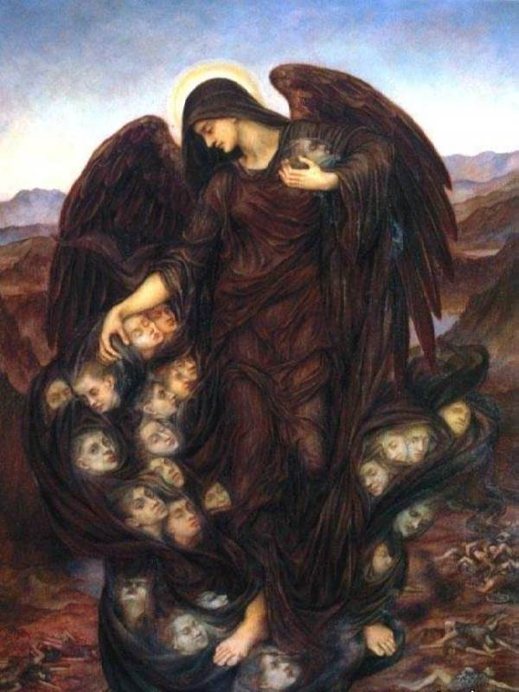 Feel free to choose the names you like best, because I’m quite sure *nothing* we call them will be right, and *they* know who they are, which is all that really matters. You can pick what you’d like them to do, too. Fight Satan, of course (Revelation 20:1-3), scare the wits out of folks by popping in to say “be not afraid,” (Luke 1:29), do a bit of patrolling the earth (Zechariah 1:10-11), and carry out the occasional judgment (2 Chronicles 32:21). But after that, chaos erupts. Perhaps you’d like to assign one to each day of the week, but of course you have to decide if Uriel or Raphael gets Wednesday, because – guess what – folks disagree. Maybe you’d like to associate one with each of the traditional “Seven Luminaries” (the seven naked-eye moving objects in the heavens: the Moon, Mercury, Venus, the Sun, Mars, Jupiter, and Saturn). Your choice of who gets which – someone out there will agree with you. You could become a proselyte of the Austrian Spiritualist Rudolf Steiner (but I’d rather you didn’t, and really wish you’d come talk to me first) and muddle them all up with the Zodiac signs. You can assign each one their own significant color (once you sort their names out) – sorta’ like the Victorians and their Language of Flowers. Michael does get blue, Gabriel claims white, Raphael picked green, but red, purple, yellow, and pink are up for grabs. Oh, but don’t forget Azrael, the Angel of Death, who separates souls from their bodies – clad him in Indigo. (Wait! What? Where’d he come from?!? He’s not on any of the lists you put on the chart above!)

Ha, ha, ha. Just be glad there isn’t a quiz. And thank – the Archangel of your choice – that we aren’t going to delve into the Dark Angels, the leaders of whom (according to Enoch) are: Sêmîazâz, their leader, and their “chiefs of tens” Arâkîba, Râmêêl, Kôkabîêl, Tâmîêl, Râmîêl, Dânêl, Êzêqêêl, Barâqîjâl, Asâêl, Armârôs, Batârêl, Anânêl, Zaqîêl, Samsâpêêl, Satarêl, Tûrêl, Jômjâêl, and Sariêl. And remember what I said when we started this series – we’re not really talking about angels, we’re talking about angelology, that is, what people believe and say about angels. Which is, apparently, pretty much whatever they want. And you?



|  |  |  |  |  |
| --- | --- | --- | --- | --- |
| **EPISCOPAL CHURCH OF THE HOLY APOSTLES UPCOMING SERVICES – MAY 2022** | | | | |
| Sunday  01 May  9:30 a.m. | Sunday  08 May  9:30 a.m. | Sunday  15 May  9:30 a.m. | Sunday  22 May  9:30 a.m. | Sunday  29 May  9:30 a.m. |
| Scheduled  Presider/ Preacher:  Gillette | Scheduled  Presider/ Preacher:  Gillette | Scheduled  Presider/ Preacher:  Gillette | Scheduled  Presider/ Preacher:  Gillette | Scheduled  Presider/ Preacher:  Gillette |
| 3rd Sunday of Easter (C) | 4th Sunday of Easter (C) | 5th Sunday of Easter (C) | 6th Sunday of Easter (C) | 7th Sunday of  Easter (C) |
| FIRST LESSON  Acts 9:1-20  RESPONSE Psalm 30  SECOND  LESSON  Revelation  5:11-14  GOSPEL  John 21:1-19 | FIRST LESSON  Acts 9:36-43  RESPONSE Psalm 23  SECOND  LESSON  Revelation  7:9-17  GOSPEL  John 10:22-30 | FIRST LESSON  Acts 11:1-18  RESPONSE Psalm 148  SECOND  LESSON  Revelation  21:1-6  GOSPEL  John 13:31-35 | FIRST LESSON  Acts 16:9-15  RESPONSE Psalm 67  SECOND  LESSON  Revelation  21:10, 22-22:5  GOSPEL  John 5:1-9 | FIRST LESSON  Acts 16:16-34  RESPONSE Psalm 97  SECOND  LESSON  Revelation  22:12-14, 16-17, 20-21  GOSPEL  John 17:20-26 |

**HERE AND THERE** *(M. C. Gillette)*

*In this on-going article, we pull things from our various Diocesan calendars and church websites to see what’s going on around us. For more information about what's happening at the Diocesan Headquarters and the Cathedral of Saint James, you can always visit their websites:* https://www.episcopalchicago.org

or https://www.saintjamescathedral.org/



**Mediation Skills Training**

**August 1-5 at St. Mark's, Glen Ellyn**

**The Lombard Mennonite Peace Center** (https://lmpeacecenter.org/)

will host a summer session of its **Mediation Skills Training Institute (MSTI)**

(https://files.constantcontact.com/dc5bcc8c101/d64648d4-7dce-4a5a-8e49-85b5f5a79d32.pdf?rdr=true)

for Church Leaders August 1-5 at St. Mark’s Episcopal Church in Glen Ellyn. MSTI training helps clergy and lay leaders deal more effectively with interpersonal, congregational, and other forms of group conflict. For more information contact the Lombard Mennonite Peace Center at 630-627-0507.

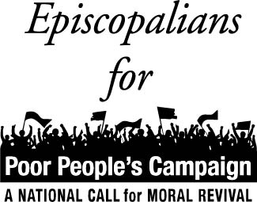**Poor People's Campaign National Gathering**

**June 18 in Washington, DC**

**The Poor People's Campaign** (PPC), (https://www.poorpeoplescampaign.org/) which both The Episcopal Church and the diocesan Peace and Justice Committee have endorsed, seeks participants and support for **The Mass Poor People's and Low-Wage Workers' Assembly and Moral March on Washington and to the Polls**. (https://www.poorpeoplescampaign.org/june18/)

On June 18, PPC teams from across the country will converge on Washington, DC.

Contact **Newland Smith** (farnssn@gmail.com) for more information.

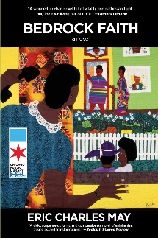**Book Club Discussion: Bedrock Faith**

**May 9 at St. Philip's, Palatine**

On May 9 from 7-9 pm, **St. Philips, Palatine's** (https://stphilipspalatine.org/) "Eat, Pray, Read" book club will host a discussion of the book Bedrock Faith by Eric Charles May. Participants are invited to bring questions and thoughts for discussion. **RSVP by May 4 via email**

(parish@stphilipspalatine.org) or leave a message at the church office at 847-358-0615.

|  |  |
| --- | --- |
|  |  |
|  |  |

**Tell Me the Truth About Racism Training**

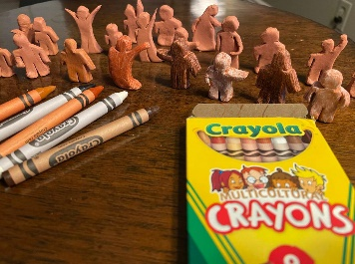**Summer cohort forming**

**Tell Me the Truth About Racism**

(https://www.tellmethetruthaboutracism.org/home) is accepting applications for a summer cohort that will gather Tuesday nights starting July 12.

**Learn more and apply online**.

(https://docs.google.com/forms/d/e/1FAIpQLSd0L3IL0FqiFdbBBNrwkVlky350-GWne18Cor1-658Fu6TSEw/viewform)

**SOME CHURCHY STUFF** *(M. C. Gillette)*

*In this monthly article, we look at terms and definitions of things you might see or hear around church. Nothing fancy here – these entries are out of the Armentrout/Slocum An Episcopal Dictionary of the Church, sometimes supplemented by me, and sometimes simply copied directly. If something in particular piques your interest, let me know, and we’ll deal with it in more depth.*

**GARTH.** Once again we begin our monthly meander through “churchy stuff,” both obvious and obscure, with a thing I didn’t even know was a thing. I apparently have been in/on a garth – I think I even participated in a caleigh (or ceilidh if you prefer) in/on the *garth* at the monastery cloister on the Isle of Iona, Scotland. Anyway, it is “a grassy quadrangle or garden surrounded by a cloister walk in a monastery, church, seminary, or college.”

**GAUDETE SUNDAY.** One of two days a year I can “officially” wear my ~~pink~~ rose-color chasuble. (The other being 4th Lent, “Laetare” (“Rejoice”) Sunday, which I usually forget because I’m being all dour in plain linen.) Anyway, it is the third Sunday of Advent in our calendar of the church year. (Well, technically, it’s only *Gaudete* Sunday on the Roman Catholic calendar. The rest of us just call it “the third Sunday of Advent.” And Thomas Cranmer intentionally swapped the readings when he put together the first Anglican prayer book so “rejoice” wasn’t there anymore. But I can still wear ~~pink~~ rose.) The term is derived from the Latin opening words of the introit antiphon, “Rejoice (Gaudete) in the Lord always.” (I know I just said “laetare” means “rejoice.” The difference between “laetare” rejoicing and “gaudete” rejoicing is that the former reflects a joy that is manifest outwardly whereas the latter reflects a way of rejoicing internally.) The theme of the day expresses the joy of anticipation at the approach of the Christmas celebration. This theme reflects a lightening of the tone of the traditional Advent observance (which is more Lent-like). It was appropriate for the celebrant of the Mass to wear rose-colored vestments on this day instead of the deeper violet vestments that were typically used in Advent (until blue became the new “deeper violet”). This Sunday was also known as “Rose Sunday.” This custom is not required in the Episcopal Church, but it is observed by some parishes with a traditional Anglo-catholic piety (or a priest who actually owns ~~pink~~ rose vestments). This custom is reflected by the practice of including a ~~pink~~ rose-colored candle among the four candles of an Advent wreath.

**GELASIAN SACRAMENTARY.** A liturgical book which contains those parts of the rites (Daily Offices, Eucharist, and Pastoral Offices) read by the person celebrating the rite. It is the second oldest western (“Roman”) liturgical book that has survived. (The Verona Sacramentary is older, but isn’t a “sacramentary” in the strictest sense of the word as currently used; it exists in a sole manuscript from about 600, containing materials from the fifth and sixth centuries.) The Gelesian Sacramentary exists in several manuscripts, the oldest dating to the 8th century. (This manuscript is in the Vatican Library, having been acquired from the library of the seventeenth century Queen Christina of Sweden.) It is the most important surviving Merovingian illuminated manuscript. (The Merovingians were a Frankish dynasty which lasted from the fifth century to the eighth century in present-day France, the Benelux Union, and a part of Germany.) It is the earliest source of a number of collects and other forms in our Book of Common Prayer. It was for a long time (incorrectly) attributed to Pope Gelasius I (died 496); hence the name.

**GENERAL BOARD OF EXAMINING CHAPLAINS (CBEC).**

Well, OK, this is what it *seems* like:

The General Convention of 1970 created this board to standardize the process of canonical examination for ordination. The GBEC includes four bishops, six clergy with pastoral cures or in specialized ministries, six members of accredited seminary faculties or of other educational institutions, and six lay persons. The members of the board are elected by the House of Bishops and confirmed by the House of Deputies for six-year terms. Each member has a special competence in one or more of the seven areas of canonical examination (see the note on the General Ordination Exams below.) The GBEC is charged with preparing and administering an examination for the entire church. The first meeting of the GBEC was at Trinity Church, New York City, Dec. 1970.

**GENERAL ORDINATION EXAMINATION.** It gives me the shivers just recalling it. Seven, three-hour exams, and you do not know the question (one per topic) until you’re sitting in your room (in some cases with no resources available – you are told what you can and cannot bring into each exam prior to it). Breathe. Breathe. Well, then. The General Convention of 1970 created the General Board of Examining Chaplains (GBEC), with responsibility to prepare at least annually a General Ordination Examination covering 1) The Holy Scriptures; 2) church history, including the ecumenical movement; 3) Christian theology; 4) Christian ethics and moral theology; 5) studies in contemporary society, including racial and minority groups; 6) liturgics and church music; Christian worship and music according to the contents and use of the Prayer Book and The Hymnal; and 7) theory and practice of ministry. Candidates are examined in these seven areas before ordination to the diaconate. The GBEC conducts, administers, and evaluates these examinations. The first General Ordination Examinations (GOEs) were administered Jan. 31-Feb. 5, 1972. The exams are read by readers chosen by the administrator of the GOE from names suggested to GBEC members. The purpose of the GOE is advisory. It offers assistance to diocesan authorities in determining a candidate's readiness for ordination. (So yeah, you can go through your long and arduous “discernment” process (whatever your diocese requires prior to endorsing you – or not – to go to seminary) and your three years of seminary and not. be. ordained.) It also provides guidance to the candidate and his or her mentors in planning future continuing education.

|  |  |  |  |  |  |  |
| --- | --- | --- | --- | --- | --- | --- |
| **MAY 2022** | | | | | | |
| **SUN** | **MON** | **TUE** | **WED** | **THU** | **FRI** | **SAT** |
| 1 | 2 | 3 | 4 | 5 | 6 | 7  10 AM--noon  Food Pantry |
| 8  9:30 AM in church | 9 | 10 | 11  Shawl Ministry  12:30 – 2:00 PM  Lincoln Hall | 12 | 13 | 14  10 AM--noon  Food Pantry |
| 15  9:30 AM in church | 16 | 17  Bishop’s Committee  7:00 PM in  Lincoln Hall | 18 | 19 | 20 | 21  10 AM--noon  Food Pantry |
| 22  9:30 AM in church | 23 | 24  Book Group  7:30 PM | 25 | 26 | 27 | 28  10 AM--noon  Food Pantry |
| 29  9:30 AM in church | 30 | 31 |  |  |  |  |

**May Birthdays**

May 03 Neil Rothenberg May 20 Tim Zuellig May 06 Jackie Smith May 23 Marty Staton

May 10 Tim Hull May 27 John Henecker

**May Anniversaries**

May 16 Carl and Lucy Reed

**IN THE PARISH**

**SHAWL MINISTRY:** Our next in-person meeting will be **Wednesday May 11 from 12:30 - 2:00 PM** in Lincoln Hall.

**BOOK GROUP**: The May selection for our book group is *Killers of the Flower Moon*by David Grann, which is available through the Ela Area Public Library. We will meet at **7:30pm on May 24.** Please contact Lisa Earley for more information at lisa.earley@groble.me

**FORMATION DISCUSSION GROUP:  “Learning to Walk in Darkness”**

Led by Nerissa Brueckbauer, this is an opportunity to ponder the extremely timely question: “What can we learn when we cannot see the way ahead, are lost, alone, frightened, not in control, or when the world around us seems to have descended into darkness?”

Using Barbara Brown Taylor’s book “Learning to Walk in the Dark” (it is not necessary to have read it) and the work of other authors who have wondered on paper about the ways God is made known in the “dark,” participants will explore lessons gleaned from those “shadow places” over the course of four weekly one-hour sessions.  Each session is “stand alone” – there is no need to prepare in advance to participate.

**When:**   **7:00 p.m., Tuesdays in May – May 3rd, 10th, 17th, and 24th.**

**Where:**  **Strawberry Moon Martini Bar (Upstairs),** 204 S Main St, Wauconda, IL 60084

**SOUP, SUPPER, SYMPOSIUM:  “BODY, MIND, and SPIRIT"**

**Sponsored by Holy Apostles and Federated Church of Wauconda**

​**What:**  Simple Supper, Interesting Information, and Collegial Conversation.

**Where:**  Federated Church, 200 Barrington Road, Wauconda 60084

**When:**  6:00 p.m. (Supper served; presentations start between 6:15 and 6:30 p.m.) to roughly 8:00 p.m.,

the 4th Wednesday of each month beginning in May and running through October.

**MAY 25**  Karen Homes on “Soulful Gardening”

**JUNE 22**  Louie Sharp on “Fun and Goals”

**JULY 27**  Marilynn Kulieke PhD on “New Discoveries on Brain Functioning”

**AUG 24**  Allison Deputy on “Healing Movement for Every Body” (Tai Chi)

**SEP 28**  John Kennedy on “Training Your Brain”

**OCT 26**  Rev. Dr. Regina Davis Bridges on “Spirituality and Personality Types”

**A REMINDER:** Your Leadership Team (Bishop’s Committee, Treasurer, Parish Administrator, Priest-in-Charge, Warden) is always available to address any questions you might have.

**Bishop’s Committee:**

Marci Suelzer / suelzerm@hotmail.com

Jane Farber / 73janie@gmail.com

Penny Treptow / PJTREPTOW@gmail.com

Tom Bachhuber / tom @centerforlifetransitions.net

Lynn McAlister / rolymac@sbcglobal.net

Jackie Smith / jacksmith5657@yahoo.com

**Treasurer:** Geoff Cooper / 1950gmjc@gmail.com

**Parish Administrator:** Jackie Smith / holyapostlesoffice@gmail.com

**Priest-in-Charge:** The Rev. Martha Gillette / marthagillette@att.net

**Warden:** Stacey Pyne

While only members are able to vote on business matters, Bishop’s Committee meetings are open to anyone who wishes to attend. Meetings are the 3rd Tuesday of each month, at 7:00 p.m., in Lincoln Hall.

Minutes of all meetings are available for you to review. They are in the black binder on the white unit next to the Parish Administrator’s desk. Please note that minutes cannot be posted until they have been approved by the Committee; therefore there is always at least one month’s delay before they are available.

**FROM: Church of the Holy Apostles**

**26238 North Highway 59**

**Wauconda, Illinois 60084**