**LAST SUNDAY AFTER THE EPIPHANY (B)**

**The Transfiguration**

*Episcopal Church of the Holy Apostles*

Sunday 14 February 2021

**OPENING VOLUNTARY**

*Near, My God, to Thee*

*It Is Well with My Soul (When Peace Like a River)*

**WORDS OF WELCOME**

**OPENING HYMN** H1982, #439

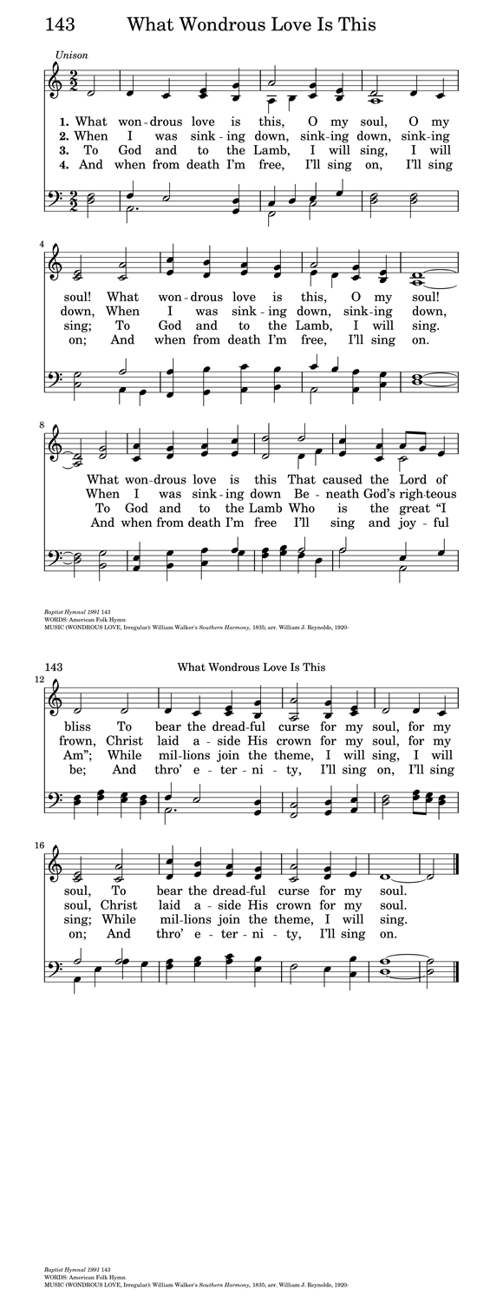

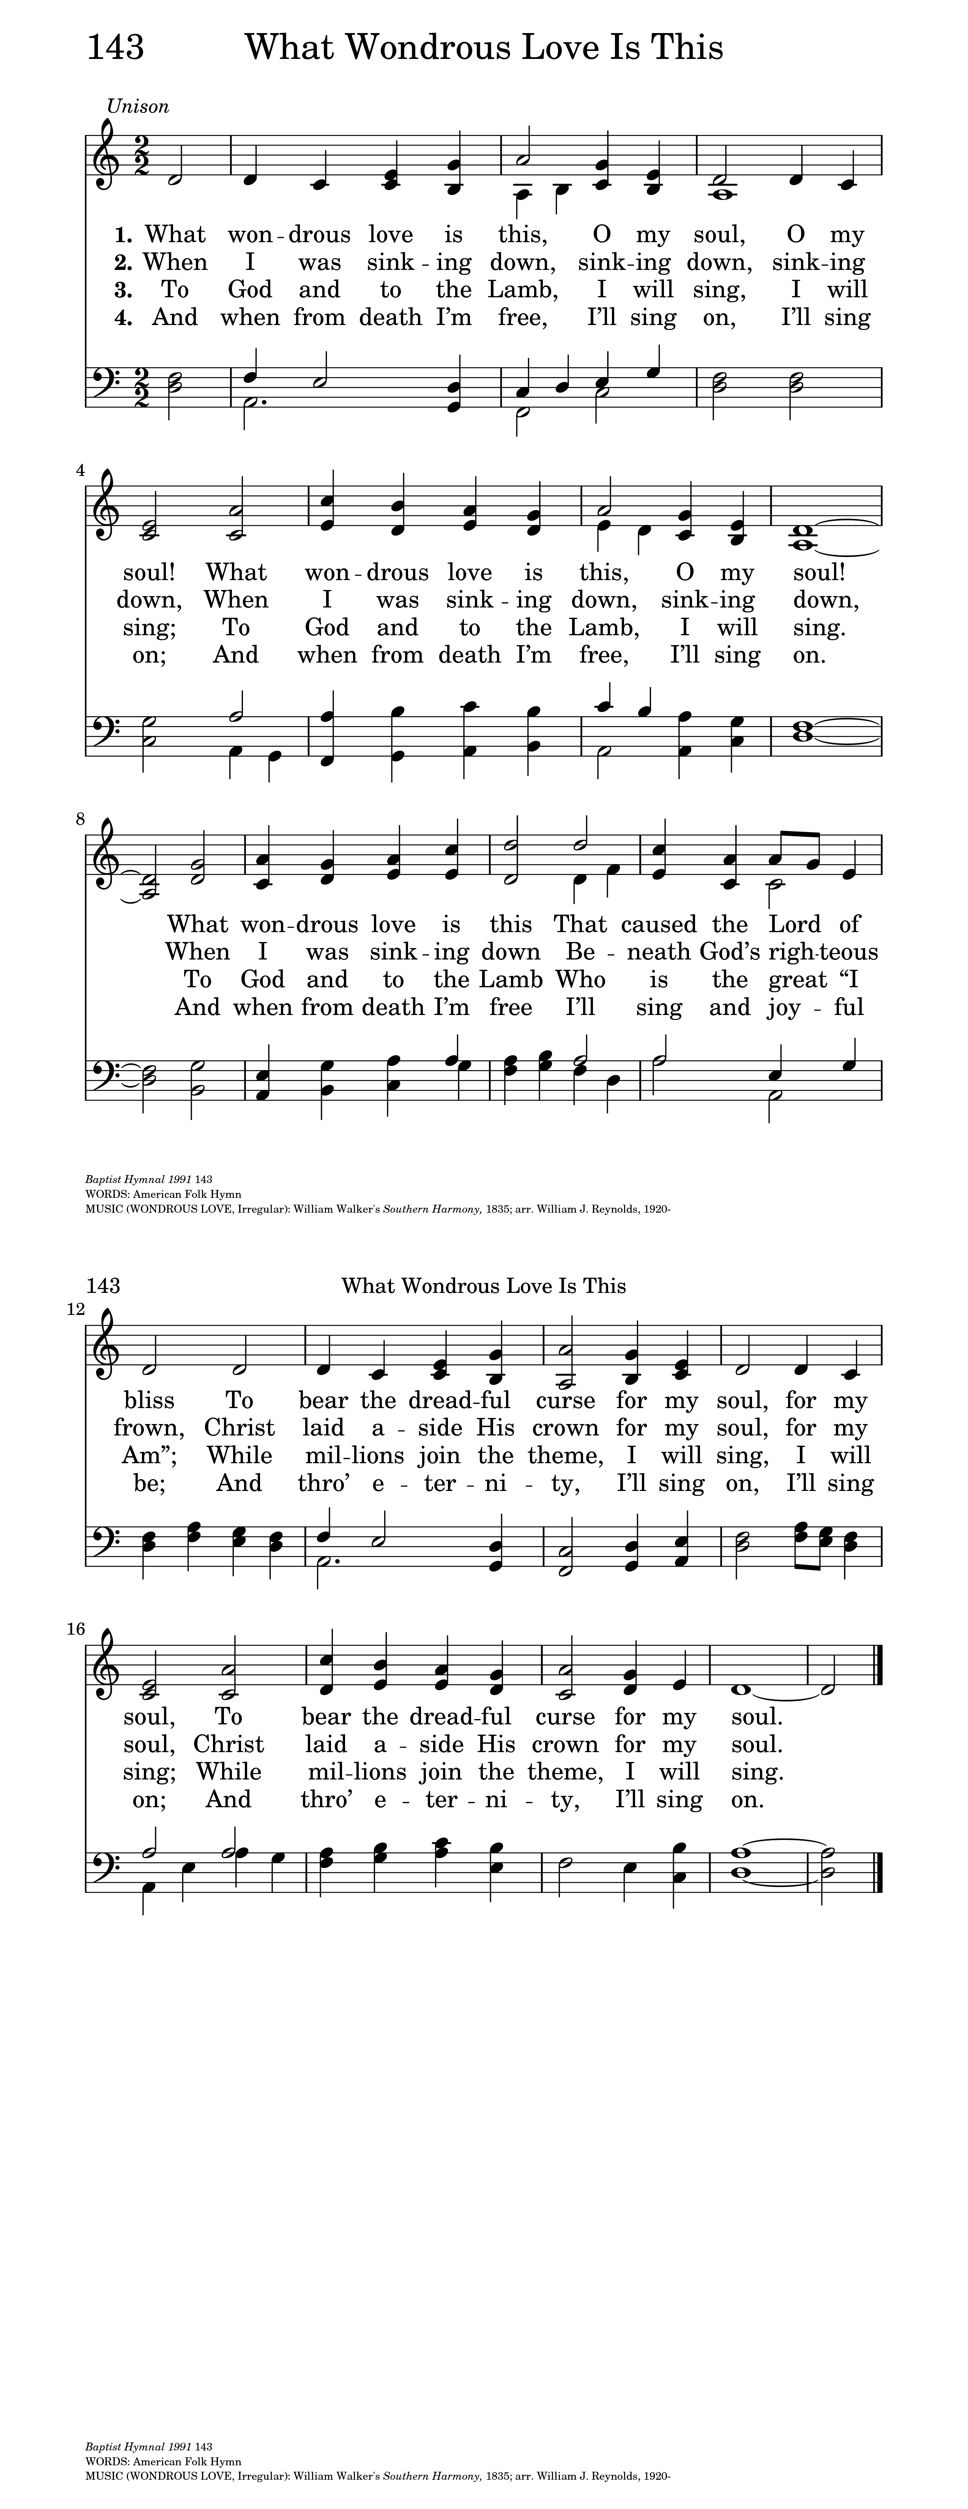

**OPENING SENTENCES**

**Presider:** Blessed be the one, holy, living, and Triune God.

***People: And blessed be God's kingdom, now and forever. Amen.***

**COLLECT FOR PURITY**

**Presider:** Almighty God, to you all hearts are open, all desires known, and from you no secrets are hid: Cleanse the thoughts of our hearts by the inspiration of your Holy Spirit, that we may perfectly love you, and worthily magnify your holy Name; through Christ our Lord. ***Amen.***

**HYMN OF PRAISE**



**COLLECT OF THE DAY**

**Presider:**  The Lord be with you.

***People: And also with you.***

**Presider:** Let us pray. God of Moses and Elijah, revealed in burning bush and chariot of fire; you speak to us in freedom, your glory escapes our naming: in your mercy, dwell with us and lift us beyond all fear and empty worship; through Jesus Christ, the glory of the Father. Amen.

***People: Amen.***

*(We read from the various translations of the Bible authorized by our Church. During the season of Epiphany we read from the Good News Translation (Today’s English Version), 1976)*

**FIRST LESSON** 2 Kings 1:1-12

**Reader:** A reading from Second Kings. When the Lord was about to take Elijah up to heaven by a whirlwind, Elijah and Elisha were on their way from Gilgal. Elijah said to Elisha, “Stay here; for the Lord has sent me as far as Bethel.” But Elisha said, “As the Lord lives, and as you yourself live, I will not leave you.” So they went down to Bethel. The company of prophets who were in Bethel came out to Elisha, and said to him, “Do you know that today the Lord will take your master away from you?” And he said, “Yes, I know; keep silent.” Elijah said to him, “Elisha, stay here; for the Lord has sent me to Jericho.” But he said, “As the Lord lives, and as you yourself live, I will not leave you.” So they came to Jericho. The company of prophets who were at Jericho drew near to Elisha, and said to him, “Do you know that today the Lord will take your master away from you?” And he answered, “Yes, I know; be silent.” Then Elijah said to him, “Stay here; for the Lord has sent me to the Jordan.” But he said, “As the Lord lives, and as you yourself live, I will not leave you.” So the two of them went on. Fifty men of the company of prophets also went, and stood at some distance from them, as they both were standing by the Jordan. Then Elijah took his mantle and rolled it up, and struck the water; the water was parted to the one side and to the other, until the two of them crossed on dry ground. When they had crossed, Elijah said to Elisha, “Tell me what I may do for you, before I am taken from you.” Elisha said, “Please let me inherit a double share of your spirit.” He responded, “You have asked a hard thing; yet, if you see me as I am being taken from you, it will be granted you; if not, it will not.” As they continued walking and talking, a chariot of fire and horses of fire separated the two of them, and Elijah ascended in a whirlwind into heaven. Elisha kept watching and crying out, “Father, father! The chariots of Israel and its horsemen!” But when he could no longer see him, he grasped his own clothes and tore them in two pieces. The word of the Lord.

***People: Thanks be to God.***

**RESPONSE** *(Please say together in unison)* Psalm 50:1-6

***1 The God of gods has spoken; God has called the earth from the rising of the sun to its setting.***

***2 Out of Zion, perfect in its beauty, God is revealed in glory.***

***3 O God, you will come and will not keep silence; before you there is a consuming flame, and round about you a raging storm.***

***4 You call the heavens and the earth from above to witness the judgment of your people.***

***5 “Gather before me my loyal followers, those who have made a covenant with me and sealed it with sacrifice.”***

***6 Let the heavens declare the rightness of your cause, for you alone are judge.***

**SECOND LESSON** 2 Corinthians 4:3-6

**Reader:** A reading from the second letter to the Corinthians. Even if our gospel is veiled, it is veiled to those who are perishing. In their case the god of this world has blinded the minds of the unbelievers, to keep them from seeing the light of the gospel of the glory of Christ, who is the image of God. For we do not proclaim ourselves; we proclaim Jesus Christ as Lord and ourselves as your slaves for Jesus’ sake. For it is the God who said, “Let light shine out of darkness,” who has shone in our hearts to give the light of the knowledge of the glory of God in the face of Jesus Christ. The word of the Lord.

***People: Thanks be to God.***

**OFFERTORY HYMN** **(vv. 1, 2, 4)**

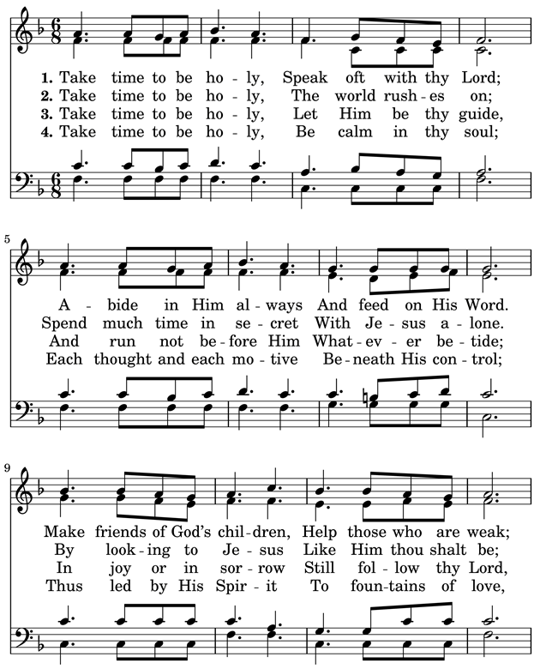

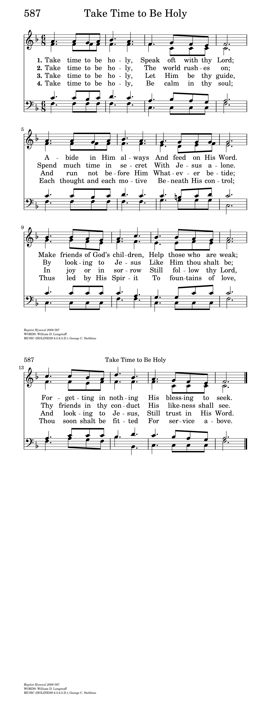

**GOSPEL** *(Please remain standing)* Mark 9:2-9

**Presider:** The Holy Gospel of our Lord Jesus Christ according to Mark.

***People: Glory to you, Lord Christ.***

**Presider:** Jesus took with him Peter and James and John, and led them up a high mountain apart, by themselves. And he was transfigured before them, and his clothes became dazzling white, such as no one on earth could bleach them. And there appeared to them Elijah with Moses, who were talking with Jesus. Then Peter said to Jesus, “Rabbi, it is good for us to be here; let us make three dwellings, one for you, one for Moses, and one for Elijah.” He did not know what to say, for they were terrified. Then a cloud overshadowed them, and from the cloud there came a voice, “This is my Son, the Beloved; listen to him!” Suddenly when they looked around, they saw no one with them any more, but only Jesus. As they were coming down the mountain, he ordered them to tell no one about what they had seen, until after the Son of Man had risen from the dead. The Gospel of the Lord.

***People: Praise to you, Lord Christ.***

**SERMON** The Rev. M. C. Gillette

*(A brief period of silence follows the sermon)*

**NICENE CREED**

***All: We believe in one God, the Father, the Almighty, maker of heaven and earth, of all that is, seen and unseen. We believe in one Lord, Jesus Christ, the only Son of God, eternally begotten of the Father, God from God, Light from Light, true God from true God, begotten, not made, of one Being with the Father. Through him all things were made. For us and for our salvation he came down from heaven: by the power of the Holy Spirit he became incarnate from the Virgin Mary, and was made man. For our sake he was crucified under Pontius Pilate; he suffered death and was buried. On the third day he rose again in accordance with the Scriptures; he ascended into heaven and is seated at the right hand of the Father. He will come again in glory to judge the living and the dead, and his kingdom will have no end. We believe in the Holy Spirit, the Lord, the giver of life, who proceeds from the Father and the Son. With the Father and the Son he is worshiped and glorified. He has spoken through the Prophets. We believe in one holy catholic and apostolic Church. We acknowledge one baptism for the forgiveness of sins. We look for the resurrection of the dead, and the life of the world to come. Amen***

**PRAYERS OF THE PEOPLE**

**Leader:** Lord, in this season of Epiphany, we remember the journey of the Magi who sought the Christ child, the light of the star which guided them, and their response to finding Jesus, the newborn king.

***People: Lord, let us seek you, follow your light, and worship you as they did long ago.***

**Leader:** We thank you for manifesting yourself to all people and for opening the doors of your church to both Jews and Gentiles.

***People: Reveal yourself, we pray, to all who long to find you, and grant them the joy of knowing you.***

**Leader:** We pray for your church around the world, that you might dwell among us, unite us, and transform us. We pray especially for those on our Episcopal and Diocesan cycles of prayer.

***People: Make your church a light to the nations, shining forth with mercy, power, and love.***

**Leader:** We pray for the leaders of our local, state, and national governments, and for all who hold power and authority in the world.

***People: Please guide their feet along the pathways of justice, compassion, reconciliation, and peace.***

**Leader:** We pray for all who suffer in body, mind, or spirit, and for those who are in any kind of trouble or sorrow, remembering especially those on our parish prayer list, and those whose names we raise up now, either silently or aloud: *(we will keep a 10-second silence)* _____

***People: Manifest yourself to them, merciful God. Grant them your gifts of healing, grace, wisdom, and comfort.***

**Leader:** We pray for those who have died. In particular, we pray for our beloved departed, and those whose names we raise up now, either silently or aloud: *(we will keep a 10-second silence)* _____ . We pray for those who have been killed in the course of service to others, giving thanks for their sacrifice.

***People: May they live eternally with you in Paradise.***

**Leader:** We thank you for the joy which fills our hearts, and for those celebrating birthdays and anniversaries this week, in particular those whose names we raise up now, either silently or aloud: (we will keep a 10-second silence: _____ . Keep us mindful of the good things in our lives.

***People: In your mercy, bless us, and make us a source of blessing to others as we share our joy with them.***

**Presider:** *(Says this or another Collect)* May your radiance shine upon us all as brightly today as the star shown upon those of another age so long ago: and grant us all a desire to seek and to serve; graciously accepting your gift of grace, and striving always to return through the love and kindness we show to our neighbors some small portion of that loving-kindness you have given us; through Jesus Christ our Lord.

***People: Amen***

**CONFESSION AND ABSOLUTION OF SIN**

**Presider:** Let us confess our sins against God and our neighbor.

*(A brief period of silence will be kept)*

***All: Most merciful God, we confess that we have sinned against you in thought, word, and deed, by what we have done, and by what we have left undone. We have not loved you with our whole heart; we have not loved our neighbors as ourselves. We are truly sorry and we humbly repent. For the sake of your Son Jesus Christ, have mercy on us and forgive us; that we may delight in your will, and walk in your ways, to the glory of your Name. Amen.***

**Presider:** Almighty God have mercy on you, forgive you all your sins through our Lord Jesus Christ, strengthen you in all goodness, and by the power of the Holy Spirit keep you in eternal life.  ***Amen.***

**THE PEACE** *(Please greet each other in the name of the Lord)*

**Presider:** The peace of the Lord be always with you.

***People: And also with you.***

*(The Presider gives an Offertory Sentence or says:)* Walk in love, as Christ loved us and gave himself for us, an offering and sacrifice to God.

**OFFERTORY HYMN (vv. 1, 2, 3)**



**THE GREAT THANKSGIVING (Rite II, Prayer B)**

**Presider:** The Lord be with you.

***People: And also with you.***

**Presider:** Lift up your hearts.

***People: We lift them to the Lord.***

**Presider:** Let us give thanks to the Lord our God.

***People: It is right to give God thanks and praise.***

**Presider:** It is indeed right and good to give you thanks and praise, almighty God and everlasting Father, through Jesus Christ your Son. Because in the mystery of the Word made flesh, you have caused a new light to shine in our hearts, to give the knowledge of your glory in the face of your Son Jesus Christ our Lord. And so we join our voices with angels and archangels and with all the company of heaven to proclaim your glory, forever praising you and saying:

**SANCTUS**

***All: Holy, holy, holy Lord, God of power and might, Heaven and earth are full of your glory. Hosanna in the highest. Blessed is the one who comes in the name of the Lord. Hosanna in the highest.***

**Presider:** We give thanks to you, O God, for the goodness and love which you have made known to us in creation; in the calling of Israel to be your people; in your Word spoken through the prophets; and above all in the Word made flesh, Jesus, your Son. For in these last days you sent him to be incarnate from the Virgin Mary, to be the Savior and Redeemer of the world. In him, you have delivered us from evil, and made us worthy to stand before you. In him, you have brought us out of error into truth, out of sin into righteousness, out of death into life.

**↑**On the night before he died for us, our Lord Jesus Christ took bread; and when he had given thanks to you, he broke it, and gave it to his disciples, and said, “Take, eat: This is my Body, which is given for you. Do this for the remembrance of me.”

**↑**After supper he took the cup of wine; and when he had given thanks, he gave it to them, and said, “Drink this, all of you: This is my Blood of the new Covenant, which is shed for you and for many for the forgiveness of sins. Whenever you drink it, do this for the remembrance of me.”

Therefore, according to his command, O Father,

***All: We remember his death, We proclaim his resurrection, We await his coming in glory;***

**Presider:** And we offer our sacrifice of praise and thanksgiving to you, O Lord of all; presenting to you, from your creation, this bread and this wine.

**∞**We pray you, gracious God, to send your Holy Spirit upon these gifts that they may be the sacrament of the Body of Christ and his Blood of the new Covenant. **+**Unite us to your Son in his sacrifice, that we may be acceptable through him, being sanctified by the Holy Spirit. In the fullness of time, put all things in subjection under your Christ, and bring us to that heavenly country where, with all your saints, we may enter the everlasting heritage of your sons and daughters; through Jesus Christ our Lord, the firstborn of all creation, the head of the Church, and the author of our salvation.

By him, and with him, and in him, in the unity of the Holy Spirit all honor and glory is yours, Almighty Father, now and for ever. ***AMEN.***

**LORD’S PRAYER:**

***All: Our Father in heaven, hallowed be your Name, your kingdom come, your will be done, on earth as in heaven. Give us today our daily bread. Forgive us our sins as we forgive those who sin against us. Save us from the time of trial and deliver us from evil. For the kingdom, the power, and the glory are yours, now and forever. Amen.***

**THE FRACTION (THE BREAKING OF THE BREAD)**

*(The Presider breaks the consecrated bread. A brief period of silence is kept.)*

**Presider:** We break this bread to share in the body of Christ.

***People: We who are many are one body, for we all share the one bread.***

**Presider:** The gifts of God for the People of God. Take them in remembrance that Christ died for you, and feed on him in your hearts by faith, with thanksgiving.

**COMMUNION HYMN** H1982, #328



**POST-COMMUNION PRAYER**

**Presider:** Let us pray.

***All: Eternal God, heavenly Father, you have graciously accepted us as living members of your Son our Savior Jesus Christ, and you have fed us with spiritual food in the Sacrament of his Body and Blood. Send us now into the world in peace, and grant us strength and courage to love and serve you with gladness and singleness of heart; through Christ our Lord. Amen.***

**BLESSING**

**Presider:** May Christ, the Son of God, be manifest in you, that your lives may be a light to the world; and the blessing of God Almighty, Father, Son, and Holy Spirit, be among you, and remain with you always. ***Amen.***

**CLOSING HYMN**

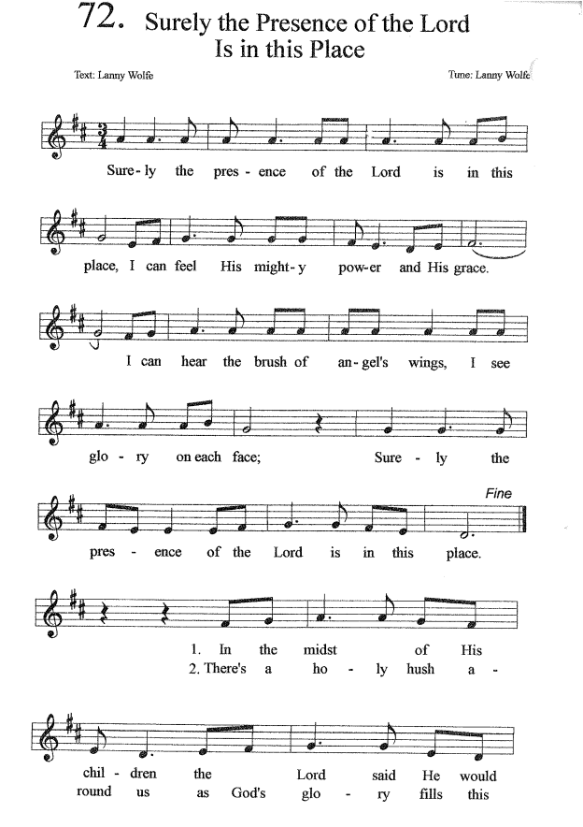

**DISMISSAL**

**Presider:** *(Says the following or another dismissal)* Our worship is over, our service now begins. Let us go forth into the world rejoicing in the power of the Holy Spirit.

***People: Thanks be to God!***

**Cover Image:** <https://vhoagland.wordpress.com/2015/02/07/he-takes-our-hand/peters-mother-in-law-2/>

**Collect of the Day:** “Prayers for an Inclusive Church,” Stephen Shakespeare