The Apostles Post
26238 North Highway 59
Wauconda, Illinois

JANUARY 2022

FROM THE VICAR’S DESK (M. C. Gillette) Angelology, Issue I
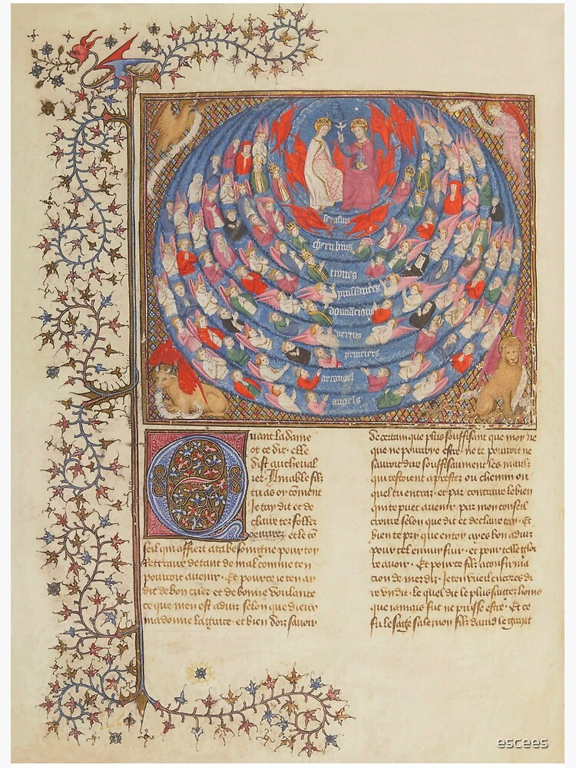
Some blogger somewhere wrote that angels are mentioned two hundred and seventy three times in the Bible. I did not have the strength of will to do the work necessary to count for myself all the times the word “angel” (or a derivative) appears in scripture, so this remains unverified. You may page through your favorite translation and tally the Angel Count up yourself, or you may take the two hundred and seventy three number, or you may join me in allowing it to suffice to say they wander (fly, flit, walk, shout, provoke, implore, command, condemn, etc.) throughout the entirety of the good book; from Genesis (3:24, when cherubim are sent to guard the east side of Eden to prevent the return of the recently banished humans) to Revelation (22:16, where Jesus tells the author ¹⁶ “I, Jesus, have sent my angel to give you (plural) this testimony for the churches”.) So, I thought maybe we’d take a look at angels this year. More accurately, I suppose – although I would love to actually take a look at angels – I thought maybe we’d take a look at angelology, that is, what people believe and say about angels. (And now that I think about it, I’m not so sure I would like to see an angel. At their best, they give you news that seems as if it must be fake, and at their worst – mmm – well, there’s Lucifer, for example, and all those sleepless eyes and wheels for feet and flying around with pokers full of red-hot coals and whatnot. But I’m probably getting ahead of myself.)
Two hundred and seventy three or not, there really are many passages about angels in the Bible. For example, the creation of angels is recorded in Psalm 148:2,5-6, “Praise him, all his angels; Let them praise the name of the Lord, for at his command they were created, and he established them for ever and ever.” Daniel was protected by an angel when he was thrown into the lion’s den in Daniel 6:22. “My God sent his angel, and he shut the mouths of the lions. They have not hurt me, because I was found innocent in his sight.” A question was asked in Hebrews 1:14, “Are not all angels ministering spirits sent to serve those who will inherit salvation?” In Luke 16:22, we are told, “The time came when the beggar died and the angels carried him to Abraham’s side. The rich man died and was buried.” Isaiah’s encounter with angels is the one with the scary burning-coal-carrying-angel. “I saw the Lord,” he said (Isaiah 6:1-7) “high and exalted, seated on a throne; Above him were seraphim, each with six wings: With two wings they covered their faces, with two they covered their feet, and with two they were flying. And they were calling to one another: ‘Holy, holy, holy is the Lord Almighty; the whole earth is full of his glory.’ At the sound of their voices the doorposts and thresholds shook and the temple was filled with smoke. ‘Woe to me! I am ruined! For I am a man of unclean lips, and I live among a people of unclean lips, and my eyes have seen the King, the Lord Almighty.’ Then one of the seraphim flew to me with a live coal in his hand, which he had taken with tongs from the altar. With it he touched my mouth and said, ‘See, this has touched your lips; your guilt is taken away and your sin atoned for.’ ” Angels appear in the apocrypha (the “not quite canon” books that still make it into some translations of the Bible, and provide some of our own lectionary readings); Tobit, for example. And they appear in extra-biblical literature such as those Gnostic works we looked at last year.
Polls are curious things. Depending on your sample size, specific wording, the sincerity of your respondents, and, perhaps, the phase of the moon, you can get statistically significant variation on the answers to just about any question. But here is one thing that seems to be consistent across polls from this century. More people believe in angels than the theory of evolution. (May I also just say that there was a Harris poll conducted that reported “In the U.S., Christians are particularly likely (99%) to believe in God or a higher power, with 80% claiming faith in a biblical God.” I’m not sure what the pollsters meant when asking about a “biblical” God, so I’m going to let that one go, but if you know a one of those “Christians” who doesn’t believe in God at all, would you introduce me? As Spock would say: “Fascinating.”) Right-o, then. It is a terrifying thing, scrolling through religious polls (76% believe the Old Testament is the word of God, but only 23% believe the Torah is the word of God?), but, having done so, I can assure you a substantial majority of American adults believe in angels. And not just Christians. Jews and Muslims also do, which makes sense, given these are the three peoples of the Abrahamic tradition. But several other religious traditions also express beliefs in angels, like our friends the Zoroastrians. And I’m sure there are angel-friendly agnostics and “un-affiliateds” and whatnot – certainly including the people who create Japanese fantasy multi-player trading card games such as Legend of the Cryptids, or exhibit their work on DeviantArt. With such a wide variety of possible thoughts about and depictions of angels, a stroll through the world of Angelology should be fun. Or utterly horrible, in which case we’ll turn our attention to something less awful, like Hell.
Who, if I cried out, would hear me among the Angelic
Orders? And even if one were to suddenly
take me to its heart, I would vanish into its
stronger existence. For beauty is nothing but
the beginning of terror, that we are still able to bear,
and we revere it so, because it calmly disdains
to destroy us. Every Angel is terrifying. Rainer Maria Rilke, The Duino Elegies (First Elegy). Translation, A. S. Kline

-----------------------------------------------------------------------------------------------------------------------------------------------

EPISCOPAL CHURCH OF THE HOLY APOSTLES UPCOMING SERVICES – JANUARY 2022
Sunday 02 January  9:30 a.m. | Sunday 09 January  9:30 a.m. | Sunday 16 January  9:30 a.m. | Sunday 23 January  9:30 a.m. | Sunday 30 January  9:30 a.m.
Scheduled  Presider/Preacher:  Gillette | Scheduled  Presider/Preacher:  Gillette | Scheduled  Presider/Preacher:  Gillette | Scheduled  Presider/Preacher:  Gillette | Scheduled  Presider/Preacher:  Gillette
Second Sunday after Christmas (C) | First Sunday after the Epiphany (C) | Second Sunday after the Epiphany (C) | Third Sunday after the Epiphany (C) | Fourth Sunday after the Epiphany (C)
FIRST LESSON  Jeremiah 31:7-14  RESPONSE  Psalm 84  2nd LESSON  Ephesians  1:3-6, 15-19a  GOSPEL  Matthew 2:13-23 | FIRST LESSON  Isaiah 43:1-7  RESPONSE  Psalm 29  2nd LESSON  Acts  8:14-17  GOSPEL  Luke3:15-17,12-22 | FIRST LESSON  Isaiah 62:1-5  RESPONSE  Psalm 36:1-10  2nd LESSON  1 Corinthians  12:1-11  GOSPEL  John 2:1-11 | FIRST LESSON  Neh.8:1-3, 5-6,8-10  RESPONSE  Psalm 19  2nd LESSON  1 Corinthians  12:12-31a  GOSPEL  Luke 4:14-21 | FIRST LESSON  Jeremiah 1:4-10  RESPONSE  Psalm 71:1-6  2nd LESSON  1 Corinthians  13:1-13  GOSPEL  Luke 4:21-30

HERE AND THERE (M. C. Gillette)
In this on-going article, we pull things from our various Diocesan calendars and church websites to see what’s going on around us. For more information about what's happening at the Diocesan Headquarters and the Cathedral of Saint James, you can always visit their websites: https://www.episcopalchicago.org or https://www.saintjamescathedral.org/

Communal Contemplative Spirituality Workshop – January 22 on Zoom
Contemplative Outreach Chicago will host a three-hour Zoom workshop on communal contemplative spirituality led by the Very Rev. Michael Battle. Titled “Releasing an Enslaved Spirit,” the workshop aims to bring together people from diverse backgrounds who share an interest in contemplation. Learn more and register online.
(https://www.centeringprayerchicago.org/events/releasing-an-enslaved-spirit/)
_____________________________________________________________________________

PRESIDING BISHOP’S CHRISTMAS MESSAGE
Watch it here: https://www.youtube.com/watch?v=CNPnJRSWTvw&feature=youtu.be
Or read the transcript below:
Presiding Bishop Michael Curry’s Christmas Message 2021
‘In the name of these refugees, let us help all refugees’
A number of years ago, I read a book by Roberta Bondi who at that time was teaching at the Candler School of Theology at Emory University. The title of the book was “To Love as God Loves”. Professor Bondi in that book looked at and examined early Christians. And one of the things she observed was that early Christians saw their vocation of following Jesus as learning how to love as God loves. And that was the title of the book, “To Love as God Loves”.
If that is true, as I believe it is, when we look at the New Testament stories of Jesus, and particularly the stories around Christmas, we see early glimmers of Jesus showing us how to love as God loves. The Christmas stories found in Matthew and in Luke, for example, actually show us something about God’s way of love.
We all know the Christmas stories, the babe wrapped in swaddling clothes as it’s found in Luke’s gospel, the baby that’s born of Mary, the stories of Mary while she was pregnant meeting her cousin Elizabeth, and words of the Magnificat – “My soul doth magnify the Lord and my spirit rejoices in God my savior.”
We know of the stories of Mary giving birth in the manger because there was no room for them in the inn, the stories of the shepherds out on the field beholding the angel choir – “Gloria in Excelsis Deo”. The stories of a baby born is the story of beauty, a story of hope; for as the Jewish tradition says, every child who is born is a reminder that God is not finished with the world yet. In this case, the baby that was born was named Jesus.
Matthew tells the same story but highlights other dimensions that remind us profoundly of the way God loves. In Matthew’s story, the child is born and there is great beauty in it, but there is some difficulty, even in the relationship between Mary and Joseph when they discover that she is with child before they are actually married. But an angel intervenes and tells Joseph in the dream that this child is God’s miracle.
And so Joseph accepts his responsibility and cares for Mary and the baby Jesus who is to be born. And all moves along well. And in Matthew’s version there is a star, the Magi or the wise men who come from afar, but then the story takes a dark turn.
And all of a sudden the same beauty that surrounded the birth of a child now is tinged by an ugliness of tyranny, the ugliness of injustice, the ugliness of hatred, the ugliness of unbridled selfishness as King Herod hears rumors of a rival to his throne being born and begins plans to execute children to stamp out his rival. In Matthew, that is the context for the birth of Jesus.
And Mary and Joseph and the baby Jesus when he is born are forced to flee as refugees seeking political asylum, eventually in Egypt, because of the wrath of King Herod. They are saved from the destruction, but many do die.
In the late 1930s, the Episcopal Church embarked on efforts to save refugees who were fleeing tyranny, evil, injustice, bigotry, and hatred in Europe at the advent of the Second World War. In The Episcopal Church, Episcopalians and many other Christians and Jewish people in the United States and people of goodwill and human decency worked together in a variety of ways to save as many refugees as they could.
And at that time, Episcopalians created this image:

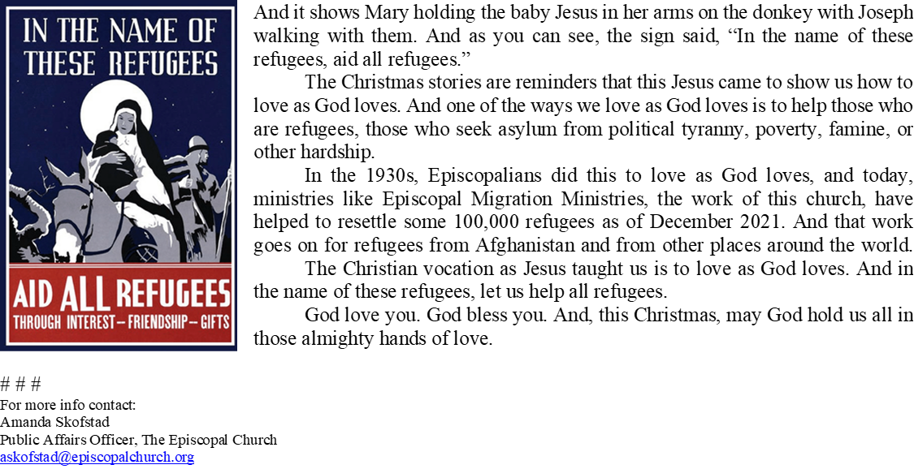

COVID-19 Updates from the COVID-19 Advisory Team – 15 December 2021
As the new year approaches and we enter another COVID surge and the uncertainty of a new variant, we thought it would be important to remind congregations of our COVID guidelines and make some recommendations for this season.

There are two Diocesan requirements that remain in place:
- In accordance with the State of Illinois mandate and at the direction of the Ecclesiastical Authority, face masks must be worn in all indoor settings. With the anticipation of visitors who may not be familiar with this expectation, please make sure you have extra masks for visitors, and visible signage.
- Please continue to refrain from using the common cup and common loaf of bread for communion.
In addition to following these requirements, there are other steps you can take to minimize the risk of COVID infection:
- Strongly encourage vaccination and booster shots. Vaccines are now available for all ages 5 and older, and boosters for those ages 16 and older. You can find locations for vaccines here, https://www.vaccines.gov.
- If your church is in a county or neighborhood with lower vaccine rates, consider hosting a vaccine clinic. Both the Illinois Department of Public Health and Chicago Department of Public Health are working with faith communities to increase vaccine rates throughout the state.
- Consider bringing in experts from your own church community or local health leaders for an adult forum on the current state of the pandemic.
- Encourage members to get tested for COVID if they are concerned about exposure or the onset of symptoms. Free testing sites are located throughout the state (https://coronavirus.illinois.gov/testing-sites.html) and at home test kits are available at local pharmacies.
- Stay home when sick. It’s not always easy to tell if symptoms belong to a cold, the flu, or COVID. If you have the sniffles, a cough or a sore throat, just stay home. That means leaders too! Think ahead about what to do if someone in worship leadership is feeling ill, and communicate your plan.
- Keep the air moving. Leave windows or doors open if possible. This is also a good opportunity to check the filters in the church furnace.
If someone who has attended one of your services notifies you that they have COVID, please notify your congregation. While you may not name the person who has COVID, you can say which service they attended. For those members who have concern about possible exposure, they should pursue testing and reach out to their health care provider or local health department with questions. You do not need to conduct contact tracing. That is a function of the health department.
As always, thank you to our diocesan COVID-19 advisory team:
The Rev. Dr. Jacqueline Cameron, The Rev. Dr. Joann Lagman, Ms. Beth Lukas, The Rev. Dr. Fulton Porter,The Rev. Wes Smedley, The Rev. Dr. Anthony Vaccaro
________________________________________________________________________________________
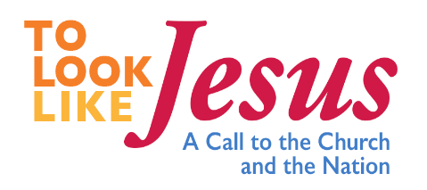

Join Episcopal Church Presiding Bishop Michael Curry, Washington Bishop Mariann Edgar Budde, the Rev.
Glenna Huber, and other local and national leaders for a livestreamed celebration of Epiphany, the season of
light, from the church of the Epiphany in Washington, D.C. on Thursday, January 6 at 12 p.m. Eastern.
https://www.episcopalchurch.org/tolooklikejesus/
This Epiphany, we will proclaim that we recognize Christ alive and moving wherever people are looking, acting, and loving like Jesus. Bishop Curry will invite Episcopalians to commit afresh to becoming vibrant, loving, healing, truth-telling embodiments of Jesus and his light – in our communities and in our nation. The worship service will feature the witness and voice of a diversity of people who are the face of Christ – from ordained Episcopal ministers to unhoused people who are also leading the church.

-------------------------------------------------------------------------------------------------------------------------------------
SOME CHURCHY STUFF (M. C. Gillette)
In this monthly article, we look at terms and definitions of things you might see or hear around church. Nothing fancy here – these entries are out of the Armentrout/Slocum An Episcopal Dictionary of the Church, sometimes supplemented by me, and sometimes simply copied directly. If something in particular piques your interest, let me know, and we’ll deal with it in more depth.

FRANCIS OF ASSISI. (118 1 or 1182 - Oct. 3, 1226).
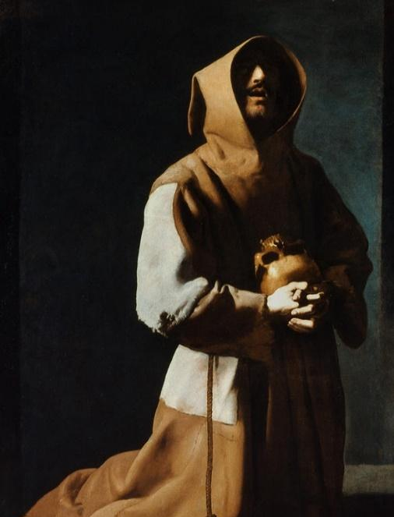
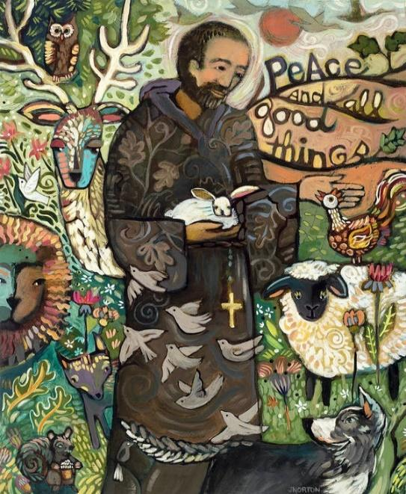
If I said “Quick! Your life depends on your ability to conjure up an image of Saint Francis of Assisi right now!” I would bet you would come up with something like the representation on the left. (Although I’m afraid it’s equally likely your mind would go utterly blank, but that’s another sort of conversation entirely.) But a more accurate picture is probably the one on the right. Sorry.
So, if you are going to think about saints at all, Francis will probably be on your list. As Britannica tells us, the founder of the Franciscan orders of the Friars Minor (Ordo Fratrum Minorum), the women’s Order of St. Clare (the Poor Clares), and the lay Third Order was born in Assisi, Italy, sometime in 1181/82, and died 03 October, 1226. He was canonized on 16 July 1228; his feast day is 04 October.
Francis was a leader of the movement of evangelical poverty in the early 13th century. His evangelical zeal, consecration to poverty, charity, and personal charisma drew thousands of followers. Francis’s devotion to the human Jesus and his desire to follow Jesus’ example reflected and reinforced important developments in medieval spirituality. The Poverello (“Poor Little Man”) is one of the most venerated religious figures in Roman Catholic history, and he and St. Catherine of Siena are the patron saints of Italy. Because everybody knows he loved “brother sun and sister moon,” et.al., in 1979 Pope John Paul II recognized him as the patron saint of ecology. Francis’ father, a cloth merchant, was on a business trip to France when he was born, and his mother had him baptized Giovanni. Upon his return, however, his father had him renamed Francesco (di Pietro di Bernadoni). He was educated locally, and as he grew, his exuberant love of life and a general spirit of worldliness made him a recognized leader of the young men of the town.
In 1202 he took part in a war between Assisi and Perugia, was held prisoner for almost a year, and on his release fell seriously ill. After his recovery, he had a vision/dream that bade him return to Assisi, which he did, dedicating himself to solitude and prayer so he might know God’s will for him. Over the course of his lifetime, he had several spiritual incidents, one of the most decisive being when he heard the crucifix above the altar at the ruined chapel of San Damiano command him: “Go, Francis, and repair my house which, as you see, is well-nigh in ruins.” Taking this literally, Francis hurried home, gathered some fine cloth from his father’s shop, and rode off to the nearby town of Foligno, where he sold both cloth and horse. He then tried to give the money to the priest at San Damiano, whose refusal prompted Francis to throw the money out the window. Angered, his father kept him at home and then brought him before the civil authorities. When Francis refused to answer the summons, his father called him before the bishop of Assisi. Before any accusations were made, Francis “without a word peeled off his garments even removing his breeches and restored them to his father.” Completely naked, he said: “Until now I have called you my father on earth. But henceforth I can truly say: Our Father who art in heaven.” The astonished bishop gave him a cloak, and Francis went off to the woods of Mount Subasio above the city.
Although as a lay person Francis was not licensed to preach, he did so. Preaching in the streets to the townspeople, he attracted followers, and eventually received permission from Pope Innocent III to found the Franciscan order. In the most endearing stories about him, he preached to the birds and persuaded a wolf to stop attacking the people of the town of Gubbio and their livestock if the townspeople agreed to feed the wolf. Whatever the historical validity of these stories, it is incontestable that he considered all nature to be the mirror of God and sought to bring the gospel to all God’s creatures. It is also true that he was fiercely devoted to the human Jesus; his “creation” of the first creche at Christmastime in 1223 reflected this. One final remarkable story about him concerns the stigmata (the marks resembling the wounds on the crucified body of Christ) which he is said to have received after an extended period of fasting and prayer focused on the Passion of Christ. Emerging from an otherworldly vision, he came to understand that “by God’s providence he would be made like to the crucified Christ not by actual martyrdom but by conformity in mind and heart.” Although he “took great pains to keep them hidden,” the “nail holes” in his hands were mentioned by his confessor and his successor as head of the Order.
Probably no one in history has set out as seriously as Francis did to imitate the life of Christ and to carry out so literally Christ’s work in Christ’s own way. This is the key to the character and spirit of St. Francis and helps explain his veneration for the Eucharist (as the body and blood of Christ) and respect for the priests who handled the elements of the communion sacrament. To neglect this point is to present an unbalanced portrait of the saint as a lover of nature, a social worker, an itinerant preacher, and a celebrant of poverty.

FRANCISCAN SPIRITUALITY. As noted above, St. Francis of Assisi initiated a form of life centered on the practice of evangelical poverty as a means and sign of a spiritual poverty that can be filled only by divine grace. Franciscan spirituality is also characterized by an attitude of reverence for God in all things and a deep appreciation of the goodness of creation as a reflection of God's love. All creatures are worthy of our respect as sisters and brothers. Francis's disciples, the Mendicant Friars (Franciscans, or First Order of St. Francis), owned no property, lived from alms, and were devoted to itinerant popular preaching. The Sisters of St. Clare (Clarists, Poor Clares, or Second Order) practiced Franciscan poverty in a cloistered life. A “Third Order of Brothers and Sisters of Penance,” a lay fraternity that, without withdrawing from the world or taking religious vows, would allow participants to carry out the principles of Franciscan life was established for those who could not leave their families or homes.
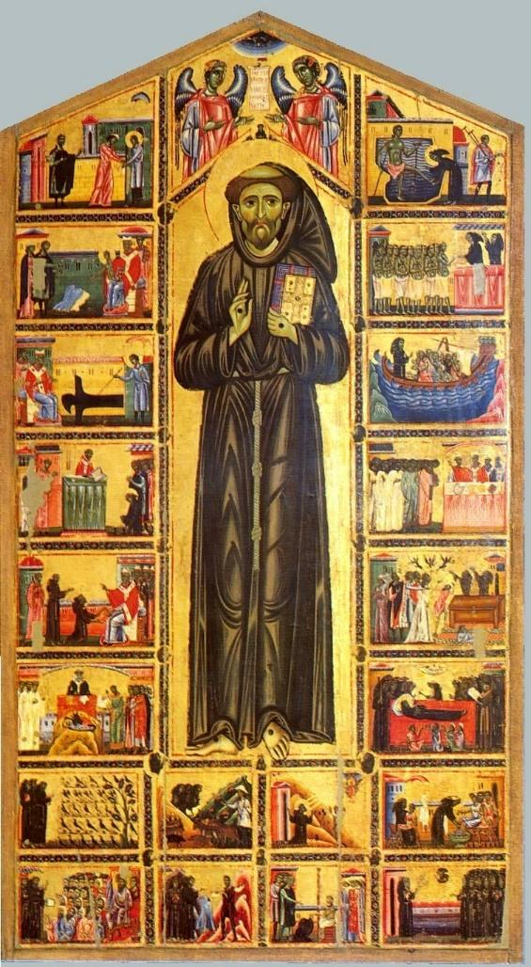
St. Francis's original Rule of Life (the Primitive Rule of 1210) was sufficient when he had only a handful of disciples, but as the order grew exponentially, more organization and structure was needed. To correct this situation, Francis prepared a new and more detailed rule (Regula prima, “First Rule”), which reasserted devotion to poverty and the apostolic life. This rule was never officially sanctioned by the pope, however, so two years later, Francis submitted a further revision of the rule—known as the (Regula secunda , “Second Rule”)—to Pope Honorius III, who approved it on November 29, 1223. As the official rule of the order, Regula secunda enjoined the friars “to observe the holy gospel of our Lord Jesus Christ, living in obedience without anything of our own and in chastity.” Francis’ hymn “Most High, Omnipotent, Good Lord (H1982, # 406/407) provides a good encapsulation of Franciscan Spirituality:
1 Most High, omnipotent, good Lord, to thee be ceaseless praise outpoured, and blessing without measure. From thee alone all creatures came; no one is worthy thee to name.
2 My Lord be praised by brother sun who through the skies his course doth run, and shines in brilliant splendor:
with brightness he doth fill the day, and signifies thy boundless sway.
3 My Lord be praised by sister moon and all the stars, that with her soon will point the glittering heavens.
Let wind and air and cloud and calm and weathers all, repeat the psalm.
4 By sister water be thou blessed, most humble, useful, precious, chaste; be praised by brother fire; jocund is he, robust and bright, and strong to lighten all the night.
5 By mother earth my Lord be praised; governed by thee she hath upraised what for our life is needful.
Sustained by thee, through every hour, she bringeth forth fruit, herb, and flower.
6 My Lord be praised by those who prove in free forgivingness their love, nor shrink from tribulation.
Happy, who peaceably endure; with thee, Lord, their reward is sure.
7 For death our sister, praised be, from whom no one alive can free. Woe to the unprepared! But blest be they who do thy will and follow thy commandments still.
8 Most High, omnipotent, good Lord, to thee be ceaseless praise outpoured, and blessing without measure.
Let creatures all give thanks to thee, and serve in great humility.
_________________________________________________________________________________________

IN THE PARISH

SHAWL MINISTRY: Our next in-person meeting will be Wednesday 12 January from 12:30 - 2:00 PM in Lincoln Hall. We are going to miss our beloved Eileen Kinney and her beautiful creations. She was so devoted to this ministry! We thank Eileen’s family for donating her yarn collection to the Shawl Ministry for our continued knitting and crocheting.

BISHOP’S COMMITTEE MEETING will be held on Tuesday 18 January at 7:00 PM in Lincoln Hall.

BOOK DISCUSSION GROUP will meet at the home of Diane Cooper on Tuesday 25 January at 7:30 PM to discuss Calling Me Home by Julie Kibler. Please contact Lisa Earley at lisa.earley@groble.me for more information.

January Birthdays
Jan 03 Michelle Permenter Jan 09 Rick Taylor
Jan 10 Diane Cooper Jan 25 Patti Glade, Elizabeth Felice

JANUARY 2022
SUN | MON | TUE | WED | THU | FRI | SAT
1
10 AM--noon
Food Pantry
2  9:30 AM in church | 3 | 4 | 5 | 6 | 7 | 8  10 AM--noon  Food Pantry
9  9:30 AM in church | 10 | 11 | 12  Shawl Ministry  12:30 – 2:00 PM  Lincoln Hall | 13 | 14 | 15  10 AM--noon  Food Pantry
16  9:30 AM in church | 18 | 19  BC Meeting  7:00 PM | 20 | 21 | 22 | 23
24  9:30 AM in church  ________________  31  9:30 AM in church | 25 | 26  Book Discussion  Group 7:30 PM | 27 | 28 | 29 | 30

FROM: Church of the Holy Apostles
26238 North Highway 59
Wauconda, Illinois 60084

