**The Apostles Post**

26238 North Highway 59

Wauconda, Illinois

JUNE 2021

2015



**FROM THE VICAR’S DESK** *(M. C. Gillette)*

Gnostic Writings, Issue VI. The Thunder, Perfect Mind (or Perfect Intellect).



Well, if you thought last month’s issue was scandalous – holding up a *woman* (Mary, we assumed of Magdala) as the preeminent disciple, suggesting *she* was the only disciple who actually “got” Jesus’ teachings and was one with him spiritually, asserting that a *female* presumed to try to teach the *men* what Jesus was actually about – well, you’ll be positively gob-smacked this month. The weird little poem that is The Thunder, Perfect Mind, speaks in the voice of – a *feminine* divine power. Aaaaaaaaaaaaahhhhhhhhhhhhhhhhhhhhhhhhhhhhhh!

The work exists only in the Coptic version found at Nag Hammadi. As is typically the case, there is no agreement on whether it is an original Coptic composition or a Coptic translation of a Greek text. When, where, and by whom it was written are unknown, but as Elaine Pagels suggests, the mixing of Egyptian, Hebrew, Greek and Roman influences suggests a cultural milieu like that of second- or third-century Alexandria. It was probably written by someone who knew the traditions of the cult of Isis and of the Jews, and was familiar with Platonic thought. It is a marvelous, strange, actually unique poem. It does speak in the voice of a feminine divine power (mostly – some androgyny helps keep it fundamentally inscrutable), but a voice that unites all opposites – one that is not only speaking to women, but to all people, not only to citizens, but aliens, not only to the poor, but to the rich. It's a poem which sees the radiance of the divine in all aspects of human life, from the sordidness of the slums of Cairo or Alexandria, as they would have been, to the villas of people of great wealth, from men to women of power and privilege to outcasts and slaves. Thunder presents a divine who/that appears in every form, including the most unexpected.

While Thunder resembles many other ancient texts in various ways, its distinctive combination of features is virtually unmatched in the religious and philosophical literature of antiquity. In form, Thunder’s first-person proclamations of identity (“I AM”) are very similar to the aretalogies of the goddess Isis. (*Aretalogies are a form of sacred biography in which a deity’s attributes are listed. Aretalogies of Isis would be recited every day by an aretalogist – a priest or priestess (they had equal ranks) who would have to memorize a huge list of attributes which he/she would have to recite.*) But the text’s alternation between first-person identity statements and second-person address also give it strong similarities to the philosophical sermon or diatribes of biblical Wisdom literature. And, just for added fun, Thunder tosses in rhetorical features, such as paradox and antithesis, which are more characteristic of the Greek riddle.

Thunder’s conception of salvation does not conform to the more familiar “Gnostic” image of a transformative movement or “conversion” from blindness to vision, deficiency to fullness, or ignorance to gnosis (*knowledge of spiritual mysteries acquired only a select few*). Rather, Thunder presents an understanding of salvation that comes through the interpretive process of grappling with the language of the text and confronting the paradoxical nature of the divine within the antitheses of ignorance and gnosis, weakness and power, shame and honor, death and life. (*Most of the “I am” statements in Thunder are mutually contradictory; for example,*

*“I am the first and the last,”  “I am the honored and the scorned,” “I am the harlot and the holy one.”*) Its persistent, uncompromising use of paradox pushes its hearers to relinquish the apparent sense of its words and to seek the hidden meaning of individual utterances and of the discourse as a whole. At the same time, Thunder forges a sharp distinction between those who merely hear the words of the text and those who hear the divine voice with gnosis, that is, between those who remain ignorant and those who come to know the divine in the fullness of her complexity and mystery. Those who hear the utterances of Thunder with gnosis enter into salvific relation with the divine through the interchange of divine utterance and divine hearing, manifested within the symbolic world of the text and within themselves.

You may read translations of the text online here:

- <https://diotima-doctafemina.org/translations/coptic/the-thunder-perfect-mind/>

- <http://gnosis.org/naghamm/thunder.html>

With analysis:

- <https://www.academia.edu/1864772/Thunder_Perfect_Mind_or_How_Nonsense_Makes_Sense>

Or (if you have $100 bucks burning a hole in your pocket) here:

- <https://www.indiebound.org/search/book?keys=thunder+perfect+mind>

- <https://keysofenoch.org/shop/product/the-thunder-perfect-mind/>

But you can get *all* the Nag Hammadi Scriptures, including Perfect Mind, in the eponymous “The Nag Hammadi Scriptures” for under $25 at Indiebound, Bookshop, or – if you must – Amazon.

And if you’re looking for Gnostic-based fiction – why not? You can try this (which I have not read).

<https://www.amazon.com/Dead-Sisters-Thunder-Perfect-Mind-ebook/dp/B00XJZ6UHK>

Sources: PBS, Wikipedia, Rhakotis, Early Christian Writings, Nag Hammadi Library references

**HERE AND THERE** *(M. C. Gillette)*

*In this on-going article, we pull things from our various Diocesan calendars and church websites to see what’s going on around us. For more information about what's happening at the Diocesan Headquarters and the Cathedral of Saint James, you can always visit their websites:* <https://www.episcopalchicago.org> or <https://www.saintjamescathedral.org/>

**Diocese of Chicago COVID-19 Worship Guidelines**

These guidelines supersede all other versions. Information relevant to Holy Apostles (for example, the participation of Deacons in the service isn’t and so has been omitted) is provided. If you’re interested in the guidelines for Deacons, Drive-through Services, and other things we don’t have, the full guidance is available online at <https://files.constantcontact.com/dc5bcc8c101/11008af9-6902-4695-8199-2cffb1524eba.pdf>

These updated guidelines effective May 5, 2021, supersede other guidelines issued by the Diocese of Chicago and its COVID-19 response team. They are informed by the most recent guidance issued by the Centers for Disease Control and state and local public health officials. No set of guidelines can anticipate every potential scenario or question. These guidelines serve as guardrails and establish maximum limits and expectations for a variety of church-related services and activities. As you review how to implement them in your congregation, it is important to consider your context, the size of your space, ventilation, and the possible mixed vaccination status of your congregation. There is clear evidence that the risk of COVID-19 is heightened by increasing the number of people in a closed space. This risk, however, is mitigated by the number of vaccinated people present and the continued wearing of masks and physical distancing. As congregations continue to plan for and begin regathering in person, the bishop’s staff remains available for consultation and support.

**-WORSHIP SERVICES**

• Continue to provide meaningful online worship and fellowship opportunities for people at home. Continue to experiment with “hybrid church” in your context.

• For indoor and outdoor services, clergy, liturgical leaders and congregants must wear face masks, regardless of vaccination status, throughout the service except when preaching or reading. When preaching or reading, fully vaccinated people may remove their masks as long as they are at least 6 feet away from any other person. Unvaccinated persons must still wear masks when reading or preaching.

• Capacity for Indoor services: (based on State of Illinois and City of Chicago guidelines as of 4/29/21)

• For all of Illinois, churches with capacity of less than 200: 50% capacity, but with a cap of 50 people

• For all of Illinois, churches with capacity of more than 200: 25% of capacity

• As you determine the number of people your church can accommodate, please keep in mind how 6 feet of distance between individuals and household groups will be maintained.

• Capacity for Outdoor services: No limit as long as physical distancing of 6 feet between individuals and household groups can be maintained.

•Guidelines for priests celebrating the Eucharist

• Only have the presider host directly in front of you during consecration. Have hosts for congregants to the side and consider covering the elements being consecrated.

• Think through how you will minimize person-to-person contact for administering the sacrament; how you will sanitize and resanitize before and while administering the sacrament; and how you will orchestrate your movements. Please remember that according to the Book of Common Prayer rubrics, consecration can be accomplished with a minimum of gestures and touching of elements.

• Create directional signage and instructions for how to receive communion.

• Communicants should receive the host while still wearing a mask and consume the host as they return to their seats (although our process is acceptable).

• Priests may consecrate a flagon of wine and pour it into individual cups to distribute to congregants (although our practice of pre-filled cups is acceptable). Have other clergy or lay Eucharistic ministers at stations with cups at least 6 feet from where communion bread is distributed. Communicants should receive the cup and move away before consuming. Set up clear directional signs and instructions for how to receive communion wine.

**- COFFEE HOUR AND OTHER MEALS**

• The preferred and safest option for fellowship and sharing of food is outdoors.

• Any food available should be individually wrapped.

• If beverages are available, they should be pre-poured into individual cups with individually packaged creamers/sweeteners for coffee or tea available at a separate table.

• Masks are required when not eating or drinking, and physical distancing is required at all times.

• Meals ministries or community meals can take place with no more than 6 people at tables spaced at least 6 feet apart. Outdoor environments are safer. Indoor meals must observe all restrictions on gathering size and be held in rooms with adequate ventilation. No self-serve or buffet style meals are allowed. Masks are required except when eating. These City of Chicago guidelines are useful for congregations throughout the diocese.

**COVID-19 Funeral Assistance**

Under the Coronavirus Response and Relief Supplemental Appropriations Act of 2021 and the American Rescue Plan Act of 2021, FEMA will provide financial assistance for COVID-19-related funeral expenses incurred after January 20, 2020. (<https://www.fema.gov/disasters/coronavirus/economic/funeral-assistance>). There is no requirement for the deceased person to have been a U.S. citizen. Applications may be made by phone at 844-684-6333 (TTY: 800-462-7585) from 8 am to 8 pm.

**xxxxxxxxxxxxxxxxxxxxxxxxxxxxxxxxxxxxxxxxxxxxxxxxxxxxxxxxxxxxxxxxxxxxxxxxxxxxxxxxxxxxxxxxxx**

**Bishop-elect Clark Recovery Progress, Consecration/Seating Information**

Late last week Bishop-elect Paula Clark was released from Shirley Ryan Ability Lab to continue her rehabilitation at home. Her doctors continue to be pleased with the pace of her recovery from the surgery of April 15 that removed an arteriovenous malformation from her brain. ﻿Please continue to keep Bishop-elect Clark and her family in your prayers, but to facilitate her rest and recovery, please do not call or visit her for any reason.

Current plans are that she will be ordained and consecrated the Thirteenth Bishop of Chicago in a service at St. James Cathedral on 12 June. Presiding Bishop Michael Curry will attend in person and serve as the chief consecrator. Bishop Mariann Budde of Washington will preach. The service will include the bishop's seating in the cathedral.

The consecration, originally scheduled for April 24, was postponed after Bishop-elect Clark underwent surgery on April 15 to remove an arteriovenous malformation (AVM) in her brain. More information about the event, including COVID-19 protocols, will be available in the coming weeks.

|  |  |  |  |
| --- | --- | --- | --- |
| **EPISCOPAL CHURCH OF THE HOLY APOSTLES UPCOMING SERVICES – JUNE 2021** | | | |
| Sunday 06 June  **9:30 a.m.** In-church  **7:00 p.m.** Online | Sunday 13 June  **9:30 a.m.** In-church  **7:00 p.m.** Online | Sunday 20 June  **9:30 a.m.** In-church  **7:00 p.m.** Online | Sunday 27 June  **9:30 a.m.** In-church  **7:00 p.m.** Online |
| Scheduled  Presider: Gillette  Scheduled  Preacher: Gillette | Scheduled  Presider: Gillette  Scheduled  Preacher: Gillette | Scheduled  Presider: Gillette  Scheduled  Preacher: Gillette | Scheduled  Presider: Gillette  Scheduled  Preacher: Gillette |
| Second Sunday after Pentecost - Proper 5(B) | Third Sunday after Pentecost - Proper 6(B) | Fourth Sunday after Pentecost - Proper 7(B) | Fifth Sunday after Pentecost - Proper 8(B) |
| FIRST LESSON  1 Samuel  8:4-20, 11:14-15  RESPONSE  Psalm 138  SECOND LESSON  2 Corinthians  4:13-5:1  GOSPEL  Mark 3:20-35 | FIRST LESSON  1 Samuel  15:34-16:33  RESPONSE  Psalm 20  SECOND LESSON  2 Corinthians  5:6-17  GOSPEL  Mark 4:26-34 | FIRST LESSON  1 Samuel  17:1a, 4-11, 19-23, 32-49  RESPONSE  Psalm 9:7-20  SECOND LESSON  2 Corinthians  6:1-13  GOSPEL  Mark 4:35-41 | FIRST LESSON  2 Samuel  1:1, 17-27  RESPONSE  Psalm 130  SECOND LESSON  2 Corinthians  8:7-15  GOSPEL  Mark 5:21-43 |

**SOME CHURCHY STUFF** *(M. C. Gillette at* [*hapostles@sbcglobal.net*](mailto:hapostles@sbcglobal.net)*) In this monthly article, we look at terms and definitions of things you might see or hear around church. Nothing fancy here – these entries are out of the Armentrout/Slocum An Episcopal Dictionary of the Church, sometimes supplemented by me, and sometimes simply copied directly. If something in particular piques your interest, let me know, and we’ll deal with it in more depth.*

**DESKS.** No, no, no, not this. Maybe more like this, but still not quite right.



“Desks,” used in the Churchy Stuff sense – also sometimes called “ethnic desks” – refer to people, not pieces of furniture, although – unless there’s a pandemic going on and they’re probably working in their jammies at the kitchen table – the people *sit* at pieces of furniture. These “desks” are the staff at the Episcopal Church Center in New York who have networks, or commissions and committees, whom they represent at Episcopal or ecumenical meetings. These "desks" may also provide program services if funded in the general church program budget. These have included American Indian/Alaska Native Ministries, Asian American Ministries, Black Ministries, and Hispanic Ministries.

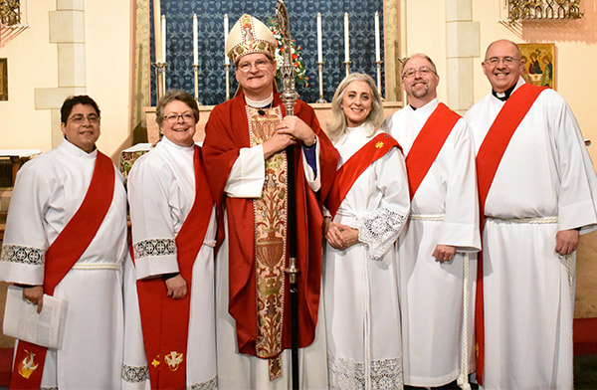**DIACONATE.** Once fallen into disuse as an inferior order (I’m going to believe this means “lower in rank” and not “inherently lesser”) used mainly as a stepping stone to the priesthood, the diaconate (order of deacons) has been restored in the Anglican, Roman Catholic, and several Protestant churches. In the Episcopal Church the diaconate is a full order equal to the presbyterate (priests) and the episcopate (bishops), and it plays an important role in many dioceses and congregations. As commonly used, the term refers to those ordained deacon as a permanent vocation. Those ordained deacon as a preliminary step toward ordination as a priest, as required by canon law, are called "transitional deacons." Many persons in the Episcopal Church question the theology and usefulness of the transitional diaconate, and want to restore direct ordination.

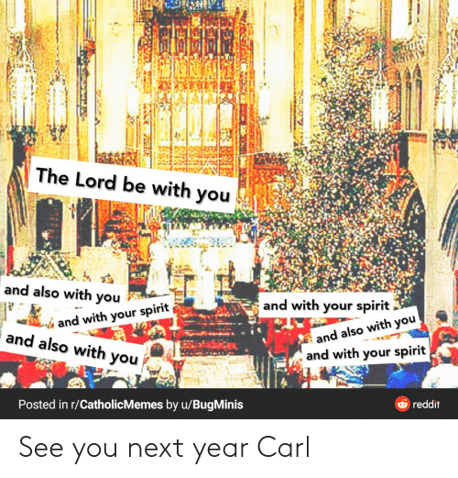**DIALOGUE.** In churchy stuff meaning, this refers to the practice of opening the eucharistic prayer with a “dialogue” between presider and people. It dates from the earliest church, as recorded in the Apostolic Tradition of Hippolytus in about the year 215. The dialogue consists of three exchanges and their agreement and consent in exchange: The salutation, "The Lord be with you," (“And also with you” – Rite II / “And with thy spirit” – Rite I), the command “Lift up your hearts” (“We lift them unto the Lord”) and the request “Let us give thanks to the Lord our God.” (“It is right to give our thanks and praise – Rite II / “It is meet and right so to do” – Rite I). Anglican Prayer Books from 1552 until recent revisions omitted the salutation, but don’t ask me why, because I haven’t a clue.

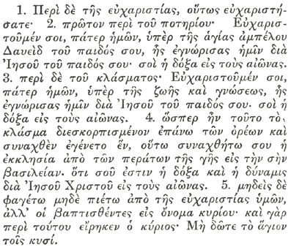**DIDACHE, The.** This document, also known as The Teaching of the Twelve Apostles, and sometimes called The Teaching of the Lord to the Heathen by the Twelve Apostles, dates from the early second century. Its author, date, and place of writing are unknown. "Didache" is Greek for "teaching." The document, an early church order, is essentially a manual of instruction for the early Christian community. The first part provides moral instruction for adherents of the faith and for catechumens. It describes the "Two Ways," the "Way of Life" and the "Way of Death." The second part is a manual of instructions about baptism, the eucharist, fasting, and prayer. Baptism is to be by immersion. Baptism can be done by threefold affusion if immersion is impossible. This is the first reference to baptism other than by immersion. See Church Orders.

|  |  |  |  |  |  |  |
| --- | --- | --- | --- | --- | --- | --- |
| **JUNE 2021** | | | | | | |
| **SUN** | **MON** | **TUE** | **WED** | **THU** | **FRI** | **SAT** |
|  |  | 1 | 2 | 3 | 4 | 5  10 AM--noon  Food Pantry |
| 6  9:30 AM in church  7:00 PM Online | 7 | 8 | 9 | 10  Coffee/Convo  8:30 am WebEx | 11 | 12  10 AM--noon  Food Pantry |
| 13  9:30 AM in church  7:00 PM Online | 14 | 15  B.C. Meeting  7:00 PM  via WebEx | 16 | 17  Coffee/Convo  8:30 am WebEx | 18 | 19  10 AM--noon  Food Pantry |
| 20  9:30 AM in church  7:00 PM Online | 21 | 22  Book Club  7:30 PM | 23 | 24  Coffee/Convo  8:30 am WebEx | 25 | 26  10 AM--noon  Food Pantry |
| 27  9:30 AM in church  7:00 PM Online | 28 | 29 | 30 |  |  |  |

. **June Birthdays June Anniversaries**

June 05 Jeremy Harvey June 03 Jim and Angie Pinder

June 12 Johnna Bradfield, Keiran Groble June 12 Ed and Judi Dura

June 17 Angie Pinder June 26 Michael Groble and Lisa Earley

June 28 Grace Henecker

June 30 Lucy Reed

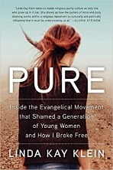**IN OUR** **PARISH LIFE:**

**BISHOP’S COMMITTEE MEETING** will be held on **Tuesday 15 June** at **7:00 PM** via WebEx.

**BOOK DISCUSSION GROUP** will meet on **Tuesday 22 June at 7:30 PM** to discuss  *Pure: Inside the Evangelical Movement*… by Linda Kay Klein   If you need an invitation to attend the Zoom meeting, please contact Lisa Earley at [lisa.earley@groble.me](mailto:lisa.earley@groble.me)

**BIG TABLE:** Big Table continues to provide food on **Tuesdays from 5:00 – 6:00 PM**. You do not have to register ahead of time, just show up!

**SHAWL MINISTRY UPDATE:** Please join our hearty group of yarn warriors! We knit, crochet and tie together prayer shawls and hats to be given away to people in need of comfort all over the world. Our next in-person meet-

ing will be Wednesday 9 June at 1:00pm in Lincoln Hall.



***A Note of Appreciation from the Diaper Bank***

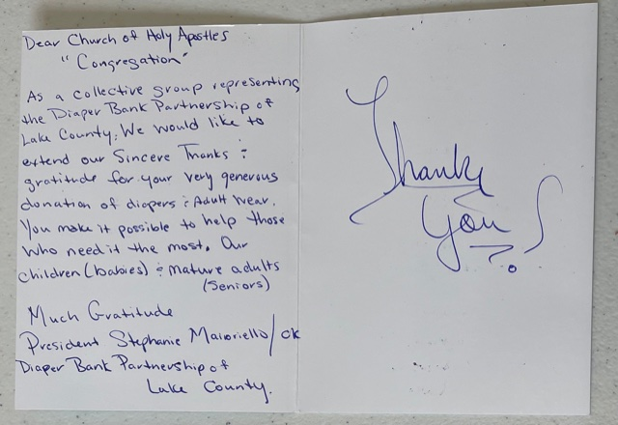

**FROM: Church of the Holy Apostles**

**26238 North Highway 59**

**Wauconda, Illinois 60084**