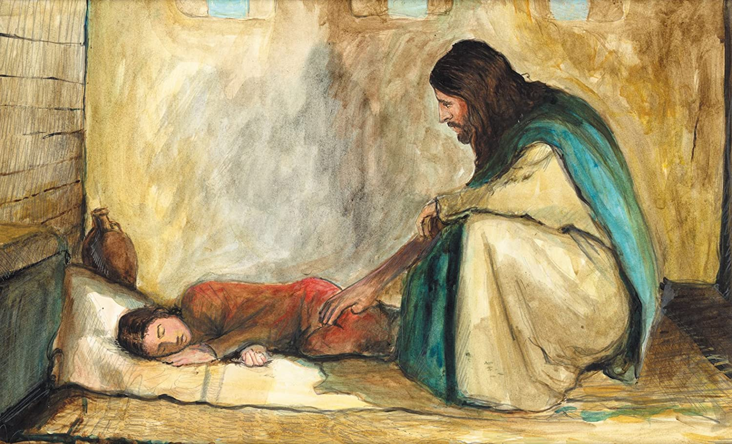

**Fifth Sunday after Pentecost**

**Proper 8 (B)**

**Sunday 27 June 2021**

**Episcopal Church of the Holy Apostles**

26238 N HWY 59, Wauconda, IL 60084

*www.holyapostleswauconda.net*

**You are encouraged to look at pictures and videos if presented.**

**They tell the story in a different way than the words in front of you.**

**But the words are important too;**

**feel free to take your bulletins with you, or access them on our website.**

**OPENING VOLUNTARY**

**WORDS OF WELCOME**

**OPENING HYMN** ***(Verses 1 and 4)***

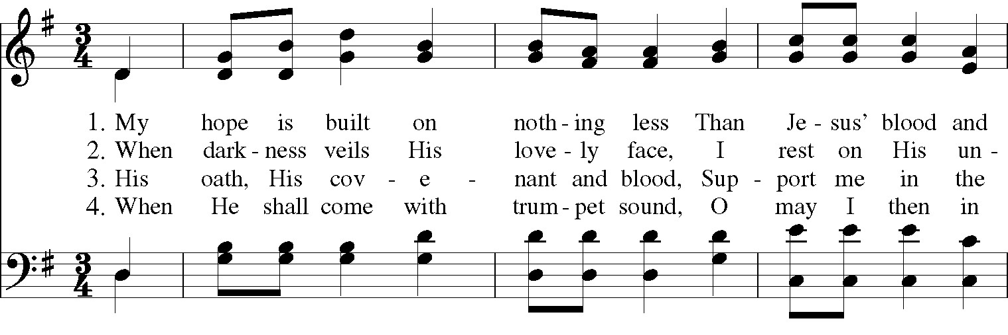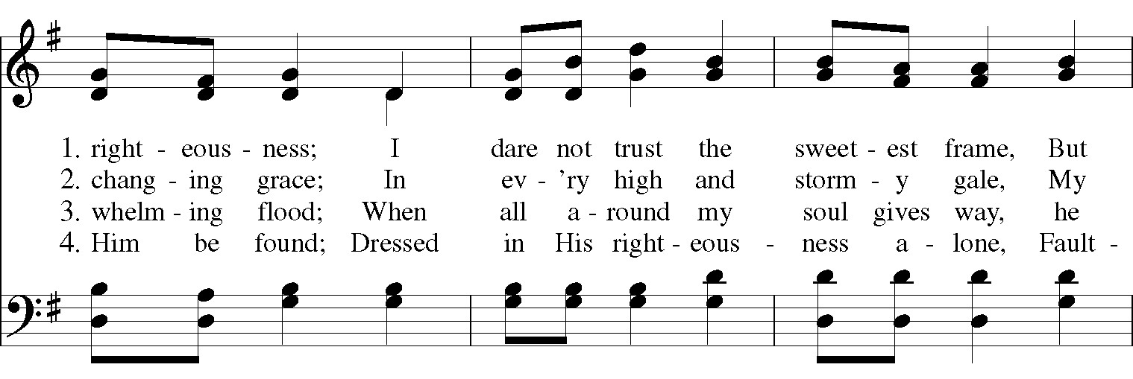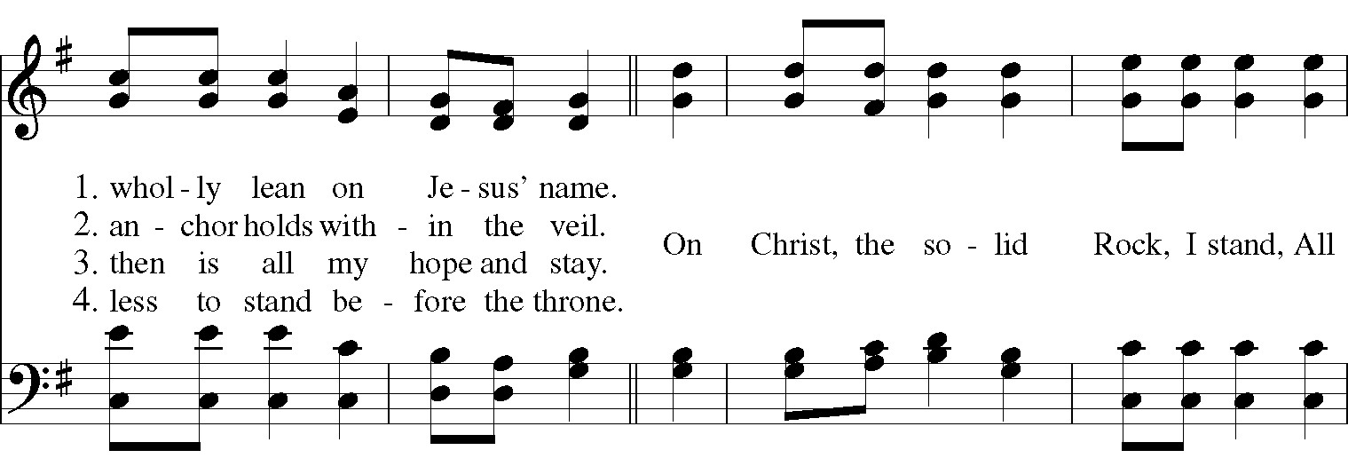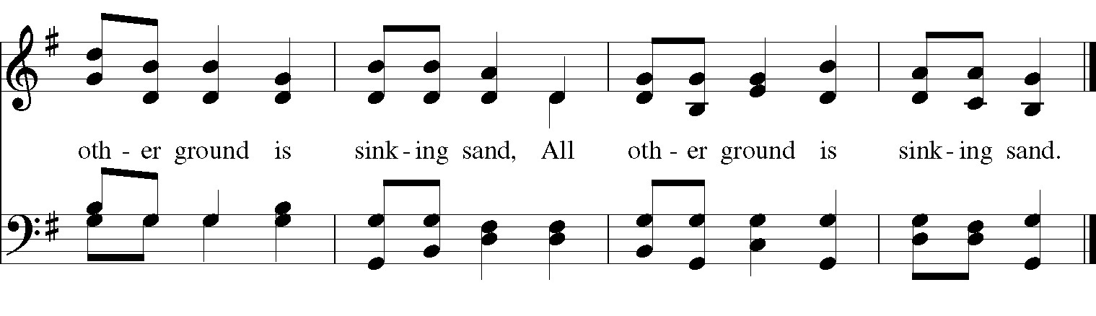

**OPENING SENTENCE**

**Presider:** Blessed be God: Holy Immortal One, Incarnate Word, and Breath of Life.

***People: And blessed be God’s kingdom, now and forever. Amen.***

**COLLECT FOR PURITY**

**Presider:** Almighty God, to you all hearts are open, all desires known, and from you no secrets are hid: Cleanse the thoughts of our hearts by the inspiration of your Holy Spirit, that we may perfectly love you, and worthily magnify your holy Name; through Christ our Lord.

***People: Amen.***

**HYMN OF PRAISE *(Third Verse Lyrics at the End)***

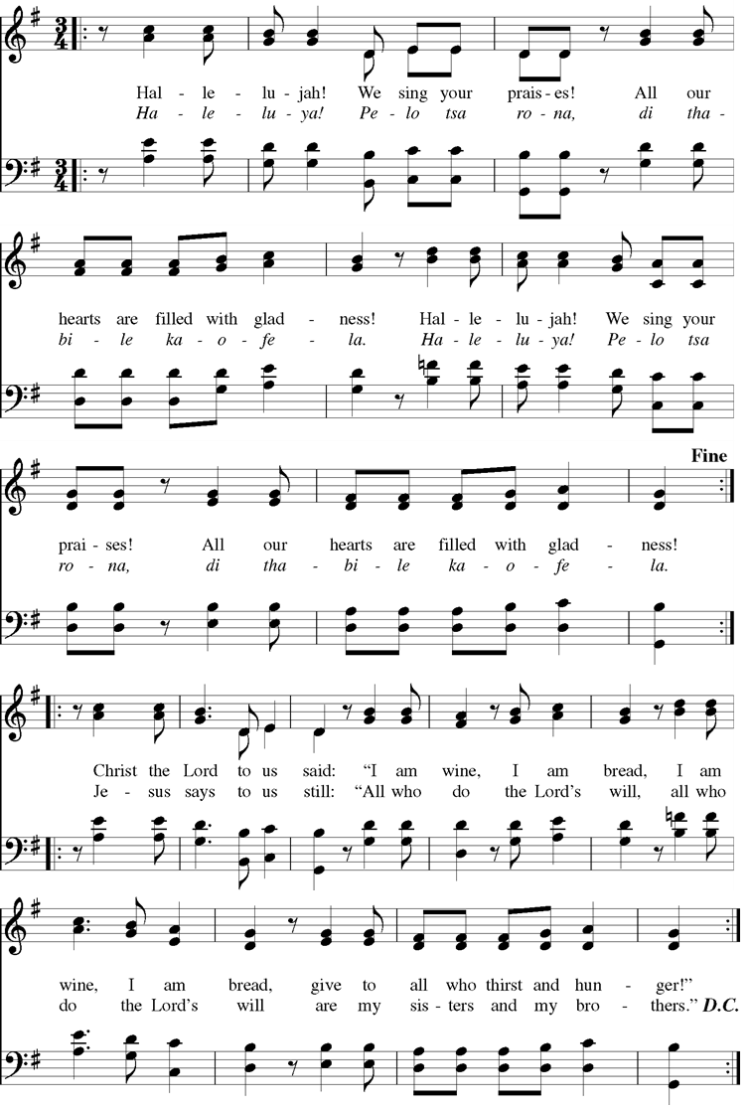

**THIRD VERSE:**

**Now he sends us all out, strong in faith, free of doubt;**

**strong in faith, free of doubt. Tell to all the joyful gospel**

**COLLECT OF THE DAY**

**Presider:** The Lord be with you.

***People: And also with you.***

**Presider:** Let us pray. God of inclusive love, who knows us each by name: we thank you for the woman, who stood out of the crowd and defied her uncleanness to connect with you; we praise you for the leader of the synagogue, who faced the mockery of others to give his daughter hope; may the flowing power of Christ bring healing and acceptance to the rejected and abused. Through Jesus Christ, giver of life.

**People: *Amen.***

*(We read from the various translations authorized by our Church. This month, we read from the New English Bible, 1970)*

**FIRST LESSON** 2 Samuel 1:1, 17-27

**Reader:**  A reading from 2nd Samuel. 1 After the death of Saul, when David had returned from defeating the Amalekites, he stayed at Ziklag for two days. 17Then David chanted this lament over Saul and his son Jonathan. 18(He gave instructions that the people of Judah should be taught “The Bow.” Indeed, it is written down in the Scroll of the Upright One.) 19“The beauty of Israel lies slain on your high places! How the mighty have fallen! 20Don’t report it in Gath,  
don’t spread the news in the streets of Ashkelon, or the daughters of the Philistines will rejoice,  
the daughters of the uncircumcised will celebrate! 21O mountains of Gilboa, may there be no dew or rain on you, nor fields of grain offerings! For it was there that the shield of warriors was defiled; the shield of Saul lies neglected without oil. 22From the blood of the slain, from the fat of warriors, the bow of Jonathan was not turned away. The sword of Saul never returned empty. 23Saul and Jonathan were greatly loved during their lives, and not even in their deaths were they separated. They were swifter than eagles, stronger than lions. 24O daughters of Israel, weep over Saul, who clothed you in scarlet as well as jewelry, who put gold jewelry on your clothes. 25How the warriors have fallen in the midst of battle! Jonathan lies slain on your high places! 26I grieve over you, my brother Jonathan. You were very dear to me. Your love was more special to me than the love of women. 27How the warriors have fallen! The weapons of war are destroyed! The Word of the Lord.

***People: Thanks be to God.***

**RESPONSE** *(Please say together in unison)* Psalm 130

***1From the deep water I cry out to you, O Lord.  
2O Lord, listen to me. Pay attention to my plea for mercy.  
3If you, O Lord, were to keep track of sins, O Lord, who could stand before you?   
4But you are willing to forgive, so that you might be honored.   
5I rely on the Lord. I rely on him with my whole being; I wait for his assuring word.   
6I yearn for the Lord, more than watchmen do for the morning, yes, more than watchmen do for the morning. 7O Israel, hope in the Lord, for the Lord exhibits loyal love, and is more than willing to deliver.   
8He will deliver Israel from all their sins.***

**SECOND READING** 2 Corinthians 8:7-15

**Reader:** A reading from the 2nd Letter to the Corinthians. 7As you excel in everything—in faith, in speech, in knowledge, and in all eagerness and in the love from us that is in you—make sure that you excel in this act of kindness too. 8I am not saying this as a command, but I am testing the genuineness of your love by comparison with the eagerness of others. 9For you know the grace of our Lord Jesus Christ, that although he was rich, he became poor for your sakes, so that you by his poverty could become rich. 10So here is my opinion on this matter: It is to your advantage, since you made a good start last year both in your giving and your desire to give, 11to finish what you started, so that just as you wanted to do it eagerly, you can also complete it according to your means. 12For if the eagerness is present, the gift itself is acceptable according to whatever one has, not according to what he does not have. 13For I do not say this so there would be relief for others and suffering for you, but as a matter of equality. 14At the present time, your abundance will meet their need, so that one day their abundance may also meet your need, and thus there may be equality, 15as it is written: “***The one who gathered*** ***much did not have too much, and the one who gathered little did not have too little***.” The Word of the Lord.

***People: Thanks be to God.***

**GOSPEL ACCLAMATION** ***(In-church service only)***



**GOSPEL** Mark 5:21-43

**Presider:** The Holy Gospel of our Lord Jesus Christ according to Mark.

***People: Glory to you, Lord Christ.***

**Presider:** 21When Jesus had crossed again in a boat to the other side, a large crowd gathered around him, and he was by the sea. 22Then one of the synagogue leaders, named Jairus, came up, and when he saw Jesus, he fell at his feet. 23He asked him urgently, “My little daughter is near death. Come and lay your hands on her so that she may be healed and live.” 24Jesus went with him, and a large crowd followed and pressed around him. 25Now a woman was there who had been suffering from a hemorrhage for twelve years. 26She had endured a great deal under the care of many doctors and had spent all that she had. Yet instead of getting better, she grew worse. 27When she heard about Jesus, she came up behind him in the crowd and touched his cloak, 28for she kept saying, “If only I touch his clothes, I will be healed.” 29At once the bleeding stopped, and she felt in her body that she was healed of her disease. 30Jesus knew at once that power had gone out from him. He turned around in the crowd and said, “Who touched my clothes?” 31His disciples said to him, “You see the crowd pressing against you and you say, ‘Who touched me?’” 32But] he looked around to see who had done it. 33Then the woman, with fear and trembling, knowing what had happened to her, came and fell down before him and told him the whole truth. 34He said to her, “Daughter, your faith has made you well. Go in peace, and be healed of your disease.” 35While he was still speaking, people came from the synagogue leader’s house saying, “Your daughter has died. Why trouble the teacher any longer?” 36But Jesus, paying no attention to what was said, told the synagogue leader, “Do not be afraid; just believe.” 37He did not let anyone follow him except Peter, James, and John, the brother of James. 38They came to the house of the synagogue leader where he saw noisy confusion and people weeping and wailing loudly. 39When he entered he said to them, “Why are you distressed and weeping? The child is not dead but asleep!” 40And they began making fun of him. But he forced them all outside, and he took the child’s father and mother and his own companions and went into the room where the child was.] 41Then, gently taking the child by the hand, he said to her, “*Talitha koum*,” which means, “Little girl, I say to you, get up.” 42The girl got up at once and began to walk around (she was twelve years old). They were completely astonished at this. 43He strictly ordered that no one should know about this, and told them to give her something to eat. The Gospel of the Lord.

***People: Praise to you, Lord Christ.***

**THE SERMON**

*(A brief period of silence follows the sermon)*

**THE NICENE CREED** *(Please say together in unison)*

***All: We believe in one God, the Father, the Almighty, maker of heaven and earth, of all that is, seen and unseen. We believe in one Lord, Jesus Christ, the only Son of God, eternally begotten of the Father, God from God, Light from Light, true God from true God, begotten, not made, of one Being with the Father. Through him all things were made. For us and for our salvation he came down from heaven: by the power of the Holy Spirit he became incarnate from the Virgin Mary, and was made man. For our sake he was crucified under Pontius Pilate; he suffered death and was buried. On the third day he rose again in accordance with the Scriptures; he ascended into heaven and is seated at the right hand of the Father. He will come again in glory to judge the living and the dead, and his kingdom will have no end. We believe in the Holy Spirit, the Lord, the giver of life, who proceeds from the Father and the Son. With the Father and the Son he is worshiped and glorified. He has spoken through the Prophets. We believe in one holy catholic and apostolic Church. We acknowledge one baptism for the forgiveness of sins. We look for the resurrection of the dead, and the life of the world to come. Amen.***

**PRAYERS OF THE PEOPLE** Personalized Form III

**Leader:** Gracious God, we pray for your holy catholic Church;

***People: That we all may be one.***

**Leader:** Grant that every member of the Church may truly and humbly serve you;

***People: That your Name may be glorified by all people.***

**Leader:** We pray for all bishops, priests, and deacons;

***People: That they may be faithful ministers of your Word and Sacraments.***

**Leader:** We pray for all who govern and hold authority in the nations of the world;

***People: That there may be justice and peace on the earth.***

**Leader:** Give us grace to do your will in all that we undertake;

***People: That our works may find favor in your sight.***

**Leader:** Have compassion on those who suffer from any grief or trouble;

***People: That they may be delivered from their distress.***

**Leader:** We pray for our beloved departed, and those whose names we raise up now either silently or aloud (*we will keep a 10-second silence*): _____. We pray for those who have been killed in the course of service to others. Give to the departed eternal rest.

***People: Let light perpetual shine upon them.***

**Leader:** We praise you for your saints who have entered into joy;

***People: May we also come to share in your heavenly kingdom.***

**Leader:** We pray for those on our parish prayer list, and those whose names we raise up now, either silently or aloud (*we will keep a 10-second silence*): _____. Let us pray also for our own needs (*we will keep a 10-second silence*).

***People: Strengthen our faith, that we might be a source of strength to others.***

**Leader:** We give thanks for those celebrating birthdays and anniversaries this week, especially those whose names we raise up now, either silently or aloud (*we will keep a 10-second silence*): _____. We offer our prayers of joy and thanksgiving for all those good gifts we have been given.

***People: Thank you, Lord, for the blessings of our lives.***

*(The Presider will add this or another concluding Collect)* Almighty and eternal God, ruler of all things in heaven and earth: Mercifully accept the prayers of your people, and strengthen us to do your will; through Jesus Christ our Lord.

***People: Amen.***

**CONFESSION AND ABSOLUTION**

**Presider:** Let us confess our sins against God and our neighbor.

***All: Most merciful God, we confess that we have sinned against you in thought, word, and deed, by what we have done, and by what we have left undone. We have not loved you with our whole heart; we have not loved our neighbours as ourselves. We are truly sorry and we humbly repent. For the sake of your Son Jesus Christ, have mercy on us and forgive us; that we may delight in your will, and walk in your ways, to the glory of your Name. Amen.***

**Presider:** Almighty God have mercy on you, forgive you all your sins through our Lord Jesus Christ, strengthen you in all goodness, and by the power of the Holy Spirit keep you in eternal life.

***People: Amen.***

**THE PEACE** *(Please greet each other in the name of the Lord)*

**Presider:** The Peace of the Lord be always with you.

***People: And also with you.***

**OFFERTORY SENTENCE**

*(The Presider gives an Offertory Sentence or says)* Walk in love, as Christ loved us and gave himself for us, an offering and sacrifice to God.

*(Please follow the Presider’s instructions for Communion)*

**GREAT THANKSGIVING** EOW-1

**Presider:** The Lord be with you.

***People: And also with you.***

**Presider:** Lift up your hearts.

***People: We lift them to the Lord.***

**Presider:** Let us give thanks to the Lord our God.

***People: It is right to give our thanks and praise.***

**Presider:** It is truly right, and good and joyful, to give you thanks, all-holy God, source of life and fountain of mercy. You have filled us and all creation with your blessing and fed us with your constant love; you have redeemed us in Jesus Christ and knit us into one body. Through your Spirit you replenish us and call us to fullness of life. Therefore, joining with Angels and Archangels and with the faithful of every generation, we lift our voices with all creation as we say:

**SANCTUS**

***Holy, holy, holy Lord, God of power and might, heaven and earth are full of your glory. Hosanna in the highest. Blessed is he who comes in the name of the Lord. Hosanna in the highest.***

**Presider:** Blessed are you, gracious God, creator of the universe and giver of life. You formed us in your own image and called us to dwell in your infinite love. You gave the world into our care that we might be your faithful stewards and show forth your bountiful grace.

But we failed to honor your image in one another and in ourselves; we would not see your goodness in the world around us; and so we violated your creation, abused one another, and rejected your love. Yet you never ceased to care for us, and prepared the way of salvation for all people.

Through Abraham and Sarah you called us into covenant with you. You delivered us from slavery, sustained us in the wilderness, and raised up prophets to renew your promise of salvation. Then, in the fullness of time, you sent your eternal Word, made mortal flesh in Jesus. Born into the human family, and dwelling among us, he revealed your glory. Giving himself freely to death on the cross, he triumphed over evil, opening the way of freedom and life.

**↑**On the night before he died for us, our savior Jesus Christ took bread, and when he had given thanks to you, he broke it, and gave it to his friends, and said: Take, eat. This is my Body, which is given for you. Do this for the remembrance of me.”

**↑**As supper was ending, Jesus took the cup of wine, and when he had given thanks, he gave it to them, and said: “Drink this, all of you. This is my blood of the New Covenant, which is poured out for you and for all for the forgiveness of sins. Whenever you drink it, do this for the remembrance of me.”

Therefore we proclaim the mystery of faith:

***All: Christ has died. Christ is risen. Christ will come again.***

**Presider:** Remembering his death and resurrection, we now present to you from your creation this bread and this wine. **∞** By your Holy Spirit may they be for us the body and blood of our savior Jesus Christ.

**+** Grant that we who share these gifts may be filled with the Holy Spirit and live as Christ’s Body in the world. Bring us into the everlasting heritage of your daughters and sons, that with all your saints, past, present, and yet to come, we may praise your Name for ever.

**↑**Through Christ and with Christ and in Christ, in the unity of the Holy Spirit, to you be honor, glory, and praise, for ever and ever. ***AMEN.***

**LORD’S PRAYER** *(Please say together in unison)*

**Presider:** As our Savior Christ has taught us, we now pray,

***Our Father in heaven, hallowed be your Name, your kingdom come, your will be done, on earth as in heaven. Give us today our daily bread. Forgive us our sins as we forgive those who sin against us. Save us from the time of trial, and deliver us from evil. For the kingdom, the power, and the glory are yours, now and for ever. Amen.***

**FRACTION (THE BREAKING OF THE BREAD)**

*(The Presider breaks the consecrated bread. A brief period of silence is kept.)*

**Presider:** This is the true bread which comes down from heaven and gives life to the world.

***People: Whoever eats this bread will live for ever.***

**↑Presider:** The Gifts of God for the People of God. Take them in remembrance that Christ died for you, and feed on him in your hearts by faith, with thanksgiving.

**POST-COMMUNION PRAYER**

**Presider:** Let us pray.

***All: Almighty and everliving God, we thank you for feeding us with the spiritual food of the most precious Body and Blood of your Son our Savior Jesus Christ; and for assuring us in these holy mysteries that we are living members of the Body of your Son, and heirs of your eternal kingdom. And now, Father, send us out to do the work you have given us to do, to love and serve you as faithful witnesses of Christ our Lord. To him, to you, and to the Holy Spirit, be honor and glory, now and for ever. Amen.***

**PARISH ANNOUNCEMENTS**

**BLESSING**

**Presider**: I bless you in the name of God. That the rich provisions of the Father who creates may be gratefully accepted and shared, I bless you. That the uncalculated love of the Son who redeems may be fully trusted and shared, I bless you.  That the undiluted fellowship of the Spirit who advocates may be enjoyed and shared, I bless you.

***People: Amen.***

**CLOSING HYMN *(Verses 1, 2, and 3)***

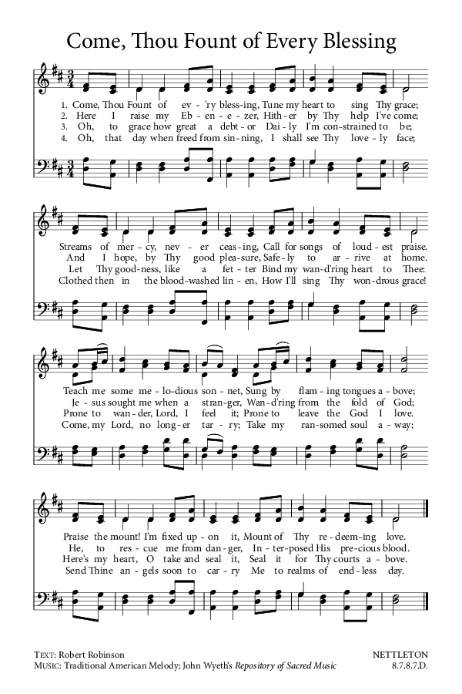

**DISMISSAL**

*(The Presider gives this or another dismissal)*

**Presider:** God, who created you in the divine image, sends you forth:

***People: We go, to reflect the presence of our Creator to everyone we meet.***

**Presider:** The Christ, who has redeemed you, has established the reign of God in our midst:

***People: We go, to bring healing to the broken of the world.***

**Presider:**  The Holy Spirit, who calls you to be God's people, goes with you on your way:

***People: We go, to tear down the walls that divide us, and to build lives of hope for all of God's children.***

***Alleluia! Amen.***

**Cover Image:** https://www.dreamstime.com/illustration/bean-germination.html

**Benediction:** adapted from Trinity Benediction by Bruce Prewer, accessed at: http://pilgrimwr.unitingchurch.org.au/?p=130

**Dismissal:** adapted from Trinity Commissioning by Thom Shuman accessed at: http://pilgrimwr.unitingchurch.org.au/?p=130