**Fourth Sunday after the Epiphany (C)**

**Sunday 30 January 2022**

**Episcopal Church of the Holy Apostles**

26238 N HWY 59, Wauconda, IL 60084

*www.holyapostleswauconda.net*

**PLEASE SILENCE YOUR MOBILE DEVICES**

***You are encouraged to look at pictures and videos if presented.***

***They tell the story in a different way than the words in front of you.***

***But the words are important too; feel free to take your bulletins with you.***

**OPENING VOLUNTARY** *(Please be seated)*

**WORDS OF WELCOME** *(Please remain seated)*

**OPENING HYMN** *(Please stand as able)*  H1982, #135

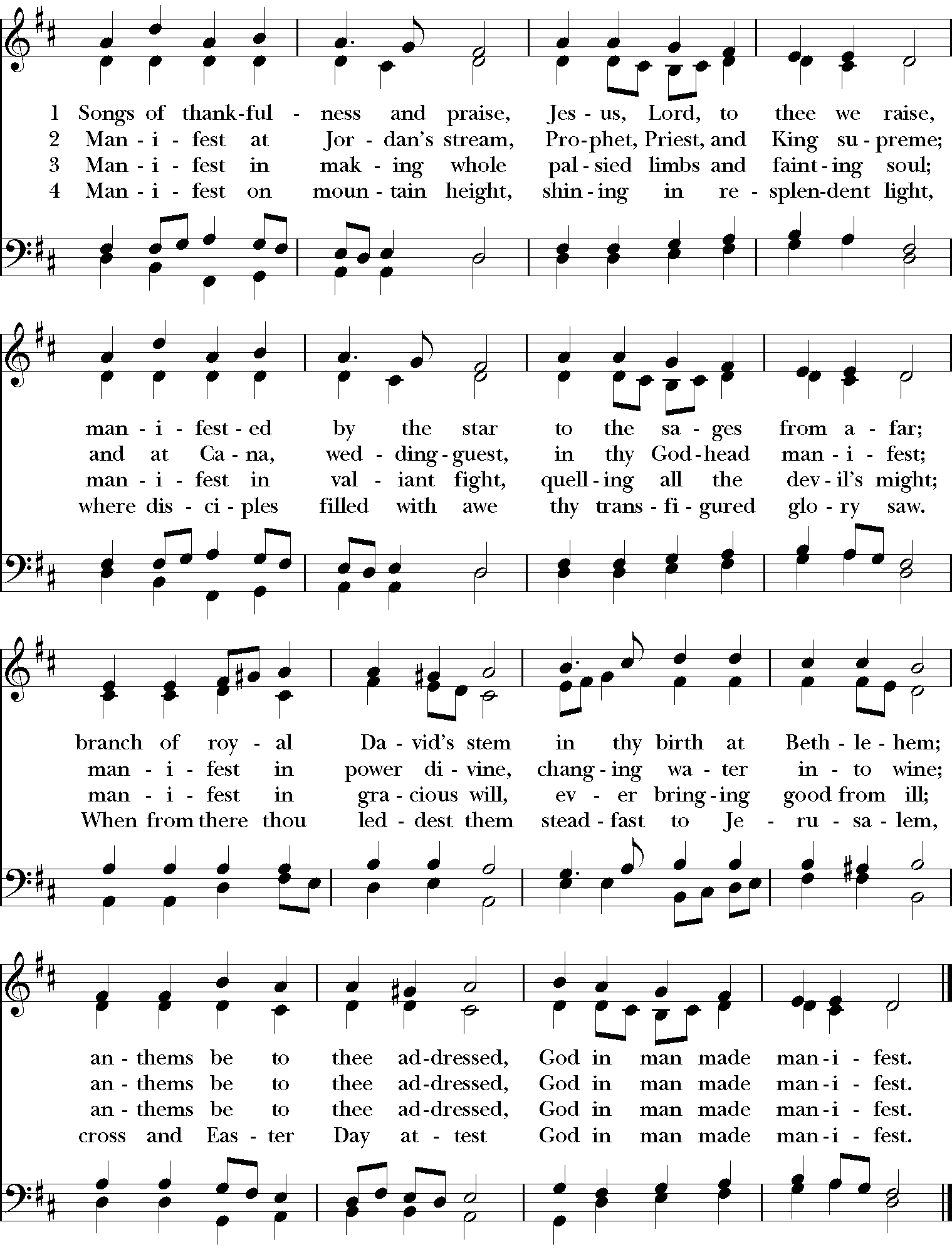

**OPENING SENTENCE** *(Please remain standing)*

**Presider:** Blessed be the One, Holy, Living, and Triune God.

***People : And blessed be God’s kingdom, now and for ever. Amen.***

**COLLECT FOR PURITY** *(Please remain standing)*

**Presider:** Almighty God, to you all hearts are open, all desires known, and from you no secrets are hid: Cleanse the thoughts of our hearts by the inspiration of your Holy Spirit, that we may perfectly love you, and worthily magnify your holy Name; through Christ our Lord.

***People: Amen.***

**HYMN OF PRAISE** *(Please remain standing)* H1982, #131

***All: When Christ’s appearing was made known, King Herod trembled for his throne;***

***but he who offers heavenly birth sought not the kingdoms of this earth.***

***The eastern sages saw from far and followed on his guiding star;***

***by light their way to Light they trod, and by their gifts confessed their God.***

***Within the Jordan’s sacred flood the heavenly Lamb in meekness stood,***

***that he, to whom no sin was known, might cleanse his people from their own.***

***O, what a miracle divine, when water reddened into wine!***

***He spoke the word, and forth it flowed in streams that nature ne’er bestowed.***

***All glory, Jesus, be to thee for this thy glad epiphany;***

***whom with the Father we adore and Holy Ghost for evermore.***

**COLLECT OF THE DAY** *(Please remain standing)*

**Presider:**  The Lord be with you.

***People: And also with you.***

**Presider:** Let us pray. Provoking God, calling us through the face of the Other: free our fickle hearts from our need to divide and exclude the foreign and the misfit; lead us through the storms of rage to a clear and new beginning; through Jesus Christ, whom hatred cannot touch.

***People: Amen.***

*(We read from the various biblical translations authorized by our church. This month, we read from The* *Good News Bible / Today's English Version, 1976)*

**FIRST LESSON** *(Please be seated)* Jeremiah 1:4-10

**Reader:** A reading from Jeremiah. 4 The Lord says, “People of Israel, if you want to turn, then turn back to me. If you are faithful to me and remove the idols I hate, 2it will be right for you to swear by my name. Then[[a](https://www.biblegateway.com/passage/?search=jeremiah+4&version=GNT#fen-GNT-22019a)] all the nations will ask me to bless them, and they will praise me.” 3The Lord says to the people of Judah and Jerusalem, “Plow up your unplowed fields; do not plant your seeds among thorns. 4Keep your covenant with me, your Lord, and dedicate yourselves to me, you people of Judah and Jerusalem. If you don't, my anger will burn like fire because of the evil things you have done. It will burn, and there will be no one to put it out.” 5Blow the trumpet throughout the land! Shout loud and clear! Tell the people of Judah and Jerusalem to run to the fortified cities. 6Point the way to Zion! Run for safety! Don't delay! The Lord is bringing disaster and great destruction from the north. 7Like a lion coming from its hiding place, a destroyer of nations has set out. He is coming to destroy Judah.  
The cities of Judah will be left in ruins, and no one will live in them. 8So put on sackcloth, and weep and wail because the fierce anger of the Lord has not turned away from Judah. 9The Lord said, “On that day kings and officials will lose their courage; priests will be shocked and prophets will be astonished.” 10Then I said, “Sovereign Lord, you have completely deceived the people of Jerusalem! You have said there would be peace, but a sword is at their throats.” The word of the Lord.

***People: Thanks be to God.***

**RESPONSE** *(Please remain seated and say together in unison)*  71:1-6

***71 Lord, I have come to you for protection; never let me be defeated!  
2Because you are righteous, help me and rescue me. Listen to me and save me!  
3Be my secure shelter and a strong fortress to protect me; you are my refuge and defense.***

***4My God, rescue me from wicked people, from the power of cruel and evil people.  
5Sovereign Lord, I put my hope in you; I have trusted in you since I was young.  
6I have relied on you all my life; you have protected me since the day I was born. I will always praise you.***

**SECOND LESSON** *(Please remain seated)* 1 Corinthians 13:1-13

**Reader:** A reading from 1st Corinthians. 13 I may be able to speak the languages of human beings and even of angels, but if I have no love, my speech is no more than a noisy gong or a clanging bell. 2I may have the gift of inspired preaching; I may have all knowledge and understand all secrets; I may have all the faith needed to move mountains—but if I have no love, I am nothing. 3I may give away everything I have, and even give up my body to be burned[[a](https://www.biblegateway.com/passage/?search=1+corinthians+13&version=GNT#fen-GNT-31700a)]—but if I have no love, this does me no good. 4Love is patient and kind; it is not jealous or conceited or proud; 5love is not ill-mannered or selfish or irritable; love does not keep a record of wrongs; 6love is not happy with evil, but is happy with the truth. 7Love never gives up; and its faith, hope, and patience never fail. 8Love is eternal. There are inspired messages, but they are temporary; there are gifts of speaking in strange tongues, but they will cease; there is knowledge, but it will pass. 9For our gifts of knowledge and of inspired messages are only partial; 10but when what is perfect comes, then what is partial will disappear. 11When I was a child, my speech, feelings, and thinking were all those of a child; now that I am an adult, I have no more use for childish ways. 12What we see now is like a dim image in a mirror; then we shall see face-to-face. What I know now is only partial; then it will be complete—as complete as God's knowledge of me. 13Meanwhile these three remain: faith, hope, and love; and the greatest of these is love. The word of the Lord.

***People: Thanks be to God.***

**GOSPEL** *(Please stand as able)* Luke 4:21-30

**Presider:** The Holy Gospel of our Lord Jesus Christ according to Luke.

***People: Glory to you, Lord Christ.***

**Presider:** 21Jesus said to the people in the synagogue at Nazareth, “This passage of scripture has come true today, as you heard it being read.” 22They were all well impressed with him and marveled at the eloquent words that he spoke. They said, “Isn't he the son of Joseph?” 23He said to them, “I am sure that you will quote this proverb to me, ‘Doctor, heal yourself.’ You will also tell me to do here in my hometown the same things you heard were done in Capernaum. 24I tell you this,” Jesus added, “prophets are never welcomed in their hometown. 25Listen to me: it is true that there were many widows in Israel during the time of Elijah, when there was no rain for three and a half years and a severe famine spread throughout the whole land. 26Yet Elijah was not sent to anyone in Israel, but only to a widow living in Zarephath in the territory of Sidon. 27And there were many people suffering from a dreaded skin disease who lived in Israel during the time of the prophet Elisha; yet not one of them was healed, but only Naaman the Syrian.” 28When the people in the synagogue heard this, they were filled with anger. 29They rose up, dragged Jesus out of town, and took him to the top of the hill on which their town was built. They meant to throw him over the cliff, 30but he walked through the middle of the crowd and went his way. The Gospel of the Lord.

***People: Praise to you, Lord Christ.***

**SERMON** *(Please be seated)* The Rev. M. C. Gillette

*(A brief period of silence follows the sermon)*

**NICENE CREED** *(Please stand as able and say together in unison)*

***All: We believe in one God, the Father, the Almighty, maker of heaven and earth, of all that is, seen and unseen. We believe in one Lord, Jesus Christ, the only Son of God, eternally begotten of the Father, God from God, Light from Light, true God from true God, begotten, not made, of one Being with the Father. Through him all things were made. For us and for our salvation he came down from heaven: by the power of the Holy Spirit he became incarnate from the Virgin Mary, and was made man. For our sake he was crucified under Pontius Pilate; he suffered death and was buried. On the third day he rose again in accordance with the Scriptures; he ascended into heaven and is seated at the right hand of the Father. He will come again in glory to judge the living and the dead, and his kingdom will have no end. We believe in the Holy Spirit, the Lord, the giver of life, who proceeds from the Father and the Son. With the Father and the Son he is worshiped and glorified. He has spoken through the Prophets. We believe in one holy catholic and apostolic Church. We acknowledge one baptism for the forgiveness of sins. We look for the resurrection of the dead, and the life of the world to come. Amen***

**PRAYERS OF THE PEOPLE** *(Please remain standing)*

**Leader:** Lord, in this season of Epiphany, we remember the journey of the Magi who sought the Christ child, the light of the star which guided them, and their response to finding Jesus, the newborn king.

***People: Lord, let us seek you, follow your light, and worship you as they did long ago.***

**Leader:** We thank you for manifesting yourself to all people and for opening the doors of your church to both Jews and Gentiles.

***People: Reveal yourself, we pray, to all who long to find you, and grant them the joy of knowing you.***

**Leader:** We pray for your church around the world, that you might dwell among us, unite us, and transform us. We pray especially for those on our Episcopal and Diocesan cycles of prayer.

***People: Make your church a light to the nations, shining forth with mercy, power, and love.***

**Leader:** We pray for the leaders of our local, state, and national governments, and for all who hold power and authority in the world.

***People: Please guide their feet along the pathways of justice, compassion, reconciliation, and peace.***

**Leader:** We pray for all who suffer in body, mind, or spirit, and for those who are in any kind of trouble or sorrow, remembering especially those whose names we raise up now, either silently or aloud: (*we will keep a 10-second silence*).

***People: Manifest yourself to them, merciful God. Grant them your gifts of healing, grace, wisdom, and comfort.***

**Leader:** We pray for those who have died. In particular, we pray for our beloved departed, for those who have been killed in the course of service to others or at the hands of the unscrupulous, and for those whose names we raise up now, either silently or aloud: (*we will keep a 10-second silence*).

***People: May they live eternally with you in Paradise.***

**Leader:** We thank you for the joy which fills our hearts, and for those celebrating birthdays and anniversaries this week, in particular those whose names we raise up now, either silently or aloud: (*we will keep a 10-second silence*).

***People: In your mercy, bless us, and make us a source of blessing to others as we share our joy with them.***

**Presider:** *(Says this or another Collect)* May your radiance shine upon us all as brightly today as the star shown upon those of another age so long ago: and grant us all a desire to seek and to serve; graciously accepting your gift of grace, and striving always to return through the love and kindness we show to our neighbors some small portion of that loving-kindness you have given us; through Jesus Christ our Lord.

***People: Amen***

**CONFESSION OF SIN** *(Please kneel or reverently bow as able)*

**Presider:** Because God is merciful, God offers us salvation through the water of rebirth and the renewing power of the Holy Spirit. But through sin we fall away from our baptismal promises. Let us repent and renew our faith by confessing our sin. *(A brief period of silence will be kept)*

***All: Manifest God, we've heard the message that heaven is open, but often we're just too anxious to notice. We crouch and hide, afraid to lift up our eyes and see the radiance around us. We stumble in the shadows of our fear; we close the shutters and draw tight the curtains to block our vision. We refuse to discern the light within ourselves, or the light within each other. We are dull and tarnished, our small flames sputtering and untended. Feeling cold and dim, we clench our teeth and fists, overwhelmed by many things. We yearn for the world to be a better place, but the news given to us from the earthly kingdoms is bad, and we shut our eyes to avoid having to see, shut our ears to avoid having to listen. Through the din of the world's clamor, we hear snatches of the angels' song, and catch glimpses of your Holy presence, filtering through the chaos in stories of hope and courage, justice and service. And yet, the cries of anger and greed, of hunger and need distract us from focusing on your Good News. O Holy God, you have revealed yourself to us and have handed us an invitation to find heaven open here and now. You have known us and loved us since the beginning, and you are here to welcome us home. Open our eyes so we might see clearly that the shutters we had closed and locked have been flung open, and the curtains we had pulled shut are now blowing on the breath of heaven. Open our ears so we might hear clearly your word and will for us. Open our hearts so we might be refreshed, revitalized, restored, and renewed. Open our minds so we might remember that although we are the people who have walked in darkness, we have now seen the light.***

**Presider:** Our God *has* known us and loved us from the beginning. Our God is gracious and merciful. Offering our contrite hearts and desiring amendment of life, we are forgiven.

***People: Thanks be to God!***

**THE PEACE** *(Please stand as able)*

**Presider:** We are the body of Christ. In the one Spirit we were all baptized into one body.

***People: Let us then pursue all that makes for peace and builds up our common life.***

*(Please greet each other in the name of the Lord.)*

*(The Presider gives an Offertory Sentence or says:)* Open the heavens, Holy Spirit, for us to see Jesus interceding for us; may we be willing to share his baptism, ready to share his cup, and strengthened to serve him for ever.

***People: Amen.***

**THE GREAT THANKSGIVING** *(Please remain standing)*Rite II, Prayer B

**Presider:** The Lord be with you.

***People: And also with you.***

**Presider:** Lift up your hearts.

***People: We lift them to the Lord.***

**Presider:** Let us give thanks to the Lord our God.

***People: It is right to give God thanks and praise.***

**Presider:** It is right, and a good and joyful thing, always and everywhere to give thanks to you, Father Almighty, Creator of heaven and earth. Because in the mystery of the Word made flesh, you have caused a new light to shine in our hearts, to give the knowledge of your glory in the face of your Son Jesus Christ our Lord. And so we join our voices with angels and archangels and with all the company of heaven to proclaim your glory, forever praising you and saying:

**SANCTUS** *(Please remain standing and say together)*

***All: Holy, holy, holy Lord, God of power and might, heaven and earth are full of your glory. Hosanna in the highest. Blessed is he who comes in the name of the Lord. Hosanna in the highest.***

**Presider:** We give thanks to you, O God, for the goodness and love which you have made known to us in creation; in the calling of Israel to be your people; in your Word spoken through the prophets; and above all in the Word made flesh, Jesus, your Son. For in these last days you sent him to be incarnate from the Virgin Mary, to be the Savior and Redeemer of the world. In him, you have delivered us from evil, and made us worthy to stand before you. In him, you have brought us out of error into truth, out of sin into righteousness, out of death into life.

**↑**On the night before he died for us, our Lord Jesus Christ took bread; and when he had given thanks to you, he broke it, and gave it to his disciples, and said, “Take, eat: This is my Body, which is given for you. Do this for the remembrance of me.”

**↑**After supper he took the cup of wine; and when he had given thanks, he gave it to them, and said, “Drink this, all of you: This is my Blood of the new Covenant, which is shed for you and for many for the forgiveness of sins. Whenever you drink it, do this for the remembrance of me.”

Therefore, according to his command, O Father,

***All: We remember his death, We proclaim his resurrection, We await his coming in glory;***

**Presider:** And we offer our sacrifice of praise and thanksgiving to you, O Lord of all; presenting to you, from your creation, this bread and this wine.

**∞** We pray you, gracious God, to send your Holy Spirit upon these gifts that they may be the sacrament of the Body of Christ and his Blood of the new Covenant. **+** Unite us to your Son in his sacrifice, that we may be acceptable through him, being sanctified by the Holy Spirit. In the fullness of time, put all things in subjection under your Christ, and bring us to that heavenly country where, with all your saints, we may enter the everlasting heritage of your sons and daughters; through Jesus Christ our Lord, the firstborn of all creation, the head of the Church, and the author of our salvation.

**↑**By him, and with him, and in him, in the unity of the Holy Spirit all honor and glory is yours, Almighty Father, now and for ever. ***AMEN.***

**THE LORD’S PRAYER:** *(Please remain standing, or kneeling)*

**Presider:** As our Savior Christ has taught us, we now pray,

***All: Our Father in heaven, hallowed be your Name, your kingdom come, your will be done, on earth as in heaven. Give us today our daily bread. Forgive us our sins as we forgive those who sin against us. Save us from the time of trial, and deliver us from evil. For the kingdom, the power, and the glory are yours, now and for ever. Amen.***

**THE FRACTION (THE BREAKING OF THE BREAD)** *(Please remain standing, or kneeling)*

*(The Presider breaks the consecrated bread. A brief period of silence is kept.)*

**Presider:** Alleluia. Christ our Passover is sacrificed for us;

***People: Therefore let us keep the feast. Alleluia.***

**Presider:** **↑**The gifts of God for the People of God. Take them in remembrance that Christ died for you, and feed on him in your hearts by faith, with thanksgiving.

*(Please follow the Presider’s instructions for Communion)*

**POST COMMUNION PRAYER** *(You may be seated)*

**Presider:** Eternal God, comfort of the afflicted and healer of the broken, you have fed us at the table of life and hope: teach us the ways of gentleness and peace, that all the world may acknowledge the kingdom of your Son, Jesus Christ our Lord.

***People: Amen.***

**BLESSING** *(Please stand as able)*

**Presider:** *(The Presider gives this or another blessing)* May the path that Christ walks to bring justice upon the earth, to bring light to those who sit in darkness, to bring out those who live in bondage, to bring new things to all creation: may this path run through our life. May we be the road Christ takes.

***People: Amen.***

**CLOSING HYMN**  *(Please remain standing)* H1982, #448



**DISMISSAL *(Please remain standing)***

**Presider:** *(The Presider gives this or another dismissal)* The curtain of heaven has parted; Jesus our savior reveals the kingdom of heaven around us. Opportunities abound to be subversive doing God's work. Go forth, knowing Christ is with you.

***People: Amen! We will go!***

**CLOSING VOLUNTARY**

**Cover Image:**

http://lavistachurchofchrist.org/Pictures/The%20Children%27s%20Friend%20(Part%202)/target18.html**Hymn of Praise:** Based on Prayer of Intercession for Epiphany, posted on the website of Churches Together in Britain and Ireland.

<http://www.ctbi.org.uk/HB/401>

**Collect of the Day:** Posted on the Church of Scotland’s Starters for Sundaywebsite.

<http://www.churchofscotland.org.uk/__data/assets/pdf_file/0005/18473/12_January_2014.pdf>

**Prayers of the People:** Adapted from Prayers of the People for Epiphany, Rick Morley, posted on A Garden Path. <http://www.rickmorley.com/>

**Blessing:** Jan L. Richardson, posted on The Painted Prayerbook.<http://paintedprayerbook.com/>