**The Apostles Post**

26238 North Highway 59

Wauconda, Illinois

AUGUST 2019

2015



**FROM THE VICAR’S DESK** *(M. C. Gillette)*

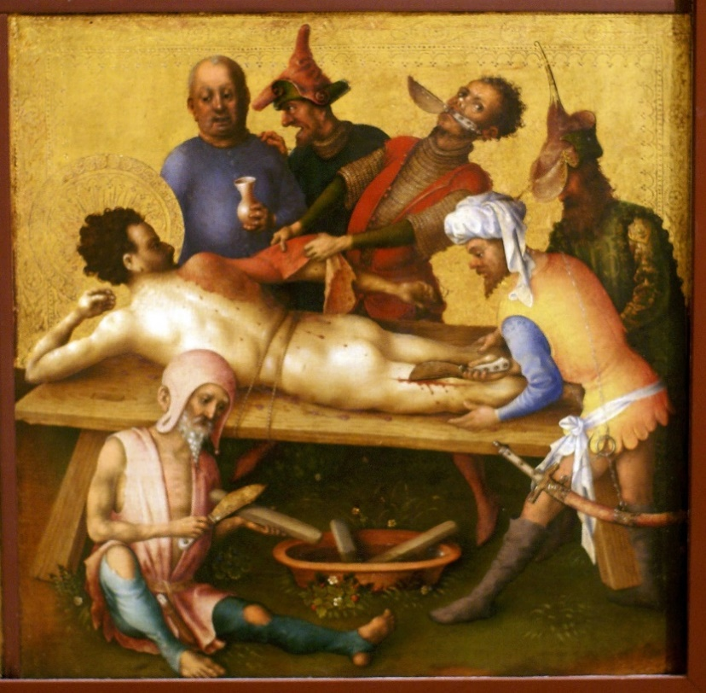 Issue VII in our “B-list” Holy Week series. Saint Bartholomew! His day is 24 August (in our reckoning – the Coptic Church honors him on the 1st day of the month of Thout, which these days is 11 September; the Eastern Church on 11 June). The readings assigned are: Deuteronomy 18:15-18 / Psalm 91 / 1 Corinthians 4:9-15 / Luke 22:24-30.

So, August also brings us the Feast of Saint Mary the Virgin – aka Jesus’ mom – and I suppose out of respect I should have chosen her, especially since last month I highlighted Saint Mary Magdalene. But the Virgin Mary was assumed (taken bodily into heaven after she died a gentle, natural death) and poor Bartholomew was flayed alive and crucified head down by Prince Astyages of Armenia (for converting his brother, King Polymius). And as I am at my core a sympathetic person, it seems fitting that we might therefore pay just a little attention to him (although I must admit that in artistic renderings he generally seems remarkably sanguine (pun!) about his fate, except maybe on the ceiling of the Sistine Chapel, where he seems pretty unhappy to be holding his own skin.)

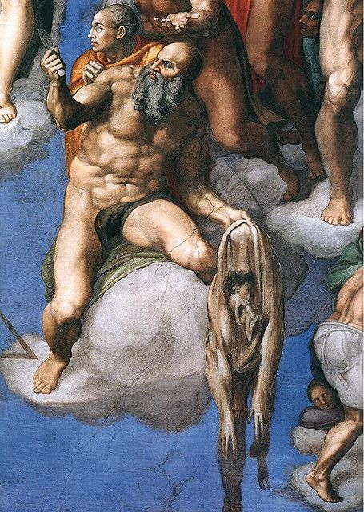 But anyway, on with it, remembering that when I say “he was” I mean “tradition says.” Bartholomew is listed (in Matthew, Mark, Luke, and Acts) as one of the twelve apostles. His name comes from the Aramaic – bar-Tolmay (or Talmai). There is a good chance, then, that “Bartholomew” was not his given name, but a family name.

The New Advent Encyclopedia notes that many scholars suggest Bartholomew is the same individual as Nathaniel (introduced in John 1:45-51 as a friend of Philip’s “from Cana of Galilee,” famous for his initial skepticism that Jesus was anybody worth meeting – “can anything good come out of Nazareth?”). One reason for this is mentioned above, that there is good reason to believe Bartholomew was not his proper name but his family name (so, for example, he might have been Nathaniel Bartholomew). Other reasons include the fact that the name Bartholomew never occurs in the Fourth Gospel (John), while Nathaniel is not mentioned in the synoptics (Matthew, Mark, and Luke); that Bartholomew's name is coupled with Philip's in the lists of Matthew and Luke, and found next to it in Mark, which agrees well with the fact shown by the author of the Fourth Gospel that Philip was an old friend of Nathaniel's and brought him to Jesus; that the call of Nathaniel, mentioned with the call of several Apostles, seems to mark him for the apostolate, especially since the rather full and beautiful narrative leads one to expect some important development; that Nathaniel was of Galilee where Jesus found most, if not all, of the Twelve; finally, that when Jesus showed up on the shore of the Sea of Tiberias after his resurrection, Nathaniel was there and so, presumably, was one of the Twelve. This chain of circumstantial evidence is ingenious and pretty strong; the weak link is that, after all, Nathaniel may have been another person in whom, for some reason, the author of the Fourth Gospel may have been particularly interested, as he was in Nicodemus, who is likewise not named in the synoptics. Thus, some scholars are content to simply recognize that the Gospels do not agree about the names of the disciples, and that Nathaniel and Bartholomew might well have been different people.

The 4th-century Bishop Eusebius of Caesarea in his Ecclesiastical History relates that, when the 2nd-century teacher St. Pantaenus of Alexandria made a visit to India, he found a Hebrew copy of The Gospel According to Matthew, which had been left behind there by Bartholomew. Traditionally, Bartholomew also served as a missionary to Ethiopia, Mesopotamia, Parthia (in modern Iran), Lycaonia (in modern Turkey), and Armenia where, as mentioned above, he met with his rather unfortunate end.

Bartholomew is the Patron Saint of Armenia and, in one of those ironic twists, butchers, tanners, and leather workers – basically anyone who pulls skin off things – along with farmers, housepainters, bookbinders, plasterers, and tailors.

|  |  |  |  |  |  |
| --- | --- | --- | --- | --- | --- |
| **EPISCOPAL CHURCH OF THE HOLY APOSTLES UPCOMING SERVICES – AUGUST 2019** | | | | | |
| Sunday 04 August  8:00 & 10:30 a.m. | Sunday 11 August  8:00 & 10:30 a.m. | Sunday 18 August  8:00 & 10:30 a.m. | Sunday 18  August  11:00 a.m.  -  2:00 p.m. | Sunday 25 August  8:00 & 10:30 a.m. | Friday 31  August  7:00 p.m. |
| Scheduled  Presider: Gillette  Scheduled  Preacher: Gillette | Scheduled  Presider: Barron  Scheduled  Preacher: Barron | Scheduled  Presider: Gillette  Scheduled  Preacher: Gillette | W  I  L  M  A  P  I  C  N  I  C  A  T  F  E  D  E  R  A  T  E  D  SPECIAL  KOREAN  DANCE  PROGRAM AT 1:00PM | Scheduled  Presider: Gillette  Scheduled  Preacher: Gillette | T  A  I  Z  E  S  E  R  V  I  C  E |
| 8th Sunday after  Pentecost  Proper 13(C) | 9th Sunday after  Pentecost  Proper 14(C) | 10th Sunday after Pentecost  Proper 15(C) | 11th Sunday after  Pentecost  Proper 16(C) |
| FIRST  LESSON  Hosea 11:1-11  RESPONSE  Psalm  107:1-9, 43  SECOND  LESSON  Colossians  3:1-11  GOSPEL  Luke  12:13-21 | FIRST  LESSON  Isaiah 1:1, 10-20  RESPONSE  Psalm  50:1-8  SECOND  LESSON  Hebrews  11:1-3, 8-16  GOSPEL  Luke  12:32-40 | FIRST  LESSON  Isaiah 5:1-7  RESPONSE  Psalm  80:1-2, 8-18  SECOND  LESSON  Hebrews  11:29-12:2  GOSPEL  Luke  12:49-56 | FIRST  LESSON  Jeremiah 14:4-10  RESPONSE  Psalm  71:1-6  SECOND  LESSON  Hebrews  12:18-29  GOSPEL  Luke  13:10-17 |

**HERE AND THERE** *(M. C. Gillette at* [*hapostles@sbcglobal.net*](mailto:hapostles@sbcglobal.net)*)*

*In this on-going article, we pull things from our various Diocesan calendars and church websites to see what’s going on around us. For more information about what's happening at the Diocesan Headquarters and the Cathedral of Saint James, you can always visit their websites:* <https://www.episcopalchicago.org> or <https://www.saintjamescathedral.org/>

**Bishop Search Listening Sessions in August: Search & Nomination Committee seeks input**

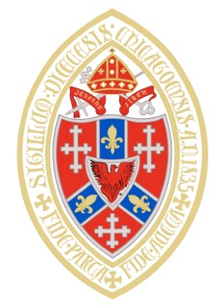The **Bishop Search & Nomination Committee** is inviting all laypeople and clergy in the diocese to attend a bishop search listening session in August. Input received at the sessions will guide the committee as it writes the diocesan profile, a detailed description of the diocese that helps applicants learn more about the Diocese of Chicago and its people.

The listening sessions, which will take place across the diocese, will focus on how attendees see God at work in the diocese, what challenges the people of the diocese are facing together, and what the diocese seeks in its next bishop.

[**Listening sessions**](https://chicagobishopsearch.org/listening-sessions) (<https://chicagobishopsearch.org/listening-sessions>) will take place:

August 3, 10 to 11:30 am at [**St. Gregory's, Deerfield**](http://r20.rs6.net/tn.jsp?f=001gCvNKifiRK9w5WKLztLb8IXIegWbvzr2a1V_kopNnBeqgrc8zNCFmj3W6DrHnMoVGFLrRdDzHQpdfdWAESI-_G2EEjnLfXvmOTYvYmYwIdHglFoe458_1yKFq_XqhzeNsIECVqqJlzc5rARBssrrMmBtUnmrpX-AKcdB7SItM-o=&c=x_ljb88HslAXqeKPzr0yuzUKVBqGLbuByeOVObjwzJ0TvGFtUWLeZQ==&ch=i4XipJ36ufGOanBD_vKcQu40he7KaebNINdaE0GfmkrTMDX_nNBlyg==)

August 3, 1 to 2:30 pm at [**Emmanuel, Rockford**](http://r20.rs6.net/tn.jsp?f=001gCvNKifiRK9w5WKLztLb8IXIegWbvzr2a1V_kopNnBeqgrc8zNCFmoCACl_N9CavJ4ViJ8fWOLCiV5UON1MS6NaAndFncxBavTNXiLoVHQKQ_UazuLBZs3N75tIOFKe_aPApdAzVc-knNF6cgKFx-HbVyWKt90DbsiOD-LyKDdNf_hqwgeXi2g==&c=x_ljb88HslAXqeKPzr0yuzUKVBqGLbuByeOVObjwzJ0TvGFtUWLeZQ==&ch=i4XipJ36ufGOanBD_vKcQu40he7KaebNINdaE0GfmkrTMDX_nNBlyg==)

August 8, 7 to 8:30 pm at [**Ascension, Chicago**](http://r20.rs6.net/tn.jsp?f=001gCvNKifiRK9w5WKLztLb8IXIegWbvzr2a1V_kopNnBeqgrc8zNCFmpOuoUtMEShN-20_g7uXZU8jER0c-gZO3Z0HYgxCXDC5sTF2hcjkh5maYIgwCevlHQKvqOUYz6V5JFBTAWvzzymTi0pxqOnF_1FHswBQhSJzrd1JU1HD-9RcK1JNYBZUmg==&c=x_ljb88HslAXqeKPzr0yuzUKVBqGLbuByeOVObjwzJ0TvGFtUWLeZQ==&ch=i4XipJ36ufGOanBD_vKcQu40he7KaebNINdaE0GfmkrTMDX_nNBlyg==)

August 10, 10 to 11:30 am at [**St. Edmund's, Chicago**](http://r20.rs6.net/tn.jsp?f=001gCvNKifiRK9w5WKLztLb8IXIegWbvzr2a1V_kopNnBeqgrc8zNCFmj3W6DrHnMoVNq5y0EEucf3klCFg02BfnfWkROa68-ASshKa4BeNxKeN8GL1KG9XWYjMHXqn3aiqqQq9h6M1rAMpTUhvhDq0g2XmOzxHGLDaOTzWInrwy3C_Sb7Tu_3fAA==&c=x_ljb88HslAXqeKPzr0yuzUKVBqGLbuByeOVObjwzJ0TvGFtUWLeZQ==&ch=i4XipJ36ufGOanBD_vKcQu40he7KaebNINdaE0GfmkrTMDX_nNBlyg==)

August 10, 1 to 2:30 pm at [**St. Paul's, Peoria**](http://r20.rs6.net/tn.jsp?f=001gCvNKifiRK9w5WKLztLb8IXIegWbvzr2a1V_kopNnBeqgrc8zNCFmj3W6DrHnMoVsrYwm2In9tY7-LdEysXf4Nr9R6rH0Ybk4N0thl38XnBP6KG9ZHGmJtbLlb2ctF4ex3zRuI_djJhS9oB6jN2PHXQuMpJSdAHZLn4NpVAgRG8-LpZPq3vrSg==&c=x_ljb88HslAXqeKPzr0yuzUKVBqGLbuByeOVObjwzJ0TvGFtUWLeZQ==&ch=i4XipJ36ufGOanBD_vKcQu40he7KaebNINdaE0GfmkrTMDX_nNBlyg==)

August 18, 3-4:30 pm at [**St. Mark's, Glen Ellyn**](http://r20.rs6.net/tn.jsp?f=001gCvNKifiRK9w5WKLztLb8IXIegWbvzr2a1V_kopNnBeqgrc8zNCFmqnxV_m5KyY4j3O2REVBrVH71evpSpvzzq62CqL2AUIk05BbxJZc-zz_uz3X4eBSYiBxbae2UKYFw8wSm8ZjwiRdk194LwLwkFG4-Um8KFEMGx0p2Rux-Zk=&c=x_ljb88HslAXqeKPzr0yuzUKVBqGLbuByeOVObjwzJ0TvGFtUWLeZQ==&ch=i4XipJ36ufGOanBD_vKcQu40he7KaebNINdaE0GfmkrTMDX_nNBlyg==)

Additional listening sessions for clergy only will be announced soon.

In addition to the listening sessions, the search committee will conduct an online survey later this summer.

Watch the newsletter for details, and find more information on the [**bishop search website**](http://r20.rs6.net/tn.jsp?f=001gCvNKifiRK9w5WKLztLb8IXIegWbvzr2a1V_kopNnBeqgrc8zNCFmj3W6DrHnMoV0oVErhZAPS3K013oC7E80yaVrHzDpQH8VxV8ta4SdVH4Uneix7G9PskA_h5eN0wjYNnNeM6TNiAP8yVEpE2qA8-DQHTiS2lacLQoA5wCVNdgqUKagJ2yHA==&c=x_ljb88HslAXqeKPzr0yuzUKVBqGLbuByeOVObjwzJ0TvGFtUWLeZQ==&ch=i4XipJ36ufGOanBD_vKcQu40he7KaebNINdaE0GfmkrTMDX_nNBlyg==).   
(<https://chicagobishopsearch.org/> ) Questions can be directed to the Search & Nomination Committee [**via email**](mailto:bishopsearch@episcopalchicago.org). ([bishopsearch@episcopalchicago.org](mailto:bishopsearch@episcopalchicago.org))



**Critical Cultural Competency Workshop**

**August 17 at McCormick Theological Seminary, Chicago**

The [**Antiracism Commission**](http://r20.rs6.net/tn.jsp?f=001gCvNKifiRK9w5WKLztLb8IXIegWbvzr2a1V_kopNnBeqgrc8zNCFmmgD06KdPupix4vgKNfkdQfnrWvSbczGJ4lcjnR8ZI2hZ0OOsTRYYh_aGVGZo0r7H5jIsqDypI3tdyBhlkdtIuaWTo-PXeySQV3BisMMEjJzaV8xoYSIaLkkCMOO7au9osGpysp_Sz_8apcxrqOK5N4sx8_YEKYETgBCmWC7q9zenZDm1zjYuvM=&c=x_ljb88HslAXqeKPzr0yuzUKVBqGLbuByeOVObjwzJ0TvGFtUWLeZQ==&ch=i4XipJ36ufGOanBD_vKcQu40he7KaebNINdaE0GfmkrTMDX_nNBlyg==) (<https://www.episcopalchicago.org/at-work-in-the-church/anti-racism>) of the Diocese of Chicago, in partnership with Chicago Regional Organizing for Antiracism, will offer a Critical Cultural Competency workshop on August 17 at McCormick Theological Seminary in Chicago.

This workshop is designed to help participants reflect on cultural shaping; understand power dynamics; develop skills to interrupt inequitable practices; and learn how to make decisions based on multiple perspectives. Members of the Episcopal Diocese of Chicago pay a discounted rate of $50 by entering discount code EDOC. [**Learn more and register online**](http://r20.rs6.net/tn.jsp?f=001gCvNKifiRK9w5WKLztLb8IXIegWbvzr2a1V_kopNnBeqgrc8zNCFmtIV95I4ClB5l6QgdviILJq1nsu_x5buX7ugEX9CHzcsTKYi-tgfjnB4Gs69IiFJQQV73oAPLxDLeefyXOR12jIEk3bCyVigCiJyYpai_06TNzNU5A5g54ymMSt_8kh0WU3ybjx-l0IFDRPcFXOk_9SnhvZgj313NRgIRrGMky_6Y4XV7mQO0nMaUKG4gZuhZh1hAzQrmLmg8VPECn4R5O_MeiScPjM7Pg==&c=x_ljb88HslAXqeKPzr0yuzUKVBqGLbuByeOVObjwzJ0TvGFtUWLeZQ==&ch=i4XipJ36ufGOanBD_vKcQu40he7KaebNINdaE0GfmkrTMDX_nNBlyg==). (<http://events.r20.constantcontact.com/register/event?oeidk=a07eg3lmzac277b86b5&llr=sysrdbqab>)

**182nd Annual Diocesan Convention  November 22-23, 2019**

The 182nd Annual Convention of the Diocese of Chicago will be held Friday, November 22 and Saturday, November 23 at the [**Westin Chicago Lombard.**](http://r20.rs6.net/tn.jsp?f=001gCvNKifiRK9w5WKLztLb8IXIegWbvzr2a1V_kopNnBeqgrc8zNCFmj3W6DrHnMoVd1BQZ-k79MKpGxAdXFLNGn1YnfF8d7bftwwSI9g20cdU3R1ex_XwWebGoKOkKXJnJv-Tu9eO5d96kTI0vqLzMf3Yxu3vzkwMVl04O2fwNyq-zAHhK0tu5Z7QDiCq-afv4OQZzGcAjIKMVl0ep-JY0IseU00I5xbpVl1NMmC_m2_TQMwcrOmB4JWy_zaXh_nbQPBjKnF_74jAwaPRF9FjumqoqEe8ggTT-Ylw-JZESac=&c=x_ljb88HslAXqeKPzr0yuzUKVBqGLbuByeOVObjwzJ0TvGFtUWLeZQ==&ch=i4XipJ36ufGOanBD_vKcQu40he7KaebNINdaE0GfmkrTMDX_nNBlyg==)

(<https://www.marriott.com/event-reservations/reservation-link.mi?id=1560277531745&key=GRP&app=resvlink>)

Convention is the annual business meeting of the diocese, during which we elect leaders, consider resolutions and hear reports from across the diocese and the wider church. More than 500 people attend convention each year.

Voting participants at convention include the clergy of the diocese and lay representatives elected from each congregation. The gathering also includes ex-officio members, who are entitled to seat and voice, and many visitors.

[**Learn more**](http://r20.rs6.net/tn.jsp?f=001gCvNKifiRK9w5WKLztLb8IXIegWbvzr2a1V_kopNnBeqgrc8zNCFmj3W6DrHnMoVLxqDth0T5JUUITzbVv-BAYe180yfcXW0O0Rwt1wzuc3Y3UfW4uIya75BzHcMnV-r3nuTnGqZ9LOn3FhqGicUQnTd1846SmytG2_ykJ8umUFVhXqXU8RRZyHyXVo1eVlMOrt3f6cVa50ZXapXwEqwzMXG1mzHi7T0FaoYYbsH6VF4jLnA_M-dkpcMBOPtV9B3&c=x_ljb88HslAXqeKPzr0yuzUKVBqGLbuByeOVObjwzJ0TvGFtUWLeZQ==&ch=i4XipJ36ufGOanBD_vKcQu40he7KaebNINdaE0GfmkrTMDX_nNBlyg==) at (<https://www.episcopalchicago.org/our-diocese/governance/2014-diocesan-convention>)

**Mediation Skills Training for Church Leaders**

**August 5-9 at St. Mark's, Glen Ellyn**



[**St. Mark's, Glen Ellyn**](http://r20.rs6.net/tn.jsp?f=001gCvNKifiRK9w5WKLztLb8IXIegWbvzr2a1V_kopNnBeqgrc8zNCFmhQ53k25Lt6A964GBPLzr253nbOxttJNgSOiVcG6kLqbp4613UTyAJkCdH0PGu2dC2M_CxI_eEibQb6IkaC_rgZMLmC7Kv7b1YbsC_1dU9l3bcVlHwpmoyryam4hupXvLA==&c=x_ljb88HslAXqeKPzr0yuzUKVBqGLbuByeOVObjwzJ0TvGFtUWLeZQ==&ch=i4XipJ36ufGOanBD_vKcQu40he7KaebNINdaE0GfmkrTMDX_nNBlyg==) (<http://stmarksglenellyn.org/>) will host a [**Mediation Skills Training Institute**](http://r20.rs6.net/tn.jsp?f=001gCvNKifiRK9w5WKLztLb8IXIegWbvzr2a1V_kopNnBeqgrc8zNCFmqBBzx12VgwmKa4VJR-zM7ulnQm_w-Eisvac8rmxyzMZHzHgXaV-n8P4H0-2pgLBh0sG4vII8JTXaWStbY_jE5ompwIdwRchkA3-u1bHO8NkDjA5mIeBhpl4L7mZs5-mvYWc-bSMES1-_e9zHiEdM6czHpw_vpPZKjUFjofpKmG9ZO10yAMqSoXhwPyoLpKR3ZefcL0oiFXfzFkxhuQ-CkvzvJC5VgeVXBm67lNwCr8s&c=x_ljb88HslAXqeKPzr0yuzUKVBqGLbuByeOVObjwzJ0TvGFtUWLeZQ==&ch=i4XipJ36ufGOanBD_vKcQu40he7KaebNINdaE0GfmkrTMDX_nNBlyg==) (<https://lmpeacecenter.org/event/mediation-skills-training-institute-for-church-leaders-august-5-9-2019/>) for clergy and lay leaders August 5-9. The training, led by the Lombard Mennonite Peace Center, will equip church leaders to deal effectively with interpersonal, congregational, and other forms of group conflict.

[**Learn more**](http://r20.rs6.net/tn.jsp?f=001gCvNKifiRK9w5WKLztLb8IXIegWbvzr2a1V_kopNnBeqgrc8zNCFmqBBzx12VgwmoLzMeQys7BRNziPgqwuT1oZbbRHvUltGFwyBSndJ0Q0_iZL6ko7CXly1O1mWaFOezfIQzSlvjENeZt3MUYUoLcQvIPjnc_Q5-X8im31TmPYgQMfqzeQOxKn5MBnUMhyXe3LQF-yrHf_YoXXsoqZ7i_Mj0aGsLPXU-wU5M8MdHMp8Lv7iMUPeUg==&c=x_ljb88HslAXqeKPzr0yuzUKVBqGLbuByeOVObjwzJ0TvGFtUWLeZQ==&ch=i4XipJ36ufGOanBD_vKcQu40he7KaebNINdaE0GfmkrTMDX_nNBlyg==) (<https://lmpeacecenter.org/wp-content/uploads/2019/01/MSTI.Broch_.2019.pdf>) and [**register online**](http://r20.rs6.net/tn.jsp?f=001gCvNKifiRK9w5WKLztLb8IXIegWbvzr2a1V_kopNnBeqgrc8zNCFmqBBzx12VgwmElv3IqaD08jnH4dtSzTlrpZW7eyMuZ2HzfiVwlthOldqHdl9qnC5zEAT4rbXgIV9DwBvEQ8sGqSdR-lfBAO0WBJMLDCfY0xut7tQxLPrLjiJuvbWUSrGuEEReUbUe7vihNSDWNoEYLQ=&c=x_ljb88HslAXqeKPzr0yuzUKVBqGLbuByeOVObjwzJ0TvGFtUWLeZQ==&ch=i4XipJ36ufGOanBD_vKcQu40he7KaebNINdaE0GfmkrTMDX_nNBlyg==). (<https://www.brownpapertickets.com/event/4025584>)

**SOME CHURCHY STUFF** *(M. C. Gillette at* [*hapostles@sbcglobal.net*](mailto:hapostles@sbcglobal.net)*) In this monthly article, we look at terms and definitions of things you might see or hear around church. Nothing fancy here – these entries are out of the Armentrout/Slocum An Episcopal Dictionary of the Church, sometimes supplemented by me, and sometimes simply copied directly. If something in particular piques your interest, let me know, and we’ll deal with it in more depth.*

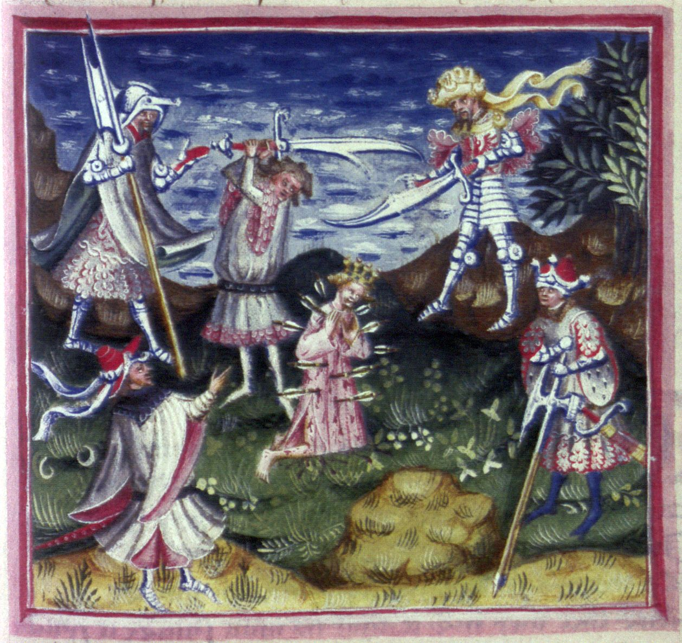**EDMUND OF EAST ANGLIA.** (c. 841 (legend says on Christmas Day) – 20 November 869 or 870, and I have no idea why there is more certainty about the day than the year.) Edmund became King of East Anglia (one of the three Anglo kingdoms established in Britian in the 400s, the other seven being Saxon ruled) at the age of fifteen. In 869 the Danes, who had been wintering at York, marched through Mercia into East Anglia and took up their quarters at Thetford. Edmund engaged them fiercely in battle, but the Danes under their leaders Ubba and Inguar were victorious and remained in possession of the field of battle. The king himself was slain. Maybe it was on the actual field of battle, but that would hardly make him a martyr, so let’s go with the widely current version of the story which says the Danes offered to spare his life if he would share his kingdom with a Danish leader. As a Christian, Edmund refused to collaborate in this way with a pagan or compromise the faith. He was tortured, used as a target for the Danes' archery practice, and finally beheaded. In any case, a martyr’s cult arose around him as early as 890. He is said to be buried, conveniently enough, at Bury St. Edmunds, by pretty much everyone except the people of Bury St. Edmunds. The coolest of saints have the coolest of legends surrounding them, and Edmund’s involves a wolf. The story goes that the Danes believed that once a head was severed from its body that person would not go to a higher plain, which is why Edmund was decapitated. Folks who liked him went looking for his body, as folks who like you are wont to do, and found it – but without the head. However, as they were contemplating what to do next, the heard a wolf call to them (in Latin, of course – *hic, hic, hic* (*here, here, here*)) and found the wolf guarding the king's head, which was then reunited with his body. Then the first miracle of the future Saint occurred when body and head fused back together. Other fun facts – Edmund was the original patron saint of England. Take that, George. (In yet another one of history’s wry twists, Edmund’s crest was a White Dragon while George, of course, was renowned for his slaying of the creatures.)

**EFFICACIOUS GRACE.** This is grace (also called “irresistible grace” in some traditions) that accomplishes its intended result in the human soul, especially in terms of a saving work or salvation. (Do not ask me what other type of grace there is, because I don’t know. Why wouldn’t it all “work?” Especially if it is “irresistible?) The English reformers affirmed the efficacious nature of the sacraments, urging that they are not mere "badges or 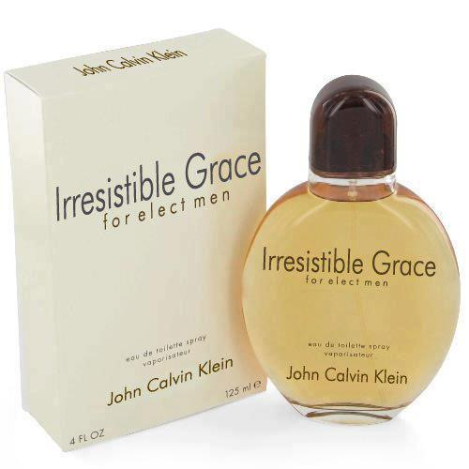tokens of Christian men's profession," but "they be certain sure witnesses, and effectual signs of grace" (Art. XXV, Articles of Religion, Book of Common Prayer, p. 872). The grace conveyed by the sacraments invariably affects the human soul, working to the soul's good. Richard Hooker stated in his *Of the Laws of Ecclesiastical Polity* that the sacraments convey the "grace which worketh salvation," which he called a "saving efficacy." (And yes, the perfume is a joke, although you *can* buy *Amazing* Grace - $49.99 for 2 ounces.)

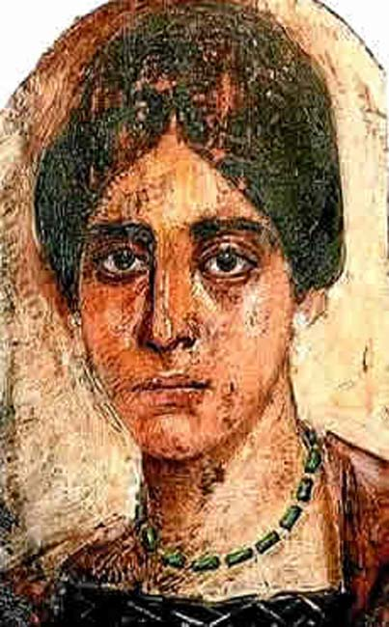**EGERIA (or Etheria or Aetheria, your choice).** Egeria was a pilgrim (of some means, given her ability to travel widely) whose personal account of her journey to holy places in the Sinai, Palestine, Egypt, Mesopotamia, and Asia Minor around the end of the fourth or the beginning of the fifth century has provided us with invaluable information about some of the earliest practices of the Church. She might well have been an abbess or nun from northern Spain or southern Gaul, although she might also have been “simply” a Christian layperson. An incomplete copy of her account of her pilgrimage was discovered in 1884 in an eleventh-century manuscript. It was written in a curious Latin dialect, which has also made it prized by philologists studying the evolution of Latin as a language. Egeria was a keen observer. She provided a detailed account of what she saw. The first half of her long letter, addressed to a circle of women at her spiritual community back home (the *Peregrinatio Aetheriae*) describes her journey from her approach to Mount Sinai until her stop in Constantinople. Staying for three years in Jerusalem, she made excursions to Mount Nebo and the tomb of Job in modern-day Syria. She also visited the burial places of Haran, brother of Abraham, as well as the site where Eliezer met with Rebecca. On her way back to Europe she stopped at the shrine of Saint Thecla (in modern Turkey), a site particularly venerated by women. The second part of her document describes the liturgical celebrations in and around Jerusalem. Her work is especially prized by liturgists for her descriptions of the daily and weekly services at Jerusalem and for her chronicle of the major celebrations of the church year. She describes the Palm Sunday procession to the top of the Mount of Olives and a later procession down from the Mount of Olives into the city of Jerusalem. The people waved palms as they walked. They also sang psalms, including Psalm 118, and shouted the antiphon, "Blessed is he who comes in the name of the Lord!" Egeria recalls that on Maundy Thursday the Eucharist was celebrated at 2 p.m. in the Martyrium. This church was a large basilica built by Helena, the mother of Constantine. After the Eucharist, a cross was erected in the courtyard of the church at the supposed site of Jesus' crucifixion. Egeria also describes the veneration of the supposed true cross in the courtyard behind the Martyrium during the morning of Good Friday. A service of psalms, readings, hymns, and prayers lasted from noon until three o'clock in the courtyard. Marion J. Hatchett dates Egeria's accounts of the Palm Sunday, Maundy Thursday, and Good Friday celebrations in Jerusalem at about 381-384. Egeria's account has also been useful in the study of the architecture of the early church.

**August Birthdays**

Aug 01 Lisa Earley Aug 14 Brennan Groble Aug 07 Tyler Sandberg Aug 15 Rachel Regan

Aug 09 Judi Dura Aug 18 Aggie Cebulka

Aug 11 Becky Deignan, Aug 20 Michelle Burke

Aug 11 Todd Seiler Aug 21 Tom Nash

Aug 13 Bill Glade Aug 24 Shelly Nash

Aug 26 Mimi Mantice

**August Anniversaries**

Aug 06 Bill and Patti Glade

Aug 16 Chris and Becky Deignan

Aug 23 Marci and Ray Suelzer

|  |  |  |  |  |  |  |
| --- | --- | --- | --- | --- | --- | --- |
| **AUGUST 2019 (See PAGE 2 above for Service Schedule.)** | | | | | | |
| **SUN** | **MON** | **TUE** | **WED** | **THU** | **FRI** | **SAT** |
|  |  |  |  | 1  Farmer’s Market 4-7PM | 2 | 3  10 AM--noon  Food Pantry |
| 4  8:00 AM service  10:30 AM service | 5 | 6 | 7 | 8  Farmer’s Market 4-7PM | 9 | 10  10 AM--noon  Food Pantry |
| 11  8:00 AM service  10:30 AM service | 12  7:00 PM  Shawl Ministry | 13 | 14 | 15  Farmer’s Market 4-7PM | 16 | 17  10 AM--noon  Food Pantry |
| 18  8:00 AM service  10:30 AM service  11 AM-2PM:  WILMA Picnic at  Federated Church | 19 | 20  7:00 PM  Bishop’s Comm. Mtg | 21 | 22  Farmer’s Market 4-7PM | 23 | 24  10 AM--noon  Food Pantry |
| 25  8:00 AM service  10:30 AM service | 26 | 27  Book Group  7:30 PM | 28 | 29  Farmer’s Market 4-7PM | 30 | 31 |



**IN OUR** **PARISH LIFE:**

**SHAWL MINISTRY:** The Shawl Ministry meets on **Monday 12 August at 7:00 PM** in Lincoln Hall. No experience is necessary! Please contact Marsha Taylor at [mktaylor730@hotmail.com](mailto:mktaylor730@hotmail.com) or 847-977-5399 with any questions.

**BISHOP’S COMMITTEE MEETING:** Bishop’s Committee will meet on **Tuesday 20 August at 7:00 p.m.** in Lincoln Hall.

**BOOK DISCUSSION GROUP:** This month the Book Group will meet **on 27 August at 7:30 PM** to discuss *The Sun Does Shine: How I Found Life and Freedom* *on Death Row* by Anthony Ray Hinton, at the home of Judi Dura.

**WAUCONDA FARMERS’ MARKET:**   This year we will have a weekly table set up at the Farmers Market, **11 July through 26 September, from 4:00 PM to 7:00 PM.** There is a sign-up sheet on the desk for those who would like to be a part of our 'ministry of presence' in the community. We will be adding some new and fun elements this year! Help with setting up and taking down the tent is especially appreciated.

 **RECYCLE YOUR SHOES!** We are continuing to collect shoes to be reused or recycled. Any and all shoes will be accepted-shoes in good condition will be given to others, and shoes that have seen better days will be ground up and reborn as playground material! You may deposit your old shoes in the collection box located in the Narthex near the Food Pantry milk jug. Please contact Marsha Fedor with any questions.

**PLEASE REMEMBER** that we have an Alcoholics Anonymous meeting at Holy Apostles **EACH SATURDAY morning from 9 a.m. – 10 a.m.**  Please do not schedule any events prior to 10:30 a.m. Saturdays.



**ECUMENICAL PICNIC:** All are invited to the Ecumenical Picnic, which will be held on **Sunday 18 August, from 11 AM – 2 PM**, in the comfortably air-conditioned Federated Church of Wauconda. Hamburgers and hot dogs will be provided- people are asked to bring a side salad/dish, fruit, or dessert. There will be an inflatable bounce house for children, and The Korean Music/Dance Team will perform at 1:00 PM. Please plan to attend!

**WAUCONDA/ISLAND LAKE FOOD PANTRY:** The milk jug count for June was $15.30. In June the food pantry served 171 families which totaled 455 individuals.  Seven families were new to the pantry. Please keep them in your prayers. There is a sign-up sheet in Lincoln Hall if you are interested in volunteering on Saturdays between 10 AM and 12 noon.

**FROM: Church of the Holy Apostles**

**26238 North Highway 59**

**Wauconda, Illinois 60084**