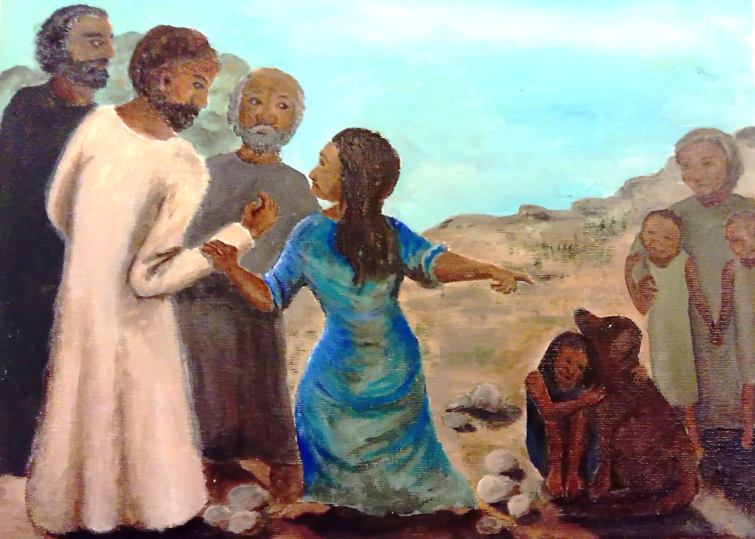

**Fifteenth Sunday after Pentecost**

**Proper 18 (B)**

**Sunday 05 September 2021**

**Episcopal Church of the Holy Apostles**

26238 N HWY 59, Wauconda, IL 60084

*www.holyapostleswauconda.net*

***You are encouraged to look at pictures and videos if presented.***

***They tell the story in a different way than the words in front of you.***

***But the words are important too;***

***feel free to take your bulletins with you, or access them on our website.***

**OPENING VOLUNTARY**

**WORDS OF WELCOME**

**OPENING HYMN** H1982, #423

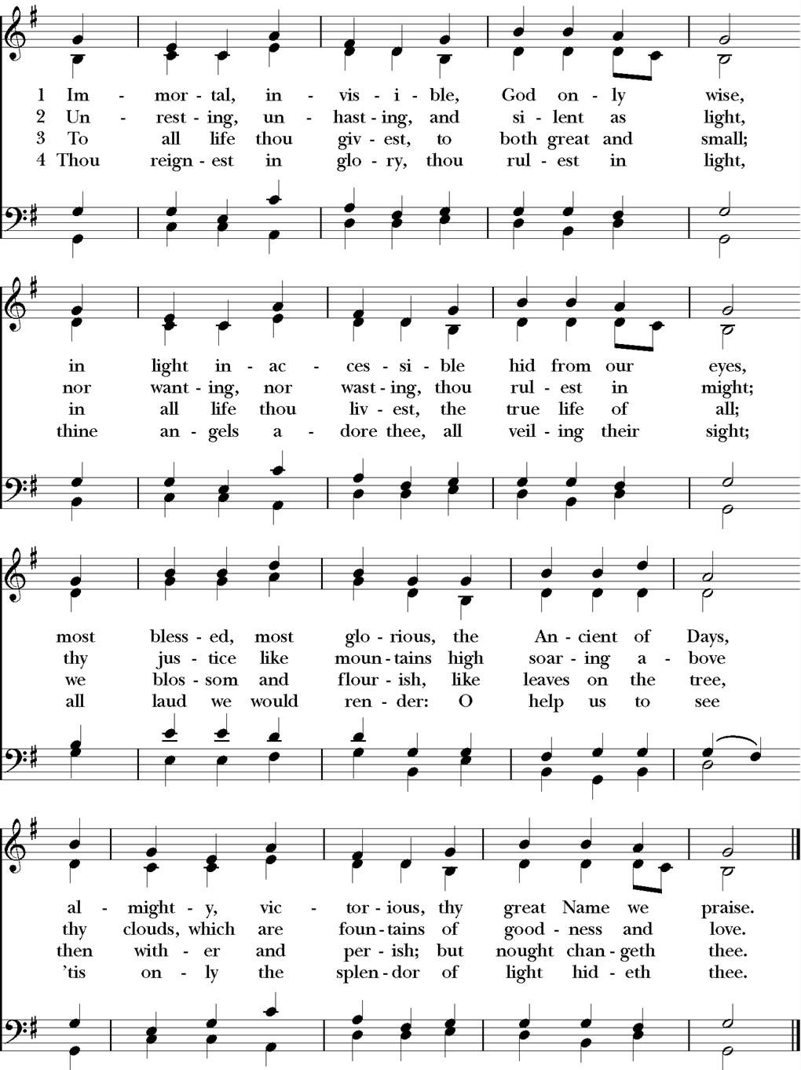

**OPENING SENTENCE**

**Presider:** Blessed be the one, holy, and living God.

***People: Glory to God for ever and ever.***

**HYMN OF PRAISE** *(Please say together in unison)*

Canticle S, *A Song Of Our True Nature*

***Christ revealed our frailty and our falling, our trespasses and our humiliations. Christ also revealed his blessed power, his blessed wisdom and love. He protects us as tenderly and as sweetly when we are in greatest need; he raises us in spirit and turns everything to glory and joy without ending. God is the ground and the substance, the very essence of nature; God is the true father and mother of natures. We are all bound to God by nature, and we are all bound to God by grace. And this grace is for all the world, because it is our precious mother, Christ. For this fair nature was prepared by Christ for the honor and nobility of all, and for the joy and bliss of salvation.***

**COLLECT OF THE DAY**

**Presider:** God be with you.

***People: And also with you.***

**Presider:** Let us pray. Lord of the changing, you help us find our voice that we might find our faith: we praise you for the Gentile woman who answered back the Son of God; release us from the crowds which command our silence and free our tongues to demand from you the healing of the earth; through Jesus Christ, the opener of the gate.

***People: Amen.***

*(We read from the various translations authorized by our Church. This month, we read from the New American Bible, 1970)*

**FIRST LESSON** Proverbs 22:1-2, 8-9, 22-23

**Reader:** A reading from Proverbs. 1A good name is more desirable than great riches, and high esteem, than gold and silver. 2Rich and poor have a common bond: the Lord is the maker of them all. Those who sow iniquity reap calamity, and the rod used in anger will fail. 9The generous will be blessed, for they share their food with the poor. 22Do not rob the poor because they are poor, nor crush the needy at the gate; 23For the Lord will defend their cause, and will plunder those who plunder them. The Word of the Lord.

***People: Thanks be to God.***

**RESPONSE** Psalm 125

***1Those trusting in the Lord are like Mount Zion, unshakable, forever enduring.***

***2As mountains surround Jerusalem, the Lord surrounds his people both now and forever.***

***3The scepter of the wicked will not prevail in the land allotted to the just, Lest the just themselves turn their hands to evil.***

***4Do good, Lord, to the good, to those who are upright of heart.***

***5But those who turn aside to crooked ways may the Lord send down with the evildoers. Peace upon Israel!***

**SECOND READING** James 2:1-17

**Reader:**  A reading from the Letter of James. 1My brothers, show no partiality as you adhere to the faith in our glorious Lord Jesus Christ. 2For if a man with gold rings on his fingers and in fine clothes comes into your assembly, and a poor person in shabby clothes also comes in, 3and you pay attention to the one wearing the fine clothes and say, “Sit here, please,” while you say to the poor one, “Stand there,” or “Sit at my feet,” 4have you not made distinctions among yourselves and become judges with evil designs? 5Listen, my beloved brothers. Did not God choose those who are poor in the world to be rich in faith and heirs of the kingdom that he promised to those who love him? 6But you dishonored the poor person. Are not the rich oppressing you? And do they themselves not haul you off to court? 7Is it not they who blaspheme the noble name that was invoked over you? 8However, if you fulfill the royal law according to the scripture, “You shall love your neighbor as yourself,” you are doing well. 9But if you show partiality, you commit sin, and are convicted by the law as transgressors. 10For whoever keeps the whole law, but falls short in one particular, has become guilty in respect to all of it. 11For he who said, “You shall not commit adultery,” also said, “You shall not kill.” Even if you do not commit adultery but kill, you have become a transgressor of the law. 12So speak and so act as people who will be judged by the law of freedom. 13For the judgment is merciless to one who has not shown mercy; mercy triumphs over judgment. 14What good is it, my brothers, if someone says he has faith but does not have works? Can that faith save him? 15If a brother or sister has nothing to wear and has no food for the day, 16and one of you says to them, “Go in peace, keep warm, and eat well,” but you do not give them the necessities of the body, what good is it? 17So also faith of itself, if it does not have works, is dead. The Word of the Lord.

***People: Thanks be to God.***

**GOSPEL** Mark 7:24-37

**Presider:** The Holy Gospel of our Lord Jesus Christ according to Mark.

***People: Glory to you, Lord Christ.***

**Presider:** 24Jesus went off to the district of Tyre. He entered a house and wanted no one to know about it, but he could not escape notice. 25Soon a woman whose daughter had an unclean spirit heard about him. She came and fell at his feet. 26The woman was a Greek, a Syrophoenician by birth, and she begged him to drive the demon out of her daughter. 27He said to her, “Let the children be fed first. For it is not right to take the food of the children and throw it to the dogs.” 28She replied and said to him, “Lord, even the dogs under the table eat the children’s scraps.” 29Then he said to her, “For saying this, you may go. The demon has gone out of your daughter.” 30When the woman went home, she found the child lying in bed and the demon gone. 31Again he left the district of Tyre and went by way of Sidon to the Sea of Galilee, into the district of the Decapolis. 32And people brought to him a deaf man who had a speech impediment and begged him to lay his hand on him. 33He took him off by himself away from the crowd. He put his finger into the man’s ears and, spitting, touched his tongue; 34then he looked up to heaven and groaned, and said to him, “*Ephphatha*!” (that is, “Be opened!”) 35And [immediately] the man’s ears were opened, his speech impediment was removed, and he spoke plainly. 36 He ordered them not to tell anyone. But the more he ordered them not to, the more they proclaimed it. 37They were exceedingly astonished and they said, “He has done all things well. He makes the deaf hear and [the] mute speak.” The Gospel of the Lord.

***People: Praise to you, Lord Christ.***

**SERMON** The Rev. M. C. Gillette

*(A brief period of silence follows the sermon)*

**NICENE CREED** *(Please say together in unison)*

***All: We believe in one God, the Father, the Almighty, maker of heaven and earth, of all that is, seen and unseen. We believe in one Lord, Jesus Christ, the only Son of God, eternally begotten of the Father, God from God, Light from Light, true God from true God, begotten, not made, of one Being with the Father. Through him all things were made. For us and for our salvation he came down from heaven: by the power of the Holy Spirit he became incarnate from the Virgin Mary, and was made man. For our sake he was crucified under Pontius Pilate; he suffered death and was buried. On the third day he rose again in accordance with the Scriptures; he ascended into heaven and is seated at the right hand of the Father. He will come again in glory to judge the living and the dead, and his kingdom will have no end. We believe in the Holy Spirit, the Lord, the giver of life, who proceeds from the Father and the Son. With the Father and the Son he is worshiped and glorified. He has spoken through the Prophets. We believe in one holy catholic and apostolic Church. We acknowledge one baptism for the forgiveness of sins. We look for the resurrection of the dead, and the life of the world to come. Amen.***

**PRAYERS OF THE PEOPLE** Personalized VI

*\* Note that the Confession is incorporated into this form of the Prayers of the People*

**Leader**: In peace, we pray to you, Lord God.

*Silence.*

**Leader:** For all people in their daily life and work;

***People: For our families, friends, and neighbors, and for those who are alone.***

**Leader**: For this community, this nation, and the world; and especially for those in positions of leadership and authority.

***People: For all who work for justice, freedom, and peace.***

**Leader:** For the just and proper use of your creation;

***People: For the victims of hunger, fear, injustice, and oppression.***

**Leader:** For all who are in danger, sorrow, or any kind of trouble, especially those whose names we raise up now, either silently or aloud: _____ (*We will keep a 10-second silence*); for all weighed down by worry and care;

***People: For the sick, the friendless, and the needy, and for those who minister to them.***

**Leader:** For the peace and unity of the Church of God;

***People:  For all who proclaim the Gospel, and all who seek the Truth.***

**Leader:**  For those named on our Anglican and Diocesan cycles of prayer; for all bishops, priests, and deacons; and for all other ministers;

***People:  For all who serve God in God’s Church.***

**Leader:**  We thank you for those celebrating birthdays and anniversaries this week, especially those whose names we raise up now, either silently or aloud: _____ (*We will keep a ten-second silence*). We thank you for all the blessings of our lives. We will exalt you, O God our King;

***People: And praise your Name for ever and ever.***

**Leader:** We pray for our beloved departed, and for those whose names we raise up now, either silently or aloud: _____ (*We will keep a ten-second silence*). We pray for all who have died, that they may have a place in your eternal kingdom. Lord, let your loving-kindness be upon them;

***People: Who put their trust in you.***

**Leader:** We pray to you also for the forgiveness of our sins.

*(Please kneel or reverently bow as able)*

*Silence*

***All: Have mercy upon us, most merciful Father; in your compassion forgive us our sins, known and unknown, things done and left undone; and so uphold us by your Spirit that we may live and serve you in newness of life, to the honor and glory of your Name; through Jesus Christ our Lord. Amen.***

**Presider:** Almighty God have mercy on you, forgive you all your sins through our Lord Jesus Christ, strengthen you in all goodness, and by the power of the Holy Spirit keep you in eternal life. Amen.

*Silence*

**THE PEACE**

**Presider:** The Peace of Christ be always with you.

***People: And also with you.***

**OFFERTORY SENTENCE**

*(The Presider gives this or another Offertory Sentence)* Yours, O Lord, is the greatness, the power, the glory, the victory, and the majesty. For everything in heaven and on earth is yours. Yours, O Lord, is the kingdom, and you are exalted as head over all.

*(Please follow the Presider’s instructions for Communion.)*

**GREAT THANKSGIVING** Scottish 1982

**Presider:** The Lord be with you.

***People: And also with you.***

**Presider:** Lift up your hearts.

***People: We lift them to the Lord.***

**Presider:** Let us give thanks to the Lord our God.

***People: It is right to give our thanks and praise.***

**Presider:** Worship and praise belong to you, Father, in every place and at all times. All power is yours. You created the heavens and established the earth; you sustain in being all that is. In Christ your Son our life and yours are brought together in a wonderful exchange. He made his home among us that we might for ever dwell in you. Through your Holy Spirit you call us to new birth in a creation restored by love. As children of your redeeming purpose we offer you our praise, with angels and archangels and the whole company of heaven, singing the hymn of your unending glory:

**SANCTUS**

***Holy, holy, holy Lord, God of power and might, heaven and earth are full of your glory. Hosanna in the highest. Blessed is the one who comes in the name of the Lord. Hosanna in the highest.***

**Presider:**  Glory and thanksgiving be to you, most loving Father, for the gift of your Son born in human flesh. He is the Word existing beyond time, both source and final purpose, bringing to wholeness all that is made. Obedient to your will he died upon the Cross. By your power you raised him from the dead. He broke the bonds of evil and set your people free to be his Body in the world.

On the night when he was given up to death, knowing that his hour had come, having loved his own, he loved them to the end.

**↑** At supper with his disciples he took bread and offered you thanks. He broke the bread, and gave it to them, saying: "Take, eat. This is my Body: it is broken for you."

**↑** After supper, he took the cup, he offered you thanks, and gave it to them saying: "Drink this, all of you. This is my Blood of the new covenant; it is poured out for you, and for all, that sins may he forgiven. Do this in remembrance of me."

We now obey your Son's command. We recall his blessed passion and death, his glorious resurrection and ascension; and we look for the coming of his Kingdom. Made one with him, we offer you these gifts and with them ourselves, **+** a single, holy, living sacrifice.

**∞** Hear us, most merciful Father, and send your Holy Spirit upon us and upon this bread and this wine, that, overshadowed by his life-giving power, they may be the Body and Blood of your Son, and we may be kindled with the fire of your love and renewed for the service of your Kingdom.

Help us, who are baptised into the fellowship of Christ's Body, to live and work to your praise and glory; may we grow together in unity and love until at last, in your new creation, we enter into our heritage in the company of the Virgin Mary, the apostles and prophets, and of all our brothers and sisters living and departed.

**↑** Through Jesus Christ our Lord, with whom, and in whom, in the unity of the Holy Spirit, all honour and glory be to you, Lord of all ages, world without end.

***People: Amen.***

**LORD’S PRAYER**  *(Please say together in unison)*

**Presider:** As our Savior has taught us, so we pray:

***All: Our Father in heaven, hallowed be your Name, your kingdom come, your will be done, on earth as in heaven. Give us today our daily bread. Forgive us our sins as we forgive those who sin against us. Save us from the time of trial, and deliver us from evil. For the kingdom, the power, and the glory are yours, now and for ever. Amen.***

**FRACTION (THE BREAKING OF THE BREAD)**

*(The Presider breaks the consecrated bread. A brief period of silence is kept.)*

**Presider:** The living bread is broken for the life of the world.

***People: Lord, unite us in this sign.***

**Presider: ↑** The Gifts of God for the People of God. Take them in remembrance that Christ died for you, and feed on him in your hearts by faith, with thanksgiving.

**POST-COMMUNION PRAYER**

**Presider:** Let us pray.

***All: Father of all, we give you thanks and praise that when we were still far off you met us in your Son and brought us home. Dying and living, he declared your love, gave us grace, and opened the gate of glory. May we who share Christ's body live his risen life; we who drink his cup bring life to others; we whom the Spirit lights, give light to the world. Keep us firm in the hope you have set before us, so we and all your children shall be free, and the whole earth live to praise your name; through Christ our Lord. Amen.***

**PARISH ANNOUNCEMENTS**

**BLESSING**

**Presider**: **+** May the One, Holy, and Living God order your steps that your feet might walk in holiness; strengthen your hands that they might be tender hands which bless; fill your heart that it might serve as a fountain of joy; loosen your tongue that you might share the Good News; open your eyes that you might truly see your neighbor; and sharpen your mind that it might be a powerful force for justice and peace.

***People: Amen.***

**CLOSING HYMN** H1982, #344



**DISMISSAL**

*(The Presider gives this or another dismissal)*  Our worship is over, our service now begins. Let us go forth into the world, rejoicing in the power of the Holy Spirit.

***People: Thanks be to God.***

**CLOSING VOLUNTARY**

**Cover Image:** http://kindredmontrose.org/blog/2020/8/31/the-sacred-art-of-talking-back-to-jesus