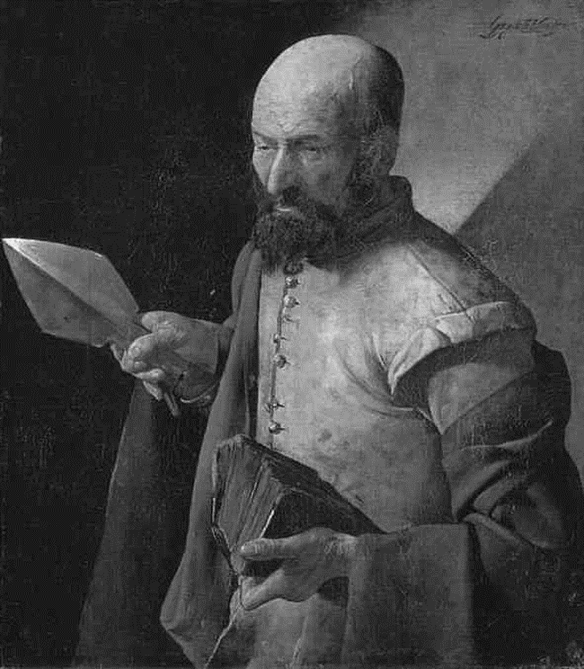

Easter Sunday (C)
Sunday 24 April 2022
Episcopal Church of the Holy Apostles
26238 N HWY 59, Wauconda, IL 60084
www.holyapostleswauconda.net

PLEASE SILENCE YOUR MOBILE DEVICES
You are encouraged to look at pictures and videos if presented.
They tell the story in a different way than the words in front of you.
But the words are important too; feel free to take your bulletins with you.
OPENING VOLUNTARY (Please be seated)

WORDS OF WELCOME (Please remain seated)

OPENING HYMN (Please stand as able)
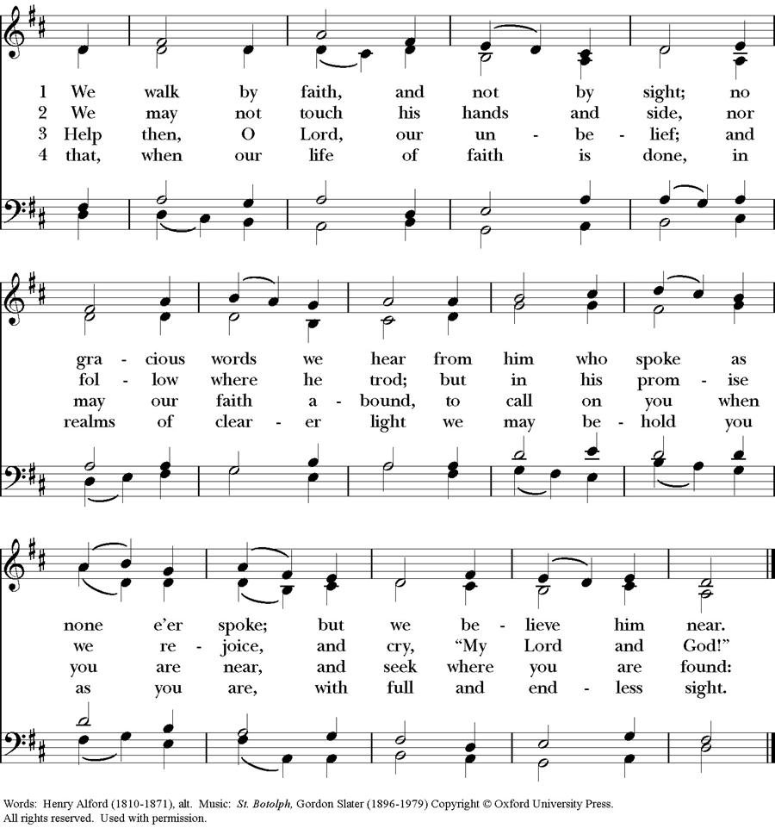
OPENING SENTENCES (Please remain standing)
Presider: Alleluia! Christ is risen.
People: The Lord is risen indeed. Alleluia!
Presider: We gather here as mixed company.
People: Some have seen and believed; some are waiting still. Some are filled with courage, peace, and joy; some are wrestling with anger, fear, and grief. Some find faith and hope with ease; some struggle with skepticism and despair.
Presider: But each of us does good, and each of us sins. We are all imperfect, and we are all beloved of God. We all need help, and we all need to help.
People: We gather here as mixed company to share the good news, to experience the presence of the risen Christ, and to worship with a common cry: My Lord and my God!

COLLECT FOR PURITY
Presider: Almighty God, to you all hearts are open, all desires known, and from you no secrets are hid: Cleanse the thoughts of our hearts by the inspiration of your Holy Spirit, that we may perfectly love you, and worthily magnify your holy Name; through Christ our Lord.
People: Amen.

HYMN OF PRAISE (Please remain standing and say together in unison)
All: Glory to God in the highest, and peace to God’s people on earth. Lord God, heavenly King, almighty God and Father, we worship you, we give you thanks, we praise you for your glory. Lord Jesus Christ, only Son of the Father, Lord God, Lamb of God, you take away the sin of the world: have mercy on us; you are seated at the right hand of the Father: receive our prayer. For you alone are the Holy One, you alone are the Lord, you alone are the Most High, Jesus Christ, with the Holy Spirit, in the glory of God the Father. Amen.

COLLECT OF THE DAY (Please remain standing)
Presider: The Lord be with you.
People: And also with you.
Presider: Let us pray. Alpha and Omega, our beginning and our end, you break through the locks of gated communities and hardened hearts: accept our doubts, heal our desire for certainty and, by your Spirit’s gentle touch, make us a people forgiven and forgiving; through Jesus Christ, the Giver of Peace.
People: Amen.

(We read from the various biblical translations authorized by our Church. This month, we read from the New Jerusalem Bible, 1987)

FIRST LESSON (Please be seated) Acts 5:27-32
Reader: A reading from Acts. ²⁷ When the temple police had brought the apostles in to face the Sanhedrin, the high priest demanded an explanation. ²⁸ 'We gave you a strong warning', he said, 'not to preach in this name, and what have you done? You have filled Jerusalem with your teaching, and seem determined to fix the guilt for this man's death on us.' ²⁹ In reply Peter and the apostles said, 'Obedience to God comes before obedience to men; ³⁰ it was the God of our ancestors who raised up Jesus, whom you executed by hanging on a tree. ³¹ By his own right hand God has now raised him up to be leader and Saviour, to give repentance and forgiveness of sins through him to Israel. ³² We are witnesses to this, we and the Holy Spirit whom God has given to those who obey him.' The Word of the Lord.
People: Thanks be to God.

RESPONSE (Please remain seated and say together in unison) Psalm 150
¹ Alleluia! Praise God in his holy place, praise him in the heavenly vault of his power,
² praise him for his mighty deeds, praise him for all his greatness.
³ Praise him with fanfare of trumpet, praise him with harp and lyre,
⁴ praise him with tambourines and dancing, praise him with strings and pipes,
⁵ praise him with the clamour of cymbals, praise him with triumphant cymbals,
⁶ Let everything that breathes praise Yahweh. Alleluia!

SECOND LESSON (Please remain seated) Revelation 1:4-8
Reader: A reading from Revelation. ⁴ John, to the seven churches of Asia: grace and peace to you from him who is, who was, and who is to come, from the seven spirits who are before his throne, ⁵ and from Jesus Christ, the faithful witness, the First-born from the dead, the highest of earthly kings. He loves us and has washed away our sins with his blood, ⁶ and made us a Kingdom of Priests to serve his God and Father; to him, then, be glory and power for ever and ever. Amen. ⁷ Look, he is coming on the clouds; everyone will see him, even those who pierced him, and all the races of the earth will mourn over him. Indeed this shall be so. Amen. ⁸ 'I am the Alpha and the Omega,' says the Lord God, who is, who was, and who is to come, the Almighty. The Word of the Lord.
People: Thanks be to God.

GOSPEL (Please stand as able) John 20:19-31
Presider: The Holy Gospel of our Lord Jesus Christ according to John.
People: Glory to you, Lord Christ.
Presider: ¹⁹ In the evening of that same day, the first day of the week, the doors were closed in the room where the disciples were, for fear of the Jews. Jesus came and stood among them. He said to them, 'Peace be with you,'
²⁰ and, after saying this, he showed them his hands and his side. The disciples were filled with joy at seeing the Lord, ²¹ and he said to them again, 'Peace be with you. 'As the Father sent me, so am I sending you.' ²² After saying this he breathed on them and said: Receive the Holy Spirit. ²³ If you forgive anyone's sins, they are forgiven; if you retain anyone's sins, they are retained. ²⁴ Thomas, called the Twin, who was one of the Twelve, was not with them when Jesus came. ²⁵ So the other disciples said to him, 'We have seen the Lord,' but he answered, 'Unless I can see the holes that the nails made in his hands and can put my finger into the holes they made, and unless I can put my hand into his side, I refuse to believe.' ²⁶ Eight days later the disciples were in the house again and Thomas was with them. The doors were closed, but Jesus came in and stood among them. 'Peace be with you,' he said. ²⁷ Then he spoke to Thomas, 'Put your finger here; look, here are my hands. Give me your hand; put it into my side. Do not be unbelieving any more but believe.' ²⁸ Thomas replied, 'My Lord and my God!' ²⁹ Jesus said to him: You believe because you can see me. Blessed are those who have not seen and yet believe. ³⁰ There were many other signs that Jesus worked in the sight of the disciples, but they are not recorded in this book. ³¹ These are recorded so that you may believe that Jesus is the Christ, the Son of God, and that believing this you may have life through his name. The Gospel of the Lord.
People: Praise to you, Lord Christ.

SERMON (Please be seated) The Rev. M. C. Gillette
(A brief period of silence will follow the sermon)

EASTER AFFIRMATION (Please stand as able)
All: We believe in God, maker and sustainer of earth, sea, and sky, and midwife of every life the earth has seen. We believe in Jesus Christ. Born of the woman Mary, he was the first of our race to live fully the destiny for which we were all created. Healing the broken and serving the poor, liberating the burdened and reconciling heaven and earth; his every action unmasked the evil that waits to enslave us all. Hell, wounded at its heart and filled with bitterness and rage, struck back in fury unrestrained. Jesus was condemned by the religious and crucified by the state. He died forsaken, a man of sorrows. No pain in our hearts or in our planet is unfamiliar to him, for he was cast into the jaws of death. Yet, redeeming even death, God raised Jesus from the grave; with wounded hands he embraces us. He ascended into heaven to be everywhere present, and there is now nothing beyond the reach of his healing touch. We believe in the Holy Spirit, who raises us from the waters of death, breathes new life into us and declares us to be God's beloved. We believe that Christ, coming that all may have life, established his Church to continue his works on earth and stand against the world’s hatred, greed, violence, and oppression. We believe that all who trust in Christ, though they die, shall be lifted to life in all its fullness. The grip of suffering will be forever broken, and death shall have no dominion. Amen.

PRAYERS OF THE PEOPLE (Please remain standing)
Leader: In the joy of the Glorious Resurrection of our Lord and Savior Jesus Christ, let us pray to the Lord saying, “Lord, in your glory, hear our prayer.”
Leader: O living Christ, unite your Church in love. Through us, show forth your message of hope and everlasting life to every corner of the world. Lord, in your glory,
People: Hear our prayer.
Leader: Grant that the leaders in your Church may manifest your Word in speech and action, faithfully preach the good news of the living Christ, and humbly serve you by the guidance and power of the Holy Spirit. Grant that those on our Anglican and Diocesan cycles of prayer may be the face of the risen Christ in your world, nourishing and nurturing all your children. Lord, in your glory,
People: Hear our prayer.
Leader: Give each of us in grace to seek and serve Christ in all persons, loving our neighbors as ourselves. Bless those who are celebrating birthdays or anniversaries this week, especially those whose names we raise up now, either silently or aloud: _____ (We will keep a 10-second silence). Bless our worship, our relationships, our lives, and our work, that we may in turn be a blessing to others. Lord, in your glory,
People: Hear our prayer.
Leader: Inspire those who govern the nations of the world to seek justice and peace. Give them hearts to protect and provide for all people, and to use wisely the resources of your good creation. Lord, in your glory.
People: Hear our prayer.
Leader: Deliver from distress all who suffer in body, mind, or spirit; the lonely, the oppressed, and those who grieve, especially those on our parish prayer list, and those whose names we raise up now, either silently or aloud: _____ (We will keep a 10-second silence). Lord, in your glory,
People: Hear our prayer.
Leader: Pour out your mercy on all who seek you, that they might realize they have already been found by you. Let this Easter season mark for them the beginning of a deeper life with you. Lord, in your glory,
People: Hear our prayer.
Leader: Lord Jesus Christ, by your victory over death, you have opened the gates of eternal life. We commend to your care all who have died, especially those whose names we raise up now, either silently or aloud: _____ (We will keep a 10-second silence). We pray for those who have given their lives in service to others. We pray that they, and we, might share with all your saints in the joy of your heavenly kingdom. Lord, in your glory,
People: Hear our prayer.
(The Presider adds this or another concluding collect) O Gracious God, we stand in awe of your sacrificial love seen in the life, death, and resurrection of your only Son. He has given us victory over sin and death, and opened the way to new life with you. Accept the fervent prayers of your people through the mercy of Jesus Christ our Lord. Accept also our thanksgiving and praise for the gift of this most glorious Eastertide, which we celebrate with abundant and profound joy.
People: Alleluia. Amen.

CONFESSION AND ABSOLUTION (Please kneel or reverently bow as able)
Presider: God who is Way and Truth and Life, we confess that at times we are skeptical wanderers, searching in unlikely places for what is freely available right in front of us.
People: We confess that at times we doubt your existence, because of the evil we see, the evil we hear, the evil we know; even the evil we do. Oppression; marginalization; victimization; manipulation; violence; and ugly, unadulterated hatred still plague our world and harden our hearts. Sometimes your light seems no more than a flicker. Sometimes your love seems to have gone cold. Sometimes, even we who claim your name – Christian – give up, turn aside, walk away. Forgive us. Please, forgive us. Help us to see your goodness in this world. Help us to show your goodness to this world. Help us to feel your love. Help us to share your love. Help us to give honor to your name by confronting the evil we see, challenging the evil we hear, standing steadfast against the evil we know; and repenting of the evil we do; that the world might come to know a different way. A better way. Your way.
Presider: The psalmist says, “I believe I shall see the goodness of our God in the land of the living. Wait for the Lord; be strong, and let your heart take courage; wait for the Lord!”
People: We know that we do not wait alone. We find strength in each other’s companionship and counsel. We know that we do not wait alone. The Spirit encourages us. We know that we do not wait alone – we wait together, in the power of the Spirit. And while we wait we work. We work to make straight the Way of the Lord. We work to proclaim the Truth, the Good News of Jesus Christ. We work on behalf of Life. We work to bring light to the darkness, love to the unloved, and justice, mercy, and peace to stand over against ugly, unadulterated hatred. We wait – we work – we believe. Lord, help our unbelief.
Presider: Christ comes to all. Our locked doors of doubt, our walls of skepticism, our failings of faith are not obstacles to him. Christ waits with us. Christ works with us. Christ forgives us. You are forgiven; be at peace.

THE PEACE (Please stand as able and greet each other in the name of Christ)
Presider: May the peace of the resurrected Jesus – the challenging peace of committed life, the liberating peace of selfless love, the vibrant peace of new possibility – recall you to radical living, empower you for rich living, and transform you with radiant joy. May this peace renew you.
People: And also you.

OFFERTORY SENTENCE (Please be seated)
Presider: Ascribe to the Lord the honor due his Name; bring offerings and come into his courts.

GREAT THANKSGIVING (Please stand as able) Rite II Prayer A
Presider: We stand in the resurrection garden of God – a place suffused with and shaped by love and ripe with its potential. And this is the table of the risen Jesus – a place fashioned and furnished by love and rich with its promises. So come – whether you have seen and believed, or are dubious and doubting still, whether you confess confidently, or with a fragile, fearful heart. Come and share these gifts of grace, encounter Christ, and be healed by Love and transformed by Life.
Presider: The Lord be with you.
People: And also with you.
Presider: Lift up your hearts.
People: We lift them to the Lord.
Presider: Let us give thanks to the Lord our God.
People: It is right to give our thanks and praise.
Presider: We praise you, God of freedom, for you breathed life into the void and showed yourself as the one who loves in freedom. From the nothingness of slavery you called a people into being and led them to springs of life; the presence of your glory went with shattered exiles into strange and distant lands and gathered from the valley of despair the flesh and blood of living hope. In Jesus, you confronted the powers that killed and oppressed; you spoke to those considered dead and helped them stand again; he taught us to die that we might live. He gave himself for us tortured and forsaken, but he could not be confined by death; in the garden he speaks our name, in the breaking of the bread he shows himself among us; by the lakeside, in the new day, he calls us to take up his work. Therefore, with all who lost faith, all who walked away in sadness, with the women at the tomb, and the men who hid in fear, we confess ourselves surprised by the suddenness of dawn, and join the undying song of heaven:

SANCTUS (Please remain standing and say together in unison)
Holy, holy, holy Lord, God of power and might, heaven and earth are full of your glory. Hosanna in the highest. Blessed is he who comes in the name of the Lord. Hosanna in the highest.

Presider: Holy and gracious Father: In your infinite love you made us for yourself; and, when we had fallen into sin and become subject to evil and death, you, in your mercy, sent Jesus Christ, your only and eternal Son, to share our human nature, to live and die as one of us, to reconcile us to you, the God and Father of all. He stretched out his arms upon the cross, and offered himself, in obedience to your will, a perfect sacrifice for the whole world.

↑On the night he was handed over to suffering and death, our Lord Jesus Christ took bread; and when he had given thanks to you, he broke it, and gave it to his disciples, and said, “Take, eat: This is my Body, which is given for you. Do this for the remembrance of me.”

↑After supper he took the cup of wine; and when he had given thanks, he gave it to them, and said, “Drink this, all of you: This is my Blood of the new Covenant, which is shed for you and for many for the forgiveness of sins. Whenever you drink it, do this for the remembrance of me.”

Therefore we proclaim the mystery of faith:
All: Christ has died. Christ is risen. Christ will come again.

Presider: We celebrate the memorial of our redemption, Father, in this sacrifice of praise and thanksgiving. Recalling his death, resurrection, and ascension, we offer you these gifts. ∞Sanctify them by your Holy Spirit to be for your people the Body and Blood of your Son, the holy food and drink of new and unending life in him. +Sanctify us also that we may faithfully receive this holy Sacrament, and serve you in unity, constancy, and peace; and at the last day bring us with all your saints into the joy of your eternal kingdom.

↑All this we ask through your Son Jesus Christ. By him, and with him, and in him, in the unity of the Holy Spirit all honor and glory is yours, Almighty Father, now and for ever. AMEN.

As our Savior Christ has taught us, we now pray,

THE LORD’S PRAYER (Please remain standing and say together in unison)
Our Father, who art in heaven, hallowed by thy Name, thy kingdom come, thy will be done on earth as it is in heaven. Give us this day our daily bread. And forgive us our trespasses as we forgive those who trespass against us. And lead us not into temptation, but deliver us from evil. For thine is the kingdom, and the power, and the glory, for ever and ever. Amen.

THE FRACTION (Please remain standing)
(The Presider breaks the consecrated bread)
Presider: Alleluia! Christ our Passover is sacrificed for us;
People: therefore let us keep the feast. Alleluia!

Presider: ↑The Gifts of God for the People of God. Take them in remembrance that Christ died for you, and feed on him in your hearts by faith, with thanksgiving.

(Please follow the Presider’s instructions for Communion)

POST-COMMUNION PRAYER (Please remain seated and say together in unison)
All: Risen Christ, whom we have seen with our eyes and touched with our hands; the word of life in whom our joy is complete: send us out to declare your truth and proclaim your unshakable faith to the world you love. Amen.

PARISH ANNOUNCEMENTS (Please remain seated)

EASTER BLESSING (Please stand as able)
Presider: May the living God remove the suffocating shroud that lies upon our world; may the risen Savior draw out the sting of death, bringing all to life in him; may the flowing Spirit set us and all creation free and seal our hearts with faith; and the blessing of God, Holy Immortal One, Risen Lord, and Breath of Heaven, be with you now and always.
People: Amen.

CLOSING HYMN (Please remain standing) H1982, #182

DISMISSAL
Presider:
You had not imagined that something so empty could fill you to overflowing
and now you carry the knowledge like an awful treasure, or like a child that roots itself beneath your heart:
how the emptiness will bear forth a new world that you cannot fathom but on whose edge you stand.

So why do you linger? You have seen and so you are already blessed.
You have been seen and so you are the blessing.

There is no other word you need. There is simply to go and tell.
There is simply to begin.
Let us go forth into the world rejoicing in the truth of the risen Christ!
People: Thanks be to God. Alleluia! Amen.

CLOSING VOLUNTARY

Cover Image: https://voiceofindia.me/tag/apostle-thomas/
Call to Worship: Adapted from N.T. Wright, Simply Christian: Why Christianity Makes Sense. accessed at https://re-worship.blogspot.com/2015/03/easter-call-to-worship-new-creation.html
Affirmation: From Laughing Bird Resources, Nathan Nettleton
Confession: Adapted from “Prayer of Confession: Skeptics,” Rev. Mindi and posted on Rev-o-lution. http://rev-o-lution.org/
Introduction to the Peace, Invitation to Communion: From ‘Transformed by Life,’ Pat Bennett, Wild Goose Publications (Iona)
Collect of the Day, Eucharistic Preface, Post-Communion Prayer, and Blessing: adapted from seasonal materials in Prayers for an Inclusive Church (Steven Shakespeare)
Dismissal: Adapted from Seen: A Blessing For Easter Sunday, written by Jan L. Richardson, and posted on The Painted Prayerbook. http://paintedprayerbook.com/ accessed at https://re-worship.blogspot.com/2014/04/an-easter-blessing-seen.html

