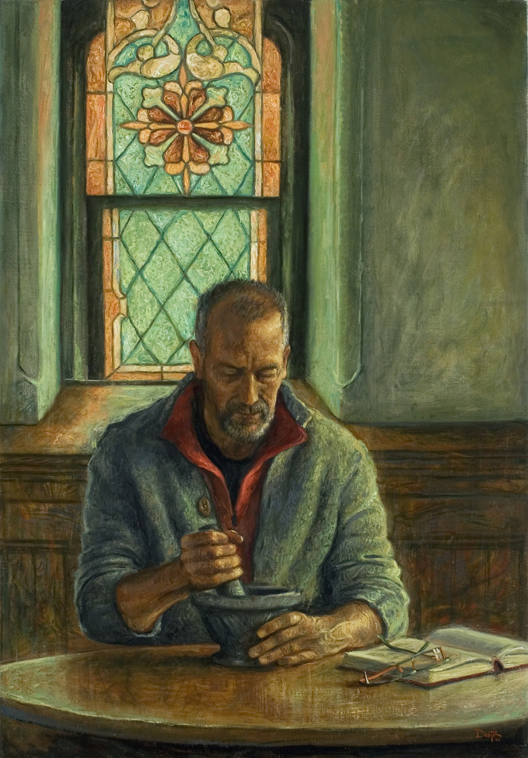
Ash Wednesday (C)
Wednesday 01 March 2022
Episcopal Church of the Holy Apostles
26238 N HWY 59, Wauconda, IL 60084
www.holyapostleswauconda.net

PLEASE SILENCE YOUR MOBILE DEVICES
You are encouraged to look at pictures and videos if presented.
They tell the story in a different way than the words in front of you.
But the words are important too; feel free to take your bulletins with you.
(Please enter quietly and be seated. The Presider begins the liturgy simply with the invitation.)

THE INVITATION (Please remain seated)
Presider: Ash Wednesday marks the beginning of the season in the church year known as Lent. Lent is a time to prepare for the celebration of Easter and to renew our life in the mystery of the saving death and resurrection of Jesus Christ. We begin this holy season by acknowledging our need to repent, and for the mercy and forgiveness proclaimed in the gospel of Jesus Christ.

We begin our journey to Easter with the sign of ashes, a biblical symbol of mourning and lament. There is a wisdom in ash, that we need so much, but seldom hear.
It is the wisdom of grief, that reminds us of our mortality, and that Life is more than this dust can contain.
It is the wisdom of confession, that brings our darkness out of hiding, and opens the windows to Light.
It is the wisdom of repentance, that stops us in our tracks, and charts the way to Love.
The wisdom in ash speaks of the fragility of human life, and marks the commitment of the community of faith to amendment of life. I invite you, therefore, in the name of Christ, to observe a holy Lent by self-examination and penitence, by prayer and fasting, by works of love, and by reading and meditating on the Word of God; beginning here and now.

SALUTATION AND COLLECT (Please remain seated)
Presider: Let us pray. Mystery of Goodness, by whose gaze we are called into being and held in life: teach us the secrecy of prayer which seeks no reward; the generosity of love which forgets itself; the gift of a treasure uncountable and unconsumed; through Jesus Christ, the Son of the Wilderness.
People: Amen.

(We read from the various biblical translations authorized by our Church. During Lent we will be reading from the New English Bible, 1970)
FIRST READING (Please remain seated) Isaiah 58:1-12
Reader: A reading from Isaiah. 58 “Shout loudly! Don’t be quiet! Yell as loudly as a trumpet! Confront my people with their rebellious deeds; confront Jacob’s family with their sin. ² They seek me day after day; they want to know my requirements, like a nation that does what is right and does not reject the law of their God. They ask me for just decrees; they want to be near God. ³ They lament, ‘Why don’t you notice when we fast? Why don’t you pay attention when we humble ourselves?’ Look, at the same time you fast, you satisfy your selfish desires, you oppress your workers. ⁴ Look, your fasting is accompanied by arguments, brawls, and fistfights. Do not fast as you do today, trying to make your voice heard in heaven. ⁵ Is this really the kind of fasting I want? Do I want a day when people merely humble themselves, bowing their heads like a reed and stretching out on sackcloth and ashes? Is this really what you call a fast, a day that is pleasing to the Lord? ⁶ No, this is the kind of fast I want: I want you to remove the sinful chains, to tear away the ropes of the burdensome yoke, to set free the oppressed, and to break every burdensome yoke. ⁷ I want you to share your food with the hungry and to provide shelter for homeless, oppressed people. When you see someone naked, clothe them! Don’t turn your back on your own flesh and blood. ⁸ Then your light will shine like the sunrise; your restoration will quickly arrive; your godly behavior will go before you, and the Lord’s splendor will be your rear guard. ⁹ Then you will call out, and the Lord will respond; you will cry out, and he will reply, ‘Here I am.’ You must remove the burdensome yoke from among you and stop pointing fingers and speaking sinfully. ¹⁰ You must actively help the hungry and feed the oppressed. Then your light will dispel the darkness, and your darkness will be transformed into noonday. ¹¹ The Lord will continually lead you; he will feed you even in parched regions. He will give you renewed strength, and you will be like a well-watered garden, like a spring that continually produces water. ¹² Your perpetual ruins will be rebuilt; you will reestablish the ancient foundations. You will be called, ‘The one who repairs broken walls, the one who makes the streets inhabitable again.’ The Word of the Lord.
People: Thanks be to God.

RESPONSE (Please reman seated and say together in unison) Psalm 103
103 Praise the Lord, O my soul. With all that is within me, praise his holy name.
² Praise the Lord, O my soul. Do not forget all his kind deeds.
³ He is the one who forgives all your sins, who heals all your diseases,
⁴ who delivers your life from the Pit, who crowns you with his loyal love and compassion,
⁵ who satisfies your life with good things, so your youth is renewed like an eagle’s.
⁶ The Lord does what is fair, and executes justice for all the oppressed.
⁷ The Lord revealed his faithful acts to Moses, his deeds to the Israelites.
⁸ The Lord is compassionate and merciful; he is patient and demonstrates great loyal love.
⁹ He does not always accuse, and does not stay angry.
¹⁰ He does not deal with us as our sins deserve; he does not repay us as our misdeeds deserve.
¹¹ For as the skies are high above the earth, so his loyal love towers over his faithful followers.
¹² As far as the eastern horizon is from the west, so he removes the guilt of our rebellious actions from us.
¹³ As a father has compassion on his children, so the Lord has compassion on his faithful followers
¹⁴ For he knows what we are made of; he realizes we are made of clay.
¹⁵ A person’s life is like grass. Like a flower in the field it flourishes,
¹⁶ but when the hot wind blows, it disappears, and one can no longer even spot the place where it once grew.
¹⁷ But the Lord continually shows loyal love to his faithful followers, and is faithful to their descendants,
¹⁸ to those who keep his covenant, who are careful to obey his commands.
¹⁹ The Lord has established his throne in heaven; his kingdom extends over everything.
²⁰ Praise the Lord, you angels of his, you powerful warriors who carry out his decrees and obey his orders.
²¹ Praise the Lord, all you warriors of his, you servants of his who carry out his desires.
²² Praise the Lord, all that he has made, in all the regions of his kingdom. Praise the Lord, O my soul.
SECOND READING Please remain seated) 2 Corinthians 5:20b-6:10
Reader: A reading from the Second Letter to the Corinthians. We plead with you on Christ’s behalf, “Be reconciled to God!” ²¹ God made the one who did not know sin to be sin for us, so that in him we would become the righteousness of God. 6 Now because we are fellow workers, we also urge you not to receive the grace of God in vain. ² For he says, “I heard you at the acceptable time, and in the day of salvation I helped you.” Look, now is the acceptable time; look, now is the day of salvation! ³ We do not give anyone an occasion for taking an offense in anything, so that no fault may be found with our ministry. ⁴ But as God’s servants, we have commended ourselves in every way, with great endurance, in persecutions, in difficulties, in distresses, ⁵ in beatings, in imprisonments, in riots, in troubles, in sleepless nights, in hunger, ⁶ by purity, by knowledge, by patience, by benevolence, by the Holy Spirit, by genuine love, ⁷ by truthful teaching, by the power of God, with weapons of righteousness both for the right hand and for the left, ⁸ through glory and dishonor, through slander and praise; regarded as impostors, and yet true; ⁹ as unknown, and yet well-known; as dying and yet—see!—we continue to live; as those who are scourged and yet not executed; ¹⁰ as sorrowful, but always rejoicing, as poor, but making many rich, as having nothing, and yet possessing everything. The Word of the Lord.
People: Thanks be to God.

FIRST SONG (Please remain seated) – Bless The Lord, My Soul

GOSPEL (Please stand as able) Matthew 6:1-6, 16-21
Presider: The Holy Gospel of our Lord Jesus Christ according to Matthew.
People: Glory to you, Lord Christ.
Presider: 6 “Be careful not to display your righteousness merely to be seen by people. Otherwise you have no reward with your Father in heaven. ² Thus whenever you do charitable giving, do not blow a trumpet before you, as the hypocrites do in synagogues and on streets so that people will praise them. I tell you the truth, they have their reward! ³ But when you do your giving, do not let your left hand know what your right hand is doing, ⁴ so that your gift may be in secret. And your Father, who sees in secret, will reward you. ⁵ “Whenever you pray, do not be like the hypocrites, because they love to pray while standing in synagogues and on street corners so that people can see them. Truly I say to you, they have their reward! ⁶ But whenever you pray, go into your inner room, close the door, and pray to your Father in secret. And your Father, who sees in secret, will reward you. ¹⁶ “When you fast, do not look sullen like the hypocrites, for they make their faces unattractive so that people will see them fasting. I tell you the truth, they have their reward! ¹⁷ When you fast, anoint your head and wash your face, ¹⁸ so that it will not be obvious to others when you are fasting, but only to your Father who is in secret. And your Father, who sees in secret, will reward you. ¹⁹ “Do not accumulate for yourselves treasures on earth, where moth and devouring insect destroy and where thieves break in and steal. ²⁰ But accumulate for yourselves treasures in heaven, where moth and devouring insect do not destroy, and thieves do not break in and steal. ²¹ For where your treasure is, there your heart will be also. The Gospel of the Lord.
People: Praise to you, Lord Christ.

SERMON (Please be seated) The Rev. M. C. Gillette
(After the sermon, there will be a brief period of silence)

SECOND SONG (Please remain seated) – Create In Me A Clean Heart, O God

IMPOSITION OF ASHES (If you wish to receive ashes, please come forward at the invitation of the Presider; when you have received your ashes, please return to your seat)
(If you are participating in our online service, obviously you cannot receive ashes. Hopefully you had an opportunity to receive yours during the day. But in any case, this meditation on the ritual remains important.)
Presider: Our ancestors in the faith used ashes as a sign of our repentance, a symbol of the uncertainty and fragility of human life. Like them, we have tasted the ashes of hopelessness; we have walked through the ashes of our loss and pain; we have stood knee-deep in the ashes of our brokenness. God of our lives, out of the dust of creation you have formed us and given us life. The cares and duties of our lives, which themselves have sprinkled ashes across our being, may have precluded our being able to receive a visible sign of our repentance and death; yet we are reminded that by your gift of grace in Jesus Christ, our Redeemer, we are granted life forever with you.
People: Amen.

LITANY OF CONFESSION (Please remain seated and say together in unison)
God of mercy, we confess to you our faulty fast.
Instead of setting the oppressed free, we buy cheap without asking who pays with poor wages and oppressive working conditions.
Instead of inviting the homeless poor into our houses, we erect fences and gates to keep them out.
Instead of breaking the yoke, we continue consuming until the earth cries out its pain.
Forgive us when we humble ourselves as an alternative to actually changing.
Forgive us when our spiritual disciplines turn us in on ourselves and away from our neighbors both near and far.
Forgive us when we hide ourselves from our kin, the hungry, the naked, the poor, our sisters and brothers in Christ.
Forgive us and turn us to the fast you desire through Jesus Christ. Amen.

Presider: As Lent begins, know that God understands how we struggle to stay open and compassionate. The invitation is not to focus on our inadequacies, but on God’s gift of grace and love which transforms our hearts and minds. That gift is given to us again, here and now. Be encouraged.
People: Amen.

THE PEACE (Please remain seated and greet each other in the name of the Lord.)

OFFERTORY
Presider: (Gives this or another offertory sentence) Gracious God, through our offerings of worship, time, money, and prayer, we seek to make space for you in our lives. During this season of Lent, may we endeavor to loosen our grasp on the treasures of this world and seek to store up for ourselves treasure in heaven. May we, with generous hearts, use the gifts we have been given for your good work of justice, peace, and service in the world.
People: Amen.

GREAT THANKSGIVING (Please stand as able) Rite II Prayer A
Presider: The Lord be with you.
People: And also with you.
Presider: Lift up your hearts.
People: We lift them to the Lord.
Presider: Let us give thanks to the Lord our God.
People: It is right to give our thanks and praise.
Presider: It is right, and a good and joyful thing, always and every-where to give thanks to you, Father Almighty, Creator of heaven and earth. Through Jesus Christ our Lord, who was tempted in every way as we are, yet did not sin. By his grace we are able to triumph over every evil, and to live no longer for ourselves alone, but for him who died for us and rose again. Therefore we praise you, joining our voices with Angels and Archangels and with all the company of heaven, who forever sing this hymn to proclaim the glory of your Name:

SANCTUS (Please remain standing)
Holy, holy, holy Lord, God of power and might, heaven and earth are full of your glory. Hosanna in the highest. Blessed is he who comes in the name of the Lord. Hosanna in the highest.

Presider: Holy and gracious Father: In your infinite love you made us for yourself; and, when we had fallen into sin and become subject to evil and death, you, in your mercy, sent Jesus Christ, your only and eternal Son, to share our human nature, to live and die as one of us, to reconcile us to you, the God and Father of all. He stretched out his arms upon the cross, and offered himself, in obedience to your will, a perfect sacrifice for the whole world.

↑On the night he was handed over to suffering and death, our Lord Jesus Christ took bread; and when he had given thanks to you, he broke it, and gave it to his disciples, and said, “Take, eat: This is my Body, which is given for you. Do this for the remembrance of me.”

↑After supper he took the cup of wine; and when he had given thanks, he gave it to them, and said, “Drink this, all of you: This is my Blood of the new Covenant, which is shed for you and for many for the forgiveness of sins. Whenever you drink it, do this for the remembrance of me.”

Therefore we proclaim the mystery of faith:
All: Christ has died. Christ is risen. Christ will come again.
Presider: We celebrate the memorial of our redemption, O Father, in this sacrifice of praise and thanksgiving. Recalling his death, resurrection, and ascension, we offer you these gifts. ∞Sanctify them by your Holy Spirit to be for your people the Body and Blood of your Son, the holy food and drink of new and unending life in him. +Sanctify us also that we may faithfully receive this holy Sacrament, and serve you in unity, constancy, and peace; and at the last day bring us with all your saints into the joy of your eternal kingdom.

↑All this we ask through your Son Jesus Christ. By him, and with him, and in him, in the unity of the Holy Spirit all honor and glory is yours, Almighty Father, now and for ever.
People: AMEN.

LORD’S PRAYER (Please remain standing)
Presider: As our Savior Christ has taught us, we now pray,
Our Father in heaven, hallowed be your Name, your kingdom come, your will be done, on earth as in heaven. Give us today our daily bread. Forgive us our sins as we forgive those who sin against us. Save us from the time of trial, and deliver us from evil. For the kingdom, the power, and the glory are yours, now and for ever. Amen.

FRACTION (THE BREAKING OF THE BREAD) (Please remain standing)
(The Presider breaks the consecrated bread. A brief period of silence is kept.)
Presider: Lamb of God, you take away the sins of the world:
People: have mercy on us.
Presider: Lamb of God, you take away the sins of the world:
People: have mercy on us.
Presider: Lamb of God, you take away the sins of the world:
People: grant us peace.
Presider: ↑The Gifts of God for the People of God. Take them in remembrance that Christ died for you, and feed on him in your hearts by faith, with thanksgiving.

THIRD SONG (Please be seated) – Forty Days And Forty Nights

POST-COMMUNION PRAYER (Please remain seated)
Presider: Let us pray.
All: Almighty and everliving God, we thank you for feeding us with the spiritual food of the most precious Body and Blood of your Son our Savior Jesus Christ; and for assuring us in these holy mysteries that we are living members of the Body of your Son, and heirs of your eternal kingdom. And now, Father, send us out to do the work you have given us to do, to love and serve you as faithful witnesses of Christ our Lord. To him, to you, and to the Holy Spirit, be honor and glory, now and for ever. Amen.

BLESSING (Please remain seated)
Presider: So let the ashes come as beginning and not as end; the first sign but not the final. Let them rest upon you as invocation and invitation, and let them take you the way that ashes know to go. May they mark you with the memory of fire and of the life that came before the burning: the life that rises and returns and finds its way again. See what shimmers amid their darkness, what endures within their dust. See how they draw us toward the mystery that will consume but not destroy, that will blossom from the blazing, that will scorch us with its joy.
People: Amen.

FOURTH SONG (Please remain seated) – Lord, Who Throughout These Forty Days

DISMISSAL (Please remain seated)
Presider: Our loving Creator does not desire the death of sinners, but rather that they may turn from their distorted lives and live. Therefore we implore God to grant us true repentance that those things which we do this day may be pleasing to God, that the rest of our lives may be lived faithfully, and that at the last we may come to God’s eternal joy; through Jesus Christ. Go in peace.
People: Amen.

Cover Illustration: https://anglicanway.org/2015/02/22/ash-wednesday/
Invitation: “Wisdom in Ash” insertion into the Invitation:
https://re-worship.blogspot.com/2013/01/reflection-wisdom-of-ash.html
Collect: Prayers For An Inclusive Church, Steven Shakespeare
Confession:
https://re-worship.blogspot.com/2014/01/prayer-of-confession-our-faulty-fast.html
Assurance of Pardon:
https://re-worship.blogspot.com/2013/08/confession-based-on-psalm-51.html
Offertory Sentence: Adapted from http://spaciousfaith.com/2011/03/09/wednesday-worship-piece-offertory-prayer/
Blessing: https://re-worship.blogspot.com/2013/08/ash-wednesday-blessing.html
Dismissal: https://re-worship.blogspot.com/2013/08/benediction-for-ash-wednesday.html

