**The Apostles Post**

26238 North Highway 59

Wauconda, Illinois

APRIL 2020

2015



**FROM THE VICAR’S DESK** *(M. C. Gillette)*

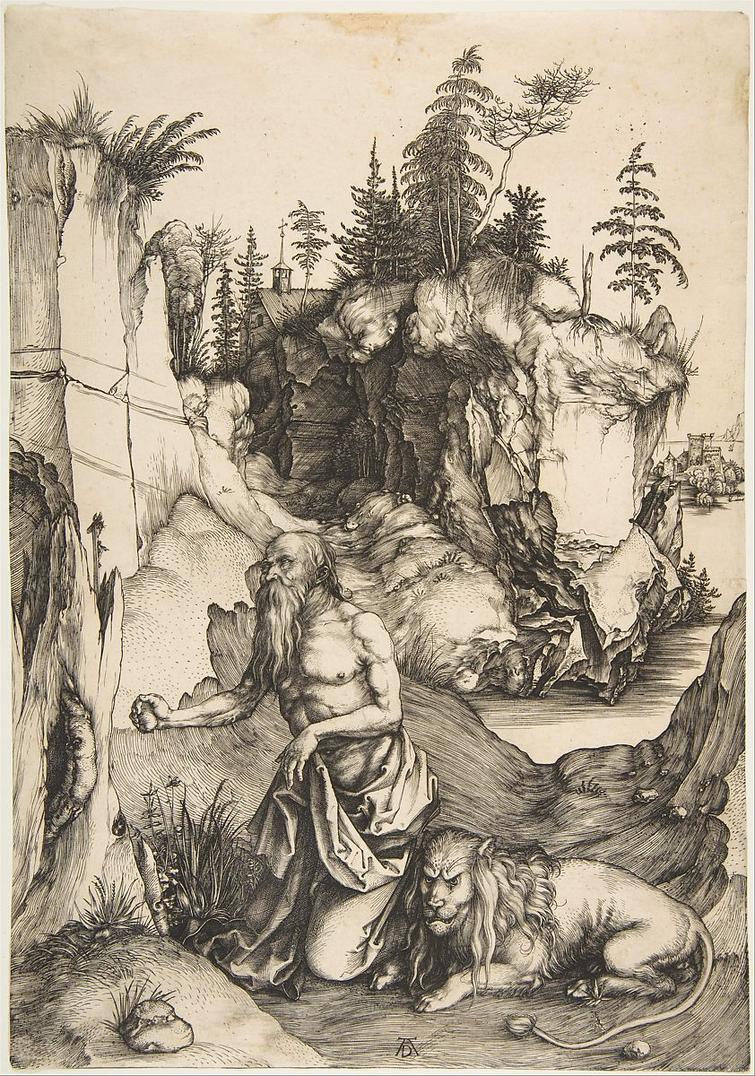 Doctors of the Church issue IV – Saint Jerome, aka Eusebius Hieronymus (his actual Latin name), aka Sophronius (a pseudonym derived from the Greek “sophron,” meaning “self-controlled or sensible,” which he most certainly was not). Along with the other seven original Doctors of the Church, he was designated as such by common acclamation. His Feast Day is 30 September. The readings appointed for the day are Nehemiah 8:1-3, 5-8 / Psalm 119:97-104 / 2 Timothy 3:14-17 / Luke 24:44-48.

A Roman of Latin background and culture, Jerome was born into a wealthy family in about 347 in Stridon, Dalmatia (the exact location of which is unknown – somewhere near what is now Ljubljana, Slovenia, or perhaps in what is now Croatia). He died in Bethlehem, Palestine, probably in 420. He is the patron saint of translators, librarians, encyclopedists, and scholars – nothing fun. He was strong-willed (in a not-so-good way), intense, and had a tendency to act hastily. His life was a tempestuous one generally immersed in controversy. He had a vile temper and a vitriolic pen and was a master of sarcasm. I find this strangely encouraging.

Jerome is generally represented in art either as a mostly naked old man (a nod to his ascetic monasticism) or in cardinal’s robes; rather oddly, given that he was barely a priest, to say nothing of a cardinal, and not to mention cardinals didn’t even exist until some decades after his death. He not infrequently is depicted wearing glasses, which is even odder, given that spectacles didn’t even exist until some *centuries* after his death. He usually has a lion hanging around, which I suppose probably *should* be odd, but at least there *were* lions in his lifetime, and anyway, lions are much more interesting than red robes or pince nez. The lion comes from a legend reporting that one day a lion came limping into the monastery (or classroom) where Jerome was – the others in his company ran off in fright – but Jerome realized the lion was hurt and pulled a thorn from its paw. In gratitude the lion is said to have become a sort of lay brother in Jerome's monastery, doing chores and guarding the monastic donkey.

Jerome is considered to be the most deeply learned of the Latin Fathers. His education began at home, but he was sent to Rome around the age of 12, where he studied grammar, rhetoric, philosophy, and literature. Given this curriculum, it is likely that he may have considered a career in law. By his own admission, once away from his (probably Christian) home, he quickly forgot his morals. While he was not studying, Jerome pursued pleasure, in particular the company of women. To alleviate the feelings of guilt he often felt after some scandalous adventure or another, he would visit the crypts in Rome and imagine himself in hell. He succeeded in frightening himself, but not in changing his ways. I find this strangely encouraging.

Jerome wandered around here and there and finally, in the year 366, decided to confess Christianity and was baptized. In 374 he became extremely ill, coming close to death. Although he downplayed them later in life, he had dreams and visions which turned him even more seriously toward theological pursuits and aestheticism. He was attracted to the monastic life, and spent some time in a desert hermitage, but was pressured by church officials to become ordained. Jerome made it *very* clear he did *not* want to be a priest, but eventually relented on the condition he would not be expected to serve in any ministry and would still be allowed to pursue his monastic life. I find this strangely encouraging.

Although he wrote *a lot,* Jerome is particularly important for having made a translation of the Bible which came to be called the Vulgate, a remarkable effort given the few resources available to him and the fact that the initiative was not widely appreciated. (“Vulgate” because at that time Latin was the “vulgar,” or “common” language.) He was commissioned to do so by Pope Damasus I. There were many different Latin versions of the Bible floating around, and Damasus wanted the church to have a standard version to promote universal doctrine. The end result was cobbled together from the various Latin texts, the Septuagint (Greek translation), and what original Hebrew texts were available. It’s rather a mash-up, but it is still in use today, and readily available.

Jerome is remembered for his extensive erudition, especially his understanding of the classics, the Bible, and Christian tradition. He was a learned scholar rather than a deep thinker, a sound traditionalist and not a speculative theologian, more competent as editor than as exegete (explainer or interpreter of text). Aside from the Vulgate, his correspondence is one of the best known parts of his literary output. It comprises about one hundred and twenty letters from him, and several from his correspondents. Aside from their literary interest they have great historical value. Relating to a period covering half a century they touch upon just about everything, and are full of Jerome’s personality: his waywardness, his love of extremes, his exceeding sensitiveness; how he was in turn exquisitely dainty and bitterly satirical, unsparingly outspoken concerning others and equally frank about himself. In general, his career was a turbulent combination of scholarship, controversy, restlessness, and [asceticism](https://www.britannica.com/topic/asceticism). I find this strangely encouraging.

**HERE AND THERE** *(M. C. Gillette at* [*hapostles@sbcglobal.net*](mailto:hapostles@sbcglobal.net)*)*

*In this on-going article, we pull things from our various Diocesan calendars and church websites to see what’s going on around us. For more information about what's happening at the Diocesan Headquarters and the Cathedral of Saint James, you can always visit their websites:* <https://www.episcopalchicago.org> or <https://www.saintjamescathedral.org/>

Well, as “virtually” everything around the Diocese and the Church as a whole is happening “virtually,” there isn’t a lot to offer in terms of in-person things to do and “out of the house” places to go. You can catch up on some of what’s happening in cyberspace, though, through these resources:

Various Worship and News Resources from the Diocese including Bishop Lee’s Holy Week Sermons

<https://episcopalchicago.org/resources-during-the-pandemic/>

Bishop Lee’s Easter Sermon (only) <https://www.youtube.com/watch?v=yoeDJBWK1_4&feature=youtu.be>

Various Worship and News Resources from the National Church, including the Presiding Bishop’s Holy Week Sermons <https://episcopalchurch.org/>

An eclectic gathering of stories, podcasts, meditations and whatnot – always something interesting and provocative. <https://www.episcopalcafe.com/>

As you can probably guess from the site’s title, “Episcopal News Service,” you can read up on current events of particular import to the Church at the moment here – Virginia Theological Seminary’s pilot “Dial-a-Priest” program, for example, or the reaction of our New England bishops to the revocation of Mashpee Wampanoag reservation status. <https://www.episcopalnewsservice.org/>

And while this is from none of our “Episcopal” information sites, the Church welcomes a bit of humor, especially in these times. If you haven’t seen these, I pray they bring a little smile to your face – famed BBC Sportscaster Andrew Cotter’s Coverage of the “Competitions” between his black and yellow Labs.

<https://www.theguardian.com/lifeandstyle/2020/apr/10/coronavirus-stars-bbc-sports-commentator-andrew-cotters-dogs-olive-and-mabel-go-viral>

**SOME CHURCHY STUFF** *(M. C. Gillette at* [*hapostles@sbcglobal.net*](mailto:hapostles@sbcglobal.net)*) In this monthly article, we look at terms and definitions of things you might see or hear around church. Nothing fancy here – these entries are out of the Armentrout/Slocum An Episcopal Dictionary of the Church, sometimes supplemented by me, and sometimes simply copied directly. If something in particular piques your interest, let me know, and we’ll deal with it in more depth.*

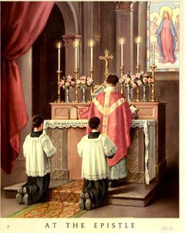**EPISTLE.** The astute reader will note that “Epistle” does not come *after* “Establishment” in any dictionary of the English language, Episcopalian or otherwise, in spite of the fact that the last entry in last month’s “Churchy Stuff” was “Establishment of Religion.” But rummaging around the online glossary is not a perfect process. So we shall go back to move ahead. (It will also be obvious that we are smooshing a couple derivative entries – Epistle Side and Epistoler – into the “Epistle” entry.)

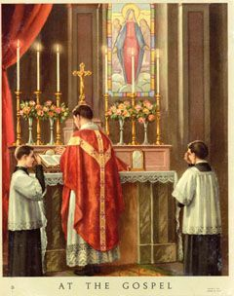 An “epistle” is a letter. As Mel Lawrenz has written, when we read from one of the epistles – which we usually do for our second lesson on Sunday – we are basically reading someone else’s mail. Some of these letters read like highly crafted treatises – the magisterial epistle to the Romans, for example. Others, like 1 and 2 Corinthians, are intimately connected with the needs of a particular group, in this case the believers in the church in Corinth. They had evidently written the apostle Paul and asked specific questions, because he says in 1 Corinthians 7:1, “Now for the matters you wrote about… ” and then goes on at some length, responding point by point. Earlier in that same letter, Paul was responding to certain oral reports he’d gotten about what was going on in that complicated and troubled church.

A wide range of circumstances prompted the writing of the epistles. Disorder in a church, the threat of false teaching, trepidation about the end of the world, confusion about death, controversy over religious practices, ambiguity about ethics, weakness in leadership. Some epistles were meant as a word of encouragement or just a way of reconnecting. The books of Hebrews and Romans offer an expansive theological perspective. Some letters focus on a particular theological point: grace in the case of Galatians, Christ in the case of Colossians, the church in the case of Ephesians. There are 21 letters in the Canon of Holy Scripture, constituting a multifaceted, real-life description of both faith and behavior.

The **EPISTLE SIDE** is an archaic term referring to the right side of the altar, and that side of the church building, as viewed by the congregation. (House Right for you theater geeks.) The epistle was read from this side of the altar in the low mass of the Roman Rite. The gospel was read from the opposite side of the altar and was therefore known, as you might expect, as the “Gospel Side.” This usage made its way into widespread Anglican practice after the revival of a more formal mass in the second half of the nineteenth century. The Book of Common Prayer discourages identifying “Epistle” and “Gospel” sides, stating "it is desirable that the lessons be read from a lectern or pulpit, and that the Gospel be read from the same lectern, or from the pulpit, or from the midst of the congregation" (p. 406). The epistle is read, although no longer from the epistle side, by an **EPISTOLER** – the term simply referring to the person who reads the second lesson in worship.

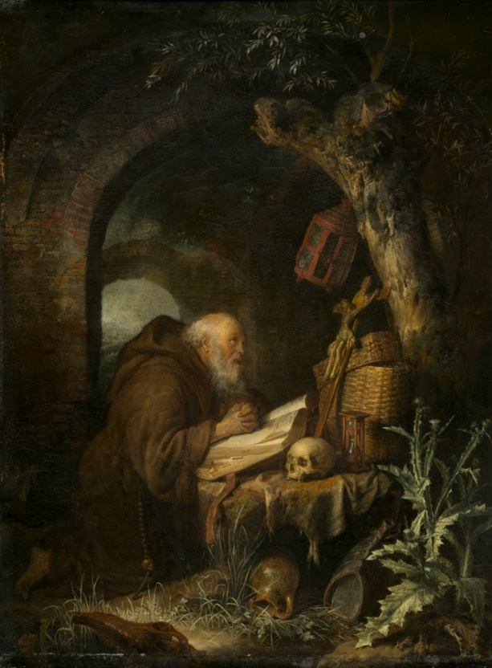**EREMITIC.** “Of or pertaining to an eremite,” duh! (One might think the Episcopal Church Dictionary would be a little more compassionate than others and refrain from “defining” a term by using the same term, leaving the whole mess functionally incomprehensible – but alas. No. And why is “eremitic” in the Episcopal Dictionary, anyway, but not “eremite?” Gnrrr, Gnrrr.) Anyway, an “eremite” is a recluse or hermit, one who has retired from the world into solitude. “Eremitic,” therefore, describes such a solitary lifestyle. The word comes from medieval Latin through ecclesiastical Greek – the root word being “desert,” or “uninhabited.” Honestly, it’s something of an affectation, since the word is basically “hermit” without the “h.” In late Latin and Old French, into Middle English, the terms h/eremite and h/ermit/e were used interchangeably, but since about the middle of the 17th century usage fell down on the “hermit” side with the use of “eremite” being restricted to poetry, rhetoric, or, apparently, Episcopal Church Dictionaries. In Christianity, the earliest eremites were the Desert Fathers of 3rd century Egypt. And as they mostly spoke Coptic, they could have found the distinction meaningless. (Do you ever wonder where these guys find all the skulls?)

**ESCHATOLOGY.** The branch of theology that deals with the “last things” (traditionally said to be four – death, judgement, heaven, and hell) – the end of time and history, the coming of the Kingdom of God in its fullness. Use of the term dates from the 19th century. It is from the Greek, eschatos, "last." Eschatology concerns the final end and meaning of all things, but it is possible to distinguish individual, social, and universal aspects of eschatology. The Christian hope is centered in the victorious Christ, who will come again in glory to judge the living and the dead and whose kingdom will have no end (see the Nicene Creed, BCP, p. 359; and the Apostles' Creed, BCP, p. 96). Some approaches to eschatology emphasize the coming of the Kingdom of God as a radical break from the existence of creation as we know it, or a breaking into time from the future. Other approaches emphasize that the power of God's Kingdom was inaugurated in Christ's life, death, and resurrection, and that God's power for salvation and the fulfillment of all things is currently active in history. Thomas Aquinas understood the ultimate end and perfect happiness of humanity in terms of union with God, which may be described as the beatific vision. He also held that each thing intends as its ultimate end to be united to God as closely as possible for it. The New Testament scholar C.H. Dodd presented a "realized eschatology" in which the perfect fulfillment of the messianic hope is realized in Jesus' incarnate life and earthly ministry. The Kingdom of God may be understood as already present through Christ's resurrection and yet to be fulfilled perfectly when Christ returns at the end of time. The theme of Christian expectation for the coming of Christ in power and glory is given liturgical expression in the season of Advent. The Prayer Book Catechism states that "the Christian hope is to live with confidence in newness and fullness of life, and to await the coming of Christ in glory, and the completion of God's purpose for the world" (BCP, p. 861). The Catechism section on the Christian Hope considers such eschatological themes as the meaning of the coming of Christ in glory, the meaning of heaven and hell, prayers for the dead, the meaning of the last judgment, the meaning of the resurrection of the body, the communion of saints, the meaning of everlasting life, and the Christian assurance (BCP, p. 862). The event eschatology deals with is the **ESCHATON**, as above, the end of history when God will act decisively to establish the divine rule of justice and peace throughout the created order. The resurrection signals a preliminary victory over sin and death and points to the final victory. The quality of life in the eschaton is shown to Christian believers by the love, justice, and peace that marked Jesus' life and death.

|  |  |  |  |  |  |  |  |  |  |  |
| --- | --- | --- | --- | --- | --- | --- | --- | --- | --- | --- |
| **EPISCOPAL CHURCH OF THE HOLY APOSTLES UPCOMING SERVICES FOR APRIL 2020 (Revised)** | | | | | | | | | | |
| **Sunday**  **April**  **05th**  **7:00**  **p.m.**  Palm  Sunday Evening  Worship | **Mon-days**  April  06th  13th  20th  27th  **8:30**  **a.m**.  Morning  Prayer | **Tues-days**  April  7th  14th  21st  28th  **8:30**  **a.m.**  Virtual  Coffee  Hour | **Wednes-**  **days**  April  1st,  8th  15th  22nd  29th  **8:30**  **a.m.**  Morning  Prayer | **Thurs-**  **days**  April  2nd  9th  16th  23rd  30th  **8:30**  **a.m.**  Virtual  Coffee  Hour | **Fri-**  **days**  April  3rd  10th  17th  24th  **8:30**  **a.m.**  Morning  Prayer | **Thursday**  **April**  **09th**  **7:00**  **p.m.**  Maundy  Thursday  Evening  Worship | **Friday**  **April**  **10th**  **7:00 p.m.**  Good  Friday  Evening  Worship | **Sunday**  **April**  **12th**  **7:00**  **p.m.**  Easter  Sunday  Evening  Worship | **Sunday**  **April**  **19th**  **7:00 p.m.**  2nd  Sunday of  Easter  Evening  Worship | **Sunday**  **April**  **26th**  **7:00**  **p.m.**  3rd  Sunday  Of  Easter  Evening  Worship. |
| Services Conducted online via WebEx  If you would like to participate but need an invitation/another invitation, please contact  (Mother) Martha at [marthagillette@att.net](mailto:marthagillette@att.net) or by text at 847.226.9043 | | | | | | | | | | |
| Liturgy  of the  Palms:  Matthew  21:1-11  Psalm  118:19-29  Liturgy  of the  Word:  First  Lesson  Isaiah  50:4-9a  Response Psalm  31:9-16  Second  Lesson  Philipp.  2:5-11  The Passion  of our Lord  Jesus Christ  according to  Matthew |  |  |  |  |  |  |  | First  Lesson  Jeremiah  31:1-6    Response Psalm  118:1-2, 14-24  Second  Lesson  Coloss.  3:1-4  Gospel  Matthew  28:1-10 | First  Lesson  Acts  2:14a, 22-32  Response Psalm  16  Second  Lesson  1 Peter  1:3-9  Gospel  John  20:19-31 | First  Lesson  Acts  2:14a, 36-41  Response Psalm:  116:1-3, 10-17  Second  Lesson  1 Peter  1:17-23  Gospel  Luke  24:13-35 |

**IN OUR** **PARISH LIFE:**

**COFFEE AND CONVERSATION: Are you missing the smiling faces of your fellow holy apostles??**

Join in on Tuesday and Thursday mornings at 8:30 AM for Virtual Coffee Hour! It’s easy, and you don’t even have to get out of your pajamas! Chat with your friends, it really helps with feeling connected. If you need an email invitation because you can’t find the original email that Mother Martha sent on March 31, she can send another invitation to your email address – contact her at 847-226-9043 or email at [marthagillette@att.net](mailto:marthagillette@att.net).

Then be sure to click on JOIN MEETING to accept the invitation right away, otherwise it will expire in 2 days. Accepting the invitation does not commit you to attend any, some, or all of the sessions, but it is necessary if you wish to do so. Then be sure to SAVE that email- DO NOT DELETE it! You can reuse it to join all subsequent Coffee Hours.

**MORNING PRAYER:** Please join Mother Martha and other apostles on Monday, Wednesday, and Friday mornings beginning at 8:30 AM for Virtual Morning Prayer. It’s the same drill as above, receive an email invitation, and click on JOIN MEETING.

**SHAWL MINISTRY:** The Shawl Ministry meets on **the second Monday of the month**. No experience is necessary! Please contact Marsha Taylor at [mktaylor730@hotmail.com](mailto:mktaylor730@hotmail.com) or 847-977-5399 with any questions.

**BISHOP’S COMMITTEE MEETING:** Bishop’s Committee will meet on **Tuesday 21 April at 7:00 p.m. via WebEx.** Mother Martha will email an invitation to all committee members.

**BOOK DISCUSSION GROUP:** The Holy Apostles Book Club meets on the fourth Tuesday of the month (unless otherwise noted) at a different member’s home each month. Our titles are available at the Ela Public Library about a month before the discussion date and the due dates are extended to after the meeting. All are welcome to come to any meeting; there is no commitment for attendance or for hosting. If you see a title that catches your eye, or would just like to try something new, please feel free to join us! For more information, contact Lisa Earley at [lisa.earley@groble.me](mailto:lisa.earley@groble.me) . This month the Book Group will meet on **April 28 at 7:30 PM** to discuss *Educated* by Tara Westover. Please contact Lisa for more information on location, virtual or otherwise.

**BIG TABLE:** Big Table is still providing food on Tuesdays from 5:00 – 6:00 PM. The new procedure involves driving your car up to the front door of Lincoln Hall, where a cheerful volunteer will bring a bag of groceries to your car to take home. You do not have to register ahead of time, just show up!

**HOSTS NEEDED:** Please consider signing up to serve as Host for occasional Sunday services in 2020. Host duties are written up on a sheet and are easy to follow and carry out. You can sign up on the colorful board in Lincoln Hall.

**ALCOHOLICS ANONYMOUS MEETINGS:** As the church buildings are closed through the end of April,

Saturday morning meetings will not take place in Lincoln Hall. Please contact Tim Zuellig for more information about meetings at 312-888-0073.

|  |  |  |  |  |  |  |
| --- | --- | --- | --- | --- | --- | --- |
| **APRIL 2020 (See PAGE above for Service Schedule)** | | | | | | |
| **SUN** | **MON** | **TUE** | **WED** | **THU** | **FRI** | **SAT** |
|  |  |  | 1  8:30 AM  Virtual Morning Prayer | 2 | 3 | 4  10 AM—noon  Food Pantry |
| 5 **PALM SUNDAY**  7:00 PM  WebEx service | 6  8:30 AM  Virtual Morning Prayer | 7  8:30 AM  Virtual Coffee  And Convo | 8  8:30 AM  Virtual Morning Prayer | 9  8:30 AM  Virtual Coffee  **MAUNDY THURSDAY**  Service: 7 PM | 10  8:30 AM  Virtual Morning Prayer  **GOOD FRIDAY**  7:00 PM | 11  10 AM—noon  Food Pantry |
| 12  **EASTER**  7:00 PM  WebEx service | 13  8:30 AM  Virtual Morning Prayer | 14  8:30 AM  Virtual Coffee  And Convo | 15  8:30 AM  Virtual Morning Prayer | 16  8:30 AM  Virtual Coffee  And Convo | 17  8:30 AM  Virtual Morning Prayer | 18  10 AM—noon  Food Pantry |
| 19  7:00 PM  WebEx service | 20  8:30 AM  Virtual Morning Prayer | 21  8:30 AM  Virtual Coffee  And Convo  ---------------  7:00 PM  Bishop’s Committee  via WebEx | 22  8:30 AM  Virtual Morning Prayer | 23  8:30 AM  Virtual Coffee  And Convo | 24  8:30 AM  Virtual Morning Prayer | 25  10 AM--noon  Food Pantry |
| 26  7:00 PM  WebEx service | 27  8:30 AM  Virtual Morning Prayer | 28  8:30 AM  Virtual Coffee  And Convo  ---------------  7:30 PM  Book Group | 29  8:30 AM  Virtual Morning Prayer | 30 |  |  |

**April Birthdays**

Apr 03 Melissa Petersen Apr 23 Emma Felice

Apr 17 Jim Pinder Apr 25 Jean Miller

**April Anniversaries**

Apr 04 Lynn and Wayne Chmiel Apr 28 Virginia and Ken Balmes

Apr 25 Kristi and Doug Connell Apr 29 Aline and Dean Denges



**FROM: Church of the Holy Apostles**

**26238 North Highway 59**

**Wauconda, Illinois 60084**