We will:
Stay home if we feel ill

Remove all non-essential items from our worship spaces

Wear a mask at all times

Follow the seating plan
Physically distance – no hugs or handshakes

Enjoy instrumental music only

Properly dispose of all items used (bulletins, communion cups, etc.)

Use hand sanitizer as appropriate

Minimize bathroom use to the extent possible

Follow the modified communion procedure

Clean and disinfect after each service

Be patient, kind, tolerant and flexible

Second Sunday of Advent (B)
Sunday 20 2020

EPISCOPAL CHURCH OF THE HOLY APOSTLES
26238 N HWY 59, Wauconda, IL 60084
www.holyapostleswauconda.net

Under our modified communion procedure, the offering plate will not be passed.
If you have gifts to share, please place them in the plate at the entrance to the church.

OPENING VOLUNTARY

WORDS OF WELCOME

INTROIT (Please remain seated)
Presider: The world is on the edge, / Taut with expectation / Breathless with imminence / Caught up in anticipation. / Some thing is going to change / Something . . . / Something hovers just out of sight / Beyond our imagining / Beyond our dreaming / Beyond our hoping / God moves / And we are on the brink / Of the incredible. / Come, Emmanuel, come.

OPENING HYMN H1982, #65
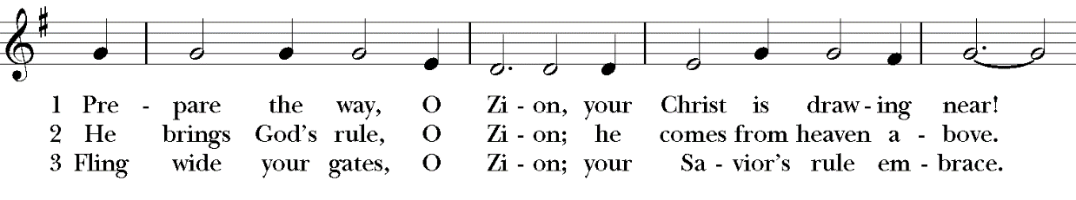
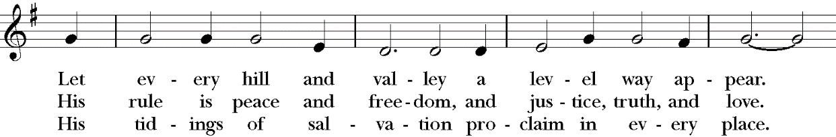
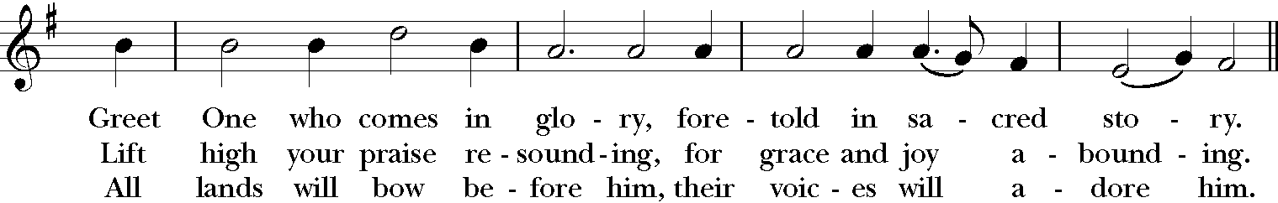
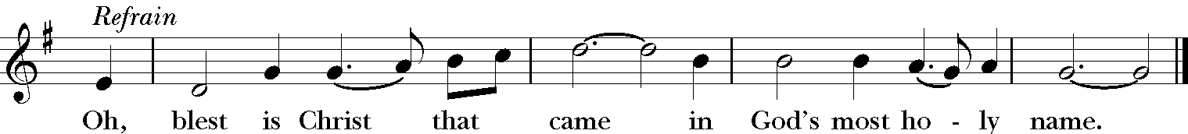

OPENING SENTENCES (Please remain standing)
Presider: Our souls magnify the Lord, and our spirits rejoice in God.
People: We trust in God’s extravagant love.
Presider: The Mighty One has done great things. Holy is God’s name.
People: We trust in God’s extravagant love.
Presider: Mercy is for those who fear God from generation to generation.
People: We trust in God’s extravagant love.
Presider: God has brought the powerful from their thrones, and lifted up the lowly. God has filled the hungry with good things and sent the rich away empty.
People: We trust in God’s extravagant love.
Presider: Three candles have been lighted in the past: candles representing hope, peace, and joy. Today we have lighted the fourth candle, the candle of love. In so doing, we remind ourselves to open our hearts to God’s love; the love that waits to fill our hearts that we may be signs of God’s extravagant love for the whole world. Amen. ^{Based on Luke 1:46-55}

COLLECT FOR PURITY
Presider: Almighty God, to you all hearts are open, all desires known, and from you no secrets are hid: Cleanse the thoughts of our hearts by the inspiration of your Holy Spirit, that we may perfectly love you, and worthily magnify your holy Name; through Christ our Lord. Amen.

HYMN OF PRAISE (Please say together in unison) H1982, #74 (v. 1)
Blest be the King whose coming is in the name of God!
For him let doors be opened, no hearts against him barred!
Not robed in royal splendor, in power and pomp, comes he;
but clad as are the poorest, such is his humility!

COLLECT OF THE DAY
Presider: The Lord be with you.
People: And also with you.
Presider: Let us pray. God of impossible love, you needed Mary to give consent, to bear the scandal, to carry your word within herself: may her courage give hope to women and men who yearn to sing new songs of justice and find the world a dwelling place for God; through Jesus Christ, the one who is to come.
People: Amen.

We read each month from the various biblical translations authorized by our Church. This month we read from the Authorized (King James) Bible (1611)

FIRST LESSON 2 Samuel 7:1-11, 16
Reader: A reading from the second Samuel. 7 And it came to pass, when the king sat in his house, and the Lord had given him rest round about from all his enemies; ² That the king said unto Nathan the prophet, See now, I dwell in an house of cedar, but the ark of God dwelleth within curtains. ³ And Nathan said to the king, Go, do all that is in thine heart; for the Lord is with thee. ⁴ And it came to pass that night, that the word of the Lord came unto Nathan, saying, ⁵ Go and tell my servant David, Thus saith the Lord, Shalt thou build me an house for me to dwell in? ⁶ Whereas I have not dwelt in any house since the time that I brought up the children of Israel out of Egypt, even to this day, but have walked in a tent and in a tabernacle. ⁷ In all the places wherein I have walked with all the children of Israel spake I a word with any of the tribes of Israel, whom I commanded to feed my people Israel, saying, Why build ye not me an house of cedar? ⁸ Now therefore so shalt thou say unto my servant David, Thus saith the Lord of hosts, I took thee from the sheepcote, from following the sheep, to be ruler over my people, over Israel: ⁹ And I was with thee whithersoever thou wentest, and have cut off all thine enemies out of thy sight, and have made thee a great name, like unto the name of the great men that are in the earth. ¹⁰ Moreover I will appoint a place for my people Israel, and will plant them, that they may dwell in a place of their own, and move no more; neither shall the children of wickedness afflict them any more, as beforetime, ¹¹ And as since the time that I commanded judges to be over my people Israel, and have caused thee to rest from all thine enemies. Also the Lord telleth thee that he will make thee an house. ¹⁶ And thine house and thy kingdom shall be established for ever before thee: thy throne shall be established for ever. The word of the Lord.
People: Thanks be to God.

RESPONSE (Please say together in unison) Psalm 89:1-4, 19-26
¹ I will sing of the mercies of the Lord for ever: with my mouth will I make known thy faithfulness to all generations.
² For I have said, Mercy shall be built up for ever: thy faithfulness shalt thou establish in the very heavens.
³ I have made a covenant with my chosen, I have sworn unto David my servant,
⁴ Thy seed will I establish for ever, and build up thy throne to all generations. Selah.
¹⁹ Then thou spakest in vision to thy holy one, and saidst, I have laid help upon one that is mighty; I have exalted one chosen out of the people.
²⁰ I have found David my servant; with my holy oil have I anointed him:
²¹ With whom my hand shall be established: mine arm also shall strengthen him.
²² The enemy shall not exact upon him; nor the son of wickedness afflict him.
²³ And I will beat down his foes before his face, and plague them that hate him.
²⁴ But my faithfulness and my mercy shall be with him: and in my name shall his horn be exalted.
²⁵ I will set his hand also in the sea, and his right hand in the rivers.
²⁶ He shall cry unto me, Thou art my father, my God, and the rock of my salvation.
SECOND READING Romans 16:25-27
Reader: A reading from the letter to the Romans. ¹⁶ Rejoice evermore. ¹⁷ Pray without ceasing. ¹⁸ In every thing give thanks: for this is the will of God in Christ J ²⁵ Now to him that is of power to stablish you according to my gospel, and the preaching of Jesus Christ, according to the revelation of the mystery, which was kept secret since the world began, ²⁶ But now is made manifest, and by the scriptures of the prophets, according to the commandment of the everlasting God, made known to all nations for the obedience of faith: ²⁷ To God only wise, be glory through Jesus Christ for ever. Amen. The word of the Lord.
People: Thanks be to God.

GRADUAL HYMN (vv. 1, 5, 6) H1982 #60
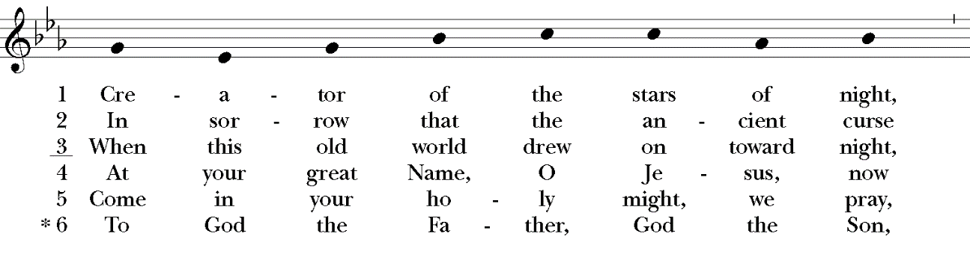
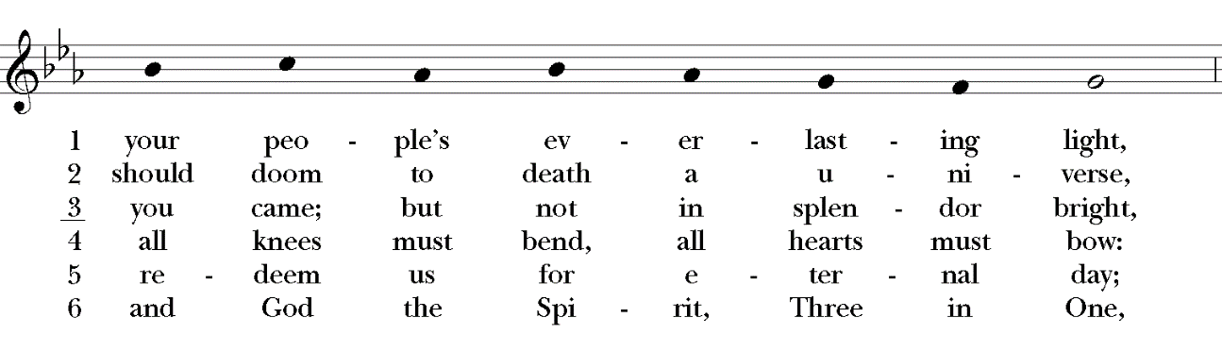
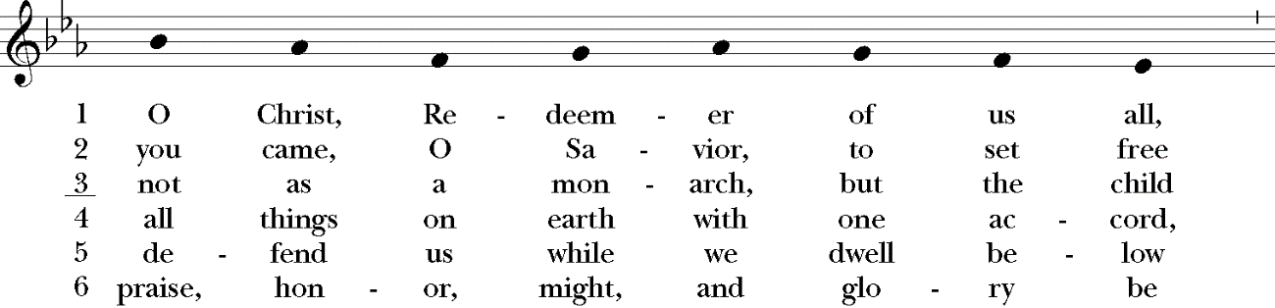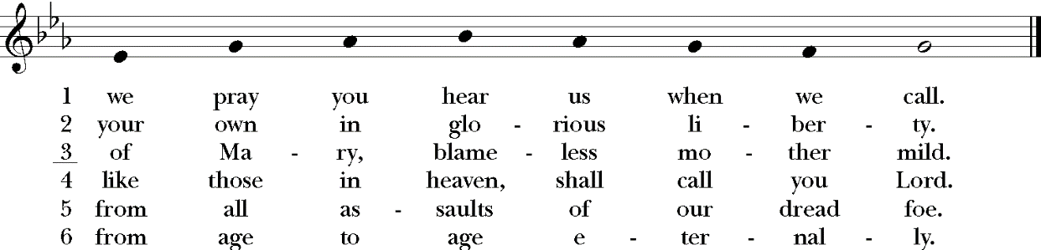

GOSPEL Luke 1:26-38
Presider: The Holy Gospel of our Lord Jesus Christ according to Luke.
People: Glory to you, Lord Christ.
Presider: ²⁶ And in the sixth month the angel Gabriel was sent from God unto a city of Galilee, named Nazareth, ²⁷ To a virgin espoused to a man whose name was Joseph, of the house of David; and the virgin's name was Mary. ²⁸ And the angel came in unto her, and said, Hail, thou that art highly favoured, the Lord is with thee: blessed art thou among women. ²⁹ And when she saw him, she was troubled at his saying, and cast in her mind what manner of salutation this should be. ³⁰ And the angel said unto her, Fear not, Mary: for thou hast found favour with God. ³¹ And, behold, thou shalt conceive in thy womb, and bring forth a son, and shalt call his name Jesus. ³² He shall be great, and shall be called the Son of the Highest: and the Lord God shall give unto him the throne of his father David: ³³ And he shall reign over the house of Jacob for ever; and of his kingdom there shall be no end. ³⁴ Then said Mary unto the angel, How shall this be, seeing I know not a man?
³⁵ And the angel answered and said unto her, The Holy Ghost shall come upon thee, and the power of the Highest shall overshadow thee: therefore also that holy thing which shall be born of thee shall be called the Son of God. ³⁶ And, behold, thy cousin Elisabeth, she hath also conceived a son in her old age: and this is the sixth month with her, who was called barren. ³⁷ For with God nothing shall be impossible. ³⁸ And Mary said, Behold the handmaid of the Lord; be it unto me according to thy word. And the angel departed from her. The Gospel of the Lord.
People: Praise to you, Lord Christ.

SERMON The Rev. M. C. Gillette
(A brief period of silence follows the sermon)

AFFIRMATION OF FAITH FOR ADVENT (Please say together in unison)
We believe in God, creator and lover of the earth, origin and destiny of us all. We believe in Jesus the Christ—God coming to us in the fragile promise of a baby yet unborn—who emerges as the herald of hope, God's laughter in the face of despair. Plunged into death and hell, he liberated the captives, and is leading the way to the land of promise where justice and peace will flourish. We believe in the Holy Spirit, who implants the seed of truth, brings us to birth as the body of Christ, and empowers us to confront and transform all that is corrupt, degrading and deceitful. We believe in the coming reign of God. Announced by the Baptist, it has drawn near to us in Jesus, and will be consummated in the glorious marriage of earth and heaven, when all who have passed through the world's deep sorrow will be raised from the waters, robed in righteousness, and gathered into the joyous fulfilment of God's desire. For the coming of that day, on this day we work and pray: Come, Lord Jesus, Come!

PRAYERS OF THE PEOPLE
Leader: Let us pray to the Lord saying, ‘Lord Jesus, come in Glory.’
Leader: In this season of preparation, we pray for the whole church; for compassion, devotion, tolerance, and a commitment to unity and concord among her leaders and members. We pray for all bishops, priests, and deacons. We pray for those on our Anglican and Diocesan Cycles of prayer. We pray for all who minister, in any capacity.
People: Lord Jesus, come in Glory.
Leader: In this season of longing, we pray for our nation, and for all the nations of the world. We pray for all those who govern, and we ask you to grant them wisdom and vision. We pray for those who hold any sort of authority, that they be filled with kind and generous hearts, and a hunger for the common good.
People: Lord Jesus, come in Glory.
Leader: In this season of vigilance, we pray for the welfare of the world. We pray for strength and courage to live as you would have us live, gently, without greed, and with reverence for your good creation.
People: Lord Jesus, come in Glory.
Leader: In this season of expectation, we pray for the needs of our community; for healing and wholeness, relief and reconciliation. We pray especially for those whose names we raise up now, either silently or aloud (we will keep a 10-second silence). We pray for all who suffer from any want or worry.
People: Lord Jesus, come in Glory.
Leader: In this season of anticipation, we thank you for those celebrating birthdays and anniversaries this week, in particular those whose names we raise up now, either silently or aloud (we will keep a 10-second silence). We also offer prayers of thanksgiving for the blessings in our lives.
People: Lord Jesus, come in Glory.
Leader: In this season of hope, we pray for those who have died, especially those whose names we raise up now, either silently or aloud (we will keep a 10-second silence). We thank you that in your grace you have offered us a new, perfect, and eternal existence, in which we are united with all your people, in the joy of fully knowing and loving you and each other.
People: Lord Jesus, come in Glory.
(The Presider offers this or another concluding collect): Hasten, O Father, the coming of your kingdom; and grant that we your servants, who now live by faith, may with joy behold your Son at his coming in glorious majesty; even Jesus Christ, our only Mediator and Advocate.
People: Amen.
CONFESSION AND ABSOLUTION OF SIN (Please say together in unison)
Presider: Let us confess our sins to God.
Almighty God, you bring our fears and failings into the light of love; we prefer to hide in the shadows. Lord have mercy. Merciful God, you promise healing for the earth; we turn our backs on our common world and our brothers and sisters in Christ. Christ have mercy. Loving God, you come near in the vulnerable Word made flesh; we worship distant idols of celebrity and power. Lord have mercy.
Presider: God’s judgment is not vengeance, an eye for an eye; his peace is not false, a veil for injustice; he comes to break the spear, to silence the guns, and still our warring souls. God have mercy on you, pardon you, and set you free, strengthening you in all goodness and keeping you in life eternal.
People: Amen.

THE PEACE (Please greet each other in the name of the Lord.)
Presider: May the peace of Christ rule our world and heal our hearts.
People: Amen.

(The Presider gives an Offertory Sentence or says:) Ascribe to the Lord the honor due his Name; bring offerings and come into his courts.

OFFERTORY HYMN H1982, #69
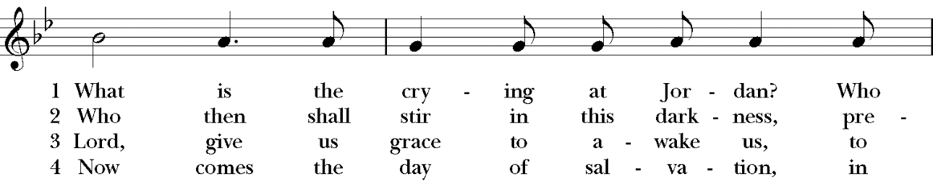
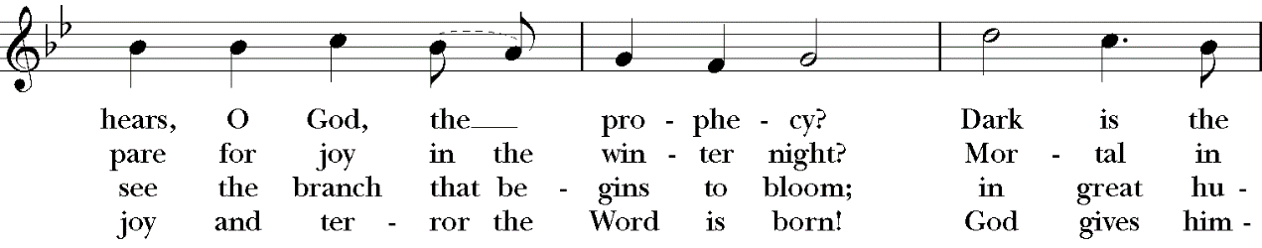
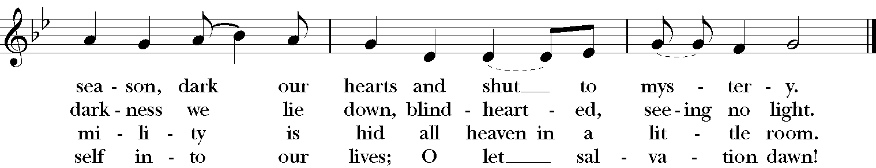

THE GREAT THANKSGIVING (Rite II, Prayer B)
Presider: The Lord be with you.
People: And also with you.
Presider: Lift up your hearts.
People: We lift them to the Lord.
Presider: Let us give thanks to the Lord our God.
People: It is right to give God thanks and praise.

Presider: Mystery of winter skies, we thank you in the darkening hour for opening our eyes to see your starlit beauty; for parting the wide heavens to send your gentle light; for offering your Word to take our mortal flesh. He was promised by those who shared your dream of peace; John the Baptist cleared his way with words of desert fire; Mary and Joseph accepted his coming with tenderness and faith; we know that he draws near again to show us who we really are with honesty and love. Now we take up the song of hope that we might awaken to his coming among us and the world might be touched by the footfall of his glory:
SANCTUS (Please say together in unison)
Holy, holy, holy Lord, God of power and might, heaven and earth are full of your glory. Hosanna in the highest. Blessed is he who comes in the name of the Lord. Hosanna in the highest.

Presider: We give thanks to you, O God, for the goodness and love which you have made known to us in creation; in the calling of Israel to be your people; in your Word spoken through the prophets; and above all in the Word made flesh, Jesus, your Son. For in these last days you sent him to be incarnate from the Virgin Mary, to be the Savior and Redeemer of the world. In him, you have delivered us from evil, and made us worthy to stand before you. In him, you have brought us out of error into truth, out of sin into righteousness, out of death into life.

↑On the night before he died for us, our Lord Jesus Christ took bread; and when he had given thanks to you, he broke it, and gave it to his disciples, and said, “Take, eat: This is my Body, which is given for you. Do this for the remembrance of me.”

↑After supper he took the cup of wine; and when he had given thanks, he gave it to them, and said, “Drink this, all of you: This is my Blood of the new Covenant, which is shed for you and for many for the forgiveness of sins. Whenever you drink it, do this for the remembrance of me.”

Therefore, according to his command, O Father,
We remember his death, We proclaim his resurrection, We await his coming in glory.

Presider: And we offer our sacrifice of praise and thanksgiving to you, O Lord of all; presenting to you, from your creation, this bread and this wine.

∞ We pray you, gracious God, to send your Holy Spirit upon these gifts that they may be the sacrament of the Body of Christ and his Blood of the new Covenant. + Unite us to your Son in his sacrifice, that we may be acceptable through him, being sanctified by the Holy Spirit. In the fullness of time, put all things in subjection under your Christ, and bring us to that heavenly country where, with all your saints, we may enter the everlasting heritage of your sons and daughters; through Jesus Christ our Lord, the firstborn of all creation, the head of the Church, and the author of our salvation.

↑By him, and with him, and in him, in the unity of the Holy Spirit all honor and glory is yours, Almighty Father, now and for ever. AMEN.

THE LORD’S PRAYER (Please say together in unison)
Presider: As our Savior Christ has taught us, we now pray,
Our Father in heaven, hallowed be your Name, your kingdom come, your will be done, on earth as in heaven. Give us today our daily bread. Forgive us our sins as we forgive those who sin against us. Save us from the time of trial, and deliver us from evil. For the kingdom, the power, and the glory are yours, now and for ever. Amen.

FRACTION (THE BREAKING OF THE BREAD)
(The Presider breaks the consecrated bread. A brief period of silence is kept.)

Presider: We break this bread to share in the body of Christ.
People: We who are many are one body, for we all share the one bread.

PRAYER OF HUMBLE ACCESS (Please say together in unison)
Most merciful Lord, your love compels us to come in. Our hands were unclean, our hearts were unprepared; we were not fit even to eat the crumbs from under your table. But you, Lord, are the God of our salvation, and share your bread with sinners. So cleanse and feed us with the precious body and blood of your Son, that he may live in us and we in him; and that we, with the whole company of Christ, may sit and eat in your kingdom. Amen.
Presider: The gifts of God for the People of God. Take them in remembrance that Christ died for you, and feed on him in your hearts by faith, with thanksgiving.

COMMUNION HYMN (vv, 1, 3, 8) H1982, #56
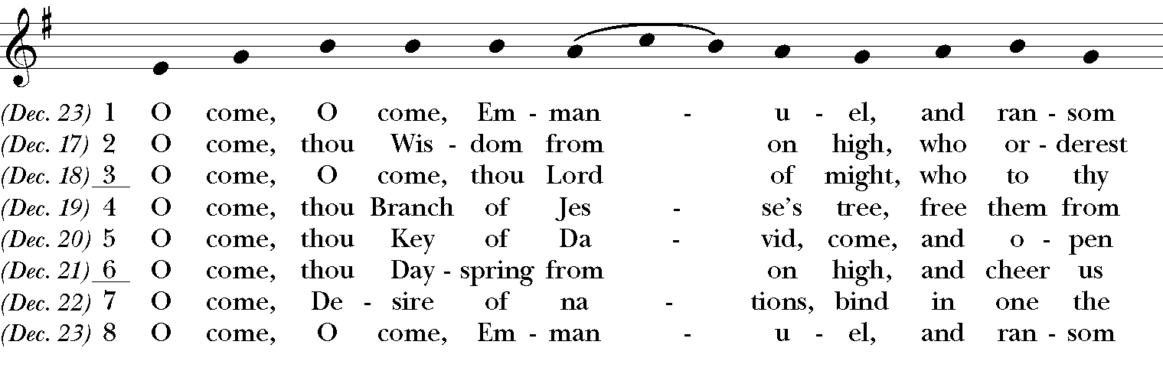
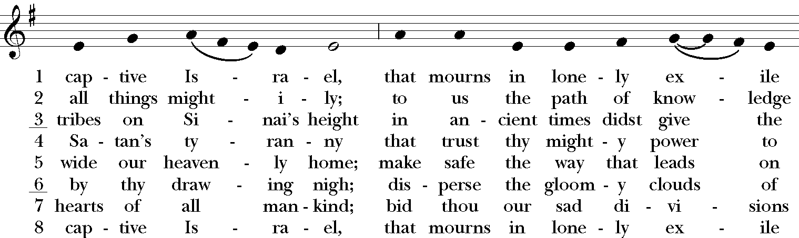
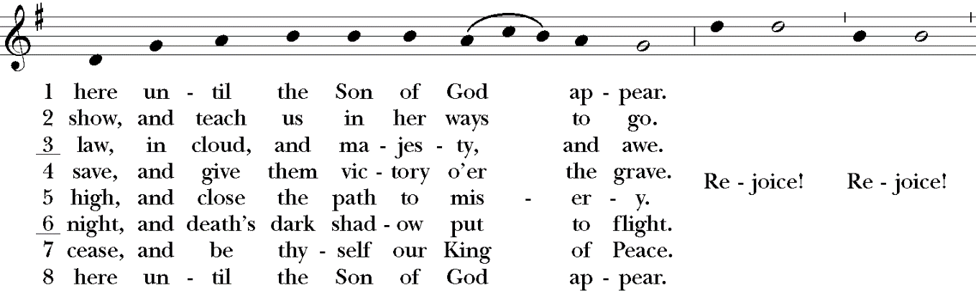

POST-COMMUNION PRAYER (Please say together in unison)
Presider: Let us pray.
Eternal God, we thank you that in Christ you give yourself into our hands: may we who have tasted life proclaim the coming feast when many will come from east and west, from north and south to greet the Lord of all; we ask this in his name. Amen.

BLESSING
Presider: May the God who brings heaven close to earth give truth to our judgment and flame to our longing that our hearts might be ready to be born again in love; and the blessing of God, the Holy Immortal One, the Incarnate Word, and the Breath of Life, be with you now and remain with you always. Amen.

CLOSING HYMN H1982, #76
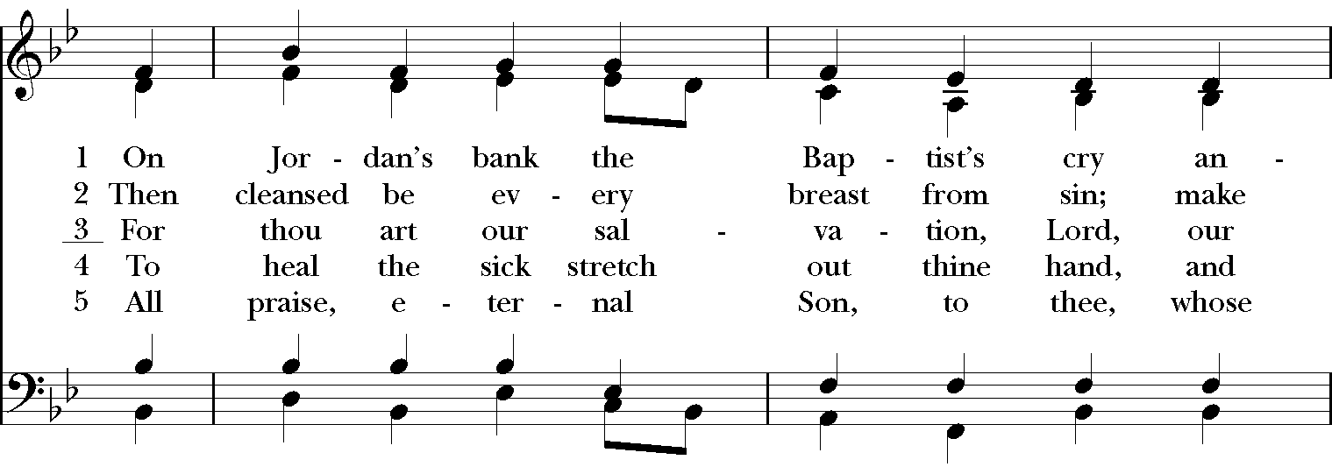
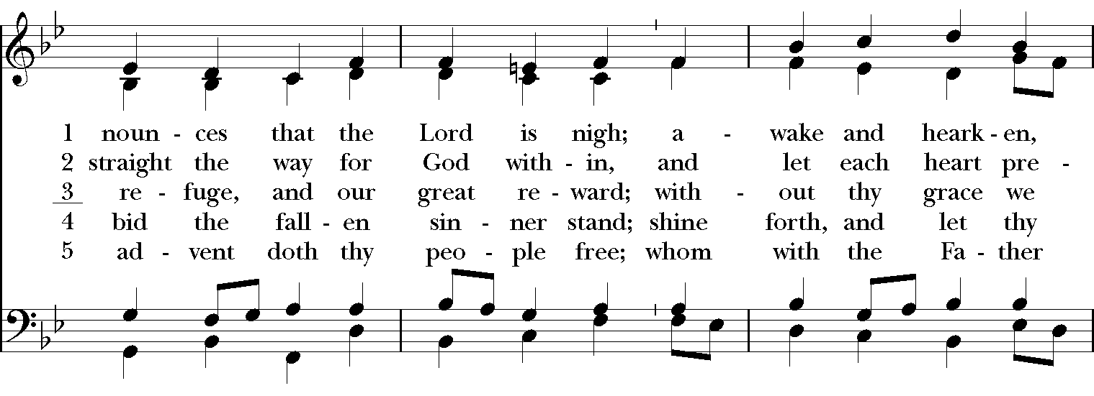
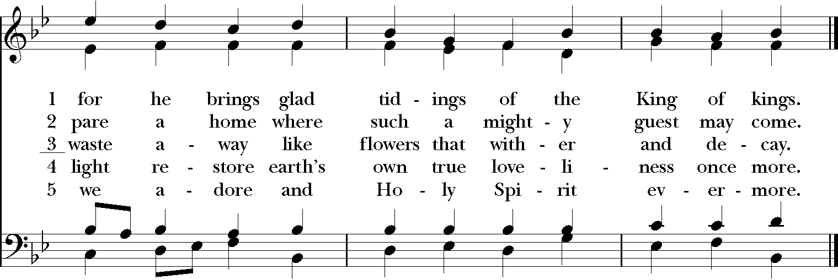

DISMISSAL
Presider: In this world: kingdom living.
People: In our mouths: kingdom praises.
Presider: In our hearts: kingdom goals.
People: In our hands: kingdom gifts.
Presider: Go forth to carry the Good News of God’s kingdom to a lost People in a world adrift, informed by the Word and inspired by the Spirit.
People: Amen. We will go!

CLOSING VOLUNTARY

Call to Worship: Leonard Sweet, posted on Preach the Story. https://preachthestory.com/
Opening Sentences: By Beth Richardson http://alivenow.upperroom.org/2010/11/08/advent-and-christmas-litanies/
Collect of the Day, Confession, Peace, Eucharistic Preface, Post-Communion Prayer, Blessing: Adapted from Prayers for an Inclusive Church, Steven Shakespeare
Affirmation of Faith: Written by Nathan Nettleton, and posted on his Laughingbird website.
Fraction Prayer of Access: A New Zealand Prayer Book
Dismissal: Carol Penner, and posted on Leading in Worship. http://carolpenner.typepad.com/

