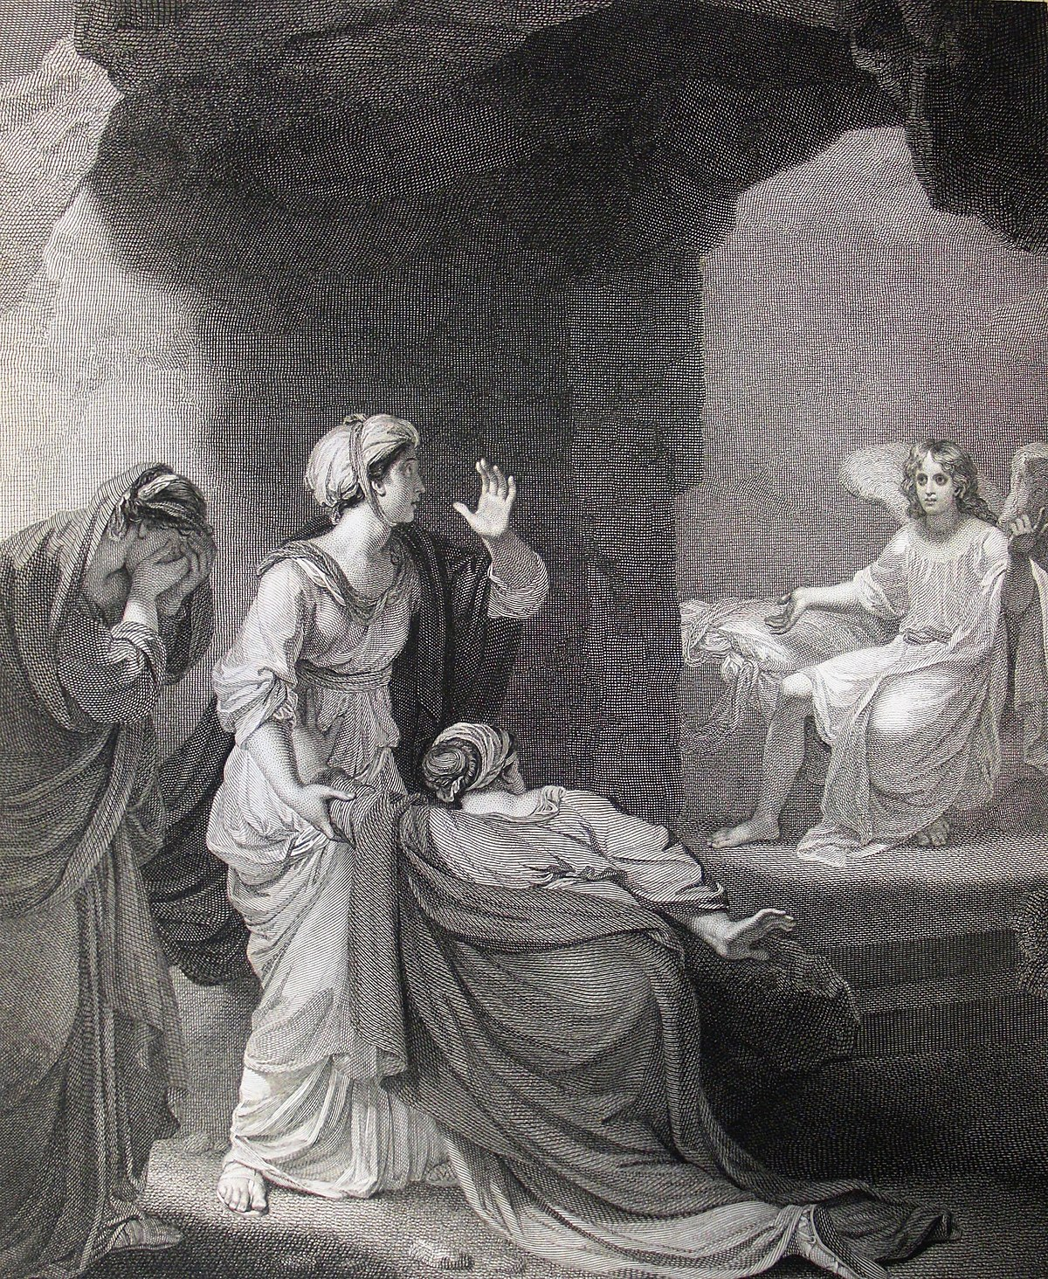

EASTER SUNDAY (B)
Sunday 04 April 2021
EPISCOPAL CHURCH OF THE HOLY APOSTLES
26238 N HWY 59, Wauconda, IL 60084
www.holyapostleswauconda.net

OPENING VOLUNTARY

INTROIT
Presider: Made for spirituality,
People: we wallow in introspection.
Presider: Made for joy,
People: we settle for pleasure.
Presider: Made for justice,
People: we clamor for vengeance.
Presider: Made for relationship,
People: we insist on our own way.
Presider: Made for beauty,
People: we are satisfied with sentiment.
Presider: But new creation has already begun. The sun has begun to rise. Christians are called to leave behind, in the tomb of Jesus Christ, all that belongs to the brokenness and incompleteness of the present world ... that, quite simply, is what it means to be Christian: to follow Jesus Christ into the new world, God's new world, which he has thrown open before us.
People: Alleluia! He is risen! Behind us lie death and despair. Before us lie life and joy. Alleluia! He is risen! Thanks be to God!

OPENING HYMN
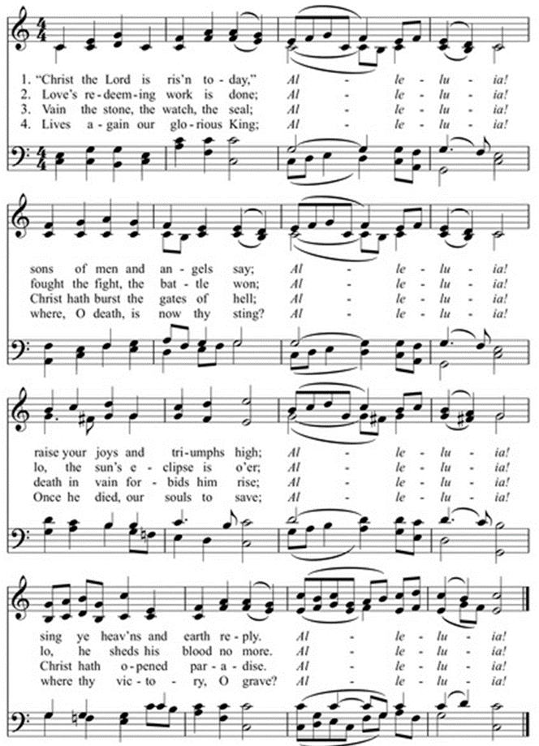
SALUTATION
Presider: Alleluia. Christ is risen.
People: The Lord is risen indeed. Alleluia.

COLLECT FOR PURITY
Presider: Almighty God, to you all hearts are open, all desires known, and from you no secrets are hid: Cleanse the thoughts of our hearts by the inspiration of your Holy Spirit, that we may perfectly love you, and worthily magnify your holy Name; through Christ our Lord.
People: Amen.

HYMN OF PRAISE H1982, #S278

COLLECT OF THE DAY
Presider: The Lord be with you.
People: And also with you.
Presider: Let us pray. God unlimited by mortal fear or tomb’s cold grip: in the lingering dark give us grace to know your life triumphant; your love undimmed in the face of Jesus Christ, the firstborn from the dead.
People: Amen.

FIRST LESSON Isaiah 25:6-9
(We read from the various translations authorized by our Church. This month, we read from The New Jerusalem Bible of 1987)
Reader: A reading from Isaiah. ⁶ On this mountain, for all peoples, Yahweh Sabaoth is preparing a banquet of rich food, a banquet of fine wines, of succulent food, of well-strained wines. ⁷ On this mountain, he has destroyed the veil which used to veil all peoples, the pall enveloping all nations; ⁸ he has destroyed death for ever. Lord Yahweh has wiped away the tears from every cheek; he has taken his people's shame away everywhere on earth, for Yahweh has spoken. ⁹ And on that day, it will be said, 'Look, this is our God, in him we put our hope that he should save us, this is Yahweh, we put our hope in him. Let us exult and rejoice since he has saved us.' The Word of the Lord.
People: Thanks be to God.

RESPONSE (Please say together in unison) Psalm 118:1-2, 14-24
¹ Alleluia! Give thanks to Yahweh for he is good, for his faithful love endures for ever.
² Let the House of Israel say, 'His faithful love endures for ever.'
¹⁴ Yahweh is my strength and my song, he has been my Saviour.
¹⁵ Shouts of joy and salvation, in the tents of the upright, 'Yahweh's right hand is triumphant,
¹⁶ Yahweh's right hand is victorious, Yahweh's right hand is triumphant!'
¹⁷ I shall not die, I shall live to recount the great deeds of Yahweh.
¹⁸ Though Yahweh punished me sternly, he has not abandoned me to death.
¹⁹ Open for me the gates of saving justice, I shall go in and thank Yahweh.
²⁰ This is the gate of Yahweh, where the upright go in.
²¹ I thank you for hearing me, and making yourself my Saviour.
²² The stone which the builders rejected has become the cornerstone;
²³ This is Yahweh's doing, and we marvel at it.
²⁴ This is the day which Yahweh has made, a day for us to rejoice and be glad.

SECOND LESSON 1 Corinthians 15:1-11
Reader: A reading from the first letter to the Corinthians. ¹ I want to make quite clear to you, brothers, what the message of the gospel that I preached to you is; you accepted it and took your stand on it, ² and you are saved by it, if you keep to the message I preached to you; otherwise your coming to believe was in vain. ³ The tradition I handed on to you in the first place, a tradition which I had myself received, was that Christ died for our sins, in accordance with the scriptures, ⁴ and that he was buried; and that on the third day, he was raised to life, in accordance with the scriptures; ⁵ and that he appeared to Cephas; and later to the Twelve; ⁶ and next he appeared to more than five hundred of the brothers at the same time, most of whom are still with us, though some have fallen asleep; ⁷ then he appeared to James, and then to all the apostles. ⁸ Last of all he appeared to me too, as though I was a child born abnormally. ⁹ For I am the least of the apostles and am not really fit to be called an apostle, because I had been persecuting the Church of God; ¹⁰ but what I am now, I am through the grace of God, and the grace which was given to me has not been wasted. Indeed, I have worked harder than all the others – not I, but the grace of God which is with me. ¹¹ Anyway, whether it was they or I, this is what we preach and what you believed. The Word of the Lord.
People: Thanks be to God.

GOSPEL HYMN (vv. 1, 4, 5)
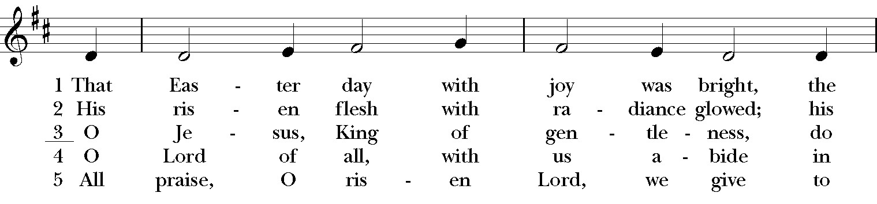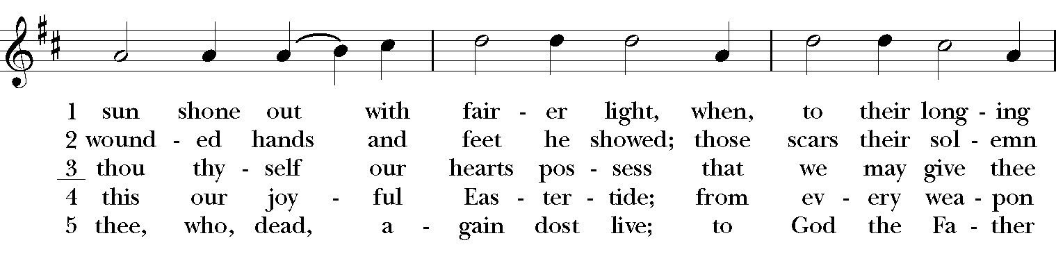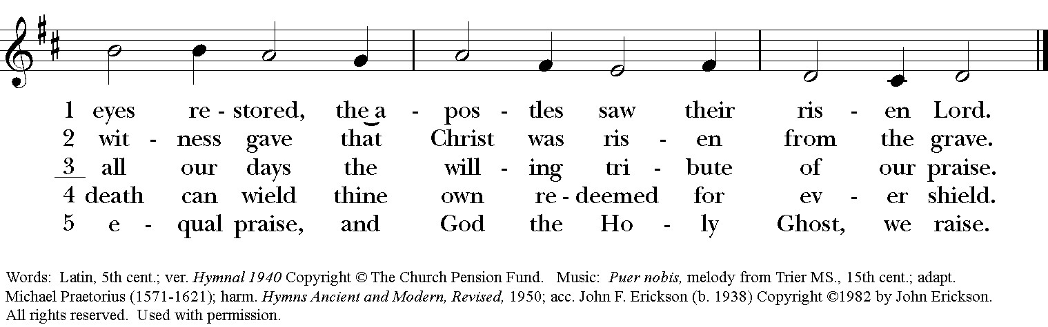

GOSPEL Mark 16:1-8
Presider: The Holy Gospel of our Lord Jesus Christ according to Mark.
People: Glory to you, Lord Christ.
Presider: ¹ When the Sabbath was over, Mary of Magdala, Mary the mother of James, and Salome, bought spices with which to go and anoint him. ² And very early in the morning on the first day of the week they went to the tomb when the sun had risen. ³ They had been saying to one another, 'Who will roll away the stone for us from the entrance to the tomb?' ⁴ But when they looked they saw that the stone – which was very big – had already been rolled back. ⁵ On entering the tomb they saw a young man in a white robe seated on the right-hand side, and they were struck with amazement. ⁶ But he said to them, 'There is no need to be so amazed. You are looking for Jesus of Nazareth, who was crucified: he has risen, he is not here. See, here is the place where they laid him.
⁷ But you must go and tell his disciples and Peter, "He is going ahead of you to Galilee; that is where you will see him, just as he told you." ' ⁸ And the women came out and ran away from the tomb because they were frightened out of their wits; and they said nothing to anyone, for they were afraid. The Gospel of the Lord.
People: Praise to you, Lord Christ.

SERMON The Rev. M. C. Gillette
(A brief period of silence will follow the sermon)

EASTER AFFIRMATION (Please say together in unison)
The text of the Nicene Creed, the full statement of our faith, is found on pages 358-359 in the Book of Common Prayer.
All: We believe in God, maker and sustainer of earth, sea, and sky, and midwife of every life the earth has seen. We believe in Jesus Christ. Born of the woman Mary, he was the first of our race to live fully the destiny for which we were all created. Healing the broken and serving the poor, liberating the burdened and reconciling heaven and earth; his every action unmasked the evil that waits to enslave us all. Hell, wounded at its heart and filled with bitterness and rage, struck back in fury unrestrained. Jesus was condemned by the religious and crucified by the state. He died forsaken, a man of sorrows. No pain in our hearts or in our planet is unfamiliar to him, for he was cast into the jaws of death. Yet, redeeming even death, God raised Jesus from the grave; with wounded hands he embraces us. He ascended into heaven to be everywhere present, and there is now nothing beyond the reach of his healing touch. We believe in the Holy Spirit, who raises us from the waters of death, breathes new life into us and declares us to be God's beloved. We believe that Christ, coming that all may have life, established his Church to continue his works on earth and stand against the world’s hatred, greed, violence, and oppression. We believe that all who trust in Christ, though they die, shall be lifted to life in all its fullness. The grip of suffering will be forever broken, and death shall have no dominion. Amen.

PRAYERS OF THE PEOPLE
Leader: In the joy of the Glorious Resurrection of our Lord and Savior Jesus Christ, let us pray to the Lord saying, “Lord, in your glory, hear our prayer.”
Leader: O living Christ, unite your Church in love. Through us, show forth your message of hope and everlasting life to every corner of the world. Lord, in your glory,
People: Hear our prayer.
Leader: Grant that the leaders in your Church may manifest your Word in speech and action, faithfully preach the good news of the living Christ, and humbly serve you by the guidance and power of the Holy Spirit. Grant that those on our Anglican and Diocesan cycles of prayer may be the face of the risen Christ in your world, nourishing and nurturing all your children. Lord, in your glory,
People: Hear our prayer.
Leader: Give each of us in grace to seek and serve Christ in all persons, loving our neighbors as ourselves. Bless those who are celebrating birthdays or anniversaries this week, especially those whose names we raise up now, either silently or aloud: _____ (We will keep a 10-second silence). Bless our worship, our relationships, our lives, and our work, that we may in turn be a blessing to others. Lord, in your glory,
People: Hear our prayer.
Leader: Inspire those who govern the nations of the world to seek justice and peace. Give them hearts to protect and provide for all people, and to use wisely the resources of your good creation. Lord, in your glory.
People: Hear our prayer.
Leader: Deliver from distress all who suffer in body, mind, or spirit; the lonely, the oppressed, and those who grieve, especially those on our parish prayer list, and those whose names we raise up now, either silently or aloud: _____ (We will keep a 10-second silence). Lord, in your glory,
People: Hear our prayer.
Leader: Pour out your mercy on all who seek you, that they might realize they have already been found by you. Let this Easter season mark for them the beginning of a deeper life with you. Lord, in your glory,
People: Hear our prayer.
Leader: Lord Jesus Christ, by your victory over death, you have opened the gates of eternal life. We commend to your care all who have died, especially those whose names we raise up now, either silently or aloud: _____ (We will keep a 10-second silence). We pray for those who have given their lives in service to others. We pray that they, and we, might share with all your saints in the joy of your heavenly kingdom. Lord, in your glory,
People: Hear our prayer.
(The Presider adds this or another concluding collect) O Gracious God, we stand in awe of your sacrificial love seen in the life, death, and resurrection of your only Son. He has given us victory over sin and death, and opened the way to new life with you. Accept the fervent prayers of your people through the mercy of Jesus Christ our Lord. Accept also our thanksgiving and praise for the gift of this most glorious Eastertide, which we celebrate with abundant and profound joy.
People: Alleluia. Amen.

THE PEACE (Please greet each other in the name of Christ)
Presider: May the peace of the resurrected Jesus – the challenging peace of committed life, the liberating peace of selfless love, the vibrant peace of new possibility – recall you to radical living, empower you for rich living, and transform you with radiant joy. May this peace renew you.
People: And also you.

BLESSING OF THE EASTER FOODS

Presider: O Lord, Jesus Christ, bread of angels, the bread of life who came down from heaven to give life to the world; bless + this bread as you blessed the five loaves in the wilderness; that all who eat of it may have health of body and soul.

Presider: O Lord, Jesus Christ, your Father’s Risen Word, let the grace of your blessing + come upon these eggs, symbols of the new life made possible when you broke the chains of sin and death; that they may be healthful food for your faithful who eat them in thanksgiving.

Presider: O Lord, Jesus Christ, multiplier of loaves and fishes and source of abundant life; + pour out your Spirit on all our offerings that they might be to us a blessing strengthening us for life in your service.

OFFERTORY SENTENCE (Please remain seated)
(The Presider gives an Offertory Sentence or says) Ascribe to the Lord the honor due his Name; bring offerings and come into his courts.

OFFERTORY HYMN (vv. 1, 2, 5) H1982, #182

(Please follow the Presider’s instructions for Communion)

GREAT THANKSGIVING Rite II Prayer A
Presider: We stand in the resurrection garden of God – a place suffused with and shaped by love and ripe with its potential. And this is the table of the risen Jesus – a place fashioned and furnished by love and rich with its promises. So come – whether you have seen and believed, or are dubious and doubting still, whether you confess confidently, or with a fragile, fearful heart. Come and share these gifts of grace, encounter Christ, and be healed by Love and transformed by Life.

Presider: The Lord be with you.
People: And also with you.
Presider: Lift up your hearts.
People: We lift them to the Lord.
Presider: Let us give thanks to the Lord our God.
People: It is right to give our thanks and praise.
Presider: It is right, and a good and joyful thing, always and every-where to give thanks to you, Father Almighty, Creator of heaven and earth. But chiefly are we bound to praise you for the glorious resurrection of your Son Jesus Christ our Lord; for he is the true Paschal Lamb, who was sacrificed for us, and has taken away the sin of the world. By his death he has destroyed death, and by his rising to life again he has won for us everlasting life. Therefore we praise you, joining our voices with Angels and Archangels and with all the company of heaven, who for ever sing this hymn to proclaim the glory of your Name:

SANCTUS (Please say together in unison)
Holy, holy, holy Lord, God of power and might, heaven and earth are full of your glory. Hosanna in the highest. Blessed is he who comes in the name of the Lord. Hosanna in the highest.

Presider: Holy and gracious Father: In your infinite love you made us for yourself; and, when we had fallen into sin and become subject to evil and death, you, in your mercy, sent Jesus Christ, your only and eternal Son, to share our human nature, to live and die as one of us, to reconcile us to you, the God and Father of all. He stretched out his arms upon the cross, and offered himself, in obedience to your will, a perfect sacrifice for the whole world.

↑On the night he was handed over to suffering and death, our Lord Jesus Christ took bread; and when he had given thanks to you, he broke it, and gave it to his disciples, and said, “Take, eat: This is my Body, which is given for you. Do this for the remembrance of me.”

↑After supper he took the cup of wine; and when he had given thanks, he gave it to them, and said, “Drink this, all of you: This is my Blood of the new Covenant, which is shed for you and for many for the forgiveness of sins. Whenever you drink it, do this for the remembrance of me.”

Therefore we proclaim the mystery of faith:
All: Christ has died. Christ is risen. Christ will come again.

Presider: We celebrate the memorial of our redemption, Father, in this sacrifice of praise and thanksgiving. Recalling his death, resurrection, and ascension, we offer you these gifts. ∞Sanctify them by your Holy Spirit to be for your people the Body and Blood of your Son, the holy food and drink of new and unending life in him. +Sanctify us also that we may faithfully receive this holy Sacrament, and serve you in unity, constancy, and peace; and at the last day bring us with all your saints into the joy of your eternal kingdom.

↑All this we ask through your Son Jesus Christ. By him, and with him, and in him, in the unity of the Holy Spirit all honor and glory is yours, Almighty Father, now and for ever. AMEN.

As our Savior Christ has taught us, we now pray,

THE LORD’S PRAYER (Please say together in unison)
Our Father, who art in heaven, hallowed by thy Name, thy kingdom come, thy will be done on earth as it is in heaven. Give us this day our daily bread. And forgive us our trespasses as we forgive those who trespass against us. And lead us not into temptation, but deliver us from evil. For thine is the kingdom, and the power, and the glory, for ever and ever. Amen.

THE FRACTION
(The Presider breaks the consecrated bread)
Presider: Alleluia! Christ our Passover is sacrificed for us;
People: therefore let us keep the feast. Alleluia!

Presider: ↑The Gifts of God for the People of God. Take them in remembrance that Christ died for you, and feed on him in your hearts by faith, with thanksgiving.

COMMUNION HYMN H1982, #302
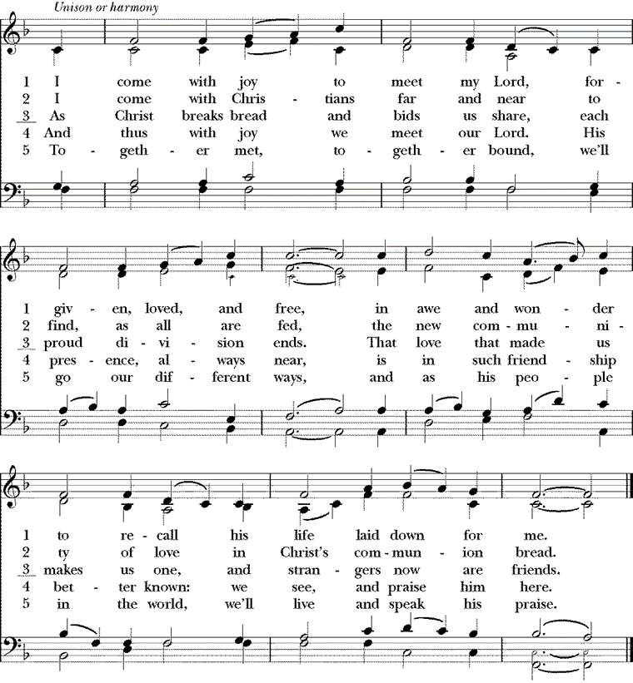

POST-COMMUNION PRAYER (Please say together in unison)
All: Risen Christ, whom we have seen with our eyes and touched with our hands; the word of life in whom our joy is complete: send us out to declare your truth and proclaim your unshakable faith to the world you love. Amen.

PARISH ANNOUNCEMENTS

EASTER BLESSING
Presider: May the living God remove the suffocating shroud that lies upon our world; may the risen Savior draw out the sting of death, bringing all to life in him; may the flowing Spirit set us and all creation free and seal our hearts with faith; and the blessing of God, Holy Immortal One, Risen Lord, and Breath of Heaven, be with you now and always.
People: Amen.

CLOSING HYMN
In Christ alone my hope is found, he is my light, my strength, my song;
This cornerstone, this solid ground, firm through the fiercest drought and storm.
What heights of love, what depths of peace, when fears are stilled, when strivings cease!
My Comforter, my All in All, here in the love of Christ I stand.
In Christ alone who took on flesh, fullness of God in helpless babe!
This gift of love and righteousness scorned by the ones he came to save:
Till on that cross as Jesus died, the Son of Man was glorified:
Incarnate Word made still by sin, here in the death of Christ I live.

There in the ground His body lay light of the world by darkness slain:
Then bursting forth in glorious day up from the grave he rose again!
And as he stands in victory sin's curse has lost its grip on me,
For I am his and he is mine - bought with the perfect love of Christ.
No guilt in life, no fear in death, this is the power of Christ in me;
From life's first cry to final breath, Jesus commands my destiny.
No power of hell, no scheme of man, can ever pluck me from his hand;
Till he returns or calls me home, here in the power of Christ I'll stand.

No power of hell, no scheme of man, can ever pluck me from his hand;
Till he returns or calls me home, here in the power of Christ I'll stand.

DISMISSAL
Presider:
You had not imagined that something so empty could fill you to overflowing
and now you carry the knowledge like an awful treasure, or like a child that roots itself beneath your heart:
how the emptiness will bear forth a new world that you cannot fathom but on whose edge you stand.

So why do you linger? You have seen and so you are already blessed.
You have been seen and so you are the blessing.

There is no other word you need. There is simply to go and tell.
There is simply to begin.
Let us go forth into the world rejoicing in the truth of the risen Christ!
People: Thanks be to God. Alleluia! Amen.

CLOSING VOLUNTARY

Cover Image: https://commons.wikimedia.org/wiki/File:264_Life_of_Christ_Phillip_Medhurst_Collection_4547._The_empty_tomb._Mark_16.5_Smirke.jpg
Call to Worship: Adapted from N.T. Wright, Simply Christian: Why Christianity Makes Sense. accessed at https://re-worship.blogspot.com/2015/03/easter-call-to-worship-new-creation.html
Affirmation: From Laughing Bird Resources, Nathan Nettleton
Introduction to the Peace, Invitation to Communion: From ‘Transformed by Life,’ Pat Bennett, Wild Goose Publications (Iona)
Collect of the Day, Eucharistic Preface, Post-Communion Prayer, and Blessing: adapted from seasonal materials in Prayers for an Inclusive Church (Steven Shakespeare)
Dismissal: Adapted from Seen: A Blessing For Easter Sunday, written by Jan L. Richardson, and posted on The Painted Prayerbook. http://paintedprayerbook.com/ accessed at https://re-worship.blogspot.com/2014/04/an-easter-blessing-seen.html

