FOURTH SUNDAY IN LENT (B)
Episcopal Church of the Holy Apostles
Sunday 14 March 2021
OPENING VOLUNTARY
I Surrender All
Jesus Lover of My Soul

WORDS OF WELCOME

OPENING HYMN
OPENING SENTENCE
Presider: + Bless the Lord who forgives all our sins.
People: God’s mercy endures for ever.

DECALOGUE
Presider: Hear the commandments of God to God’s people: I am the Lord your God who brought you out of bondage. You shall have no other gods but me.
People: Amen. Lord have mercy.
Presider: You shall not make for yourself any idol.
People: Amen. Lord have mercy.
Presider: You shall not invoke with malice the Name of the Lord your God.
People: Amen. Lord have mercy.
Presider: Remember the Sabbath Day and keep it holy.
People: Amen. Lord have mercy.
Presider: Honor your father and your mother.
People: Amen. Lord have mercy.
Presider: You shall not commit murder.
People: Amen. Lord have mercy.
Presider: You shall not commit adultery.
People: Amen. Lord have mercy.
Presider: You shall not steal.
People: Amen. Lord have mercy.
Presider: You shall not be a false witness.
People: Amen. Lord have mercy.
Presider: You shall not covet anything that belongs to your neighbor.
People: Amen. Lord have mercy.

CONFESSIONAL SENTENCE
Presider: If we say that we have no sin, we deceive ourselves, and the truth is not in us. But if we confess our sins, God, who is faithful and just, will forgive our sins and cleanse us from all unrighteousness.

CONFESSION AND ABSOLUTION
Presider: Let us confess our sins against God and our neighbor.
All: Creative, passionate God, you have delighted in shaping the world into a thing of beauty and harmony. You have invited us to be constructive participates in maintaining the health and wholeness of creation. You have given us the capacity to grow in wisdom through experience; to learn from our errors; to find strength and courage when faced with danger and difficulty. Yet too often we decline the gifts you offer; too often we succumb to temptation; too often we fail to consider the consequences of what we do and say; too often we let our words and actions be governed by fear, anger, or hurt rather than by confidence, compassion, and joy. We cannot undo all our mistakes; but we can turn once more to the living presence of Jesus and find new ways to live and love each other and the earth. Dear God, we ask you to help us to do so. Open our hearts and minds that we might acknowledge our sin, repent, and return to you. Grant us the forgiveness that restores and renews us.
(Silence)
Presider: God takes broken promises and turns them into vows of faithfulness. God takes our biggest failings and shapes lives of service. God listens to our prayers of confession and changes them into songs of mercy. +The one who pours forgiveness into our lives has promised that with repentance and amendment of life our sins are forgiven.
People: Thanks be to God!

COLLECT OF THE DAY
Presider: The Lord be with you.
People: And also with you.
Presider: Let us pray. God, rich in mercy, whose light reveals the truth of things, the judgment we bring on ourselves: we thank you that you sent your Son to save and not condemn; in his self-giving love may life abundant reign; through Jesus Christ, who was lifted up for us.
People: Amen.

(We read from the various biblical translations authorized by our Church. During Lent we will be reading from the Revised English Version of 1881)

FIRST LESSON Numbers 21:4-9
Reader: A reading from Numbers. The Israelites journeyed from mount Hor by the way to the Red Sea, to compass the land of Edom: and the soul of the people was much discouraged because of the way. And the people spake against God, and against Moses, Wherefore have ye brought us up out of Egypt to die in the wilderness? for there is no bread, and there is no water; and our soul loatheth this light bread. And the LORD sent fiery serpents among the people, and they bit the people; and much people of Israel died. And the people came to Moses, and said, We have sinned, because we have spoken against the LORD, and against thee; pray unto the LORD, that he take away the serpents from us. And Moses prayed for the people. And the LORD said unto Moses, Make thee a fiery serpent, and set it upon a standard: and it shall come to pass, that every one that is bitten, when he seeth it, shall live. And Moses made a serpent of brass, and set it upon the standard: and it came to pass, that if a serpent had bitten any man, when he looked unto the serpent of brass, he lived.
The Word of the Lord.
People: Thanks be to God.

RESPONSE (Please say together in unison) Psalm 107:1-3, 17-22
1. Give thanks unto the LORD; for he is good: for his mercy endureth for ever.
2. Let the redeemed of the LORD say so, whom he hath redeemed from the hand of the adversary;
3. And gathered them out of the lands, from the east and from the west, from the north and from the south 17. Fools because of their transgression, and because of their iniquities, are afflicted.
18. Their soul abhorreth all manner of meat; and they draw near unto the gates of death.
19. Then they cry unto the LORD in their trouble, and he saveth them out of their distresses.
20. He sendeth his word, and healeth them, and delivereth them from their destructions.
21. Oh that men would praise the LORD for his goodness, and for his wonderful works to the children of men!
22. And let them offer the sacrifices of thanksgiving, and declare his works with singing.

SECOND LESSON Ephesians 2:1-10
Reader: A reading from the letter to the Ephesians. You did he quicken, when ye were dead through your trespasses and sins, wherein aforetime ye walked according to the course of this world, according to the prince of the power of the air, of the spirit that now worketh in the sons of disobedience; among whom we also all once lived in the lusts of our flesh, doing the desires of the flesh and of the mind, and were by nature children of wrath, even as the rest: but God, being rich in mercy, for his great love wherewith he loved us, even when we were dead through our trespasses, quickened us together with Christ (by grace have ye been saved), and raised us up with him, and made us to sit with him in the heavenly places, in Christ Jesus: that in the ages to come he might shew the exceeding riches of his grace in kindness toward us in Christ Jesus: for by grace have ye been saved through faith; and that not of yourselves: it is the gift of God: not of works, that no man should glory. For we are his workmanship, created in Christ Jesus for good works, which God afore prepared that we should walk in them. The Word of the Lord.
People: Thanks be to God.

GOSPEL HYMN

GOSPEL John 3:14-21
Presider: The Holy Gospel of our Lord Jesus Christ according to John.
People: Glory to you, Lord Christ.
Presider: Jesus said, “Just as Moses lifted up the serpent in the wilderness, even so must the Son of man be lifted up: that whosoever believeth may in him have eternal life. For God so loved the world, that he gave his only begotten Son, that whosoever believeth on him should not perish, but have eternal life. For God sent not the Son into the world to judge the world; but that the world should be saved through him. He that believeth on him is not judged: he that believeth not hath been judged already, because he hath not believed on the name of the only begotten Son of God. And this is the judgment, that the light is come into the world, and men loved the darkness rather than the light; for their works were evil. For every one that doeth ill hateth the light, and cometh not to the light, lest his works should be reproved. But he that doeth the truth cometh to the light, that his works may be made manifest, that they have been wrought in God.” The Gospel of the Lord.
People: Praise to you, Lord Christ.

SERMON The Rev. M. C. Gillette
(A brief period of silence follows the sermon)

NICENE CREED
All: We believe in one God, the Father, the Almighty, maker of heaven and earth, of all that is, seen and unseen. We believe in one Lord, Jesus Christ, the only Son of God, eternally begotten of the Father, God from God, Light from Light, true God from true God, begotten, not made, of one Being with the Father. Through him all things were made. For us and for our salvation he came down from heaven: by the power of the Holy Spirit he became incarnate from the Virgin Mary, and was made man. For our sake he was crucified under Pontius Pilate; he suffered death and was buried. On the third day he rose again in accordance with the Scriptures; he ascended into heaven and is seated at the right hand of the Father. He will come again in glory to judge the living and the dead, and his kingdom will have no end. We believe in the Holy Spirit, the Lord, the giver of life, who proceeds from the Father and the Son. With the Father and the Son he is worshiped and glorified. He has spoken through the Prophets. We believe in one holy catholic and apostolic Church. We acknowledge one baptism for the forgiveness of sins. We look for the resurrection of the dead, and the life of the world to come. Amen.
PRAYERS OF THE PEOPLE Personalized Form II
Leader: I ask your prayers for God’s people throughout the world; for our bishops, priests, and deacons; for this congregation; and for all people who minister in God’s name. Pray for the whole Church.
(Silence during which you may offer you own prayers, silently or aloud.)
Leader: I ask your prayers for peace; for goodwill among nations; and for the well-being of all people. Pray for justice and peace.
(Silence during which you may offer your own prayers, silently or aloud.)
Leader: I ask your prayers for all who seek God, or a deeper knowledge of God. Pray that all who seek may find and be found by God.
(Silence during which you may offer your own prayers, silently or aloud.)
Leader: I ask your prayers of thanksgiving for those people and ministries which help us know and love God, and for those with birthdays and anniversaries this week, in particular those whose names we raise up now, either silently or aloud: (we will keep a 10-second silence) _____. We give thanks, O God, for the blessings in our lives.
(Silence during which you may offer your own prayers, silently or aloud.)
Leader: I ask your prayers for the poor, the sick, the hungry, the oppressed, and those in prison; I ask your prayers for those whose names we raise up now, either silently or aloud: (we will keep a 10-second silence)_____. Pray for those in any kind of need or trouble.
(Silence during which you may offer your own prayers, silently or aloud.)
Leader: I ask your prayers for our beloved departed, for those killed in the course of service to others, and for those whose names we raise up now, either silently or aloud: (we will keep a 10-second silence) _____. Pray for those who have died.
(Silence during which you may offer your own prayers, silently or aloud.)
Leader: Praise God for those in every generation in whom Christ has been honored. Pray that we may have grace to glorify Christ in our own day.
(Silence during which you may offer your own prayers, silently or aloud.)
(The Presider adds this or another concluding Collect) Hasten, O Father, the coming of your kingdom; and grant that we your servants, who now live by faith, may with joy behold your Son at his coming in glorious majesty; even Jesus Christ, our only Mediator and Advocate.
People: Amen.

THE PEACE (Please greet each other in the name of the Lord)
Presider: God of the Garden, God of the Wilderness, you offer us your peace wherever we find ourselves. Help us to take your gift of shalom and share it with all. / God’s peace be always with you.
People: And also with you.

OFFERTORY SENTENCE
Presider: (Gives this or another offertory sentence) Gracious God, through our offerings of worship, time, money, and prayer, we seek to make space for you in our lives. During this season of Lent, may we endeavor to loosen our grasp on the treasures of this world and seek to store up for ourselves treasure in heaven. May we, with generous hearts, use the gifts we have been given for your good work of justice, peace, and service in the world.
People: Amen.

OFFERTORY HYMN H1982, #147

THE GREAT THANKSGIVING Lent/PCUSA
Presider: Like a tent in the wilderness the table of God stands open and ready as a place of sanctuary and safety, of hospitality and healing. So come, all you who are tired and travel-stained, footsore and famished; come with your fellow travelers and find companionship and comfort. For here, Jesus – who knows what it is to wander, watch and wrestle in desert places – waits to meet us and welcome us in, offering us rest and restoration, solace and strength, for the journey still to come.

Presider: The Lord be with you.
People: And also with you.
Presider: Lift up your hearts.
People: We lift them to the Lord.
Presider: Let us give thanks to the Lord our God.
People: It is right to give our thanks and praise.

Presider: It is truly right and our greatest joy to give you thanks and praise, O Lord our God, creator and ruler of the universe. You made a covenant with our ancestor Abraham, promising to make of him a great nation, and a blessing to all the families of the earth. Therefore we praise you, joining our voices with choirs of angels; with prophets, apostles, and martyrs; and with all the faithful of every time and place who forever sing to the glory of your name:

All: Holy, holy, holy Lord, God of power and might, heaven and earth are full of your glory. Hosanna in the highest. Blessed is he who comes in the name of the Lord. Hosanna in the highest.
Presider: You are holy, O God of majesty, and blessed is Jesus Christ, your Son, our Lord. Out of your great love for the world, you sent Jesus, not to condemn, but to save, so that everyone who believes in him might not perish, but have eternal life, born again from above by water and the Spirit.

Remembering your gracious acts in Jesus Christ, we take from your creation this bread and this wine and joyfully celebrate his dying and rising, as we await the day of his coming. + With thanksgiving, we offer our very selves to you as holy and living sacrifices, a people dedicated to your service.

Great is the mystery of faith:
All: Christ has died, Christ is risen, Christ will come again.

Presider: ↑On the night when he was betrayed, our Lord Jesus Christ took bread, and when he had given thanks, he broke it, and gave it to his disciples, saying “This is my body, which is given for you. Eat, and remember me.”

↑When their supper had ended, Jesus took a cup of wine, blessed it, and gave it, also, to his disciples, saying, “This cup is the new covenant in my blood. Drink, and remember me.”

Gracious God, ∞ pour out your Holy Spirit upon us and upon these your gifts of bread and wine, that the bread we break and the cup we bless may be for us the body and blood of Christ, the food and drink of new and unending life in him.

By your Spirit, make us one us with Christ and one with your church in all the world. By faith, make us children of Abraham, justified by the righteousness and grace of Christ, so that we may share the blessings of your covenant people.

↑ Through Christ, with Christ, in Christ, in the unity of the Holy Spirit, all glory and honor are yours, almighty God, now and forever. AMEN.

And now, as our Savior Christ has taught us, we are bold to say,

LORD’S PRAYER (Please remain standing and say together in unison)
Our Father, who art in heaven, hallowed be thy Name, thy kingdom come, thy will be done, on earth as it is in heaven. Give us this day our daily bread. And forgive us our trespasses, as we forgive those who trespass against us. And lead us not into temptation, but deliver us from evil. For thine is the kingdom, and the power, and the glory, for ever and ever. Amen.

FRACTION (Please remain standing)
Presider: Lamb of God, you take away the sins of the world:
All: have mercy on us.
Presider: Lamb of God, you take away the sins of the world:
All: have mercy on us.
Presider: Lamb of God, you take away the sins of the world:
All: grant us peace.

PRAYER OF HUMBLE ACCESS (Please remain standing and say together in unison)
All: We do not presume to come to this your Table, O merciful Lord, trusting in our own righteousness, but in your manifold and great mercies. We are not worthy so much as to gather up the crumbs under your Table. But you are the same Lord whose property is always to have mercy. Grant us therefore, gracious Lord, so to eat the flesh of your dear Son Jesus Christ, and to drink his blood, that we may evermore dwell in him, and he in us. Amen.

Presider: ↑The Gifts of God for the People of God. Take them in remembrance that Christ died for you, and feed on him in your hearts by faith, with thanksgiving.

COMMUNION HYMN H1982, #314
POST-COMMUNION PRAYER
All: Lord of this feast beyond measure and price; we thank you for meeting us in our brokenness so that none might be lost: liberate us now to share bread with our neighbor, each receiving from the other what we need to be ourselves. Amen.

SOLEMN PRAYER OVER THE PEOPLE
Presider: Bow down before the Lord. Keep this your family, Lord, with your never-failing mercy, that relying solely on the help of your heavenly grace, they may be upheld by your divine protection; through Christ our Lord. Amen.

CLOSING HYMN H1982, #150
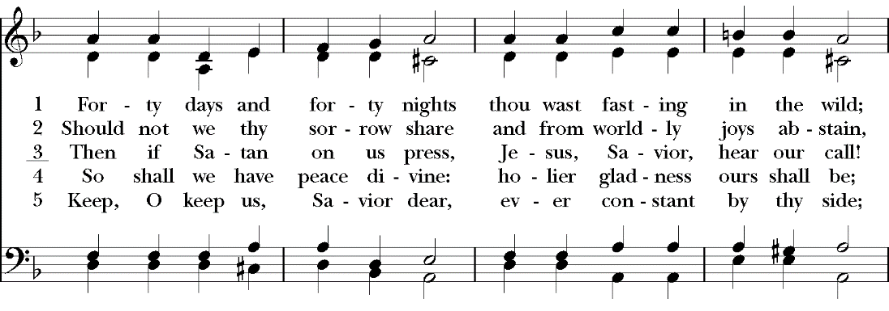
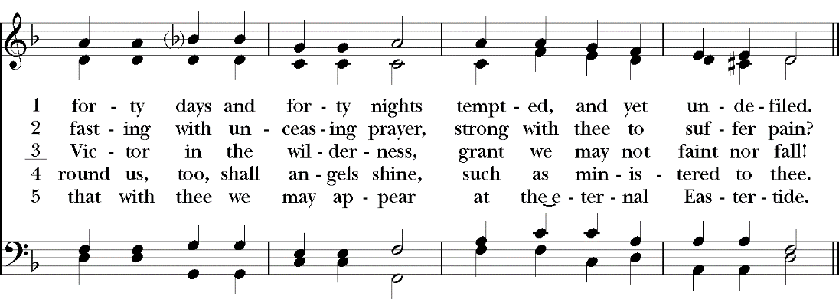
DISMISSAL (Please remain standing)
Presider: The Holy One whom we serve promises that the Word will abide with us in our times of trouble and testing, and the Spirit sustain us in the wilderness. Trusting in this promise, we go into the world rejoicing in the faithfulness of the Lord our God.
People: Amen.

Collect of the Day, Introduction to the Peace, and Post-Communion Prayer: based on Lenten Seasonal Materials in Prayers for an Inclusive Church (Steven Shakespeare)
Confession: from Tempting! Service Prayers for the First Sunday of Lent, written by the Rev. Elizabeth Dilley. Posted on the United Church of Christ’s Worship Ways website. http://www.ucc.org/worship/worship-ways/
Assurance of Pardon: https://re-worship.blogspot.com/2012/02/act-of-confession-lent-1-b.html
Eucharistic Prayer and Dismissal based on Prayers for Lent material from the Office of Theology and Worship, Presbyterian Church (U.S.A.)

