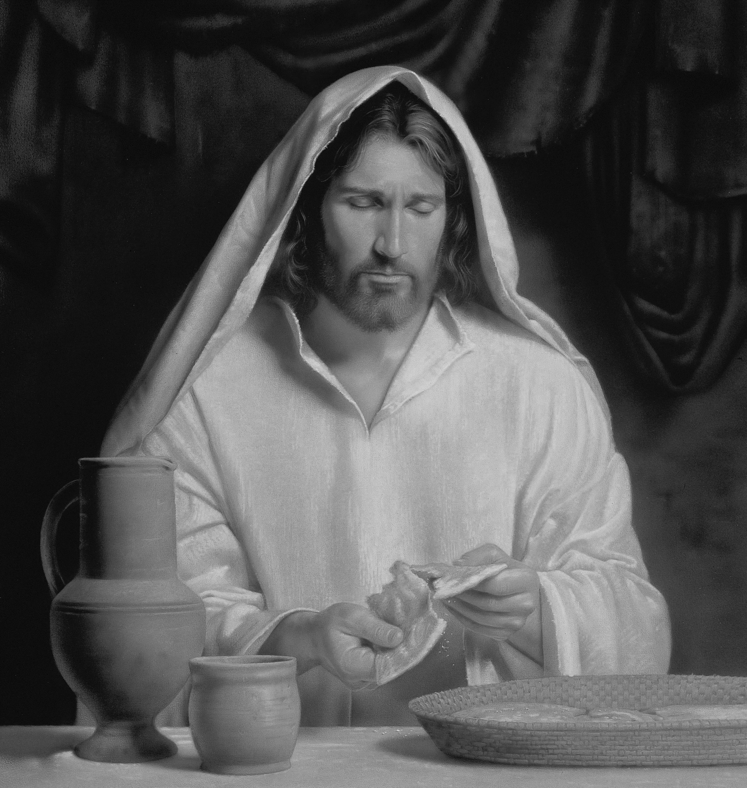

**MAUNDY THURSDAY (B)**

**Thursday 01 April 2021**

**Episcopal Church of the Holy Apostles**

26238 N HWY 59, Wauconda, IL 60084

*www.holyapostleswauconda.net*

**OPENING HYMN**

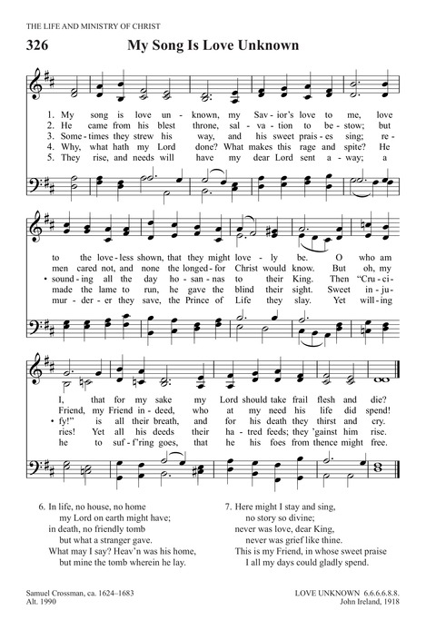

**CALL TO WORSHIP**

**Presider:** Peace be with you.

***People: And also with you.***

**Presider:** This is a day complicated day. It is a day of remembrance, thanksgiving, sorrow, and sacrifice. It is a day with many things to tell us. Loving God, give us ears to listen and hear.

**Presider:** On this day,

***People: Jesus gathered with his disciples in an upper room to commemorate God’s mighty works in human history and give thanks for God’s eternal presence and faithful promise-keeping.***

**Presider:** On this day,

***People: Jesus took a towel and washed his disciples’ feet, setting before us an example of discipleship; teaching us that freedom is found in obedience to God’s call to be humble, pursue justice and mercy, care for those in need, and offer oneself in service to one’s neighbors.***

**Presider:**  On this day,

***People: Jesus said, “I give you a new commandment, that you love one another. Just as I have loved you, you also should love one another.”***

**Presider:** On this day,

***People: Jesus ordained for us a holy feast, that we who eat this bread and drink this cup may enter into the everlasting heritage prepared for us from the foundation of the world, and at the last day may reign with him in heaven.***

**Presider:** And on this day,

***People: Jesus gave himself into the hands of those who would kill him, that we might live.***

**PRAYER**

**Presider:** Let us pray.

***All: Holy God, source of all love, on the night of his betrayal Jesus gave his disciples a new commandment, to love one another as he loved them. Write this commandment in our hearts; give us the will to serve others as he was the servant of all, who gave his life and died for us, yet is alive and reigns with you and the Holy Spirit, one God, now and forever. Amen.***

**HYMN OF PRAISE** **(vv. 1, 2)**

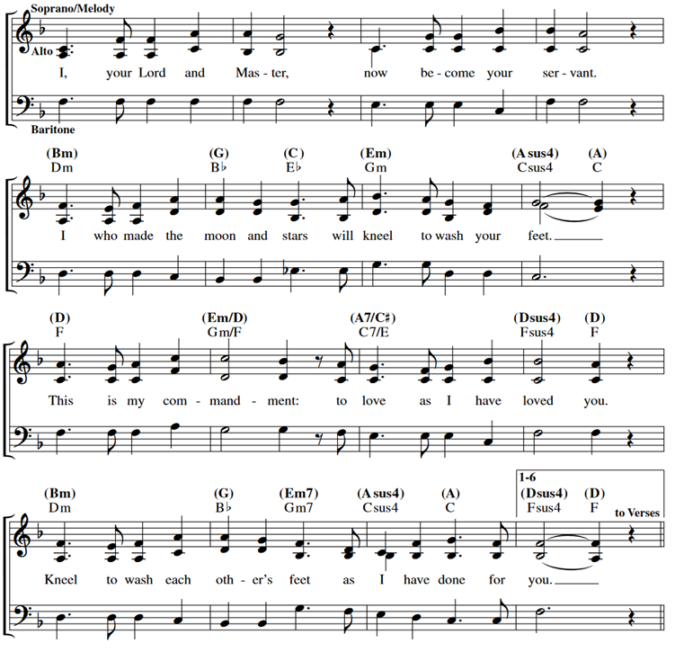

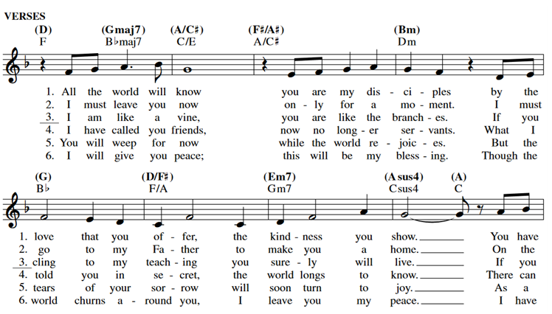

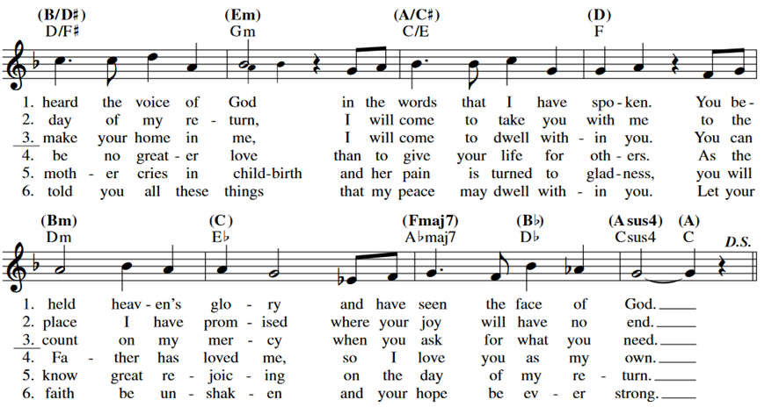

**COLLECT OF THE DAY**

**Presider:** The Lord be with you.

***People: And also with you.***

**Presider:** Let us pray. Almighty Father, whose dear Son, on the night before he suffered, instituted the Sacrament of his Body and Blood: Mercifully grant that we may receive it thankfully in remembrance of Jesus Christ our Lord, who in these holy mysteries gives us a pledge of eternal life; and who now lives and reigns with you and the Holy Spirit, one God, for ever and ever.

***People: Amen.***

*(We read from the various biblical translations authorized by our Church. This month we read from the New Jerusalem Bible of 1987)*

**FIRST LESSON** Exodus 12:1-14

**Reader:** A reading from Exodus. 1 Yahweh said to Moses and Aaron in Egypt, 2 'This month must be the first of all the months for you, the first month of your year. 3 Speak to the whole community of Israel and say, "On the tenth day of this month each man must take an animal from the flock for his family: one animal for each household. 4 If the household is too small for the animal, he must join with his neighbour nearest to his house, depending on the number of persons. When you choose the animal, you will take into account what each can eat. 5 It must be an animal without blemish, a male one year old; you may choose it either from the sheep or from the goats. 6 You must keep it till the fourteenth day of the month when the whole assembly of the community of Israel will slaughter it at twilight. 7 Some of the blood must then be taken and put on both door-posts and the lintel of the houses where it is eaten. 8 That night, the flesh must be eaten, roasted over the fire; it must be eaten with unleavened bread and bitter herbs. 9 Do not eat any of it raw or boiled in water, but roasted over the fire, with the head, feet and entrails. 10 You must not leave any of it over till the morning: whatever is left till morning you must burn. 11 This is how you must eat it: with a belt round your waist, your sandals on your feet and your staff in your hand. You must eat it hurriedly: it is a Passover in Yahweh's honour. 12 That night, I shall go through Egypt and strike down all the first-born in Egypt, man and beast alike, and shall execute [justice](https://www.catholic.org/encyclopedia/view.php?id=6550) on all the gods of Egypt, I, Yahweh! 13 The blood will be a sign for you on the houses where you are. When I see the blood I shall pass over you, and you will escape the destructive plague when I strike Egypt. 14 This day must be commemorated by you, and you must keep it as a feast in Yahweh's honour. You must keep it as a feast-day for all generations; this is a decree for all time. The Word of the Lord.

***People: Thanks be to God.***

**RESPONSE** *(Please say together in unison)*

Psalm 116: 1, 10-17 (116:1-2, 12-19 in this translation)

***1 Alleluia! I am filled with love when Yahweh listens to the sound of my prayer,***

***2 when he bends down to hear me, as I call.***

***12 What return can I make to Yahweh for his generosity to me?***

***13 I shall take up the cup of salvation and call on the name of Yahweh.***

***14 I shall fulfil my vows to Yahweh, witnessed by all his people.***

***15 Costly in Yahweh's sight is the death of his faithful.***

***16 I beg you, Yahweh! I am your servant, I am your servant and my mother was your servant; you have undone my fetters.***

***17 I shall offer you a sacrifice of thanksgiving and call on the name of Yahweh.***

***18 I shall fulfil my vows to Yahweh, witnessed by all his people,***

***19 in the courts of the house of Yahweh, in your very heart, Jerusalem.***

**SECOND LESSON** 1 Corinthians 11:23-26

**Reader:** A reading from the first letter to the Corinthians. 23 For the tradition I received from the Lord and also handed on to you is that on the night he was betrayed, the Lord Jesus took some bread, 24 and after he had given thanks, he broke it, and he said, 'This is my body, which is for you; do this in remembrance of me.' 25 And in the same way, with the cup after supper, saying, 'This cup is the new covenant in my blood. Whenever you drink it, do this as a memorial of me.' 26 Whenever you eat this bread, then, and drink this cup, you are proclaiming the Lord's death until he comes. The Word of the Lord.

***People: Thanks be to God.***

**GOSPEL HYMN (vv. 1, 2, 4)**



**GOSPEL** John 13:1-17, 31b-35

**Presider:** The Holy Gospel of our Lord Jesus Christ according to John.

***People: Glory to you, Lord Christ.***

**Presider:** 1 Before the festival of the Passover, Jesus, knowing that his hour had come to pass from this world to the Father, having loved those who were his in the world, loved them to the end. 2 They were at supper, and the devil had already put it into the mind of Judas Iscariot son of Simon, to betray him. 3 Jesus knew that the Father had put everything into his hands, and that he had come from God and was returning to God, 4 and he got up from table, removed his outer garments and, taking a towel, wrapped it round his waist; 5 he then poured water into a basin and began to wash the disciples' feet and to wipe them with the towel he was wearing. 6 He came to Simon Peter, who said to him, 'Lord, are you going to wash my feet?' 7 Jesus answered, 'At the moment you do not know what I am doing, but later you will understand.' 8 'Never!' said Peter. 'You shall never wash my feet.' Jesus replied, 'If I do not wash you, you can have no share with me.' Simon Peter said, 9 'Well then, Lord, not only my feet, but my hands and my head as well!' 10 Jesus said, 'No one who has had a bath needs washing, such a person is clean all over. You too are clean, though not all of you are.' 11 He knew who was going to betray him, and that was why he said, 'though not all of you are'. 12 When he had washed their feet and put on his outer garments again he went back to the table. 'Do you understand', he said, 'what I have done to you? 3 You call me Master and Lord, and rightly; so I am. 14 If I, then, the Lord and Master, have washed your feet, you must wash each other's feet. 15 I have given you an example so that you may copy what I have done to you. 16 'In all truth I tell you, no servant is greater than his master, no messenger is greater than the one who sent him. 17 'Now that you know this, blessed are you if you behave accordingly. 31Now has the Son of man been glorified, and in him God has been glorified. 32 If God has been glorified in him, God will in turn glorify him in himself, and will glorify him very soon. 33 Little children, I shall be with you only a little longer. You will look for me, and, as I told the Jews, where I am going, you cannot come. 34 I give you a new commandment: love one another; you must love one another just as I have loved you. 35 It is by your love for one another, that everyone will recognise you as my disciples. The Gospel of the Lord.

***People: Praise to you, Lord Christ.***

**REFLECTION** (The Rev. M. C. Gillette)

**REFLECTION HYMN (vv. 1, 2, 4)**

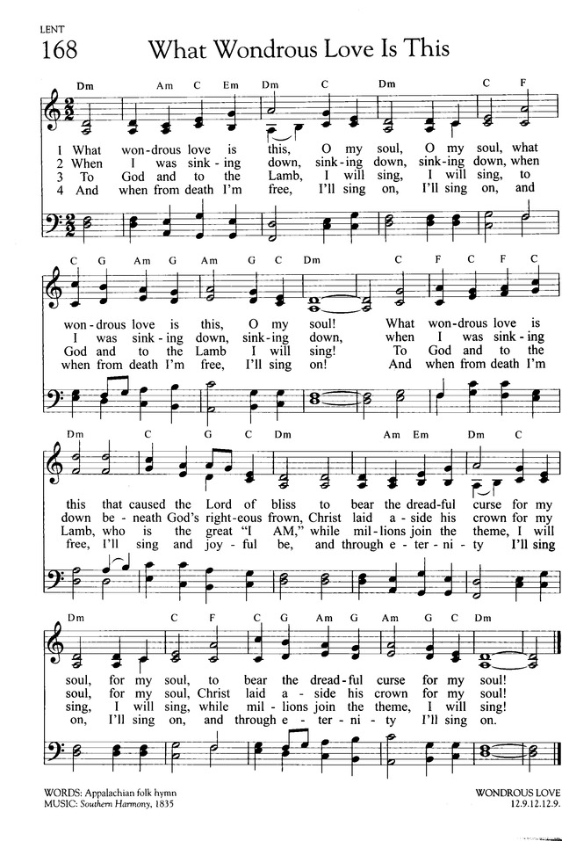

**THE NICENE CREED**

***All: We believe in one God, the Father, the Almighty, maker of heaven and earth, of all that is, seen and unseen. We believe in one Lord, Jesus Christ, the only Son of God, eternally begotten of the Father, God from God, Light from Light, true God from true God, begotten, not made, of one Being with the Father. Through him all things were made. For us and for our salvation he came down from heaven: by the power of the Holy Spirit he became incarnate from the Virgin Mary, and was made man. For our sake he was crucified under Pontius Pilate; he suffered death and was buried. On the third day he rose again in accordance with the Scriptures; he ascended into heaven and is seated at the right hand of the Father. He will come again in glory to judge the living and the dead, and his kingdom will have no end. We believe in the Holy Spirit, the Lord, the giver of life, who proceeds from the Father and the Son. With the Father and the Son he is worshiped and glorified. He has spoken through the Prophets. We believe in one holy catholic and apostolic Church. We acknowledge one baptism for the forgiveness of sins. We look for the resurrection of the dead, and the life of the world to come. Amen***

**THE PRAYERS OF THE PEOPLE** Personalized Form II

**Leader:**  I ask your prayers for God’s people throughout the world; for our Bishops; for this gathering; and for all ministers and people. Pray for the church.

*(We will keep a 10-second silence during which you may offer your own prayers, either silently or aloud.)*

**Leader:** I ask your prayers for peace; for goodwill among nations; and for the well-being of all people. Pray for justice and peace.

*(We will keep a 10-second silence during which you may offer your own prayers, either silently or aloud.)*

**Leader:** I ask your prayers for the poor, the sick, the hungry, the oppressed, and those in prison. Pray for those in any need or trouble.

*(We will keep a 10-second silence during which you may offer your own prayers, either silently or aloud.)*

**Leader:** I ask your prayers for all who seek God, or a deeper knowledge of God. Pray that they may find and be found by him.

*(We will keep a 10-second silence during which you may offer your own prayers, either silently or aloud.)*

**Leader:** I ask your prayer for the departed. Pray for those who have died.

*(We will keep a 10-second silence during which you may offer your own prayers, either silently or aloud.)*

**Leader:**  Let us thank God for the good things in our lives.

*(We will keep a 10-second silence during which you may offer your own prayers, either silently or aloud.)*

**Leader:** Praise God for those in every generation in whom Christ has been honored. Pray that we may have grace to glorify Christ in our own day.

*(We will keep a 10-second silence during which you may offer your own prayers, either silently or aloud.)*

**Presider:** Almighty and eternal God, ruler of all things in heaven and earth: Mercifully accept the prayers of your people, and strengthen us to do y our will; through Jesus Christ our Lord.

***People: Amen.***

**CONFESSION** *(Please say together in unison)*

**Presider:**  Forgive us, Lord.

***Forgive us, Lord, when we forget your sacrifice and assume your grace is cheap.***

***Forgive us, Lord, when we use the cross as a mere trinket, or seek to appropriate it for the exclusive use of our own doctrine or creed.***

***Forgive us, Lord, when we take our worship for granted, forgetting that there are those who would call us “bad Christians” for failing to believe what they believe and worship as they do.***

***Forgive us, Lord, for being calloused to human cruelty, forgetting that every victim is a creature of God.***

***Forgive us, Lord, for being nonchalant about injustice, forgetting that it still nails innocence to the cross.***

***Forgive us, Lord, for thinking that sacrifice is obsolete, forgetting that we still contend against the powers of darkness.***

**Presider:** Forgive us, Lord. We ask you to receive the prayers we offer in all humility, as we remember and honor Christ our Lord who prays for us still.    
***People: Amen.***

**THE PEACE** *(Please offer each other a sign of peace in the Lord’s name.)*

**Presider:** The Peace of the Lord be always with you.

***People: And also with you.***

*The Presider gives an Offertory Sentence or says:* Through Christ, let us offer God an unending sacrifice of praise, the fruit of the lips of those who acknowledge his name. Keep doing good works and sharing your resources, for these are the kinds of sacrifices that please God.

**OFFERTORY HYMN (vv. 1, 2, 4, 5, 6** *(verse 6 is a repeat of verse 1)***)**

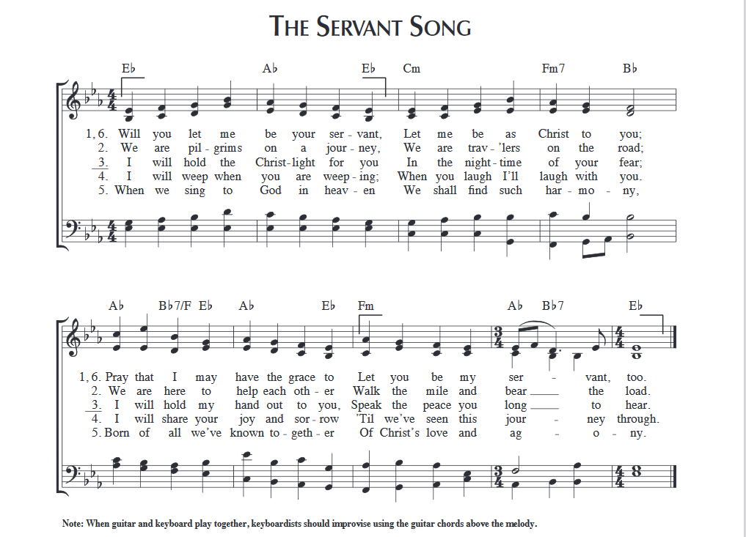

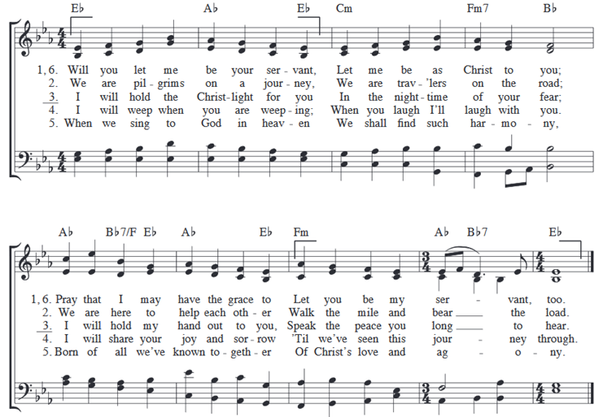

**INVITATION TO THE TABLE**

**Presider:** This is a table of new expectations.

A table at which everyone has a seat.

A table for those who have met Jesus and those who have not.

A table where we are reconciled.

A table where there is safety and acceptance.

A table which invites, welcomes, provides, and unites.

This is a table where uncomfortable things can happen.

A table where wonderful things can happen

A table where mysterious things can happen.

A table where strength is restored.

A table where courage is found.

A table where renewal happens.

This is the table of life.

**THE GREAT THANKSGIVING**

**Presider:** The Lord be with you.

***People: And also with you.***

**Presider:** Lift up your hearts.

***People: We lift them to the Lord.***

**Presider:** Let us give thanks to the Lord our God.

***People: It is right to give our thanks and praise.***

**Presider:** It is right, and a good and joyful thing, always and every‑where to give thanks to you, Father Almighty, Creator of heaven and earth. Through Jesus Christ our Lord. For our sins he was lifted high upon the cross, that he might draw the whole world to himself; and, by his suffering and death, he became the source of eternal salvation for all who put their trustTherefore we praise you, joining our voices with Angels and Archangels and with all the company of heaven, who for ever sing this hymn to proclaim the glory of your Name:

**SANCTUS** *(Please say together in unison)*

***Holy, holy, holy Lord, God of power and might, heaven and earth are full of your glory. Hosanna in the highest. Blessed is he who comes in the name of the Lord. Hosanna in the highest.***

**Presider:** Holy and gracious Father: In your infinite love you made us for yourself; and, when we had fallen into sin and become subject to evil and death, you, in your mercy, sent Jesus Christ, your only and eternal Son, to share our human nature, to live and die as one of us, to reconcile us to you, the God and Father of all. He stretched out his arms upon the cross, and offered himself, in obedience to your will, a perfect sacrifice for the whole world.

**↑**On the night he was handed over to suffering and death, our Lord Jesus Christ took bread; and when he had given thanks to you, he broke it, and gave it to his disciples, and said, “Take, eat: This is my Body, which is given for you. Do this for the remembrance of me.”

**↑**After supper he took the cup of wine; and when he had given thanks, he gave it to them, and said, “Drink this, all of you: This is my Blood of the new Covenant, which is shed for you and for many for the forgiveness of sins. Whenever you drink it, do this for the remembrance of me.”

Therefore we proclaim the mystery of faith:

***All: Christ has died. Christ is risen. Christ will come again.***

**Presider:** We celebrate the memorial of our redemption, O Father, in this sacrifice of praise and thanksgiving. Recalling his death, resurrection, and ascension, we offer you these gifts. **∞** Sanctify them by your Holy Spirit to be for your people the Body and Blood of your Son, the holy food and drink of new and unending life in him. **+** Sanctify us also that we may faithfully receive this holy Sacrament, and serve you in unity, constancy, and peace; and at the last day bring us with all your saints into the joy of your eternal kingdom.

**↑**All this we ask through your Son Jesus Christ. By him, and with him, and in him, in the unity of the Holy Spirit all honor and glory is yours, Almighty Father, now and for ever. ***AMEN.***

**THE LORD’S PRAYER** *(Please say together in unison)*

**Presider:** As our Savior Christ has taught us, we now pray,

***Our Father in heaven, hallowed be your Name, your kingdom come, your will be done, on earth as in heaven. Give us today our daily bread. Forgive us our sins as we forgive those who sin against us. Save us from the time of trial, and deliver us from evil. For the kingdom, the power, and the glory are yours, now and for ever. Amen.***

**THE FRACTION**

*(The Presider breaks the consecrated bread. A brief period of silence is kept.)*

**Presider:** Christ our Passover is sacrificed for us;

***People: Therefore let us keep the feast.***

**Presider:** **↑**The Gifts of God for the People of God. Take them in remembrance that Christ died for you, and feed on him in your hearts by faith, with thanksgiving.

*(Please follow the Presider’s directions for Communion)*

**POST-COMMUNION PRAYER** *(Please say together in unison)*

**Presider:** Let us pray.

***Lord, we thank you that in your passion you offer forgiveness and invite us to be with you where hunger is no more and death has no dominion: ay the broken bread of life fracture our stony hearts for the sake of another world. Amen.***

**BLESSING**

**Presider:** May the cross be the sign in which we begin again to undo the cords of violence and the misery of exclusion, and proclaim a love without conditions; and the blessing of God, the Holy Immortal One, the Incarnate Word, and the Breath of Life, be with you now and remain with you always.

**CLOSING HYMN** *(The music – Via Dolorosa – is recorded.)*

**DISMISSAL**

**Presider:** Come, walk the way of the cross. There is grace to be had. There is work to be done.

***People: Amen.***

**Cover Image:** https://www.churchofjesuschrist.org/media/image/the-last-supper-78f3ce4?lang=eng

**Confession:** Adapted from Confession for Holy Week, posted on **Life in Liturgy,** from the Christian Church (Disciples of Christ). https://lifeinliturgy.wordpress.com/ accessed onhttps://re-worship.blogspot.com/search/label/Maundy%20Thursday

**Invitation to Communion:** Adapted from Prayer at the Table, by Johnny Baker, and posted on **jonnybaker.** <http://jonnybaker.blogs.com/jonnybaker/2013/10/your-grace-is-enough.html>, accessed at https://re-worship.blogspot.com/search/label/Maundy%20Thursday

**Post-Communion Prayer and Blessing:**  Prayers for an Inclusive Church, Stephen Shakespeare