**The Apostles Post**

26238 North Highway 59

Wauconda, Illinois

SEPTEMBER 2019

2015



**FROM THE VICAR’S DESK** *(M. C. Gillette)*

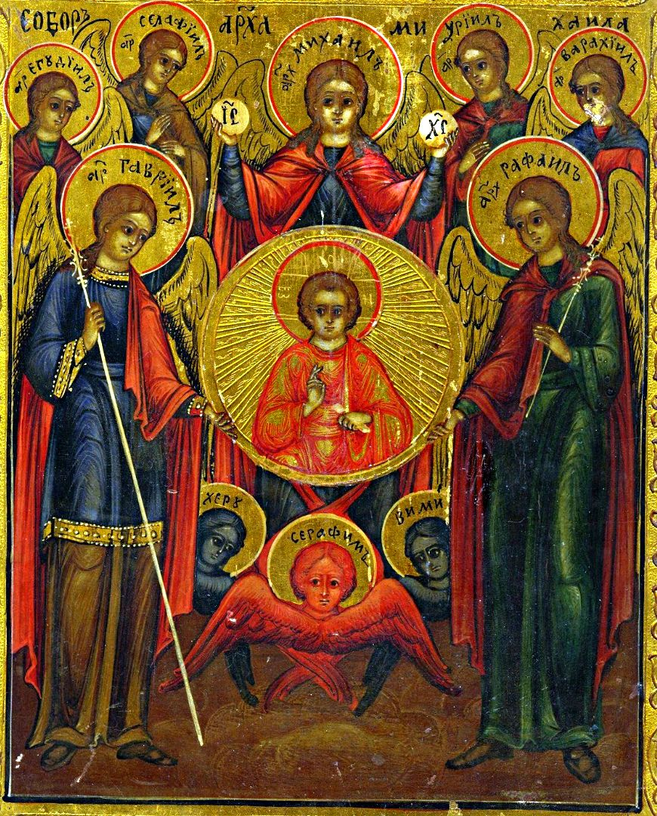 Issue VIII in our “B-list” Holy Week series. The Feast of Saint Michael and All Angels, *aka* the Feast of Saints Michael (“who is like God?”), Gabriel (“God is my strength”), and Raphael (“God has healed”), *aka* the Feast of the Archangels, *aka* Michaelmas! (Sometimes, Uriel (“God is my light”) gets included along with Michael, Gabriel, and Raphael, although he tends to get dis’d because he only shows up in the Apocrypha, such as Enoch. But he’s still better known than the other “Enoch” archangels, Saraqael – or Selaphiel (“Prince of God”), Raguel – or Jegudiel (“Friend of God”), and Remiel – or Barachiel (“Thunder of God”). Anyway, their day is 29 September. The readings assigned are: Genesis 28:10-17 / Psalm 103 / Revelation 12:7-12 / John 1:47-51.

Although, as I just mentioned, nobody but Enoch seems to have been acquainted with all seven archangels, we have not been prevented from making meaning of their number. Some traditions give one day of the week to each one: Michael (Sunday), Gabriel (Monday), Raphael (Tuesday), Uriel (Wednesday), Selaphiel (Thursday), Raguel or Jegudiel (Friday), and Barachiel (Saturday). Others associate each archangel with one of the traditional "seven luminaries" (the seven naked-eye moving objects in the heavens: the Seven Classical Planets): the Moon, Mercury, Venus, the Sun, Mars, Jupiter, and Saturn; but there is disagreement as to which archangel corresponds to which body. Of course.

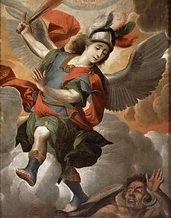 Of all the possible names for this feast, I like “Michaelmas” best, so we’ll focus on Michael; plus, he *is* the leader of the heavenly host and that has to count for something. (His status as the leader of God’s army is why “all angels” were eventually incorporated into what was traditionally *his* feast day.) Mind you, opinions about his actual rank in the celestial hierarchy vary, because – why *wouldn’t* we fight about such things? The Greek Fathers of the Church name him Prince over *all* the angels, saying he is called “archangel” because of his primacy. Others say he is the Prince of the Seraphim, the highest of the nine orders (or choirs) of angels. But then there are those like Saint Thomas Aquinas who relegate him to being Prince only of the last and lowest choir, Angels. I really don’t care, because no matter how low down he might be on the Prince of Heavenly Beings totem pole, he is still higher than I am. I do care that he usually is pictured in absurd outfits, all rosy-cheeked and perfectly coiffed. Surely combatting the Powers of Darkness would at least cause one to sweat a bit? Although I suppose if it’s really no more than a skip through the sky, he would have plenty of time to do those other jobs. 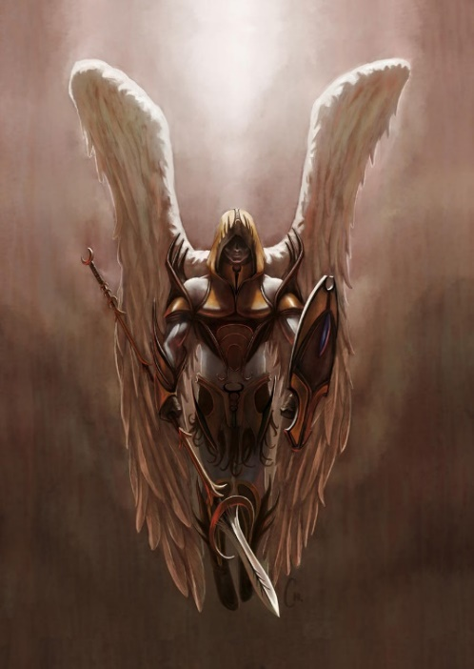But couldn’t he at least look a *little* scary?

*Of course, we don’t really canonize angels (subject them to the sort of “vetting” process we use to determine if a human measures up to meet all the requirements for sainthood) because they’re already holy, and it would be rather impertinent. In this case, then, “Saint” is more of an honorific, maybe like conferring an honorary degree on someone.*

Christian tradition gives Michael four “offices” – four “jobs.” First, he is responsible for battling Satan and the other fallen angels. Now one might think this would be enough of a responsibility, but … no.

He is also tasked with saving the souls of the faithful from the power of Satan, especially at the time of death; protecting God’s people (the Jews in the Old Law, the Christians in the New Testament), in effect making him the patron of the Church; and leading the souls of the departed from this life and presenting to Christ for their particular judgment, and at the end of time for the final judgment. He’s big on justice – a good deal of sacred art depicts him holding a scale on which to weigh the souls of the dead. Plus, he’s really good at healing. (In the earliest Church, despite Michael’s warrior skills, it was his cure of the sick through miraculous springs, pools, rivers, and the occasional church that built his cult.) Oh, and you can’t do a proper Exorcism without him.

Finally, it’s worth mentioning that Michael is the only Archangel mentioned in the scripture of all three Abrahamic religions – Judaism (Old Testament), Christianity (New Testament), and Islam (Qur’an). In Islam, Michael (Mika'il) is one of the archangels and said to be responsible for the forces of nature. I especially like this: From the tears of Michael, angels are created. Such angels are the helpers of Michael. Lovely, isn’t it?

|  |  |  |  |  |
| --- | --- | --- | --- | --- |
| **EPISCOPAL CHURCH OF THE HOLY APOSTLES UPCOMING SERVICES – SEPTEMBER 2019** | | | | |
|  | | | | |
| Sunday  01 September  8:00 & 10:30 a.m. | Sunday  08 September  8:00 & 10:30 a.m. | Sunday  15 September  8:00 & 10:30 a.m. | Sunday  22 September  8:00 & 10:30 a.m. | Sunday  29 September  8:00 & 10:30 a.m. |
| Scheduled  Presider: Gillette  Preacher: Gillette | Scheduled  Presider: Gillette  Preacher: Gillette | Scheduled  Presider: Gillette  Preacher: Gillette | Scheduled  Presider: Gillette  Preacher: Gillette | Scheduled  Presider: Gillette  Preacher: Gillette |
| 12th Sunday after Pentecost  Proper 17(C) | 13th Sunday after Pentecost  Proper 18(C) | 14th Sunday after Pentecost  Proper 19(C) | 15th Sunday after Pentecost  Proper 20(C) | 16th Sunday after Pentecost  Proper 21(C) |
| FIRST LESSON  Jeremiah  2:4-13  RESPONSE Psalm 81:1, 10-16  SECOND LESSON  Hebrews 13:1-8  GOSPEL  Luke  14:1, 7-14 | FIRST LESSON  Jeremiah  18:1-11  RESPONSE Psalm139:1-5,12-17  SECOND LESSON  Philemon 1-21  GOSPEL  Luke  14:25-33 | FIRST LESSON  Jeremiah  4:11-12, 22-28  RESPONSE Psalm 14  SECOND LESSON  1 Timothy 1:12-17  GOSPEL  Luke  15:1-10 | FIRST LESSON  Jeremiah  8:18-9:1  RESPONSE Psalm 79:1-9  SECOND LESSON  1 Timothy 2:1-7  GOSPEL  Luke  16:1-13 | FIRST LESSON  Jeremiah  32:1-3a, 6-15  RESPONSE Psalm 91:1-6, 14-16  SECOND LESSON  1 Timothy 6:6-19  GOSPEL  Luke  16:19-31 |

**HERE AND THERE** *(M. C. Gillette at* [*hapostles@sbcglobal.net*](mailto:hapostles@sbcglobal.net)*)*

*In this on-going article, we pull things from our various Diocesan calendars and church websites to see what’s going on around us. For more information about what's happening at the Diocesan Headquarters and the Cathedral of Saint James, you can always visit their websites:* <https://www.episcopalchicago.org> or <https://www.saintjamescathedral.org/>

**The Bishop Search & Nomination Committee invites all laypeople and clergy in the Diocese of Chicago to attend a Bishop Search Listening Session. There are two sessions in September.**

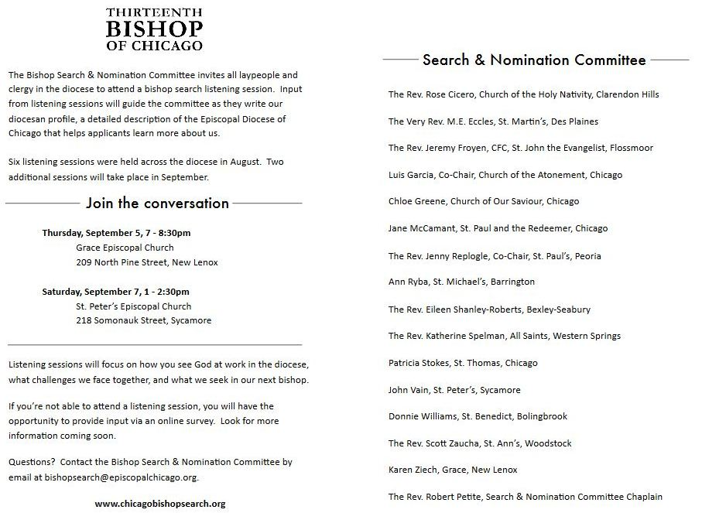

<https://chicagobishopsearch.org/listening-sessions/grace-new-lenox>

<https://chicagobishopsearch.org/listening-sessions/st-peters>

**A Prayer for the Election of a Bishop**: The Standing Committee requests your prayers during this time of transition in our diocese for those who serve on the Search and Nomination committee and all who may be discerning a call to be our next bishop. Please pray for them during weekly worship through the election convention in June of 2020.

*Almighty God, giver of every good gift: Look graciously on your Church, and so guide the minds of those who shall choose a bishop for this diocese that we may receive a faithful pastor, who will care for your people and equip us for our ministries, through Jesus Christ our Lord.* ***Amen.***

**Learn more about the search process:** <https://chicagobishopsearch.org/>

**Contact the Search Committee:** [bishopsearch@episcopalchicago.org](mailto:bishopsearch@episcopalchicago.org)

**Faith in Action: Walking with Immigrants**: **A video message from the Episcopal Church**

|  |
| --- |
|  |
|  |

In this new video, [The Episcopal Church: Walking with Immigrants,](http://r20.rs6.net/tn.jsp?f=001NDt03_KjX74KPE-yWwedAmi4aw9-EfcKEEg5rdnBDJxhmETWGnngxy6zBrjwkAxZ2aGW2_JWF7Zs0p768ReNKxxoWsNNUJBWbBui6i4zndDlKysrzABzZB5-li8ViNuzucPw-a6bF1zjnre0Y_FloDP66vmiLiGAXEKH7XNbxsJrpT6RWzy4jn-KeYEcU4ohFC0N-vF0c807eIO4FA4jZo5soV6d8cMBPqrnVos6AbXqhr5M9H0bopODDJA-__bRBr4GOvjEbf4=&c=1kMr9jdeIUSjHI-Eroe7FkSlPw5ucec7y25Dagd4BYRPgUx4EKY44g==&ch=z-ppvEyth4Z2p5d3_z9V62OVF-ihmYp2uZTWz3AEWNp2yJtMLqgfcA==) (<https://www.episcopalnewsservice.org/pressreleases/supporting-immigrants-a-video-from-the-episcopal-church/>), Presiding Bishop Michael Curry shares the stories of five bishops whose dioceses are actively engaged in immigrant welcome through Episcopal Migration Ministries and the Episcopal Church's Office of Government Relations.

"Many Episcopalians have asked, 'what is The Episcopal Church doing?' And maybe the deeper question behind that has been the question, 'what can I do?'" Curry said. "This video is intended to address those questions and to provide some ways that we, as followers of Jesus of Nazareth, can respond to this humanitarian crisis."

To learn more, visit [Episcopal Migration Ministries](http://r20.rs6.net/tn.jsp?f=001NDt03_KjX74KPE-yWwedAmi4aw9-EfcKEEg5rdnBDJxhmETWGnngx0z04dAxPfztq21iMvI0J3fBaDf7h_oJp8IXOPXsHPsJRNqsabnkoG_SyE75vtVgjEfwSgpE05GN0TnejPlHPAbmwXZbym4j9sg3KWDWfjsnwBLu0Dm8oZUXFn6VTx6oc3f7SML4Sjl9&c=1kMr9jdeIUSjHI-Eroe7FkSlPw5ucec7y25Dagd4BYRPgUx4EKY44g==&ch=z-ppvEyth4Z2p5d3_z9V62OVF-ihmYp2uZTWz3AEWNp2yJtMLqgfcA==) online. (<https://episcopalmigrationministries.org/> )

For advocacy and policy information, visit the [Office of Government Relations](http://r20.rs6.net/tn.jsp?f=001NDt03_KjX74KPE-yWwedAmi4aw9-EfcKEEg5rdnBDJxhmETWGnngxy6zBrjwkAxZTi8qL6BXKBnnlpP75veQxbFb36mSYLSVmSZF2LKZUVTwWYS5ycGBEZBvA5kVVYErbYC57kGDZnMX3RAGFPHt5SrXv1WKalXk_p2LRwV0OIbiv32aRKYgVFHIGxf6iuenm8nqhysFK_06auRAUgxYsnEv4n7arzi6&c=1kMr9jdeIUSjHI-Eroe7FkSlPw5ucec7y25Dagd4BYRPgUx4EKY44g==&ch=z-ppvEyth4Z2p5d3_z9V62OVF-ihmYp2uZTWz3AEWNp2yJtMLqgfcA==). (<https://www.episcopalchurch.org/office-government-relations>)

**"Whaling" Email Attacks & How to Foil Them**

In recent months, many congregations and dioceses have experienced email "whaling" attacks, in which emails appearing to be from the bishop or a clergy leader solicit church members to send money, provide information, or purchase gift cards.

This is a form of email "phishing" known as "whaling." [**Nina Nicholson, director of communications and technology in the Episcopal Diocese of Newark, provides helpful suggestions for how to avoid these attacks.**](http://r20.rs6.net/tn.jsp?f=001NDt03_KjX74KPE-yWwedAmi4aw9-EfcKEEg5rdnBDJxhmETWGnngxy6zBrjwkAxZ8NNE7cfX86c4TnK5pgXUaX_v9G_QwkZVO1MkaY_gzdXMfBiySwJZZXFdwvYhEDQVPQE5LzWbkXOdS1Yqv7EAMnvODMp1t3J6Unn2No3-1Be9-YLsPHhLGYS2KSXbksq1CjBpuoQ9WEt-1npY0eYErJ_gy0qmwafwUMoi6Tp8Nrs=&c=1kMr9jdeIUSjHI-Eroe7FkSlPw5ucec7y25Dagd4BYRPgUx4EKY44g==&ch=z-ppvEyth4Z2p5d3_z9V62OVF-ihmYp2uZTWz3AEWNp2yJtMLqgfcA==) (https://dioceseofnewark.org/geeks/whaling-email-attacks-how-foil-them)

**SOME CHURCHY STUFF** *(M. C. Gillette at* [*hapostles@sbcglobal.net*](mailto:hapostles@sbcglobal.net)*) In this monthly article, we look at terms and definitions of things you might see or hear around church. Nothing fancy here – these entries are out of the Armentrout/Slocum An Episcopal Dictionary of the Church, sometimes supplemented by me, and sometimes simply copied directly. If something in particular piques your interest, let me know, and we’ll deal with it in more depth.*

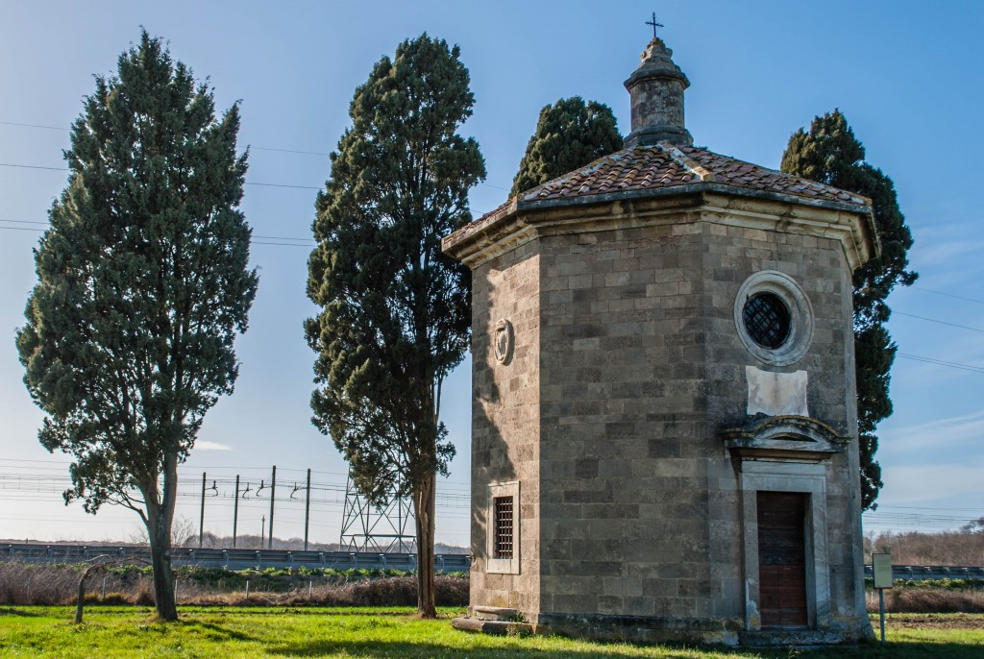**EIGHTH DAY.** Surprise! It’s Sunday, aka the Lord's Day. Of course, it’s also a book by Thornton Wilder (and one by John Case – how does that work?), but that’s not the direction in which we are going here. Sunday is both the First Day and the Eighth Day of the liturgical week because, you know, the Church is supposed to mess with the worldly systems every now and then. The Christian week has been ordered around the Sunday Eucharist since the days of the early church. Sunday is the day of Christ's resurrection and the day of the gift of the Holy Spirit. The term was used in early Christian literature for the Christian observance of Sunday. Each Sunday was (and is) celebrated as an Easter festival. For Christians, whatever you want to call this day – Eighth, or Lord’s, or Sun – it took the place of the Jewish Sabbath as the weekly day of rest appointed by God. The Book of Common Prayer doesn’t use this particular term, using instead “Lord’s Day” in stating that the eucharist is "the principal act of Christian worship" on the sabbath. “Eighth Day” also acknowledges that the number eight breaks the closed seven-day cycle of the week. It surpasses the weekly cycle of chronological time. The number eight has been associated with resurrection, the eschatological fulfillment of time, new life, redemption, and baptism. Octagonal baptisteries and fonts reflect this symbolism of the number eight, and faith that in baptism we share the new life of Christ's resurrection and rebirth by the Holy Spirit. Sunday, the day of Jesus Christ's resurrection, the first day of the week.

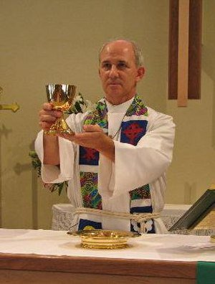**ELEVATION of the ELEMENTS.** The lifting up of the eucharistic elements for adoration at the concluding doxology of the eucharistic prayer. This gesture identifies the bread and wine with the sacrifice of Christ. The presider lifts the bread (host) and wine (cup) unless there is a deacon, in which case he/she lifts the cup, replacing them after the people respond "Amen." Historically, the bread and cup have also been lifted up at the words of institution or at the oblation (offering) of the elements in the eucharistic prayer. The Book of Common Prayer rubrics direct that at the words of institution the celebrant will hold or lay a hand on the bread and vessels of wine to be consecrated. Elevation of the elements at this time is permissible but not required. The bread and wine may also be lifted up at the time of the presentation of the gifts, prior to the eucharistic prayer. As with most of our liturgical traditions, this had the original (and in some traditions current) practical purpose (when mass was celebrated with the priest’s back to the people) of showing the people, as an act of reverence, what they were about to receive.

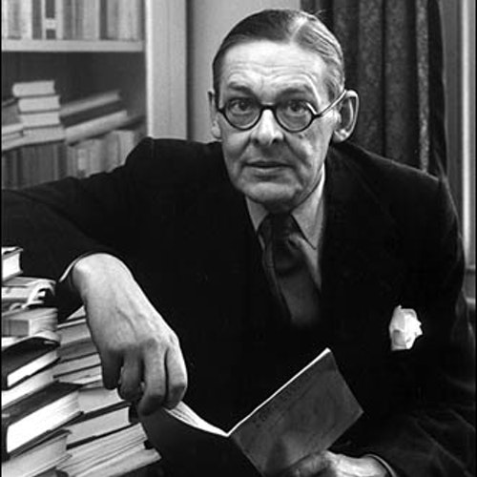**ELIOT, THOMAS STEARNS** (26 September 1888 – 04 January 1965). Of *course* you know T. S. Eliot, editor, dramatist, literary critic, philosophical poet, occasional banker, teacher, air-raid warden, and whatnot (because why just have one career when you can have many?), but did you know what the “T. S.” stood for? Or that he was an Episcopalian? (Well, Anglican, but it’s all the same bolt of cloth.) He was an American, born in St. Louis of a distinguished New England family who had relocated there – the youngest of seven children, born when his family was prosperous and secure (his father had had an earlier business failure) in their mid-forties (!). He was born with a congenital double hernia, and was therefore constantly fussed over by his mother and five older sisters, poor dear. His family allowed him the widest education available in his time, with no influence from his father to be “practical” and go into business. He ended up at Harvard, the Sorbonne, and Merton College, Oxford, and got to do cool stuff like studying Indian philosophy and Sanskrit. He finished his Ph.D. dissertation (Knowledge and Experience in the Philosophy of F. H.Y. Bradley) but that horrible World War I erupted and he never returned to Harvard to take his final oral exam, therefore never being awarded his degree. He became a British citizen. He worked and wrote in London most of his life. After being raised in the Unitarian tradition and going through a time of agnosticism, Eliot was baptized in the (Church of England) parish church at Finstock, Oxfordshire, in 1927. He subsequently declared his perspective in religion to be Anglo-catholic. His poetry reflected his intense faith, as his poem The Waste Land (1922) and The Hollow Men (1925) had expressed his earlier experience of meaninglessness. His religious poems include Journey of the Magi (1927) and Ash Wednesday (1930). Eliot was responsible to a large extent for the revival of interest in the so-called metaphysical poets, several of whom were Anglican priests, including John Donne, George Herbert, and Thomas Traherne. He also used Little Gidding, the religious house founded by Nicholas Ferrar, as the inspiration and title of one of his Four Quartets (1935-1942). Eliot wrote the play Murder in the Cathedral (1935), which deals with the martyrdom of Archbishop Thomas Becket in Canterbury Cathedral. In 1948 Eliot received the Nobel Prize for literature and the Order of Merit.

|  |  |  |  |  |  |  |
| --- | --- | --- | --- | --- | --- | --- |
| **SEPTEMBER 2019 (See PAGE 2 above for Service Schedule.)** | | | | | | |
| **SUN** | **MON** | **TUE** | **WED** | **THU** | **FRI** | **SAT** |
| 1 | 2 | 3 | 4 | 5  Farmer’s Market 4-7PM | 6 | 7  10 AM--noon  Food Pantry |
| 08  8:00 AM service  10:30 AM service | 09  7:00 PM  Shawl Ministry | 10 | 11 | 12  Farmer’s Market 4-7PM | 13 | 14  10 AM--noon  Food Pantry |
| 15  8:00 AM service  10:30 AM service | 16 | 17  7:00 PM  Bishop’s Comm. Mtg | 18 | 19  Farmer’s Market 4-7PM | 20 | 21  10 AM--noon  Food Pantry |
| 22  8:00 AM service  Adult Formation  10:30 AM service | 23 | 24  Book Group  7:30 PM | 25 | 26  Farmer’s Market 4-7PM | 27 | 28  10 AM--noon  Food Pantry |
| 29  8:00 AM service  10:30 AM service | 30 |  |  |  |  |  |

**September Birthdays**

Sept 08 Doug Connell Sept 21 Martha Gillette

Sept 12 Sally Norwich Sept 24 Wayne Chmiel

Sept 14 Michael Groble

Sept 18 Avery Sandberg, Rhys Sandberg

**September Anniversaries**

Sept 01 Dave and Sharon Thompson

Sept 18 Aggie Cebulka

**IN OUR** **PARISH LIFE:**

**SHAWL MINISTRY:** The Shawl Ministry meets on **Monday 09 September at 7:00 PM** in Lincoln Hall. No experience is necessary! Please contact Marsha Taylor at [mktaylor730@hotmail.com](mailto:mktaylor730@hotmail.com) or 847-977-5399 with any questions.

**BISHOP’S COMMITTEE MEETING:** Bishop’s Committee will meet on **Tuesday 17 September at 7:00 p.m.** in Lincoln Hall.

**BOOK DISCUSSION GROUP:** This month the Book Group will meet **on 24 September at 7:30 PM** to discuss *Orphan Train* by Christina Baker Klein, at the home of Stacey Pyne.

**WAUCONDA FARMERS’ MARKET:**   The remaining dates for the Farmers’ Market **are Thursdays 05, 12, 19, and 26 September, from 4:00 PM to 7:00 PM.** There is a sign-up sheet on the desk for those who would like to be a part of our 'ministry of presence' in the community. We will be adding some new and fun elements this year! Help with setting up and taking down the tent is especially appreciated.

**HOLY APOSTLES DOES PADS:** On **Saturday** **Nov. 9 through Sunday Nov. 10,** Holy Apostles will be running the PADS program at **Messiah** **Lutheran Church.** Not only is this a valuable service to those who need shelter during the winter months, it is an opportunity for each of us to be "the hands and feet" of Christ. Plus, it is an opportunity to reach out to those we know who aren't "into church" but might be interesting in helping. There will be ways for everyone to make a difference. In addition to direct service to the guests, there needs to be food & snacks purchased; dinner and breakfast cooked; sack lunches packed; sleeping mats set up before the guest arrive; dishes washed; mattresses put away on Sunday morning; laundry done. SO. MANY. WAYS. to help. Look for more details over the next weeks: in the Bulletin, in email, and in Lincoln Hall. If you have any questions or suggestions, email Marci Suelzer at [suelzerm@hotmail.com](mailto:suelzerm@hotmail.com)

**DIOCESAN CONVENTION DELEGATES**: Please consider representing your church at the 182nd Annual Diocesan Convention to be held on **Friday, November 22 and Saturday, November 23** at the Westin Hotel in Lombard. For more information, please see Mother Martha.

**ADULT FORMATION:**  ***Making Sense of Scripture: Big Questions About the Book of Faith.***Please come join us this fall as we delve into the first of seven questions as posed by the author, David J. Lose. The author invites us to engage in a conversation, one he imagines around his kitchen table. As he says, "Questions are, I think, the engine of all great conversations..." See dates and topics below:

**22 September** - What is the Bible?

**20 October** - Is the Bible True?

**17 November** - How is the Bible the Word of God?

We will meet between services to engage in conversation surrounding the week's question. No sign-up is required, and no prior preparation is needed. Feel free to attend any one or all; each conversation stands on its own. (In the spring, we will converse around the remaining four questions of his work.)

**RECYCLE YOUR SHOES!** We are continuing to collect shoes to be reused or recycled. Any and all shoes will be accepted-shoes in good condition will be given to others, and shoes that have seen better days will be ground up and reborn as playground material! You may deposit your old shoes in the collection box located in the Narthex near the Food Pantry milk jug. Please contact Marsha Fedor with any questions.

**PLEASE REMEMBER** that we have an Alcoholics Anonymous meeting at Holy Apostles **EACH SATURDAY morning from 9 a.m. – 10 a.m.**  Please do not schedule any events prior to 10:30 a.m. Saturdays.

**WAUCONDA/ISLAND LAKE FOOD PANTRY:** The milk jug count for July was $61.68. In July the food pantry served 180 families which totaled 474 individuals.  Five families were new to the pantry. Please keep them in your prayers.

**BLESSING OF THE ANIMALS:** The Blessing of the Animals will be held on Sunday, October 06 at 4:30pm. All creatures great and small, wild and tame, are welcome – Dog Cake and pet treats will be served! If you are planning to participate in this event, please sign-up in Lincoln Hall. If you are able to bring chili or cornbread, please indicate so on the sign-up sheet.







**TEN THINGS TO KNOW ABOUT**

***Holy Apostles 51ST Annual Dinner and Dance Fundraiser***

1. Saturday, November 16, 2019 at Mill Creek Banquets-333 Mill Street, Wauconda, beginning at 6:00 PM
2. Tickets will be available between services most Sundays & on the website
3. $35/per person before Nov 3rd, $40/person after Nov 3rd.
4. This year you can sign out tickets and sell them on your own.
5. All drink prices have been increased by a $1, and that $1 comes back to the church.
6. Turn in $75 of full face value Gift Cards (any denominations as long as they are full face value and total at least $75) and we will give you a $10 Big Raffle Ticket.
7. “The Big Raffle” tickets will be available, $10 per ticket.
8. Start thinking about building your Raffle Basket.
9. Start thinking about making items to donate.

10) We are selling ads for the Auction Booklet, forms are on Jackie’s desk.

***Please remember that YOU ARE THE REASON the auction is a success!***

If you have any questions, please feel free to give me a call at 847-775-0770.

Todd Seiler, Auction Dinner Coordinator

**FROM: Church of the Holy Apostles**

**26238 North Highway 59**

**Wauconda, Illinois 60084**